A submission to the Australian Government Productivity Commission on Right to Repair

Good product design starts with design for durability and reparability, and minimal life-cycle environmental impact.
It finishes with product reincarnation with no concept of waste.

Submission Authors:

Shaun Scallan | John Gertsakis

February 2021

The problem is just a symptom 3
Product Design Hierarchy 3
Designing for Landfill is the dominant paradigm 4
Definition of Right to Repair 4
Are there unnecessary barriers to repair? 5
What is great design? 5
Measuring Durability and Impact 5
French Durability Index 5
Measuring Impact 6
Current State of Reparability 6
Right to Repair Movement 6
Engineers, Designers and Marketers make product repair increasingly impossible 7
Assembly Barriers 7
Complexity of Design 7
Cannot be Disassembled even if you wanted to 9
Appliance Control Obsolescence 9
Fashion drives obsolescence not improved functionality 10
Finding a new way to truly sustainable design 10
Current Policy and Regulation 10
Australia 10
UN Sustainable Development Goals 12
Design for Durability 13
The key role of brand owners 13
Other key stakeholders 14
Role of the Circular Economy 14
Conclusion 14
The implications of repair issues for e-waste is less e-waste period. 15
Recommendations 15
Self-regulation has limits – Smart policies and proportionate regulation needed 15
Carrots & Sticks 15
Brand Owner Leadership Required 16
Consumer Leadership Required 16

The problem is just a symptom

From Terms of Reference
“existing provisions amount to some limited rights or protections in relation
to repair facilities in Australia, but do not amount to a full ‘right to repair’. As such,
premature product obsolescence and a lack of competition in repair markets remain. The
expense of repair and product design accelerate the transfer of consumer goods into waste.”

We could not agree more, both premature and planned product obsolescence and lack of competition in repair markets represent a classic market failure, if the market was designed with the design principles of durability and reparability. Clearly the market was not designed with these in mind, and there’s the rub.

As consumers we should claim the right to well-made highly durable products. This right is not based on some right conferred by obsessive consumerism or a dominant brand, manufacturer or retailer. This right is a proxy for the planet we depend on, its health underpins all life. That needs to be the starting point as this is causal in the need for, not just repair but superior product design overall. It should be a right to not have shit products that degrade the Earth’s Natural Capital, which we all depend on.

The Right to Repair must facilitate and enable easy and if possible (and safe) DIY repair, this will lower the cost of repair dramatically.

This starts with the design of the product, design with long life as the primary goal and secondary design goal is to design with not just repair in mind, but with enhancement. Good design should be restorative and regenerative. The concept of ‘less harm’ is inadequate in 2021 given the environmental challenges being faced locally, nationally and globally.

Yet it goes further than this, we suggest a hierarchy of product design that has direct parallels to the waste management hierarchy.

Product Design Hierarchy

- Avoid new resource consumption
- Minimise resource consumption
- Design for longevity (Long initial Lifespan, Upgradability and Reparability) & positive environmental impact; or

- Design for longevity and minimal environmental impact – next least worst option as a transition.

- Elimination of hazardous and toxic substance from any material utilised.

When in service, products must be able to be:
- Upgraded
- Repaired
- Remanufactured
- Repurposed
- Recycled – 100% Resource Recovery
Inherent in the hierarchy we propose, that there is no disposal option, and that the concept of waste is eliminated. It is not part of the narrative.

Designing for Landfill is the dominant paradigm

The ever growing tsunami of ewaste is an example of a market failure. Consumer products are designed for “shortevity” rather than longevity as this generates ongoing and increasing sales and product throughput i.e. the current consumption business driven paradigm.
The dominant business model at present designs with sales in mind, not longevity or circularity. Programmed or planned obsolescence as a concept is socially, culturally and environmentally wrong.

Product design across most product categories, has been becoming less and less repairable over time, either from ignorance or consciously. It is clear the latter is dominant as there are examples of good product design in the world, we just don’t do it in the majority of cases. And while some products have become more reliable, the duration of such performance is can be surprisingly short-lived and result in premature disposal.

Definition of Right to Repair

The TOR gives us “‘right to repair’ relates to the ability of consumers to have
their products repaired at a competitive price by the repairer of their choice”

This means a repairer is the only option offered, what about self-repair? This is, we would argue, is an attribute of great design.

Why are we not looking at a 100 year kettle or a 50 year toaster as design objectives. Much of our appliance stock life seems to be shortening before our eyes to two year lifespans. If we made it even 10 years, such an increase in lifespan could reduce the waste to 20% of current levels.

Are there unnecessary barriers to repair?

It beggars belief that this is a serious question when you look around the needlessly non-standard and proprietary strictures placed around common appliances in particular. Not to mention the tsunami of ewaste that is crashing upon us currently, including the projected volume of Internet of Things devices likely to end up in landfill at end-of-life.

Ewaste represents a systems failure and a market failure at the same time.

There is a need to protect IP, genuine IP, that distinguishes a product from its competitor. Or is this actually part of the problem?

However, design to defeat the ability to upgrade and repair is unacceptable morally and environmentally. Indeed a strong service-oriented design ethos moves us from box shifting on a regular basis as manufacturers to service-based businesses which would help underpin the business model that will flatten the tide of ewaste and inevitable consequential environmental impacts of our wasteful lifestyle, including resource depletion and impact of human health through the use of toxic substances and materials often found in certain types of electronic goods.

The needless churn of consumer goods has created a mountain of ewaste that is an appalling legacy that the post-war generation has left for their descendants and future generations.

The ultimate barrier for design that doesn’t have such negative outcomes is the current economic system that mindlessly rewards those who sell more and more ‘stuff’ on shorter and shorter lifetimes. Such lifetimes are engineered for this outcome, the less you pay the shorter it lasts. There really is something going wrong around here. The ethics that allow such wilful poor design and engineering is a blight on our society and the environment.

What is great design?
There are many opinions on what good design is. We offer a simple definition.
Great design is both functional and highly durable and uses minimum resources to achieve this, both in production and during a product lifecycle which uses minimum resources for that product type. Great design prolongs the life of products, components and materials and keeps them circulating in an economy underpinned by renewable energy.

Measuring Durability and Impact

Currently there exists no agreed definition or measurement of product durability. Making things to last has all but disappeared from our design lexicon. Society needs to re-learn how to make things last. A new relationship with the functional objects that surround us needs to develop and evolve. This a just much a cultural shift as it is a technologically issue.

French Durability Index

HOP (Halte à l'Obsolescence Programmée - Stop Programmed Obsolescence)
Rating from 1 – 10 indicating the products durability.
“This durability score would take into account reparability as well as solidity of materials. This is a strong demand from civil society: 92% of Europeans want a mandatory durability labelling (Eurobarometer 2014). Members of Parliament have heard this concern and introduced this mandatory labelling into the law to come into effect in 2024.” https://repair.eu/news/major-steps-taken-for-durability-and-right-to-repair-in-france/

“However, the ticket proposal will still be voluntary, which, Meunier says, means that “only businesses that already behave virtuously” are likely to use the new sticker plan, and other, perhaps less scrupulous companies, would be unlikely to adopt the system.” https://www.connexionfrance.com/French-news/Products-to-show-durability-and-reparability-rating

The point above is that voluntary programs won’t work unless they align with existing ethos and practice. Something to note when forming policy direction.

Measuring Impact

Fortunately, the science and practice of Life Cycle Assessment is well developed and established, this allows us to define in great detail the impact of activities in terms of air, land and water environmental emissions. The impacts in resource extraction, production, in use then end of life stages are assessed and this allows a benchmark to be set for that particular product.

Designers are then able to target improvements in lifecycle impact. Add to this design for reparability then product durability is extended even further. When the product does eventually require replacing after a long life the resources are reincarnated in a new form to continue the journey of functionality and utility in the new product.

The design principles from Cradle to Cradle acknowledges that no product “lives” forever, however, the aim should be to maximise the lifespan of all products. This extension of useful life dilutes the impact of the product in direct proportion to its lifetime. The impact is diluted by the products lifespan.

Current State of Reparability

Right to Repair Movement

The North American Right to Repair movement is growing and proving to be a potent advocate of repair, both self-repair and the wider repair industry.
- The European Right to Repair movement has a stronger focus on design for durability and other policy measures, and this is backed by the European parliament with particularly proactive member countries innovating through their own programs and initiatives.
- The growth in popularity of iFixit and its repair kits, ‘how-to’ videos and instructional guides, is noteworthy and underlines growing worldwide interested in self-repair by consumers.
- The growing number of Repair Cafés globally and in Australia demonstrates the community energy and interest and self-empowerment to prolong the life of products and to do this safely and legally.

The increasing number of community-based Repair Cafés nationwide is also testament to the growing appetite for repair and reuse by households. The Bower Reuse and Repair Centre further underscore this appetite and its relevance at a local government level. In short, parts of the community are eager to keep their products going longer and maintain control over this process in a very practical way, be it for waste avoidance/reduction reasons, cost savings or lifestyle considerations.
Related to the above is a growing consumer distaste for planned and premature obsolescence in many products they purchase but especially electrical and electronics products. The Right to Repair movements in North America and the EU to different degrees, are confronting planned obsolescence through legal, policy and regulatory measures eg. the nascent Durability Index in France and tax concessions/deductions for the cost of appliance repairs costs in Sweden. Their potential positive impact on the top half of the waste hierarchy is seemingly obvious, and therefore has relevance to why product durability repair and reuse will gain prominence as part of the any strategy, plan or education campaign to avoid and reduce waste, in addition to materials recycling.

Engineers, Designers and Marketers make product repair increasingly impossible

If you ever have attempted to repair household appliances like washing machines, dryers, dishwashers, computers, phones, toasters, kettles etc. you find out a bit about what something repairable or not. The following are some groupings that illustrate the barriers to repair.

Assembly Barriers

Appliances that are stuck together is a classic barrier to repair as you physically have to break an adhesive bond, which inevitably results in the enclosure breaking around the adhesive meaning you can’t easily reassemble, or at all as the little tabs that assist holding the device together also break off being one way devices.

Security screws and proprietary tools are useful in stopping the average punter in getting into an appliance, but why are they needed? Well safety is a good reason of course but many devices are not a danger to the repairer. Safety as a barrier to reparability should not be conveniently used to justify inaction or perpetuate a vested-interest.

Complexity of Design

This is where we have the largest opportunity to make a product repairable and upgradable.

Customised spare parts that are extremely expensive because they are unique to the model of the appliance. This makes repair a second choice behind replacing, is that an intentional part of the business model? The evidence seems to indicate in the affirmative.

One of the authors attempted a repair on a kettle a few years ago and could not believe how many parts were in something whose purpose is to boil water. Why? In search of the perfect cuppa? Is that really the best use of industrial designers and engineers? Perhaps not.

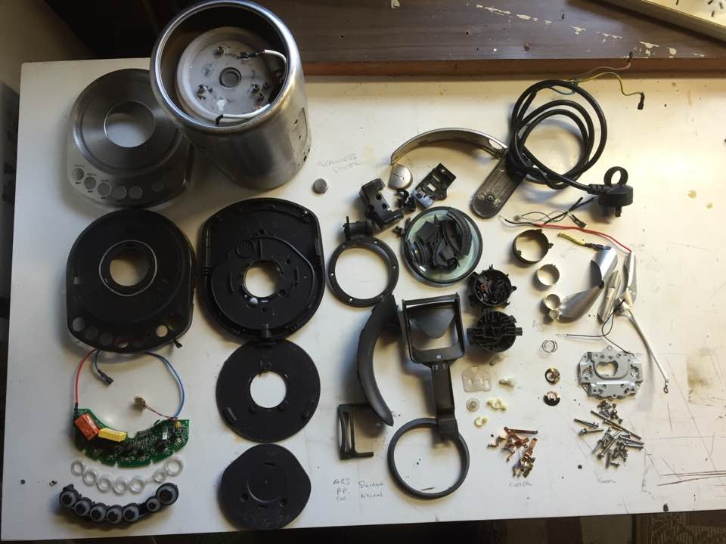

The above photo shows how we multiply the amount of ewaste by making things more complex than they need to be, mostly needlessly.

More is not better necessarily with the simple ceramic and wire element from a ceramic jug the mainstay of water boiling in Australia, and the world, for many decades. Many of us had one of these brown jugs for many years (what were we thinking?). Same functionality, way simpler to make and repair, this could easily be the basis for a 100 year kettle. Replacing the element with a sealed unit is the only suggested design change.

Cannot be Disassembled even if you wanted to

Some appliances are put together in a way that means they cannot be effectively recycled because you can’t separate the melange of different materials that make them up. For example the different plastics bonded together to render them unrecyclable and the gluing and other fixing techniques that make simple disassembly impossible. This results in having to grind it all up and separate in very energy intensive processes adding to the footprint of the appliance ecosystem.

Appliance Control Obsolescence

Adding features to appliances sells new appliances, superseding the old model, and generating mountains of ewaste. What if, instead, we upgrade the functionality by replacing the smarts with a new version of the software that runs the appliance. I must be clear here, not everything needs to have a computer controlling it, or be connected to the Internet. There are those that do more complex functions like washing machines, dishwashers, maybe ovens, air conditioning and heating systems, that could benefit from the increase in functionality through software upgrades.

Toasters are the same deal, more and more complexity but cheaper and cheaper materials to reduce effective life. The list goes on and on.

There are a group of basic household activities that have largely not changed in the last 100 years e.g. cooking in pots or in an oven, boiling water for beverages, heating water for cooking, washing and personal hygiene, making toast, washing clothes and so on. These activities are the baseload of household energy demand, everyone uses appliance that carry out these tasks. More recently there has emerged a bewildering array of time saving (not in some cases) appliances that are multifunction in application and increasingly complex from an electronic design perspective, thus rendering them obsolete either through the next most fashionable gadget or that they are not designed to be repaired, just replaced.

Fashion drives obsolescence not improved functionality

Good industrial design is in some ways functional art; the problem is it is visual aesthetics over real benefit to consumers. It is lovely to have beautiful things but if the cost of this indulgence is planetary destruction, is it really worth it?

Finding a new way to truly sustainable design

Changing this dominant attitude toward consumption is difficult. I believe we need to reframe our drivers to find form and function in perfect harmony. Something akin to the Japanese notion of Wabi Sabi, which can be translated as the beauty of things imperfect. Yet there is so much more to unpack in this concept which is driven by a respect for the natural world and the resources we “borrow” from it are treasured and given a long life. These items become cherished heirlooms that are always in fashion as they do not follow fashion. They are a reflection of the reverence we place on both the craft and material used to produce them.

Contrast this to the jarring impact on the senses and the environment of mass made and temporarily appealing highly finished goods that will become landfill in inside three years.

There is indeed something going wrong around here, which is an opportunity to do something different and find the harmony and poetry in the way we design and produce the goods that are part of our consensus lifestyle.

By using great design to deliver higher levels of durability and reparability we are positively enabling society to consumer differently. New patterns of consumption that engage with questions of waste, clean energy and cultural relevance, provide a platform for change and more sustainable living.

Current Policy and Regulation

Australia
Most State Governments in Australia have developed and are implementing circular economy policies and programs that call-out greater attention to repair, reuse and product durability.
- The recently enacted Commonwealth Recycling and Waste Reduction Act 2020 features the relevance of repair, reuse and design for durability, reparability and re-usability in its objects and subclauses.
Historically in Australia, most policy and regulatory reform in the waste area by Commonwealth and State Governments has focused on the bottom half of the waste hierarchy, despite growing evidence that more focused practical action and policy reform on avoidance and reduction (through repair and reuse), can deliver more jobs, less waste to landfill and greater consumer empowerment.
While the widely promoted public mantra of ‘reduce, reuse and recycle’ is widely advocated at a general level, specific practical attention to, and government funding for, product durability and repair activities is negligible compared to grants and funds invested in the collection and processing of materials from post-consumer goods across diverse product categories.
At a Federal level, the Australian Government’s response to the Review of the Product Stewardship Act 2011 (July 2020), made specific recommendations with the aim/intent of continuing to apply product stewardship as an essential policy tool for transitioning to a circular economy. Repair-relevant recommendations accepted in the Review of the Product Stewardship Act 2011 with implications for durability and reparability include the following:
Recommendation # 6 - Improve community support for, awareness of and engagement in product stewardship schemes.
- Recommendation #8 - Broaden the objects of the Act to include product design improvements related to durability, reparability, re-usability and recyclability.
- Recommendation #16 - Consider options to broaden the focus of the NTCRS to address the full product life cycle in line with the objectives of the Product Stewardship Act.
- Recommendation #24 - Develop a policy position for the NTCRS on re-use before the next review.
The recently enacted (Commonwealth) Recycling and Waste Reduction Act 2020 includes attention to a much stronger life-cycle approach to products, materials, waste and the associated impacts. It is especially important to note the Objects if the Act and specific subclauses that cite repair and relates aspects:
“The objects of the Bill will include reducing the impact that products and waste material have on human and environmental health and realising community and economic benefits by taking responsibility for products and waste material. The objects will be achieved by regulating the export of waste material to promote its management in an environmentally sound way, encouraging reuse, recycling and recovery of products, as well as responsible product design.”
Subclause 3(2) talks about how the objects are to be achieved by: encouraging and regulating those responsible for using, designing, manufacturing and distributing products to take responsibility for those products, including by taking action that relates to: improving the durability, reparability and re-usability of products; and managing products throughout their life cycle.
Additional momentum for attention to policy reform and action on repair is to be found at a National and State level through policies and actions plans, as well as through research-oriented and public / business education initiatives:
- National Waste Policy Action Plan (2019)
- NSW Circular Economy Policy Statement – Too Good to Waste (2019)
- Product Stewardship Centre of Excellence
- Australian Circular Economy Hub
- NSW Circular
- Institute for Frontier Materials at Deakin University

UN Sustainable Development Goals

Goal 12 - Ensure sustainable consumption and production patterns says it all and gives business the opportunity to join the global effort to build a more sustainable and just world.

In 2010 – 2019 Ewaste grew by 38% and less than 20% is recycled, we are losing the war on waste.

Our global footprint is growing and is crushing our Natural Capital under the weight of growing impact on the ecosystem we depend upon for life.

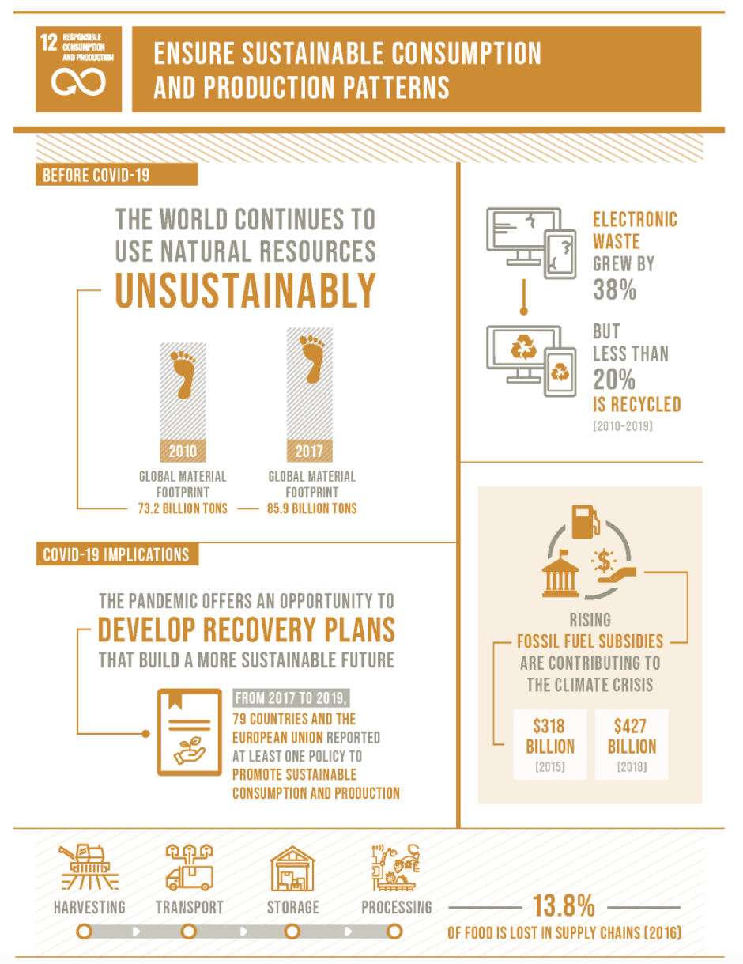
Ref: https://sdgs.un.org/goals/goal12

Design for Durability

The key role of brand owners
Brand owners of all products are in a unique position of being able to shape the future of product development and create a value proposition that lead to the multiple benefits that can accrue to consumer, business and the environment.

Truly sustainable product development ecosystems will eventually allow for material flows that help restore the environment by living off the interest rather than eroding the Natural Capital of the planet. There are many tools to measure and address a businesses’ sustainability from B Corp Certification through to GRI type measurement and disclosure frameworks.

True sustainability is defined by growth not erosion of the Earth’s Natural Capital

Other key stakeholders
In addition to brands, manufacturers and retailers, local government needs to be part of the conversation about the Right to Repair given its key role in managing waste and post-consumer products; and that repair and upgrade/reuse feature at the top of the waste management hierarchy.

Role of the Circular Economy

It is widely accepted that the top half of the waste management hierarchy is the most effective point of intervention to avoid waste from the outset i.e. prevention is better than cure, and that avoidance, reuse, repair, should be the priorities, ahead of post-consumer materials recycling.

Key principles of the circular economy explicitly talk about designing-out waste from the outset; and prolonging the life of products through repair, refurbishment, remanufacturing and reuse.
Waste avoidance and reduction by extending product life and prolonging the life of products, components and materials, is also considered to be an important contribution toward achieving a circular economy by diverting end-of-life products from landfill and maximising their functionality, value and environmental benefit.
Design for durability, repair and reuse can be seen as the ‘first responders’ when considering solutions and preventative measures that can avoid and reduce waste. Indeed design for durability and reparability are explicit ‘preventative’ measures that effectively aim to design-out waste from the outset and therefore underscore one of the key principles of what constitutes a circular economy, and the significantly impact that design can have on keeping products going long, and materials circulating in the economy.
The relevance of repair to local government talks directly to the waste management hierarchy and the opportunities that exist in the top half of the hierarchy (avoidance and reduction through reuse and repair), as opposed to the bottom half and its focus on collecting and processing end-of-life products for materials recovery, as well as safe treatment and disposal.

Conclusion

It all starts with design, good design.

Good product design starts with design for durability, minimal lifecycle impact and design for reparability and upgradability. It finishes with product reincarnation with no concept of waste.

Consumer Demand in the form of more conscious consumption is the other key part of the equation. The approach of making better products and they will come will not work when competing against cheaper but badly designed products. Giving people clear choices about the impact their consumption has will help, but experience says not much. The difference between sentiments to do the right thing environmentally versus actual behaviour is stark. Greenpower is a prime example of this, in the early days take-up was a few percentage points compared to the very high percentage of consumers who said they would use Greenpower. Good intentions, no translation into action. Economists 1 Planet 0.

The implications of repair issues for e-waste is less e-waste period.

This would seem intuitively obvious and coupled with the principle of designed in upgradability to breathe immortality into the product design zeitgeist seems the only right thinking way of creating products and services.

Recommendations

Self-regulation has limits – Smart policies and proportionate regulation needed

It is clear that without some form of effective incentive we will continue to get products that will be designed with a minimum lifetime in mind and the overarching driver will be repeat and ongoing sales thus perpetuating poor design.

A shift to a’ product as a service’ market construct seems an obvious way to give business revenue certainty, but does not by itself promote better product design. We can still rent out crap products and change them over regularly, witness mobile phones as the prime example, highly designed for aesthetics and limited life. That new phone feeling is a signpost to our lack of accountability for the impact of our spending choices. Fashion drives bad design, overconsumption and the attendant needless environmental impacts that result.

Carrots & Sticks

Possible policy options to address barriers to repair;

1. Reward organisations committing to produce long lived, upgradable and repairable products. Tax incentives and product development loans being 2 examples.

2. Penalise organisations which produce high levels of end of life waste, through punitive waste levies. These waste levies should be based on the impact of extraction, processing, use phase and end of life impacts of particular materials.

3. Fund Research into establishing design excellence on a sector by sector basis starting with those that produce the most waste and shortest lifespan.

4. Measure the waste produced and normalise over the goods life. The lower the ratio of waste to life the higher the score. The goods with the highest score get a GST reduction that is based on the benefit to the economy in a holistic sense.

5. Establish Good Product Design Code of Practice, overall and then by Industry Sector.

6. Do not allow self-regulation because of the inherent conflict of interest this presents. This only serves to create lobbying bodies committed to maintaining the status quo.

7. Have a Federal government sponsored Product Design Oscars that is focused on Australian products.

8. Develop a Product Design Best Practice Rating Scheme. Product Star Rating will draw on other element rating schemes e.g. Energy Star but be informed primarily about Durability, Impact, Upgradability and Reparability elements of design.

Brand Owner Leadership Required

Brand owners try and perceive consumer requirements and focus on delivering products that people will buy and then return to buy again. Access to cheap labour to manufacture our goods has also driven down quality in pursuit of the $7 toaster and kettle.
Turnover is now the driving paradigm of consumer goods and it is clearly unsustainable.

Reimagining the interaction with consumers to provide cost effective access to quality goods is a key lever brand owners have. This is their challenge and one that has great rewards for all stakeholders, including our planet.

Consumer Leadership Required

Consumers drive production, which drives design, which drive resource usage and therefore impact. Awareness of product impact is a key piece of the information consumers require to give an informed decision. This can be framed in measures like durability indices, but the comparative planetary impact of production, distribution, usage and end of life needs to be made visible. Well designed durable products will have less environmental impacts.

Federal Register of Legislation, Australian Government. https://www.legislation.gov.au/Details/C2020B00104/Explanatory%20Memorandum/Text
Federal Register of Legislation, Australian Government. https://www.legislation.gov.au/Details/C2020B00104/Explanatory%20Memorandum/Text

