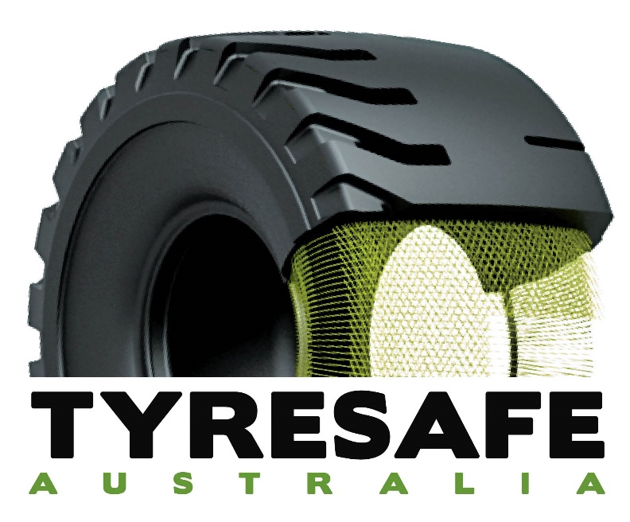

Tyres; a critical supply line item
Why tyres NEED to be included
May 2021

This document is subject to copyright laws and remains the property of the Productivity Commission (Australian Federal Government) and TyreSafe Australia. As such it may be circulated in reports as the Productivity Commission deems appropriate.
Further use is © 2021 TyreSafe Australia

Status: active ver 1.10
Document #: 2105031906
Authorised by: Adam Gosling
Prepared for: PRODUCTIVITY COMMISSION
Vulnerable Supply Chains enquiry
AUSTRALIAN PARLIAMENT HOUSE
CANBERRA
Date; APRIL 2021

TyreSafe Australia (TSA) presents the following information in response to the public request made by the Productivity Commission and in conjunction of meetings with Senator Louise Pratt (WA) and Senator Glenn Sterle (WA).

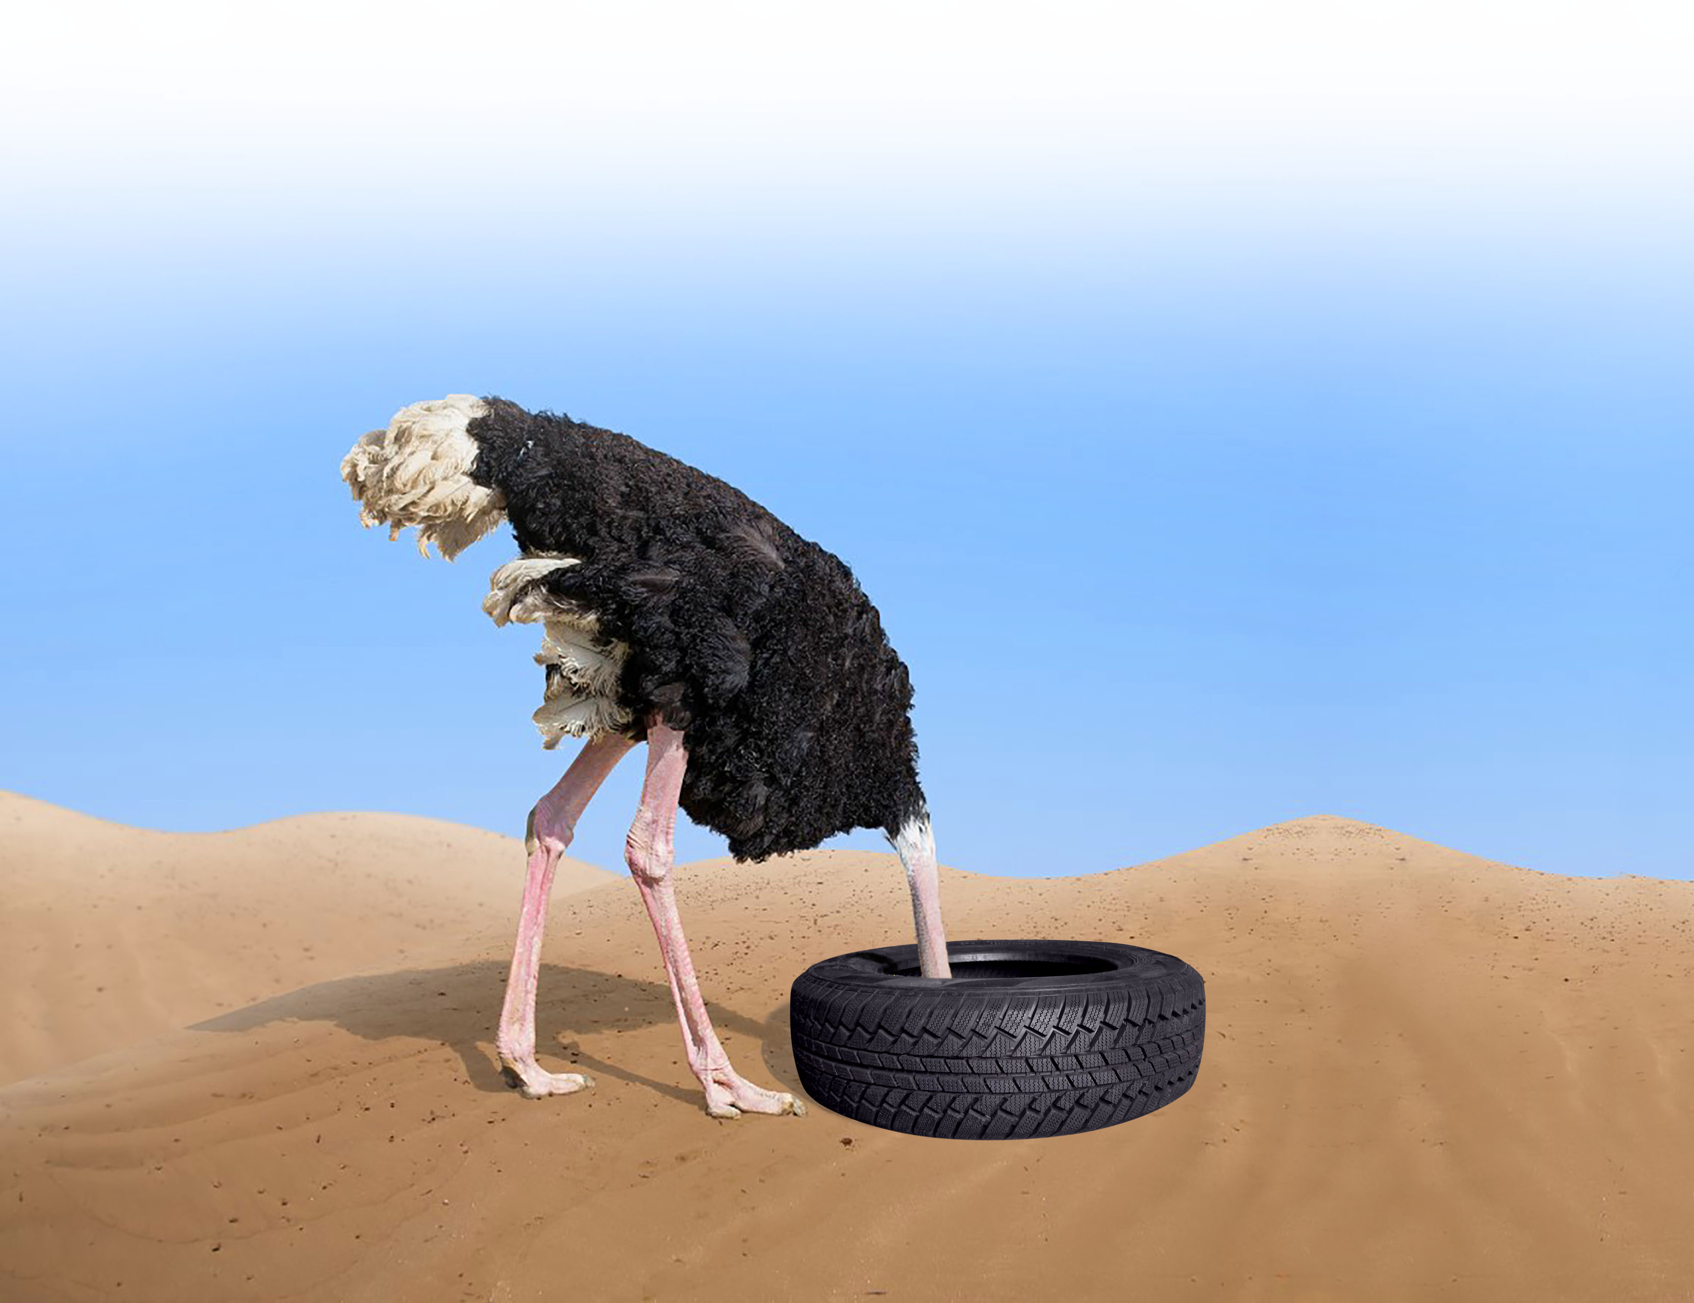
Rationale;
Figure 1; (image copyright TyreSafe Australia 2019 ©)
The inclusion of tyres into the strategically critical section of the Productivity Commissions (APC) report into Vulnerable Supply Chains is a firm requirement.
The case for such action will be outlined in the following submission.

It is noted on the cover of the PC Interim report the statement;
“The interim report focuses on how disruptions to supply chains might affect Australian’s access to essential goods and services.”

The report details how logistics and energy sectors are rated as the highest classification (Table C.3, p 125).

Tyres MUST be rated at the very top of the risk strategy as each of the sectors listed on table C.3 absolutely rely upon tyres for on-going service provision and product distribution and production.
Given that many components used in ground transport vehicles can be manufactured on shore by either traditional means (fabrication and machining) or with the use of emerging technologies such as 3D printing the criticality of tyres has to be very strongly acknowledged. Tyres have not been produced in Australia for some years now since the closure of the Bridgestone facility in South Australia.
The Australian Federal Government has taken a strong role within the fuel sustainability arena and strategic thinking as outlined by the United Nations (UN) requires that at least 90 days of fuel are maintained for use “in country”. With the emergence of alternative means of fuelling on road vehicles developing quickly (i.e. electric and hydrogen) the criticality of petroleum based fuels is receding as the uptake and development of these alternative fuel sources are explored.
All these vehicles regardless of the nature of the energy source used to motivate the vehicle rely totally upon the humble pneumatic tyre to successfully operate.
- Without tyres the vast majority of our transport sector would cease to function
- The agricultural food production sectors, without tyres many of the food production operations taken so much for granted would have to cease operations
- Large scale mining which heavily rely upon the giant (OTR) tyres
- Even aircraft shifting people and goods rely absolutely upon tyres
- Not forgetting the large scale public transport systems
- Even the rail industry relies upon tyres to deliver goods for transport to rail heads but also for the maintenance aspects
- Energy operations (read water, gas, power) all access facilities and maintenance operations via rubber tyred vehicles
- Other essential services such as medical all rely on the prompt delivery and transport of supplies and patients, without tyres this supply ceases

The end result of a tyre supply shortage (or cessation) would be highly dangerous to the continuity and well-being of the Australian Society as we know it in 2021.

Tyres are the most critical of all automotive components imported into Australia, most nearly everything else can be manufactured or repaired. One only has to observe the many older vehicles still operating in countries such as Cuba to understand how that can be made to work.
The humble pneumatic tyre is probably the most complex single assembly on a modern motor vehicle.

General tyre information
Tyres are not manufactured (on any scale) in Australia as at 2021. Tyres have been manufactured in Australia in the past but in the push for “out-sourcing and cost down” tyres were seen as a low importance commodity or little strategic importance.
It is interesting to note here that Finland, a country of 5.5 million people, supports a major tyre manufacturer (Nokian). Other lower ranking countries such as Kazakhstan have tyre manufacturing facilities. Australia being an “advanced” country has no tyre manufacturing facilities unlike global competitors such as the US, EU, China, India, Japan, Taiwan, Korea, Indonesia, Malaysia, Spain, Turkey, Russia, Belarus et al.
Tyres can be repaired and retreaded by current facilities though these have fallen away in number over years due to the lack of support by all levels governments.
- Many governments in the USA require essential service vehicles such as fire appliances and other such vehicles to operate on tyres that have been retreaded.
- The great majority of commercial aircraft operate (globally) on tyres that have been retreaded. Australia does not even recognise the importance of having tyres on heavy vehicles actually inflated unlike New Zealand who legislated this requirement in 2001. This indicates the level of consideration provided to “tyres” by the Australian regulatory sphere.

This state of affairs is despite tyres being acknowledged by non less than the Australian Federal Parliament House of Representatives Tyre Safety Committee (June 1980, ISBN 0 642 04871 1)
- The APH HoR report suggests in 1980 there was in excess of 300 retreading facilities around Australia, the writer feels it would be lucky to be 10% remaining.
The recent maritime events in the Suez Canal where trade from west of the Middle East was held up or suffered substantial time imposts is a demonstration of the situation for tyres.
With the supply line from Europe cut major manufacturers such as Michelin, Continental, Pirelli, Goodyear with a plethora of smaller manufacturers such as Nokian (Finland) and tyre manufacturers in Turkey all have supply lines cut.

For mining the impost is more than substantial with well over 40% of the giant OTR tyres used in iron ore, coal gold and copper mining coming from Michelin production facilities in France and Spain. Add many agricultural tyres from Goodyear Belgium as well as passenger and truck tyres from Michelin and Continental the fall out potential was and remains substantial

It can be easily said and understood that “Tyres are manufactured by entities at off-shore locations that may not always be “friendly” towards Australia.” To wit the current trade wars with China on agricultural products as well as mining products. It is quite feasible that China could “cut” tyre supply to Australia or install an export tariff in Chinese produced tyre products to increase the cost to Australia substantively, at no negative cost impost to China.
This situation is current for the US where certain tyres attract an inbound duty to provide price competitively with the locally manufactured products.

The establishment of a tyre production facility in Australia will require quite substantial investment with potentially limited economic positives however the situation of not having tyres is far more damaging.
It is feasible to establish a full supply chain from natural rubber to finished products using the modern robotic production lines to acquire the efficiencies required to operate in the Australian industry-scape. Synthetic rubbers can be sourced from natural gas, likewise the carbon black used as a high volume filler in rubber mixing used in tyres.
There is a vision required to facilitate the investment, over the entire chain. Whether such vision will be encountered prior to a tyre shortage will be interesting to observe.

Tyre statistics
The Australian Bureau of Statistics has been asked but not as yet provided the following details;
NB: Any reference to “tyre” indicates a pneumatic tyre as opposed to a filled or solid rubber tyre used in industrial applications.
I have formally requested as follows:
Q
The information would be most useful if presented on a decade basis, ie over the last 10 years the info is presented year by year. I am trying to understand the growth (positive or negative) in rubber imports and processing in Australia. In the longer term I would like to go back to the decade prior but that can wait. If the info is going to take time to generate for the past decade then for the purposes of the submission to the PC a current snapshot will suffice.

- Countries from which Australia imports tyres
- Volume of tyre by total tonnes by country
- Volume of tyres by tyre class (PCR (passenger) LT (light truck) TBR (on road truck), AGS (agricultural service), IDS (industrial service), OTR (off the road ie mining and construction), AC (aircraft), remaining specialty eg small such as wheel barrow
- Volume (ideally by class) of new unused tyres exported from Australia (including on new vehicles)
- Volume (ideally by class) of used tyres (not scrap or waste tyres) exported from Australia
- Volume of tyre derived rubber (or rubber pieces) exported from Australia
- Volume of tyre derived rubber (or rubber pieces) used on-shore for other purposes (eg road pavement surface, inclusion as a filler for other products, tyre derived fuel eg clinker kilns, et al)
- Volume of natural rubber imported (raw rubber or associated products derived from plant base)
- Volume of rubber in “master batches” ready for processing by formation into products, eg pre cured tread rubbers
- Volume of raw synthetic rubber imported (rubber derived from petrochemical sources)
- Volume of “carbon black” for production of rubber based products imported to Australia
- Volume of specific chemicals required for production of raw rubber into useable components (zinc oxide, accelerants, pigments etc)
- Volume of rubber products manufactured in Australia (breakdown by relevant classification eg conveyor belt, coolant hoses, hydraulic hoses, dampers and mounts, etc)
- Number of Australian academic facilities involved with research and development of rubber related products (eg hoses, belts, mounts etc)
- Number of businesses involved in tyre manufacturing in Australia
- Number of businesses involved in tyre retreading in Australia
- Number of businesses involved in importing and distributing tyres in Australia
- Number of business involved in retailing of tyres in Australia
- Number of businesses in Australia active in the tyre service field (who may not actively sell or supply tyres to the end user)
- Number of employees within the broader “rubber industry” encompassing not only the tyre industry but also conveyor belts, hoses and other rubber products
UQ
Once this detail is acquired a further addition to this submission is proposed in support of the issue.

Adam Gosling
TyreSafe Australia Pty Ltd
Perth; Australia
 : adamg@tyresafe.com.au
http://www.tyresafe.com.au

Conclusions
Tyres MUST be treated as a strategically critical component within not only international trade considerations but also for essential industries such as road transport, energy, medical, food production, not to forget public transport.
- Simply put without tyres Australia stops.
Tyres are a strategically critical item for Australia.
Whilst mechanical components can be fabricated tyres are a complex process of material sourcing as well as actual production, not-withstanding the considerable intellectual property involved in all aspects of producing tyres.

The Productivity Commission should initiate a process to identify products that are critically important to the strategic well-being of Australia, fuel being foremost followed by tyres as a very close second.

References

https://auto.economictimes.indiatimes.com/news/tyres/centre-mulls-institute-of-excellence-for-rubber-tyre-sector/55595963

Attachments

End of document

