

**CHL Group**

**ABN 11 062 802 797**

**Housing and Homelessness Review Submission**

**2022**

**CONTENTS**

1. **EXECUTIVE SUMMARY**
2. **MISSION STATEMENT**

2.1 Vision

2.2 Mission

2.3 Our Clients

2.4 Our Reach

3.0 **COMPANY SERVICES**

4.0 **CHL’S CONTRIBUTION TO HOUSING PROVISION IN AUSTRALIA**

5.0 **CURRENT FEDERAL HOUSING ASSISTANCE**

6.0 **HOUSING AFFORDABILITY IN AUSTRALIA**

6.1 Residential property prices

6.2 Housing ownership in Australia

6.3 Social and Community Rental Housing

6.4 Overall need for Social and Community Rental Housing

7.0 **POLICY ON SOCIAL AND COMMUNITY HOUSING**

7.1 Reducing levels of public housing stock transfer

7.2 Social housing stimulus

7.3 Specialist Disability Accommodation (SDA)

7.4 Public housing estate renewal

7.5 National Rental Affordability Scheme (NRAS)

7.6 Financing

7.7 Community Housing Regulation

7.8 Industry Development

7.9 Aboriginal and Torres Strait Islander Housing

8.0 **RESPONSE TO THE ISSUES PAPER**

8.1 Question in the Issues Paper

8.2 Repurposing the NHHA to support growth of social and affordable housing

9.0 **CONCLUSION**

1. **EXECUTIVE SUMMARY**

1.1 Community Housing Limited has the largest reach of any community housing provider in Australia with nearly 11,400 community rental housing homes under management and a current design and construction program of nearly 2,000 homes across six States.

1.2 There is a present need of more than 650,000 social and affordable rental homes in Australia which is more than double current available stock to house those most in need. It is estimated that the shortfall will further increase without action in the next 15 years. Apart from the Nationbuilding and Economic Stimulus Package which contributed 20,000 new homes a decade ago and the National Rental Affordability Program over the past ten years which temporarily committed around 36,000 additional affordable homes (noting that most will now be lost due to expiry of incentives over the next five years), there have been no federal initiatives of any substance to address one of the major social infrastructure deficits in the country over the past 25 years.

1.3 The solution to this overwhelming problem is relatively simple and financially achievable for any Federal Government: -

1. Convert, and steadily expand funding through the National Housing and Homelessness Agreement (NHHA), into a program of availability payments to stimulate supply funding the gap between cost of finance/operational costs and rental payments. A Program of availability payments of $12,000-$15,000 per unit per annum of between 20-40 years should suffice to create a pipeline of required residential development over the next 15 years to resolve need.
2. Expand a range of guarantees to financiers such as National Housing Finance and Investment Corporation (NHFIC), debt and equity providers to ensure a steady stream of capital investment is available.
3. Develop the National Regulatory Scheme for Community Housing as an independent mechanism to perform the role of reporting on investment and growth of community housing to Governments and the financial markets.

1.4 Australia’s current shortage of 650,000 social and affordable housing units will rise to over 1 million within 15 years unless urgent action is taken. The States/Territories do not have the resources to meet this deficit through current funding arrangements. The community housing sector has reached the level of maturity where it can attract non-government investment to meet the capital requirement to create a pipeline to meet this gap. The current NHHA provides $1.466 billion per annum towards the provision of social housing by the States. Internal modelling and project examples delivered by CHL demonstrate that if this is repurposed into availability payments to fund social and affordable housing supply then around 110,000 homes could be constructed. This number could be increased steadily over the next 15 years by an additional $750 million per annum to meet current and projected shortfall. This would mean that the NHHA would reach an annual $13 billion per annum to deliver social and affordable housing infrastructure of 1.4 million homes in Australia by 2036 managed principally by the community housing sector.

2.0 **CHL MISSION STATEMENT**

2.1 **Our Vision**

A world without housing poverty.

2.2 **Our Mission**

Working to ensure the provision of affordable and sustainable housing for all by: -

* Providing housing which is affordable, has long-term tenure and appropriate services to live comfortably.
* Assisting residents to access housing and to maintain links with their communities.
* Ensuring that the development of housing improves social, economic and environmental sustainability.
* Creating employment and training opportunities.
* Assisting the development and sustainability of strong communities with social diversity by fostering community building initiatives to improve the health and wellbeing of disadvantaged people.

2.3 **Our Clients**

CHL develops housing strategies in partnership with communities and their governments to assist: -

* Low to moderate income people in metropolitan and regional Australia who are in highest housing need and/or have been disadvantaged by market failure on the path to securing long-term rental or home ownership.
* People who live in informal and slum housing in international locations and/or low to moderate income people who are unable to secure long-term affordable housing.

2.4 **Our Reach**

CHL is building a strong national presence across Australia and expanding its international footprint across those regions where extreme poverty remains pervasive.

3.0 **COMPANY SERVICES**

3.1 The CHL Group currently has the following activities: -

* Management of long-term community rental housing presently across six states of Australia.

* Homelessness Services for those who are homeless or at risk of homelessness in Australia.

* Development, design, and construction of housing for people in need in Australia.

* Development of affordable housing in Chile, India, Indonesia, PNG, Peru, Rwanda and Timor Leste.

* Community development, training, business development and employment creation activity in relation to some of the communities where it provides housing.

4.0 **CHL’S CONTRIBUTION TO HOUSING PROVISION IN AUSTRALIA**

4.1 CHL is Australia’s leading, largest, and most geographically diverse community housing provider in Australia: -

1. Is the only national Australian community housing provider having housing management and development operations in six states.
2. Carries out design and construction of housing projects for low-income people with around 11,400 houses under management in Australia.
3. Having a staff and operational network distributed all six states providing local services through 22 locations to ensure responsive client service delivery.
4. Is one of Australia’s larger providers of housing for Aboriginal people stock of around 1,300 houses under management through a related entity, Aboriginal Community Housing Limited.
5. Has a present housing development and construction program of 1,905 homes in Australia.

5.0 **CURRENT FEDERAL HOUSING ASSISTANCE**

5.1 The Federal Government historically underpinned the national housing market through six decades of Commonwealth State Housing Agreements which ensured a steady growth of social and affordable housing until the 1990s when rising housing prices allied to a NHHA which didn’t add to supply constrained the growth of this essential social infrastructure. The Federal Government has not increased its role in the funding of housing supply for those in high housing need to match population growth or those disadvantaged by the rise in housing costs ahead of incomes over the past 25 years. This is evident despite notable initiatives such as the Nationbuilding and Economic Package to respond to the Global Financial Crisis and the National Rental Affordability Scheme (NRAS) which both delivered additional housing but were initiated more than 10 years ago. The Federal Government has continued but not expanded the NHHA which provides this year around $1.595 billion for housing and homelessness assistance and provided $237 million for remote Aboriginal and Torres Strait Housing largely in the Northern Territory (NT). Outside of this the Federal Government committed $980 million to its Homebuilder home purchase assistance scheme. Indeed, the Federal Government has been reducing the value of its assistance to lower income renters through the winding down of NRAS from around 36,000 to 29,000 by the end of 2022.

5.2 The main contribution by the Federal Government to the development of housing supply in recent years has been growing the capacity of the NHFIC in having its bonds issued to the market guaranteed by the Federal Government up to a cap of $3 billion, recently increased to $3.5 billion. Another sector where the Federal Government has been funding increased accommodation options has been through the National Disability Insurance Scheme (NDIS) specialist disability accommodation (SDA). Up to the end 2021 the number of beneficiaries who receive SDA are 15,700.

5.3 The Federal Government also provided Commonwealth Rental Assistance of $5.5 billion in 2020/21 nationally through a rental subsidy of between $98-$190 per fortnight dependent on the household size and level of rent charged for those in receipt of Centrelink benefits who are not in public housing and renting.

6.0 **HOUSING AFFORDABILITY IN AUSTRALIA**

6.1 **Residential property prices**

As a multiple of average household disposable income per person aged 15 and over, average residential property prices rose from less than 6 times in the early 1990s to over 11 times by the end of 2021 (Chart 1) from census data.

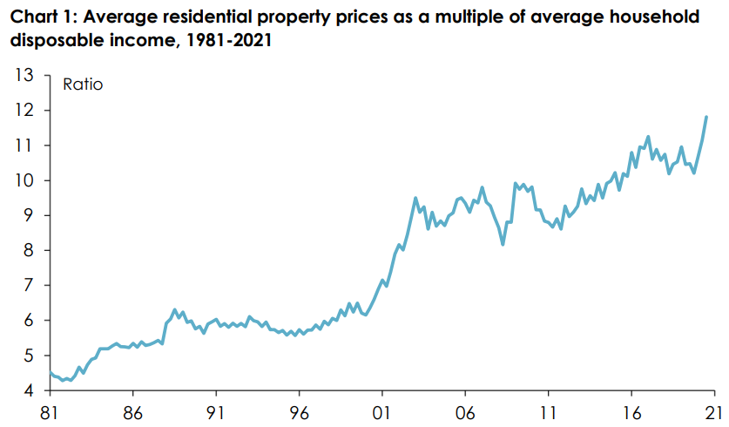

6.2 **Housing ownership in Australia**

Since 1991, 3.2 million Australian households (out of a total of almost 4.5 million) who own at least one property – and especially for the almost 750,000 Australians who owned at least one investment property – benefited from the dramatic escalation in residential property prices giving them wealth at the beginning of the period. However, 1.1 million Australian households have had increased housing costs (almost one-quarter of the total) whilst living in rental accommodation at the beginning which rose by the time of the 2016 census to almost 2.6 million (or almost 31% of the total).

Between the 1991 and 2016 Censuses, Australia’s home ownership rate fell from 68.9% to 65.5% – the lowest it has been since the Census of 1954. But for people aged between 25 and 34, the home ownership rate dropped by 11 percentage points between 1991 and 2016, to a lower level than it had been in 1954, indeed to only 3 percentage points above where it had been in 1947 (Chart 2). For people aged between 35 and 44, the home ownership rate dropped by 12 percentage points, to a level just 1 percentage point above where it had been in 1954.

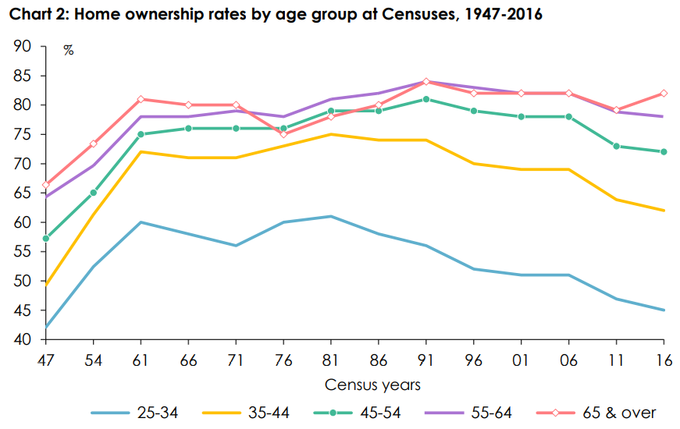

The last decade has been characterized by historically low interest rates and high migration which has driven the rises in housing prices to its current level of 12 times average incomes. Economic analysts are forecasting that the long-term trend of low interest rates will end in the coming years which could place economic pressures on households who have invested in high prices and need to maintain mortgages or rises in private rents for landlords who have invested and must pay higher interest costs.

6.3 **Social and Community Rental Housing**

The situation for social housing in Australia is one where community housing continues its trajectory of increasing stock under management compared to a declining public housing sector.

Social and affordable housing rental

|  |  |  |  |  |
| --- | --- | --- | --- | --- |
|  | 2009 | 2013 | 2017 | 2019 |
|  | Dwellings | | |  |
| Public housing | 336,464 | 328,340 | 319,913 | 305,191 |
| Community housing | 39,770 | 67,385 | 82,902 | 100,205 |
| Aboriginal housing | 32,288 | 27,249 | 32,846 | 32,322 |
| **Total** | **408,522** | **422,974** | **435,661** | **437,318** |

*Source: Australian Institute of Housing and Welfare 2020*

.

6.4 **Overall need for Social and Community Rental Housing**

Australia needs to build more than 1 million social and affordable homes by 2036 to arrest the shortfall caused by a lack of investment across decades and anemic wage growth.

The existing deficit of 651,300 social and affordable homes will blow out to nearly 1,024,000 by 2036 unless a change in policy is introduced, with nearly one-third of the shortfall occurring in NSW, a report to be published on Thursday by the UNSW City Futures Research Centre and Community Housing Industry Association (CHIA) NSW shows. Current rental stress in different communities is demonstrated by the *National Cities Performance Framework 2019* is as follows: -

Available levels of social housing in Australian cities are as follows: -

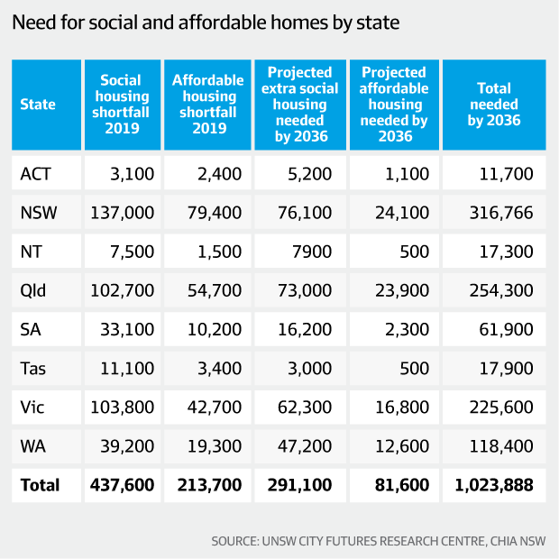

7.0 **POLICY ON SOCIAL AND COMMUNITY HOUSING**

7.1 **Reducing levels of public housing stock transfer**

The policy environment has transitioned from a period during the 2010s where the Tasmanian, SA and NSW Governments focused on management transfer principally to assist in containing the increasing costs of managing public housing portfolios. The only State Government that has recently undertaken significant further transfer of public housing is in Tasmania where it is transferring 2,000 homes.

7.2 **Social housing stimulus**

There is now a focus on social housing development in some States to assist housing those most in need who have been left behind by rising private rental levels and reducing vacancy rates in many States. In Tasmania the Government is funding 1,000 new units over the next two years to be delivered by partners; Queensland has set a target of 6,000 additional units over the next four years; most significantly to address historical social and affordable rental housing deficits, Victoria is planning 13,400 additional units over four years all to be delivered or managed by the community housing sector; and WA which is planning 3,300 additional units over the next four years. The rental deficit is also prevalent in NSW but there is, at the time of writing, no coherent State Government response at scale. Despite these significant initiatives they will only just increase available housing for those most in need by a small amount given the loss of NRAS accommodation over the next five years.

7.3 **Specialist Disability Accommodation (SDA)**

The development of SDA commencing as a pilot in 2013 has been growing and is likely to achieve maturity over the next three years. The NDIA considers 6% of beneficiaries (28,000) to be the best current estimate of the number of participants who will be found eligible for SDA funding under the NDIS. It is estimated that there is existing specialist accommodation for 15,700 people, implying the need for new dwellings to accommodate an additional 12,300 participants.

7.4 **Public housing estate renewal**

The prospective renewal projects that are now emerging in States such as Victoria, NSW, SA and prospectively Queensland provide significant redevelopment opportunities for public housing estates. These both generate additional housing for those in need and market “build to rent” housing that cross subsidizes lower rental properties and creates the opportunities for more integrated communities.

7.5 **National Rental Affordability Scheme (NRAS)**

Despite the significant investment by Governments to develop more than 25,000 social and affordable housing units across Australia, continuing expiry of NRAS incentives will trigger sales of investor-owned accommodation. Expiry of NRAS will reduce incentives by 30,746 over the next five calendar years of which it is expected up to 20,000 private investor-owned homes will be sold into the market meaning that most of the development funded by State Governments will principally cover the deficit created by NRAS expiry.

7.6 **Financing**

The chief positive development for the community housing sector over the period has been the maturing of the National Housing Finance and Infrastructure Corporation (NHFIC) which has expanded its initial $2 billion cap liability from the Federal Government to $3.5 billion. Of this figure more than 16% is being committed to projects developed by CHL. In addition to this CHL has managed to refinance debt and develop projects in Victoria utilizing low-cost finance provided by Treasury Corporation Victoria (TCV). The increasing profile of CHL and the sector more generally has attracted equity financiers who are able to provide the necessary risk capital to complement senior debt. This has been provided through NHFIC and TCV which have been able to provide senior debt at fixed low-cost interest rates for terms between 10-30 years.

7.7 **Community Housing Regulation**

The National Regulatory System for Community Housing (NRSCH) continues to be the principal regulator for the community housing sector in Australia. It was expected that Western Australia and Victoria would have integrated their regulatory systems with the NRSCH over the period which did not occur and a Federal funded review of the NRSCH did not go further to resolve this issue. This continues the complexity of regulatory compliance beyond that necessary for the community housing sector and creates an extra administrative burden for national organizations such as CHL. More to the point the Federal Government does not have an independent monitor to evaluate the allocation of public funds for social and affordable housing growth which a single national regulator would be able to undertake. It is the lack of a framework for monitoring the impact of Commonwealth funding of the NHHA which has often been the cited reason for the lack of expansion of this important funding source for social housing infrastructure by the Federal Government.

7.8 **Industry development**

The development of a national industry continues its momentum assisted by the growing influence of the Community Housing Industry Association (CHIA). The NRSCH has a system of tiers of community housing providers where the highest tier is regulated to higher degree due to increased risk of development and financing. There are now 38 tier one community housing providers and housing associations in Australia. CHL remains the largest CHP in the country with nearly 11,400 units in six States under management followed by Housing Choices Australia with 8,500 units in four States, Compass Housing with 7,600 units in two States, Link Wentworth and SGCH from NSW each with 6,500-7,500 units under management. The community housing sector has demonstrated the success of the industry to meet need; manage assets and housing development ensuring that there is an investable framework for growth. The long track record of 15 years of regulation provides a source of data on performance that is now encouraging large scale non-government capital investment in the community housing sector.

7.9 **Aboriginal and Torres Strait Islander housing**

The number of homes occupied by Aboriginal and Torres Strait Islander people in housing managed Aboriginal corporations and State Governments has marginally reduced across the country despite strong population growth. Unmet demand is characterized by overcrowding of housing for this cohort as well as those in high need across the general community. It should be however noted that data in relation to health, employment and homelessness indicate that a larger proportion of this cohort than the general community is affected by the lack of growth in low-cost housing options. The Closing the Gap report 2021 advised funding to reduce overcrowding by 1,950 bedrooms in housing in the NT. This is the equivalent to an additional 650 three-bedroom homes over the period from 2018-2023. Other States have announced a focus of attention on housing for Aboriginal people including Victoria which committed 10% of its Big Housing Build stimulus program to Aboriginal and Torres Strait Islander people in need.

8.0 **RESPONSE TO THE ISSUES PAPER OF THE REVIEW**

8.1 **Questions in the Issues Paper**

The Issues Paper includes many detailed questions which the writer considered as secondary to the fundamental urgency of supply in the face of a current shortfall in social and affordable housing. To discuss the distribution of nearly $1.6 billion (less than 0.75% of the current capital requirement) through a response to these questions as stated is replaced here by a proposal on how the current funding structure can lend itself to creating a system that starts to resolve housing need for those least well off in Australia.

8.2 At present State and Territories have the assets and planning powers to designate land for social and affordable housing. The provision of large-scale capital funding is beyond the appetite of most State Governments despite the recent commitments made by the Queensland, Tasmanian, Victorian and WA Governments in their 2021 budgets. What has occurred in the past decade across all State and Territory Governments is the commitment of NHHA funds by the States to cover the gap between rental revenue and operational costs whilst managing the declining asset of their public housing portfolios. It would be fair to say the principal motivation for transfer of management of public housing to the community housing sector in NSW, SA, and Tasmania has been to transfer liability and to concentrate Commonwealth grant funds through the NHHA on the remaining smaller proportion of housing stock under public housing management. At the same time the Commonwealth Government has been dissatisfied with the use of the NHHA grants for maintaining rather than expanding the pool of social and affordable housing.

8.3 The simple reality is if the NHHA is to stay at the same level without significant growth then it is really a very small contribution to the development of housing and housing services for Australians in need. What should be occurring is for there to be:-

1. The development and funding of a National Housing Strategy that Commonwealth, States/Territories commit to based on evidenced need.
2. That the current arrangements where the States simply receive a grant and be required to report no longer apply and that NHHA funds be directed to increasing the social and affordable housing portfolio. There should be a return to shared funding for social and affordable housing development where Commonwealth funding is the largest component complementing State funding of growth of supply.

8.4 **Repurposing the NHHA to support growth of social and affordable housing**

The arrival of NHFIC provided a source of low-cost debt finance at a historical low cost and created an asset class through issuance of bonds to refinance current CHP debt and new debt financing to grow stock. The limitation of CHP balance sheets will inevitably constrain the current expansion of use of non-government senior debt. However, there is ample availability for equity funds at reasonable cost which matched to senior debt can fill the capital requirement to ensure large portfolios of housing can be developed by the community housing sector. The level of social and affordable housing rents is however insufficient to pay the cost of finance; meet operating costs and maintain the asset. If the NHHA is repurposed into the provision of availability payments to cover the subsidy gap and then expanded to provide a pipeline of supply, then Australia’s shortage of social and affordable housing would be resolved. The current level of the NHHA at $1.595 billion per annum (noting that $129 million is used to support homelessness provision) provides support of $1.466 billion to the States to administer social housing. If $1.466 billion is converted to availability payments of between $12,000-$15,000 per unit per annum to secure access to equity and debt to develop more social and affordable housing, then a pipeline of 110,000 homes could be developed simply by repurposing current funds and continuing payments over a 20–40-year period. Using the current NHHA funding level as a pilot pipeline for such a reform could, once proven, allow expansion of the NHHA by $750 million per annum over the next 15 years to provide a pipeline of 58,000-60,000 additional social and affordable homes per annum meeting nearly all the current and developing shortfall of stock over time. By 2036 Australia would have sufficient social and affordable housing to meet need at a cost under $13 billion per annum. Building such a program into the forward estimates would provide this essential social infrastructure for the future. After 20-40 years the scale of funding could be wound back to meet demand as it arises given that the portfolio would have been created, debt and equity paid down.

8.5 Delivery of such a Program would need to start at a small scale at around 10,000 homes per annum in Year One and rise to the level of 60,000+ homes per annum by 2036. An initial four-year period transitioning current NHHA grants to stimulate supply of new social and affordable housing would allow the States to undertake the necessary review of asset strategy to designate housing for redevelopment or disposal and allow the construction sector to adjust to deliver an overall higher number of homes per annum in the nation. It should be noted that CHL is presently redeveloping public housing in Victoria under a longterm lease to deliver 1,100 social, affordable, disability and market rental housing using the structure of an annual availability payment. This leverages $450 million in debt and equity to complement a $50 million State Government grant and longterm peppercorn lease of land. After 12 years the equity is paid down and the availability payment is utilized to double the housing made available over the following 28 years. This approach can be replicated across Australia, both resolving current asset management challenges in State Government owned housing stock and the need for growth in social and affordable housing supply.

9.0 **CONCLUSION**

9.1 Australia’s current shortage of 650,000 social and affordable housing units will rise to over 1 million within 15 years unless urgent action is taken. The States/Territories do not have the resources to meet this deficit through current funding arrangements. The community housing sector has reached the level of maturity where it can attract non-government investment to meet the capital requirement to create a pipeline to meet this gap. The current NHHA provides $1.466 billion per annum towards the provision of social housing by the States. Internal modelling and project examples delivered by CHL, driven by pricing of available low-cost equity allied to senior debt coupled with the Government guarantee of the availability payment, can fund supply. Such a fund if repurposed into availability payments to fund additional social and affordable housing supply would mean around 110,000 social and affordable homes could be constructed as long as such a payment was continued over the next 25-30 years. This number could be increased steadily over the next 15 years by an additional $750 million per annum to meet the current and projected shortfall. This would mean that the NHHA would reach an annual $13 billion per annum to deliver social and affordable housing infrastructure of 1.4 million homes in Australia by 2036 managed principally through the community housing sector.