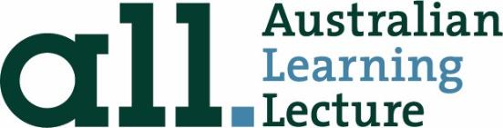

REVIEW OF THE NATIONAL SCHOOL REFORM AGREEMENT
Submission from Australian Learning Lecture (ALL)

This submission is from the Australian Learning Lecture, in conjunction with Tom Greenwell and Chris Bonnor, authors of Waiting for Gonski: How Australia failed its schools, published by UNSW Press.

The Australian Learning Lecture is a ten-year initiative by Koshland Education Innovation Ltd designed to bring big ideas and new approaches in education to national attention. The Australian Learning Lecture is built around a biennial lecture. Each lecture introduces a big new idea which is supported by an impact program. The program is designed to show that big ideas are possible in practice, to create awareness of the need for a learning culture and to build engagement with learning.

ALL acts as a hub and a catalyst, working with the world’s leading knowledge shapers to drive impact in key areas of need for change. It draws on the input of multiple voices and stakeholders to strengthen the importance of learning for all Australians. ALL is not politically or commercially aligned.

Overview

The current Productivity Commission review of the National School Reform Agreement (NRSA), together with its National Policy Initiatives (NPIs), has the potential to be a defining event in the evolution of Australia’s school system.

In its review, the Commission is seeking to align the NRSA with emerging policy issues, priorities and evidence relating to schools. Significantly, it includes a focus on the key policy and external drivers of student outcomes. Its information request relating to drivers of student outcomes invites a broad and evidence-based response.

We contend that a thorough reassessment of these drivers is essential if reforms and initiatives are to align with, and respond to, priorities and strategies to improve student outcomes. One critical driver is external to the reach of most school reforms but, unless addressed, will continue to undermine the purpose of the National Policy Initiatives.

Main points
- This submission focuses on drivers of student outcomes and responds, with evidence, to the information request questions listed on page 8 of the Productivity Commission’s call for submissions.
- The ALL team directs the Commission’s attention to a key driver which is not adequately addressed by the National Policy Initiatives (NPIs): the effect variously known as the peer effect, compositional effect or neighbourhood effect. This refers to the impact of a student’s peers in their class, cohort or school on learning and achievement.
- This driver is substantially caused by long-term policy settings which generate large concentrations of disadvantaged students in some schools, creating a segregated school system, along with negative peer effects which persistently undermine equity and overall achievement in Australia’s schools.
- The NPIs fail to address the role of government policies in worsening negative peer effects. Until attention is given to this problem, the efficacy of the National Policy Initiatives will remain substantially diminished.

What does the evidence suggest are the key drivers of student outcomes across the three key NSRA domains — academic achievement, engagement, and skill acquisition?

The NPIs reflect admirable attempts over recent decades to improve educational outcomes for all Australian school students. However, they do not address a major driver of ongoing decline nor the substantial gaps in the achievement of advantaged and disadvantaged students.

Compositional or peer effects refer to the collective impact of all the other students at a school on a student’s educational outcomes, over and above the impact of their own family circumstances. Within schools, peer effects impact in different ways on such things such as the level of social and cultural capital, time on task and focus on learning, attention to individual students, teacher expectations, depth of curriculum, student identity and aspirations, learning opportunities and resources. The net effect is that negative peer effects are associated with students from disadvantaged social backgrounds and positive effects with students from advantaged backgrounds.
The Review of Funding for Schooling (2011) found that the socio-economic status of a school’s student profile affects the performance of individuals within that school, irrespective of their own socio-economic status.

The review concluded that: “Many international studies, as well as research using PISA and NAPLAN data, confirm that concentrations of students from certain socioeconomic groups within a school has a strong impact on the educational outcomes achieved by all students at the school. Importantly, research also suggests that this impact is more significant than the effect of an individual student’s own socioeconomic status on outcomes.”
Critical evidence in support of this finding was presented by the New South Wales Department of Education which showed that the effect of school SES on student performance is profound and exists across the SES range. The effect also grows stronger from Year 3 to Year 9.

The paper pointed to the considerable independent effect of concentrations of disadvantage at the school-level, an effect over and above the SES of an individual student. The achievement of students rose, sometimes dramatically, if they enrolled in schools where students, on average, had a higher socio-educational status.

The discussion paper demonstrated this to great effect in this graph: the dashed horizontal lines represent average scores for students from different family backgrounds; the full lines represent student performance as school SES changes.
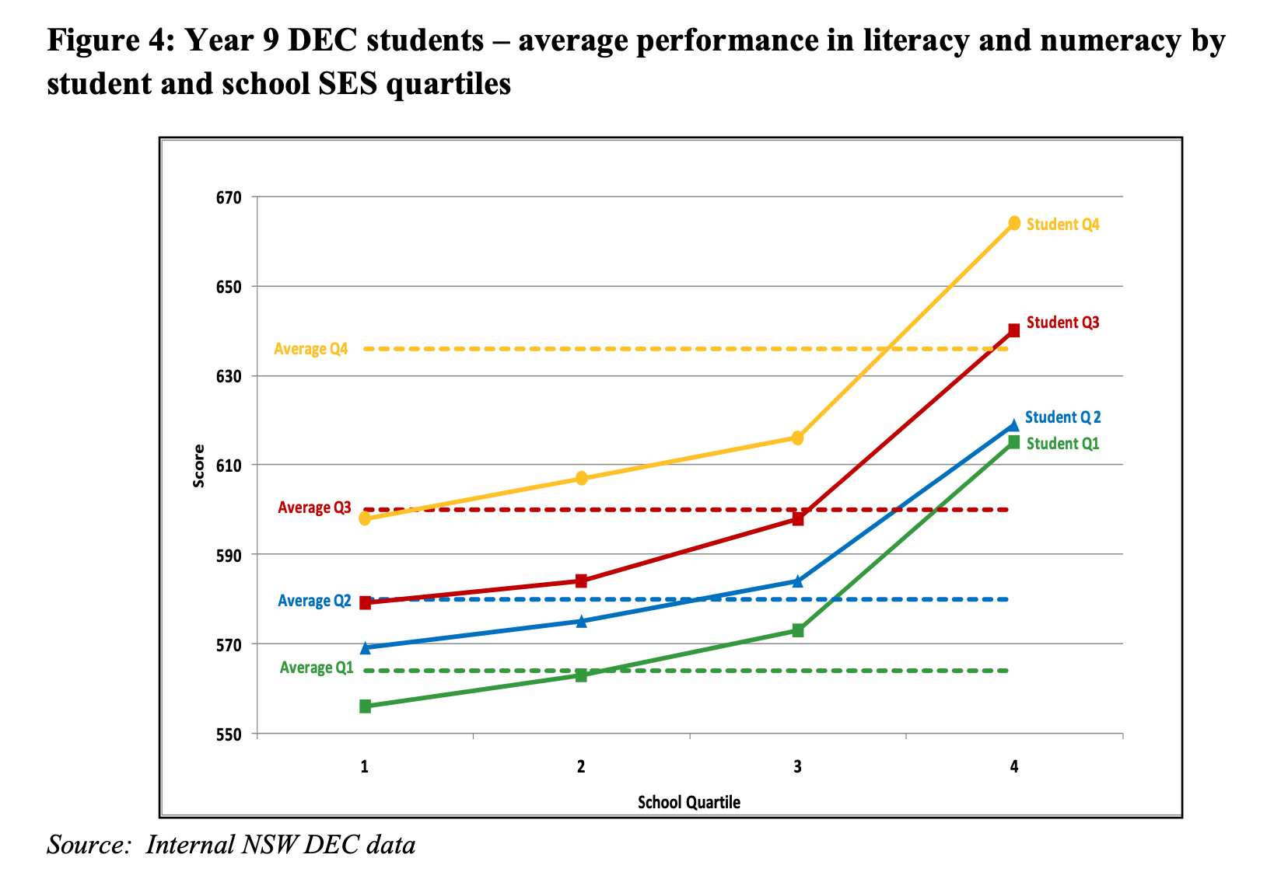

Professor Richard Teese replicated the New South Wales findings in other school jurisdictions and sectors. Research commissioned for the 2011 Gonski review stated that peers have a significant influence on the behavioural and cognitive development of young people, and that placing a lower performing student into a higher performing school creates a significant positive effect on that student’s performance.
At the same time, an international meta-analysis of studies on peer effects conducted in 2010 found a substantial effect on test scores every time the average socioeconomic status of a student’s peer group increased by one standard deviation.
These findings have been confirmed by more recent evidence. In its analysis of the results of the 2015 round of Programme for International Student Assessment (PISA) tests, the Australian Council for Educational Research (ACER) concluded: “Regardless of their own socioeconomic background students enrolled in a school with a high average socioeconomic background tended to perform at a higher level than students enrolled in a school with a low average socioeconomic background.”

Importantly, the ACER analysis confirmed that peer effects are a significant driver of student outcomes. “Disadvantaged students in average socioeconomic level schools scored about 25 points, or almost a year of schooling, higher than those in disadvantaged schools. Similarly, disadvantaged students in advantaged schools scored another 33 points, which was equal to more than one year of schooling.” The report concluded that: “the social composition of schools had just as strong an impact on the likelihood of being a low achiever as a student’s own family background.”
In 2018, Dr Jenny Chesters, research fellow at the Melbourne Graduate School of Education, conducted an analysis using data from the PISA tests and the Longitudinal Surveys of Australian Youth. Chesters found that: “The SES of the school attended is positively associated with PISA score with students attending high SES schools scoring, on average, 66 points higher than those attending low SES schools, net of other factors.”

In 2019, the OECD concluded that: “Students’ performance is influenced by their personal characteristics, but also by those of their schoolmates. Schoolmates can motivate other students and help each other overcome learning difficulties; but they can also disrupt instruction, require disproportionate attention from teachers, and be a source of anxiety… The concentration of low achievers usually has negative consequences on student performance, and this is especially the case for students who are themselves low achievers.”

In 2020, economists Alexandre de Genre and Nicolas Salamanca found that “a one standard deviation (1 SD) increase in the average test scores of classroom peers at baseline increases own test scores by 5.2 percent of a standard deviation two years later.”

Changes in Year 12 results in NSW, Victoria and Queensland between 2006 and 2018 has shown further evidence of the tightening links between the SES distribution of students between schools and the distribution of both high achievement scores and high achieving students. Schools in the highest ICSEA ranges have, on average, seen an increasing concentration of high SES students and high-end results. The lowest ICSEA schools in all three states have an increasing concentration of low SES students, and lower results.

Which of these drivers or barriers can governments change or influence?

The socio-economic character of Australian schools is partly produced by geographical location; to an extent, student populations reflect the character of the communities they are located in. However, 95 percent of Australian schools compete with at least one other school. The basis on which this competition occurs has an additional effect of sorting young people from advantaged and disadvantaged backgrounds into separate schools, producing intense concentrations of disadvantage and exacerbating the negative impact of peer effects.

Australia has one of the most segregated school systems in the OECD, with more intense concentrations of social disadvantage than countries like Russia and Tunisia.

The impact of Government policies

Government policies are responsible for this phenomenon in three critical respects.
Firstly, the effect of Commonwealth, state and territory government funding is to provide non-government schools with significant advantages in net recurrent income per student. This makes those schools more attractive to the families of advantaged and/or high performing students, pulling those students away from less well-resourced public schools.

Around one third of non-government schools receive more taxpayer funding (state and Commonwealth combined) than at least half of comparable public schools. On average, net recurrent income per student is a third higher in independent schools. Catholic schools also enjoy an advantage despite enrolling a much lower proportion of disadvantaged students.

Secondly, Australia is unusual internationally in permitting largely publicly funded non-government schools the freedom to charge entry fees as they please. Fees are a significant barrier to entry for low-income families and this is reflected in the under-representation of low-income and disadvantaged students in non-government schools, as well as the corresponding over-representation of those students in free, comprehensive public schools.

Government policies have actively exacerbated the role of fees in excluding low-income students from non-government schools. At the start of this century, the calculation of funding levels for non-government schools shifted from a measure of actual school income to a measure of parental capacity to pay. The explicit purpose of this shift was to allow non-government schools to increase fees – as high as the market would bear – without losing public funding as a consequence.

The policy has succeeded in it its intent: for the last two decades private school fees have consistently grown at a faster rate than CPI and the Education and Training Wage Price Index. The result has been to intensify concentrations of social disadvantage in free, comprehensive schools where the challenges of negative peer effects are correspondingly greater.

Thirdly, Australia is also internationally unusual in permitting largely publicly funded non-government schools almost complete autonomy over enrolment practices. Selective tests and entrance criteria, as well as expulsion policies, are additional mechanisms of exclusion for disadvantaged and/or low achieving young people. In addition, fully or partially selective public schools, particularly in New South Wales, enrol a disproportionate number of advantaged students, increasing the proportion of disadvantaged students in comprehensive schools.
The effect of taxpayer-fuelled resource advantages, ever-increasing fees and exclusive enrolment practices can be seen in the divergence between the socio-economic character of government and non-government schools in recent decades.

The following graph shows the ratios of low/high family income in government and non-government schools for all secondary schools in each census year 1986 to 2016. There is a clear family income divergence between, in this case, Australian public and private schools.

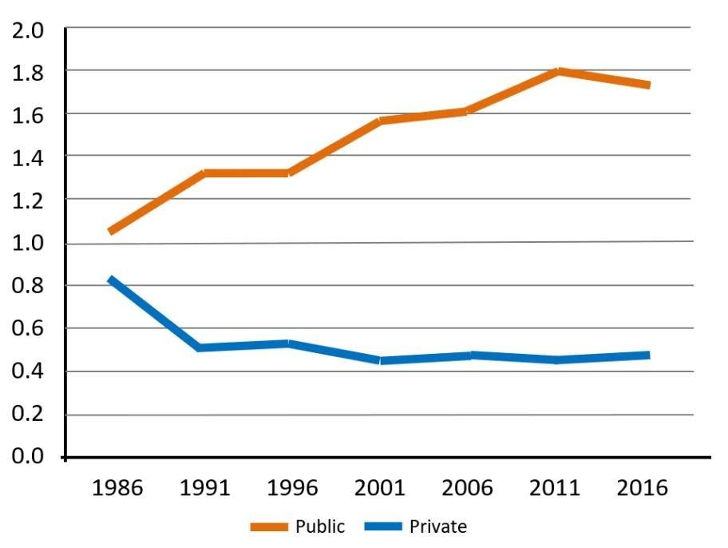
Source: Preston B (2018), ‘The social make-up of schools’

These trends are significant for two reasons.

Firstly, in family income terms, one sector is shedding, and the other accumulating, a more advantaged enrolment. While not shown on the graph, enrolments in the public sector were increasingly comprising disadvantaged cohorts; enrolled students were increasingly in a class of their own disadvantaged peers.
Secondly, it helps explain why peer impacts seemed to be having a telling effect in different ways on high and low SES schools - and may be contributing to the overall achievement declines in Australian schooling.

Are there barriers that disproportionately impact outcomes for specific cohorts of students?

Disadvantaged students are disproportionately impacted by the socio-economic segregation, and associated negative peer effects, apparent in the Australian school system. This is illustrated in the evidence presented above, including data from NAPLAN and PISA tests, as well as other measures. On average, three years of learning separates the most advantaged and disadvantaged students in Australian schools.

While students in high-ICSEA schools disproportionately benefit from positive peer effects, there is also evidence of significant declines in student achievement amongst high-performers and advantaged students.

Professor John Hattie has explained this surprising phenomenon in the following way: “Social stratification is sharper in Australian, and a lower proportion go to socially mixed schools than in most countries which we wish to compare. Paradoxically, this not only leads to more low-income students facing greater obstacles to educational achievement because they are segregated into residualised schools, but also to more ‘cruising’ schools serving better off students, but not adding significant value to their educational achievement. This latter trend is a major contributor to Australia’s declining educational performance.”
At present, policy settings permit and even encourage schools to pursue success, or the appearance of it, by cherry picking students. There is correspondingly less incentive to innovate to value-add, leading to a phenomenon of “cruiser” schools. To maximise effectiveness and productivity we need high-level policy settings that reward, rather than punish, schools and systems which add value rather than specialise in enrolling already high-performing students.

The OECD has also emphasised that allowing school competition to centre on recruiting high-performing students does not promote improved student outcomes overall: “The international evidence suggests that schools that are selective in their admissions tend to attract students with greater ability and higher socio-economic status, regardless of the quality of the education they provide. Given that high-ability students can be less costly to educate, and their presence can make a school more attractive to parents, schools that can control their intake wind up with a competitive advantage. Allowing private schools to select their students thus gives these schools an incentive to compete on the basis of exclusiveness rather than on their intrinsic quality. That, in turn, can undermine the positive effects of competition.”
Have these drivers changed over the past decade or over the life of the NSRA?

Taxpayer-fuelled resource disparities have continued to provide some non-government schools with a competitive advantage, helping them attract advantaged students and engendering concentrations of disadvantage at free, comprehensive public schools.
Firstly, the design of the schooling resource standard includes funding loadings for disadvantaged groups that expand in size as the proportion of students in that category at a given school increases. This has the effect of providing financial resourcing to schools to address the consequences of negative peer effects. If fully delivered, this funding could also make these schools relatively more attractive in competition for new enrolments.
However, public schools continue to be substantially underfunded against the resource standard. This means they are not adequately equipped to serve the students they currently enrol. It also means they are less well positioned to attract new enrolments and move towards a greater socio-economic balance in the communities they serve.
The failure to fund schools according to the schooling resource standard is exacerbated by a second development which has occurred over the life of the NSRA.

Total taxpayer funding has increased at a much faster rate to schools in the non-government sector, in turn enhancing their capacity to attract new enrolments away from comprehensive public schools. At the same time, fees and exclusive enrolment practices continue to function as forms of exclusion for students from disadvantaged backgrounds.

Over the last decade, My School website data points to trends which, when considered together, should be raising considerable concern. These include:

- The most disadvantaged students now form an average of 49 per cent of the enrolments in schools below ICSEA 1000, up from just over 30 per cent in 2012. The most advantaged students represent a declining proportion of these schools’ enrolments.
- The importance of school SES (and/or sector) is showing up in other diverse indicators, including the size of schools, the distribution of Indigenous students, levels of capital investment, staff/student ratios, fee levels, and recurrent funding per student.
- There seems to be a strengthening link between the socio-educational advantage of school enrolments and student outcomes, quite the reverse of what is needed if schools are to be the primary drivers of these outcomes.

Many of these trends are noticeable in all sectors but are more noticeable between the sectors. Aside from the importance of geolocation, they overwhelmingly reflect the variable capacity of some schools to influence or control who enrols. A range of discriminators, especially including fees and enrolment tests, are available to some schools more than others.

Critically, these discriminators combine to shape the differences between schools in almost every locality in Australia. It is ironic that while attention is focused on school funding, it is the most able and aspirant students which are the most important resource. Some schools are able to either passively or actively engineer their enrolments and peer group.

Looking forward, are there changes in the external environment or policy context that will affect these drivers?

The biggest change in the policy context is the increased funding of non-government schools. Governments (plural) have become equivalent stakeholders, in recurrent funding terms, in both government and non-government schools. This is illustrated in the table below.

Government recurrent funding per-student by sector/ICSEA bands
ICSEA category | Sector | Median govt funding | % of $ to gov schools | Median govt funding | % of $ to gov schools
 |  | 2011 |  | 2018
ICSEA  950-999 | Government | 11,017 | (100%) | 14,270 | (100%)
 | Catholic | 10,383 | 94.2% | 15,536 | 108.9%
 | Independent | 9,445 | 85.7% | 14,896 | 104.4%
ICSEA  1000-1049 | Government | 10,323 | (100%) | 12,888 | (100%)
 | Catholic | 9,044 | 87.6% | 12,988 | 100.8%
 | Independent | 8,705 | 84.3% | 12,951 | 100.5%
ICSEA  1050-1099 | Government | 9,704 | (100%) | 11,630 | (100%)
 | Catholic | 8,105 | 83.5% | 10,966 | 94.3%
 | Independent | 7,909 | 81.5% | 11,259 | 96.8%

Source: My School, 2011 and 2018.
The table shows the increase in non-government school funding as a proportion of government spending on similar public schools. Almost two-thirds of Australian students attend schools in the ICSEA ranges shown. While the public funding is similar across the sectors, the similarity does not extend to the obligations and operations of the schools.

There is now an increased capacity of state and federal governments, acting in unison, to reform the regulatory environment. It creates an opportunity to ensure that all schools in this publicly-funded framework operate in ways to reduce peer impacts by slowing and reversing the SES gaps between schools and the disproportionate impact of peers on learning.

Conclusion

The opportunity cost of not reforming the school framework will be substantial. Put another way, we contend that the cost of productivity to the nation is at stake. This is evidenced by the data which. suggests that almost two decades of residualizing low SES schools and their students will continue.

In particular:

- The way school choice is currently structured, especially in favouring those families with the required resources, including social and cultural capital, will continue to advantage high SES schools at the expense of others. Peer effects will continue to be a significant driver of outcomes. Our equity gradient will continue to steepen.

- The present school framework also contributes to the overall underperformance of Australian students attending well-resourced schools, high SES schools. This is not in the best interests of the nation or those students.

- Low and high SES schools will continue to diverge in respect of their attractiveness, their size, the students they enrol and in their achievement profile. The essential diversity and social and academic balance in school enrolments will continue to decline.
- Our most vulnerable students, their schools, and their communities – already under strain because of the pandemic – will continue to struggle. Current funding arrangements will continue to delay the date when public schools will reach their Schools Resourcing Standard.

- Despite the best efforts of governments to improve school outcomes through school reform, there will be little change in existing patterns, and the likelihood of further decline.

- While governments have tracked changes in student achievement over time, they haven’t monitored the SES underpinnings of changing school enrolments, nor have they evaluated the impact of policies on peer effects across the school system.

We submit that to maximise effectiveness and productivity, we need high-level policy settings that reward, rather than punish; and schools and systems which add value rather than specialise in enrolling already high-performing students.

Further, we believe that there is now an increased capacity of state and federal governments, acting in unison, to reform the regulatory environment. This creates an opportunity to ensure that all schools in this publicly-funded framework operate in ways to reduce peer impacts by slowing and reversing the SES gaps between schools and the disproportionate impact of peers on learning.

Notes

https://all-learning.org.au/
https://www.acnc.gov.au/charity/charities/e3401b57-7c06-ea11-a811-000d3ad1fbf8/profile
D Gonski, K Greiner, K Boston, C Lawrence, P Tannock & B Scales, Review of Funding for Schooling: Final report, Federal Department of Education, Employment and Workplace Relations, Canberra, 2011, p. 124.
New South Wales Department of Education and Communities, Australian School Funding Arrangements Discussion paper, NSW DEC, 2011, p. 12.
R Teese, ‘From opportunity to outcomes: The changing role of public schooling in Australia and national funding arrangements’, University of Melbourne Centre for Research on Education Systems, Melbourne, 2011, p. 64
Nous Group, Schooling challenges and opportunities – A report for the Review of Funding for Schooling, with the Melbourne Graduate School of Education (MGSE) and the National Institute of Labour Studies (NILS), August 2011. p.70
The effect of peer socioeconomic status on student achievement: A meta-analysis, January 2010, Educational Research Review 5(2):134-150, DOI:10.2139/ssrn.1402645
S Thomson et al (2017), PISA 2015: Reporting Australia's results, Australian Council for Educational Research, p. xxx https://research.acer.edu.au/cgi/viewcontent.cgi?article=1023&context=ozpisa
S Thomson et al (2017), PISA 2015: Reporting Australia's results, Australian Council for Educational Research, p. 218 https://research.acer.edu.au/cgi/viewcontent.cgi?article=1023&context=ozpisa
S Thomson et al (2017), PISA 2015: Reporting Australia's results, Australian Council for Educational Research, p. 207 https://research.acer.edu.au/cgi/viewcontent.cgi?article=1023&context=ozpisa
Chesters J. ‘The marketisation of education in Australia: Does investment in private schooling improve post-school outcomes?’. Aust J Soc Issues. 2018; 53: 147. https://search.informit.org/doi/epdf/10.3316/ielapa.643296090724817 ‬
OECD (2019) Balancing School Choice and Equity: An International Perspective Based on PISA, PISA, OECD Publishing, Paris. P.46 https://doi.org/10.1787/2592c974-en
de Gendre & Salamanca (2020), ‘On the Mechanisms of Ability Peer Effects’ ZA DP No. 13938, p.1 https://docs.iza.org/dp13938.pdf
C Bonnor, ‘Separating scholars: How Australia abandons its struggling schools’, Centre for Policy Development, 2019.
OECD (2019), Balancing School Choice and Equity: An International Perspective Based on PISA, OECD Publishing, Paris, p. 32 https://doi.org/10.1787/2592c974-en
OECD (2018), Equity in Education: Breaking down barriers to social mobility, p.122, https://www.oecd-ilibrary.org/education/equity-in-education_9789264073234-en
I Ting, R Liu & A Palmer, ‘Counting the cost of the education revolution’, ABC News, 30 June 2020. <www.abc.net.au/news/2018-11-22/counting-the-cost-of- the-education-revolution/10495756>.
Australian Curriculum, Assessment and Reporting Authority (ACARA) 2022, National Report on Schooling in Australia 2020 ‬p. 103 https://www.acara.edu.au/docs/default-source/default-document-library/national-report-on-schooling-in-australia-2020.pdf?sfvrsn=3faa4c07_0 ‬‬‬‬‬‬‬‬‬‬‬‬‬
Greenwell & Bonnor (2022), Waiting for Gonski: How Australia failed its schools, UNSW Press, pp. 87-91 & pp. 243-245
Greenwell & Bonnor (2022), Waiting for Gonski: How Australia failed its schools, UNSW Press, pp. 108-113
T Greenwell, ‘Less choice, less affordability: The private school subsidy paradox’, Inside Story, 24 January 2020. <insidestory.org.au/less-choice-less-affordability- the-private-school-subsidy-paradox/>.
Greenwell & Bonnor (2022), Waiting for Gonski: How Australia failed its schools, UNSW Press, p. 85
S Thomson, L De Bortoli, C Underwood & M Schmid, ‘PISA in Brief: Student Performance’, Australian Council for Educational Research, under contract with the Commonwealth of Australia as represented by the Department of Education, 2019, p. 18. <research.acer.edu.au/cgi/viewcontent. cgi?article=1036&context=ozpisa>.
Ainley & Gebhart (2013) , Measure for measure: A review of outcomes school education in Australia, p.15 https://research.acer.edu.au/ar_misc/15/
Hattie (2016), Shifting away from distractions to improve Australia's schools: Time for a Reboot https://goodtogreatschools.org.au/wp-content/uploads/2017/05/John-Hattie-Jack-Keating-Memorial-Lecture-2016-transcript.pdf
OECD (2019) Balancing School Choice and Equity: An International Perspective Based on PISA, PISA, OECD Publishing, Paris. p.82 https://doi.org/10.1787/2592c974-en
Cobbold (2021), Private Schools Over-Funded by $6 Billion: Public Schools Under-Funded by $60 Billion, Trevor Cobbold, February 14, 2021 https://saveourschools.com.au/media-releases/private-schools-over-funded-by-6-billion-public-schools-under-funded-by-60-billion/
Cobbold (2022), Stuart Robert’s Duplicities on School Funding and Outcomes, Trevor Cobbold, May 16, 2022 https://saveourschools.com.au/funding/stuart-roberts-duplicities-on-school-funding-and-outcomes/
Greenwell & Bonnor (2022), Waiting for Gonski: How Australia failed its schools, UNSW Press, p. 253
C Bonnor, C Ho & G Richards, ‘A creeping Indigenous separation’, discussion paper, Centre for Policy Development, 2018.
Greenwell & Bonnor (2022), Waiting for Gonski: How Australia failed its schools, UNSW Press, p. 258/9

