Executive Officer

Southern Riverina Irrigators

Southern riverina irrigators – productivity commission submission 31.7.23

**OVERVIEW**

Southern Riverina Irrigators (SRI) represents 1850 generational farming families across the Riverina. We produce many of Australia’s staple food products including rice, dairy, cereal, livestock and horticulture.

* Our region is a significant contributor to the nations economy producing over $6 billion in agricultural production and manufacturing every single year.
* 22 per cent of the nations fresh milk is produced in the Murray dairy region.
* Southern NSW is home to the Australian rice industry producing on average 629,000 tonnes of rice and supporting $400 million industry and over 400 jobs.
* Our success is heavily underpinned by access to reliable irrigation which ensures the success of our rural towns – our business, our community and of course the environment.
* For generations our farmers have successfully farmed along the rich and fertile. floodplains of the Riverina while protecting remanent vegetation, our rivers and supporting biodiversity.
* Australia is home to over 650 different bird species, 450 of them are still found in the Riverina.
* Our farmers remain some of the greatest environmentalists in the country planting tens of thousands of trees, fencing off remanent vegetation and protecting wetlands. Our farm dams are a permanent water source and environment to a myriad of bird species, lizards, insects, mammals, fish and turtles.
* Farmers in our region have already given up water for environmental outcomes through voluntary contributions prior to the implementation of the plan.

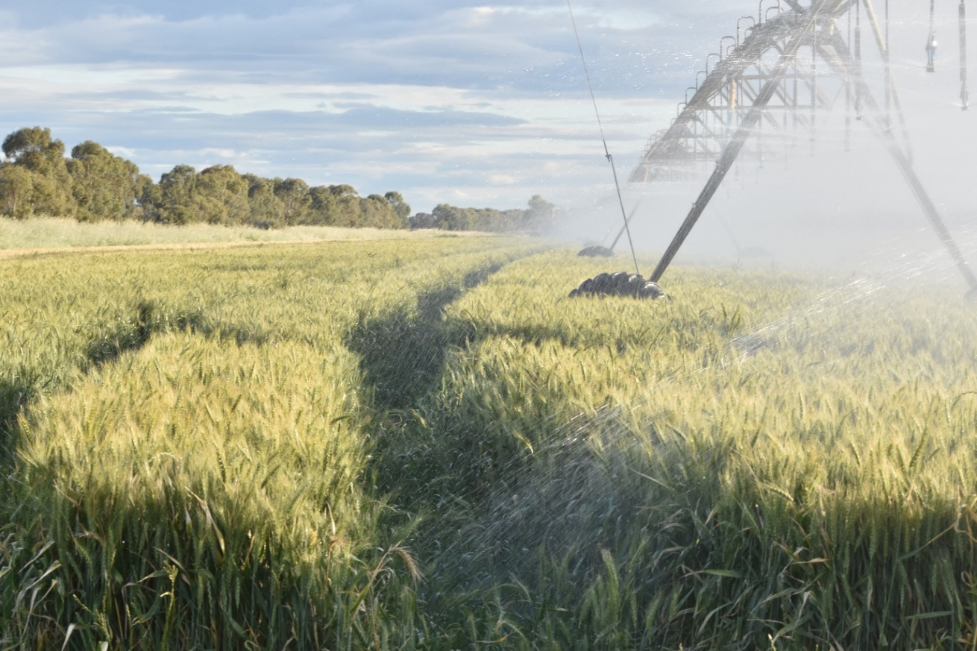

**PRODUCTIVITY COMMISSION MEETING IN DENILIQUIN IN JUNE**

Our region has been decimated by the basin plan as evidenced by the large turnout at the Productivity Commission meeting in Deniliquin in May. Over 120 people from across the community were consistent in delivering the same and very clear message –

* we are sick of lack of consultation,
* we have given up enough water
* business and community cannot afford to lose any more productive water
* our industry is threatened
* our community is threatened
* our environment is threatened
* our river environment is struggling
* full dams put our region under a continuous flood risk
* irrigators are disheartened and ready to give up because it is just too hard

It was bought up at the meeting for the Productivity Commission;

* to publicly confirm the actual volume of water (more than 4000GL) owned by the Environmental water holders
* publicly provide scientific and social data proving the need for more environmental water to be accumulated.
* Since the plan began how much federal Government money has been spent in SA?
* The PC made a number of recommendations following the last review 5 years ago, what percentage have been implemented and what were the ones that have not been dealt with?

We realise a number of these issues must be answered by other government agencies but as the majority of our community members have lost trust and confidence in the engagement process, we were hoping the productivity commission could help to facilitate responses.

We have heard nothing to date.

**SOME BASIC FACTS**

* **There are over 4,600,000 megalitres of entitlements in the held environmental water bucket**
* **The basin plan cannot deliver the enhanced environmental objectives set out in the 2012 plan of 80,000ML a day at the SA Border, keeping the Murray mouth open**
* **Basin plan modelling is out of date and based on flawed science so why are we continuing down this path of madness?**

As a result of an inflexible and poorly implemented plan and an ethos adding copious volumes of water is the answer, the pendulum has swung too far to the left and the future of our country and staple food production is now threatened. We have a river in crisis as it implodes, delivering unnatural and unseasonal volumes of water downstream to support unachievable environmental outcomes.

The Murray River now operates outside of its natural constraints. Turning it into a freeway has resulted in massive upstream bank erosion, frequent flooding and habitat loss. Changes to system management and storage of huge volumes of water is also placing our communities under increasing threat of flood.

* Of the water recovered under the basin plan to date, 83 per cent has come directly from southern NSW and Victorian allocations, putting at risk a combined $30 billion agricultural industry – there is no more water left to sacrifice.
* NSW Murray General Security allocation reliability has reduced from 84% to 50%.
* The Barmah choke has lost 25% of delivery capacity in the last decade.
* We have licensing of floodplain harvesting in northern NSW above the legislated legal level of cap (while every other southern basin irrigator operates under) with no end of system flows to protect connectivity, despite connectivity remaining a key principle of the plan.
* Overextraction (below) of the Darling River has resulted in fish kills and poor water quality. Why isnt the Federal Governemnt focusing on licensing floodplain harvesting under the cap to prevent this from happening again and again?

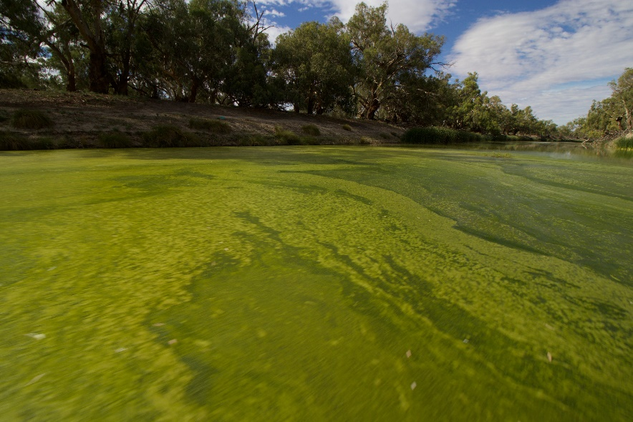

**MURRAY IRRIGTAION LIMITED (MIL)**

MIL is Australia’s largest private water supply network. It was built by our forefathers to drought proof the nation. In 1995 control was handed over to irrigators.

Every single drop of water that enters and leaves the system is metered and monitored.

The MIL system supports over 740,000ha of productive land growing anything from rice and dairy through to horticulture, crops and livestock. Our farmers produce over $6billion in agricultural product that supports the Australian economy, local business and our community

* In the last decade MIL has lost 50 per cent of the water delivered through the footprint – from a peak of around 1500GL to around 600GL and dropping
* MIL has lost 30 per cent of productive water delivered through the footprint directly due to buybacks. Any further losses will impact the future viability of the company.
* Every megalitre leaving the MIL footprint impacts makes it more expensive for those who choose to stay
* Fees and charges have increased by 22 per cent in the last 14 months.
* MIL is approaching a critical period where the future of the business and staple food production hangs under a dark cloud.

**WHAT WE WILL LOSE IF THE MADNESS CONTINUES**

* Access to affordable irrigation and staple food production
* 22% of the fresh milk consumed in Australia is produced in the Murray dairy region.
* $400 million Australian rice industry
* $6 billion in agricultural product
* 24,000 manufacturing jobs
* on farm biodiversity supported by irrigation
* thriving rural communities
* regional health and education opportunities.
* cost of living pressures will rise

**As evidenced below: NSW Murray, has already been over recovered. Any over recovery should be returned to the productive pool to grow food and generate economic revenue immediately.**

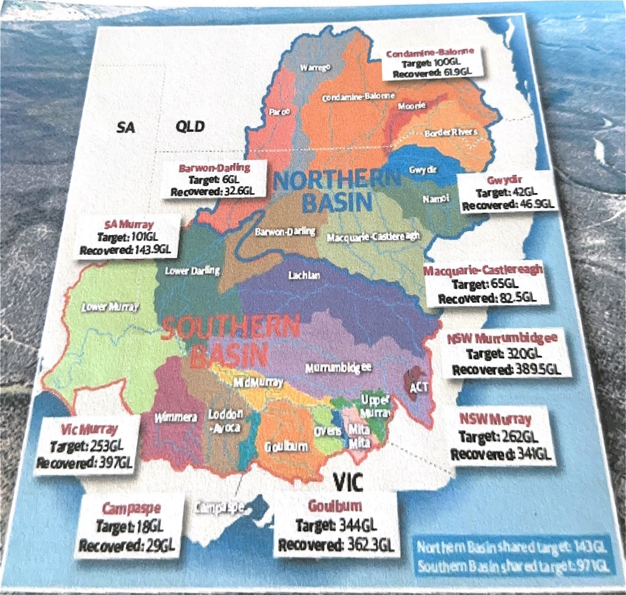

**BUYBACKS – a case study Wakool**

If ever you needed proof of the negative impact of buybacks look no further than an MDBA case study on Wakool published in October 2016 where 34.5 per cent of the available water in Wakool was purchased (103.9GL) through buybacks resulting in:

* a reduction in the maximum area irrigated of around 37% to 39%.
* milk production dropped from around 7 million litres to approximately 5.5 million litres
* total employment fell by around 54% between 2001–16.

Buybacks were just the beginning of the demise of Wakool. In 2023 there is no longer a dairy industry, the Barriboi school has closed and Wakool Primary School enrolments have dropped from nearly fifty to just eight - most farmers send their children away to boarding school to achieve a proper education. The local tennis, basketball and football club have all closed. The demise of Wakool is directly linked to a loss of water.

**Over-recovery under the basin plan in the NSW Murray Valley.**

* **NSW Murray Valley has consistently operated under the Cap, (21% less than the environmentally sustainable level of take).**
* **Despite this, a further 10GL of water is being bought back in the Murray Valley through ‘bridging the gap’ water which equates to a 16GL general security equivalent. This volume will be the death knell for irrigated agriculture in the Riverina because the smaller volume of water put through the system the more expensive it is for irrigators to remain – effectively shutting the system down and destroying all associated productivity.**

**FLOOD RISK**

As larger volumes of water are stored in dams for downstream delivery, communities across the Riverina are placed under increasing flood risk as evidenced by the catastrophic floods witnessed in 2022. These floods cost billions of dollars in lost economic revenue through stock and crop losses and infrastructure damage. These floods were unprecedented as water flooded into areas never before impacted. This is a direct consequence of the basin plan and shows the impossible lunacy of the ideology to deliver 80,000ML a day to the SA border.



**Trucking out flood affected stock Moulamein 2022.**

**QUESTIONS**

***What needs to change to ensure water recovery targets are met and supply and efficiency measures are delivered?***

We would argue the objectives of the basin plan are farcical and undeliverable and we would argue no more water be taken from the productive system until it can be proven

* the plan is based on the best available science
* publicly provide scientific and social data that proves the need for more environmental water to be accumulated

When it comes to lessons from past experiences you only need to look at environmental damage to the upstream system under current volumes to work out any additional flows will further devastate the system, increase erosion and cause irreparable environmental damage. Not to forget the increasing flood risk our region is placed under by storing more and more water in upstream storages.

We don’t need to reinvent the wheel. There have been enough studies and reports completed over the years.

* request a comprehensive literature review of all social and economic studies and reports commissioned and collate a public summary report
* request a comprehensive review of modelling that set basin plan targets more than 11 years ago.
* the two major floods of 2016 and 2023 have proven targets and goals are unrealistic

***Are current arrangements for implementing the plan operating effectively? How could arrangements be improved?***

How can they be working effectively when there is no meaningful public community consultation, no transparency and the tick a box mentality remains. The department need to be open and honest about the basin plan – both successes and failures an dthey need to do it in a public domain. Our message has consistently remained the same since the plan was first implemented and remains relevant today.

***Have the governance and institutional arrangements for the plan including the arrangements for compliance and monitoring, evaluation and reporting – proved effective? What changes would you recommend?***

It is clear the governance and institutional arrangements have failed.  For example:

* Inspector General Troy Grant informed senate the laws have more loopholes than a [monopoly board](https://www.smh.com.au/national/nsw/water-laws-have-more-loopholes-than-a-monopoly-board-regulator-20230530-p5dck5.html) and you would have to be a moron to be caught
* NSW have failed to implement compulsory metering in northern NSW
* Environmental water is modelled and not metered
* The “cost” of conveying large volumes of water recovered at the top of the system to the South Australian border is not reported
* NSW has failed to enforce law and prevent illegal floodplain harvesting diversions
* The NSW regulator (NRAR) has failed to successfully prosecute large water theft matters for various reasons including:
  + cost of running cases is prohibitive.
  + penalties are not a deterrent and viewed as a “cost of doing business” – small irrigators have been prosecuted successfully whilst large operators have avoided penalties.
  + evidentiary burden to prove theft is too high
* The Natural Resource Commission said the 2019 drought was a man-made drought brought on [three years early](https://www.theguardian.com/australia-news/2019/aug/28/shooting-the-messenger-water-experts-say-nsw-minister-wrong-to-question-drought-findings) due to mismanagement in northern NSW.  No substantive modifications have occurred to prevent a repeat.
* In 2019, two years after significant flooding, NSW Murray Valley general security licence holders received an allocation of 0%.  The following year they received 3% at the end of the year.  No robust evaluations have occurred to determine why this occurred and how water can be better managed in the future.
* The NSW Murray Valley operates more than 20 per cent below the sustainable diversion limit.  Primary producers are underutilised and productivity could be increased by more than 25 per cent if the issue of underusage was addressed.
* There has been no evaluation to determine if recovered water has been recovered in the correct areas.

**RECOMENDATIONS**

NSW must strengthen laws to allow NRAR to work much more effectively and ensure rules are enforced uniformly right across the basin. Unfortunately, the majority of enforcement action is occurring in the southern basin for comparatively minor volumes and in circumstances where metering is 98% compliant.  The issue of overallocated floodplain harvesting licenses must be addressed and metering enforced.

The evaluating and assessment of outcomes, in particular those of environmental water managers, must be addressed holistically and broadly.  There must be accountability for environmental disasters (including riverbank degradation, fish kills and blue green algae blooms). This should be balanced with prioritising the maximum volume of water under the environmentally sustainable level of take.

Finally Australia needs a roadmap of how we plan to sustain the nation in the future.  This would encourage investment and production into regions in a sustainable manner.  The alternative is increased imports of staple foods, loss of knowledge capital as farmers exit the industry and increased cost of living.

***How well has community consultation and engagement been conducted?***

Consultation has been poor and isolating over the years which has turned into a divide and conquer methodology by the department.

The MDBA no longer hold public meetings so they can prevent their work from being scrutinised. They have taken the path of identifying key individuals and approaching them separately, bypassing and undermining key stakeholder groups. Stakeholders have elected and knowledgeable representatives who are missing out on the opportunity to deliver important information on behalf of the broader community.

* Reconnecting Rivers is a perfect example. Rather than speak to elected representatives the department insisted a person be personally supported by five individuals and the code of conduct would only allow for communication with those five people and no one else.
* The Strategic Water Buyback meeting held in Deniliquin is another example. Attendees were invited and had to show a photo license to enter. People didn’t even know where the meeting was going to be held until the night before and nobody was there to address the issues, it was a tick a box meeting and nothing else. The MDBA representative also publicly stated attendees didn’t want the media there - that was a blatant lie, the MDBA didn’t want the media there. Their meeting minutes were not relevant to any of the issues discussed either.

This has been ongoing and is only getting worse as the narrative of the basin plan continues to remain manipulated.

***What lessons should be learned from programs aimed at helping communities adjust to the plan?***

Communities have the right to be heard when it comes to basin plan impacts- a lesson can only ever be learnt if you actually look at the problem and this is continually disregarded when it comes to the plan. Its whole premise is based on flawed science and the numeric volumes are simply undeliverable. If the department was serious about delivering a plan for the good of the environment and our communities it would certainly be different to what we currently have.

* If you look at the case study on Wakool in 2016 (and other region) you will note there has been no further follow up and the impact has flowed even further on into the wider community.

**Does the implementation of the plan reflect a commitment to the best available scientific knowledge?**

We all know the answer to this question is a big fat NO and has been since the plan was first implemented.

**Are there any other issues with plan implementation you wish to raise?**

The plan has never been about environmental outcomes. It has always been a political grab for water. We have had continuous federal ministers who refuse to meet with concerned stakeholders and refuse to question the science and flawed methodology at its very core. How can we ever expect this to change when there is no political will to ever do so.

**IRRIGATION IS DUAL PURPOSE WATER**

Considering 90% of wetlands in the basin are found on private land, the solution is a simple one- STOP BUYBACKS and instead use the irrigation footprint as a means to deliver water. If the basin plan was truly about environmental outcomes and not politics this would have been one of the first considerations when implementation began. Irrigation supports biodiversity while growing food for our nation and creating economic wealth.

***The basin plan is basically irrigation!***

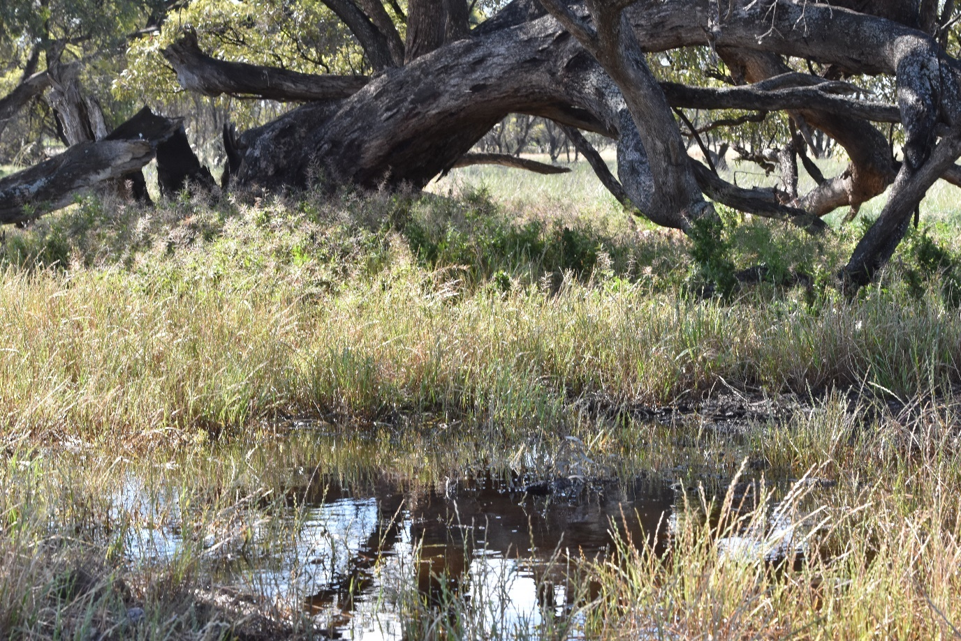

**This is a 60-acre wetland on a working farm in the Riverina producing organic beef and wine. This wetland was restored through the farming families own initiative in 2007 and is supported by environmental water delivery through Murray Darling Working Wetlands Group. The wetland is regularly surveyed by ANU in Canberra which has documented over 60 species of birds, four frog species, reptiles, insects and many plant species, dependent on the season. This is a great example of agriculture and biodiversity working and thriving side by side.**

**SOLUTIONS**

* Halt buybacks until a proper economic assessment of the basin plan has been completed.
* Stop letting the MDBA mark their own homework and allow a true and transparent picture of what is happening across the basin, including environmental watering projects.
* Purchase Riverina shallow spear point licenses and at the same time manage salinity, which is an environmental issue and should be treated as such and not left up to farmers to bare the running and pumping costs of bores which are hardly used.
* Buyback the volumes of water illegally issued to floodplain harvesters above the legislated level of Cap and use those volumes to connect the Darling River to the Murray which is a key principle of the plan.
* Introduction of conveyance for downstream allocation users.
* Buyback water from market investors only who do not grow food.
* Address the issue of carryover along with management of dams based on 1;100 dry scenario away from the ideology it is never going to rain again.
* RAMSAR listing of rice paddocks. In Japan 75,000 hectares of rice paddies are Rams – growing staple food while supporting bio-diversity. Why can’t environmental water holders provide water to rice farmers?
* South Australian engineering solutions including the structure of south-east drains.
* Build more dams. The last dam built in NSW was 1986 when the population of Australia was 16 million, today we are over 26 million.
* National agriculture

**CONCLUSION**

The continual ignorance to implement any transparent and meaningful reform is draining and distressing. If the war in Ukraine and a global pandemic have taught us anything it should be to support staple food production in this country.

The fact previous recommendations made by the Productivity Commission have been ignored gives us little faith in this review holding any sway either. As an irrigation community we would love this to not be the case however, history continues to repeat itself and until someone has the courage to publicly denounce the plan, truly question the science and the lack of transparency, we will remain caught on this ridiculous merry go round.

The gravity fed, irrigation system set up by our forefathers as a means to drought proof the country and feed the nation has been turned on its head and rather than being the plan to save the nation, we have a plan which will destroy the nation. History will not be kind on any future assessment, particularly on the impact it will have on staple food production and the security of our nation.

**REFERENCES**

[P742-Southern-Discomfort-WEB_0.pdf (australiainstitute.org.au)](https://australiainstitute.org.au/wp-content/uploads/2020/12/P742-Southern-Discomfort-WEB_0.pdf)

CROSS-ORTFOLIO MURRAY-DARLING BASIN PLAN MATTERS MAY 2023

<https://parlinfo.aph.gov.au/parlInfo/search/display/display.w3p;query=Id%3A%22committees%2Festimate%2F26906%2F0003%22>

[**Senator ROBERTS:**](https://parlinfo.aph.gov.au/parlInfo/search/display/display.w3p;query=Id%3A%22handbook%2Fallmps%2F266524%22;querytype=;rec=0)I won't say any more about that. The report card published by the Murray-Darling Basin Authority in December 2022 on page eight shows acquisitions have already exceeded the legislated targets in some catchments. Others have still not taken water off farmers to the limit that the plan envisaged and stated. Minister, will you return the water that has been acquired in excess of targets back to farmers

<https://www.mdba.gov.au/basin/why-murray-darling-basin-matters/darling-baaka-rivers-contribution-murray>

<https://www.agriculture.gov.au/abares/products/insights/economic-effects-of-water-recovery-in-murray-darling-basin#conclusions>

Page 4 [Business Review - Murray Irrigation](https://www.murrayirrigation.com.au/businessreview)  (it has a factsheet where the graph is located).

Page 5- <https://www.weeklytimesnow.com.au/news/national/murraydarling-basin-plan-john-howards-vision-still-controversial/news-story/5ad40b31c3d4d4c4c09276672db5799d>