22 March 2007  Review of NDIS Costs  Productivity Commission  GPO Box 1428  BARTON ACT 2600  Attention: Mr. Peter Harris, Chairman |  | 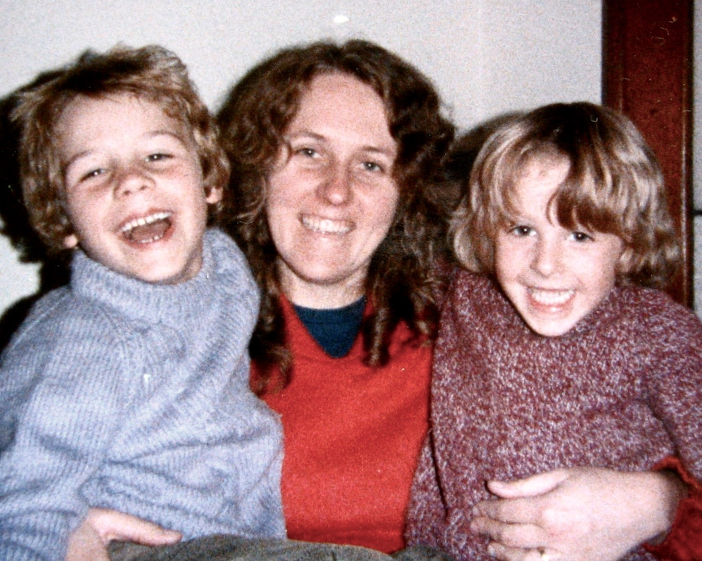
Dear Mr Harris,

Thank you for this valued opportunity to respond to the Issues Paper.

The cost of running an effective and sustainable NDIS will depend on the Scheme meeting its objectives: the ability to provide life-long security of funded care, and upon the particular theatre of care: the housing (accommodation) model/s.

Care costs are dependent upon where, how, and by whom, the care is provided. If it were the case that a particular model of housing was able to reduce overall NDIS care costs, such a model ought to be supported. Freedom Housing fulfils this criterion: it ought to be supported.

Four Freedom Key dwellings - houses or apartments - are conjoined through internal space: the Freedom Key. This configuration constitutes every Freedom Housing development. Persons with disabilities may live in Freedom Key dwellings with family or friends, and receive up to 24/7 high-care. Freedom Key dwellings may be purchased and owned privately, or leased, just like other conventional property.

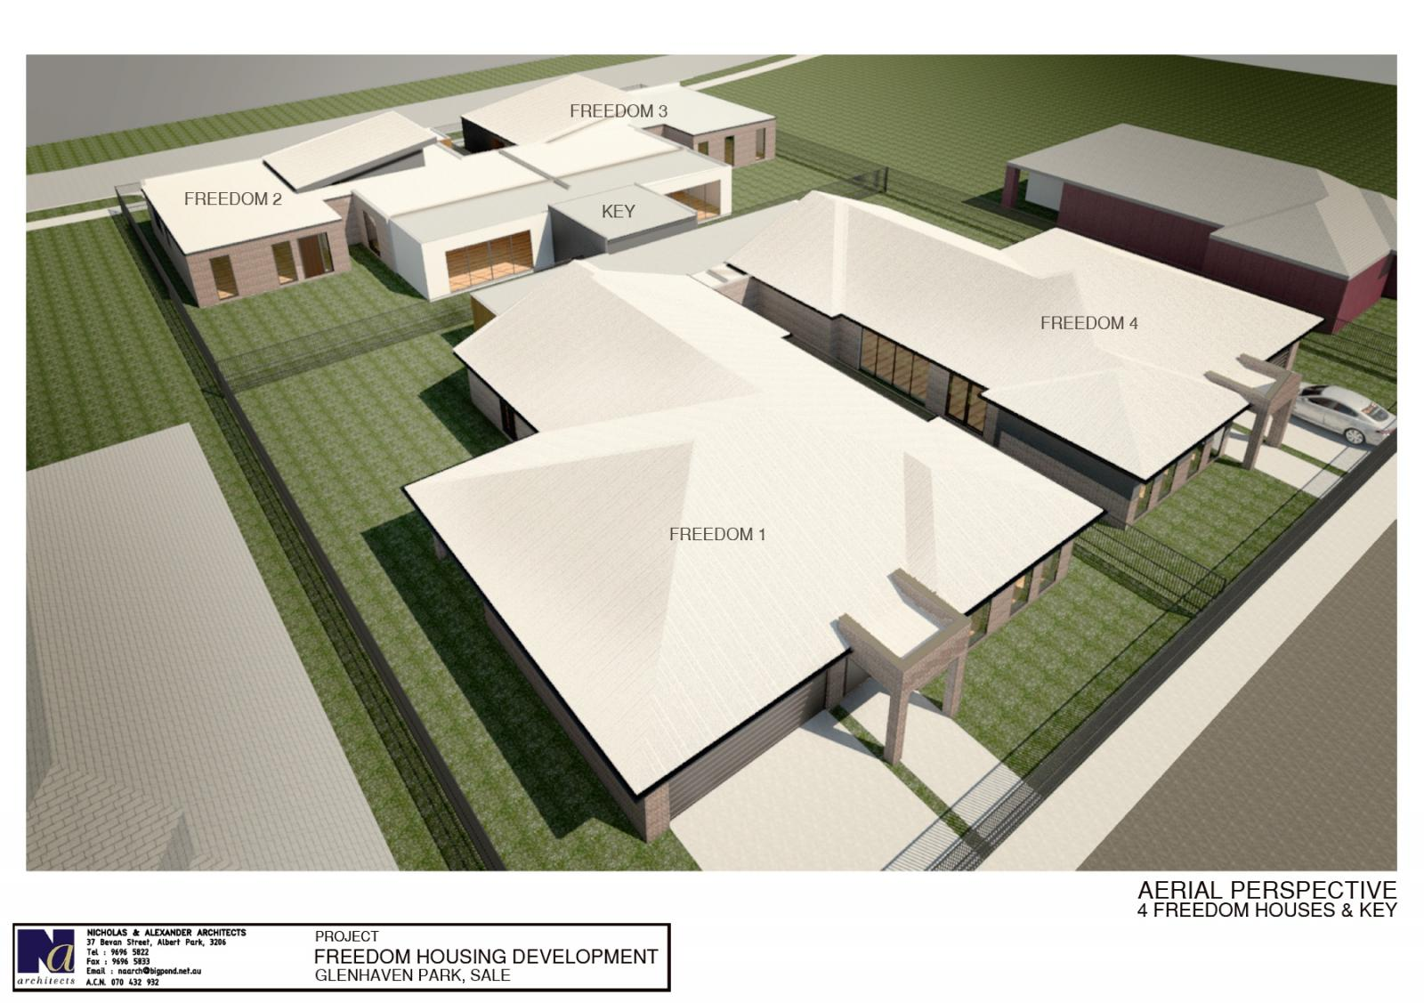 | 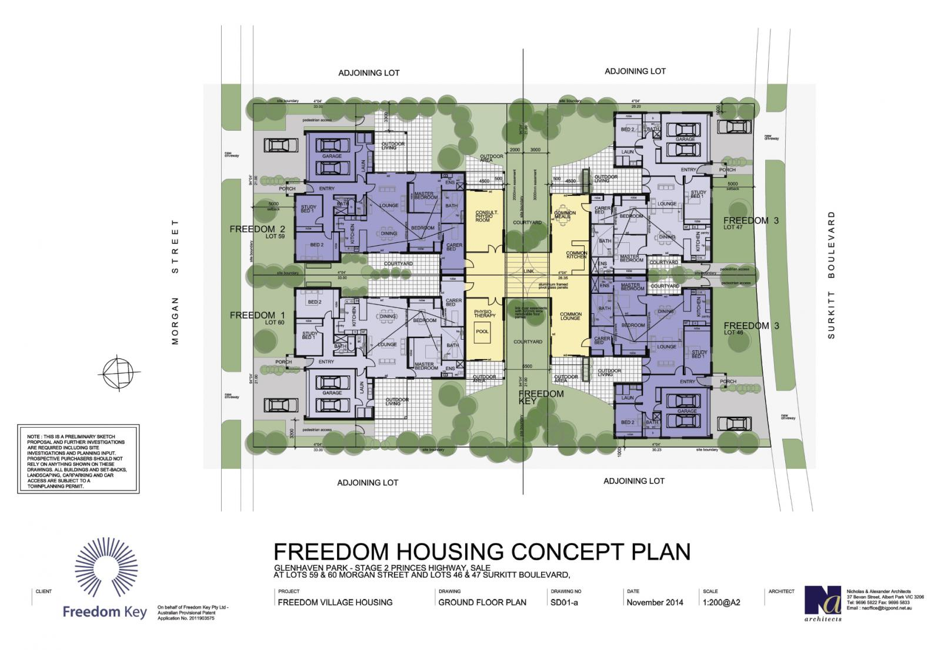

The four Freedom Key properties are bound by an Owners Corporation (Victoria). It is responsible for the maintenance of the common property area: the Freedom Key building, its garden, and its street access corridor. The persons with disabilities - or their nominees - sit on the Freedom Key Management Committee (FKMC). This takes the legal form of a Company Limited by Guarantee. The Committee is responsible for the management, advocacy, and governance functions. Freedom Housing is a private wholly self-managing model, although some or all of these functions may be outsourced if necessary.

Since there are four households in each development, there will usually be sufficient skilled individuals to draw from, for the effective dispatch of the aforementioned functions. Freedom Key Pty Ltd has a Tripartite License Agreement with the Owners Corporation, and the Company Limited by Guarantee (FKMC). The parties to the License Agreement agree to abide by The Freedom Key Protocols, which ensure the model fulfils its objectives in perpetuity.

The FKMC will - in most cases - deal directly with the NDIS, thus bypassing expensive consultancy service providers. The FKMC will also contract directly with personal care providers, or with a care provider organisation. This is an efficient and cost-effective way to source the services, as well as being respectful of individual choice. The FKMC may also apply for charitable status, thereby being able to accept tax-deductible donations directly from individuals and organisations.

So far, most disability housing models in Australia have been custodial/institutional. Institutional models are mostly inefficient, undesirable, and very costly. This is due to their nature and design, and the cost burdens associated with state oversight. Freedom Housing is a private model of care in the form of conventional housing. The State is not involved. Private capital is able to finance this model. It appears that the Freedom Key section may be funded by the NDIS SDA Rules 2016. Freedom Housing turns the traditional disability care paradigm on its head in two important and fundamental ways:

“An institutional model delivers hitherto free persons with disabilities, to a custodial place, at which they are forced to live and socialise with strangers: and where care is provided at the cost of their personal privacy and freedom. Freedom Housing delivers care, to a private place where persons with disabilities prefer to live, in freedom, with persons of their choice, or independently.”
- Christos Iliopoulos
Australia is a signatory to the United Nations Convention on the Rights of Persons with Disabilities. The NDIS-preferred care and housing model ought to comply with this important international legal and moral obligation. The model also ought to comply with the Objects and Principals of the NDIS Act 2013. Freedom Housing is the only model, which is currently able to comply fully with both of these instruments. Please refer to the attached comparative report. Or access it on the Freedom Housing website.

Freedom Housing has the potential to reduce NDIS costs substantially, whilst also reducing misery for persons with disabilities, as well as for those in their circle. Freedom Housing increases the happiness and wellbeing of the Australian community as a whole. Freedom Housing is also able to assist persons with disabilities, to increase their personal economic engagement and productivity, and to reduce their dependence on welfare.

“…live an ordinary life, including care and support to build skills and capability, so that they can engage in education, employment and community activities.”
Page 4, Productivity Commission issues paper

The Commission will find that Freedom Housing is formally able to displace most demand for nursing homes, group accommodation facilities, respite facilities, and hospices. This move from state funded institutional models to a privately owned and market driven one, will result in substantial capital savings for the NDIS.

Savings for the NDIS will also result from the fact that in-kind supports from family and friends, and the community, are ‘at hand’ and readily available to the persons with disability living in Freedom Housing. Such in-kind supports cannot be accessed in an institutional model, with the result being, that substitute costly supports, and non-authentic ‘social’ activities must be artificially created and recurrently funded by the NDIS.

Freedom Housing does not discriminate between aged care, disability care, or motor accident care. All are the same in essence: frail old age is a disability, as is a motor accident acquired injury. The upshot of this is that children with disabilities may live under the same roof as their elderly frail parents in conventional housing, whilst they all receive appropriate care. Freedom Housing is able to provide up to 24/7 high-care and hospice care: it is the ultimate person-centred model of care: one which is able to keep families together instead of pulling them apart (custodial/institutional models).

Freedom Housing is able to provide early intervention, and is able to provide an appropriate theatre of care and housing through every phase of life to a person with disabilities. The following is written about the aims of the NDIS. It could equally have been written about the outcomes of Freedom Housing:

“… is about ensuring people with disability can get out and about in the community - it’s about getting them to work, to school and to cafes and restaurants so that they can catch up with family and friends. It’s about getting people with disability being able to be part of the workforce, getting an education and spending money on food and drinks – in other words, being part of the economic, social and cultural fabric of our lives. It isn’t just making life equitable for people with disability. It’s also making it possible for them to participate in every-day life with their families.”
McEwen 2016, page 5 Productivity Commission issues paper

Scheme Costs and Freedom Housing

Access:
Many families will be willing to continue to provide in-kind supports to their loved ones with disabilities, if they had Freedom Housing in which to do it. They would not be forced by circumstances to endure the terrible grief of having to relinquish their loved ones to institutional care: which is less desirable and more expensive. Freedom Housing will reduce the number of participants accessing NDIS support, or participants will access a reduced level of support.

Scope:
Freedom Housing provides an authentic lifestyle setting. The NDIS does not have to fund the creation of artificial activities and forced social opportunities: the household in a natural setting provides activities and social occasions.

Volume:
The Freedom Housing model achieves economic efficiency due to the four dwelling design. This may reduce the per capita volume of supports required. A further reduction in supports may be achieved by accessing in-kind supports, which are readily available and provided by the household: cooking, laundry, transport, entertainment, social interaction, etc.

Price:
Because the FKMC is able to self-manage the requirements of the persons with disabilities, the price paid for supports may be reduced.

Delivery:
If ten years from now, most of the care has shifted to Freedom Housing, the NDIS will mostly be dealing with multiple FKMC’s directly, to establish the level of support (funding) for the participants, and to moderate that support over time. This will represent a marked reduction in delivery costs for the NDIS. Add to the above, the benefits of early intervention, and pre-emptive therapies, and the savings to the NDIS of adopting the Freedom Housing model become substantial: as will be the whole-of-government knock-on savings.

Freedom Housing may also meet the needs of those who may have been covered by a National Injury Insurance Scheme. Such participants may live in Freedom Housing with other members of the family, who may themselves be receiving aged-care, or disability care. Freedom Housing does not divide or differentiate: care can be delivered in a natural home setting to anyone who requires it. The current duplications in institutional specialist disability accommodation will be reduced, along with the associated costs.

Assessment Tools
All the assessment tools – valid; reliable; accurate, and efficient – are housing-model-dependent. Freedom Housing provides an advanced housing and theatre-of-care platform, upon which these tools may yield better outcomes for participants, and for the NDIS.

Recruiting Staff
Most carers prefer to work in a natural home setting like Freedom Housing, to group homes, respite homes, or nursing homes. Because Freedom Housing is able to provide whole
continuous shifts (eight hours) and weekly workloads, it will attract a new profile of applicant, who will find a long-term career in Freedom Housing attractive.

Freedom Housing addresses most of the issues mentioned in the Issues Paper. We are happy to attend a meeting with Commission officers to elaborate on this submission.

Freedom Housing was driven primarily by the urgent need to find a happier and more humane model of housing and care, for the needs of persons with disabilities and their families. That Freedom Housing is also able to save taxpayer dollars, comes as an added fortuitous benefit.

The Commission may wish to consider the possibility of developing Freedom Housing in a similar manner to the housing developed successfully by Defence Housing Australia. This will attract private capital to facilitate the roll out of this much-needed disability-friendly housing - houses and high-rise apartments - quickly across Australia: thereby providing the housing platform upon which cost savings may be secured which will enhance the long-term viability of the NDIS.

More information is available on the websites as below.

Yours truly,

Christos Iliopoulos
Founder & Governing Director

http://freedomhousing.com.au & http://freedomkey.com.au

Note:
The Freedom Housing model is subject to an IP Australia patent. Freedom Housing and Freedom Key are registered trademarks.

