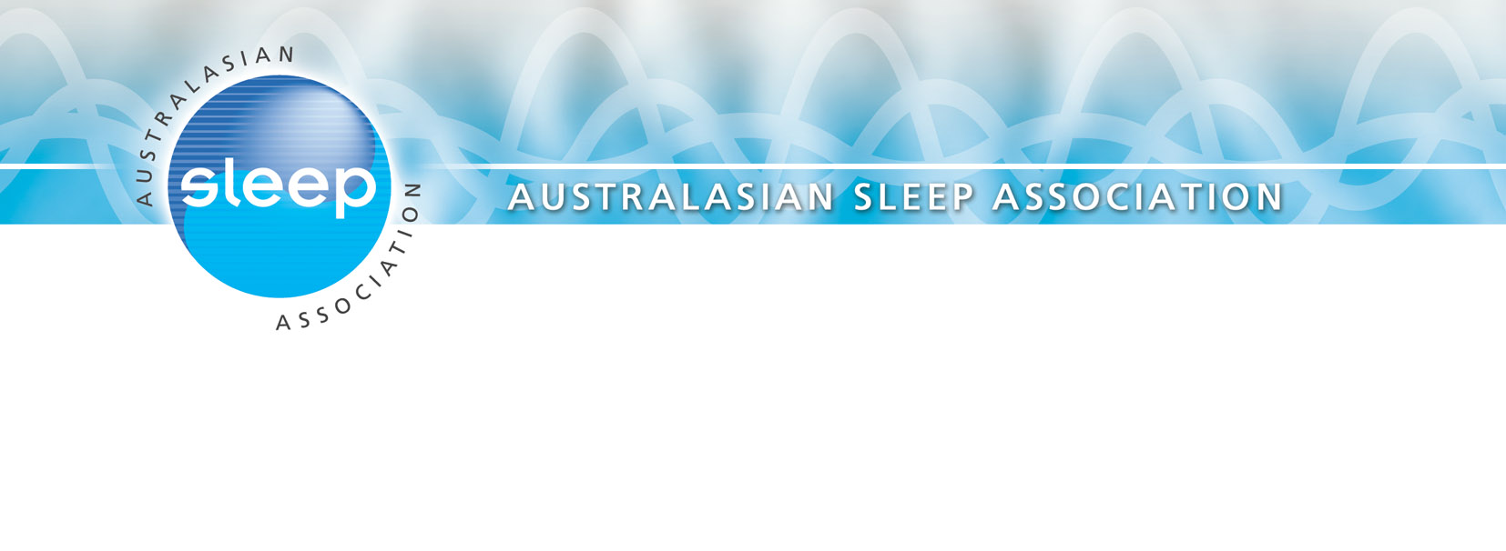
114/30 Campbell Street
BLACKTOWN NSW 2148
ABN: 51 138 032 014
Phone: + 61 2 9920 1968
Fax: + 61 2 9672 3884
E-mail: admin@sleep.org.au
Web: www.sleep.org.au

4 July 2017

Angela MacRae
Richard Spencer

Commissioners
Productivity Commission
GPO Box 1428
CANBERRA CITY ACT 2600

Dear Commissioners

Re: Productivity Commission Submission on the NDIS

The Australasian Sleep Association (ASA) is the peak scientific body in Australia & New Zealand representing clinicians, scientists and researchers in the broad area of Sleep. Our vision is the provision of world standard research, education and training, and establishment of clinical standards to ensure clinical best practice in sleep medicine resulting in an informed community with healthy sleep practices.

ASA supports the principle of funding being provided to those with disabilities on a needs basis.

Although the introduction of the NDIS has been problematic, we encourage Government and providers to continue to work to improve the supports for those with disabilities.

Many people with disabilities have sleep disorders, predominantly obstructive sleep apnoea (common in patients with Down Syndrome) and insomnia. Therefore our member treating clinicians look forward to working with NDIS providers to improve the sleep of those with disabilities. Through improved sleep, patients will be better able to benefit from other services offered, including rehabilitation and training, thus improving their integration into and contribution to Australian society.

Should you require any further information in this regard please do not hesitate to contact me.

Kind regards

Maree Barnes
President

