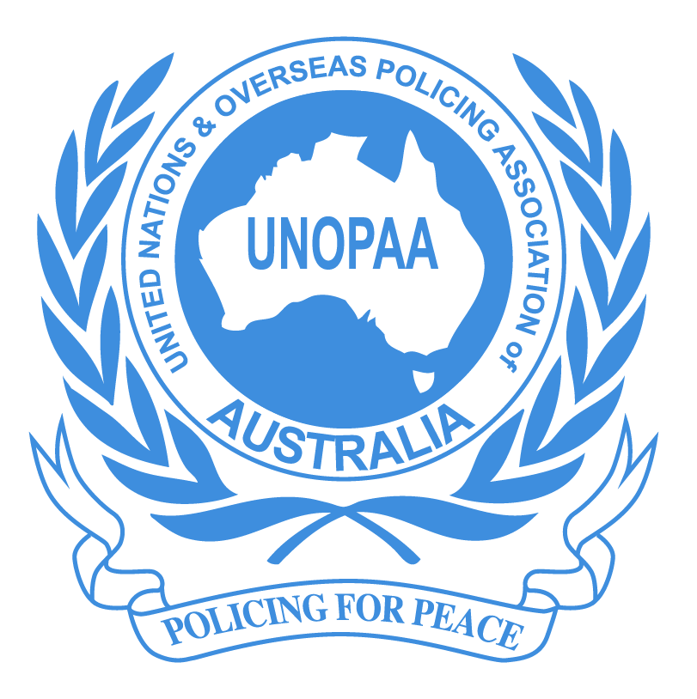
ABN 56 838 671 889

February 2019

What About Us ?

Submission to the Productivity Commission Inquiry
into Compensation and Rehabilitation for Veterans

The United Nations & Overseas Policing Association of Australia (UNOPAA) is an Australia wide, incorporated non profit organisation whose members are serving, retired and former police officers from police forces across Australia who have served overseas with the United Nations and on other Australian peacekeeping/capacity building missions since 1964. Its membership also includes the widows and relatives of those members.

The aims of UNOPAA are to maintain and foster the memory and service of Australian police who have served overseas through the provision of welfare and other support, the promotion of commemorative activities and social events, and improving the benefits available to our members.

Purpose

This submission has been prepared in response to the Productivity Commission’s terms of reference in relation to its Inquiry into Compensation and Rehabilitation for Veterans and the recommendations in its Draft Report issued in December 2018.

It focuses specifically on Australian police peacekeeping veterans, that is, the police from all Australian police jurisdictions who have served overseas on peacekeeping and capacity building missions since 1964.

Background

Australian police who have served overseas as peacekeepers are included in Schedule 3 of the Veterans Entitlement Act 1986. This provides an entitlement to full or part disability pensions and access to treatment for any disease or injury that is accepted as being caused by peacekeeping service (sections 68-72 & 85 VEA and DVA Factsheet DP15). Gold and White Cards can be applied for, as well as non-liability health care for cancer, pulmonary tuberculosis and any mental health condition.

The coverage provided by Schedule 3 has since been extended, by Ministerial determination, to an additional five overseas missions. The full list, as it pertains to policing, is as follows:

Location | Description of Peacekeeping Force | Start Date
Cyprus | United Nations Force in Cyprus (UNFICYP) | 14 May 1964
Cambodia | The Australian Police Contingent of the United Nations Transitional Authority in Cambodia (UNTAC) | 18 May 1992
Mozambique | The Australian Police Contingent of the United Nations Operations in Mozambique (UNOMOZ) | 27 March 1994
Haiti | The Australian Police Contingent of the Multi-National Force in Haiti | 10 October 1994
Schedule 3 VEA

Location | Description of Peacekeeping Force | Start Date
East Timor | The Australian Police Contingent of the United Nations Assistance Mission in East Timor (UNAMET) | 11 June 1999 -  25 October 1999
East Timor | The Australian Police Contingent of the United Nations Transitional Administration in East Timor (UNTAET) | 25 October 1999 -  19 May 2002
East Timor | The Australian Police Contingent of the United Nations Mission in Support of East Timor (UNMISET) | 20 May 2002
Solomon Islands | The Australian Police Contingent of the Regional Assistance Mission Solomon Islands (RAMSI) | 23 July 2003
Sudan | The Australian Police Contingent of the United Nations Mission in Sudan (UNMIS) | 1 January 2006
Ministerial determinations

Each of these missions has now concluded and no Australian police are currently serving in UN peacekeeping roles overseas. However, Australian police have been deployed in the past to peacekeeping in Somalia, and to in order maintenance, capacity building and training roles in locations such as Bougainville, Papua New Guinea and Pakistan. A number are still working in places including Timor Leste and Afghanistan. Australian police are also deployed overseas from time to time when a humanitarian crisis occurs.

No legislation apart from the VEA specifically addresses the service of Australian police as overseas peacekeepers. They were specifically excluded from the Military Rehabilitation and Compensation Act 2004, when it was enacted, on the understanding that their needs and requirements would be separately addressed. This has not occurred.

The report of the Review of Military Compensation Arrangements in 2011, Chapter 27, provides a good overview of the police situation, as it still stands to this day:

Chapter 27

Chapter summary
The current Australian Government gave a 2007 election commitment to consider the appropriateness of compensating Australian Federal Police (AFP) members for conditions arising from high-risk overseas missions through military compensation arrangements. This consideration forms part of the Review.
As Australian Government employees, AFP members are covered by the Safety, Rehabilitation and Compensation Act 1988 (SRCA) including when deployed, posted or working overseas. AFP members deployed with Peacekeeping Forces were eligible for benefits under the Veterans’ Entitlements Act 1986 (VEA) until the enactment of the Military Rehabilitation and Compensation Act 2004 (MRCA), and some on high-risk missions continued to be eligible. However, VEA coverage effectively ceased for the AFP when the previous Government announced in 2006 its intention that AFP members with eligible overseas service would be compensated under new arrangements comparable to the provisions of the MRCA. It was intended that these arrangements would be included in an enhanced SRCA. However, while work on amendments to the SRCA commenced in 2006, technical difficulties halted the work and the requisite legislation has not been drafted. The AFP has recently introduced interim compensation arrangements for members posted to Afghanistan, Timor Leste and Papua New Guinea.
When the MRCA replaced the VEA in 2004, coverage for AFP members was intentionally not carried over into the new legislation, as the MRCA was designed to be a military-specific scheme and to take account of the special characteristics of military service. The Committee believes that bringing the AFP into the MRCA would run counter to the commitments given to ADF members and the ex-service community in promoting acceptance of the MRCA on the basis it was specifically for military personnel.
The Committee also believes that the work performed by the AFP and the ADF while on overseas operations is not the same, nor is the role of the two organisations always integrated. Bringing the AFP into the MRCA would necessitate not insignificant technical amendments to the legislation, and give rise to considerable complexity and anomalies in administration.
For these reasons, the Committee recommends that AFP members not be given access to the MRCA.
UNOPAA disputes some of the views expressed by the Review Committee, in particular that comparisons cannot be made between police in peacekeeping roles and those of the military. In United Nations missions, civilian police operate as key community interfaces – particularly between the opposing sides. Australian police have in the past “been in the thick of it”, for example during the Turkish occupation of Cyprus in 1964 and in East Timor during the ballot for independence when the unrest and violence caused the deployment of the multi-national task force under Major General Sir Peter Cosgrove to quell it. Some of the impact on the police involved at the time is still emerging, and of considerable concern to us.

The limited involvement of the ADF in United Nations peacekeeping may have contributed to the lack of appreciation of the police role. Hopefully this can be remedied; however we do not dispute the ultimate conclusion that police peacekeeping veterans should not be given access to the MRCA. Their needs should be separately considered (and enhanced).

Although reliable records are difficult to source, it is estimated that around 4,500 Australian police have worked as overseas peacekeepers. We do not know how many have made claims and have Gold or White cards. DVA have advised that separate records are not kept.

UNOPAA has proposed for some time that an “Australian Police Overseas Peacekeepers Health Audit” be conducted. This is seen as essential and, we would submit, a necessary pre-requisite to any change to our current entitlements. Sadly many of our members, particularly from the earlier contingents, have now passed on and the health and well-being of others, needs close monitoring.

Victoria Police, for example, sent 118 members to Cyprus from 1964 to 1976 (12 years). 55 are now deceased.

Observations

- It is commendable that the Department of Veterans Affairs and the ADF are committed to a “whole of life” approach to their veterans. That is, supporting them during their service, assisting them to transition to civilian life, honouring their contribution and ensuring they and their dependants are appropriately cared for (both health-wise and financially).

This is not a feature of policing, where leaving or retiring often means the end of involvement with the “police family”. Steps are now being taken, particularly in Victoria, to address the needs of retired police through the appointment of funded Peer Support Officers, but there is no organisation such as DVA charged with this responsibility. Thus UNOPAA does not have any expectation that many of the income, compensation and transition support arrangements referred to in the Productivity Commission Draft Report ought to apply to us – although it would be nice!!

Our needs centre on health care, rehabilitation and services to support the wellbeing of our members. The ADF is well ahead under the MRCA and also within the VEA, hence our plea – what about us?

- It is galling that Australian police have been serving in some theatres of operation at the same time as ADF personnel, yet have not been regarded as being at the same risk. For example, active service medals have been awarded to military personnel for serving in “warlike operations” in Somalia in 1993-95, Cambodia in 1999 and East Timor from 1999-2003. No such recognition has been given to police serving with the AFP. This has implications under the VEA where a veteran is 70 years or over.

- The terms of reference given to the Productivity Commissioner by the (then) Treasurer asked the Commission to inquire into “the system of compensation and rehabilitation for veterans (Serving and Ex-Serving Defence Force members)”. We originally saw this as limiting, as police peacekeeping veterans were not included. However it raises the question – were we overlooked or intentionally omitted?

Issues

We support many of the observations in the Draft Report concerning the legislative complexity and inefficiency of the current system, and the need for improved processes and additional training of staff. As our members age, they need assistance to navigate through the processes and advice they trust is only generally available through organisations such as the Vietnam Veterans Association or the RSL.

Our specific comments are:

- Initial Liability Assessment (draft recommendation 8.1)

We agree that the liability provisions in the VEA, DRCA and MRCA should be standardised. Setting the liability level for disability pensions at “beyond reasonable doubt” is far too high.

- Role/Funding of Repatriation Medical Authority (draft recommendation 8.2)

We agree that the Authority (or a similar body) be given the capacity to undertake pro-active research. It could be informed by studies such as the “Australian Police Overseas Peacekeepers Health Audit” we’ve proposed earlier, and not simply by the claims process.

- Review Processes (draft recommendations 10.1 to 10.4)

We agree that reviews should be streamlined. The proposed process would do so, provided
it is consistent across all areas.

- Governance and Funding (draft recommendations 11.1 to 11.5)

We are unsure of the value of moving the whole of the veteran’s support system under the Defence umbrella. The role of Defence, as we understand it, is to protect Australia from external threat. This requires vigilance and a focus on current operations. Giving it responsibility to care for those who have previously served and their dependents, extending back many years, would enlarge the portfolio’s responsibility and possibly make it unmanageable.

A modernised Department of Veterans Affairs seems preferable. The draft recommendation to establish a Veterans Services Commission, as an independent statutory authority reporting to a Minister for Defence Personnel and Veterans, doesn’t add much value – except to extend the remit of Defence. The proposed functions of the VSC ought to be those of the DVA (and probably are at present).

In addition, the proposal does not adequately address our own situation. Will responsibility for Australian police peacekeeping veterans move under Defence, together with others (such as ex-service personnel from Commonwealth countries eligible for treatment under the VEA). Or have we again been overlooked?

- Compensation and Payment Arrangements (draft recommendations 12.1 to 12.2, 13.1 to 13.8, 14.1 to 14.6)

Most of these proposals are focused on military personnel. Any standardisation should include police peacekeepers, however we don’t know enough about the MRCA benefits to comment further.

- Health Care (draft recommendations 15.1 to 15.4)

The proper treatment of service-related conditions is essential, and should be available to all who are eligible – without any unnecessary hurdles to get it. Moving away from the Gold Card/White Card system needs to be carefully considered, as the veteran community is familiar with it and unintended consequences may result.

The key principle should be that no one is disadvantaged. However that is not to say that improvements should not be considered.

UNOPAA strongly supports the Non-Liability Health Care over for cancer, tuberculosis and particularly any mental health condition. This should not be changed, and in fact could be extended.

- Data and Evidence (draft recommendations 16.1 to 16.3)

While these recommendations relate to performance monitoring of DVA processes, recognition that the Department should be undertaking research is encouraging.

It should be extended to assessments of the health and service needs of its customers so its programs can be shaped to address them. One would think that some of their needs could be anticipated – such as through our proposal for a police peacekeepers health audit.

- Bringing It All Together (draft recommendation 17.1)

We do not support the proposal to create two schemes for veteran support, principally the suggestion to close off future claims under the VEA (Scheme 1) and direct all future claims to Scheme 2.

Police peacekeeping veterans who have not yet lodged a claim under the VEA would be excluded. They cannot move to the MRCA or DRCA as they are not eligible to do so.

Is there an intention to open up the MRCA and DRCA to police peacekeepers – or again, have we been overlooked ?

We know of members who are suffering emerging issues, particularly with mental health and often due to their service overseas. They have not lodged claims but it is not unreasonable to think they will do so.

In Conclusion

We have labelled this submission “What About Us?” and welcome the opportunity to speak to the Commission as well as present our views in writing.

Many of the recommendations in the Draft Report are sound and UNOPAA is supportive of them. However we have raised a number of concerns where it could be said that Australian police peacekeeping veterans have been undervalued or overlooked.

The role of police in overseas peacekeeping is widely recognised across the world. There are currently 14 active UN peacekeeping missions across 4 continents, including hotspots such as Iraq, Lebanon, Afghanistan, South Sudan, the Congo, Darfur and Mali. Approximately 11,000 police from various countries are deployed there, and 90,000 military personnel. The United Nations has a peacekeeping budget of $7.3 billion to support them.

This is a large commitment, where police play a key role in peacekeeping across the world. Australia has a proud history of involvement, its police leading the way. Those who have served should be treated appropriately.

Prepared by:

Peter McDonald
National Secretary/Treasurer
United Nations & Overseas Policing Association of Australia Inc. (UNOPAA)

