Attachment A
Current Approach to Monitoring and Evaluation under Indigenous Australians’ Health Programme
Purpose
This document provides an overview of the current approach to monitoring and evaluation under the Indigenous Australians’ Health Programme (IAHP). This is provided to assist the Productivity Commission to consider its future role in identifying priorities for evaluation and developing guidance about undertaking evaluations on cross-cutting issues or themes.
Health’s approach to evaluation
The objective of the IAHP is to provide Aboriginal and Torres Strait Islander people with access to effective high quality, comprehensive, culturally appropriate, primary health care services in urban, regional, rural and remote locations across Australia. The IAHP seeks to improve:
- the health of Aboriginal and Torres Strait Islander people;
- access to high quality, comprehensive and culturally appropriate primary health care; and
- system-level support to the Aboriginal and Torres Strait Islander primary health care sector to increase the effectiveness and efficiency of services.

The Government has increased funding for Indigenous-specific health initiatives to $4.1 billion over four years to 2022-23. More than half of the IAHP funding (approximately $543.8 million per annum) is spent on comprehensive primary health care services.

The IAHP has a rigorous Evaluation Strategy in place that includes well established data collections, such as the National Key Performance Indicators for Aboriginal and Torres Strait Islander Primary Health care and Online Services Report. These collections provide valuable information to monitor and improve program performance and Indigenous health outcomes. The IHD approach is also guided by the IDA Data Strategy 2018-2023, which is an internal document that aims to guide the use, improvement and development of data in the IHD and includes a plan for data development.

Whilst all activities under the IAHP are monitored, a mandatory continuous quality improvement approach is also used with funded PHC organisations that moves far beyond traditional ideas of accountability to supporting a learning and developmental approach to program improvement. In addition, the Aboriginal and Torres Strait Islander Health Performance Framework Report brings together analysis of the latest data and research evidence to inform policy every two years.

As part of the Evaluation Strategy, Indigenous Health has a suite of concurrent evaluations underway to continue to build a rigorous evidence base to contribute to Closing the Gap. These include evaluations of specific initiatives where there is a particular policy imperative and/or as part of appropriations for specific initiatives, for example, in crucial areas such as tobacco cessation and early childhood.

The Indigenous Health Division’s Evaluation Strategy and Guide (see Attachment B) identifies that in addition to evaluations of specific initiatives or IAHP sub-program elements, strategic and holistic evaluations should also be undertaken to enhance the effectiveness of the IAHP. Accordingly, an overarching, independent evaluation of the Australian Government's investment in Aboriginal and Torres Strait Islander Primary Health Care (PHC Systems Evaluation) under the IAHP is being undertaken over four years (2018-19 to 2021-22). The $18.6 million investment in the evaluation marks the largest investment in a single Indigenous health evaluation to date, reflecting the significance of the project. The evaluation is being undertaken by a collaboration that includes Allen + Clarke, Monaghan Dreaming, and the Centre for Indigenous Equity Research (Central Queensland University).

What is the purpose of the PHC Systems evaluation?

The evaluation is taking a whole of system, person-centred approach that not only focuses on the IAHP, but its interactions and influence on other parts of the PHC and wider health system. The evaluation will assess the appropriateness and effectiveness of the IAHP, and actively support the health system to produce sustained improvements in service delivery and health outcomes for Aboriginal and Torre Strait Islander people.

To do this, the evaluation is about:
- Aboriginal and Torres Strait Islander people and communities’ values, experiences and perspectives being ‘front and centre’.
- Leadership and co-design with experts in Aboriginal and Torres Strait Islander health and with local Aboriginal and Torres Strait Islander communities to ensure that the methods and evaluation focus reflect things that are genuinely important to people, and where the evaluation can really make a difference nationally and locally.
- Collaboration – Creating multiple opportunities for Aboriginal and Torres Strait Islander people and others to work together within and across PHC systems, sense-making, and showcasing good practice and positive stories.
- Systems – The evaluation is not looking at the IAHP in isolation but considering how this program interacts with and influences other parts of the health system, in a more holistic and integrated way.
- Action – The focus is on generating ideas and actions to drive improvements in policy, investment decisions, service delivery, and health and wellbeing outcomes over the four years.
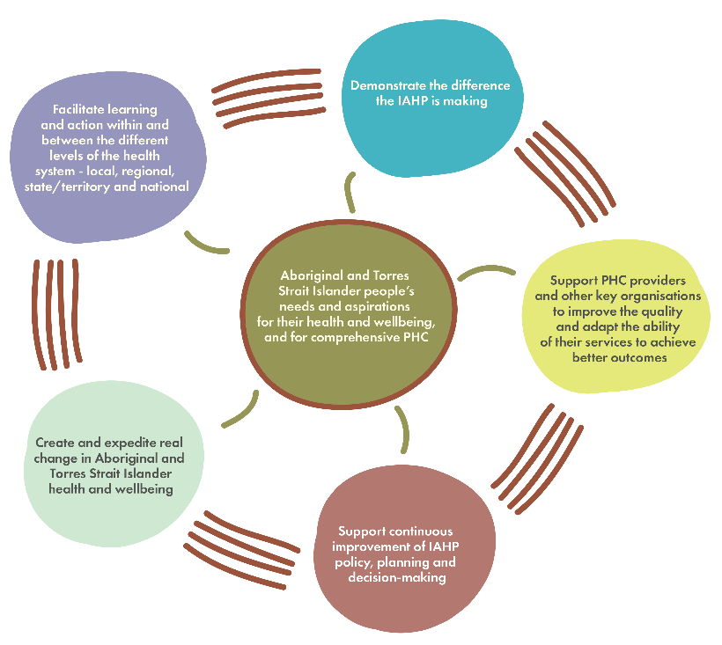
The overarching purpose of the evaluation is to strengthen PHC for Aboriginal and Torres Strait Islander people and communities as represented visually below:

Figure 1: Purpose of the evaluation

Among other things, the evaluation process will also be used to scope a recommended monitoring and evaluation framework from 2022 onwards.

What approach is being taken to the PHC Systems evaluation?

A central part of the evaluation design is the establishment of up to 20 place based, system-focussed site studies to assess the impact of the IAHP on the ground as well as contribute to a national assessment of what is being achieved through Australian Government investment. A site is a geographic area where people live, work, seek and receive (or not) PHC and related services. The following diagram provides an illustration of an evaluation site along with organisations and groups of people who may be potential evaluation participants.

Participation Agreements are being progressively negotiated with key site partners and are expected to be in place by September 2019. Determination of the ‘shortlist’ of potential sites has been based on a range of criteria, including variations in service models and geography.
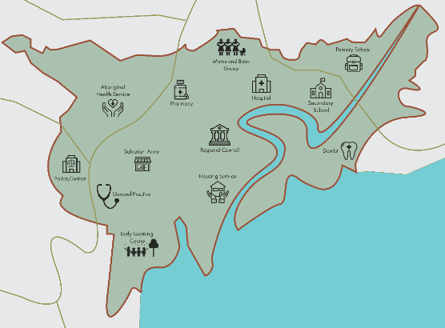
Figure 2: An evaluation site

The use of sites is intended to enable a contextualised, in-depth understanding of the complex interactions within and between the communities, PHC, other relevant systems, programs and factors to establish whether or not the IAHP is having the desired impact. The sites will be geographic areas large enough to explore the PHC system in operation, to consider trends over time, and to enable comparisons between sites and the rest of Australia. The sites will include a range of PHC providers – Aboriginal Community Controlled Health Services, Aboriginal Medical Services, private general practices and other government and non-government funded services – in a variety of different contexts. Participation in the evaluation is voluntary as is the preferred depth of engagement.

Key benefits of participation will include the regular production of tailored evidence to support ongoing planning and continuous improvement at the local, regional, state and national levels – this will include a strong focus on interactive engagement, shared sense making and knowledge co-creation. There will also be opportunities to participate in collaboratives on cross-cutting themes and issues that bring stakeholders together across the system to problem solve and take positive action. The tailored reports will feed into national reports with a final synthesis report due in 2022, along with a recommended future approach for monitoring and evaluation over the medium to longer term (5-10 years). The latter may include consideration of the development of a future accountability framework that measures the ‘public value’ of the Australian Government’s Aboriginal and Torres Strait Islander specific PHC investment.

The multilevel and mixed method approach is designed to maximise system learning and support the continuous improvement, adaptive management and accountability needs of a variety of stakeholders to inform and bring about real change.

Why does there need to be such a focus in the evaluation of driving positive change?
The National Aboriginal and Torres Strait Islander Health Plan 2013-23 (the Health Plan) provides a long-term, evidence-based policy framework to reduce Indigenous health inequality. The Health Plan has an ambitious vision that:
The Australian health system is free of racism and inequality and all Aboriginal and Torres Strait Islander people have access to health services that are effective, high quality, appropriate and affordable. Together with strategies to address social inequalities and determinants of health, this provides the necessary platform to realise health equality by 2031.
Through this vision, the Health Plan reflects the Government’s health reform agenda by promoting strategies that are consumer-centric and seek to:
- empower Aboriginal and Torres Strait Islander people to take control of their own health;
- address racism and inequality, and emphasise the centrality of culture in the health of Aboriginal and Torres Strait Islander people; and
- make the health system more responsive to the clinical health care needs as well as the social and emotional wellbeing of Indigenous Australians.
The Implementation Plan for the Health Plan also notes how the overarching evaluation of the IAHP – the Australian Government’s primary investment in Indigenous Health – will measure the effectiveness of the current approach to closing the gap and inform future revisions of the Health Plan.
In terms of the broader reform context, the Australian Government has established a major health reform agenda to address the significant challenges facing the health system. The reforms focus on improving access, quality and efficiency of services, particularly for vulnerable groups, by placing the consumer – not the provider – at the centre of the health system. Achieving this orientation, particularly in respect of minority populations, such as Aboriginal and Torres Strait Islander people, remains a significant health system challenge, not just in Australia but worldwide. Within this broader health reform context there is a prime opportunity for strategic evaluations such as the PHC systems evaluation to contribute to helping facilitate the desired health system reorientation.

Why is this type of evaluation approach being undertaken?
This approach consolidates and builds on what has been learnt from undertaking Indigenous health evaluations over the past decade. Key to this is the recognition that evaluations that are solely focused on individual programs are of limited usefulness in the face of systemic issues that continue to perpetuate health inequality. In addition, a repeated finding has been that public health initiatives are implemented in diverse settings which impacts on their effectiveness. Therefore, evaluations of large scale programs such as the IAHP cannot be confined to the program itself themselves but need to encompass a strong understanding of setting and context for an evaluation to be realistic and useful.
The approach also builds on what has been learnt about the value of formative, place based evaluation to inform program implementation and refinement, such as the Sentinel Sites Evaluation of the Indigenous Chronic Disease Package (2010-2013), which complemented a separate national evaluation of the Package. The current approach moves things to a new level by focusing much more on the consumers’ experience of the system in terms of their perspectives and what they value, as well as strengthening stakeholder engagement through the co-design approach.
In particular, although it is clear that there is an accountability requirement to evaluate the IAHP as a ‘program’, there is also an enhanced recognition that there needs to be a key focus on how the PHC system as a whole is working for Aboriginal and Torres Strait Islander peoples if the evaluation process is to have optimal utility. The evaluation design therefore seeks to appropriately balance the tensions between these different drivers and during the process also engage more actively with mainstream programs who are also accountable for improving health and wellbeing outcomes for Aboriginal and Torres Strait Islander Australians.
How have Aboriginal and Torres Strait Islander values been incorporated into the design and ongoing implementation of the evaluation?
The evaluation is seeking to ensure the centrality and range of Aboriginal and Torres Strait Islander values throughout all design and implementation components of the evaluation. A co-accountability approach is being taken to ensure that both the Australian Government, as the funder of the program, and the program providers planning and delivering the program, are accountable for results. Fundamentally, this accountability requires there to be a focus on what Aboriginal and Torres Strait Islander people value. As Sullivan (2015) notes:
The bedrock of accountability for public value must be an understanding of what is valued in the first place. This can only be done in cooperation with the client communities. Aboriginal people cannot, for example, be coerced into valuing those health outcomes that the wider community values for them. There must be a process of dialogue and consultation, which requires some movement in both directions and includes an understanding of those outcomes that are uniquely valuable to a particular Aboriginal client group (p. 19).
Therefore, the evaluation framework needs to be fully informed by Aboriginal and Torres Strait Islander people’s needs and aspirations for their health and wellbeing, and for comprehensive primary health care.

How has the co-design process occurred to date?
The evaluation design is the result of a multi-layered co-design process that occurred over ten months (Sep 2017 – Jun 2018) and involved participants from across the PHC system – including community members, providers, and state/territory and national organisations as follows:
- The establishment of the Health Sector Co-Design Group (HSCG) brought together a wide range of experiences and perspectives from professionals working across the health system, and experts in evaluation, research and co-design. The two co-chairs and more than half the members are Aboriginal and/or Torres Strait Islander. The evaluation team continues to work closely with the HSCG on co-designing key aspects of the evaluation into implementation.
- Initial engagement in the formative, early co-design stage of the evaluation occurred with community-based groups (about 40 people across six groups) with whom the evaluation team had existing relationships in recognition of the time it takes to develop relationships, trust and rapport. More extensive engagement with communities (including the potential establishment of a Community Co-Design Group) is built into the implementation of the system-focussed site studies where it can occur with an assurance of a four-year commitment.
- Engagement has also occurred with 103 members (formal and ex-officio) of the various state/territory Aboriginal and Torres Strat Islander Health Partnership Forums, and other key national organisations/agencies (a total of 36 organisations or alliances).
The engagements above informed the design of the evaluation, extended the evaluation questions initially identified by the Department and importantly, informed the development of the evaluation framework, specifically the areas that the evaluation needs to focus on to answer the questions and the criteria for making evaluative judgements.
To date a progressive approach has been taken that balances the tension between ensuring authentic engagement and input, at the same time as practically progressing work on the evaluation framework and its implementation.
Integrating western and Indigenous knowledge and understanding of a primary health care system
The design brief includes addressing the evaluation questions, testing and building the IAHP logic and theory of change, as well as focusing on Aboriginal and Torres Strait Islander people’s experiences of the PHC system and ensuring that what they value is included in an understanding of ‘what matters’. This requires the team to develop an evaluation framework that integrates western and Indigenous knowledge and understanding in both the process of developing the framework, as well as the content of the framework. This is being addressed by working with the questions, IAHP theory of change and logic, and progressively asking stakeholders (at different levels of the system) what is important and of priority. In developing the evaluation framework, the evaluation team is also drawing on existing documented knowledge regarding what is important for Aboriginal and Torres Strait Islander people and communities in the provision of PHC.
Reflections on the co-design process to date
A fundamental contextual factor for this evaluation is that many Aboriginal and Torres Strait Islander people have been, and continue to be, affected by a colonial history that has exposed Aboriginal and Torres Strait Islander people to racism, social exclusion and discrimination. Researchers and evaluators have contributed to this context, leading to a “wariness and weariness of research and evaluations that are conducted on them, rather than with or by them and for them” (Cram, Tibbetts, and LaFrance 2018, p. 8). The approach being undertaken in the PHC Systems evaluation is attempting as much as possible to decolonise the way the evaluation is undertaken and through this has a strong alignment with the Australian Government health reform agenda and ethical guidelines for research and evaluation with Aboriginal and Torres Strait Islander people and communities (National Health and Medical Research Council 2018).
Co-design and participatory evaluation are understood and applied in a variety of ways. A consumer engagement approach developed by Health Consumers Queensland identifies that the spectrum of engagement can range from inform, consult, involve, collaborate to empower (which the evaluation team have reframed as being ‘led by participants’). Literature canvassed to date suggests that design thinking and co-design of health services predominantly ‘involves’ patients or users. In contrast, the brief for this evaluation locates the evaluation co-design at the collaborate and led by participants end of the spectrum, as illustrated in Figure 2.

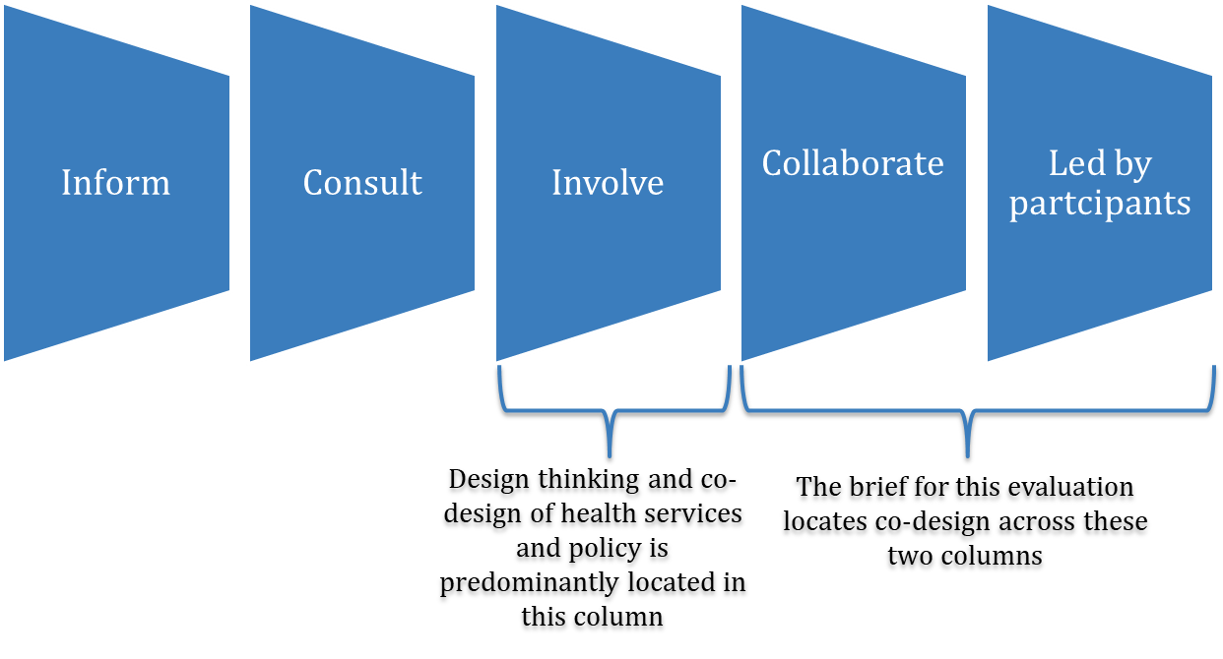
Figure 3: Spectrum of engagement
The term ‘co-design’ is currently a popular and overused term that engenders various understandings in terms of the continuum of engagement. Put simply, for the purpose of the PHC Systems evaluation it is defined as the active involvement of stakeholders (including a diversity of consumer voices from people who may or may not be accessing services) at all levels, whose perspectives will collectively inform and shape the evaluation over its life course. Taking such a co-design approach to evaluation is very new, especially in relation to the evaluation of large, national, government funded programs.
Co-design provides a tool for system learning and adaptation and for Aboriginal and Torres Strait Islander Australians to have a real voice. It can be used to disrupt the status quo and help people to problem solve collectively and bring about positive change to improve outcomes for Aboriginal and Torres Strait Islander Australians. To date the evaluation team, the Department, and the Health Sector Co-design Group have reflected that co-design:
- Is a process
- Takes time
- Is about relationships
- Requires trust and trustworthiness
However, it is not co-design in and of itself that will achieve this potential. Rather, it is the people themselves, and the application of principles and practices that consciously address issues of cultural safety, inequity in power, governance, diversity of voices, values and knowledge, and the distribution of benefits arising from the evaluation project.
Transparency
In line with the Productivity Commission’s focus on transparency in relation to evaluation processes and products, the IHD’s Evaluation Strategy and Guide emphasises the importance of publishing evaluation reports and sharing the findings and lessons with a broad audience in accessible ways, as part of a comprehensive knowledge sharing strategy. Release of evaluation reports in the public domain is encouraged as the norm, with the proviso that the final decision to do so is a Ministerial one. In addition, a successful evaluation is not just about a quality final evaluation report. Meaningful and impactful evaluations engage relevant stakeholders throughout the evaluation process to maximise the ability to respond to issues and ideas that have emerged throughout the evaluation.
Comprehensive information about the PHC Systems evaluation including the Monitoring and Evaluation Design Report is available on the dedicated website for the project at www.IPHCeval.com.

https://www.health.gov.au/internet/budget/publishing.nsf/Content/budget2019-glance.htm page 20.
Sullivan, P. 2015, A Reciprocal Relationship: Accountability for public value in the Aboriginal community sector, The Lowitja Institute, Melbourne.
Cram, Fiona, Katherine A. Tibbetts, and Joan LaFrance. 2018. “Editors’ Notes: A Stepping Stone in Indigenous Evaluation.” New Directions for Evaluation 159(Fall):7–16.
National Health and Medical Research Council. 2018. “Ethical Conduct in Research with Aboriginal and Torres Strait Islander Peoples and Communities: Guidelines for Researchers and Stakeholders.”
Health Consumers Queensland. (February 2017). Consumer and Community Engagement Framework for Health Organisations and Consumers. Retrieved 25 October 2017 from http://www.hcq.org.au/wp-content/uploads/2017/03/HCQ-CCE-Framework-2017.pdf.

