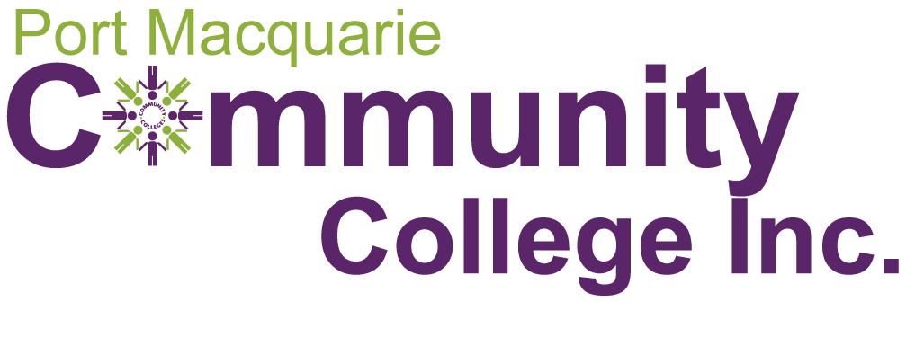
The Return To Work Friendly Mid North Coast Program
24 October 2018
- Concept & Rationale

Rural and regional employers often struggle to make ends meet in an increasingly competitive business environment. Workplace injuries add an extra burden, in supporting workers to recover, finding replacements while they do, training new staff, and meeting workers compensation premium payments.

So Return To Work can be a daunting prospect for both employers and employees. That’s why the MNC Branch of the NSW Business Chamber has teamed up with Port Macquarie Community College (PMCC) to create the Return To Work (RTW) Friendly Mid North Coast program. Its aim is to help both bosses and their workers to manage the changes that need to be made, in helping injured workers successfully recover from workplace injuries and get back on the job. Whether returning to the same workplace or job role, or heading into different work, this program provides support for all aspects of the change process, using the lifelong and lifewide learning principles and practices of Adult Community Education (ACE). These treat the learners as equal with their teachers, be they business owners or workers.

By supporting the four main groups involved in the RTW experience, we will help to build stronger workplace cultures, more profitable businesses, and happier managers & workers. These are:
- Workers needing sustained recovery pathways to be RTW Ready
- Families of those workers needing to know a recovery process is available after injury, and a Community of Belonging to support successful recovery and adapting to new ways of working, or finding different pathways in life
- Owners and Managers of businesses needing to know that a structured program of RTW can be run without interfering with day-to-day operations
- Peer Workers who need help in adjusting to a RTW process, whether receiving their existing colleagues back after injury, or taking on new workers who have been injured elsewhere.

- The Model

  - RTW Champion Employers – Businesses self nominate to join this pilot program and receive a discounted fee. These champions will be part of a 12 month trial in which the elements of a sustainable model will be fine tuned with them. The aim is to save money, strengthen and enrich workplace cultures, and increase sustained profitability through creating happier, more responsive workplaces.

  - Partnership Program with Workers Compensation Insurers – Insurance companies managing RTW cases will be invited to join the program and contribute their knowledge of how best to encourage successful RTW for all parties.

  - Adult Community Education Programs fostering RTW Ready skills among workers –
PMCC will bring its extensive experience working with vulnerable communities to help injured workers and their families to engage with a recovery and skills rebuilding program. This will aim to assist RTW or finding alternative life paths.

  - Family support programs in the ACE environment’s Community of Belonging – While families wait to see if RTW is possible in the same workplace, or another path is preferable, they need support in programs that acknowledge their challenges. PMCC specialises in using adult education to assist people making major life changes, and its Community of Belonging is a warm and welcoming place of recovery.

  - Workplace Induction Program for RTW candidates, managers and peer workers – the biggest challenge for all parties is handling someone’s RTW when they are no longer exactly the same, and they need understanding to fit back in or find new roles. This program provides a simple, respectful set of guidelines for all parties, to ensure the RTW experience is supportive and developing new abilities.

  - Ongoing Monitoring, Evaluation & Improvement using Strengths-based Appreciative Inquiry Research by the participants themselves – RTW participants and their carers can join the strengths-based qualitative research program, which is a conversational, narrative-style sharing approach. It asks “What’s been working, and what’s not been working for you?” This honours the voices of those recovering from injury, and gives them a voice in sharing their journey of recovery, which helps in itself to heal self-esteem and builds motivation for RTW. It also provides a continual “live” evidence base to prove the worth of this program to business & government.

- SMART Objectives

- Specific – Business owners and managers who are part of the Mid North Coast Branch of the NSW Business Chamber, Workers on the MNC of NSW who are seeking recovery from injuries for RTW, and their carers & families. A 12 month pilot program illustrating the effectiveness of intentional Return To Work Friendly approaches in workplaces and Adult Community Education (ACE) settings.

- Measurable – Up to 30 MNC workplaces will be approached between November 2018 and January 2019 to invite them to join the program from February 2019 to February 2020. The RTW participants will be sourced through employers, case managers for scheme agent workers compensation insurers, GPs and rehabilitation consultants, and worker self referrals. The results will be measured in both quantitative and qualitative annual data.

- Achievable – Business owners and managers will be given assistance in providing Workplace Re-entry Induction programs for RTW candidates, peer workers and managers.

- Relevant – Everything is focused towards on-the-job changes to policies and practices to improve RTW outcomes. Employers will find it helps them to achieve more positive RTW outcomes, and less staff turnover. This saves on recruitment and retraining costs, as well as increasing morale and productivity.

- Time oriented – Twelve months is the limit of this pilot (Feb 2019 – Feb 2020), with quarterly progress reports and a final annual Evaluation Report to assess its worth.

- Participants & Partnering groups

The MNC Branch of the NSW Business Chamber and PMCC will bring other organisations on board as required, to expand the effectiveness of the program according to the feedback gained progressively from the continual research program Evidence Base collection with participating RTWers and their carers/families, peer workers and business managers. A parallel Evaluation Survey and follow up Interviews and Focus Groups will be conducted with case managers, insurance scheme agents, and GPs, allied health and rehabilitation consultants.

- Budget & Timeline

A cost per participant of …. will cover the roll-out of case assessments, learning support assessments, skills training and SEWB support, plus the links with partnering groups and the work placement process.

Timing will be from Feb. 2019 to Feb. 2020, with exact dates to be defined in consultation with businesses. Three monthly milestones will frame the progress and reporting schedule.

- Monitoring, Evaluation & Reporting

PMCC’s monthly Budget & Activity reporting will include this project, so it will be monitored by the publicly accountable PMCC Board, as well as providing quarterly reports to MNC NSW Business Chamber, and a full financial acquittal at the conclusion. The Appreciative Inquiry Research Evidence will be collated at the end of the 12 month pilot and used to inform a final Independent Evaluation Report.

