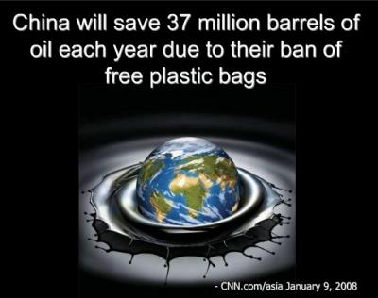
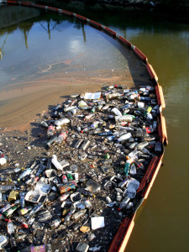

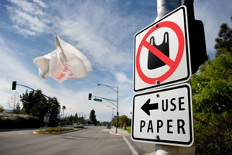
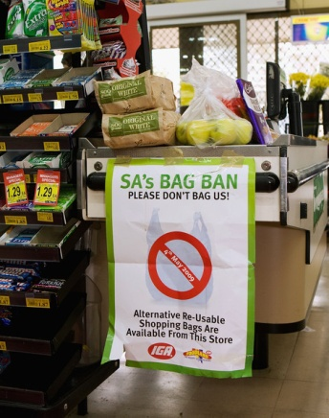

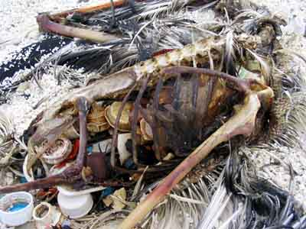
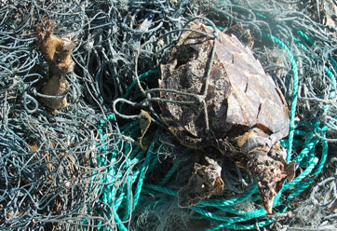

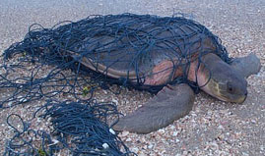

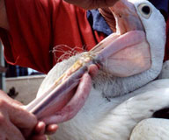
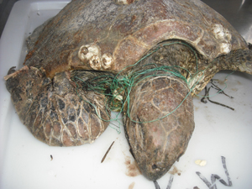

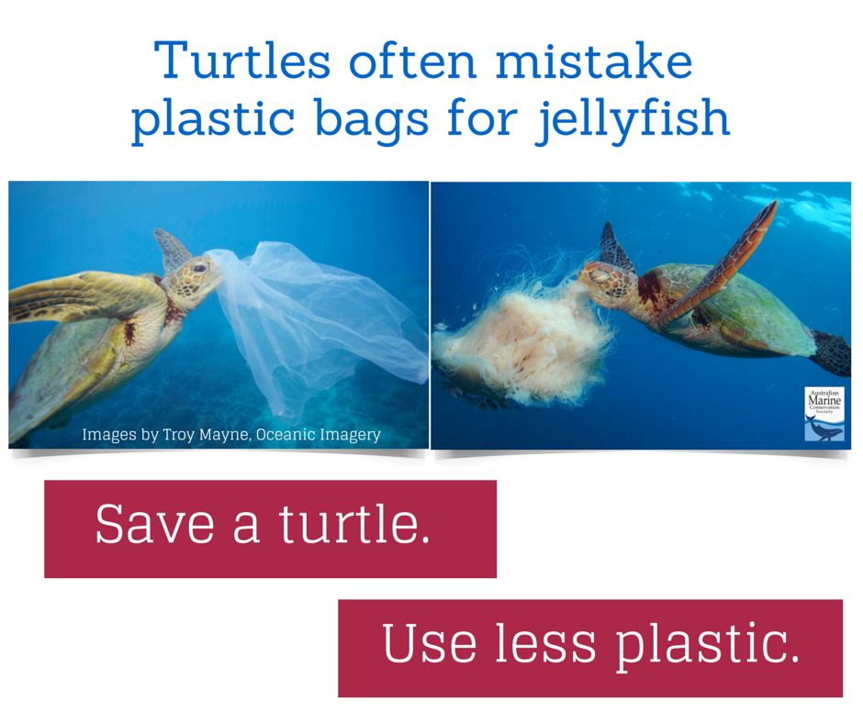

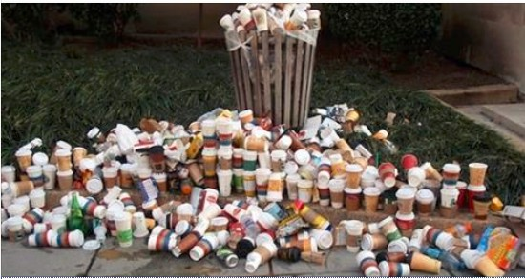
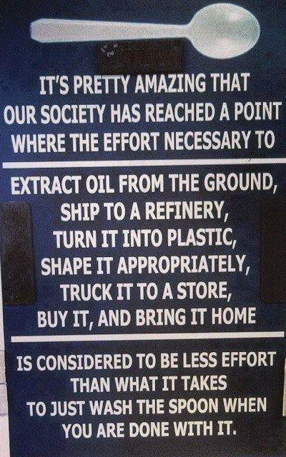

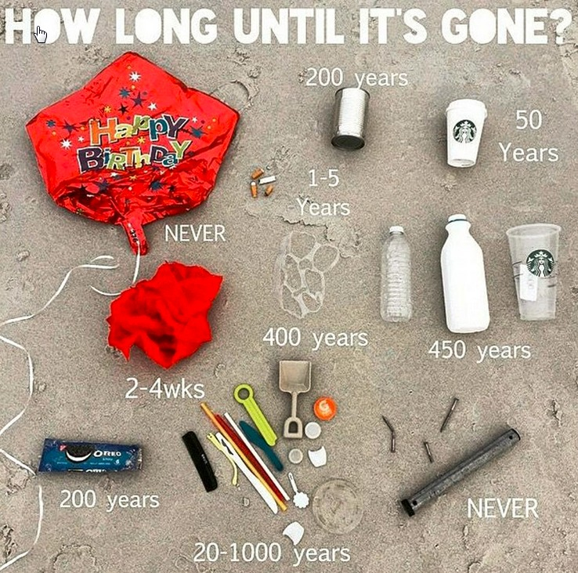
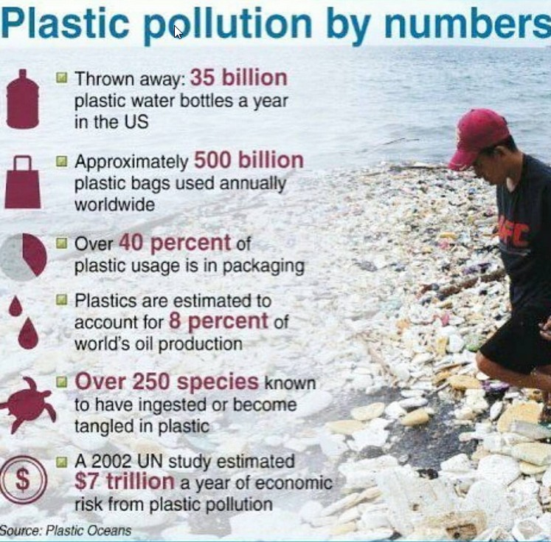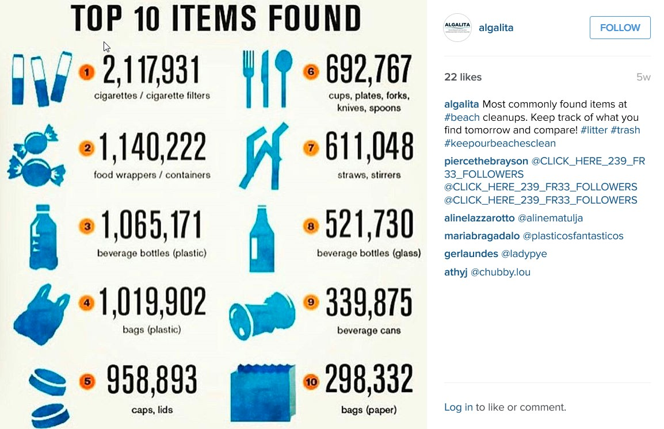
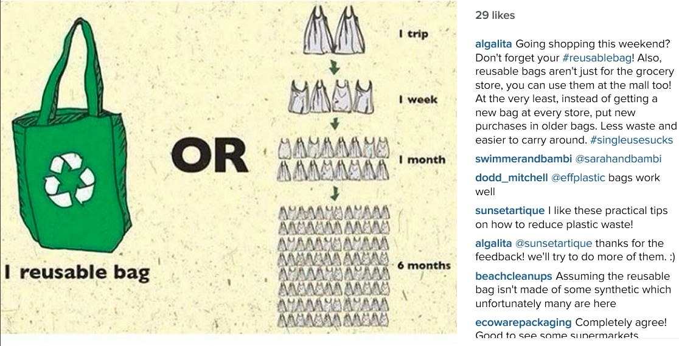
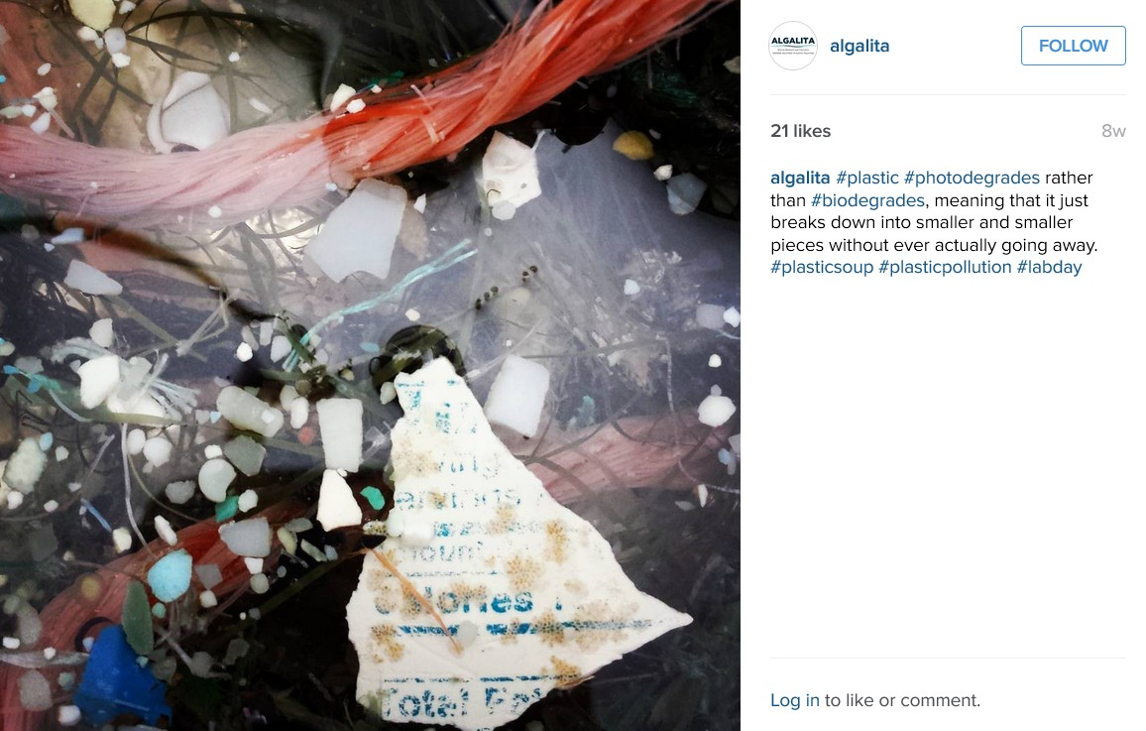

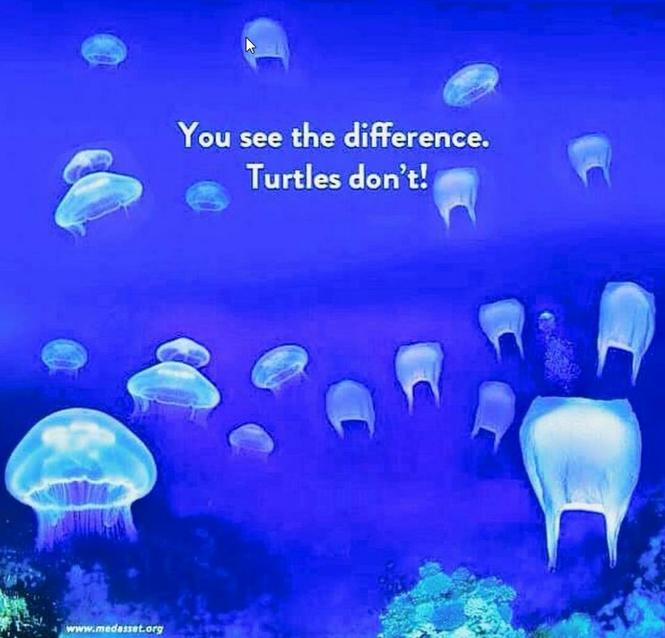
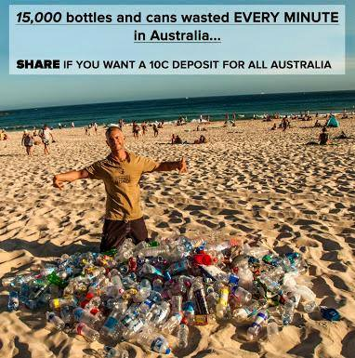
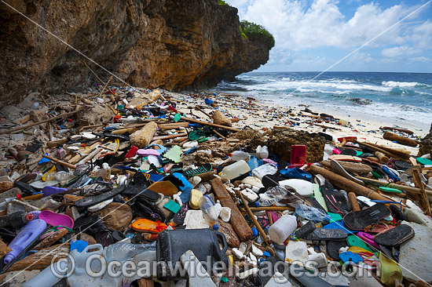
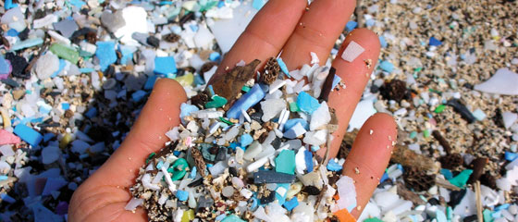

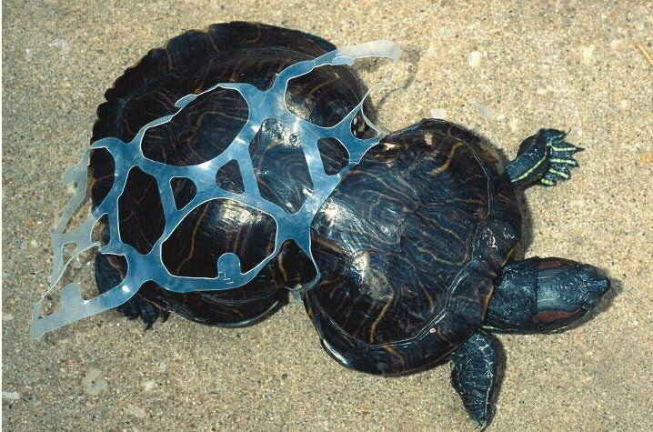
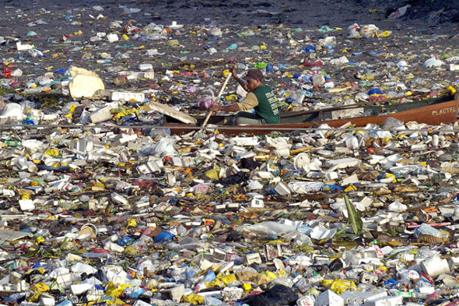

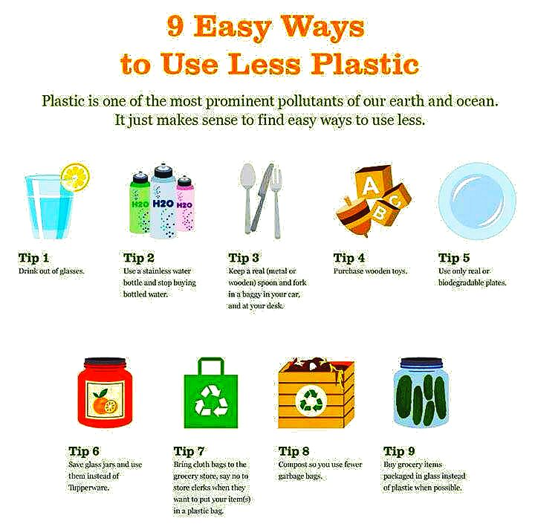

Plastic Free Cayman “For those asking where this is, it is the canal of Leogane, Haiti. Many people here are using this video to say Trump was justified in calling poor countries with people wanting to immigrate to the US "shit holes". On the face of it this is somewhat correct, when one looks at the amount of garbage in this canal it is hard to deny that it is a shit hole. However, instead of the wealthy first world condemnation of Trump and his supporters one should look at the context of why an area becomes a shit hole.
First of all in more recent history, Leogane was the epicentre of the devastating earthquake in 2010 that destroyed 80 to 90% of its buildings and killed 20 to 30 thousand people in Leogane alone or between 10-20% of its population. Western aid efforts were well funded intentional failures in which most of the money went other places than to the people. The worst instance of this was the alternative to Trump in the last election, Hillary Clinton and the Clinton Foundation came to Haiti supposedly to save and help the people but mostly siphoned off the aid money and made sure Haitian agriculture and commerce was even more under the domination of US corporations.
To go further back in history Haiti was a French slave colony in which one of the world's most important historical events occurred in 1804, a revolution in which slaves overthrew their masters and ruled their own country. Despite the historical importance of this event, it is not given very much importance or attention in our schools and I suspect that is not by coincidence. Haiti was building a successful country despite trade sanctions placed on them by both France and the US when the French navy showed up in 1825 and demanded compensation for the property lost through the revolution, in other words they wanted the slaves to pay the slave masters for the plantations they had taken over. The sum demanded was 150 million Francs or twice the amount the US had paid France for Louisiana. It is estimated as anywhere between 20 and 40 billion in today's currency. If Haiti did not pay up the French would invade it and retake the country. The Haitians paid the money, crippling their economy and putting them in severe debt to both US and French banks as they had to borrow much of the money.
Since then the history of Haiti has been one of foreign interference, coup d'etats, military invasion and occupation. A similar incident to the French one occurred in 1915 when the US invaded and the country was ruled by the US military for the next 19 years. One of the first acts of the US was to take the Haitian gold reserve to the US for “safe keeping” in the vaults of the predecessor of Citibank, wealth that has never been returned to Haiti. Whenever a leader was elected who tried to correct some of the injustices in Haiti with ideas such as the wealth of Haitian resources going to the Haitian people instead of foreign corporations or asking for reparations to France or the US for stolen money, that resulted in them being overthrown by our human rights loving democracies. In Canada the far lesser known of the Meech Lake conferences was the one in which the governments of the US, Canada and France decided to overthrow Aristide with the help of the puppet government installed in its neighbour the Dominican Republic.
So yes many countries may be to some extent shit holes but when we call them that we ignore our role in making them into shit holes. When rich countries have a lot of immigrants and refugees from another country it is often an indication that this particular country did a lot of bad things in the other country which produced poverty and refugees. France has many Algerians, England has many Indians and Pakistanis, the US has many people from Central America, Canada has many Haitians and Europe is now inundated by the Libyan and Syrian victims of NATO aggression. We love to point to poverty in countries like Cuba and Venezuela or North Korea and say this is proof socialism or communism does not work. Yet while these countries are poor they are also under many of the same sanctions that Haiti has been under when we did not like the fact that the slaves had a successful revolution and ruled their country. Haiti is also the poorest country in the western hemisphere and is a capitalist democracy not a socialist country. So while many socialist countries are poor also, in most regions the poorest countries are capitalist democracies who in true capitalist fashion are being exploited, bullied and when our human rights loving democracies deem it necessary bombed and invaded by the richer capitalist countries. Many poor people in this world may be living in shit holes but the shit hole they live in is being dug by the rich countries.”

Anita Horan video
• • • •
A brown pelican coated in oil struggles on East Grand Terre Island, Louisiana, on June 4, 2010.
Photograph by Win McNamee, Getty Images

Ten years later, BP oil spill continues to harm wildlife—especially dolphins

Some species, such as brown pelicans, have rebounded, while long-lived species have been hindered for generations. Still, data is scarce.

