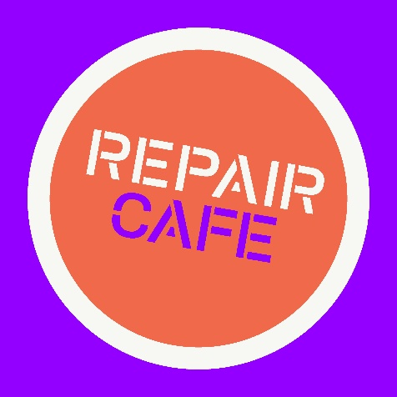
Repair Café Woolloongabba (Community Group)

26/1/2021

Australian Competition and Consumer Commission
23 Marcus Clarke Street
Canberra ACT 2601

Dear Productivity Commission,
Repair Café Woolloongabba are a community group with the purpose of holding free repair events for the public. We would like to submit the following responses in regards to your request for information.

Information Request 1.
- What would a ‘right to repair’ entail in an Australian context? How should it be defined?
We are a not-for-profit community group with a common goal of reducing waste and providing a free service for people to get broken items repaired. As one of the many repair cafes which are now being set-up in Australia, the USA and Europe, we see our role as ‘value-adding’ to both the items we repair and the communities we engage with.
A ‘right to repair’ should ‘value add’ to items after the initial sale; for example, by contributing to the item’s initial quality, its upkeep or its disposal/repurposing after the end of useful life.
Information Request 2.
- What types of products and repair markets should the Commission focus on?
- What are the unique issues in those product repairs that support such a focus?
In our experience, household electrical items, tools and computers are often products which break within a short time frame. These products are usually replaced by the seller if the item is still within the warranty period and provided the consumer still has proof of purchase. However, many small items such as kettles and toasters are thrown away because it is cheaper and easier to buy another one rather than repair it.
The ability to replace elements, power cords and other minor electrical repairs in a cheap and easily accessible manner is part of the Repair Café focus. However, these cafes rely on the goodwill of volunteers and are not sustainable in the long-term. A wider network of repair services which the community is aware of and can easily access would be preferable for long-term planning and reduction of e-waste.
Information request 3.
- Do the consumer guarantees under the ACL provide adequate access to repair remedies for defective goods? If not, what changes could be made?
It is often difficult for consumers to find out about the viability of repair. Many companies require the product to be sent to them which creates time delays and cost to consumers. These costs often deter consumers from enforcing warranties. Repair Cafes enable people to access information about viability of repairs even if this means we eventually tell them:
- it can’t be repaired because there is some part of the item that is irreparably broken
- Can be repaired, but can’t be restored to its original condition
- It can’t be repaired with the tools and expertise we have available but could be taken to the original equipment manufacturer (OEM) or independent repairers.
There is a need for information about the viability of repairs to be provided for consumers in a cost-negative and easily accessible manner.
d) Are consumers sufficiently aware of the remedies that are available to them, including the option to repair faulty products, under the ACL’s consumer guarantees?
Consumers are generally unaware of their legal rights under ACL consumer guarantees. Requirements such as registering the product purchase online to activate the warranty deters people (or they simply forget). The wording of warranties is also a barrier as many people ‘turn off’ reading anything which they think looks ‘legal’. A legislated ‘general warranty’ which covers all products and does not require any actions by the consumer after purchase would assist consumers.
In addition, simplifying the format and wording of warranties would be beneficial. The use of Plain English would improve consumer understanding of warranties (in a similar manner to previously legislated changes to insurance and real-estate contracts).
If not, would more information and education be a cost-effective measure to assist consumers?
There is already a wealth of consumer information available online and through government departments and community legal services. However, as with many other legal issues, most people are unaware of this information or can’t access it for a variety of reasons (literacy issues, internet access etc). An education program such as TV advertisements would possibly be helpful but there are many other issues competing for advertising attention.
A more long-lasting solution would be to remove the requirement for individual consumers to take action and place a heavier onus on manufacturers to produce quality, long-lasting goods with easy access to repair services.

Information Request 5.
- Do current IP laws pose a significant barrier to repair in Australia?
Confusion and concern about IP laws do currently pose a barrier to repair in Australia.
Many things that are fixed do not directly interfere with the Intellectual Property of an item, but the power inequity between large multinational corporations, small repairers and community groups such as our Repair Café limits us in what we feel legally safe to repair or provide advice on.
Legal protections for small repairers and services such as Repair Cafes would be helpful. These protections could include requirements to follow reasonable steps to ensure that repair activities are law-abiding and safe (e.g. electrical repairs) and that the knowledge and advice is provided by someone with industry or relevant practical experience.
Information Request 6.
- Do concerns about planned obsolescence principally relate to premature failure of devices or in them being discarded still working when more attractive products enter the market?
In our experience, planned product obsolescence relates to premature failure of devices. This is due to the nature of the service we provide, where customers are enquiring about attempting to extend the life of current items. Our customers are using our service because they are attempting to avoid buying a new product, despite its potential attractiveness to consumers.
- Do consumers have access to good information about durability and reparability when making purchases? If not, how could access to information be improved?
Consumers do not have access to good information about durability and reparability when making purchases. Please see comments relating to viability of repairs in Information Request 3 above.

We hope our answers are useful in this commission’s investigations. Thank you for your consideration of our response and we look forward to the results of the “Right to Repair” enquiry.

Kind Regards,

Repair Café Woolloongabba

