To: Commissioner Dr Jane Doolan, Associate Commissioner Drew Collins

Productivity Commission
National Water Reform 2020

Submission by John F Kell BE (SYD), M App Sc (UNSW), MIEAust, MICE
Date: 25 March 2021
Revision: 3

Summary of Contents
1.0 Introduction
2.0 Current Situation / Problem Solution
3.0 The Solution
4.0 Dam Location
5.0 Water channel design
6.0 Commonwealth of Australia Constitution Act – Section 100
7.0 Federal and State Responses
8.0 Conclusion
9.0 Acknowledgements

Attachments
1 Referenced Data
2A Preliminary Design of Gravity Flow Channel Summary
2B Preliminary Design of Gravity Flow Channel Summary
3 Effectiveness of Dam Size Design

Units
L litres
KL kilolitres
ML Megalitres
GL Gigalitres (Sydney Harbour ~ 500GL)
GL/a Gigalitres / annum
RL Relative Level - above sea level (m)
m metre
TEL Townsville Enterprise Limited
SMEC Snowy Mountains Engineering Corporation
MDBA Murray Darling Basin Authority

1.0 Introduction
This submission is to present a practical solution to restore balance in the Murray Daring Basin (MDB) with a significant regular inflow of water from the Burdekin and Herbert Rivers in Queensland.

My background is civil/structural engineering (BE Sydney Uni - 1973).
As a fresh graduate, I worked in South Africa and UK for ~6 years, including a stint with a water consulting practice in Johannesburg, including relieving Mafeking as a site engineer on a water canal project. Attained the MICE (UK) in Manchester in 1979.
In 1980 returning to Sydney, I joined Connell Wagner (now Aurecon), designing large scale industrial projects.
Since 1990, I have headed a manufacturing company in the specialised field of investment casting (www.hycast.com.au) at Smithfield, NSW.
In 1995, I graduated in Masters of Applied Science at UNSW.
I’ve had my fair share of time in the bush. I walked the Thorsborne Trail on Hinchinbrook Is, twice (not in February). I’ve been bitten by a bug - the Burdekin Bug.
I have maintained a strong interest in water engineering throughout my career.

2.0 Current Situation / Problem
The current situation is that the MDB is in a very distressed state. The inflow variability has been well documented and the average inflow has dropped from ~10,000 GL/a 1896-1995 to ~6,000 GL/a in the last 25 years. This 6,000 GL/a average is similar to the 1920-1950 period but with far less demand. Refer to MDBA data Graph 1.

Water demand has increased and that will continue. Water has been pumped since 2018 from Wentworth on the Murray to Broken Hill as the Darling River is dying. Towns are being forced to truck in water. The situation is dire and depressing for all concerned Australians.

A stark realisation, is the significant variation in inflows and how large and small quantities are often grouped together, possibly mirroring the Indian Ocean dipole effect.

Indications are that conditions will only get worse.

Graph 1 Murray River Inflows 1896-2020
(3,507 GL/a added to the bottom line – see later)
Reference MDBA

Meanwhile, in Queensland, 12,500 GL/a is discharged into the Coral Sea, from the Herbert and Burdekin Rivers, being excess to Queensland requirements. The current proposal of building the 2,100 GL Hells Gate Dam for Queensland, will reduce this excess to 10,400 GL/a. Compared to the ~10,000 GL/a averages in Graph 1, this is a significant quantity being discarded.

The construction of this Hells Gate dam would forever negate the only chance we have to address the MDB problem and Queensland could still be serviced in another way, with excess water.

In many minds, Section 100 of our Constitution prohibits water being transferred from one state to another.

The current situation is approaching catastrophic …… and yet there is a solution.

3.0 The Solution

There have been many proposals offering a solution to solve the MDB problem to bring the Burdekin and Herbert northern rivers into action. Each solution has been discarded with:
“heard it all before”, or
“pumping is so expensive” or
“it’s my water and I’m not sharing” or
“it’s Queensland water, we can’t take it from them”.
However all authorities and schemes do agree on one thing - that there is excess water in the Burdekin River system in northern Queensland.

3.1 The Solution - Five Key Points
Elevation Gravity channel to the MDB from an upper Burdekin Dam ,
Inflow 3,507 GL/a available – a significant volume (see Graph 1).
Storage ~9,000 GL water storage possible in the Burdekin River gorge. This volume is effective to service the MDB
Evaporation A dam in the Burdekin gorge minimises this Queensland evaporation curse.
Section 100 As there is sufficient water to share, our Constitution, Section 100 allows the Federal Govt to request the Qld Govt to share its water to the nation or, Queensland can offer the water for the benefit of the nation, as there is excess to Queensland’s needs.

3.2 Summary of the Preferred Solution
Step 1 Capture average 3,507 GL/a, inflow from Burdekin River and the Herbert River with a 25km tunnel from Glen Eagle RL555 on the Herbert to Wairuna RL 530 on the Burdekin.

Step 2 Build storage dam on the Burdekin River Gorge at Mt Foxton. Its capacity of 9,000 GL provides a buffer for the dry years and at a minimum water level of RL 350m...

Step 3 Transfer this 3,507 GL annually, via a gravity channel, located just inland of the Great Dividing Range, to the MDB and Great Artesian Basin (GAB), a distance ~2,500km, with take-offs on the way.

Step 4 Ensure Queensland has “reasonable use of the water of rivers for conservation or irrigation” (Section 100), after the 3,507 GL/a is sent to the MDB and 2,100GL/a has been allocated for the Charters Towers / Townsville regions.

4.0 Dam Location
Dam Location – choice of three:
New dam the Burdekin gorge at Hells Gate or
New dam in the Burdekin gorge at Mt Foxton or
Raising the existing Burdekin Falls Dam.

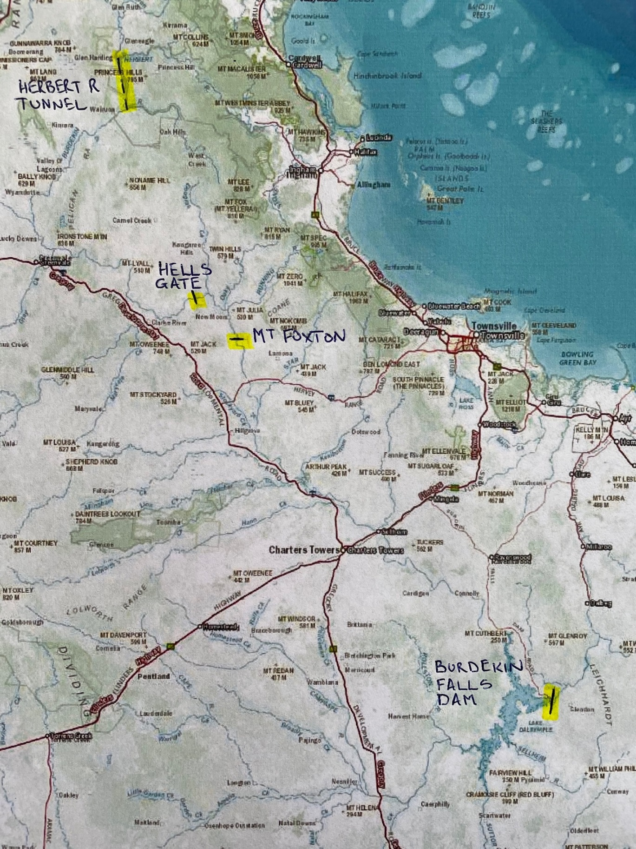

Map 1
Mt Foxton, Hells Gate and Burdekin Falls Dam Locations, with Herbert River Tunnel

4.1 Hells Gate Dam. Dam Water RL 372m
This Hells Gate site was Dr JJC Bradfield’s choice of 1930s and has recently been the subject of Snowy Mountains Engineering Corporation (SMEC) Study of 14/09/2018. This recommendation is impressive; however, each entity was aiming at different targets, with no regard to the MDB.
This site has three major limitations – inflow, future extensions and suitability for MDB:

The inflow to the Hells Gate site is just 1,817 GL/a (ref Mt Fullstop 120110A). Deducting evaporation and there is even less (refer Table 3)
To extend capacity of this dam, the gorge advantage is lost and evaporation is significant upstream, away from the gorge.
This site would be suitable for storage on the basis of dam level, as the level allows for gravity channel to the MDB.
However, this site is not suitable for storage for the MDB, as the inflows are not maximised.

4.2 Mt Foxton – 30km downstream from Hells Gate. Dam Water Level RL380
Mt Foxton - (Referred in CSIRO Northern Rivers and Dams, 5/12/2014 Fig 4-14), has additional inflow from Douglas Creek, Oaky Creek and Running River (~600 GL/a).
This site has the following features:
Mt Foxton has an inflow of ~2,400 GL/a. (result of the three additional rivers inflow)
To extend capacity of this dam, the gorge is used, absorbing the proposed Hells Gate dam site. Evaporation is minimised.
This site is suitable for storage for the MDB, as the inflows are maximised (with 3,507GL/a).
This site is also suitable for storage on the basis of RL380 dam level as the level allows for gravity channel to the MDB from 350m

4.3 Burdekin Falls Dam – 220km downstream from Mt Foxton. Dam Water Level RL 154
The dam level is being raised from existing RL154 to either RL156-RL160.
Downstream from the Burdekin Falls Dam, there is a current outflow of 6,657 GL/a. (at hydro site)
The existing capacity of 1,850 GL is being increased by raising the dam wall to either 2,010GL or 2,435 GL, depending on the wall increase.
This site is not suitable for storage (even if wall is raised further) for the MDB on the basis of dam level, as the level of the dam would require pumping, which is not feasible with current technology and considering the volume involved.
The dam is suitable to be extended to service the TEL requirements, pumping with either Solar or Hydro (possibly from Mt Foxton discharge hydropower to MDB).

4.4 Summary of inflows for dams

Item | Hells Gate | Mt Foxton | Burdekin Falls Dam
Inflow (Burdekin R only) | 1,817 GL/a | 2,400 GL/a | 6,657 GL/a

Table 1 Dam Water Inflows

Item | Hells Gate | Mt Foxton | Burdekin Falls Dam
Inflow  (additional Herbert R) | 1,817 + 1,107 =  2,924 GL/a | 2,400 + 1,107 =  3,507 GL/a | 6,657 GL/a

Table 2 Dam Water Inflows with Herbert River

Table 2 provides flow meter data, demonstrating the inflows when the Herbert River 1,107 GL/a is added.

4.5 Evaporation Loss
Evaporation losses vary over the nation. The losses are at extreme rates in Queensland. Evaporation creates a loss of ~3.0 m/a (Longreach 3.038 m/a, Charleville 2.621 m/a).
https://www.stateoftheenvironment.des.qld.gov.au/climate/climate-observations/evaporation-rate

Gorges are the preferred targets to build dams. The Burdekin Gorge is perfect.
The larger the dam’s capacity related to surface area, the less evaporation loss.
Mt Foxton water level at 380m, would assist in the dry spells and evaporation losses.
Refer to Table 3.

Dam | Surface  Area | Capacity | Evapor’n Loss * | Evapor’n  Loss | Evapor’n  Loss | Available Annual  Discharge
 | sq.km | GL | m / a | GL | % | GL/a
Mt Foxton RL350  (MDB takeoff level) | 260 (est) | 2,000 | n/a | n/a | n/a | n/a
Mt Foxton RL380 | 360 (est) | 9,000 | 2.6 | 900 | 10% | 8,100
Mt Foxton RL380 effective discharge to MDB | 360 (est) | 7,000 |  |  |  | 8,100
Hells Gate | 180 (est) | 2,100 | 2.6 | 450 | 21% | 1,650
Burdekin Falls (current)  RL154m | 286 | 1,860 | 2.6 | 700 | 37% | 1,160
Burdekin Falls 2m extension  RL156m | 344 | 2,010 | 2.6 | 900 | 45% | 1,110
Burdekin Falls 6m extension  RL 160m | 483 | 2,435 | 2.6 | 1250 | 51% | 1,185
MDB Channel  2,400km x 18m | 45 | 3,507 GL/a | 2.6 | 120 | 3.4% | 3,400
Warragamba (comparison) | 75 | 2,030 | 0.85 | 64 | 3% | n/a

Table 3 Evaporation Impact
* Evaporation rates - Townsville Airport 2.588m, Charleville Airport 2.621m

4.6 Conclusion on dam site choice

1. Mt Foxton Mt Foxton, with dam level at RL380 satisfies the three critical elements of water inflow, elevation and capacity to feed the MDB.

2. Hells Gate Not suitable for MBD. The preliminary construction work being done on the Hells Gate site will not deliver the designed 2,100 GL/a… because of inflow and dam storage capacity are insufficient. The nett inflow for this dam is 1,650 GL/a after evaporation. (ref Table 3)

3. Burdekin Falls Dam Extended dam can store the requirements for the TEL and SMEC for local irrigation with solar or hydro pumps for transfer above Charters Towers.

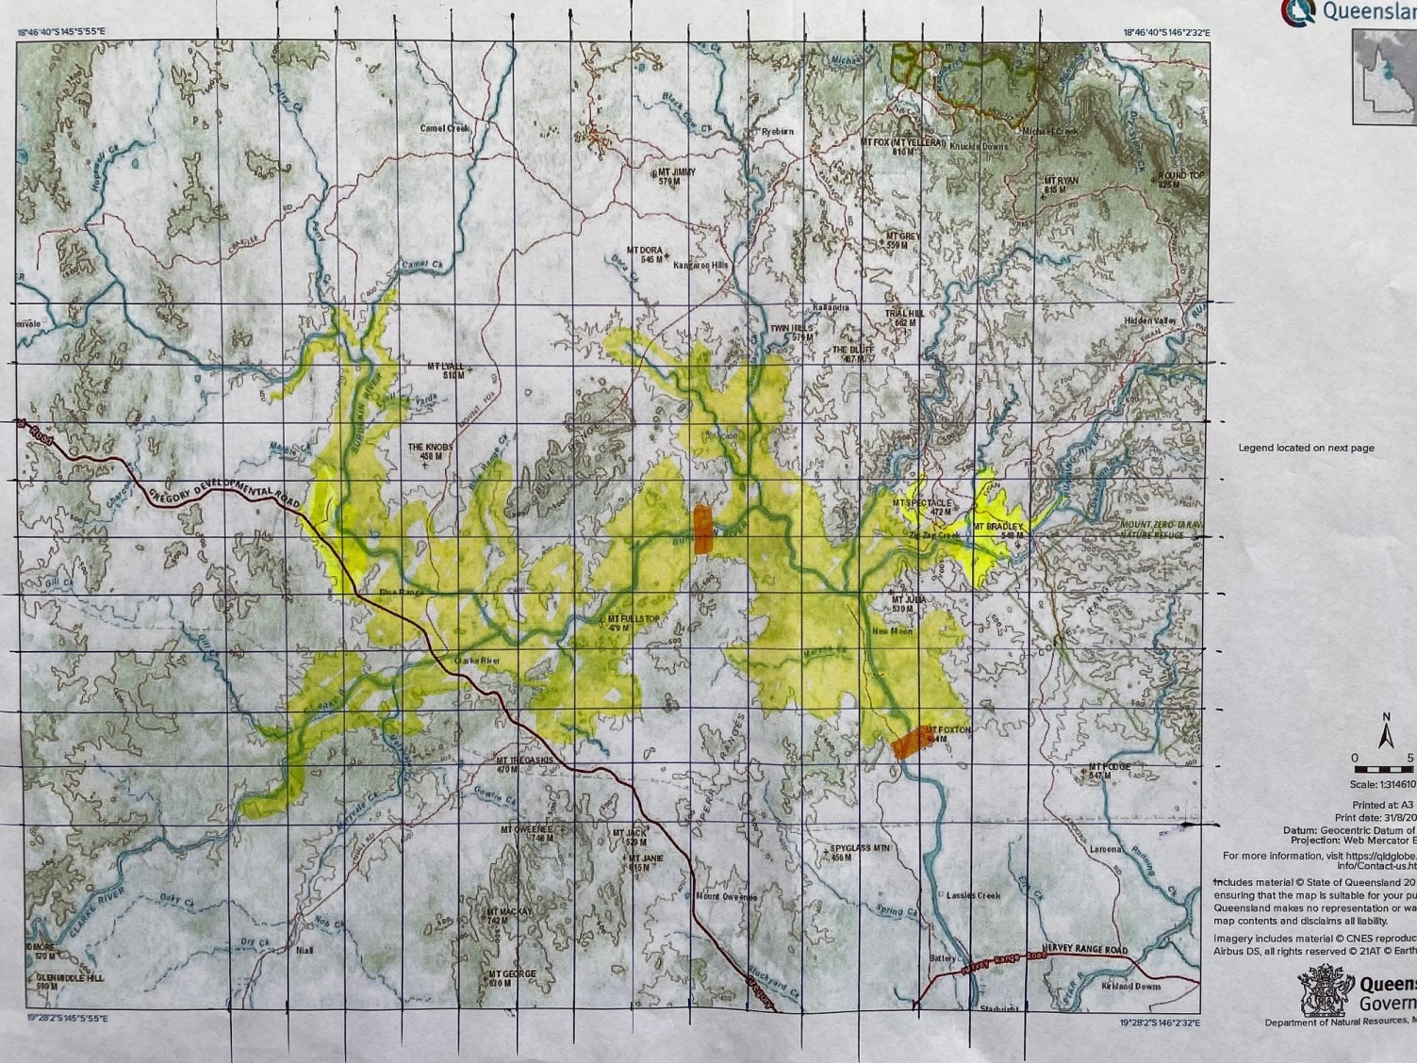

Map 2
Map of Upper Burdekin River, with Mt Foxton Dam site, merging the Hells Gate Site

4.7 Building Storage Dam at Mt Foxton
Referring to the SMEC Hells Gate Dam Feasibility Study dated 14/06/2018, the Mt Foxton dam site is compared with the Hells Gate site in Table 1.
Mt Foxton was rated as a possible dam site and has suitable construction materials nearby, based on an initial assessment of the geology.

The capacity of the dam is related to the consistency of flow deemed sufficient for the MBD.

4.8 Dam Capacity – determination for suitability
A dam capacity of 9,000 GL, with RL 380 is envisaged as being a practical size, with 2,000GL of this storage is redundant, as water would be discharged from RL380-RL350.
There will be times when water is not transferred, being excessive water levels in the MDB (no point in adding water to floods) and reduced from the optimum of 3,500 GL/a when inflow is not sufficient.

Graph 2 was obtained from Graph 1, adding the Burdekin water from 1966-2019.

Graph 2 Murray R Inflows + Burdekin Addition (when required)
Attachment 3 tabulates and Graph 2 shows:
- MDB water inflows, compared with
- the inflows of the Burdekin, from 1966 – 2019.

Please note that water has been tabulated NOT to be transferred from Mt Foxton Dam when the inflows in the MDB exceed:
- the average of 10,230 GL/a for the MDB + the average transfer of 3,500 GL/a from the Burdekin
- equating to 13,730 GL.
This effect is to allow the dam at Mt Foxton to take in additional inflow, when the MDB inflows are sufficient.

This table was generated with the aim of determining a suitable dam capacity.
Would it be 7,000 GL or 10,000 GL or 15,000 GL?

As a result of this exercise for a 7,000 GL capacity, 10 years out of the 54 years were not able to send the 3,500 GL as hoped (averaged 1,270 GL instead of the 3,500).
The exercise was also carried out on a 15,000 GL storage dam and there were 4 years.
In other words, the difference between a 7,000 GL and 15,000GL dam was negligible.

4.9 Conclusion on dam capacity
Choice is 9,000GL dam at Mt Foxton, with 2,000GL being unusable (below RL350m) for allowing gravity channel from RL350m.

The dam volume would need to be investigated thoroughly in the next phase.

5.0 Water Channel Design - Mt Foxton to MDB
My preliminary design for 3,500 GL/a to be transferred from the dam at Mt Foxton to take offs in Qld and the MDB is included in attachment 2A and 2B.
This 3,500 GL/a is a significant volume, and is sufficient proportion of the current total inflow to the Murray River of 10,000 GL/a – refer to Graph 1.
This 3,500 GL will not be discharged each year, for reasons mentioned in clause 4.8 above.

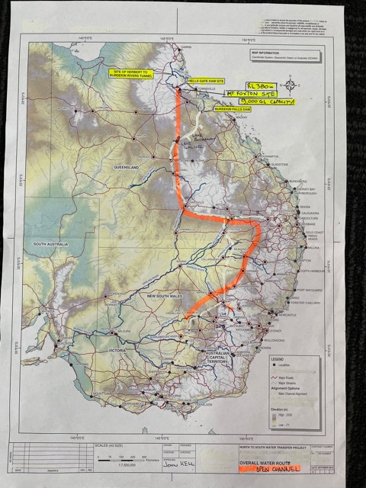
- Map of Overall Water Route, with Gravity Channel

5.1 First Leg
The first leg is from Mt Foxton to the saddle at Lake Galilee which is a natural salt lake in the Barcaldine Region. The channel would go straight past this feature. It would not be used as a storage facility.
In a straight line the distance is 350km but 450km is assumed to allow for some twists and turns to follow the contour. The initial RL (Relative Level above sea level) at dam discharge is 350m. This height is to allow for the upper 30m below the RL 380 to be used for MDB requirements. The level at Lake Galilee is RL310, resulting in a 40m fall over 450km.

The water level of the Mt Foxton dam is preliminarily set at RL 380m.

5.2 Southern Extent of Gravity Channel
The open channel will then extend generally south, following and gradually falling with the contours on the western side of the Great Dividing Range, to the Qld/NSW border via Moree, and beyond into NSW, with discharges at the crossing of the various rivers of the MD catchment, including the Barwon Upper Darling River.
The open channel in these preliminary calculations will eventually finish up a Lake Cargelligo on the Lachlan River.

5.3 Wear of Channel
The velocity of the water is around 1.74 m/sec or 6.2 km/hr… so it takes just ~3 days for that 450km from Foxton Dam to Lake Galilee and a further 18 days to Lake Cargelligo. Reasonable low velocity reduces wear on the channel material, expected to be reinforced concrete.

5.4 Evaporation Losses
Evaporation losses during transfer related to the 18m channel top width and 2,400 km length, at a rate of 2.6 m/a is 3.4%. Refer to Table 3.

5.5 Possible take-offs
5.5.1 Toowoomba Take off
Toowoomba - to address a chronic water shortage problem in that city.

5.5.2 Tamworth Take off
Tamworth - to address the problems for that inland city.

5.5.3 Sydney Take off
The addition of solar pumps enables water to be sent up to the Burrendong Dam and eventually to the Coxs River (RL 400) to feed to the Warragamba Dam and the Sydney system. Burrendong Dam (1,678 GL) could be the backup Sydney so desperately requires by:
- building the 90 GL/a desalination plant in 2010 with,
- an additional desalination plant on the drawing board and
- plans to extend the Warragamba Dam capacity.

5.5.4 Longreach Take off
A gravity channel is included to service Longreach and that city’s environs and feeding into the Barcoo R and Great Artesian Basin.

5.6 Environmental Concerns
There are environmental concerns. The submission describes the engineering behind a scheme to save the MDB from extinction, which would be considered absolutely critical from an environmental viewpoint.

Our country has tropical rain water traversing the country when we have high rainfall in Far North Queensland (FNQ), so there is nothing new in this exercise.

The channel would need to have multiple and frequent crossings for the wildlife and landowners to have full access to their properties. Envisaged are cuttings at spurs and bridges over creeks in a way that life can cross over easily. Frequent water points to provide outside the security fences for wildlife.
The design of the channel would certainly consider local requirements. A central long column (not to reduce flow rates) could be inserted to reduce the roof span, when deemed necessary for crossings.
This channel could be designed as a centre piece in environmental engineering for generations of all species to benefit.
The channel will also require the highest level of high tech security.

6.0 Commonwealth of Australia Constitution Act – Section 100
There is plenty of water in coastal North Queensland; but we must use the precious resource wisely, by transferring to areas where it is desperately needed to address the National challenge, whilst not affecting the donating state of Queensland.

Table 4 outlines the excess water situation for the Burdekin and Herbert Rivers, after the MDB and Qld have removed required quantities.
It is clear with the excess flows detailed, the state of Queensland would not suffer with the MDB being rejuvenated with 2,400 (Burdekin R) + 1,107 (Herbert R ) = 3,507 GL/a.

River | Current Outflow | Deduct Take-off | Excess Outflow after take-off
 | Sea Level
Burdekin River  River Mouth | 8,574 GL/a  (Clare 120006B)  Burdekin River Mouth | MDB 2,400 GL/a  QLD 2,100 GL/a | 4,074 GL/a at river mouth
 | RL 130m
Burdekin River  At Burdekin Falls Dam Site | 6,657 GL/a  (Hydro Site 120015A)  Just downstream from Burdekin Falls Dam Site | MDB 2,400 GL/a  QLD 2,100 GL/a | 2,157 GL/a at Hydro Site 120015A
 | Sea Level
Herbert River | 3,924 GL/a  (Ingham 116001F)  Herbert River Mouth | MDB 1,107 GL/a | 2,817 GL/a at river mouth

Table 4 Excess Water for “reasonable use”

This Section 100 is a single sentence:
“The Commonwealth shall not, by any law or regulation of trade or commerce, abridge the right of a State or the residents therein to the reasonable use of the waters of rivers for conservation or irrigation.”

S100 Appraisal
With the Table 4 figures in mind, the following appraisal from legal Counsel was obtained.
“S100 would not be infringed by a Commonwealth law or regulation (include ‘direction’, etc) which facilitated works to enable the passage of water from Queensland to NSW in circumstances where Queensland retained its existing water supplies and a generous buffer supply to cope with its reasonable requirements for the present and future needs of Queensland and its residents.”
Christopher McEwen SC, Martin Place Chambers, Sydney

7.0 Federal and State Responses
I have been communicating with both the Federal Government though the Minister for Infrastructure and was referred to the state of Queensland’s Minister for Infrastructure. The conclusion reached was:
- Federal Government says water is a State issue and
- Queensland does not comment.
- The Federal Government suggested that we get Queensland to ask to send water to the MDB. This request could come, but it never has in the past and we have an 80 year record of this not happening.

Now is the time to act everyone, as a team… for the sake of our nation’s future generations.

8.0 Conclusion
Headline: If Hells Gate Dam is built, Australia will NEVER get another chance to save the MDB!!

8.1 There is ample flow, elevation and storage capacity to proceed with developing a proper design to provide security to the MDB and assistance to the GAB into the future, without S100 being compromised.

8.2 The current Hells Gate site work needs to be stopped urgently (I recognise this is a bold statement!) – as it prevents water ever flowing down to the MBD.

8.3 The Mt Foxton dam site needs to be thoroughly investigated.
The five key items have been covered:
Elevation
Inflow
Storage
Evaporation
Section 100

I do hope that the Productivity Commission, through the National Water Reform 2020 is able to take on board, the critical national importance of the objectives of this scheme.

I shall be available to provide clarifications or additional details as may be required.

9.0 Acknowledgements
I wish to thank a number of agencies for their assistance in preparing this submission:
Queensland DNRME (Dept of Natural Resources, Mines and Energy)
Sunwater for Burdekin Falls Dam data
Australian Bureau of Meteorology
National Water Reform Feb 2021
MDBA
SMEC “Hells Gate Dam Feasibility Study” 14/09/2018
Christopher McEwen SC

John F Kell
BE, M App Sc, MIE Aust, MICE
Managing Director
Hycast Metals Pty Ltd
john.kell@hycast.com.au

Attachments
- Referenced Data
- Preliminary Design of Gravity Flow Channel Summary
- 9,000 GL Dam Size and Effectiveness

Below is a table of average flows, storage capacities, excess water of the Burdekin and Herbert Rivers.
There is also a comparison with Sydney Desalination Plant and the Wentworth-Broken Hill pipeline.

 |  |  | Excess | Reference
River Flows |  | GL/a | GL/a
Burdekin River | Outflow at mouth | 8,574 |  | Clare 120006B
Burdekin River | Dalrymple Dam | 6,657 |  | Hydro Site 120015A
Burdekin River | Hells Gate Site | 1,817 |  | Mt Fullstop 120110A
Burdekin River | Mt Foxton Site extra to Hells Gate | ~600 |  | Running R, Douglas Ck & Oxley Ck included (JFK estimate)
Herbert River | Tunnel to Burdekin | 1,107 |  | Glen Eagle 116004C
Herbert River | Mouth | 3,924 |  | Ingham 116001F
Tully River | Tully Gorge | 77 |  | Tully Gorge NP 113015A (irrelevant)
 |  |  |  | (Broken Hill pipeline is 13.6 GL/a !)
Hells Gate Site | With Herbert R | 2,914 |  | To supply 2,100 Qld
Mt Foxton Site | With Herbert R | 3,507 |  | To supply 2,100 Qld + 3,500 MDB
Excess to Coral Sea |  | GL/a | GL/a
Burdekin River | Current Flow | 8,574 |  | Clare 120006B
Burdekin River | Deduct MDB |  | 6,174 | 8,574 – 2,400 = 6,174 GL/a
 | Deduct QLD |  | 4,074 | 6,174 – 2,100 =4,074 GL/a
Herbert River | Current | 3,924 |  | Ingham 116001F
Herbert River | Deduct MDB |  | 2,817 | 3,924 -1,107 = 2,817 GL/a
Dams |  | GL
Hells Gate Site |  | 2,100 |  | SMEC report 09/2018 (tbc)
Mt Foxton Site |  | 9,000 |  | JFK estimate, water level 380m
Burdekin Falls Dam |  | 1,850
 | With extension 2m | 2,010
Warragamba Dam |  | 2,030
Sydney Harbour |  | 500
Eucumbene Dam | Snowy | 4,798
Burrendong Dam | Wellington | 1,678
Others |  | GL/a
Sydney Desal Plant | Max capacity | 90
Wentworth - | Broken Hill Pipeline | 13.6
Great Artesian Basin |  | 65mil | GL | estimate
Murray River Inflows* |  | 10,000 | GL/a | Estimates from 1896-2016
*3,500 GL/a would significantly increase, the Murray River inflows, by 35% in fact…

Please note that these average GL/a figures change annually and need to be taken as estimates only.

1. Referenced Data

Design Criteria
- Manning Formula for Uniform Trapezoidal Flow
- Manning Roughness coefficient 0.011 concrete construction, or steel formwork

2A. Preliminary Channel Design (1 of 2)

2B. Preliminary Channel Design (2 of 2)

3.Effectiveness of Dam Design for period 1966-2019

