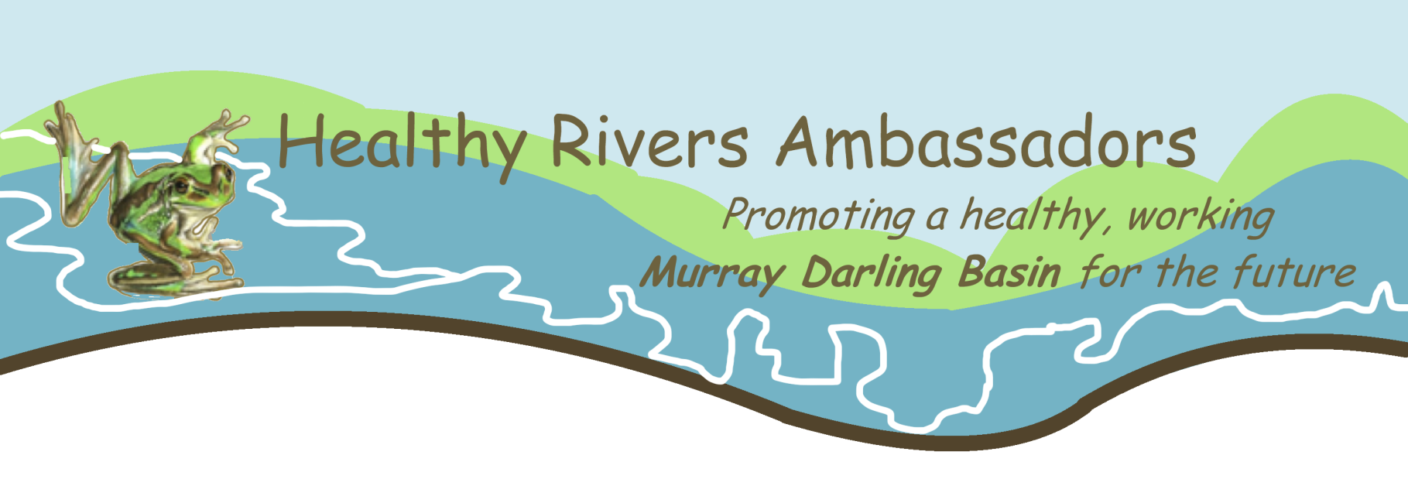
24 March 2021
National Water Reform inquiry
Productivity Commission
Locked Bag 2 Collins Street East
Melbourne Vic 8003

Submission to the Productivity Commission’s Draft Report ‘National Water Reform 2020’.
Thank you for the opportunity to provide input to this inquiry following the release of the draft report. Please find my submission below. I would be happy to provide additional information if required.

Background to comments in submission
I am providing comments as a Healthy Rivers Ambassador, and as a member of Lifeblood Alliance, a group of individuals from throughout the Murray-Darling Basin who aim to generate support for sustainable management to maintain a healthy Murray Darling Basin for the future.
As a professional hydrologist (retired), having been involved throughout the latter part of my career with the Murray-Darling Basin I appreciate the complexities of managing the nation’s water resources. I continue to relate to the profession of hydrology as a past chairman and continuing active member of the Hydrological Society (SA). My primary interest relates to the health of the MD-B and I remain extremely concerned about the poor outcomes associated with the implementation of the MD-B Basin Plan (2012 to 2024).
The adoption of the National Water Initiative in 2004 and the National Water Commission was welcome by the profession and appeared to represent a mindset change away from exploitation towards sustainable water resource management. Unfortunately, the increasing politization of the water portfolio as expressed by the abolishment of the NWC in 2014 was a great disappointment. Nevertheless, the review process taken up by the Productivity Commission appears to continue an honest approach to identify the shortcomings.
My submission follows in the attachments and wholeheartedly supports the more detailed submission developed jointly by members of the Lifeblood Alliance which has been submitted separately and is also attached.
Bob Newman
Healthy Rivers Ambassador (SA)
Attachment A
Submission to the Productivity Commission’s Draft Report ‘National Water Reform 2020’.
By Bob Newman Healthy River Ambassador
Supporter of the Lifeblood Alliance
Retired Engineer – Hydrology

The key point of my submission is that water resource management needs to take a more precautionary account of Australia’s variable of rainfall and consequential river flows and this should take specific account of the current climate change predictions. The question of sharing the risks across communities and the environment is critical. The move towards a market-based management regime has resulted in ‘Big Agriculture’ taking advantage of water markets to the disadvantage of local communities and, more particularly, the environment. In a relatively short time water rights, which previously had little value, have been turned into gambling chips. The result is massive winners and disaffected losers.
The Australian Government legislation of the Water Act 2007 was landmark change. It specifically acknowledged that water rights had been over allocated to productive uses and that ecologically sustainable limit to water take must be developed based upon the best scientific evidence. Unfortunately, following five years of scientific analysis resulting in the definition of ESLs, politics took over and settled on a plan with low chance of success which has been progressively undermined by political processes so that the Basin Plan now has effectively zero chance of achieving an ecological equilibrium. The ecology of the Basin’s rivers and floodplains will collapse.
The irrigation industry was already facing market instabilities and inefficient infrastructure. The regional tourism sector was fast overtaking irrigated agriculture as the major regional socio-economic drivers. I suggest that regional restructuring aspirations have been incorporated into a water management plan. That mix is doomed to failure. Accordingly, I emphasise support for the Commission’s advice (12.1) on decoupling water reform from regional structural adjustment.
The recent SA Royal Commission on the Murray-Darling Basin Plan clearly identified that the a sustainable environment should have been the core agenda of the Basin Plan to meet the requirements of the 2007 Water Act. Given the complexity of the issues facing rural and regional Australia beyond just irrigation water rights, I would suggest that a Royal Commission (or the like) into the principles for future support for the regions with an emphasis on adaptation to the impacts of climate change is warranted. A water management plan isn’t sufficient to address such complexities.
Beyond this one issue, I fully support the submission of the Lifeblood Alliance that deals in detail with the many water / ecology matters (attached).

Bob Newman
Healthy River Ambassador
Supporter of the Lifeblood Alliance
Retired Engineer – Hydrology

Attachment B: Lifeblood Alliance submission (separate file)

