26 April 2023
Dr Liz Killen

Re: Early Childhood Education and Care – Productivity Commission – Call for submissions

This submission draws attention to a piece of work done as part of a doctoral thesis, estimating increases in formal care costs over the past two decades.

Key findings
When indexed to inflation (CPI) and taking increased hours of formal care into account, there were real cost increases in formal care across all states between 2000-2019, with formal care costs increasing by more than three times in real terms in South Australia, Tasmania, Victoria, Western Australia and Queensland.

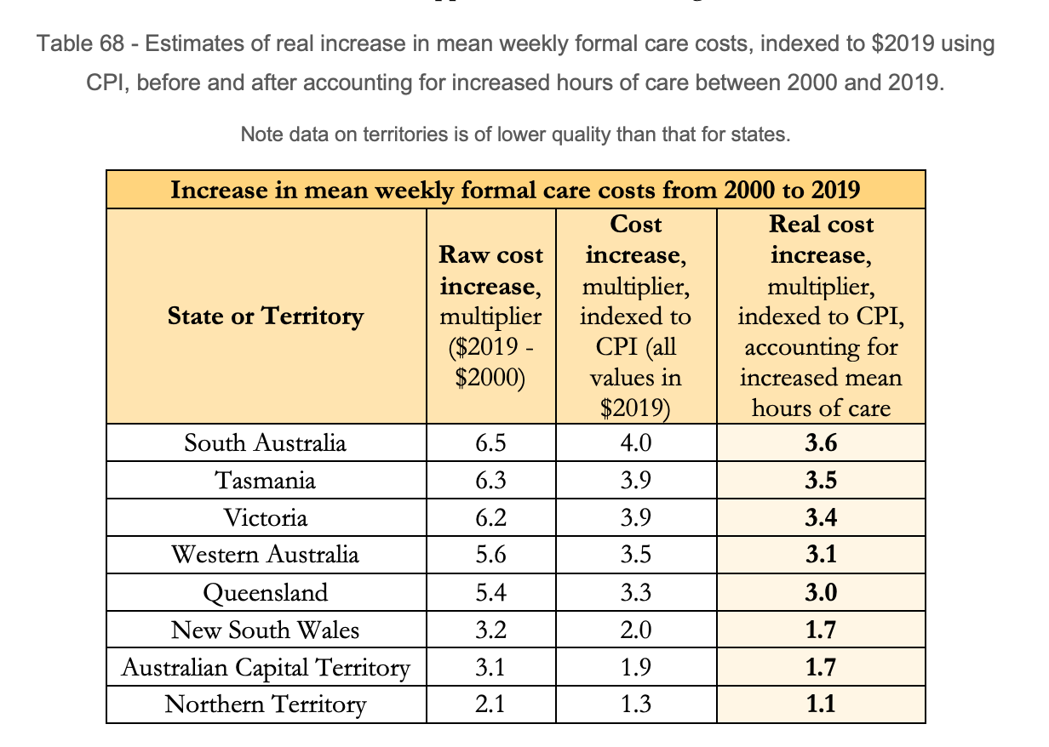

Wages have grown significantly in real terms between 2000-2019, with estimates from this study using household income putting the value around a 1.47 times higher real wages, while the ABS Wage Price Index estimates using hourly rates of pay estimate a 1.83 rise in hourly pay over the same period (ABS 6345.0, 2021). However, even at these rates, the real cost increases of formal care have outstripped the increases in wages in most states of Australia.

Other relevant sections
“There is also the question of those who are excluded from use of childcare due to the high costs, who are not reflected in these figures. The Australian Government collects statistics on those who are not in the labour force due to caring for children. Across the states and territories of Australia, the numbers of parents who do not work because child care is too expensive (31%) is roughly equal to the proportion who are not in work because they prefer to look after their children (27%) (Productivity Commission, 2021). This compares poorly to other nations. In Denmark and Sweden, where government provides heavily subsidised public ECEC from a very young age, only around 2% of low-income households say they would like to make more use of childcare but cannot afford to do so (OECD, 2020). As a proportion of income, childcare is more expensive in Australia than many other nations, including Italy, Germany, Austria, Korea, Sweden, Iceland, Spain, Norway, Greece, Denmark, and Belgium (OECD, 2020).”

Study Abstract
This study develops estimates which indicate that childcare costs have been increasing between 2000-2019 in every state and territory of Australia. In some states and territories, this cost increase has made formal care as much as three times more expensive in real terms, after accounting for inflation and allowing for increases in real wages and hours of use. The highest increases, at over three times increase in real cost, are seen for South Australia, Tasmania, Victoria, and Western Australia. As far as the author is aware, there are no comparable publicly available datasets that provide these estimates, and no other papers which identify the scale of the cost increase over this time period. These estimates were produced from aggregate and publicly available ABS data.

Suggestions for ways forward
These estimates were produced from aggregate and publicly available ABS data. There would be scope for ABS to develop accurate estimates from unit-level data, disaggregated by state and territory, to inform this review by the Productivity Commission.

Access
The Appendix: “An investigation into the rising costs of formal care in Australia, 2000-2019” can be accessed here: https://picaamicrosimulationmodel.files.wordpress.com/2022/01/r-rising-costs-of-formal-care-in-australia-27-january-2022.pdf

The full doctoral thesis is available here: https://doi.org/10.17863/CAM.86445

Notes on data
Please note that as an appendix to a doctoral thesis, this was not required to be considered as part of the assessment of this work. As such, this work cannot be considered peer reviewed. This has not been submitted to an academic journal.

The major issue with data availability was significant gaps in ACT and NT data. There was data only for 2002 for the NT and 2002 and 2005 only for the ACT. Due to this, additional sources from the ABS data were sought from Productivity Commission reports (Productivity Commission, 2014). It should be noted here that the data constructed for ACT and NT are highly unreliable as there is no recent data on which to base these assumptions. Further information available in the paper.

Conflicts of interest
I would like to note that I am currently an Australian Government employee, but completed this work prior to commencing my employment with the Department for Industry, Science and Resources. The information in this study is not connected to my current work, but was completed as part of my doctoral thesis at University of Cambridge within the Department of Education.

Noting that there has been work done previously by the Productivity Commission – see Productivity Commission (2021), Table 3A.22.

