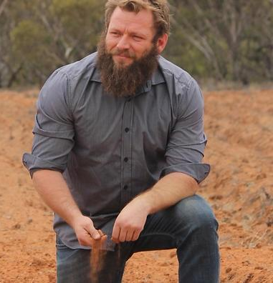
Dominic Smith
Aboriginal Liaison Officer, SA Health
Monash, Murraylands

A holistic healing approach towards people, country and land.
That’s the principal that Dominic Smith uses in all aspects of his life.
The Yuni Indigenous man is a native food grower and an Aboriginal Liaison Officer for SA Health, as well as being a dad of three, his “most important job”.
Dominic is also in the midst of a nursing degree, which will be a perfect addition to his healing repertoire.
Pundi Produce - his native food business - produces organically grown Australian fruit, vegetables and herbs through aquaponics.
Dominic has worked hard on the microbiology on his property at Monash in South Australia’s Riverland, establishing specific ecosystems to produce native foods.
Foods grown on-farm include Rivermint, Saltbush, Lemon Myrtle, Wattle Seed, Warrigal (native spinach) and Bush Tomatoes, with Quandongs soon to be harvested as well.
His interest in agriculture started at Adelaide’s Urrbrae Agricultural High School and continued on through a certificate in land conservation.
Pundi Produce came about when Dominic “met some elders and they said I should get into native foods - so I did” and it has grown from there.
He now combines his passion for agriculture and his Indigenous heritage to produce food that celebrates that culture and makes a difference for others in his community.
Dominic describes his introduction to the Drought Resilience Leaders Development Program (DRLDP) much the same as the way he started out in other areas of his life - he saw a good opportunity, so he took it.
“It got advertised so I just signed up. I had no idea what I was in for,” he said.
“But it has definitely taught me different leadership styles - it subjected me to uncomfortable situations causing growth.”
He added that the reason he liked undertaking leadership courses such as the DRLDP was because it helped “improve how I serve people”.
Which is what he does so well already across all his “day” jobs.
Dominic says the whole community has “gone through it” when it comes to drought, and they’ve also been hit by other adverse weather events.
“We live in the Riverland, and the only thing that keeps us alive is the Murray system. We’ve had minimal water go through in recent years and that puts a big strain on the system,” he said.
“A lot of people don’t understand that the weather systems are changing, massive storms go through, crop damage has been part of it. It’s about adapting, but farmers are good at that.”
At Pundi Produce, Dominic has planted drought resilient species that can survive the harsh conditions of the desert, as well as being frost and pest resilient and requiring minimal water once established.
“If there is no rain or too much rain then we have issues. The first year I planted I got hit by hail twice, big rains came and knocked all the leaves off,” he said.
“But luckily most of the plants I have become stronger because of it.”
And so has Dominic and the community around him, especially after coming together for the DRLDP.
“At the start it was quite confronting, all coming together to chat about a scenario. Everyone has got their opinion,” Dominic said.
“There were people talking and people leading and it was a different approach to what I was used to. At the farm, I just make decisions by myself, and this way we were taking into consideration all walks of life.”
“It was quite draining but in a good way, to see what is actually going on in the communities, that there are people making ground - and there are a lot more like-minded people than I thought.”

