dney, melbourne, brisbane, adelaide, perth, canberra, hobart hobart
sydney, melbourne, brisbane, adelaide, perth, canberra, hobart obart
www.bscaa.com
www.bscaa.asn.au
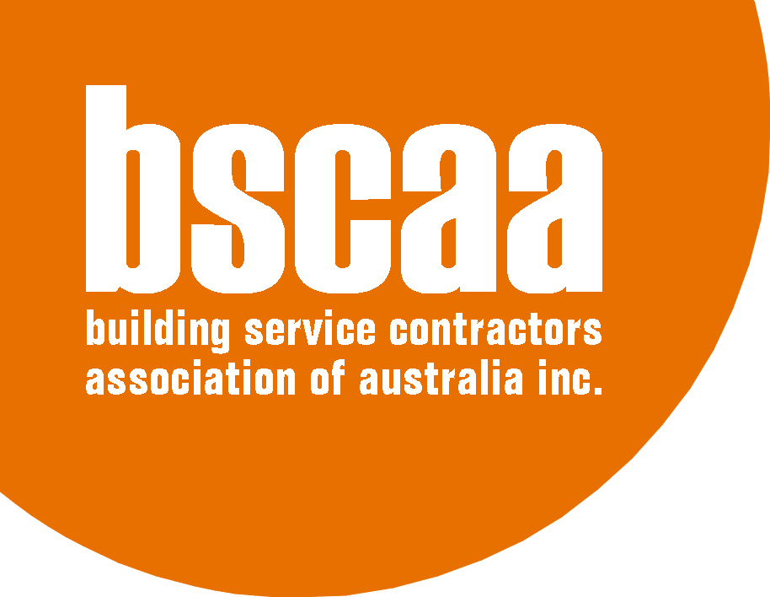
PO Box 554 Crows Nest NSW 1585
Cleaning: Security:
Tel: 02 9437 4411 02 9439 0142
Fax 02 9906 8146 02 9906 8146
Email: national@bscaa.com
ABN 30 881 326 071

BSCAA SUBMISSION FOR
PRODUCTIVITY COMMISSION REVIEW OF FAIR WORK ACT

Overview

The contract cleaning industry is an industry that has existed in Australia on a significant commercial scale since the early 1960s. It grew quickly as a dynamic and fiercely competitive industry that realised enormous gains in the efficiency of diurnal cleaning. It is interesting to note that between 1980 and 2010 the efficiency gain in cleaning of commercial office space increased by over 400%. If one was to conduct an analysis of “productivity gain” in its purest sense of those words one would immediately look to the contract cleaning industry as an example.

These opening comments are made to place the submission of BSCAA in some context. BSCAA is the only industry advocate that solely represents the contract cleaning industry. BSCAA has continuously represented the industry for over 50 years (albeit under different titles) and as the industry representative the Association is uniquely placed to make a submission on how the Fair Work Act has had an impact on the industry and how it may be improved.

General Comment

The contract cleaning industry is one of the few industries in Australia where the Award is the primary document for the setting of rates of pay and conditions of employment. The majority of other major labour-using industries regulate rates of pay and conditions of employment through a mixture of the Award, Enterprise Agreements registered through the Fair Work Commission and local agreements either with a workforce or with individuals. The contract cleaning industry relies almost entirely on the Award.

It is for this reason that the industry has placed so much emphasis on the content of the prevailing Award. The advent of the Fair Work Act 2009 did provide one positive and immediate
benefit for the industry through the introduction of one (1) Federal Award to the exclusion of the various State Awards which had hitherto governed the industry. Although it took time through the use of the Transitional Rates under the new Modern Award the industry was able to reach a place where it had relative uniformity of rates of pay and conditions of employment across the country. That of itself has aided rather than hindered efficiency in the industry.

Where the industry feels that the Act has retarded rather than aided improvements in efficiency is that the Modern Award is now a cumbersome, overlong and highly intricate document that governs employment in an industry where sophisticated literacy is not a core attribute. In simple terms, cleaners and managers are subject to a document that too often looks as if it were constructed by and for lawyers. BSCAA and its members are of the view that there is little which could be done of a practical nature to solve that dilemma but it perhaps emblematic of the particular issues which are posed below in this submission.

Protection for Employees

The contract cleaning industry is neither blind nor deaf to criticism that the industry permits or conceals exploitation of those who work in it. That criticism is firmly rejected. Indeed BSCAA has always said that the industry functions best when its main asset, being the people who do the cleaning, are valued and respected. What goes with that is the necessity to have a framework in which employees are not the subject of unfair or unreasonable exploitation. Putting aside political considerations, Australia and its employees need a system where purest laissez faire principles are tempered by laws that provide defined protections to employees. The extent of the protections can be a matter of debate but BSCAA and its members are not advocating for the removal of the tribunal the Fair Work Commission (FWC), Workplace Health and Safety Laws or the protection of rights in respect of discrimination etc.

Members of BSCAA have achieved consensus on three areas in which they believe the Fair Work Act could be changed to permit either by agreement or by direction of FWC the following innovations:

- Minimum Starts
The industry award currently provides that employees are entitled to a minimum number of hours every time they start work based on the square meterage they are required to clean. While this is not uncommon in industry the question must be asked: why do this? Surely in a genuinely flexible economy, if an employer is unable to offer sufficient hours of work to attract employees that will become that employer’s problem. Why force minimum hours on to an industry that is supposed to be flexible?

The BSCAA submits that cleaners in the industry should be able to be hired on an hourly basis where appropriate rather than be limited to three or four hour minimum starts. The Act can be changed to allow an application to FWC by a representative employer association registered under the Fair Work Act in which FWC is asked (and is empowered) to vary the Award by the deletion of minimum starts.

Saturday and Sunday penalties

Employers in the contract cleaning industry are not opposed to penalty rates in the way some industries appear to be. However the industry does question why penalties should differ from a Saturday (time and a half under the industry award) to a Sunday (double time). The industry believes that a flat penalty structure of time and half for all weekend or Public Holiday work should apply. That still preserves the notion of compensating employees for working unsociable hours but makes the system simpler and fairer.

The BSCAA submits that cleaners in the industry should be able to be engaged on weekends or Public Holidays at a flat time and a quarter penalty. The Act can be changed to allow an application to FWC by a representative employer association registered under the Fair Work Act in which FWC is asked (and is empowered) to vary the Award by a reduction in penalty rates on weekends and Public Holidays to time and a quarter.

Unfair Dismissal claims

The system is currently burdened with Unfair Dismissal claims that on any reasonable analysis are unsustainable. Often an employer will pay an agreed settlement amount just to avoid the trouble and cost of ongoing litigation.

BSCAA members strongly believe that one filter to unsustainable claims could be that claimants are required to swear their applications (and factual allegations) on oath from the very start of the claim. That of itself might reduce frivolous claims to some extent without taking away the right to make an Unfair Dismissal claim.

The second point that BSCAA would submit is that all Unfair Dismissal claims should be open to a costs award against unsuccessful claimants. The current system only allows such an order in rare cases whereas if costs followed the event (as they do in most jurisdictions) that would sharply reduce the claims burden on the Fair Work Commission.

The third and perhaps more contentious point is that reverse burden of proof in General Protections cases has led to a significant increase in those sorts of claims. It has been the experience of many BSCAA members that too great a number of General Protections claims are meretricious. If the burden of proof was changed (by a simple amendment to the Fair Work Act) to provide that the burden of proof rests on the claimant rather than the respondent then BSCAA believes that the volume of claims would fall in general and the volume of claims lacking in genuine merit would particularly fall.

Barbara Connolly

National Officer

Building Service Contractors Association of Australia.

27 March 2015

