Intellectual Property Arrangements
Productivity Commission
GPO Box 1428
Canberra City ACT 2601
Intellectual.property@pc.gov.au

Dear Commission,

The Australian Technology Network of Universities (ATN) is pleased to make the following submission to the Productivity Commission’s Review on Intellectual Property Arrangements.
Universities have a strong role to play in the commercialisation of research as they are closely linked to the generation of knowledge via the training of human capital and producing public research and development (R&D), in addition to having an increasing focus on technology transfer activities.
As noted by Innovation Australia chair, Bill Ferris, while Australia produces high quality research, collectively we fail in “our ability to commercialise and get our fair share of the world’s marketplace for this intellectual property and inventiveness. Australia is struggling to even stay within the top 30 OECD nations in terms of any commercialisation metrics. In doing so we are now at risk of squandering opportunities created by our highly credentialed R&D platforms.”
The ATN supports the Commission’s proposed approach of clearer, flexible and transparent models of IP management so that outcomes of research have every opportunity to deliver economic, social and environmental benefits. The system needs to provide the right incentives to Publicly Funded Research Organisations (PFROs), industry collaborators and entrepreneurs in Australia to invest and create innovative products and services.
Collaboration has consistently been noted as a key to increasing the reach of impact from scientific research. It has been shown that firms which innovate and source their ideas from research organisations (‘science-based’ innovation) are 34 per cent more productive than those that do not; and that firms that accompany their innovations with collaboration are 31 per cent more productive.
It is essential that policy frameworks such as Intellectual Property (IP) enables and incentivises R&D collaboration between the creators and researchers of technology, along with their industry partners and the community impacted by the technology. The ATN urges the Productivity Commission to support IP arrangements which ensure that the maximum value in terms of impact and community benefit can be gained from the application of R&D activities. Further, the ATN supports developing an innovation framework for assessing IP arrangements that targets additional innovation and creative output. Noting that Australian enterprises tend to limit their innovation to ‘new to business’ rather than ‘new to market’ or ‘new to world’ innovations, it is important that IP arrangements target the efficiency of such processes. Significant work in this area has been done by IP Australia in developing Source IP, an open source portal allowing users to search for Australian inventions, discover licensable IP and make contact with inventors.

Efficiency and Performance of Australia’s IP System

Regarding the efficiency of Australia’s IP system, while Australia’s resourcing for commercialisation (in terms of FTE per institution) is roughly on par with that of countries such as the US, Canada and the UK, our comparative output is poor, with fewer invention disclosures and US Patents issued per $US100m in Research Expenditure. According to a recent report by UNESCO, Australia has recorded the greatest decline within the G20 in share of triadic patents between 2002 and 2012.
Scale is an issue Australia needs to address in order to emulate other countries’ productivity with IP. Australia's 20 largest corporations have just 3,400 patents between them, compared to US companies such as Google and IBM who own around 50,000 alone. The IP Australia Report shows that although 19,304 patents were granted in 2014, an overwhelming 94 per cent were granted to non-residents in Australia, with the remainder filed by Australian resident companies and Australia’s publicly funded research organisations (including universities). Incentives need to be put in place to compel Australia’s innovators and entrepreneurs to develop and license their IP in Australia.
Further highlighting Australia’s low innovation efficiency, in 2013, Australia’s investment in generating IP as a share of GDP was 2.6 per cent, compared to the US who invested 4.7 percent in generating IP – almost double the Australian investment. Patent and Trademarks Attorneys Kaggwa and Caporn note that,
“Australian entities paid nearly $4 billion to foreign companies or entities [in 2013] and received $748 million from foreign entities in charges for the use of IP. Australia is therefore operating in an environment where the value of IP imports exceeds IP exports and is therefore running what can be considered a consistent IP trade deficit. As such, there is further room to improve for Australian businesses when it comes to generating innovative outputs that can provide a source of revenue, not only for business but also for the national economy.”
Table 1 and figure 1 below shows that per $US100 million of research expenditure, Australia trails its international competitors in terms of invention disclosures, US patents issued, LOAs executed, and number of start-ups formed.

Table 1. International Comparison of Intellectual Property Activity
 |  | Australia |  |  | Canada |  |  | US |  |  | UK
 | 2012 | 2013 | 5-year Ave. | 2012 | 2013 | 5-year Ave. | 2012 | 2013 | 5-year Ave. | 2012 | 2013 | 5-year Ave.
Number of Invention Disclosures per $US100m research expenditure | 22.1 | 23.6 | 25.3 | 39.5 | 43.2 | 39.2 | 37.3 | 36.9 | 36.5 | 45.0 | - | 44.6
US Patents issued per $100m research expenditure | 1.8 | 2.0 | 1.8 | 4.0 | 5.3 | 3.7 | 8.1 | 8.8 | 7.7 | 10.0 | - | 9.0
Number of LOAs Executed per $US100m research expenditure | 7.4 | 10.1 | 8.6 | 12.1 | 9.5 | 11.8 | 10 | 10.1 | 9.8 | 95 | - | 69.5
Number of start-up companies formed per $US100m research expenditure, | 0.4 | 0.4 | 0.4 | 1.3 | 1.5 | 1.3 | 1.1 | 1.3 | 1.1 | 1.6 | - | 2.3
Data from the Department of Industry, Innovation and Science's National Survey for Research Commercialisation 2013; Comparison sources: AUTM US and Canadian Licensing Activity Surveys, AUTM Statistics Access for Tech Transfer (STATT) Database, UK Higher Education - Business Community Interaction Survey.

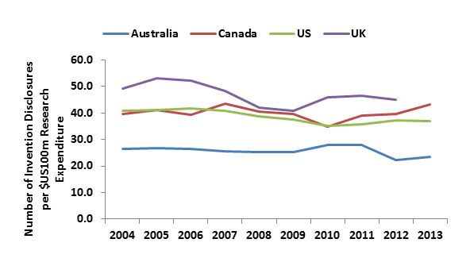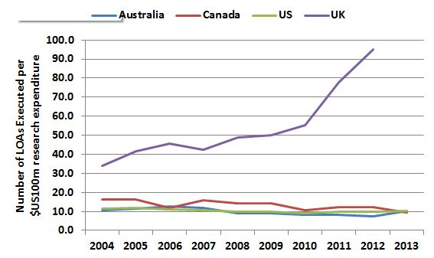
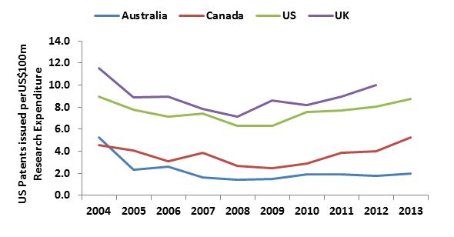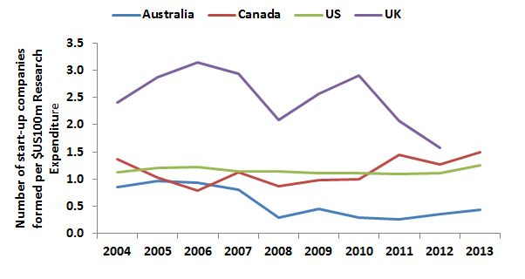

Publicly Funded Research Organisations and Intellectual Property

As stated in the Productivity Commission’s Issues Paper, the costs and benefits of generating IP vary between the public, private and not-for-profit sectors. Innovative, high income countries successfully integrate publicly funded research into both their value chains and commercialisation practices. Table 2 shows that Australia’s PFROs, over the most recent five year period for which data was collected, had on average 672 dedicated commercialisation staff a year, amounting to approximately $89 million in staff costs. In terms of resourcing, this is a significant investment into the commercialisation of research findings within PFROs. For this level of resourcing, in the last 5 years, PFROs have produced an average of 956 new patent and plant breeder rights per year, 22 new start-up companies per, and generated an annual average of $222 million of gross income from LOAs, and $153 million worth of equity holdings from start-up companies.

Table 2. Australian publicly funded research organisations
 | 2013 | 2012 | 5-year average
Dedicated Commercialisation staff (FTE) | 724 | 575 | 672
Total staff costs ($’000) | 101,746 | 78,061 | 89,118
Invention disclosures (No.) | 1,420 | 1,390 | 1530
Patent and plant breeder rights filed (No.) | 1,872 | 1,779 | 1813
Patent and plant breeder rights issued worldwide (No.) | 1,059 | 857 | 956
LOAs yielding income (No.) | 950 | 762 | 803
Adjusted gross income from LOAs ($000's) | 120,210 | 344,718 | 221,692
Start-up companies formed during the year (No.) | 26 | 22 | 22
Value of start-up company equity holdings ($000's) | 144,050 | 99,629 | 153,027

However, the IP outputs of PFROs have a similar lack of scale as that of Australia’s broader IP system. For example, in 2012, of the total $345 million generated from active LOAs by PFROs, $290 million was attributable to one case. Similar findings have been shown elsewhere. In a 2013 study of 130 US-based universities, it was found that the majority of successful commercial ventures are driven by a few institutions or single cases. The study also suggested that the universities did not generate enough licensing income to cover the wages of their technology transfer staff and the legal costs for the patents they file. To provide the right level of incentive to create IP, proportional to the effort to generate it, reward structures within universities could recognise a greater range of activity including traditional measures such as publications and research income, but also engagement activities such as partnering with industries, influencing policy and IP activity.
International Benchmarks
There is no shortage of international frameworks to look to in developing IP policies which support innovation.
China is currently implementing its’ 2014–2020 Action Plan on the Implementation of National Intellectual Property Strategy with significant reform. In the US, the Bayh-Dole Act has had a significant impact on the nations’ landscape of technology transfer. The major provisions of the Bayh-Doyle Act are:
- Non-profits, including universities, and small businesses may elect to retain title to innovations developed under federally-funded research programs;
- Universities are encouraged to collaborate with commercial concerns to promote the utilization of inventions arising from federal funding;
- Universities are expected to file patents on inventions they elect to own;
- Universities are expected to give licensing preference to small businesses;
- The government retains a non-exclusive license to practice the patent throughout the world; and
- The government retains march-in rights.
Legislative approaches to incentivise PFROs to commercialise their research have also been adopted in other economies. Israel was among the first countries to implement IP policies for its universities in the 1960s, with the following principles:
- Researchers must disclose to the university any research of commercial potential;
- Universities own the IP of “institute inventions” (service invention);
- Institute inventions are discoveries of employees and others, related to the university;
- Institute inventions are commercialized solely by the TTC (Technology Transfer Company);
- Commercialization revenues are shared by the inventors (40- 50%; 50-60%) and the university; and
- If the TTC chooses not to file for patent, the inventors can do it at their own expense.
Significantly, Israel’s Office of the Chief Scientist (OSC) at the ministry of Industry, Trade and Labor have restrictions on the internationalization of knowledge created under their R&D programs. Under Israel’s Encouragement of Research and Development Law, 1984 (the “R&D Law”) transfer of ‘know-how’ to entities outside of Israel is subject to OCS approval and requires the OCS-supported company to pay a "redemption fee" to the OCS depending on how much of the R&D positions remains in Israel.
The ATN acknowledges that simply enacting legislation is not sufficient to increase innovative outputs and intellectual property activity, and advises the Productivity Commission consider the inquiry into IP arrangements within the scope of related innovation policies and the national context.
If you have any queries or would like to discuss this submission further, please do not hesitate to call me .
Yours sincerely,

Renee Hindmarsh
ATN Executive Director
Appendix 1. Case Studies of Successful ATN Ventures

Curtin – iCetana
iCentana is a software company that has developed a video analytics application based on a patented innovative technology for “anomaly detection in large data-sets” developed by Prof. Svetha Venkatesh and her research team at Curtin University. The software application automatically learns “movement patterns” in a scene and then analyses live feeds from multiple video cameras to detect and send alerts of any “abnormal movement behaviour” in real-time. The initial focus of the anomaly detection technology is in the field of Video Content Analytics, particularly in the area of public security surveillance.
Other potential applications for the anomaly detection technology outside the public security video surveillance market include the use in complex data network intrusion/exception detection, network performance monitoring, financial data-mining and defence oriented developments.
iCetana received patent approval from the United States Patent and Trademark Office in 2014, and is a winner of the “Broadband Innovation Award” at the 2010 Tech 23 Event, the WA Innovator of the Year Award in 2011, and Milestone System’s “Best Solution Partner” in 2013.
QUT Bluebox – Tissue Therapies Limited
Over the past decade, researchers at the QUT Tissue Repair and Regeneration Program have developed a new, cost-effective, innovative wound treatment, VitroGro® ECM. VitroGro® ECM is a synthetic protein that replaces the degraded matrix of a hard to heal wound. VitroGro® ECM binds to a prepared wound bed and provides a scaffold for cell attachment, which is a requirement for subsequent cell functions critical for healing, such as cell proliferation and migration. The degraded ECM present in hard to heal wounds confounds healing and by replacing this dysfunctional ECM the cycle of wound chronicity (non-healing) can be broken and the normal healing processes initiated.
VitroGro® ECM is a safe, easy to use liquid that is applied to the surface of the wound reducing time and costs of treatment for hard to heal wounds, delivering both improved patient outcomes and an economic benefit for the healthcare community. Early in the development process, VitroGro® was identified as an exciting synthetic protein technology platform that had a variety of applications in medical and research markets. Following the discovery, intellectual property protection was sought by QUT in 2001 and Tissue Therapies Limited was formed in 2003 to commercialise products resulting from the VitroGro® platform. VitroGro® ECM is the first commercial product for VitroGro® technology.
To enable the commercialisation of the QUT Intellectual Property, Tissue Therapies Limited secured a world-wide exclusive licence from QUT to commercialise VitroGro® products. Tissue Therapies Limited identified a significant need in wound care for improving the outcome of hard to heal wounds, such as venous leg ulcers, arterial leg ulcers, mixed leg ulcers, diabetic foot ulcers and pressure ulcers and the VitroGro® ECM product was developed to address this need.
In order to raise further funds to produce VitroGro® ECM on a commercial scale, Tissue Therapies Limited listed publically on the Australian Stock Exchange (ASX) in 2004. They raised significant capital and also had further support from key strategic partners, the Queensland State Government, the Australian Research Council and the National Health and Medical Research Council. The QUT research team collaborated extensively with Tissue Therapies Limited to enable the development, pre-clinical trials, cGMP manufacture, regulatory approvals and a successful human clinical trial of VitroGro® ECM.
RMIT – Anti-Turbulance Technology
Australian researchers are seeking a patent on an system that mimics the way feathers help birds detect disturbances in the air. Inspired by nature’s own anti-turbulence devices, RMIT University engineers say they are developing technology to end turbulence on flights. The patent submission is the result of PhD research by Abdulghani Mohamed, supervised by experts from the School of Aerospace, Mechanical and Manufacturing Engineering.
Research supervisor for RMIT’s Unmanned Aircraft Systems Research Team, Professor Simon Watkins, says flight testing on a micro plane showed the system significantly reduced the effects of turbulence.
“By sensing gusts and disturbances in air flow through their feathers, birds are able to fly gracefully rather than bouncing around in turbulent air,” he said.
“The system we have developed replicates this natural technology, with the aim of enabling planes to fly smoothly through even severe turbulence - just like birds.”
The system is based on the concept of phase-advanced sensing, in which flow disturbance is sensed before it results in aircraft movement. This is achieved by early sensing of the pressures from gust effects on the leading parts of the wing or by measuring the gusts ahead of the wing.
Professor Watkins says the system has great potential for all sizes of aircraft and could not only reduce the effects of turbulence on passengers but also reduce loads on plane wings, leading to lower fatigue and hence longer life.
“While we need to explore new sensor arrangements to apply this technology to larger and faster aircraft, we have proven the idea on the most challenging problem of keeping small, lightweight planes steady - since these are the ones that get bounced around the most,” he said.
UTS – Piivot
UTS is at the heart of fostering Australia’s own ‘Silicon Valley’, as a key partner in Piivot, Sydney’s recently launched digital creative knowledge hub.
Incubated at UTS’s Ultimo campus – the nexus of a vibrant digital creative entrepreneurial ecosystem – Piivot is a collaboration between UTS, the NSW Government, Commonwealth Bank, Microsoft, engineering and design firm ARUP and Ultimo’s co-working startup Fishburners.
Startup hubs like Silicon Valley, the United Kingdom’s TechCity, Hub Singapore and Start Tel Aviv have shown that collaboration is critical to driving innovation. With UTS at its core, Ultimo is an ideal location for a Sydney-based hub, with the suburb and neighbouring Surry Hills and CBD areas boasting a high concentration of entrepreneurial and innovative organisations.
"Sydney is a global innovation leader, with NSW home to 40 per cent of Australia's creative and digital industries, and City of Sydney data showing a 252 per cent jump in workers in those industries in Pyrmont and Ultimo over the past six years," said UTS Deputy-Vice Chancellor (Resources) Patrick Woods.
"The industry profile and workforce is here, and at the same time the physical infrastructure is transforming the urban landscape with billions of dollars in new developments at Central Park, the UTS campus, Darling Harbour, the Goods Line and Barangaroo."
Mr Woods said although Ultimo and the surrounding precinct were thriving by Australian standards, industry had recognised a need to increase competitiveness on a global scale, and that the Piivot hub would add value in this area by working with the tech startup community to strengthen activity.
“We are not trying to replicate or stifle what is already taking place here or what has already happened organically,” he said. “We want to facilitate something that gets the best out of it.”
Piivot aims to cement Sydney’s place on the map as the nation’s digital creative capital, by connecting start-ups to more established innovative companies and other startups, as well as fostering opportunities for learning, networking, mentoring and internships.
It also seeks to stimulate and influence national debate and policymaking by gathering and sharing information, news and leading thinking on innovation and entrepreneurship.
The launch of Piivot continues UTS’s commitment to supporting Australia’s startup ecosystem, following on from the creation of ‘The Hatchery’, a startup pre-incubator designed to equip UTS undergraduates and research students with the skills to start their own innovative businesses.
This focus on innovation and creativity has also been seen in the university’s 2014 appointment of Apple co-founder Steve Wozniak as an Adjunct Professor, and former IBM Australia’s research director Professor Glenn Wightwick as Deputy Vice-Chancellor (Research).
UTS is based in Ultimo which has the highest density of tech startups in Australia. Ultimo boasts 51.9 startups per square kilometre according to StartUp Muster, the largest survey of the Australian startup community run by Murray Hurps.
The Australian tech startup sector has the potential to contribute $109 billion or 4% of GDP to the Australian economy and 540,000 jobs by 2033 with concerted effort by entrepreneurs, educators, the government and corporate Australia. (PWC / Google The Startup Economy 2013)
UniSA Ventures – Codha Wireless
Cohda Wireless was founded in 2004 by a group of highly regarded research scientists working at the University of South Australia's Institute for Telecommunications Research. Cohda Wireless’ key patented technology, called Dedicated Short Range Communications, is embedded in the receive side of an 802.11p radio and Cohda has also developed complete software solutions (from network layer to applications) to run on this hardware.
The technology has been tested in major trials around the world in Germany, France, United States, Korea and Australia, effectively allowing cars to ‘talk’ to each other and reduce or eliminate crashes through car-to-car data transmission that provides drivers with an audio or visual alert in the threat of an accident.
It is estimated by the US Department of Transport that these car-to-car technologies may address up to 82 per cent of crash scenarios. Car-to-infrastructure network communications will also capture real-time data from on-board technology to better manage transportation system congestion and maximise vehicles operating maintenance and fuel efficiency.
Cohda has more than 20 granted patents across a broad range of the V2X system. There are a further 50 patents pending in several countries. All of Cohda's applications have been granted, an impressive track record given that the USPTO reports that about 50% of all patent applications result in successful grants.
More recently, Cohda wireless has been part of the South Australian trials testing driverless cars on Australian roads.

Many universities have dedicated technology transfer offices responsible for the commercialisation of research. For example, ATN member universities have various successful ventures including, Curtin Accelerate, UTS Hatchery, QUT Bluebox, the RMIT New Enterprise Fund, and UniSA Ventures (formerly ITEK).
WIPO (2011) Harnessing Public Research for Innovation – The Role of Intellectual Property, in World Intellectual Property Report 2011, http://www.wipo.int/export/sites/www/econ_stat/en/economics/wipr/pdf/wipr_2011_chapter4.pdf
http://www.industry.gov.au/AboutUs/Media/Pages/Innovation-Report-shows-change-needed.aspx
For example, Department of Industry, Innovation and Science, Australian Innovation Systems Report, (2015), http://www.industry.gov.au/Office-of-the-Chief-Economist/Publications/Pages/Australian-Innovation-System-Report-2015.aspx; Australian Government (2014) Boosting the Commercial Returns from Research; Kemp (1999) Knowledge and innovation: a policy statement on research and research training; WIPO (2011) Harnessing Public Research for Innovation – The Role of Intellectual Property, http://www.wipo.int/export/sites/www/econ_stat/en/economics/wipr/pdf/wipr_2011_chapter4.pdf
Palangkaraya, A., Spurling, T., & Webster, E.( 2014). Securing Australia’s Future – The role of science, research and technology in lifting Australia’s productivity: Is science-based innovation more productive? A firm-level study. Australian Council of Learned Academies (ACOLA).
Department of Industry, , Australian Innovation Systems Report, (2014), http://www.industry.gov.au/Office-of-the-Chief-Economist/Publications/Documents/Australian-Innovation-System/Australian-Innovation-System-Report-2014.pdf
Australian Government, IP Australia, http://sourceip.ipaustralia.gov.au/
Department of Industry, Innovation and Science (2015) National Survey of Research Commercialisation January 2015, http://www.industry.gov.au/innovation/reportsandstudies/Pages/Summary-of-selected-commercialisation-metrics-for-Australia-US-Canada-and-UK-2004-2013.aspx
UNESCO Institute for Statistics (2015) UNESCO Science Report: Towards 2030, based on OECD online database (OECD.Stat), August 2015 http://unesdoc.unesco.org/images/0023/002354/235406e.pdf
Maxwell, I.A (2014) How Australia can invent a Thriving Technology Export Sector. http://issuu.com/ianmax/docs/how_australia_can_invent_a_thriving
Commonwealth of Australia (2015), IP Australia, Australian Intellectual Property Report 2015, ISBN 978-1-925245-07-3.
Kaggwa, G. & Caporn, P (2015) Missing the Mark: Do Australian Businesses Recognise the Value in Patent Protection? http://www.wrays.com.au/insights/blogs/missing-the-mark-do-australian-businesses-recognise-the-value-in-patent-protection/
Ibid, page 1
Valdivia, W.D. (2013) University Start-Ups: Critical for Improving Technology Transfer, http://www.brookings.edu/~/media/research/files/papers/2013/11/start-ups-tech-transfer-valdivia/valdivia_tech-transfer_v29_no-embargo.pdf
Cornell University, INSEAD, and WIPO (2015): The Global Innovation Index 2015: Effective Innovation Policies for Development, Fontainebleau, Ithaca, and Geneva.
Association of University Technology Managers (AUTM) Bayh-Dole Act: Landmark Law Helped Universities Lead the Way, http://www.autm.net/advocacy-topics/government-issues/bayh-dole-act/
WIPO (2011) Harnessing Public Research for Innovation – The Role of Intellectual Property, http://www.wipo.int/export/sites/www/econ_stat/en/economics/wipr/pdf/wipr_2011_chapter4.pdf
Hegit Messer-Yaron (2014), Technology Transfer Policy in Israel – From bottom-up to top-down, 6th Meeting of the European TTO Circle, https://ec.europa.eu/jrc/sites/default/files/events/20140120-tto-circle/jrc-20140120-tto-circle-messer.pdf
Meitar Liquornik Geva and Leshem Brandwein (2015) New R&D Regulations Affect Redemption Fees Payable to the Office of the Chief Scientist, http://meitar.com/181064

