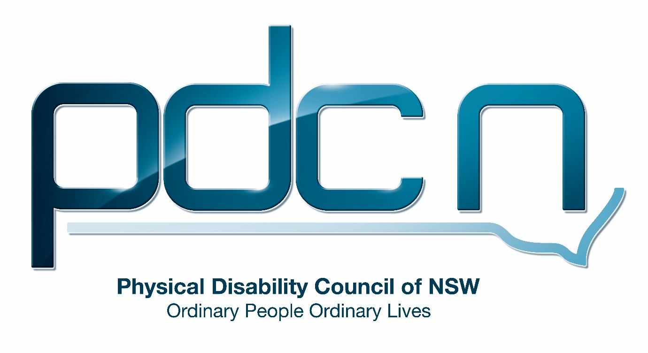

Submission for the Productivity Commission Issues Paper

National Disability Agreement Review

August 21st 2018

Ellen Small

Physical Disability Council of NSW
3/184 Glebe Point Road, Glebe NSW 2037

02 9552 1606
www.pdcnsw.org.au

Who is the Physical Disability Council of NSW?
The Physical Disability Council of NSW (PDCN) is the peak body representing people with physical disabilities across New South Wales. This includes people with a range of physical disability issues, from young children and their representatives to aged people, who are from a wide range of socio-economic circumstances and live in metropolitan, rural and regional areas of NSW.

Our core function to is influence and advocate for the achievement of systemic change to ensure the rights of all people with a physical disability are improved and upheld.

The objectives of PDCN are:
- To educate, inform and assist people with physical disabilities in NSW about the range of services, structure and programs available that enable their full participation, equality of opportunity and equality of citizenship.
- To develop the capacity of people with physical disability in NSW to identify their own goals, and the confidence to develop a pathway to achieving their goals (i.e: self-advocate).
- To educate and inform stakeholders (ie: about the needs of people with a physical disability) so they are able to achieve and maintain full participation, equality of opportunity and equality of citizenship.

Introduction:
The Physical Disability Council of NSW (PDCN) appreciates the opportunity to provide feedback to the productivity commission on the review of the National Disability Agreement (NDA). We will provide a general response, addressing the consultation questions where appropriate.

PDCN would like to emphasise the importance of the NDA as we believe it is essential to have a national framework with key areas of reform in order to continue to improve outcomes for all people with disability and achieve greater access and inclusion in Australian society. PDCN suggests the NDA be updated to reflect the changes in the disability policy landscape and intergovernmental funding arrangements that have occurred since 2012 when it was last reviewed.

PDCN suggests the current scope of the NDA be retained, with the Agreement continuing to cover all people with disability. PDCN believes the NDA and the National Disability Strategy 2010-2020 (NDS) both play an essential role in facilitating equitable access, including physical access, to the community and mainstream services for people with disability. As many individuals with disability in NSW will not be eligible for individualised funding through the NDIS the Agreement, alongside the NDS is essential to improve access to mainstream support services for all people with disability and ensure that barriers to education, employment and participation in the community are addressed and removed.

Objectives, outcomes and outputs of the NDA

PDCN feels the objectives, outcomes and outputs of the NDA continue to be relevant in the contemporary policy context and are appropriately aligned with the six outcomes of the NDS and the philosophy underpinning the NDIS. PDCN believes there is little benefit in having aspirational outcomes and recommends the outcomes and outputs in the NDA be connected to defined and measurable indicators with governments adopting a set time frame for their achievement.

Roles and Responsibilities
There has been a significant change in the roles and responsibilities of governments for disability services since the NDA’s last update in 2012. The implementation of the NDIS has shifted the primary responsibility for funding disability specific support services to the federal government, with states such as NSW retaining some responsibilities for regulation, service quality and assurance during the transition period. PDCN feels the NDIS has been a catalyst for a lack of clarity in the roles and responsibilities between state and federal government regarding funding of mainstream supports accessed by the whole community, including people with disability. This has led to people with disabilities experiencing gaps in services, particularly in relation to transport, health and education.
PDCN strongly recommends the NDA roles and responsibilities be updated to better reflect the changing policy landscape and ensure state governments continue to meet their responsibilities for NDIS participants and particularly people the disability who are not eligible for the NDIS. In NSW this includes the state government continuing to fund systemic and individual advocacy organisations, and disability peak representative bodies as the vitally important functions and services they provide, to both government and people with disability, will not be covered by the NDIS.
Systemic advocacy plays an indispensable role in the provision of disability services including policy development. PDCN believes continued funding for peak organisations to provide systemic advocacy, independent information and representation for people living with disability in New South Wales is essential to meet the objectives, outcomes and outputs of the NDA (as well as those of the NDS and NDIS).

Additionally, hundreds of years’ worth of expertise, community knowledge and advice to government and collaborative relationships will be lost should these organisations no longer be funded. As is the case in this submission, Government processes frequently rely on representative organisations for feedback, comment and direction (i.e. progress reports/submissions) or even access to their individual members with disability for expertise/lived experience and advice.

In addition, PDCN sits on over twenty government advisory groups providing advice and expertise. As a member of the Transport for NSW Accessible Transport Advisory Committee (ATAC), PDCN provides guidance on accessibility issues experienced by people with disability along with reviewing and advising on transport infrastructure projects.

PDCN has also worked in partnership with NSW Roads and Maritime Services, the Sydney Harbour Foreshore Committee, local councils and other government experts to bring about the construction of lifts for step free access, to the Sydney Harbour bridge (due to open in October 2018.) We have championed the introduction of height adjustable beds in all NSW registered GP services, again partnering with NSW Ministry of Health and the RACGP to do so.

When many of our members were struggling with Enable NSW, a government provider of equipment for people with disability, experiencing incredibly long delays on provision, and difficulty understanding documentation processes, we sought to work with this government body to collaborate on ways to reduce timeframes and better address issues and documentation – providing advice and cost effective solutions across a whole system (rather than government dealing with many individual complaints over and over again.)

In Addition, advocacy organisations are also well placed to contribute to the ongoing monitoring and evaluation of both the NDA and the NDS. This role is vital to ensure government is accountable for meeting performance indicators and benchmarks.

PDCN believes the responsibility for reforms to broader regulation such as building standards should remain part of the NDS. However, PDCN believes one of the key gaps in the implementation of the strategy, requiring alteration is the lack of enforceable requirements for federal, state and local governments to reach set targets and outcomes for the greater inclusion of people with disabilities.

Introduction of the NDIS
PDCN has significant concerns about how the NDIS has impacted on access to services for people with disability who are not eligible for individual funding under the scheme. The removal of state-based disability services has left significant gaps in supports for people with disabilities in NSW.

In the case of transport, the transition to individualised funding within NDIS plans and the removal of subsidisations for community transport, previously through Government funded programs (such as the Community Transport Program and Community Care Support Program through Transport for NSW) has increased community transport organisation trip prices considerably (to market price).

In conjunction with the introduction of new forms of transport charged at market rates, PDCN is concerned that funding for transport in NDIS plans at the current set levels will be insufficient to cover these increases and this will severely limit the ability of NDIS participants to access the community and essential services. In addition, individuals with disability who are not eligible for the NDIS but have previously utilised community transport will find price increases may make this service unaffordable.

PDCN believes service gaps created by the removal of state funded disability services are also evident in the health sector where there is considerable disagreement and inconsistency between NSW Ministry of Health and the National Disability Insurance Agency (NDIA) around who is responsible for funding specific services for individuals with disability.

For example, a PDCN member was receiving community nursing services for wound management and upon moving onto the NDIS was told this would no longer be provided by NSW Health. However, the wound was deemed a health issue by the NDIA and was therefore not funded in her individual plan either – leaving her without the essential supports needed for her care.

In addition, individuals previously receiving low level disability supports in the community funded through the Department of Ageing Disability and Home Care (ADHC) under the Community Care and Support Program (CCSP) are likely to be ineligible for the NDIS and will lose their current services. Rather than encouraging greater inclusion, policy decisions such as these will see individuals face greater challenges in daily living which will inevitably lead to increased hospitalisations, increased social isolation and in some cases put lives at risk.

Although it is expected that many people with disability will benefit from enhanced community inclusion supported by the Information, Linkages and Capacity (ILC) building element of the NDIS the initial roll out of these projects and services is recent. As many organisations have only newly received ILC grants, and are yet to implement their funded program fully, PDCN believes it is too early to provide comment on the effectiveness of ILC activities in supporting those not eligible for individualised funding.
In addition, at this stage due to the high volume of new NDIS participants Local Area Coordinators (LACs) are working with, we feel they do not have the resources to cater to people with disability outside of the NDIS. (As is suggested it is part of their role – linking anyone with a disability to known services whether or not they have an NDIS plan.) In PDCN’s experience the workload of LACs has also impacted negatively on NDIS participants. PDCN has observed many participants with individual funding not receiving the level of support they require to successfully implement their own NDIS plans, including choosing service providers and in making appropriate service agreements.
PDCN has also observed that people with disabilities who are not eligible for an NDIS plan are unaware of their ability to access programs and activities funded through the ILC. PDCN believes the NDA must play a central role in guaranteeing state governments address the support gaps left by the shift of state disability funding to the NDIS, as decided in the bilateral agreement. In addition, as the majority of participants receiving individual funding under the NDIS (approximately 62%) are people with intellectual disabilities, agreements such as the NDA that represent and promote the interest of all people with disability are critical for the cohort PDCN represents.

Performance Framework
PDCN is disappointed that the NDA and its current performance framework has not played a substantial role in supporting improved outcomes for people with disability. As discussed in the issues paper the most recent dashboard data (showing figures at the end of the 2015) shows that Australia wide the first two performance benchmarks: Outcome A and Outcome B, are not on track to be achieved by 2018. Furthermore, there has been a reduction in the percentage of people with disability reporting participation in social and community activities.
PDCN feels it is important to highlight how the NDA has positively influenced and reinforced government policy and improved outcomes for people with disability, their families and carers.
The NDA has a focus on supporting carers and families of people with disability. For example, the Agreement has performance indicators that report on proportion of carers of people with disability participating in the labour force, proportion reporting their health and wellbeing as positive and proportion of carers satisfied with the range, adequacy and quality of services available to assist them and the person for whom they are caring.
In 2015 the Australia government set up Carer Gateway, a national online and phone service that provides practical information and resources to carers. Government initiatives such as this assist in improving outcomes for carers but given there is a National Carers Strategy and the Integrated plan for Carer Support Services, it is difficult to attribute progress in these initiatives solely to the NDA.
In addition, despite the challenges currently occurring with the implementation the NDIS, it is an important policy reform whose goals and objectives are championed by the NDA’s policy directions of ensuring services are person centered and prioritising strategies for increased choice, control through self-directed funding models.
PDCN believes that despite public reporting against the NDA performance indicators, due to a lack of publicity and public awareness of the agreement, federal and state governments have not been held accountable in completing the policies and actions that should have been assumed under the NDA. In addition, we feel the several different formats used for public reporting on the agreement, prior to the current data dashboard arrangement, may have created difficulty for the public in understanding the significance of government underperformances in meeting the set benchmarks.
Reform and Policy Direction

PDCN believes the reform and policy directions in the NDA complement the policy directions and actions articulated in the NDS and the NDIS Act. Furthermore, the reform and policy directions captured in the agreement in 2009 remain pertinent for people with disability.
For example: Reform and Policy Direction 27 states ‘all governments recognise the importance of mainstream services in achieving the outcomes of this agreement’. PDCN believes guaranteeing state governments fulfill their responsibilities to meet the objectives of the NDA and NDS, post NDIS roll out, is crucial for people with disability to participate as valued members of society.
Additionally, achieving Reform and Policy Direction 28 (d): ‘maintain innovative and flexible support models for people with high and complex support needs’ is also relevant. In the NSW context, this is a concern for PDCN as we believe there is a significant gap in the support provided by the NDIS to individuals with high and complex support needs.
PDCN is concerned that the privatisation of disability services and the closure of the Department of Ageing Disability and Home Care (ADHC) in NSW will leave people with disability who are currently receiving support from government run services in a vulnerable position. ADHC previously provided wraparound services including case management for individuals with complex care and support needs. This included providing additional support in circumstances where the client is facing crisis. The process under ADHC for securing additional funding or support to quickly address a crisis situation was straightforward and we are concerned this is not being replicated in the private market.
Additionally, the funding arrangements under the NDIS have resulted in disability support providers being apprehensive about working with difficult or challenging clients, due to the additional costs involved, and many are choosing not to offer these types of services. Under the NDA it is the responsibility of both federal and state governments to ensure people with disability who have complex support needs are not left without disability specific services and access to the mainstream supports they require.
Finally, PDCN believes there would be some merit in merging the NDA and NDS into a single agreement as they both inform overarching policy changes that will assist all Australians with disability. The priorities such as advancing the national research and development agenda are relevant to achieving the goals outlined in both. However, both require set mandates to achieve their current specified outcomes.

Recommendation 1: The outcomes and outputs in the NDA be connected to defined and measurable indicators with governments adopting a set time frame for their achievement. We recommend mandates for government to ensure concrete progress is achieved against performance benchmarks and indicators.

Recommendation 2: The NDA states the responsibility of both federal and state governments to provide disability specific support services and guarantee access to mainstream services for people with disability.

Recommendation 3: The NDA roles and responsibilities be updated to better reflect the changing policy landscape and ensure state governments continue to meet their responsibilities for NDIS participants and people the disability who are not eligible for the NDIS.

Recommendation 4: The NSW state government continue to fund systemic and individual advocacy organisations, and disability peak representative organisations beyond the transition to the NDIS.

National Disability Insurance Agency, NSW Participants Public Dashboard, 31st March 2018, https://www.ndis.gov.au/medias/documents/dashboard-nsw-mar-18-pdf/dashboard-nsw-march-18-pdf.pdf

