CREATING MENTALLY HEALTHY WORKPLACES ACROSS AUSTRALIA

Taking action in the
superannuation and life insurance industry

SuperFriend’s submission to the
Productivity Commission’s Mental Health Inquiry

5th April 2019

Key contact:
Margo Lydon, CEO
SuperFriend - Industry Funds’ Mental Health Initiative

A: Level 2, 157 Spring Street, Melbourne Victoria 3000
W: www.superfriend.com.au

SuperFriend – Industry Funds’ Mental Health Initiative

SuperFriend is a national workplace mental health not-for-profit organisation, partnering with the superannuation and life insurance industry to achieve our vision for an Australia where all workplaces are mentally healthy. SuperFriend advocates for, equips and empowers industry superannuation funds and insurers to achieve mentally healthy workplaces for their staff and members. We do this through:

- Solutions - evidence-informed and useful programs, training, resources and events.
- Advocacy - collaborations, national working groups, international alliances and Government forums.
- Insights - regular national and local research analysing trends, impacts and outcomes.

We have a unique model, primarily working collaboratively with our Partner industry superannuation funds and insurers (see Attachment One for list of Partners), together with their participating employers and members. Through this model, uniquely and importantly, we have the potential to embed mental health and wellbeing best practices into 750,000 workplaces and impact more than half of Australia’s workforce.

Table of Contents

Executive Summary | 4
REDUCING THE COST:  Taking action in the superannuation and life insurance industry to reduce the cost of mental ill-health in the working population | 5
Recommendation to the Australian Government: Establish a cross-sector working group | 7
ADDRESSING THE BARRIERS:  Introducing a co-designed National Workplace Initiative to address common barriers to workplace implementation | 9
Recommendation to the Australian Government: Invest in the development of a National Workplace Initiative | 11
MAXIMISING EMPLOYER UPTAKE:  Through co-design and the use of external contextual experts, maximising employer uptake of workplace mental health and wellbeing initiatives | 12
Recommendation to the Australian Government: Develop incentives for industry-led implementation | 13
IMPROVING CONTRIBUTION, PRODUCTIVITY AND PARTICIPATION:  Promoting positive workplace mental health and wellbeing to improve worker contribution, productivity and participation | 14
Recommendation to the Australian Government: Incorporate positive, strength-based strategies in all investments | 16
Conclusion | 17
Attachment One: SuperFriend Partner Superannuation Funds and Life Insurers | 18

Executive Summary

SuperFriend welcomes the opportunity to make this submission. We applaud the Australian Government for recognising the important role that sectors, systems and contributors outside of healthcare can take to promote population mental health and wellbeing, and boost workforce participation and productivity. With the growing momentum for action to create mentally healthy workplaces on the part of employers and business owners in this area, comes significant opportunities for Australian Government leadership to promote what works, catalyse industry-led implementation and bring together stakeholders who have not traditionally collaborated.

This submission draws on our on-the-ground experience and unique research insights, as the only workplace mental health organisation focused on working with the superannuation and life insurance industries to improve the mental health of their staff and members.

Based on this experience and insight, we call on the Australian Government to take the following four practical actions towards creating mentally healthy workplaces across Australia:

- Establish a cross-sector working group to identify, and document, best practice for the early intervention and effective management of poor mental health, in the context of claims management, and reflecting the biopsychosocial model. The identified best practice could then be used as a ‘single source of truth’ to guide consistent biopsychosocial approaches to recovery when workers become unwell. Given the unique reach of the superannuation and life insurance industry across Australia’s working population, the industry needs to be recognised as a critical player in this endeavour.
- Invest in the development and robust evaluation of a National Workplace Initiative led by the Mentally Healthy Workplace Alliance (MHWA) and co-designed by representatives of the Australian community, to be implemented in businesses of all sizes across the economy.
- Develop incentives for industries to adopt national evidence-based approaches to workplace mental health and wellbeing (that is, the proposed National Workplace Initiative), adapt it to their contexts, environments and working conditions, and drive industry-led implementation.
- Ensure that positive, strength-based strategies in the workplace are reflected in Australian Government investments in this field, along with the demonstrated link between these and improved engagement, productivity, contribution and participation at work and across the economy.

Taken together, we believe these four practical actions will:
- Reduce the costs of mental ill-health to individuals, communities, workplaces and the economy as a whole.
- Address the barriers to the widespread implementation of evidence-informed workplace mental health initiatives.
- Maximise employer uptake of these initiatives.
- Improve contribution, productivity and participation of workers across all Australian workplaces.

SuperFriend welcomes the opportunity to partner with the Australian Government to achieve our shared vision of improving the mental health and wellbeing of the Australian working population.

REDUCING THE COST:
Taking action in the superannuation and life insurance industry to reduce the cost of mental ill-health in the working population

The prevalence and impacts of mental illness outlined in the Productivity Commission’s Issues Paper are also reflected in the superannuation and life insurance industry’s data and experience. In 2014, SuperFriend released research demonstrating the cost and proportion of insurance claims relating to mental illness and suicide. The research, SuperMIND, showed that over a five year period claims related to suicide collectively cost the superannuation funds’ insurers over $200 million p.a. with an average cost per claim of $120,410. Mental illness-related Total and Permanent Disablement (TPD) claims cost $147.9 million p.a., at an average cost per claim of $82,960. The research found claims attributed to mental illness and suicide represent approximately 10% of all insurance claims within superannuation. Since then, the approximate average of mental illness-related claims has risen to over 15%, with indications that this trajectory will continue. Further, there is a much larger, unquantified, portion of insurance claims for physical illness and injury where mental illness is a secondary cause. For example, a back injury (musculoskeletal claim) with chronic pain, or cancer, where the person on claim then develops depression. These claims add an additional layer of complexity and cost.
The Super Mental Illness National Data (SuperMIND) Research:
Data was collected from 13 industry superannuation funds and six major group insurers from 2007 to 2011, covering 4.1 million members. It included data analysis on claims related to mental illness, both TPD and Income Protection, and suicide by gender, age and location.

Mental illness-related claims tend to be inherently more difficult and complex than those related to physical illness or injury. This is partly because the symptoms and treatments for various mental illnesses can vary from individual to individual. Root cause may also not be entirely clear and it is often a combination of factors, with relapse also common.

The impact and complexity of mental illness related claims, and death claims where the cause of death is suicide, led the superannuation and life insurance industry to come together to establish SuperFriend in 2007. This collaborative industry initiative aims to reduce suicide and improve the mental health of their members. Superannuation funds are now actively engaged in talking to their employers about creating mentally healthy workplaces. This action not only benefits workers, workplaces and the industry (by reducing costs), it also has the potential to save governments money in welfare benefits and healthcare costs.
Mental illness-related claims are one of the few insurance claim types that a fund and their insurer can influence, lessen and ideally prevent, if detected early and managed effectively.

Insurance claims staff and superannuation fund member services staff frequently face challenges in dealing with workers with poor mental health and therefore need to be equipped to effectively and compassionately respond. For example, situations where fund staff are dealing with a member who demands to change the beneficiary for their superannuation in the middle of relationship breakdown; a member who is grieving after a death; or, a commercial farmer in the middle of a protracted drought facing financial hardship. To tackle this need, SuperFriend has developed evidence-based Mental Health and Wellbeing Training that aims to build the skills and confidence of the superannuation fund and insurer employees to support members in distress, experiencing mental ill-health or at risk of self-harm or suicide. It was co-designed by the superannuation and life insurance industry. The training has now been delivered to over 4,500 Financial Services industry employees since 2015. Evaluation of the training showed significant increases in participant confidence and knowledge. Further a Social Return on Investment analysis, conducted in August 2015 has shown that every dollar invested in SuperFriend’s Mental Health and Wellbeing Training has a return in social value of $3.10–$3.60.
“In just one day, the knowledge and skills gained by our staff after participating in SuperFriend’s Mental Health and Wellbeing Training helped save two lives.

It allowed staff members to provide support to a member who was in suicidal crisis, and another staff member intervene appropriately to support a colleague who was at high risk.”

- Fund Administrator Representative

Given the Australian Government’s commitment to the twin objectives of improving population mental health and increasing productivity, we draw to the Productivity Commission’s attention the SuperFriend Taking Action Framework, as a useful case study example with potentially broader application beyond this sector.
Action Areas:
- Developing the Management Practices for Psychological Claims
- Optimising Claims Management Teams
- Bringing Evidence to Treatment and Rehabilitation
- Effective Decision Making Supported By Analytics and Automation
- Tailored Support for the Person on Claim
- Transforming Product Design
- Engaging Employers in Stay at Work/Return to Work
- Recording Progress

TAKING ACTION: A Best Practice Framework for the Management of Psychological Claims

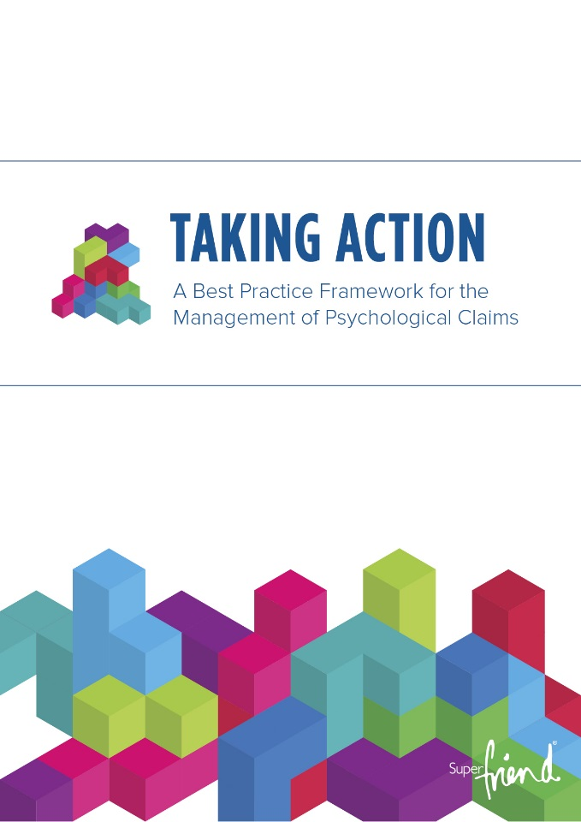
The Taking Action Framework draws on the latest evidence and industry best practice, both within Australia and internationally. It takes a person-centric approach and gives insurers, superannuation funds and other jurisdiction providers, clear guidance on how to better support people on claim who are either experiencing psychological illness, or who are at risk of developing psychological problems while on claim. The Framework provides the following important benefits:

- Aspirational benchmarks that encourage life insurers to strive for better practice in the management of psychological claims.
- Realistic options for optimising their processes and products to support and protect member mental health.
- Suggestions, strategies and tips that balance wellbeing with commercial outcomes.
- Practical recommendations for improving claims management in particular.
- Action Area Guides that provide “how to” implementation advice to address specific challenges faced by Group Insurers.

SuperFriend has recently worked with Safe Work Australia to successfully adapt these guidelines for the workers’ compensation sector.

Recommendation to the Australian Government:
Establish a cross-sector working group

Given the complexities outlined above, we call on the Australian Government to establish a cross-sector working group to identify, and document, best practice for the early intervention and effective management of poor mental health, in the context of claims management, and reflecting the biopsychosocial model.

This working group should include the following sectors:

- Workers’ compensation
- Superannuation and life insurance
- Healthcare (particularly health service providers, such as GPs)
- Health insurance

All these have different legislation and jurisdictions with currently no oversight to ensure they are aligned. The identified best practice could then be used as a ‘single source of truth’ to guide consistent biopsychosocial recovery approaches when workers become unwell. It should be co-funded by all members of the working group.

This working group must focus on achieving the best outcomes for unwell workers, which in turn, will provide benefit to employers, governments and the economy, and ensure problem identification and solution design are co-produced with workers. As the superannuation and life insurance industry has potential reach and influence into every employer and the vast majority of the working population, the industry should be recognised as a critical player in this endeavour.
The following list outlines the types of issues that could be tackled by the working group:

- Consistent implementation of person-centered best practice in claims management.
- Promotion and application of a biopsychosocial model for recovery, rather than a medical model.
- Identify action to change attitudes to return to work, for example, practitioner education regarding the health benefits of work.
- Development of practical guidance for employers, insurers and practitioners to increase ‘recovery at work / stay at work’ outcomes
- Identify parts of the systems that are unintentionally keeping people unwell.
- Single source of truth for best practice recovery approaches (biopsychosocial approaches, not just medical treatment) to enable improved functioning and return a person to wellness.

ADDRESSING THE BARRIERS:
Introducing a co-designed National Workplace Initiative to address common barriers to workplace implementation

The Productivity Commission has requested comment on the barriers for industries and employers that could be preventing the uptake of workplace mental health and wellbeing initiatives. Since 2007, SuperFriend has been implementing a range of workplace programs and initiatives with industry superannuation funds, their insurers and employers across diverse sectors, for example, construction, tertiary education, retail, healthcare and manufacturing. Given this experience, we are well placed to comment on the barriers to widespread implementation and meaningful workplace change.

In 2018, SuperFriend published the national results from our fourth annual Indicators of a Thriving Workplace Survey. Survey respondents were asked to identify implementation barriers in their workplace. The top three barriers identified were:

- 33% of respondents identified lack of time and level of busyness.
- 30% of respondents reported managers’ lack of skills and training to address mental health and wellbeing issues.
- 25% of respondents said a lack of understanding about mental health and wellbeing issues prevented employers from taking action.
Indicators of a Thriving Workplace Research:

This research included responses from over 5,000 Australian employers, business owners, managers and workers in a broad range of industries, business sizes and occupations. The survey tracks the progress of workplace mental health and wellbeing across Australia against an ideal or desired state and includes 40 scientifically validated indicators.

In 2016, SuperFriend and Beyond Blue commissioned KPMG to conduct over 70 consultations with experts and key stakeholders as part of the development of a discussion paper on workplace mental health. While there was a demonstrated appetite for action amongst Australian employers, many also reported feeling confused about exactly what action or actions they might usefully take. They described feeling overwhelmed by the sheer quantity of information available and daunted by the need to distinguish between evidence and anecdote, for example. The issues identified in that study align with, and indeed echo, SuperFriend’s experience over the last decade of working in this space. As a result, we believe their importance cannot be over-emphasised. There is an urgent need for a national approach to tackle the confusing deluge of information employers complain of. Feeling both swamped and underequipped to make sound decisions, too many employers decide instead to adopt a superficial approach or indeed nothing at all, with no action preferred to spending money on wrong action.

Further uptake barriers identified in the SuperFriend and Beyond Blue discussion paper:

- A lack of understanding of what best practice is and how to achieve meaningful change at work (what to do).
- A lack of guidance focusing on implementation (how to do it).
- Perceptions that improving workplace mental health and wellbeing can be costly and is time-consuming or is only relevant to large organisations.
- Perceptions that addressing mental health in the workplace creates additional risks.
In this context, it is important to note that the Mentally Healthy Workplace Alliance (MHWA) was formed in 2012 by the National Mental Health Commission to progress a nationally consistent approach to enable policy makers, regulators and the wide range of NGOs and other stakeholders working towards more mentally healthy workplaces to coordinate their efforts. After consideration of the SuperFriend and Beyond Blue commissioned research, all MHWA CEOs committed to collective action to achieve the introduction of a national approach and realisation of our shared vision. We are united in our belief that the initiative is the single most important contribution that can be made to the mental health and wellbeing of the Australian working population.

In these Alliance CEO forums, SuperFriend has consistently argued that a national approach should be designed for all workers, not just those who have employers, for example, small business owners, sole traders and the rapidly growing number of Australians working in the ‘gig economy’. We see this as critical as many working Australians are not currently covered by government or corporate strategies for occupational health and safety or employee welfare and assistance programs. To this end, we applaud the Australian Government’s recent Small Business and Mental Health Roundtables, which we have been delighted to contribute to.
The Mentally Healthy Workplace Alliance: The MHWA is chaired by Lucy Brogden, National Mental Health Commissioner and is an alliance of national organisations from the business, union, community and government sectors leading change to promote and create mentally healthy workplaces. The Alliance recognises that a mentally healthy workplace is not just good for people – it also makes good business and economic sense.

The following organisations are members of the Alliance:

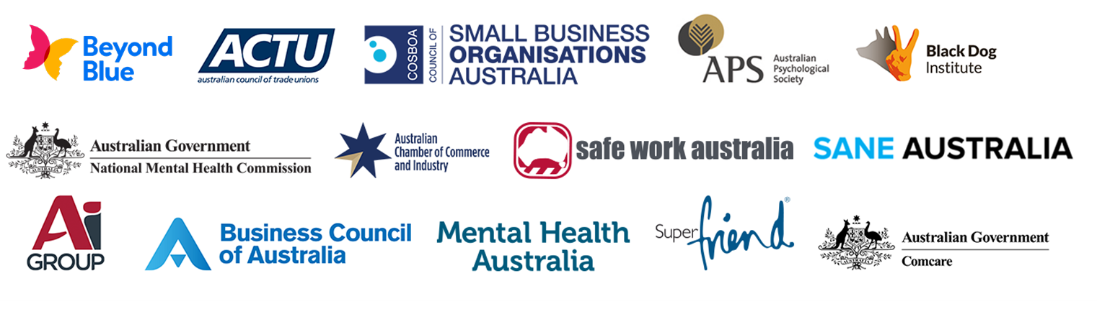

Recommendation to the Australian Government:
Invest in the development of a National Workplace Initiative

SuperFriend calls on the Australian Government to support the recommendation outlined in a separate submission from the MHWA to build on the foundational work over the last seven years by business, unions, community and the government sector (through the MHWA) and fund the development of the National Workplace Initiative. This is an opportunity for the Australian Government to demonstrate its commitment to early intervention and prevention in the working population.

The National Workplace Initiative will include:

- A definitive national workplace mental health online resource, outlining ‘what works’ and clear, step-by-step processes for taking action. All employers will be able to voluntarily choose a level of commitment that meets their needs from ‘meets legal obligations’ – which may be suitable for new and smaller businesses – to ‘meets best practice’, which may be attractive for employers looking to reap the full benefits of a thriving workforce and become employers of choice.
- Simple, practical online implementation guidance material.
- Implementation support expertise to assist workplaces put the guidance advice into action.

We believe that the MHWA has the track record, experience and reach to ensure this investment leads to:

- More Australian workers leading contributing lives.
- Meaningful improvements in population mental health and wellbeing.
- Boosts in productivity.

We support the KPMG and Mental Health Australia recommendation to link workers’ compensation insurance premiums to the implementation of mentally healthy workplaces (for example, through the National Workplace Initiative). We believe a model such as this to incentivise employers to create mental health promoting workplaces is worth further investigation.
Based on the evidence presented in the MHWA submission, SuperFriend strongly believes the introduction of a National Workplace Initiative, as proposed by the MHWA, will achieve the following outcomes:

- Improved population mental health and wellbeing via reduced work-related risks to mental health and increased work-related protective factors.
- Reduced costs of mental ill-health to individuals, society and employers.
- Reduced workplace stigma so those with mental illness can be employed, can return to employment and/or stay employed, and are supported to do so.

MAXIMISING EMPLOYER UPTAKE:
Through co-design and the use of external contextual experts, maximising employer uptake of workplace mental health and wellbeing initiatives

The increasing focus on workplace mental health and wellbeing over the last ten years has resulted in the production of a plethora of fact sheets, toolkits, information resources, websites, reports and guidelines developed by NGOs, governments, regulators and commercial operators. Much of this material has been developed with minimal involvement from the end users of these products, who are most commonly those responsible for the implementation of workplace initiatives, such as employers, business owners, managers and supervisors. This has meant that the specific needs and contexts of end users are not necessarily reflected in the material. As a result, adoption is compromised, resources are wasted and ultimately impact is reduced. A study in Canada assessing the effectiveness of the National Standard of Canada for Psychological Health and Safety in the Workplace highlighted the importance of tailoring national guidance material to the specific needs and types of industries.

This experience was reinforced by the research commissioned by SuperFriend and Beyond Blue, on behalf of the MHWA. A key theme from this work was a warning from employers and industry representatives against the development of generic, one-size-fits-all solutions, as this approach was seen as a major barrier to industry and employer uptake. There is a prevalent view that “it’s different in our industry”. The evidence, here and internationally, is that resources and interventions need to be customised and context specific if they are to be effective and deliver value. While a common set of principles is useful, there does need to be the opportunity for local voices to be heard. This highlights the need for adoption and implementation to be industry-led. SuperFriend strongly encourages the Australian Government to see this perception of uniqueness as an opportunity for engagement, meaningful co-design and effective implementation, rather than simply a barrier to be overcome.

In this context, the SuperFriend model is an example of how a third party organisation, with intimate knowledge of a specific industry can build relationships and develop trust to maximise uptake and engagement in the area of workplace mental health and wellbeing. SuperFriend is seen as the mental health expert within the superannuation and life insurance industry.

Evidence of the success of SuperFriend’s approach is that mental health is now an accepted and expected part of all superannuation and life insurance industry events. For example, SuperFriend was recently invited to facilitate a Conexus Financial Roundtable, the first to be hosted by an external facilitator. The topic explored how superannuation funds and life insurers can work more constructively with employers to create mentally healthy workplaces.

The following are some examples of SuperFriend’s approach to co-design:

- Involving superannuation and life insurance end users (for example, financial planners or claims managers) in the design of workplace mental health solutions targeting workers in those roles.
- Convening reference groups of representative from superannuation and life insurance for industry specific initiatives.
- Including industry representatives on our Board and Program Sub-Committee.

The benefits that we’ve seen as a result of SuperFriend’s approach to co-design with industry are:

- Greater ability to develop tailored solutions for the superannuation and life insurance industry.
- Increased efficiency when programs and initiatives are built around the needs of specific employers.
- Greater end user uptake and satisfaction.
- Up-skilling and developing the capability and capacity of staff in superannuation funds and life insurance to continue these efforts independently.
“AustralianSuper’s partnership with SuperFriend has been incredibly valuable to us for the best part of a decade. SuperFriend is the only specialist organisation that provides these services to superannuation funds that are then able to go out to hundreds of thousands of workplaces and assist employers and their employees to address the problems of mental health that affect so many Australians. To have a dedicated organisation that is aware of the peculiarities of superannuation funds and insurance companies and to be a vehicle for providing information to the funds and help us disseminate that information has been a fantastic partnership.”

- Ian Silk, CEO, AustralianSuper

Recommendation to the Australian Government:
Develop incentives for industry-led implementation

SuperFriend calls on the Australian Government to develop incentives for industries to adopt national evidence-based approaches to workplace mental health and wellbeing (that is, the proposed National Workplace Initiative outlined above, and in a separate submission by the Mentally Healthy Workplace Alliance), adapt it to their contexts, environments and working conditions, and drive industry-led implementation.

Such incentives might include funding for implementation support ‘navigators’ (from industry) who can take the national guidance about how to do it and facilitate the adaption of it with key stakeholders from specific industries (for example, employers, unions, industry associations, workers with lived experience). Seed funding (with co-investment from the specific industry) will support the development of a tailored action plan and the implementation of the plan. Government’s involvement in this regard will simultaneously ensure a nationally consistent and evidence-based approach, with industry-led and owned implementation.
IMPROVING CONTRIBUTION, PRODUCTIVITY AND PARTICIPATION:
Promoting positive workplace mental health and wellbeing to improve worker contribution, productivity and participation

Approaches to mental health in the workplace have traditionally focussed on the negative impact that work, and the work environment, can have on employees and organisations, and the impact of mental illness in the workplace. For example, OHS risk and hazard management models and the delivery of information sessions on signs, symptoms and the management of mental illness. Understanding the potential negative impacts of work is important and can contribute to preventing mental illnesses and losses in productivity. However, an approach that focuses solely on the dysfunctional elements of work in order to prevent illness does not adequately capture the elements of the workplace that engage employees, nor does it explain why some organisations develop environments where employees can flourish and reach their optimal potential.

In our experience, leaders and business owners (and employees) are now demanding a more sophisticated and positive approach to the contribution of work to our health and the impact of our health on work. They want advice on supporting all of their workers, not just those experiencing a mental health condition, and on how to get the most from their workers by encouraging them to be their best and do their best.

The critical role of the positive, strengths based approach is reflected in the widely accepted Integrated Approach to Workplace Mental Health. This model highlights the importance of three components of effective workplace mental health interventions: preventing harm, responding to illness and promoting the positive. In 2016, University of Tasmania brought together 50 experts and stakeholders to identify implementation priorities for the integrated approach. SuperFriend was on the Advisory Committee for this initiative and the summary publication called ‘An integrated approach to workplace mental health: Nine priorities for implementation in Australia’.

SuperFriend has had a longstanding commitment, as one critical component of an Integrated Approach, to promoting the benefits of a more positive approach to workplace mental health and designing solutions that reflect the growing evidence of these benefits. Promoting the positive includes: promoting positive aspects of work and employee capabilities; focusing on strengths; modelling positive leadership practices; ensuring work is meaningful; and, building a positive organisational climate. We developed a practical guide for organisations detailing how to implement a positive approach. The guide, called ‘Building Thriving Workplaces: Guidelines and Actions’, outlines five domains of a thriving workplace: leadership, connectedness, policy, capability and culture. Building on the Indicators of a Thriving Workplace research outlined earlier, this ‘how to’ guide outlines practical and proven strategies to help employees thrive. This resource, now in its second edition, has proved to be one of our most popular with 6,000 downloads in the last two years.

The benefits of happy and healthy workplaces have been demonstrated in a wide range of settings. Internationally, the evidence suggests that a workforce that experiences positive states and positive psychological health contributes to the organisation’s bottom line through their high performance. Positive and high-functioning employees are also more likely to be self-motivated, persist in the face of challenge, go the extra mile in achieving organisational goals, and help their colleagues to achieve. Happy and healthy employees are also happier and healthier in all domains of their life. Satisfaction with life, intimate relationships, friendships, income, work performance and health tends to lead to high levels of wellbeing.

Drawing on this positive approach, SuperFriend’s Indicators of a Thriving Workplace Survey Report (outlined earlier in this submission) has captured insights from over 15,000 workers across the country since the project’s inception in 2015. This research is built on the growing evidence for a positive approach by defining what a ‘thriving workplace’ looks like. Using 40 scientifically validated indicators, it measures progress in Australia against this desired state across a broad range of industries, occupations and roles. Results showed that 64% of respondents believe that investing in mental health would improve productivity. The national workplace mental health and wellbeing score is 65 out of 100 – suggesting that we are two thirds of the way towards optimal mental health and wellbeing in Australian workplaces.

Thriving workplaces are mentally healthy workplaces. They are environments where people can do their best and be their best. Thriving workplaces promote the positive mental health and wellbeing of all people who participate in that workplace including workers, leaders, contractors and consultants.

Through a strengths-based approach SuperFriend examined the key characteristics present when workers stated they ‘loved their job’. These workers are more likely to describe their workplace as the best or one of the best in the sector. They are also more likely to describe their workplace as having high levels of civility, effective team working and a supportive team environment. Workers who describe loving their job also indicate that managers set a good example of a happy, healthy and productive workplace and are accessible when you need them and will listen. These workers are more engaged, perform better and intend to stay longer in their role. The main benefits reported by Australian workers regarding their personal experiences of a mentally healthy workplace are:

- Increased feelings of being valued.
- Greater ability to bring their best self to work.
- Increased willingness to contribute more.

The implications of this are clear. A workplace where people feel they belong and can contribute is also one where organisational goals are achieved. Thus the benefits are individual, social and economic, with this trio tightly interlinked and interdependent. Gains on one front flow through to the others. Likewise detriments and deficiencies cause a negative ripple across systems.

SuperFriend recognised the importance of collaborating with others to ensure positive approaches are embedded in workplace practice. To this end, SuperFriend, VicHealth and WorkSafe Victoria have established the Victorian Workplace Mental Wellbeing Collaboration to promote positive mental wellbeing in Victorian workplaces. The Collaboration’s unique expertise in mental wellbeing, health promotion, and occupational health and safety enables us to take a holistic approach to testing, developing and sharing world-class products for Victorian workplaces. More recently, SuperFriend has partnered with the Office of Industrial Relations Queensland – Workplace Health and Safety and WorkCover Queensland to establish the Leading Well Queensland Collaboration. Both collaborations:

- Host regular, and highly popular, strategic leadership events and masterclasses.
- Provide online access to practical tools and resources.
- Share case stories and best practice information and benchmarks.

The Victorian Workplace Mental Wellbeing Collaboration recently commissioned a rapid review titled ‘What works to promote workplace wellbeing?’ The review looked at policy development, and interventions from the last five years that have proved effective in relation to promoting the positive.

Recommendation to the Australian Government:
Incorporate positive, strength-based strategies in all investments

Drawing on the above evidence, SuperFriend calls on the Australian Government to ensure that their investments in workplace mental health and wellbeing reflect the emerging science demonstrating the link between positive, strength-based strategies in the workplace and improved engagement, productivity, contribution and participation at work and across the economy.
State-based pilot worth watching:

The Wellbeing On Call: Creating Thriving Contact Centres Project is an 18 month co-design project to improve the job satisfaction and job engagement of contact centre workers from the superannuation and life insurance industry. SuperFriend is working with organisations to develop and deliver a solution to implement in contact centres that will focus on team leaders and workers. The effectiveness of the approach in creating thriving work cultures will be evaluated. Participating organisations are: UniSuper, MLC Life Insurance, Concentrix, Link Group and Mercer.

This is a WorkSafe Victoria, WorkWell funded project.

Conclusion

We are delighted to contribute to this historic Productivity Commission inquiry into the impacts of mental ill-health on workplace participation, contribution and productivity. We are particularly pleased to see the Australian Government recognising the important role that sectors, outside of the healthcare sector, can play in the promotion of population mental health and wellbeing. SuperFriend is uniquely placed to embed best practice in this field with reach across over half of the Australian workforce.

In this submission we have outlined four critically important practical actions for the Australian Government to take:

- Establish a cross-sector working group.
- Invest in the development of a National Workplace Initiative.
- Develop incentives for industry-led implementation.
- Incorporate positive, strength-based strategies in all investments.

Overall, we argue that these actions will:

- Reduce costs.
- Address implementation barriers.
- Maximise employer uptake of initiatives.
- Improve contribution, productivity and participation across workplaces and the economy.

SuperFriend would be delighted to expand on any element of this submission. We welcome the opportunity to partner with the Australian Government in the future to achieve our shared vision of improving population mental health for the benefit of workers, their families, workplaces, the community and the economy as a whole.

ATTACHMENT ONE

SuperFriend Partner Superannuation Funds and Life Insurers

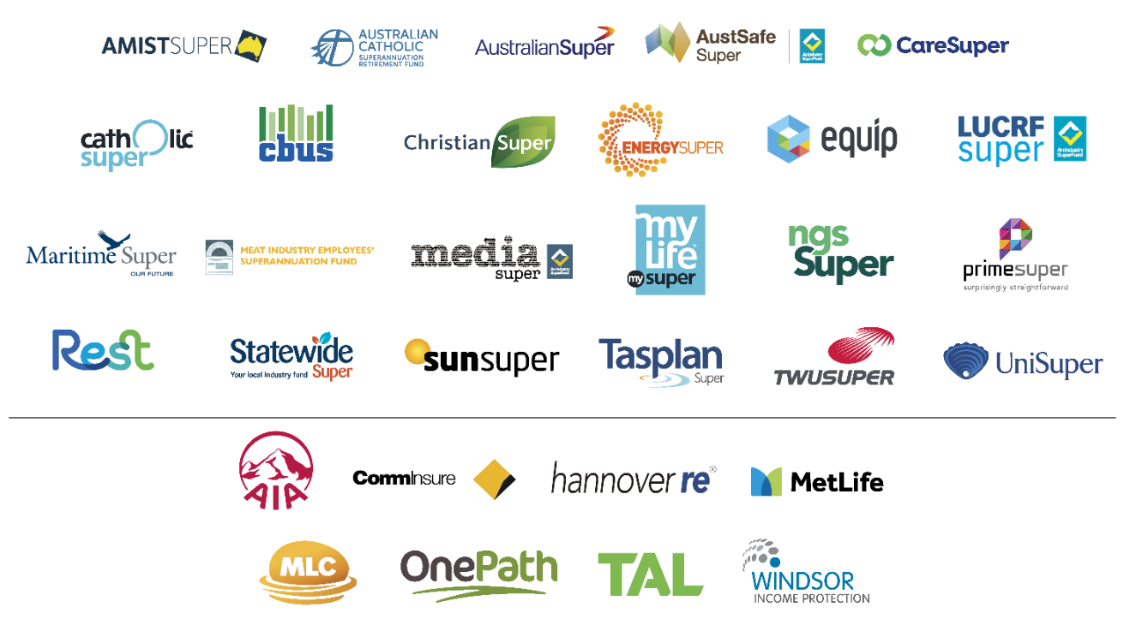

Through these Partnerships, SuperFriend has potential reach to 7.5 million members and over 750,000 employers nationally.

A mentally healthy workplace is defined as “one that actively minimises risks to mental health, promotes positive mental health and wellbeing, is free of stigma and discrimination, and supports the recovery of workers with mental health conditions, for the benefit of the individual, organisation and community.” Source: www.headsup.org.au
Summary of the SuperMIND research can be accessed here: https://www.superfriend.com.au/how-can-we-help/financial-services-industry/supermind/
Actuaries Institute (2017). Mental Health and Insurance Green Paper, page 17. Access here: https://actuaries.asn.au/Library/Miscellaneous/2017/GPMENTALHEALTHWEBRCopy.pdf
SuperFriend’s ‘Taking Action: A Best Practice Framework for the Management of Psychological Claims. Access here: https://www.superfriend.com.au/resources/
SuperFriend’s ‘Taking Action: A Best Practice Framework for the Management of Psychological Claims. Access here: https://www.superfriend.com.au/resources/
The evidence review that informed the development of the guidelines can be accessed here: https://www.superfriend.com.au/how-can-we-help/financial-services-industry/taking-action/
SuperFriend and Work Safe Australian guidelines can be accessed here: https://www.safeworkaustralia.gov.au/doc/taking-action-best-practice-framework-management-psychological-claims-australian-workers
Full report can be accessed here: https://www.superfriend.com.au/resources/
KPMG, commissioned by the Mentally Healthy Workplace Alliance and funded by Beyond Blue and SuperFriend. (2016). National Workplace Mental Health Framework for Australia Discussion Paper.
KPMG and Mental Health Australia. (2018). Investing to Save: The Economic Benefits for Australia of Investment in Mental Health Reforms. Access here: https://mhaustralia.org/publication/investing-save-kpmg-and-mental-health-australia-report-may-2018
Kunyk, D., Craig-Broadwith, M., Morris, H., Diaz, R., Reisdorfer, E. and Wang, JL. (2016). Employers’ perceptions and attitudes toward the Canadian national standard on psychological health and safety in the workplace: A qualitative study. International Journal of Law and Psychiatry, 44, 41–47
LaMontagne, A.D., Martin, A., Page, K.M., Reavley, N., Noblet, A.J., Milner, A.J., Keegal, T., & Smith, P.M. (2014). Workplace mental health: developing an integrated intervention approach. BMC Psychiatry, 14 (131).
White paper can be accessed here: http://www.utas.edu.au/__data/assets/pdf_file/0008/972395/WHW-Network-White-Paper.pdf
Guide can be accessed here: https://www.superfriend.com.au/resources/
Avey, J.B., et al. (2011). Meta-analysis of the impact of positive psychological capital on employee attitudes, behaviors, and performance. Human Resource Development Quarterly, 22(2), 127–152.
Lyubomirsky, S., L. King, and E. Diener. (2005). The Benefits of Frequent Positive Affect: Does Happiness Lead to Success? Psychological Bulletin, 131(6), 803–855.
For example, Corey Keyes (Emroy College of Arts and Sciences), Kim Cameron (Center for Positive Organizations) and Martin Seligman (University of Pennsylvania).
Rapid review can be accessed here: http://leadingwellvic.com.au/projects/
For example, Corey Keyes (model of flourishing), Martin Seligman (positive psychology), David Cooperrider (appreciative inquiry) and Alex Haslam (social identity approach).

