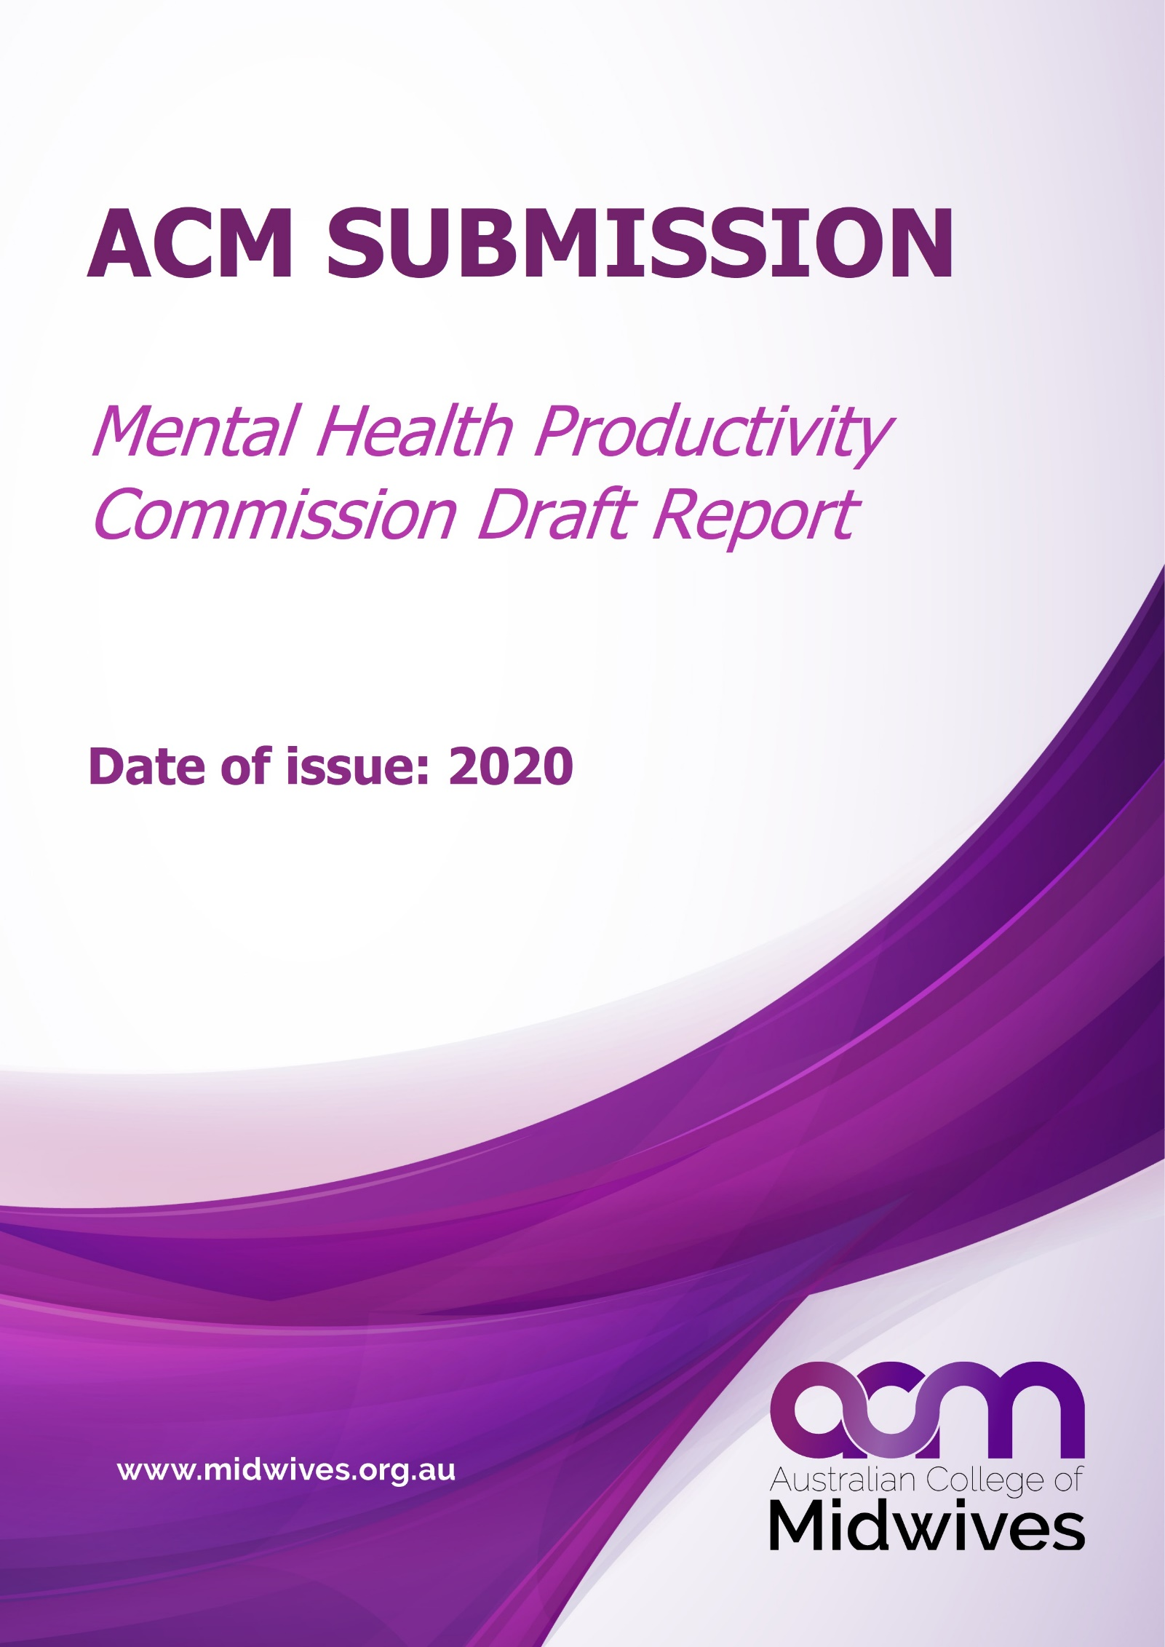

ACM Submission: Mental Health Productivity Commission Draft Report

Are you responding on behalf of an organisation?
Yes | The Australian College of Midwives
Name (optional) | Dr Megan Cooper (Midwifery Advisor)
Contact details (optional) | ProfessionalPractice@midwives.org.au

General comments

The Australian College of Midwives are disappointed by the omission of midwives and any mention of midwifery from the Mental Health Productivity Commission Draft Report (referred to as ‘the Report’ throughout this submission). While we recognise that nurses and nursing are referred to consistently throughout the report, we would like to highlight that nursing and midwifery are distinct professions and therefore, legally acknowledged as such. Midwives are autonomous, skilled health care professionals who have the capacity to positively support women, families and communities in matters related to health and wellbeing, not least of all, their psychological and mental health.

All midwives are equipped with the knowledge and skill to assess, monitor and support women who may experience mental health concerns. As a core aspect of undergraduate curricula, midwives understand the importance of supporting a woman’s holistic wellbeing through the provision of care that encompasses all factors that lead to health or alternatively, result in ill-health. As such, midwives recognise that health extends beyond just the physical to the psychological. Consequently, care provided by a midwife during pregnancy, birth and the postnatal period, significantly and positively influences not only the woman’s mental health but also her transition to parenthood, the health and wellbeing of her baby both in the short and long term and more, can positively influence the health of the wider family unit.

With the increasing rates of perinatal depression, anxiety and mood disorders, it is imperative that midwives are equipped and skilled to recognise and respond to the mental health needs of women and families as they arise. In response, midwives are seeking opportunities to become specialised in the provision of mental health care through the completion of postgraduate qualifications specific to perinatal mental health. With recognition that pregnancy and birth present opportunities to discuss mental and psychological health with women, midwives are able to instigate the necessary supports and referrals maximising prevention and early intervention, ongoing support and follow up and importantly, the best start for the baby.

Prevention and early intervention

Figure 1.3 provides an overview of the risks to mental health over the lifespan and specifically highlights that these risks include:
- Insecure attachment
- Malnutrition
- Parental mental illness
- Substance abuse in pregnancy

These factors can arguably be addressed, or at least lessened, by the provision of high quality and responsive care during the childbearing years with this being well within the scope of a midwife. The report suggests that ‘consumers must be matched with the right care’ while also advocating for a multidisciplinary approach to the provision of mental health care. It is important to note that midwives work collaboratively with a multitude of professionals with this addressing the requirement that care provision be relevant and appropriate for the person seeking care. It is therefore disappointing that midwives have neither been recognised nor acknowledged throughout this report.

Section 17.1 speaks specifically to the mental health and wellbeing of infants through to three years of age. While there is an acknowledgement of the experiences and environment that infants are exposed to as instrumental to their physical and mental wellbeing, there is no mention of the importance of the care that is provided during pregnancy. There is, however, mention of ‘specific models of care and practice guidelines’ (p. 653) that should ideally include the care provided during the perinatal period. Further to this, there is also mention of ‘strategies to tackle specific risks to mental health and wellbeing, such as fetal alcohol spectrum disorder’ (p. 653) which are particularly relevant to the care and support women and families receive during pregnancy.

With an understanding that good health starts prior to conception, the health of women and families is essential to combatting mental health concerns. Pregnancy is therefore an opportune time to discuss, assess and refer women who are identified as experiencing mental or psychological health concerns. While the report acknowledges that the interactions that women and families have with health professionals during pregnancy, birth and the postnatal period (pp. 653-4), there is no discussion of the midwife as important to both recognising and supporting women and families to achieve both physical and psychological health.

We draw attention to the quote on page 654 which states:
…insufficient consideration is given to workforce development to ensure health professionals are ready to have difficult conversations, know how to explore sensitive and complex issues and feel confident responding when concerns are raised. This gap in confidence and skill set might be one explanation as to why most parents experiencing perinatal anxiety and depression are not identified by care providers (PANDA, sub. 344, p. 15)
We would also argue that this is complicated by the fragmentation of maternity care across Australia. The current systemic approach to maternity care does not always facilitate an opportunity for women to see the same health care provider on a consistent basis. As such, they are not able to build confidence and rapport and are commonly forced to retell their story multiple times. This is likely to inhibit sharing of information between the woman and her health care provider including any mental and/or psychological health concerns. This is acknowledged in the report on page 655 (paragraph one) and in section 10.2 (p. 346).

As midwifery is largely underpinned by a partnership model, rapport built with a midwife can facilitate opportunities for the woman’s concerns to be raised in a safe and trusting environment. This is further strengthened by the provision of midwifery continuity of carer that ensures that women and families have access to a known midwife across the full extent of the perinatal period. Statistics suggest that less than 10% of women have access to this model of care which is proven to positively influence pregnancy and birth outcomes. The development of trust and reciprocity further reduces the likelihood of stigma or misunderstanding and instead, facilitates opportunities where strategies can be put in place with the view of working towards the best possible perinatal outcomes, including those that pertain specifically to mental health. While the report refers to screening and screening tools as a means of detecting mental health issues, there appears to be no emphasis on the importance of relational care that facilitates a safe and supportive environment in which women and families are able to disclose information that has the potential to inform referral, treatment and ultimately, early intervention.
There is, however, acknowledgement of the importance of a family-focused approach throughout the report. Specifically, page 656 discusses the importance of information and guidance for new parents. There is also recognition that the provision of antenatal and postnatal care has ‘substantial benefits’ and yet, there is no mention of midwives or midwifery throughout the report, despite the fact that most women will receive some kind of midwifery care throughout their pregnancy, birth and/or postnatal period.

Given the above, we request that midwifery and more particularly, midwives are acknowledged as key health professionals to improving the mental health and wellbeing, particularly for women, babies and families in the final version of this report.

Rural regional and remote issues

The report suggests that mental health issues are potentially more likely in rural and remote populations (p.121) due to isolation, stigma, health service and staffing shortages, communication, transport and cultural challenges as examples. Aboriginal and Torres Strait Islander women commonly experience additional challenges including but not limited to systemic and institutional racism, transgenerational trauma and separation from Country and family. Many are forced to access care in metropolitan areas with this further adding to the burden and increasing the risk of psychological distress or mental health issues.

The provision of midwifery care and more particularly, midwifery continuity of care in rural and remote regions of Australia has consistently demonstrated excellent outcomes. This is also true of Birthing on Country models of midwifery care which have supported Aboriginal and Torres Strait Islander women to birth in their community. The benefits of care provided by a midwife are often underacknowledged and so too are the benefits that midwives experience working in a model of care that supports their professional autonomy. Subsequently, increasing access to midwifery continuity of carer models in rural and remote regions not only has the potential to attract midwives to rural and remote communities but also to ensure that perinatal mental health care can be provided close to home. There appears to be no reference to the importance of maternity care or perinatal mental health in rural and remote regions.

Interestingly, the only specific mention of midwives or midwifes (sic) in this document, appears to be with respect to rural and regional access (p. 408). Subsequently, we interpret this to mean that midwives are recognised as a valuable asset in the provision of rural and regional health care, despite the fact that they have not been consistently acknowledged as such. We feel the omission of midwifery and/or midwives with respect to rural and remote mental health care is a significant oversight in this document that needs to be urgently rectified.

Health and medical services

Section 11 suggests that interventions to improve mental health include an increase in the number of locally-trained mental health nurses. It would be advantageous to extend this to an increase in the number of midwives trained in mental health given the evident increase in perinatal mental health issues. As mentioned above, this would be particularly advantageous for rural, regional and remote settings.

We are particularly disappointed by the fact that midwives, especially those who are trained in perinatal mental health are not listed in box 11.1. More so because the paragraph above suggests that this list includes those who specialise in mental health and those that are important to supporting individuals experiencing mental health issues. We would strongly suggest that midwives fit in to one or both of these categories.

Midwifery is a primary health care focused community strategy that seeks to provide care where it is needed most. Midwives, as autonomous practitioners, have the ability to provide high quality care in a range of settings. However, we would argue that midwives are an underutilised resource and that given the evident shortage of health workforce specific to mental health, midwives could assist with addressing some of the burden faced in ensuring accessible health care (p. 371), particularly with respect to perinatal mental health.

While section 5.1 refers to GPs as the front line of consumer-focused care, we would also argue that during the perinatal period, midwives fulfil this role. While it is true that many will seek the help and guidance of a GP for health-related issues, many women come to pregnancy without a history of mental or psychological health issues and therefore may experience a first episode as part of the perinatal period. Given this, midwives are often the front-line care provider and responder to mental health issues where there is no previous history. As midwifery is underpinned by woman-centred care, the woman’s holistic health is factored into care provision with this including any mental health related concerns.

Section 10.2 discusses the importance of enabling coordination and continuity of care. The provision of continuity of care is a well-known benefit particularly in the provision of maternity care and more specifically, care provided by a known midwife. Midwifery continuity of care has extensive benefits and these benefits extend to a more positive experience and improved satisfaction throughout pregnancy, birth and the early postnatal period. These positive experiences which are associated with care provided by a known midwife are known to lessen the burden of mental health and psychological sequalae and therefore improve both short- and long-term outcomes for women, babies and families.

Despite the well-known and documented benefits, midwifery continuity of care remains limited across Australia. While the research base continues to accumulate and extensive lobbying for this model of care continues across the nation, there appears to be limited commitment from government or policy makers to increase access to this model of care. As such, there is an urgent need for the current fragmented system to be reconsidered. The provision of midwifery continuity of carer for all women, regardless of risk, is a positive step towards achieving a health system that is truly consumer-focused.

With recognition and understanding of continuity of care as a significant aspect to improving mental health outcomes across Australia, we find it disappointing that the extensive literature base reflecting the benefits of midwifery continuity of care has not been referenced or referred to throughout the report and more, that midwives have not been acknowledged as key mental health care workers. As discussed on page 347, such an approach would facilitate effective information sharing.

