STRENTHENING INDUSTRY LINKAGES AND GROWING APPRENTICESHIPS

JULY 2020
Strengthening industry linkages
and growing apprenticeships
july 2020
Response to the Interim Report of the Productivity Commission
Response to the Interim Report
of the Productivity Commission
Strengthening industry linkages
and growing apprenticeships
july 2020
About Construction Skills Queensland (CSQ)
CSQ is the Building and Construction Industry Training Fund in Queensland. Our Annual Training Plan (ATP) invests in education, training and support programs for the Queensland building and construction industry. We have three pillars:
1. Attract | inform, inspire and provide pathways for people to join the building and construction industry
2. Develop | provide training solutions to increase the capability of the existing workforce
3. Retain | help the sector to develop strategies to keep talented people in the industry.

Our approach
We aim to ensure our industry has access to a suitably skilled workforce. Our method and approach to identifying industry issues and skills needs focuses on:

Procuring training through a network of RTOs and other partners across Queensland to deliver a range of accredited training, non-accredited training and health and safety focused wellbeing programs.
A place-based approach to engaging with industry stakeholders across regional Queensland to identify key local industry issues, and skills and training needs.
Analysis of the magnitude, frequency, distribution and cause of skills gaps in the industry. Using this insight we work directly with industry and employers to identify opportunities and offerings that respond to changing workforce needs.
Leading industry thinking via key research projects that explore the future of work and skills. This ‘farsight’ research aims to future-proof the industry by equipping businesses and workers with the knowledge, skills and training needed to adapt to changes, adopt new technologies and improve innovation and competitiveness.

Activity highlights
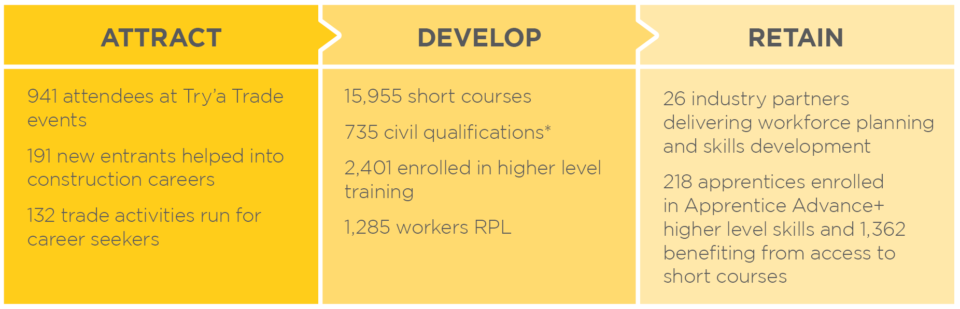
*in partnership with the Queensland Government

The levy
The Building and Construction Industry Training Levy (the levy) is a statutory training levy established under the Building and Construction Industry (Portable Long Service Leave) Act 1991 (Qld). Effective 1 July 2020 a levy is imposed on the total cost, whether direct or indirect, of eligible building and construction work in Queensland costing $150,000 or more (excluding GST). CSQ procures training and support programs that are complementary to, and do not duplicate, public VET investment.

Table of contents

Executive summary | 4
Linking VET to industry | 5
Supporting trade apprenticeships | 9
Barriers, incentives and support | 17
References | 19

Executive summary
The Productivity Commission’s Interim Report on the National Agreement for Skills and Workforce Development (NASWD) is a welcome addition to the body of knowledge for the vocational education and training (VET) sector. The report demonstrates the complexity of the sector and the many issues faced. We have limited our comments to three areas where we believe we can add value and perspective, that may a warrant more direct treatment in the final report, and that represent key issues for the building and construction industry.
First amongst is the issue of VET linkages with industry. VET straddles AQF levels from school to higher education. Similarly it endeavours to cover a range of policy outcomes from engagement, participation, pathways through to attainment and frequently with an industry overlay. Some agreed tenets may help the system define clear roles and corresponding measures.
In our response we see the link with industry as indispensable and an area that could be expanded. Government plays a critical role in supporting a robust and responsive quality VET system, however workforce development and training is, and should be, largely the responsibility of industry with a greater focus on placing industry at the centre of the system.
Rather than chasing skills shortages, the VET sector has the capacity to prepare the workforce for the future. The nature and speed of change demonstrates that skilling, reskilling and upskilling relies on the culmination of a partnership between industry, government, employers and training providers working together.
This leads to our second response issue, apprenticeships. The apprenticeship system is strong in building construction with on-the-job training a critical element. There is not a crisis as such in apprenticeships in our sector, however there is room for improvement in both commencements and completions.
The developing economic impacts of COVID is creating new threats and opportunities. The threat to employment and businesses may open opportunities to trial new approaches to apprenticeships. Unemployment impacts apprentices deeply as it also breaks their education, removing the established pathway to qualification, licensing and the ability to trade. We highlight four programmatic approaches suitable for scaling-up. This includes: prevocational- incorporating soft and technical skills as well as work experience; and a trade pathway program for individuals unable to access a traditional apprenticeship. We also highlight Apprentice Advance+, a program that recognises an apprenticeship frequently does end at qualification attainment – that there are additional steps and supports need to gain licensing or registration. Lastly employer support via dedicated workforce planning is outlined. This explicitly links skills and employment.
The last area our submission covers is the issue of barriers, incentives and support. We concur with the view of the Productivity Commission that the current incentive model has muted impact, we also note difficulties with time release, scheduling and paid time for the off-the-job training. Meanwhile apprentices, especially in their first and second year, struggle with extremely low wages. We explore whether the COVID experience presents an opportunity to reset traditional supports in this area. We believe opportunity exists for living wage assistance to be provided to apprentices, and employers to be more directly compensated for the administrative, educational requirements and mentoring aspects of the apprentice relationship.
We are heading into a time of great uncertainty. At CSQ we envisage a strong role for the VET sector in skilling and reskilling Australians, boosting employment prospects and helping industry develop and deliver the skills and qualifications needed. A renewed and reshaped NASWD can help this process.
Construction Skills Queensland (CSQ) provides this response in good faith and to provide additional evidence, data and a building and construction industry perspective on three areas of the VET sector.
- Linking VET to industry
The PC has sought information on:
- What are useful ways of defining and measuring the skills shortages (and surpluses) relevant to the VET sector?
- To what extent are skills forecasts based on future industry growth a useful and reliable basis for providing course subsidies?
This submission considers issues around skills shortages and the role of industry. This section includes information on:
- A longer term view of movements between trades and non-trades in the VET sector
- Skills shortages and the associated role in setting direction
- Student choice, demand and supply

Key points | an overview
- VET sector enrolments have grown significantly over the past three decades.
- The sector has a wide remit. Clearly defining the roles and expectations of the sector may help set suitable performance measures and provide a set of guiding principles.
- It is important that VET continues to provide a range options, however evidence indicates that employment-linked programs provide improved income and jobs prospects for participants.
- The focus of the sector should focus more strongly on the needs of industry and employers, along with coupling to industry policy (and investment). This would represent a resetting of the current focus on skills shortages.
- Linkages to industry, whether it be through course or training package development, or student communications, needs to actively involve RTOs, trainers / teachers and, where applicable, licensing bodies.

  - Australia’s training boom
Over recent decades VET activity has grown significantly (figure 1). The growth has been accompanied a proportionate shift away from employment-based training and towards boosting numbers in and achievement of: year 12 or equivalent (Certificate II), general Certificate III/IV attainment or higher qualifications. A side effect of this shift is dilution of the role of industry. Apprenticeships are the cornerstone of delivery-level industry involvement. Apprenticeships continue to form an important part of the VET landscape but enrolments without an employment contract have come to dominate the VET landscape (figure 1).

Figure 1 | Australia’s training boom | number of VET enrolments, Australia
VET: a long term perspective
The long term enrolment profile supports views of VET sector that the system, while infinitely more accessible than in the past, is driven by a supply chain of public and private players with incentives to push enrolments ever higher, rather than promote employment.
(ACIL Allen, 2015, Review of the National Partnership Agreement on Skills Reform).

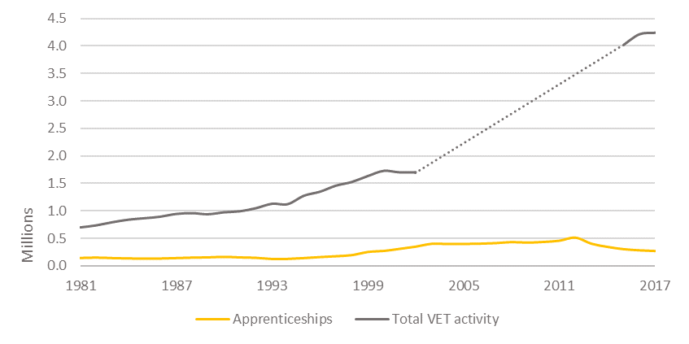
Source: CSQ, using NCVER data. Note: there is a data gap between 2003 and 2015 due to privately-funded VET enrolments being excluded from national training statisitics. Accurate estimates of total VET acitvity are unavailable for this period.
The recent boom (figure 1) in institution-based activity has not improved participants’ job prospects, nor arguably, has it served to deepen the human capital of the workforce. The Interim Report outlines minimal financial or income returns for VET level study. Unlike higher education qualifications, VET courses generally do little to improve young people’s labour market prospects. More than a quarter of Certificate I and II completers believed they gained no benefit from their qualification. Other studies have shown VET participation yields few advantages over employment without post-school study, and our own analysis of LSAY data confirm these findings. Additionally nearly half of all employed Australians hold a non-school qualification that is not relevant to their job, while 40% believe their skills exceed the requirements of their jobs.,
VET fulfils a range of roles and delivers a relatively wide spectrum of AQF qualifications – covering school to higher education. The sector also delivers workforce skills, strives for employment outcomes, maintains industry relationships and provides pathways to higher education. A set of guiding principles or tenets for the VET sector that aligns to and recognises the variety of roles are needed. The guiding thread should be a link to employment and deep industry engagement.
It is importance that moving forward VET students, providers and industry can improve on these perceptions and outcomes.
Clarity on purpose and function may assist along with renewed focus on increasing the role of industry and industry requirements, particularly in priority and course development (discussed below).

Skills shortages
The most important priority for the VET system is to re-anchor itself to industry. A strong focus and priority is currently attached to skills shortages. While important, this can be a narrow and reactive lens. The Interim Report makes frequent reference to the Department of Education, Skills and Employment’s skill shortage survey (SERA). Perhaps illustrative of the fraught nature of skills shortages, this survey is according to the Department, ‘not based on a statistically valid sample and does not enable the compilation of quantitative estimates of skill shortages.’
Rather than chasing indeterminate skill shortages, the VET system needs to be tightly coupled to industry policy. Calibrating the VET sector to support expected or desired economic restructuring is needed. This involves identifying the sectors that the nation intends to grow and use the VET system as a mechanism for producing the human capital to support this restructuring. This should occur at the level of national strategic priorities as well as at the regional level.
One possible touchstone in this regard may be the outcomes of the National COVID-19 Coordination Commission. To the extent that this Commission’s work leads to a renewed national industrial strategy, the VET sector should be leveraged to fulfil its human capital requirements.

Student choice, demand and supply
Student choice (alone) should not guide course allocation. The VET-FEE HELP experience demonstrates the risks of a ‘demand-led’ system. The information asymmetry between students and RTOs creates an environment that prioritises the highest-profit courses – not the most economically, or even privately, useful. We support a moderated market. Controls or price signals are needed to ensure that good value for money is achieved. For students this may apply across course, materials other student fees and for government, across allocation and pricing methodology.

Integrating with industry in course development
One way to improve industry linkages is to consider the end-to-end outcomes and relationship to skills development (figure 2). Improved integration of those charged with delivering VET (leading RTOs and trainers / teachers) with the development process will help bring together the educational necessities and industry needs. A stronger focus on the full pathway, whether it be to higher education or to licensing or registration will help students make informed choices and also strengthen and embed industry needs in the VET sector. Currently only 16 per cent of secondary students understand the VET pathway, it can reasonably be expected that fewer would understand the full pathway to licensing.
We recognise the important of foundational skills and in particular literacy and numeracy for both education and employment. The OECD PISA literacy and numeracy measures show that VET students are increasingly less well-prepared, creating added pressure for the sector. Research into the rates of adult illiteracy in the community and an assessment of the impact on and role of the VET sector in this area is needed.

Figure 2 | Industry linkages: bringing together VET and other industries
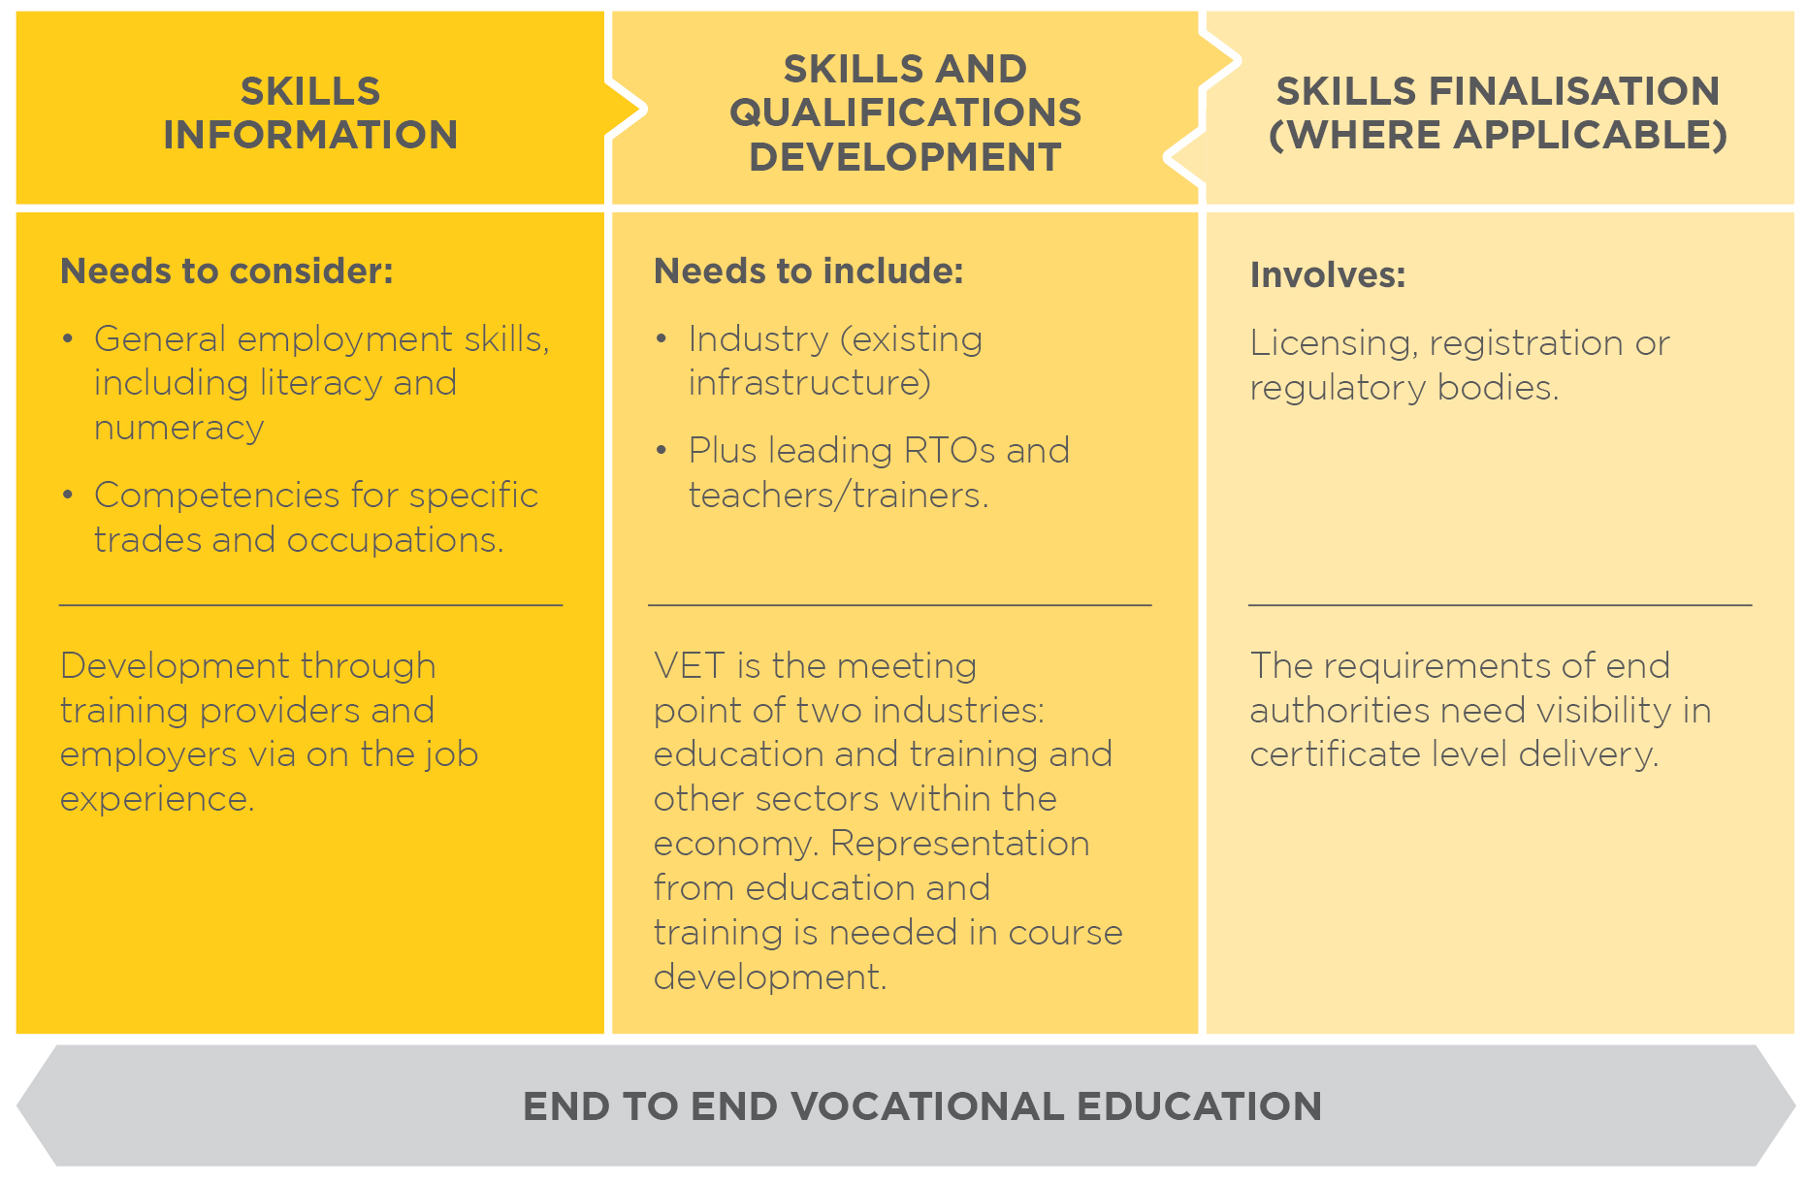

- Supporting trade apprenticeships
The Productivity Commission has sought information on ‘Supporting trade apprenticeships’ including:
- does the nature and size of the ‘apprenticeship problem’ merit new policy measures?
- how effective are levies in increasing apprenticeships?
- are there other reasons for using industry levies?
Our response considers:
- Apprenticeships and traineeships (trade and non-trade) and the interplay between educational and employment policy. We seek to highlight data relating to building and construction apprenticeships.
- Alternative models.
- Policy levers and levies.

Key points | an overview
- The apprenticeship system has served employers and apprentices well over an extended period. Any changes to the system need to be undertaken carefully and on an industry-by-industry basis.
- The apprentice completion rate has remained stable for building and construction in Queensland.
- Recent declines in commencements, and to a lesser extent, in-training figures suggest that steps may need to be taken to shore up new apprentices. The economic challenges presented by COVID-19 will likely intensify this need.
- Alternative models that focus on:
    - Prevocational exposure: soft skills, accredited training and work experience may assist employers and potential workers alike test industry suitability.
    - Recognition of existing skills and gap training that deliver apprentice qualifications without an apprenticeship per se may help improve supply and alleviate the need for a four year commitment. Suitable protections and controls must be in place.
    - Supporting existing apprentices with additional skills and taking the next step to licensing or business establishment are essential.
    - Workforce planning to ensure jobs are available and needed.
- Industry levies and government policy have a role to play in ensuring an adequately skilled workforce

  - Apprenticeships | educational and employment policy
VET’s core value proposition lies in tight coupling to industry. For centuries, the apprenticeship model has delivered reliable outcomes for both participants and industry. In recent decades this has expanded to include a new suite of ‘non-trade’ programs or traineeships, in response to a variety of needs including the 1980s/1990s recession, early childhood minimum qualification regulations and the NDIS. It is movements in non-trade trainees and apprentices that has driven recent declines in apprenticeship headline figures (Figure 3).
Figure 3 | Growth in apprenticeships driven by non-trade occupations | number of apprentices and trainees, Australia
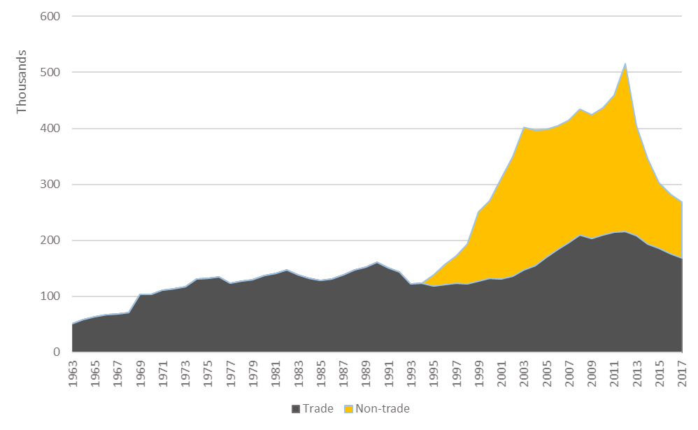
Trades history
Trade-related delivery in the
VET sector
has a relatively
stable history
Source: NCVER
Given this longer term perspective on movements between trade and non-trade areas, CSQ does not believe there is a crisis or sizeable problem in apprenticeships. There are however emerging indicators and shifts in program delivery that suggest that there may be opportunity trial different approaches to employment-based training and seek ways to overcome long held concerns expressed by both employers and apprentices. This is discussed in more detail in the sections 2.3 and 2.4.
  - Building and construction apprenticeships

A brief overview
The building and construction industry is a key employer of apprentices. Figure 4 illustrates the prominence of building and construction in the apprentice pathway in Queensland. Overall the apprenticeship system works well for the building and construction industry in Queensland. The apprenticeship and traineeship pathway is valued and the restricted calling and licensing regimes mean that this pathway remains a key entry point into a construction career.
Figure 4 | Apprentice in-training by industry, Queensland, Sept 2019
Strong linkage with industry
Any potential reforms to the apprenticeship model need to take an industry centric approach. Changes or flexibility that may work in one industry may create unintended industrial or regulatory issues in another industry.
Source: CSQ, 2020, Building Skills for Prosperity. Please note that CSQ defines building and construction and associated qualifications to align with the Queensland legislative definitition.

Traditional trade-based apprenticeships continue to provide sound outcomes. Young people who complete an apprenticeship are more likely to be employed at age 25 (figure 5), and enjoy almost 20 per cent higher earning than those who complete an institution-based VET program (figure 6). VET programs combined with employment deliver significant benefits.

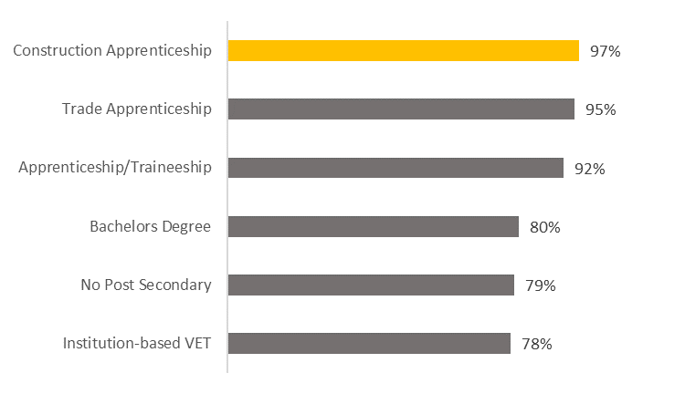
Figure 5 | More job certainty for apprentices | Likelihood of being employed full-time at age 25
Source: CSQ.

Figure 6 | Apprentices enjoy early career pay outcomes | Weekly earnings at age 25 (annualised), Australia
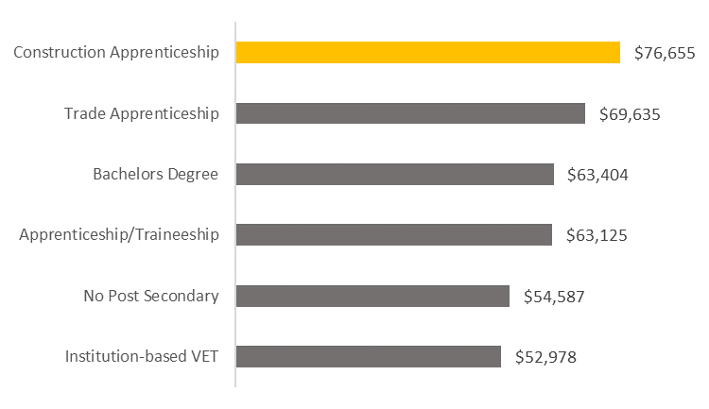
Source: CSQ

Despite these positive fundamentals, there is emerging data, that commencements are an issue. Additionally, there is a strong relationship between market conditions and construction apprentice entrants. This view is supported by the experience of apprentices during the Global Financial Crisis 2007-08 (GFC) which saw new entrant construction apprentices fall sharply. After prolonged and strong growth in commencements 2001 – 2008, the environment has since has been variable in commencements and declining since 2015.
Building and construction apprentices in-training has been more stable and similarly apprenticeship and traineeship completion rates are at satisfactory levels (approximately 65 per cent apprenticeship completion rate in building and construction in Queensland). This is comparable to higher education completion (six-year cohort completion 63.2% with 11.8% still enrolled) (Department of Education, 2019).
Against the backdrop of potential further falls in apprentice commencements CSQ is keen to explore ways to make the apprentice pathway clearer, more accessible and to provide certainty to both apprentices and employers alike.
  - Alternative and wrap around models
While the apprenticeship system has and continues to serve our industry, like any government-funded program, periodic review and consideration is needed. It is fundamental that the link between employment and training is maintained in the apprenticeship system. There can be flexibility in how this is achieved.
CSQ sees the apprenticeship model working on a spectrum with associated programs and wraparound services essential to provide end-to-end solutions for employers and apprentices. The following paragraphs outline some of the CSQ programs that illustrate potential ways to approach the apprentice skills challenge. Figures 7 illustrates these add-on services and alternatives to the traditional apprenticeship model.

Figure 7 | Summary of apprentice spectrum and services
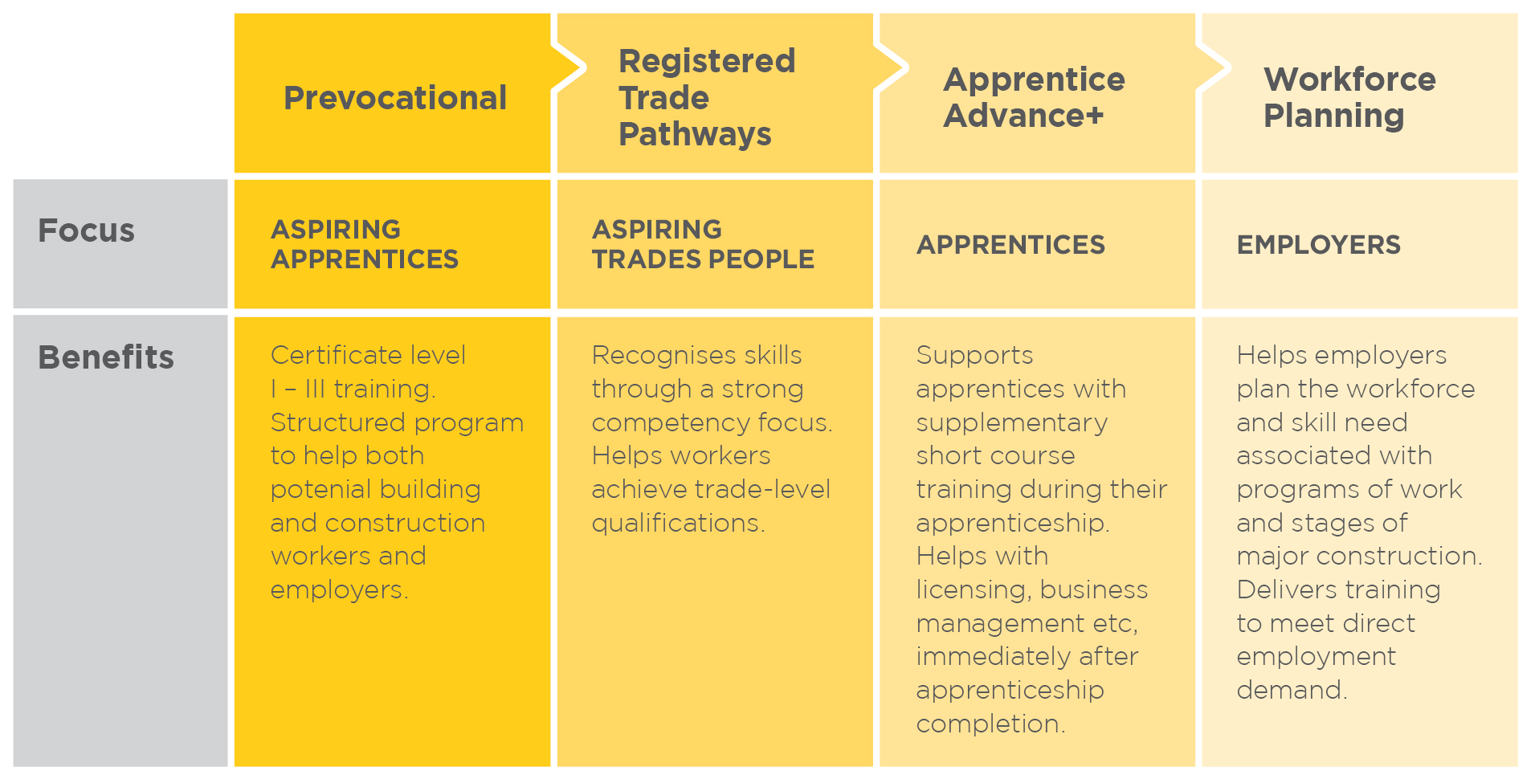

Pre-vocational program (under development)
We are developing a new program to shore-up the supply of construction apprentices into next year, and if needed due to economic conditions, subsequent years.
This program will help provide an apprenticeship-ready, work-ready workforce and help reduce employment uncertainty through the:
Why prevocational?
Our experience with prevocational programs that are embedded with industry and employment can help reduce employer costs and help aspiring young apprentices make a smooth transition from school to work

- provision of accredited training at Certificate I – III level
- delivery of work experience
- provision of life skills training (for example budgeting,
health and resilience)
- eligibility for transitioning workers from other industries
Delivered over 16 weeks the program will provide training to get an individual started in the industry, Certificate III training that can be recognised towards an apprenticeship, training to develop soft skills and direct work experience.

Registered Trade Skills Pathways (RTSP)

This program produces qualified tradespeople outside of the traditional apprenticeship pathway. Since introduction as a trial in 2013 the program has become embedded in our operations and offerings to industry.
RTSP produces qualified trades people flexibly, creating opportunities for those unable to participate in or access a traditional apprenticeship. It provides:
Improving access to trade qualifications
This program produces qualified tradespeople via a flexible delivery mode. It provides opportunities for unqualified workers, or workers aspiring to a trade-level qualification, to build on existing skills, knowledge and experience to gain a trade qualification
- Training and work based skill formation in selected traditional trade occupations.
- Delivery that is flexible and can work around differing individual circumstance (e.g. casual employment arrangements/ remote locality).
We deliver the RTSP in partnership with the Queensland Department of Employment, Small Business and Training (DESBT). Administratively, participants complete and submit an RSTP application for approval and registration to DESBT. The RTO is part of the application process. Approval of registration is sent by DESBT to the participant, the contracted RTO and CSQ – to notify that training can commence. Licensed trades are not part of the program.

Table 1 | RTSP | Differences from and similarities to an apprenticeship
Differences from an apprenticeship | Similarities to an apprenticeship
There is no ‘Training Contract’ (the agreement that is signed by an employer and an apprentice and then registered with the Department).  The participant undertakes the training in their own time. | The program incorporates 3 important elements of the apprenticeship system:  - The RTSP requires approval from and registration with DESBT  - A Training Plan and Training Record book, (responsibility of the RTO), is developed and maintained.

Apprentice Advance+
Supporting apprentices to take the next step
This program provides critical support to apprentices who may need additional short course training across the duration of their apprenticeship. This program creates a line of sight to, and actively supports the next steps needed to establish a foothold in the industry and, where needed to gain licensing or registration.
The CSQ Apprentice Advance+ program, provides eligible apprentices with:
- Access to fully subsidised short courses
- Higher level skills training, for third and fourth year apprentices
Apprenticeship qualification attainment in our industry is frequently followed by licensing or registration requirements - 2/3 of building and construction apprentices are in the electrical, plumbing and carpentry trades. Introduced this year this initiative helps apprentices access additional training, gain licensing and ability to trade.
CSQ provides a full subsidy to the RTO. No additional fees are charged however students may incur non-training related costs such as PPE, resource costs, and travel and accommodation
costs to attend training.

Workforce planning
Working directly with industry and employers this approach links training, jobs and workflow. Through our Major Projects and Industry Skills Coordination Program, CSQ works directly with employers to provide the link between building and construction stages, required occupations and community or workforce skills profiles. We establish training plans to deliver the right training and right skills.
Figure 8 | Key components of workforce planning in Queensland building and construction
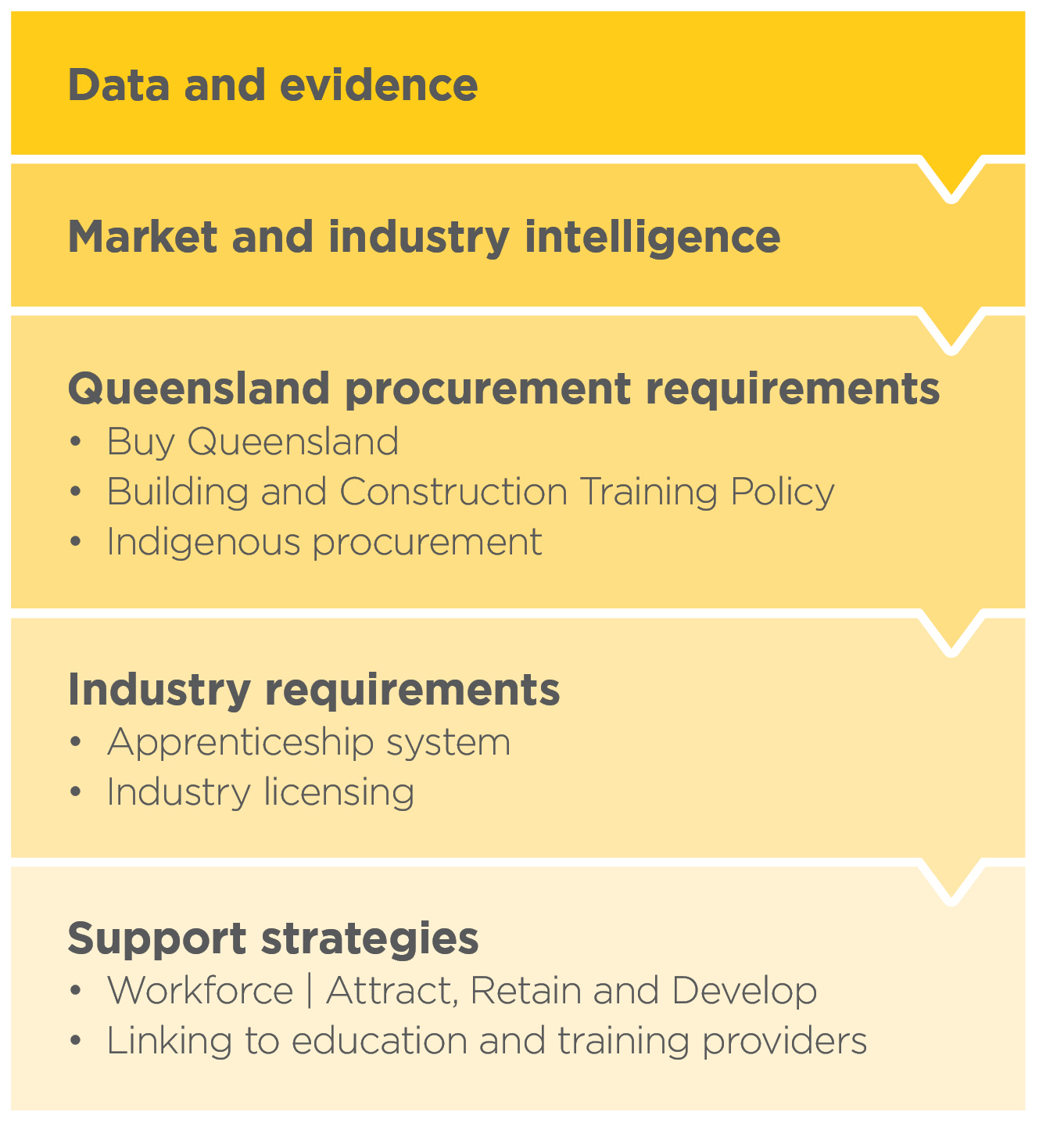
Why workforce planning?
CSQ’s workforce planning model works by:
- Providing a direct and tangible link between employment and education
- Considering the needs of the project and the supply of skills of the local workforce
- Identifying and filling
skill gaps.

Workforce planning requires wraparound support. This includes staff dedicated to working with industry on specific outcomes, expertise in occupational analysis, VET competencies and the capacity to deliver education and training solutions.
In undertaking this task we also map to the Queensland Training Policy (see 2.4 next section) to help government building and construction providers ensure they meet or exceed required apprentices, indigenous and other targets.
  - Policy levers
The Queensland Government Building and Construction Training Policy helps to optimise employment and skills development in building and construction. The policy mandates that contractors meet employment targets and undertake other workforce training as a component of being awarded work on eligible Queensland Government projects.
These policies support local skills development and employment. These policies are particularly effective in regional areas where employment and skilling opportunities can be more limited.
CSQ is engaged in a long term campaign to encourage both construction companies and workers to invest in skills. This involves industry awareness campaigns, targeted engagement and co-investment with companies with a willingness and ability to drive training behaviour among employers and suppliers.
  - Industry levies
We work collaboratively with the Queensland Government to ensure that training procured by CSQ is complementary to, and does not duplicate, public VET investment. We do not fund qualifications available to the market through alternative mechanisms, such as Queensland’s user choice funding for apprenticeships.
Industry funds are targeted into higher level qualification and pathways, competencies, skill sets, wraparound services and unaccredited training. This approach provides workers and industry with a ready source of training needed for safety, compliance, upskilling and reskilling.
CSQ pays location loadings for RTO delivered training: +25% for delivery in regional locations; and +50% for delivery in remote locations.
Workers in our industry participate in training at relatively high rates, as illustrated in figure 9.
Figure 9 | Apprentices in-training, Qld, Sept 2019
- Barriers, incentives and support
The Productivity Commission has sought information on:
- The relative costs and benefits of incentives
- Alternative ways to encourage governments to coordinate or streamline their employer incentive programs
We also note that the Commission has commented on apprentice wages and the need to be paid when undertaking training.
This section considers the need for a living wage for apprentices and alternative models for incentives.

Key points | an overview
- Apprentices and employers both need support, particularly as economic conditions worsen
- A living wage for apprentices requires consideration
- Regular payments to employers should be considered

  - Living wage and wage assistance
The Productivity Commission has identified that incentives are not particularly effective for trade apprenticeships. A fresh look at support is timely. As economic headwinds increase we anticipate the need to support both employers and apprentices will increase.
There are essentially two related issues:
- Ensuring monetary support for apprentices is sufficient
- Helping employers maintain apprentices for the duration of the four year apprenticeship
The COVID Apprentice Subsidy and JobKeeper provide potential models and ways to conceptualise employer and apprentice support that both incentivises employers, and also supports cashflow, ongoing employment and explicitly recognises the role of off-the-job training.
Options for further exploration could include:
- an Austudy or JobKeeper-style payment for apprentices that provides a living wage
- a subsidy to apprentice employers paid on a regular basis that assists with off-the-job training time
Apprentice wages are below the minimum wage, and for a first-year building and construction apprentice vary by trade at approximately $515 - $550 per week (below JobKeeper and JobSeeker). Monetary reward is important. In the context of falling commencements it is critical that apprentices are paid a rate that rewards work; and that apprentices are able to afford tools; travel to work; and other employment-related costs and stay above the poverty line (2020 Australian poverty line is $457 per week for a single adult).
Equally, apprentice wages reflect the lower productivity of apprentices and additional support needed. Trade school, formal institutional learning or off-the-job training varies by trade, typically averaging approximately one day a week for 40 weeks of the year. A potential arrangement could see employers paid an ongoing subsidy of 20 per cent of the apprentice award wage. While additional research, and with industry by industry impact assessment needed, the arrangement could replace existing incentives.
This approach would assist business with cash flow and support ongoing apprentice employment. Economic recessions disproportionately impact young people. This type of support will help maintain a sound, employment-linked pathway.

References

ABS (2015) cat no. 4235.0 - Qualifications and Work, Australia, 2015

ACIL Allen Consulting (2015) Review of the National Partnership Agreement on Skills Reform, Final
Report, https://docs.education.gov.au/system/files/doc/other/final_report_npa_review.pdf

Construction Skills Queensland (2019) Apprentice Annual 2019, available at https://www.csq.org.au/wp-content/uploads/2019/11/CSQ-2019_Apprentice Annual_A4_Final_Reduced.pdf

Construction Skills Queensland (2018) Apprentice Annual 2018, available at https://www.csq.org.au/wp-content/uploads/2019/02/CSQ-Apprentice-Annual-2018.pdf

Department of Education (2019) Completion rates of higher education students https://app.powerbi.com/view?r=eyJrIjoiM2MwMWQ2ZDMtNGViNy00Mjc5LThkOTgtNzJhMmM5ZDQwYWUxIiwidCI6ImRkMGNmZDE1LTQ1NTgtNGIxMi04YmFkLWVhMjY5ODRmYzQxNyJ9 accesed 22 June, 2020

Department of Employment (2017) Skill shortage research methodology https://docs.employment.gov.au/documents/skill-shortage-research-methodology-0 accessed 7 July 2020

Lee, W. and Coelli, M. (2010) The Labour Market Effects of Vocational Education and Training in Australia, Australian Economic Review, 43(4), pp. 389–408

Linsley, I. (2005) Causes of Overeducation in the Australian Labour Market, Australian Journal of Labour Economics, 8(2), pp. 121-43

Marks, G. (2017). University and vocational education, and youth labour market outcomes in Australia, Journal of Education and Work, 30(8), pp. 868-80

Mavromaras, K. et al. (2010) The Problem of Overskilling in Australia and Britain, The Manchester School, 78(3), pp. 219-241

Misko, J. and Wibrow, B.(2020) Traditional trade apprenticeships: learnings from the field, NCVER available at https://www.ncver.edu.au/research-and-statistics/publications/all-publications/traditional-trade-apprenticeships-learnings-from-the-field

Marks, G. (2017). University and vocational education, and youth labour market outcomes in Australia, Journal of Education and Work, 30(8), pp. 868-80

Productivity Commission (2020) Interim report, National Agreement for Skills and Workforce Development Review, May 2020

Roberts, M. (2020) Lifting Australia’s Productivity, Productivity Commission p. 28

CSQ understands:

- Construction and skills
- The policy and legislative environment for building and construction
- Industry stakeholders, their goals and objectives
- The economic and social value of the industry
- The occupational profiles and different skills required in the construction of infrastructure, buildings and houses
- The supply of workers and existing skills in Queensland’s regions, cities and towns
- The baseline skills required to successfully enter each industry sector
- The best training pathways to guide workers through the industry
- How innovation and technology is shaping the industry

CSQ (2018) Apprentice Annual 2018, includes special feature: linking training to industry, https://www.csq.org.au/wp-content/uploads/2019/02/CSQ-Apprentice-Annual-2018.pdf
Productivity Commission (2020) Interim report, National Agreement for Skills and Workforce Development Review, May 2020 p.126
ABS (2011) cat no. 4235.0 - Learning And Work, Australia, 2010-11
Marks, G. (2017). University and vocational education, and youth labour market outcomes in Australia, Journal of Education and Work, 30(8), pp. 868-80 Lee, W. and Coelli, M. (2010) The Labour Market Effects of Vocational Education and Training in Australia, Australian Economic Review, 43(4), pp. 389–408
CSQ, op cit
ABS (2015) cat no. 4235.0 - Qualifications and Work, Australia, 2015
Mavromaras, K. et al. (2010) The Problem of Overskilling in Australia and Britain, The Manchester School, 78(3), pp. 219-241 Linsley, I. (2005) Causes of Overeducation in the Australian Labour Market, Australian Journal of Labour Economics, 8(2), pp. 121-43
Education Council (2019) Discussion paper: Review of senior secondary pathways
Roberts, M. (2020) Lifting Australia’s Productivity, Productivity Commission p. 28
CSQ (2019) Apprentice Annual 2019 page 9
Qualifications currently offered Certificate III in Carpentry; Painting and Decorating; Solid Plastering; Wall and Ceiling Lining; Wall and Floor Tiling; Construction Waterproofing; Civil Construction Plant Operations; and Civil Construction.
Access to full subsidies is available during the apprenticeship and within one year of completion; and is also open to cancelled apprentices accessing state government funding to complete their institution based training.

