To –
The Hon. Josh Frydenberg
Cc:
Julie Abramson
Paul Lindwall
Yvette Goss
Thank for you for allowing my company the opportunity to make a submission to the Productivity Commission in regard to a potential enquiry for “Right to Repair” in Australia.
We are an independent watch repair company based in Adelaide, South Australia. We primarily focus our work on vintage, mechanically driven Japanese watches but often repair other brands, mostly manufactured in Switzerland. We also manufacture watch parts that have been unavailable for decades and quite proudly say approximately half of that production happens in Australia. We have shipped our products to around 110 countries over the past 4 years. We started in approx. 2009 doing repairs and making parts during the evening after a day job and have grown to a global business.
Over time, we have found the ability to repair customer’s watches has been steadily impeded by watch manufacturers refusing to supply parts, technical information, errata and tools to us and other independent repairers across the world.
While we entirely support and uphold the ideals behind the free market and businesses choosing who they deal with, the obfuscation and anti-competitive practices of several companies within the watch industry are egregious and arbitrarily applied. This leads to a poor outcome to the end user of the watch as their choice for routine service and repair of the watch is limited to, usually, the brand’s repair centre only, with no serious options for independent repair. Most mechanical watches need routine service every 5-10 years, just like a car would need routine service.
In most cases the brand’s repair centres are extremely expensive and they often undertake practices such as replacing a watch dial/face and hands without consulting the customer. This can significantly impact the value of a watch. For example, you could send your vintage ROLEX watch to a ROLEX service centre with a fairly rare dial/face and it could be replaced at the service centre without consultation. The watch in original condition is considerably more desirable and valuable. So a $20,000 watch could now be worth $10,000 or even less due to these parts being replaced. ROLEX also retain any replaced parts after service and there is no option to get them back, despite the parts being part of the watch you own. It is unknown what happens to these often quite valuable parts after ROLEX has taken possession of them. The used vintage dial can often be worth several thousand dollars.
Due to a refusal to supply parts, technical information, errata or tools, quite often an independent repairer would be unable to undertake the same repair. An independent repairer is usually much more flexible in their approach to repair and can better accommodate what the customer would like to do with their property. There are really no safety considerations to consider here as it’s unlikely you will be killed by your watch, which could be argued by other industries.

In addition to that, an independent repairer can be local to the customer, so the customer would not need to risk sending their quite valuable timepiece in the mail or via a courier service to the official service centre. We quite regularly hear stories of watches lost in the post and often the insurance does not cover the full value.
Finally, particularly in reference to ROLEX, a lack of parts supply helps to support a booming counterfeit industry. Often the counterfeit parts are of much lower quality than OEM parts. In most cases the consumer would have no idea their watch contained counterfeit parts unless checked over by a professional. We are very much against the counterfeit industry as firstly it exists to deceive consumers and secondly it has been reported that the counterfeit watch and watch part industry has been used to launder money and support terrorist activity around the world.
The struggles of independent repairers are compounded by the introduction of exotic, non-metallic materials in the balance and escapement part of the watch. These parts form the “heart” of a mechanical watch and attention to these parts is critical to efficient timekeeping. For example, The OMEGA “Co-Axial” escapement & balance uses silicon for several components. The methods of handling these parts differs from the way you would handle traditional, metallic components. OMEGA do not openly provide technical information, errata or parts to independent repairers. This makes it highly risky for an independent repairer to undertake a repair on these watches and in most cases, it is prudent to say no. Should a part be damaged, the repairer will be unable to purchase the part and due to the lack of technical information and errata, will not know of any revisions to the parts or how they should be lubricated.
While there is a process to become an authorised OMEGA service agent, most repairers we know that have undertaken this, invested in equipment for the certification, and find the agency not worthwhile maintaining. Ordering parts is a considerably prescriptive, tedious process and OMEGA set a fixed repair pricing structure which make it very difficult to complete the work profitably. This again leads the consumer to the brand service centre and makes independent repair sufficiently complex and convoluted, it often isn’t worthwhile. It could be fair to say, in some circumstances, a 5 year old watch may be considered not viable to repair. From what we understand, consumer law in Australia states a product must be reasonably durable and last a reasonable amount of time. It could be argued in some of these cases, these products would not fit within that description.
While you can be an OMEGA service agent, in most cases, OMEGA will refuse to supply parts for vintage watches to the agents (meaning repair is impossible), but will accept a repair direct to the service centre. Most vintage watches are less complex than modern watches so there is no practical reason why they would do this except to maintain a repair monopoly.
OMEGA are a brand of the SWATCH GROUP, which are currently in a high profile litigation, in Switzerland, with COUSINS UK, who are a UK based watch parts supplier. A determination on the case had been delayed by COVID-19, but it would appear that the case may be concluded in 2021. COUSINS UK are seeking a judgment in their favour which would compel SWATCH GROUP to supply parts, technical information, errata and tools to them. If there was a judgement in COUSINS’ favour, you could assume it would allow other watch part supply companies to also take a similar action.
As another example of the ineffectiveness and poor customer outcomes from official service centres, I have attached a letter (Appendix A) from the SEIKO USA service centre. The customer paid $240.86 USD (approx. $313AUD) in labour and no repair was attempted. The only offer made to the customer was a discount on a new watch. While this is quite generous, it was not what the customer wanted as a repair outcome.
The customer really wanted “his” watch repaired and not a modern replacement. Here, it could be argued that the brand has engaged in coercion and anti-competitive practices because the customer has no other way of achieving value for money unless they purchase a discounted replacement watch from SEIKO. In fact, most of the SEIKO range is excluded from the offer.
The customer fortunately contacted my company and I advised him we would be able to repair the watch.
While the customer booked in the job with SEIKO USA to repair a calendar issue. When I received the watch it did not run at all. On inspection, I found a fairly large hair wrapped inside the gear train which was sufficient to stop the watch. This should have been picked up immediately at the service centre as the issue was obvious. The stated reason for not attempting to repair the watch was a discontinued part. On our inspection, the part was in good, usable condition and most of the issues with the watch were due to the hair in the gear train and a minor issue with the calendar system, both easily resolved.
The report also states that the water resistance cannot be restored.
The good news story here is that we, being an independent repairer, can undertake the work, get the watch running again, restore the water resistance and meet the customer’s repair goals, where the official service channels cannot. As we pay tax in Australia, this is a net gain to the Australian economy and tax base that would otherwise be lost or never generated. Independent repair is a net benefit to economy in every way. Some of the parts we manufacture in Australia will be used during repair.
To summarise here are our key reasons why we support “Right to Repair” in Australia –

- Greater consumer choice and repair outcomes. The consumer can choose between authorised or independent repairers for their device or product.

- Independent repairers are often willing to take on work that authorised repair is not able to do within their framework.

- Independent repairers have the scope to be more innovative and “agile” in repair techniques and parts. The innovation is driven by the goal of achieving the best repair outcome for the consumer. Major brands have little commercial pressure to innovate.

- Major brands egregiously obscure and hide technical information and errata with the goal of directing consumers to their own service centres, destroying local, independent repair. Some of these brands will send the watch outside of the country, which means the technical work and/or any admin will not be done by a native Australian.

- Major brands often “confiscate” customer’s parts during service and there is no recourse to recover these often very valuable parts.

- The quality of repair from authorised service centres is variable and often worse than an independent repairer.

- Right to Repair would create a net gain to the Australian economy as it will enable independent watch repairers to take on work, in Australia, they would currently need to turn away.
Thank you again for taking the opportunity to begin an enquiry into “Right to Repair” in Australia. We think it is an increasingly important issue and becomes more important by the day due to the complexity of modern consumer goods and increasing obfuscation by major brands.

Yours Truly,

Adrian Sellick
Manager
Vintage Time Australia

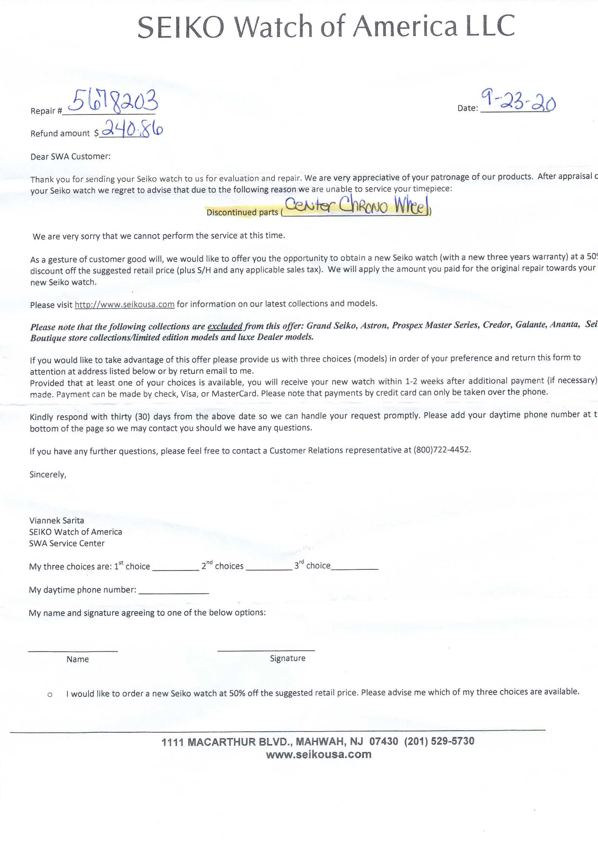
APPENDIX A

