Productivity Commission Productivity Review submission
Global Sisters is a not-for-profit organisation with a proven operational model that enables women to become financially independent.
It provides a genuine alternative for women who find mainstream employment inaccessible. By removing the barriers like childcare responsibilities and welfare disincentives, Global Sisters make self-employment a viable option by providing a marketplace enabling online sales, business education, coaching and pro bono services, microfinance and sales and marketing assistance. A significant beneficiary group is single mothers. For many in this cohort, structural, political and cultural issues lock them out of mainstream employment.
Impact of Global Sisters (GS) programs to date:
- Directly supported over 5,500 women across Australia
- 60% of participants who joined GS business education programs in 2020 started generating income that year
- Average weekly income of GS participants rose from $155 to $360
- 65% of GS participants surveyed in 2020 reported that GS had helped them secure income through self-employment
- Of GS participants surveyed in 2020, 29% had an active business when they started the program, 79% had active, successful businesses after the GS program

CONTENTS
Introduction 2
Recommendation 1: Welfare reform 4
Recommendation 2: Financial services products 10
Case Study: Supporting women in tech 11
Recommendation 3: Grants and funding 12
Productivity context 12
Final comments 17

MICRO-BUSINESS, MEGA IMPACT
Increasing Australia’s Workforce of Women to Generate Prosperity
To the Commissioners
On behalf of Global Sisters, I provide this submission to the Productivity Commission’s 2022 Productivity Review.
In its call for submissions to this review, the Productivity Commission has noted the falling contribution of labour utilisation in Australia, highlighting the requirement for market development that facilitates resources moving in a timely way to higher value use, with institutions that support these features.
This submission suggests a crucial productivity enhancing reform: moving women, particularly single mothers and others who are welfare dependent, to self-employment through establishment of their own micro-business (defined as a business with less than four employees). It represents a highly productive investment in human capital.
- The Organisation for Economic Co-operation and Development (OECD) estimates that closing the gender participation gap by 75% could increase growth in Australian GDP per capita from 2% per annum to 2.4% (now an agreed G20 target).
- Women comprise 62% of 1.1m underutilised Australian workers, with a higher underutilisation rate (15.1%) than men (12.1%).
- From July 2019 to July 2020 women in micro-business exhibited the strongest growth of any category of employment, increasing by 8,800 in this period alone.
- Women consistently report that childcare responsibilities inhibit their opportunities for work. Self-employment through micro-business is a uniquely suitable manner of work because of its inherent, self-controlled flexibility, allowing women to produce value and generate income while caring for children.
- Global Sisters has found that income generated by women through micro-business has a flow on effect to the entire family unit, impacting, on average, four family members.

Without targeted action women will continue to be forced into unsuitable, precarious or undesirable work, or simply remain unemployed, stifling productivity. This contributes to an unsustainable cycle of repeated instances of welfare dependence over a lifetime, often resulting in intergenerational welfare dependence.
A key driver of productivity growth that the Government should be influencing is increasing the number of women in the workforce, facilitating inclusion that responds to women’s desire for flexible, self-directed work. Our suggested reforms create schemes, services and funding that facilitate the self-employment of welfare-dependent women, particularly single mothers, through micro-business.
Global examples of success can be found in the OECD’s 2017 report “Policy Brief on Women’s Entrepreneurship”.
Global Sisters believes that our recommended reforms will:
- Expand people’s work choices
- Deliver greater means to consume more or of improved quality through increases to personal income and generation of a greater volume of goods and services available in the market
- Increase capacity to provide public goods and services through an increased taxation pool
- Give women an opportunity to complement other forms of income
- Reduce the risk of homelessness in the fastest growing cohort: women over 55
- Reduce welfare reliance and support women to stay off welfare

Governments should prioritise the following areas in the short to medium term:
- Welfare reform
- Financial services products
- Grants and funding

RECOMMENDATIONS
- Welfare reform: Pilot a Single Mother Enterprise Incentive Scheme
- Financial services products: Mandate provision of customised financial products for women on low incomes starting micro-businesses
- Grants and funding: Prioritise Government engagement with micro-businesses to increase the percentage of micro-businesses accessing funding and support

RECOMMENDATION |  | RESPONSIBLE MINISTER | DEPARTMENT
1 | Welfare reform | - Minister for Employment, Workforce, Skills, Small and Family Business  - Minister for Women's Economic Security | - Department of Education, Skills and Employment  - Office for Women, Department of Prime Minister & Cabinet
2 | Financial services products | Minister for Superannuation, Financial Services and the Digital Economy, Minister for Women's Economic Security | - Treasury  - Office for Women, Department of Prime Minister & Cabinet
3 | Grants and funding | - Treasurer  - Minister for Industry, Energy and Emissions Reduction  - Australian Small Business and Family Enterprise Ombudsman | - Treasury  - Department of Industry, Science, Energy and Resources  - Office of the Australian Small Business and Family Enterprise Ombudsman

RECOMMENDATION 1: WELFARE REFORM
Pilot a Single Mother Enterprise Incentive Scheme
A. Sufficient fixed income allowance
B. Training and tailored coaching that helps make business possible
C. 21 months of support
D. Reporting obligations and participation requirements that do not get in the way
E. Increased knowledge and awareness among service providers

Global Sisters has a record of demonstrating that self-employment is one of the most effective pathways to independence, however the current welfare system works against women achieving this goal. The welfare system includes a range of barriers to single mothers including;
- counterproductive and burdensome reporting obligations and program requirements,
- allowance income that varies significantly based on business income
- variable quality of advice from welfare officers

The creation of a Single Mother Enterprise Incentive Scheme to overcome these barriers and provide appropriate support will see many more single mothers becoming financially independent, moving from welfare to empowerment.
A successful government program already exists that utilises this model. The New Enterprise Incentive Scheme has helped people move from welfare to self-employment. This scheme seeks to address some of the above barriers, however a number of elements in the structure of the scheme mean that it is inaccessible or problematic for single mothers.
The proposed Single Mother Enterprise Incentive Scheme takes the strength and learnings from NEIS, but adapts the scheme to ensure that it works for single mothers. Our proposal is built from our experience with single mothers on welfare, numerous consultations with NEIS providers and single mother entrepreneurs, and detailed primary research (some of our research findings are outlined below).
The increased cost to government of administering this scheme will be small. Most single mothers who take up the scheme will already be receiving support (at the rate we suggest). We anticipate this will promptly save Government resources as single parents gain financial independence and move off welfare.
Single mothers in Australia are disproportionately represented amongst the financially vulnerable. One third of all single parent families live in poverty. 83% of those families are headed by mothers.
STANDOUT BARRIER: Shifting mothers from parenting payments to the lower rate of Job Seeker when their youngest child turns 8 makes scarce financial resources even scarcer. The problem is compounded by the current obligations in the Welfare to Work system which place onerous and anxiety-fuelling requirements on single mothers that not only fail to add value, but work against the program’s stated objectives of improving workforce participation, financial security and self-reliance.
Global Sisters believes that the success of the New Enterprise Incentive Scheme (NEIS) demonstrates a pathway that, with some alteration, could be effectively utilised for single parents. The NEIS’s reduction of counter-productive reporting obligations, the ability to access a consistent allowance regardless of fluctuations in business income, and tailored mentoring and training address many of the issues in Welfare to Work for single mother entrepreneurs.
However, this option is unviable for most single mothers due to the low rate of the fixed payment, which is capped at the single, no-children rate of Newstart, as well as a default expectation that NEIS recipients devote full-time hours to the project. Further, the framework of the NEIS can be complex, onerous and particularly challenging for single parents to navigate. Global Sisters has found many women are unsure or have received inappropriate professional advice about the scheme. These people are missing out on its potential benefits.
The Global Sisters proposal is built from our experience with successfully helping single mothers on welfare to make business possible, and successful. Global Sisters also undertook numerous consultations with NEIS providers and single mother entrepreneurs. Finally, we invested in research, surveying single mothers receiving welfare who have considered starting or have started their own business (or become otherwise self-employed). Findings from this research have been key in shaping the following key dimensions of the scheme’s design. All quotes come directly from those who participated in the survey.

        - Sufficient fixed income allowance
Single mothers on welfare should be able to receive a consistent allowance as they start up their business. This allowance should not be impacted by fluctuations in business revenue and be set at the Parenting Payment Single rate (the payment that single mothers with young children will already be receiving).
Single parents wishing to start their own business should be able to access a fixed allowance at the Parenting Payment Single rate that is not impacted by income from the start-up business. This would provide certainty of income for single parents and reduce the administrative burden on parents and providers during the business start-up phase.
Single mothers who wish to start a business can maintain their parenting payment, however this triggers burdensome reporting obligations including a monthly or fortnightly profit and loss report to Centrelink. For those mothers who also have welfare-to-work obligations (due to the age of their youngest child), many of their business activities are not counted towards meeting those obligations, further increasing the unnecessary work burden placed on them and, counter productively, making it more difficult to work on their business and achieve financial independence.
“It’s financially very difficult to complete the sessions while putting together the business plan, while at the same time juggling care of children and fitting in work. More financial support for single parents would help.”
Furthermore, it creates fluctuations in the level of government support that these mothers receive, which can make cash flow difficult to manage (as support level is based on provided profit and loss statements). Errors in appropriately calibrating government support against business income are (unavoidably) common, which further leads to heightened and unnecessary stress and difficulty.
The NEIS program was designed to address some of these very concerns for welfare recipients, however the fixed allowance in NEIS is set at the single, no-children Newstart rate – a rate that is prohibitively low for single mothers wishing to engage in the program. Single mothers who engage in NEIS can request a “top-up” payment for Centrelink, this however triggers many of the above reporting obligations and discussed barriers.
“I did the whole program worrying about income from Centrelink.”
Providers are also often unsure on how to administer or recommend these payments.
- 70% of survey participants did not participate or otherwise complete the NEIS due to financial concerns, citing income levels that were too low, having to give up single parenting payments and having to rely on variable income as the biggest obstacles.
- Over a third of participants said the significant administrative burden involved in participating in the scheme would be the main thing they would improve about the NEIS.

        - Training and tailored coaching that helps make business possible
Single mothers with entrepreneurial hopes need support and assistance to transform their ideas into a viable business. This should include flexibly delivered business training courses and business coaching that is tailored and supportive.
“The NEIS needs to be more flexible (dates, times, locations), perhaps available online, and offer longer term support. It takes a lot longer to ideate, create, launch and grow a business than the NEIS program timeframe of support”
Our research and anecdotal reports indicate that business advice from Departmental support staff, while well-meaning, lacked professional, real-world experience and was based on theoretical information rather than practical expertise.
- 48% said there was a lack of support in NEIS and a lack of awareness about how to participate, particularly support for single mothers and the unique challenges they face.

        - 21 months of support
Our research and experience suggest a minimum of 21 months is needed for single mothers to go from pursuing a business idea to having a viable business. Along the way, they require support, training, assistance and financial certainty. This should be the minimum duration to provide a measurable possibility of success, with the option of program flexibility to be extended in high needs cases.
“Their insistence that I must work full time in the business. The whole point of self-employment was that it would be flexible around my children’s needs. I have a child with disabilities…”
The caring responsibilities of single mothers means that they will need additional time and flexibility relative to other would-be business founders in creating a viable business. The low success rate of NEIS amongst single mothers demonstrates this point (see data below). The fixed allowance and support for the scheme should last for a minimum of 21 months (in contrast to the 9 months of NEIS). This minimum duration is consistent with Global Sisters’ experience and the feedback from our consultations and research.
- 58% of those who had participated in the NEIS cited that the program was not supportive of single mothers, highlighting aspects of the scheme, such as the 9-month time frame and expectation of full-time participation, making it inaccessible to single mothers.
- Only 3% of survey participants said that participating in the NEIS meant they are now financially independent and no longer on parenting payments or Newstart.
- 56% of survey participants said participating in the NEIS did not enable them to set up a successful business and increase their income at all.

        - Reporting obligations and participation requirements that do not get in the way
Reporting obligations should not be counterproductive or inhibitive, but rather they should track and support the outcomes and milestones that women are achieving.
The need for flexibility in participation and reporting requirements is likewise crucial. Single mothers should not be expected to work ‘full-time’ in the business in order to participate in the scheme, as is the default expectation with NEIS. A significant part of the appeal of self-employment for many single mothers is the flexibility it provides around caring for children.
Rather than measuring activity, we look to business outcomes and the successful achievement of different milestones on the way towards developing a viable business. Global Sisters has a detailed outcomes framework to track the progress of single mother entrepreneurs that the Government could adopt. Key stages may include completion of training, development of a business plan, product to market and demonstration of scaling.
Tranches of allowance funding could be released based on achieving these milestones.

        - Increased knowledge and awareness among service providers
An awareness campaign should be conducted and directed at Centrelink, jobactive and NEIS providers about the Single Mother Enterprise Incentive Scheme. This would ensure that potential candidates are made aware of the scheme, feel supported to participate and that Centrelink and other providers are confident in recommending it and administering it.
“All people on welfare should be told about this scheme, I only heard through a neighbour.”
Single mothers frequently speak of the difficulty and frustration they face in trying to navigate the welfare system and the incomplete or inaccurate advice they receive from providers. While there are a range of reasons that comprehension of advice varies, it has led to exclusion from relevant program opportunities or participation in programs that don’t result in a benefit. Engagement with NEIS was demonstrative of this, with providers often neglecting to recommend NEIS to those that are interested in self-employment or providing confusing and conflicting advice about people’s eligibility and the requirements involved.
“The scheme needs to be better known through Centrelink services…”
An awareness campaign should be run directed at Centrelink, jobactive and NEIS providers about the Single Mothers Enterprise Incentive Scheme. This will ensure that potential candidates are made aware of the scheme, they feel supported to participate and that Centrelink and providers are confident in recommending it and providers in administering it.
- 67% of survey participants said they would be interested in training and support that helps to start a business or use self-employment to gain financial independence, while guaranteeing their current welfare payments.
- Of the 83% of survey participants who had heard about the NEIS, only 28% heard about it through Centrelink or a jobactive provider. The majority (55%) heard through a friend, or through their own research.
- 42% of those who participated in the NEIS said that there was a general lack of awareness about the NEIS and/or support to effectively participate in the scheme.

Piloting a Single Parent Enterprise Incentive Scheme
The approach that we are proposing should be piloted to demonstrate effectiveness before being scaled up nationally. We believe that the proposed scheme will work best when paired with providers that are specifically skilled in supporting and understanding women in vulnerable situations while also having the required business and coaching expertise.
Global Sisters is well placed to be a pilot partner of such a scheme. We have the most innovative and successful approach in Australia to help vulnerable women gain financial independence through self-employment. We tailor our approach to each woman we support and ensure that they have the right tools, networks, training and resources to develop their business. We also have a cutting-edge impact measurement framework which tracks participant progress from milestone to milestone.

Cost implications
Global Sisters has developed a program that at scale costs $1000 per woman to establish her business and start selling. With $10m Global Sisters would be able to support 10,000 women into self-employment in new female-led business. See $10m budget below.
$10m would alternatively allow concentrated work with 600 women over three years, to get them off welfare, saving the Government $10m in one year of welfare payments.

Estimated average welfare payments = $620 per fortnight per women*

$620 x 26 fortnights = $16,120 per person, per annum

$16,120 x 620 women = $9.99m

*Conservative estimate based on the following Government payments (note that these figures do not take into account additional rental assistance).

Payment | Amount per fortnight | Source (March 2022)
Single Newstart payment (no children) | $642.70 | https://www.servicesaustralia.gov.au/how-much-jobseeker-payment-you-can-get?context=51411
Disability payment rate (single) | $900.80 | https://www.servicesaustralia.gov.au/how-much-parenting-payment-you-can-get?context=22196
Parenting payment rate | $880.20 | https://www.servicesaustralia.gov.au/how-much-parenting-payment-you-can-get?context=22196

$10 Million Budget | Year 1 | Year 2 | Year 3 | Total
Programs (all associated costs running programs supporting Sisters) | 2,585,000 | 2,887,000 | 3,219,712 | 8,691,712
Social Impact (key costs re tracking and reporting impact) | 210,000 | 220,500 | 231,525 | 662,025
Infrastructure (admin, finance, HR, travel etc) | 205,000 | 215,250 | 226,013 | 646,263
 | 3,000,000 | 3,322,750 | 3,677,250 | 10,000,000

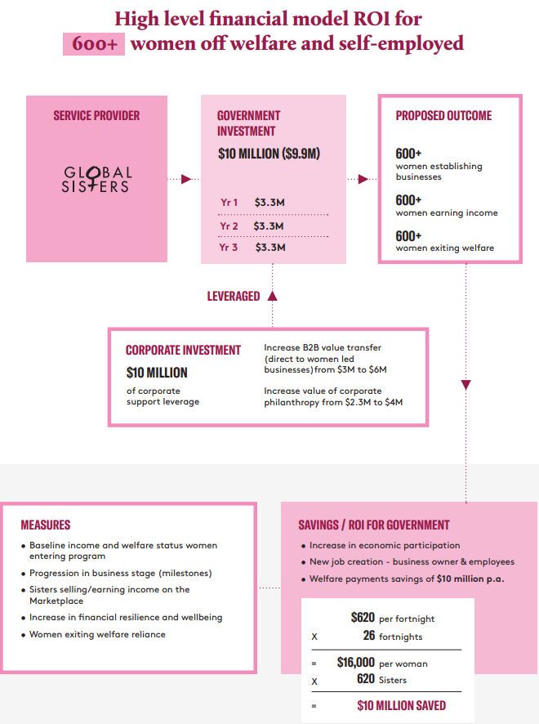
RECOMMENDATION 2: FINANCIAL SERVICES PRODUCTS
Mandate provision of customised financial products for women on low incomes starting micro-businesses.
A. Business loans and insurance
B. Financial planning and advice
C. Superannuation and investment portfolios
D. Affordable housing finance

  - Business loans and insurance
Currently women on low incomes face a multitude of barriers to securing appropriate loans and business insurance. Good intentions to grow a business through investment loans can become a financial burden and move women further into debt and poverty. Servicing a loan without appropriate guidance can result in debilitating financial dependence upon an institution. Similarly, business insurance is often regarded as out of reach for women starting up a micro-business.
These problems end up costing financial institutions and reduce their willingness to provide affordable, sustainable financial assistance to micro-businesswomen.
Microfinance loans
Successful loans are about more than receiving a sum of money. Global Sisters provides guidance to women over the five stages of using a loan to ensure financial security is sustained:
- Enquiring and applying for a loan
- Loan assessment, approval and agreement
- Loan disbursement into bank accounts
- Investing the loan into the business
- Repaying the loan, which is “recycled” to support more women
We believe that this type of support should be mandated for financial institutions providing loans for women in micro-business.
To overcome common challenges women face when securing, investing and servicing a business loan, Global Sisters has developed products for women in micro-businesses that are safe, affordable and accessible. They are no and low interest business loans for entrepreneurs across Australia created specifically for early-stage business.
These loans provide a model for other financial institutions to use when designing a loan product.
The Start Up Purse – turning an idea into a business
- No-interest loan with no fees
- Up to $1000
- Use to get your business off the ground
- Flexible repayment options
The Growth Wallet – growing an early stage business
- Low interest loan (3.5% flat) with no fees
- Between $1000 - $4000
- Use to grow your early-stage business
- Flexible repayment options
Small business insurance
Global Sisters has worked closely with AAMI Business Insurance to provide a tailored product for women on low incomes looking for small business insurance.
The insurance product is designed for women who:
- are on a low income,
- hold a health care card or receive a Centrelink benefit or
- have an annual household income of $48,000 or less (excluding Superannuation) and
- are part of the Global Sisters program.

CASE STUDY: SUPPORTING WOMEN IN TECH
Being part of the Sistertribe has meant a lot to me. I don’t feel I’m alone, there are so many Sisters out there. Whenever I’m facing some issue, I know where to go. They’re friends but they’re sisters.
I worked in IT in India for 18 years before migrating to Australia for a better environment for our son. When I initially came here, my husband and I were both searching for a job and while we were in the process I met one prospective client who wanted a customised IT solution for his office. He was very happy with the service I presented and I did not look back.
When I first started, I found that my biggest barrier was knowing what to do next. I had already taken a few steps before meeting Global Sisters in 2018, but where to go next? How should I approach my clients? Where should I look for them? When I met Global Sisters, it was like light at the end of the tunnel and I knew that I had to continue this journey. It motivated me and gave me positive energy.
I completed the My Big Idea workshop in 2018 and immediately learnt that no idea is a small idea. Even a single thought in your mind can turn into a big business. It can help people, and if you work towards that thought, it’s like a little seed you’re planting and after some years it turns into a big tree, giving you and other people fruits.
But money is not the only thing for which you build a business. The second thing is your contentment. It gives you internal satisfaction when you work, it’s like food for your mind. You’re building something, you’re giving it to people to use and when they gain something out of your business, it helps their business and they also gain a lot.
I’d recommend Sister School to others who are in exactly the same position as I once was. It will inspire them and motivate them and show them the way to go. It taught me how to do things on my own – from being introduced to Canva, to increasing my network, to all of the lessons at LinkedIn Learning that I was able to implement in my business.

While providing detail about the following recommendations fall outside the scope of our expertise, our experience points to three further financial services products that would provide significant benefit to women in micro-business, if tailored appropriately to their needs:
  - Financial planning and advice
  - Superannuation and investment portfolios
  - Affordable housing finance

RECOMMENDATION 3: GRANTS AND FUNDING
Prioritise Government engagement with micro-businesses to increase the percentage of micro-businesses accessing funding and support
A. Review and measure outcomes
B. Government initiatives for businesses that are ready to scale
C. Leveraging public private partnerships to deliver programs
Micro-businesses are the pipeline for all other businesses. Providing meaningful support at a micro-business level provides opportunities for growth that will lead to Australia’s next unicorn. Using agencies like the ATO, business.gov.au and ASBFEO, the Government must prioritise an increase in the percentage of micro-businesses accessing funding and support.
  - Review and measure outcomes
There is a dearth of Australian research relating to the efficacy and effects of microfinance for women. We use the following metrics for programs and suggest that they be used in all Government grants programs:
- Baseline women entering program
- Progression in business stage
- Women selling/earning income (we used our Global Marketplace as a source of data)
- Increase in economic security and wellbeing
- Women exiting welfare reliance

- Government initiatives for businesses that are ready to scale
While we commend the Government’s focus on supporting entrepreneurship, we have found that support for small businesses that are ready to scale is lacking.
Grants and mentorship for businesses that have moved beyond ideation and early start-up phase are lacking, meaning the pipeline is missing a link that launches small operations into commercial viability and larger scale growth.

- Leveraging public private partnerships
Part of the success of the Global Sisters programs relies on the partnerships we form with private enterprise with expertise in business success. While the Government’s Women’s Economic Security Statement was a step in the right direction, updates to this plan have not been forthcoming. We urge the Government to continue its work in this space.

PRODUCTIVITY CONTEXT
Women’s participation expected to add billions to national GDP
Improvements to women’s participation and economic security are not just meaningful at an individual and societal level but could significantly increase potential GDP and thereby add to Australia’s economic growth. It is estimated that 20 to 40 per cent of per person growth in the United States between 1960 and 2010 may be due to the reduction of barriers faced by women and minority groups that prevented making the best use of people’s talents in the economy.
Australia has the most highly educated and skilled prime-age female labour force in the OECD. Last month the ABS reported 50% of young women aged 25 to 34 have a university degree. Given the underutilisation rate, this base represents a huge untapped resource of skills and knowledge.
In 2012, the Grattan Institute found that if there were an extra 6 per cent of women in the workforce, we could add up to $25 billion, or approximately 1 per cent, to Australia’s Gross Domestic Product (GDP).⁵ The Organisation for Economic Co-operation and Development (OECD) also estimates that closing the gender participation gap by 75 per cent could increase growth in Australian GDP per capita from 2 per cent per annum to 2.4 per cent.

Women are still underrepresented in the workforce
In 2019-20, for those aged 20-74 years, the underemployment rate for women was 10.3% and for men was 7.2%. This represents people in the labour force who wanted, and were available for, more hours of work than they currently had.
Underutilisation of women in the workforce is a recognised as a global problem. The 2014 G20 meeting in Brisbane saw leaders from G20 countries agree to reduce the gender participation gap between working aged men and women (aged 15–64 years) by 25 per cent by 2025.
Adding people who are either unemployed or underemployed together creates an underutilised labour force population, from which an underutilisation rate can be derived. The labour force underutilisation rate in Australia in 2019–20 for those aged 20–74 years old was higher for women (15.1%) than it was for men (12.1%).
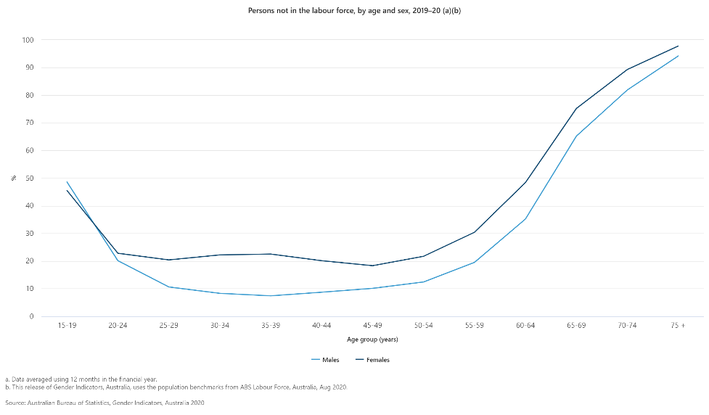
Reasons for working part-time differ by gender. For men, the main reason is studying. Over time, an increasing share of men have also reported working part-time due to preferences, or because their preferred job is part-time. By comparison, women are most likely to report working part-time due to caring responsibilities (28 per cent compared with 5 per cent of male part-time workers).
Women’s workforce participation is growing but it is demonstrably underutilised
The sustained increase in the female participation rate in Australia has been larger than projected in previous reports but is broadly mirrored by the experience of similar countries. However, the female participation rate remains well below that of males. In 2019-20, the participation rate for women aged over 15 was 60.5 per cent, compared with 70.4 per cent for men. As participation rates for women aged over 40 are expected to increase, the gap between female and male participation is expected to narrow by around 2 percentage points by 2060-61. Continued policy support could further encourage female participation.
But women want jobs: the main reason women were unavailable to start work was "Caring for children" (48%). The most important incentives for people to seek a job or more hours were those related to child-care access and costs. There were 2.7 million people who did not work full-time and wanted a job or preferred to work more hours. Of these, there were 1.1 million people who wanted a job or work with more hours, were available but were not looking. 62% of this group were women and commonly reported that "Caring for Children" was the main reason for not looking for a job or work with more hours (85% compared to 15% for men).

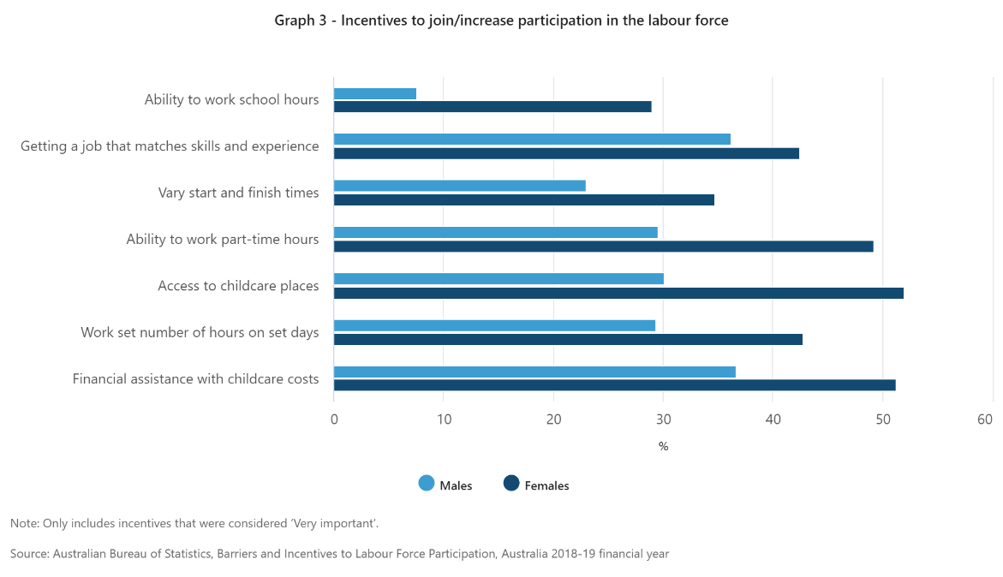

Women continue to face barriers, particularly related to responsibility for childcare
Primary caring responsibilities continue to fall disproportionately to women. There is still a significant gap in the amount of unpaid care work undertaken by mothers and fathers, even beyond the early years of child rearing. This may present ongoing barriers to mothers increasing their workforce participation.
An ASBFEO survey of more than 600 Australian women-owned, women-led small businesses has revealed 43% of respondents identified access to capital as a central barrier to growth.
Global Sisters’ most recent research, which surveyed nearly 200 entrepreneurial women, pointed to three key barriers that stop women starting and growing their business:
- Lack of confidence (68%)
- Lack of connection & support (65%)
- Lack of business skills (64%)

The number of women-led micro-businesses is growing
Small business contributed almost $418 billion of value added in 2018-19, which represents over 32% of Australia’s total GDP.
The data shows a steady upwards trend in the proportion of female business owners/managers over the last 20 years, with women now representing 35.4% of business owner/managers (number estimated by ASBFEO).
Micro-businesses represent 89.2% of all Australian businesses and yet they receive just 7.3% of government funding as a proportion of total funds granted to business.
While the number of employees fell by 312,400 between July 2019 and July 2020 the number of women in micro-business actually increased by 8,800. In fact, over that period women in micro-business exhibited the strongest growth of any category of employment. Figure 1 compares the relative growth of males and females categorised as employees or micro-business owners over the past 12 months.
Figure 1 shows that over the most recent 12 months for which there is ABS data the number of women who are owner managers of unincorporated enterprises has grown by 2.3 per cent while the number of male and female employees have declined by 2.6 and 3.3 percent respectively. The number of male micro-business owners has fallen nearly 10 percent.
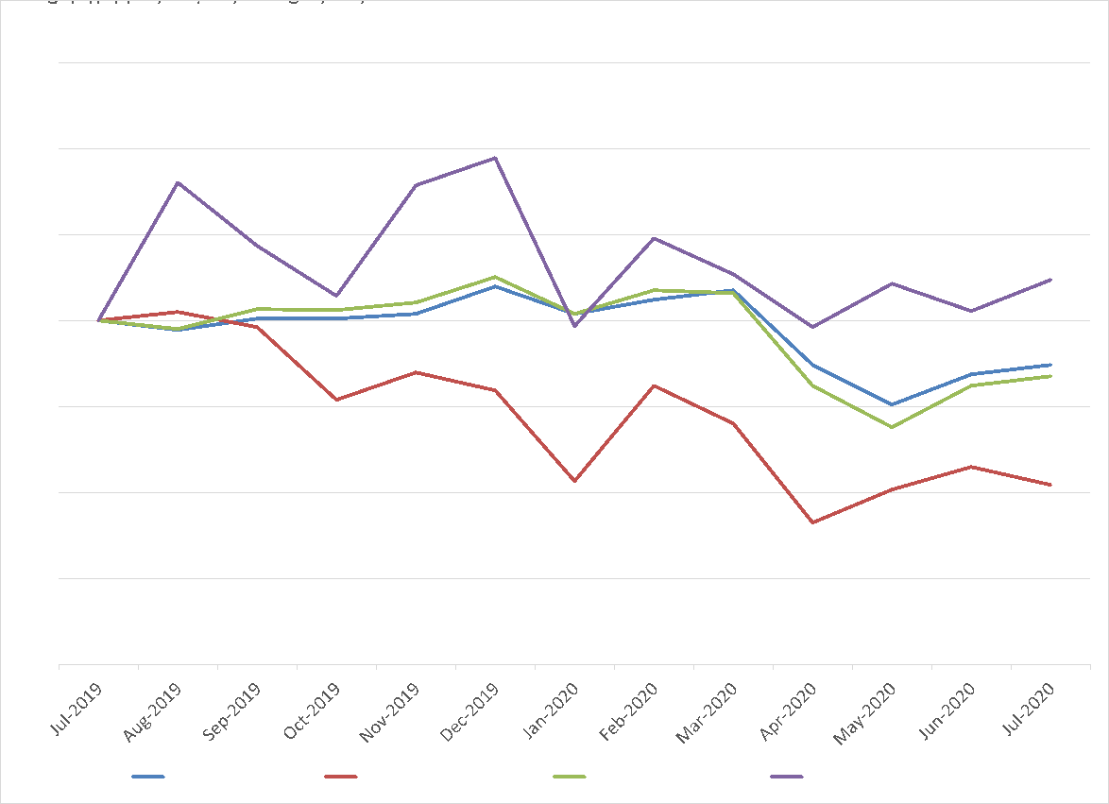
Figure 1 Source: ABS 6291.0.55.001 - EM6 - Employed persons by Hours actually worked in all jobs, Sex and Status in employment of main job
While women have been hit hard by this recession women in micro-business have, to date, bucked the trend. Owning a micro-business is not without its challenges, and there is no doubt that the lack of income security, sick leave and holiday leave associated with owning and running a micro-business can be a significant challenge. But there is also no doubt that for many people with caring responsibilities, the flexibility of being your own boss and/or working from home can provide significant benefits. And as a disproportionate amount of women take on caring roles in Australia, the benefits of owning a micro-business are likely to be particularly valuable to women.
While the data presented above does not provide clear evidence of what is driving these trends, it is clear that while men have become less willing or able to operate micro-business since the arrival of COVID19 a growing number of women are choosing to do so.
In turn, the more support and opportunities that women with an interest in establishing a micro-business can receive, the lower the level of unemployment is likely to be.

Wage growth in micro-businesses is strong (but starts from a much lower base)
Growth in median employment per job between 2012–13 and 2016–17 was highest for firms employing fewer than five employees (at 2.9 per cent per annum). In contrast, median employment income for employees of large firms grew at an annual average of 2.1 per cent.
However, employees of smaller firms receive on average lower average annual wages and salaries than employees of medium–sized and large–sized firms. (These figures also don’t account for hours worked)
Small businesses contributed a smaller share of IVA compared with their share of total employment commensurate with their smaller scale and productive capacity. However – better employed in small business than nothing.

FINAL COMMENTS
Global Sisters would welcome the opportunity to engage in a roundtable discussion and present at a public hearing as part of the Productivity Commission’s inquiry. We believe our experience and evidence-based programs should be part of one of the key pillars of improving Australia’s productivity – empowering more women to participate in meaningful work.

Mandy Richardson
CEO & Founder, Global Sisters
23 March 2022

https://www.oecd.org/cfe/smes/Policy-Brief-on-Women-s-Entrepreneurship.pdf
Eligible single parents can have their income payment ‘topped up’ to the parenting payment single rate, but this creates significant additional reporting burdens, results in their income fluctuating based on business profitability, and causes them to have to re-apply for their parenting payment at the end of 9 months.
Global Sisters has a detailed outcomes framework that is used to analyse the progress of businesses at key milestones that could be used for this purpose.
https://globalsisters.org/AnnualReport/wp-content/uploads/2021/02/GS200922-Microfinance-Leaflet.pdf
https://globalsisters.org/wp-content/uploads/2020/11/GlobalSisters_business_insurance.pdf
https://treasury.gov.au/sites/default/files/2021-06/p2021_182464.pdf (Intergenerational Report 2021)
https://www.theguardian.com/commentisfree/2021/dec/14/australias-working-women-are-productivity-gold-here-are-five-ways-to-help-them-thrive
https://womensworkforceparticipation.pmc.gov.au/womens-workforce-participation-economic-priority.html#:~:text=The%20Australian%20economy%20would%20grow,Gross%20Domestic%20Product%20(GDP)
https://www.pmc.gov.au/sites/default/files/publications/womens-economic-security-statement-2018.pdf
https://www.abs.gov.au/statistics/people/people-and-communities/gender-indicators-australia/latest-release
https://treasury.gov.au/sites/default/files/2021-06/p2021_182464.pdf (Intergenerational Report 2021)
https://treasury.gov.au/sites/default/files/2021-06/p2021_182464.pdf (Intergenerational Report 2021)
https://www.abs.gov.au/statistics/labour/employment-and-unemployment/barriers-and-incentives-labour-force-participation-australia/latest-release
https://treasury.gov.au/sites/default/files/2021-06/p2021_182464.pdf (Intergenerational Report 2021)
https://www.asbfeo.gov.au/media-centre/media-releases/access-capital-still-barrier-women-led-small-businesses
https://www.asbfeo.gov.au/sites/default/files/2021-11/ASBFEO%20Small%20Business%20Counts%20Dec%202020%20v2_0.pdf
https://www.asbfeo.gov.au/sites/default/files/2021-11/ASBFEO%20Small%20Business%20Counts%20Dec%202020%20v2_0.pdf
https://www.aph.gov.au/About_Parliament/Parliamentary_Departments/Parliamentary_Library/pubs/rp/rp1920/SmallBusinessSectorAustralianEconomy#_Toc29222126

