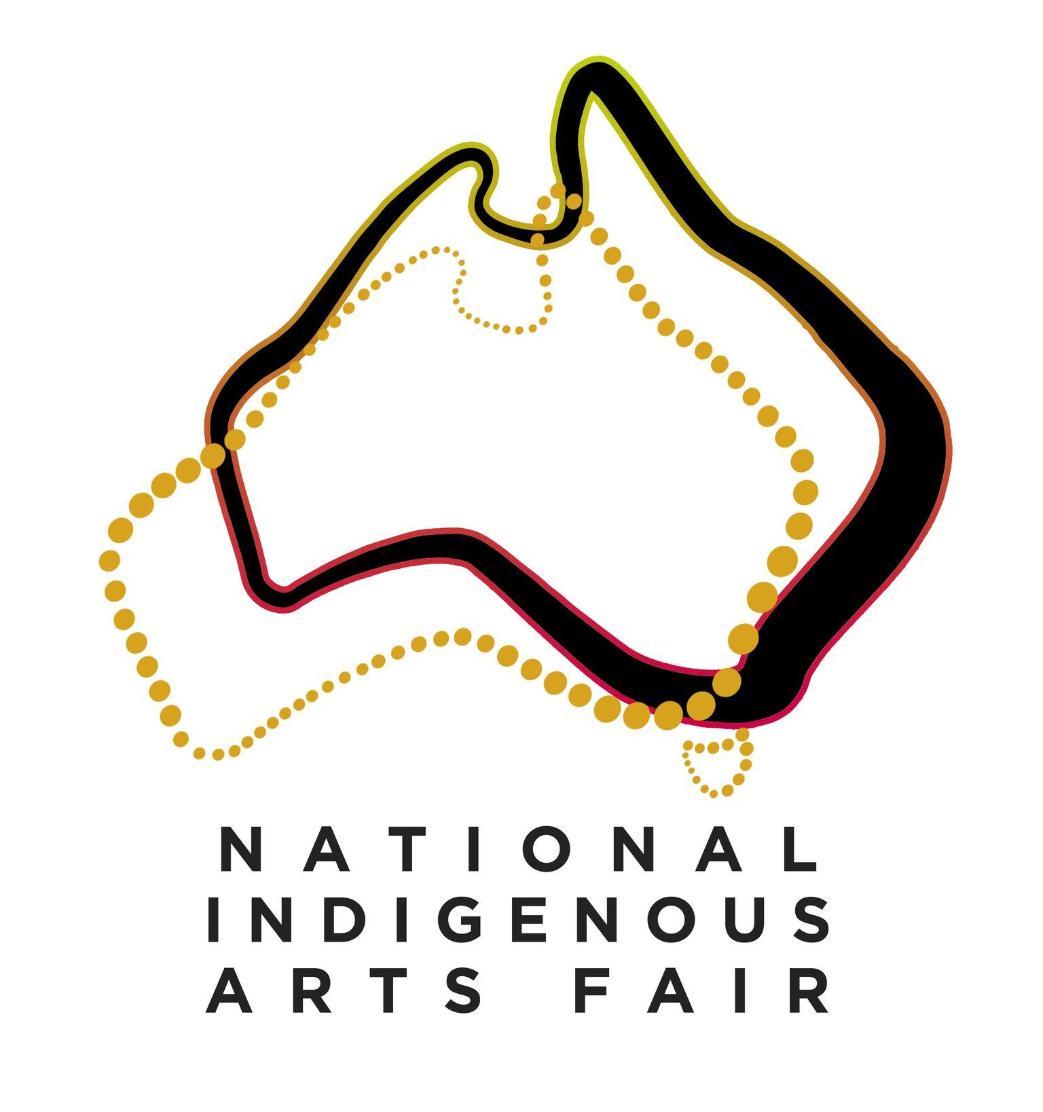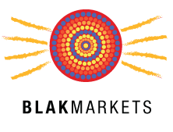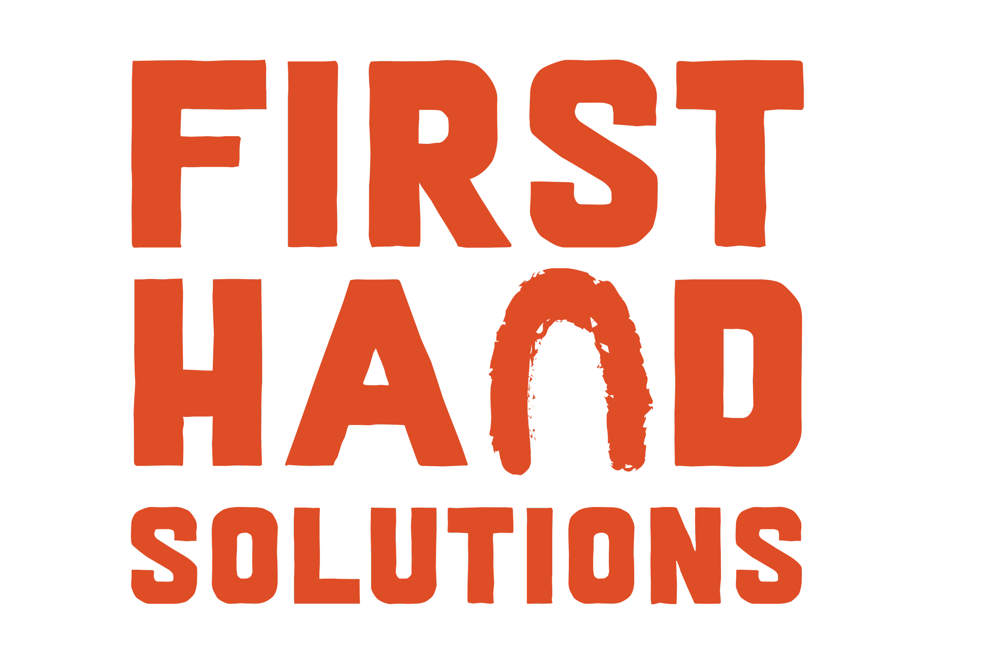

Ensuring that Aboriginal and Torres Strait islander artists/artisans, their businesses, families, communities and organisations are the beneficiaries of any legal or policy changes to protect the industry

We are submitting this piece as the Productivity Commission has asked stakeholders to highlight areas they feel need to be looked at to ensure future decisions support the Aboriginal and Torres Strait Island arts and craft industry and artists.
First Hand Solutions Aboriginal Corporation is the creator of two economic marketplaces - the Blak Markets and the National Indigenous Art Fair. We see the huge benefits gained from having Indigenous organisations at the retail end of the marketplace both from an economic and cultural leadership perspective. We are also concerned that in 2021 there are still so few, and that policies need to both recognise their importance and assist and support more Indigneous people into this space.
Indigenous-run structures not only ensure authenticity and help stop carpet-bagging behaviour but enable the many Consumers wanting to make a decision on the basis of buying directly from Indigenous artists and organisations due to the increased impact of their purchase, a clearer pathway to do so.
As pointed out by many research papers, including Dr Eloise Zoppos, from Monash Business School’s Australian Consumer and Retail Studies unit, ethical consumers are changing the retail landscape.
“ The modern shopper is constantly searching for meaning, not only in how they live, but also how they consume,” Dr Zoppos said. It is now extremely important to them that their purchases are meaningful and making a difference on the ground and is why many now want to purchase directly and not through third parties."
"Research shows that two-thirds of consumers are willing to splurge on products from a sustainable or socially conscious brand (this rises to 73 per cent for millennials), while 70 per cent will pay more for products that don’t infringe on human rights.
This is why consumers need to be educated not just about buying from non-Indigenous organisations who have applied an ethical code to their behaviour in this space but also how they can purchase their art directly from Indigenous businesses and community art centres if they so choose, because of the significant social impact achieved when doing so.
This has been well demonstrated in Supply Nation's Sleeping Giant Report which showed that Indigenous business owners use their business as a vehicle to drive change for themselves, their families and wider community expressing pride in being an example of strength, independence and positive role models for the next generation. Business owners invest in their children’s well-being, education, act as mentors for their employees and other businesses, and are positive role models in the community – factors they attribute to owning their own business.
These changes were given a monetary value. Across the five Certified Supplier businesses the Social Return on Investment (SROI) averaged $4.41 for every dollar of revenue for a Certified Supplier. This means that for every dollar of revenue they generate, in addition to goods and services, Certified Suppliers create an average $3.41 social value. Higher SROI ratios were associated with smaller businesses and those associated with those producing cultural products (which would include Arts and Craft).
So we ask that the future focus of policy is to direct people directly to Indigenous business or organisations, or assist to build more Indigenous run business, marketplaces, retail and art galleries.

This would in turn ensure:
1) More of the profit generated from the sale go directly back to Indigenous artists/ communities
2) Building consumer trust to buy knowing their purchase is authentic as the Indigenous organisations have their own process of demonstrating their governance
3)The huge business learnings and leadership gained from having more Indigenous people in the retail end of the supply chain which in 2021 across Australia can still be counted on two hands.
4) Increased business skills and development from operating in a real live marketplace.
The newly formed national indigenous peak body, First Nations Bushfood and Botanical Alliance Australia (FNBBAA) which requires individual members to confirm Aboriginality and businesses must prove they are 51% or more Indigenous owned and operated to become members & get the certification logo. We believe this is one way ahead.
In FNBBAA's case the logo represents that a business is Indigenous and there are similar Indigneous certifications such as Supply Nation certification. In the art industry there is only the Indigenous Art Code certification which provides some guarantees that non-Indigenous dealers are following ethical practices but doesn't provide the important information about whether it is an Indigenous organisation or not.
While there is certainly a role for non-Indigenous business in this space, there needs to be policies introduced that close the huge gap of the lack of Indigenous organisations in this space into the future which will ensure increased Indigenous leadership and Indigenous driven initiatives in this space.
First Hand Solutions is aware of many ways to support Indigenous-owned organisations into the retail end of the supply chain into the future. Our business model is based on setting up & running marketplaces intermittently and not operating 365 days of the year.
There are many potential retail models that could help increase representation of Indigenous business and organisations at the retail end of the supply chain, which would assist in further closing the gap.
Sarah Martin, General Manager, National Indigenous Art Fair & Founder of Blak Markets
Peter Cooley, CEO, First Hand Solutions Aboriginal Corporation

