The WIM Alliance, consisting of the Regional Councils of Whitsunday, Isaac and Mackay, provide the following submission in response to the inquiry into the National Water Initiative. The inquiry will examine the progress of Australian governments towards achieving the objectives and outcomes of the 2004 Intergovernmental Agreement on a National Water Initiative (NWI). This inquiry is the third undertaken by the Commission on national water reform.
The Commission has been asked to make recommendations:
- On actions that the parties to the NWI might take to better achieve the objectives and outcomes of the NWI.
- To support all Australian governments in efforts to progress national water reform in light of current priorities, including water security and the involvement of First Nations communities in water management.
- On how the Australian Government can better utilise the Water Act 2007 (Cth) as a framework for guiding national water reform policy.
The Commission is also interested in whether the findings and recommendations and the NWI renewal advice from the Commission’s 2020 inquiry should be strengthened or added to in light of policy developments, environmental or other changes over the past three years.

This submission provides an introductory statement outlining the WIM Alliance recommendations and advice and then provides an edited version of the NWI Renewal Advice from National Water Reform 2020 Inquiry Report (Table 1) providing recommended amendments and potential inclusions for the NWI Inquiry Report 2024. This submission also provides comment against the six elements of the National Water Initative.
Summarised Recommendations
The NWI should ensure long term water security by enabling all three level of governments to have a view of efficient water demand and water security so that proactive measures can be taken. Each level of governments views and policies should stand as a potential challenge and provide the opportunity for continuous improvement to each level of government in a collaborative and continuing improvement process.
In Australia we understand water management challenges but in order to keep water management efficient, we need to make the correct risk weighted decisions to avoid real drought responses that on a risk weighted basis could have been avoided by alternate choices changes. From this point, each level of government can define and improve the water management strategies (such as reduce open space potable water demand through high quality recycled water and or bore water use etc).
The NWI should define what first people’s water is and the many ways in which first peoples water can assist each and every one of them in their many and diverse ways. If a first peoples water concept is to have maximal benefit for minimal costs the maximal ways to benefit first nations peoples in diverse ways should be considered. Once this is understood how this impact on other water users, entitlements and parameters can be defined.
Efficient management of water demand will vary due to varying climates across Australia (from Tropical to Temperate) and community size thus the diversity of water services provided will differ.

The key points highlighted by the WIM Alliance members are:
- Water Licencing allocations are fair and cost effective, while ensuring long-term water security for communities.
- Urban Water Reforms could include integration of regional utilities across regional Queensland e.g. QWRAP areas.
- Ensuring support for other regional areas. Regional communities often have limited capacity to assist other regional area – e.g. Cyclone Jasper.
- Ageing work force (>50 years) within water providers. The capacity to deliver may increase with regional wide approach to water utilities.
- A layered management structure like Disaster Management style coordination is suggested for provision of water services.
- Funding models linked to economic requirements to ensure water utilities are viable based on increasing costs (water pricing – Sunwater/mining companies).
- Water Security increasing economics costs (water pricing) as well as raw water quality concerns; surety of raw water where mining companies are the only identity that have agreements to purchase water from Sunwater.
- Remote access using state of the art systems with roving crews to address issues / maintenance of water infrastructure.
- A more centralised (regional) approach for environmental management, plant design and water infrastructure planning while water infrastructure operations and maintenance still locally based to ensure efficient and cost-effective delivery of water services.
- Water utilities corporatised where economically viable.
- Lack of formalised structured Certificate Training within the water industry.
- Different needs from different areas due to varying populations, raw water quality and travel costs (plus available resources).

Edited version of the NWI Renewal Advice from National Water Reform 2020 Inquiry Report (Table 1)

Outlined below is an edited version of the NWI Renewal Advice from National Water Reform 2020 Inquiry Report (Table 1), with relevant points to the WIM Alliance highlighted in yellow and comments / recommendations highlighted in green.

NWI Renewal Advice from National Water Reform 2020 Inquiry Report
Table 1 NWI renewal advice: high-level summary by area
A refreshed intent
- Modernise the National Water Initiative (NWI) goal by including references to climate change and Traditional Owners. (3.1)
- Increase emphasis on water service provision, provide more detail for water resource management and refer to cultural outcomes in NWI objectives. (3.2, 3.3)
- Embed six overarching principles in all policy areas. (3.4)
- Develop new elements covering Aboriginal and Torres Strait Islander people’s interests in water, and infrastructure development. Significantly enhance the environmental management and water accounting (system integrity) elements. (3.5)
- Update references to interactions between the NWI and other key initiatives. (3.6)
Governance of the agreement
- Water ministers should convene periodically to oversee development of a renewed NWI. (4.1)
- The renewed NWI should clearly link desired outcomes to objectives and limit prescriptive actions, instead setting out principles for best-practice, fit-for-purpose policy approaches. (4.1)
- Jurisdictions should prepare 3-year rolling work programs, with progress independently assessed on a triennial basis. (4.1)
- There should be a comprehensive review of national water policy every 10 years. (4.1)
- The National Water Reform Committee should provide transparent on-going oversight of the agreement. (4.1)
A framework for water resource management
- Embed the concept of fit-for-purpose water resource management in a new NWI. (5.1)
Water entitlements and planning
- Recommit to the key outcomes and actions related to water access privately held (excluding federally or state) entitlements, and ensure entitlements and access rights frameworks are fit for purpose. Remove the special provision / restrictions for mineral, petroleum and mining industries (where appropriate); consider exemptions / hierarchy on the basis of context, not industry or user; establish a process to determine whether alternative water sources can be incorporated into water access entitlements frameworks; and adopt a risk-based approach to managing significant interception or provision (mine pit water access and treatment / dewatering) activities. (6.1)
- Revise and re-publish water security parameters at each Water Planning instrument review timeline (maximum interval 10 years). Require State, federal and Local Governments to state a “desired security and desired minimum efficient demand parameters”.
  - For all systems and catchments where Reserves exist (strategic and or general) urban security is assessed and potentially allowed for using up to date understanding of climate, catchment behaviour, storage operation, environmental, first nations (net change only), and other net water users impact as well as a common view of range of efficient water demand (that may inform potential restriction efficiency). The intent if moving to a common water security language (and similar and aligning basis of assessment) is to minimise the number of regions where water allocations are challenged by real droughts or other water users rights are impacted in a real drought. The approach would also allow for strategic choices could be made in times of plenty / water resource growth (Dam building / raising) / normal times.
  - If a process of continual improvement in defining water resources is pursued (distinct from pursuing additional conservatism) national and international reputation of trusting and understanding asset rights may be enhanced even in potentially uncertain times.
- Enhance water planning provisions to better reflect current best practice and embed processes to better account for economic and cultural importance of current permanent populations (water security and climate variability understood currently (for all persons including first nations)), climate change including in relation to: dealing with expected extremes (maximal climate variability) beyond historical extreme scenarios; water quality issues and potential solutions (including timeline to deliver, informing trigger levels of responses); rebalancing and hierarchy of water users if any; modelling climate; and provisions for allocating risk. (6.2)
Trading and markets
- Emphasise that the purpose of water trading and markets is as a tool within a water resource management framework to increase efficiency. Market arrangements need to be fit-for-purpose and support quality of life, productive or environmental values (in addition / distinct from simply financial / economic assessment (charging more for the same water)). (7.1)
- Recommit to the NWI water trading and market principles. Reshape principles covering governance, regulatory and operational arrangements for water trading and markets to provide leading practice foundations for developing markets with clear intensions and measurement systems. (7.2)
- Provide information to support efficient water markets. (7.3)

Environmental management
- Adopt best-practice development of environmental objectives and agreed environmental targets outcomes. (8.1)
- Integrate management of environmental water and complementary natural resource management. (8.2) and first nations water management if / where overlaps exist
- Where not in place, establish a formal institutional oversight responsibility for wetland and waterway management preferably within an existing entity stakeholder group with aligned interest. (8.3)
- Establish clear processes for reviewing progress on environmental outcomes within a clear probabilistic framework. (8.4)
- Embed criteria for prioritising environmental watering of prioritised environmental assts, and objectives for environmental watering under different climate scenarios. (8.5)
- Ensure environmental water holders’ trade strategies are in place, transparent and reviewed updated regularly to minimise arbitrage financial losses to other traders where inefficient long term. (8.6)
- Environmental water holders should pursue innovative market approaches with a long-term efficiency effectiveness target. (8.7)
- Enable environmental water holders to vary their entitlement portfolio over time. (8.8)
- Actively pursue public benefit outcomes where they do not compromise environmental outcomes and consider water on the scale of the catchment (infiltration is often a groundwater / spring recharge as well as a loss). (8.9)
- Independently audit the adequacy and use of environmental water entitlements every three years. (8.10)
- Obligate system managers to use their best endeavours to achieve agreed targets. (8.11)
- Commit to adaptive management. (8.12)
Aboriginal and Torres Strait Islander people’s interests in water
- Co-design a new NWI element dedicated to Aboriginal and Torres Strait Islander people’s interests in water and involvement in water and environmental management. (9.1)
- Improve cultural outcomes (and potentially economic opportunities) using existing frameworks. (9.2)
- Improve access to water for economic development in a maximum range of ways to support the diverse desires and needs of this (and all) groups of Australians. (9.3)
- Specifically define and understand first nations role as being from the environment and sustainably harvesting plants and animals historically and through to this day. Consider economic opportunities for first nations people to sustainable continue this be that through sharing the bounty and / or sharing the experience with customers / others should water resources yield a safe take of the plants or animals.
System integrity
- Build system integrity through a renewed element and regular real improvement of understanding of water in line with planning / regulator instrument review. (10.1)
- Ensure system integrity through fit-for-purpose metering and measurement, registers and effective compliance and enforcement systems and real and improving understanding of losses impact (positive and negative) on the system / catchment. (10.2)
- Ensure the integrity of water system management via effective information provision. (10.3)
- Ensure information on the broader water context aligns with users’ needs. (10.4)
Pricing and institutional arrangements
- Maintain core principle of cost-reflective, consumption-based pricing with full cost recovery. Maintain institutional separation of water resource management, standard setting and regulatory enforcement from service delivery. (11.1)
- Adopt principles for best-practice independent economic regulation. Commit to light touch economic oversight for small regional and remote urban water providers and a framework for applying different models where the benefits exceed the costs. (11.2, 11.3)
- Maintain water service provider performance monitoring and reporting. (11.4)
Urban water services
- Update the National Water Urban Planning Principles and embed them in the NWI. (12.1)
- Update and recommit to the NWI Pricing Principles. (12.2)
- Subject all urban water service providers to performance monitoring and reporting. (12.3)
- Commit to ensuring affordable access to a basic level of water services for all Australians. At a minimum, these would include safe and reliable drinking water. Where subsidies are needed, they should be provided as transparent community service obligation payments. (12.4)
- Include principles for governance of regional and remote water services where local governments retain ownership of utilities. (12.5)
- Monitor and report on water quality and service outcomes in remote Aboriginal and Torres Strait Islander communities. (12.6)

Infrastructure development
- Develop an element to guide investment in water infrastructure. Restate the high-level requirement for all infrastructure to be assessed as economically viable and ecologically sustainable prior to the commitment of funding, with cost recovery from users the norm. Add a further requirement that infrastructure development processes are culturally responsive to Traditional Owners’ interests to ensure deep engagement and, at a minimum, protection of cultural assets. (14.1)
- Agree to criteria on how major projects can demonstrate adherence to the NWI requirements for infrastructure. (14.2)
- Clarify institutional roles and responsibilities underpinning government investment. (14.3)
Community engagement, and adjustment
- Include guiding principles clarifying how governments can respond to any significant community adjustment pressures resulting from policy-induced reductions in water availability. (13.1)
- Recommit to best-practice, cost-effective engagement with communities on all water matters. (15.1)
Knowledge, capacity and capability building
- Commit to a culture of evidence-based decision making, innovation and continuous improvement to underpin successful implementation. (16.1)

Elements of the National Water Initiative.
Outlined below are further comments on the different elements of the National Water Initiative.
1. Water access entitlements and planning frameworks
2. Water markets and trading (No comments)
3. Best-practice water pricing and institutional arrangements
4. Integrated management of water for environmental and other public benefit outcomes
5. Water resource accounting
6. Urban water reform
7. Knowledge and capacity building
8. Community partnerships and adjustment. (No comments)

Response:
Element 1 - Water access entitlements and planning frameworks / Element 5 – Water Resource Accounting
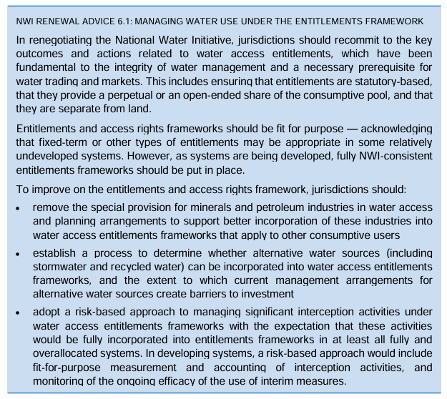
It is noted that there has been limited direction made available by Queensland State Government in relation to establishing a process for determining the suitability of alternative water sources to be incorporated into water access entitlement frameworks. There is certainly some provision for this through things such as stormwater offsets but no formal process or consideration for water management across all water streams and no accounting for water return from stormwater or treated effluent.
Further existing management arrangements (regulatory) create barriers to investment/opportunities in this space.
There is a low level of risk-based maturity within the Queensland State Government to effectively manage interception activities and a lack of entitlement frameworks to understand system utilisation, allocation and availability. Significant infrastructure projects are currently under investigation but there appears to be little water reliability, water balance or yield assessment works undertaken and if they are undertaken are not made readily available to stakeholders.
Finally, a number of water service providers within Queensland have major issues with water resource availability from both a reliability and cost perspective with significant challenges in working with SunWater on the appropriateness of charge rates whereby utility service providers are significantly cross-subsidising lower priority water users (e.g. high cost for raw water for town water supply vs. cost for irrigation access). There are similar issues for water service providers who need to engage with the private sector for water entitlements and access (e.g. mining sector).

Limited consistency in how water planning is completed within organisations, across regions or states. Generally limited availability of tools or principles to assist those completing water planning to make informed decisions on complex topics/questions. There is also limited documentation about the approach, extent and expectations of stakeholder engagement.
The recommendations from the previous review are all geared around a lower water future where drought as a result of changing climatic conditions results in poorer water quality and water delivery for customers. The recent and ongoing weather events and infrastructure challenges across North Queensland demonstrate that water planning needs to consider not only the impact of drought but also the impact of extended periods of wet weather and high flows and the impact that this has on water quality and provision of safe drinking water for customers. Similarly funding for resilience should not just consider trying to increase storage but also to increase the ability of water treatment and network facilities to operate under extreme conditions (dry weather, wet weather, major events).
There is still a high degree of variability in consumptive use across the country that is more than just weather dependent. A lack of overarching guidance or direction from regulators or the state on ensuring efficient consumptive use and targeting wastage has meant that this is driven by individual organisations. It has also resulted in inefficient allocation of state and federal funding for water projects. An example of this is the amount of funding allocated for the Haughton Pipeline Project in Townsville where major state funding was provided for a new water main to improve water security and resilience when the average consumptive is 400-500 L/EP/day. Comparatively water use per equivalent person (EP) per day in Mackay is 200-230 L/EP/day and elsewhere along the eastern seaboard between 140-250 L/EP/day.
No state or federal funding should be allocated for water security or resilience where utilities, communities and residents are inefficiently using a water resource.
System losses as a result of a changing climate also need to be proportionally weighted based on the surety of allocation and based on a framework that assesses the efficiency of the water user. For example, an irrigation entitlement is typically at a lower level of reliability than an entitlement for drinking water however if an irrigator has taken all steps to reduce water loss or waste it is not fair if they are significantly more restricted than a water services provider that has a high percentage of non-revenue water (NRW) and that is not promoting water education and efficiency for their customers. Incentivising positive behaviour or punishing poor behaviour in terms of water management should be encouraged.

Element 3 – Best-practice water pricing and institutional arrangements
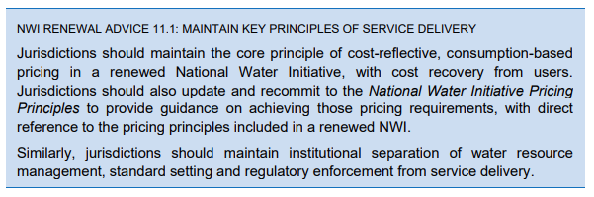
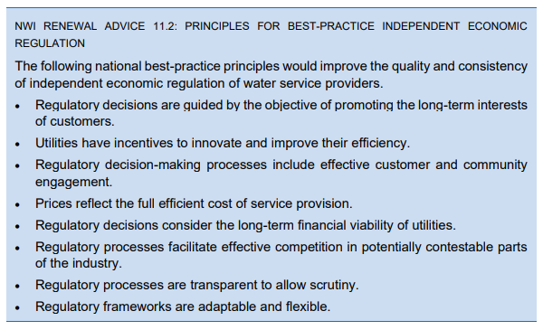
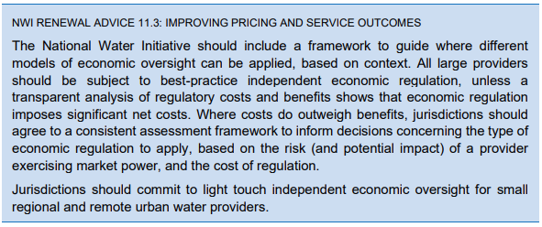
Observations from regional QLD and NSW is that LGA’s providing water and sewerage services have a very low level of understanding of the price of service provision. There is a lack of capability to complete a full cost pricing model and to ensure that customer charges are reflective of the cost of a sustainable service now and into the future. There is a clear and present need for Queensland Treasury Corporation (QTC) or the Queensland Competition Authority (QCA) to provide industry standard guidelines, training and templates such that water service providers can understand the cost of service provision and make sure that this is understood by communities and councillors.
There is a lack of consistency in pricing approaches as well with a high degree of variance between fixed and volumetric charges in terms of composition of total revenue stream. Many providers are sending a price signal to encourage water efficiency for customers which is positive but not understanding that there is a minimum percentage of revenue that must remain fixed to allow for asset deterioration and mortality that is largely unchanged regardless of the incremental cost of production and service (e.g. chemicals, energy, raw water pricing).
There is also a lack of consistency in the approach to setting either postage stamp (regional) or nodal pricing (system/scheme) which with no real locality pricing signal available through appropriately calculated and justified developer charges means water utilities may be increasing their risk profile by effectively undercharging for services in small schemes. An effective locality pricing signal through either nodal water pricing or scheme specific and appropriate developer charges helps to ensure that growth within the regions occurs in the areas that are best positioned to service the growth at the lowest total lifecycle cost.
Finally, there remains an inconsistent approach to calculating and declaring Community Service Obligations (CSOs) between authorities and also a lack of clarity and transparency around how the fixed charges are calculated for users with many authorities charging based on factors (land use codes or activities) as opposed to charging based on customer’s service potential and demand (i.e. connection size).

Element 4 – Integrated management of water for environmental and other public benefit outcomes
Existing recommendations and content of element 4 relates almost exclusively to quantitative outcomes in terms of volume of water in the environment. There is no real commentary or targets around the quality of water in the environment and enabling ways to allow for conversion of existing water entitlements into other innovative entitlement types (e.g. recycled effluent, treated stormwater, groundwater recharge schemes, etc.). The lived experience is still very much that licensing for treatment activities for point sources is highly variable between industry, commercial and utility emitters. There is also very limited interest or accountability for diffuse pollutant discharges particularly in the urban environment (stormwater). A true integrated management approach for water that considers environmental and other public benefits needs to consider the sources of water entering or leaving the environment and the opportunity cost or risk of water entering or leaving the system and the quality of the water. An assessment process that considers only water extraction and the maintenance of a base riparian or environmental flow is not a full integrated water cycle management approach and does not appropriately address environmental, social or economic requirements of water.
What does this mean? An increased focus on a full integrated water management approach for water service providers across the three major water streams (drinking water – surface water or groundwater sourced, wastewater/recycled water, stormwater) that considers volume as well as quality of water extracted and returned. An improved level of licensing and monitoring for industrial and commercial water extractors and emitters. Increased focus on the impacts of stormwater quality on the environmental performance and social value of our watercourses – this includes the positive impact of effective and fit for purpose stormwater treatment infrastructure.

Element 6 – Urban Water Reform
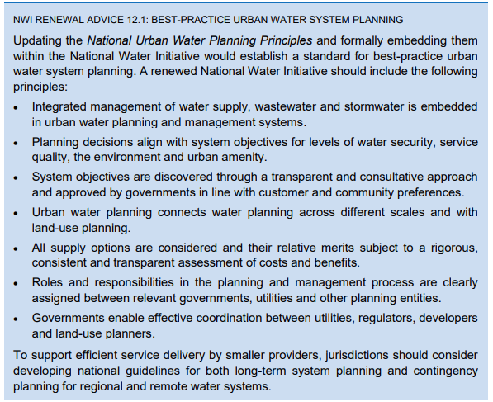
There is no evidence of any progress on the development of frameworks, tools or processes to ensure that integrated management of water supply, wastewater and stormwater is embedded within urban water planning and management systems. Further the existing regulatory approaches for management of these water streams is not complementary or compatible and perverse outcomes frequently occur (e.g. no formal requirement for stormwater treatment and monitoring of stormwater performance however stringent requirements for wastewater pumping and overflow requirements based on arbitrary flow triggers). There is not a true effects-based approach to the management of discharge of any type to the environment and a poor understanding of the receiving environments capacity to absorb or assimilate pollutant loads. The use of a one sized fits approach based purely on flow triggers is nonsensical when the flows in the receiving environment are not considered as part of the approach. Similarly, all discharges should be considered as part of a catchment based mass balance equation to understand the pollutant loads within a catchment as well as the natural capability of the catchment to absorb or assimilate pollutants loads without resulting in significant environmental, amenity or social impact.
There is no to little use of cost benefit analysis or assessment in different options for water infrastructure and again if considered is considered at the micro level rather than the macro level. This is again evidenced by the willingness of the state to government and in some instances federal government to fund projects that are not clearly scoped and that are not addressing a clear community need or risk (e.g. Haughton Pipeline).

Currently there is no requirement or incentive for systems based thinking and current boundaries for service providers don’t encourage a collaborative approach to water resource management or management of discharges that could impact downstream users (one utilities poorly managed stormwater discharge can sometimes be another utilities raw water source). This level of collaboration only occurs through voluntary mechanisms such as those supported by Regional Organisations of Council’s (ROCs), through qldwater directorate supported Queensland Water Regional Alliance Programs (QWRAP) or similar. There is a need for the Queensland and NSW state governments to commit to similar pieces of legislation as the Water Corporations Act (2008) that the Tasmanian State Government enacted to drive change in the provision of water and wastewater services. As a major public health or environmental harm incident is highly likely to occur due to limited resourcing, capability and capacity for a number of remote, regional and even larger regional areas. Developing dedicated regional water corporations helps to mitigate this risk significantly.
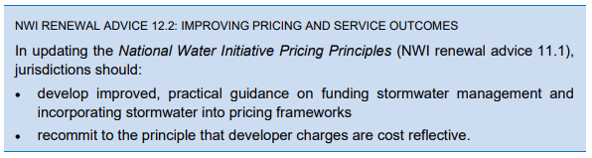
Agreed this should be a priority action and needs to be driven at a state level. It is noted however that the developer charges caps that are in place do not reflect the true infrastructure burden associated with provision of infrastructure to support development activities. Propose that the legacy IPART guidelines developed by NSW state government in the early 2000’s be revisited and utility service providers be required to calculate and publish the true cost of development so that the level of cross-subsidisation that is occurring can be transparently demonstrated to ratepayers and other stakeholders.
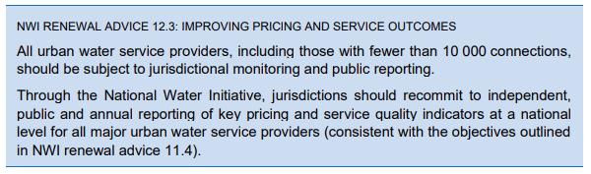
Agreed – without reporting at all levels the extent of challenges faced by small service providers cannot be easily communicated/understood. Given there are resource implications associated with completion of the reporting it would be helpful for some form of funding or in-kind support been provided to smaller service providers to assist them in completing reporting. The benefit of this is two-fold, one it ensures that all service providers report and two it will help to improve the accuracy of reporting as historically the level of rigour and accuracy in reporting has been poor even for larger service providers.
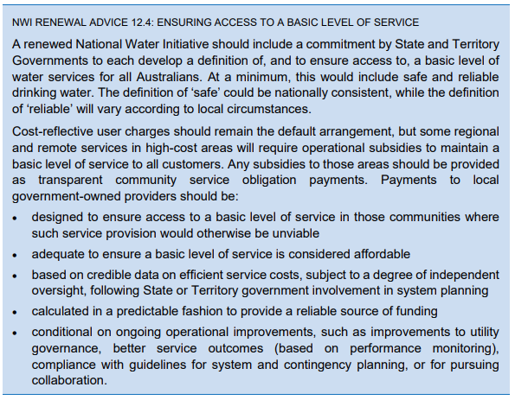
Disagree with this statement – provision of safe drinking water is not a universal right where individuals have consciously made an economic and lifestyle decision to live in towns/regions where provision of potable drinking water is not economically sustainable or feasible even with a high degree of cross-subsidisation from other sources.
Recent campaigns by entities such as TasWater with their 24 glasses campaign and by other water advocates to push a full potable water supply for systems with less than 100 connections represents an ‘all-care, no responsibility’ attitude. It is categorically unfair that customers in urban, semi-urban and regional areas are forced to cross-subsidise lifestyle choices for those who live in remote areas. The level of service that people can expect is in many ways tied to the purchase price of the property that they live in. The principle of caveat emptor should be more rigorously applied by those buying properties in these areas. If an individual can purchase a property at 20-30% of the purchase price of an equivalent property in a regional or semi urban area then the cost and risks of the water supply and sewage treatment should be reasonably expected to be borne by the individual. To commit to providing a full treated supply to every community in the country is grossly unsustainable and would mean that the current generation of water professionals are committing intergenerational inequity and forcing their successors to deal with a problem that they were too frightened to address.
The use of non-regulated supplies or non-potable supplies must be considered and a level of personal responsibility placed on residents in areas where the cost of service provision is grossly disproportionate to other schemes/areas.
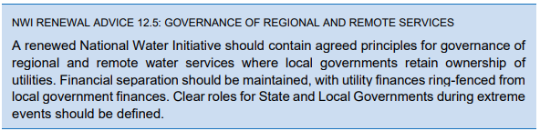
Agreed although the earlier sentiments remain – some form of cross-subsidisation is inevitable and should be tolerated however there is a point where it becomes manifestly unfair for other customers and for future customers. The level of cross-subsidisation should be calculated and reported so that the true cost of service provision for regional and remote schemes is understood. At some stage a discussion on service removal in remote schemes will need to be had and it would be prudent for guidelines to be developed to support water utilities through this difficult process.

Element 7 – Knowledge and Capacity Building
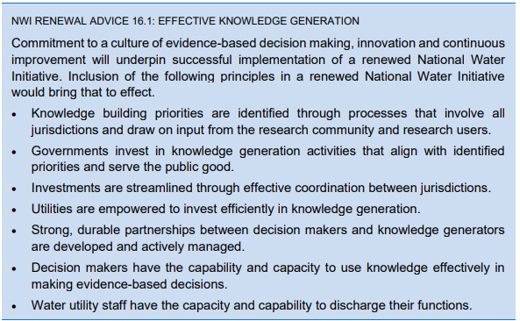
Although not directly relevant to the objectives currently captured within the NWI it is clear that there are significant issues with knowledge, capability and capacity within the water sector particularly in those areas that have not undergone major water reform (regional NSW and QLD). The timelapse between significant reform activities within Victoria (early 90s), SA, WA and Tas (mid 2000s) until now means that depending on the locality of where staff initially worked that local government employees in regional NSW and QLD may never have had any experience within water and sewer as in other jurisdictions this is a specialist function. This becomes even more telling as we see generational change within the water sector with a significant contingent of operational and technical staff (engineering, scientist, finance) leaving the sector through retirement. This results in a major knowledge vacuum in these areas and a further increase in the gap in terms of maturity in water infrastructure management between the areas that have undergone water reform and those that have not.
It is further observed that resourcing and capability in regional and remote areas remains an issue and that recent major weather events have demonstrated a lack of depth within organisations to manage in challenging situations. Lived experience from the Tasmanian water reform is that consolidation of resources from multiple LGAs into a single regional and ultimately single state entity significantly reduced the risks and performance impacts of major weather events, loss of long term staff and turnover of critical roles (scientists, engineers, project managers, accountants, etc.). It also allowed for consistency in approach (e.g. SCADA, design standards, equipment types, testing regimes, etc.) which further reduced complexity and increased organisational resilience and redundancy.
Personal belief is that regional NSW and regional QLD are feeling very similar to what Tasmania felt like in the mid to late 2000s where there are major issues with system and asset performance, a lack of understanding of infrastructure risk and an impending asset renewal/upgrade crisis as a result of asset mortality and increased level of regulatory and social expectation in relation to water and wastewater infrastructure performance and outcomes. The review of the NWI provides a platform to raise these concerns and if water reform is not politically or socially palatable at this time at least provides the mechanism to support the water sector through development of frameworks, tools and processes to improve water outcomes and also provides the rationale around requesting for additional support through funding or other government mechanisms.

This page is left intentional blank

