# THE COSTS AND BENEFITS OF GEOGRAPHIC LABOUR MOBILITY: A REGIONAL PERSPECTIVE

*Submission to Productivity Commission Inquiry into Geographic Labour Mobility*

*29 August 2013*

Preface

Independent and informed by both research and ongoing dialogue with the community, the Regional Australia Institute (RAI) develops policy and advocates for change to build a stronger economy and better quality of life in regional Australia – for the benefit of all Australians. The RAI was specifically formed to help bridge the gap between knowledge, debate and decision-making for the potential and future pathways of regional Australia. It exists to ensure local, state and federal policy makers, researchers and members of the community have access to the information they need to make informed choices about the future of regional Australia.

Geographic labour mobility is an essential component of the labour market and national efficiency. It is a mechanism for matching supply and demand of labour in circumstances of acute and long term economic change. Yet, the reasons people live and move where they do extends beyond labour opportunity to a myriad of decision making factors. The motivators, enablers and impediments to mobility envelop the assessment of geographic labour mobility and efficiency with a complex and diverse set of costs and benefits which have particular pertinence to regional Australia. Between 2006 and 2011, population turnover rates were dominated by regional areas, far outnumbering their capital city counterparts. Advances in travel and technology suggest that geographic labour mobility will continue to be important in both regions and national labour trends.

RAI believes geographic labour mobility is crucial to regional economics and has a strong interest in ensuring that regional areas are able to optimise their participation in the wider economy for the benefit of their citizens, the citizens of other regions as well as Australia as a whole. The effects of mobility, both positive and negative, recur as central themes in much of the research we have undertaken and in the conversations we have had with regional Australia. Realising the extent to which geographic labour mobility contributes to efficiency in some regions and conversely how it creates inefficiencies in the same or disparate regions is central to both regional and national productivity. It is with this strong interest and belief in labour mobility as a core theme of regional, and subsequently national, efficiency that RAI has made this submission.

RAI welcomes the opportunity to make a submission to the Productivity Commission inquiry into Geographic Labour Mobility and looks forward to an opportunity for further discussion with the Commission.

## Executive Summary

KEY POINTS

* Labour mobility in regional Australia is essential to optimising the social and economic benefits for all of Australia.
* The movement of people and labour is determined by many social, economic and structural factors - not just jobs.
* Regional Australia has some of the highest population turnover in Australia and is more sensitive to labour mobility than metropolitan areas.
* Each region is diverse and will have different sensitivities and house different opportunities in response to labour mobility and will reap diverse costs and benefits.

## One size does not fit all - Estimating the full costs and benefits of labour mobility requires consideration on who can and can’t be mobilised and which regions can and can’t participating the effects on those who can’t be mobilised as much as those who can.

Geographic labour mobility enables the demand for labour to be met. Flexible labour markets are critical for allowing an efficient allocation of resources, particularly in non-metropolitan regions of Australia where resources are scarce.

As such, labour market efficiency is reflective of how effectively a region shifts workers from one economic activity to another in a timely manner, at a low cost and with little social disruption. Labour market efficiency allows regions to adapt to and withstand external shocks, which is particularly important during times of greater economic uncertainty.

In regional areas, where there are lower concentrations of labour resources, the mobility of labour is essential to allowing resources to be allocated where needed. Large and small movements of labour into and out of localities can have a large impact on regional areas as they have smaller economies and are therefore more sensitive to fluctuations and change.

Yet it is unlikely, due to the many determinants of migration decision making, that the spatial supply of labour will equal the demand for labour. This results in imbalances in the spatial distribution of labour supply and labour demand and ultimately inefficiencies in economic activity.

As Australia’s regions vary significantly in their natural, human and labour capital it is inevitable that some will be more sensitive to the effects of labour mobility than others. A locality’s ability to retain and retract labour, particularly in more remote areas, is often not aligned with other determinants in the migration decision making process such as lifestyle and educational opportunity. Therefore, incentives in the form of salary are often needed in order to mobilise labour to that locality.

Over the last decade the mining boom has seen a huge demand for labour in localities with generally small labour markets. The enhanced mobility of labour has enabled the development of these markets and has brought many benefits to the local as well as the national economies.

RAI recognises, apart from general movements, that there are three mobility events in current Australian society;

* Those in response to booming markets;
* Those in response to structural adjustment; and
* Those related to natural disasters (often more acute events).

All of these events necessitate constant shift and adjustment of labour across the nation and within and between regions. In theory, labour mobility would result in a perfect matching of labour supply to demand and the most efficient market. Yet efficiency concerns not just pure equilibrium of markets but also whole of society costs.

For example while the mining boom has undoubtedly brought many benefits, whether these have provided the highest allocative efficiency for the well-being of all the community is questionable.

The clear winners of labour mobility are those that have the capital and skills which are in demand while those who suffer the biggest loss are those with small amounts of capital and skill sets of low demand. Ironically, these groups also carry the largest risk in migration decision making. Eliminating this risk is key to improving participation and improving the equitable distribution of benefits and therefore improving national efficiency through mobile labour.

Australia’s regions suffer a similar fate; those with poor resources and labour markets are unable to attract or retain higher skilled workers and those with better resources are able to attract more.

To ensure each sector of the economy operates as efficiently and effectively as possible it is necessary to ensure that the right resources are available at the right time, at the right place and price and that the collective wellbeing of the community is maximised. This involves assessing the costs and benefits of labour mobility to the efficiency of all types of Australia’s regions and holistically as a nation.

To gain an understanding of these costs and benefits we need to appreciate the demand and supply of the labour market now and in the future, the population, economic and market trends across Australia and internationally, as well as understand why people chose to live where they do, their migration determinants and drivers and those tools which enable and impede people to move and partake in the economy.

### Introduction

The RAI has completed a number of research and policy papers exploring the topics of labour mobility and regional issues in a regional context. These papers offer generous insight into the role of regions in Australia, their future and the issues and opportunities facing them. They provide extensive background into labour mobility and the considerations for national policy making and in examining the costs and benefits to regional communities in attaining overall national efficiency.

To understand labour mobility issues in regional Australia and the associated policy considerations this submission provides information on:

* Why people move and relative motivations in regional Australia;
* Impediments and enablers of mobility for regions and for different population groups;
* Labour market efficiency and the role of mobility in achieving efficiency;
* The trends in population movements;
* Trends in normative, temporal and acute mobility events within Australia;
* The implication of these trends on achieving labour mobility and its efficiency;
* Assessing the efficiency of labour mobility through spatial sensitivity and regional types; and
* The future policy discussions and points of further investigation.

### Why people move

While the Productivity Commission is charged with examining the economic outcomes from geographic labour mobility, it is essential to recognise that people move for many and varied reasons including employment but also lifestyle, family and education. The movement of people for any reason takes with it the labour resources and capital of those people, providing the new location with additional resources and the former location with fewer resources to support economic growth and development over time.

***DRIVERS OF MOBILITY***

* *Employment opportunities*
* *Life Satisfaction*
* *Education levels*
* *Expectations to achieve valued goals*
* *Income levels*
* *Lifestyle aspirations*
* *Health and education services*
* *Family connections*
* *Cultural migration behaviours*
* *Access to education*
* *Access to housing*
* *Drought*
* *Climatic conditions*
* *Access to health services*
* *Age – Stage of life*
* *Natural disasters*
* *Low confidence for future*

Migration decision-making is strongly influenced by factors such as lack of employment opportunities, drought, policies, education, better living conditions, climate and family. Migration determinants are commonly divided into two groups of factors: push and pull. Push factors are things that are unfavourable about the area that one lives in, and pull factors are things that attract one to another area (F.De Jong 2000).

The RAI recently completed regression analysis modelling to determine the relationship between services, social outcomes and people’s intention to leave the existing place of residence by different types of regions utilising the Household Income and Labour Dynamics in Australia (HILDA) survey data.

The graph in Figure 1 plots the level of significance being unemployed and having a low life satisfaction have on a persons’ preference to leave an area in each type of region. To measure the significance the graph also shows the average response of people with a desire to leave an area.

It is clear that having low life satisfaction is of much greater significance to determining whether someone has a desire to leave and that being unemployed is only marginally more significant than the average controlled score for each type of region. The graph also shows that people in remote areas have a much higher preference to move than any other region type, while those in very remote are less likely to have such a desire.

It is clear that migration choices are not made on employment alone. In fact, this analysis suggests that mobility is primarily driven by an individual’s life satisfaction and as a result, decisions to move are bound to sense of place, social well-being and the balance of financial, costs and gains from relocating (F De Long, 2000).

*Figure 1. Probability of leaving by location*

Source: RAI, 2013

### Major impediments

Labour mobility is the “fluid” that allows the labour market to operate efficiently. Regional employment growth disparities which create pockets of unemployment may be partly resolved by the improved job matching that migration engenders. Yet mobility can only play this role if barriers to migration are low and inter-regional migration (and commuting patterns) reflect changing spatial labour market conditions (Mitchell 2008).

Impediments to the free movement of labour exist in the decision making process of individuals and market characteristics as well as the structural barriers presented through income, education and regulations.

Individuals may be negatively influenced by poor access to information regarding the availability of employment, the employment conditions, low levels of confidence in the longevity of markets as well as personal drivers such as access to health and education services, connectivity to the wider community and net incomes gains.

Other impediments arise from licensing mandates, which preclude some people from participating across administrative boundaries, the lack of transport links to provide incentives for workers to commute and the poor dissemination of market signals which create lag times in the supply of markets, results in persistent pockets of high unemployment in localities with low demand and poor connectivity to markets.

While access to services plays an important role in the migration decision making process, larger impediments face the task of physically mobilising people. The largest differentials for those who participate in labour mobility and those who don’t can be stratified by income and education levels. Therefore the major impediments to labour mobility for individuals are education levels, skill levels, incomes and proximity to labour demand (Reichlova 2005).

Those on low incomes are less likely to have the capital to enable them to move and seek other work and because of lower skill sets, the outlay of relocating is less likely to be compensated by wage gains. These groups are also less likely to commute to work because of the low wage compensation for the costs of daily travel.

The provision of welfare payments to lower socio-economic groups can also act as a disincentive to relocate for employment as higher costs of living in locations with greater labour demand may not outweigh the gains made through paid employment. People on lower incomes and with lower educational attainment often have extensive networks on which they rely for social interaction, childcare and other communal types of cost sharing; benefits which may not be readily available to them in new locations (Mitchell 2008). In contrast, those with higher disposable incomes and educational attainment were more likely to engage others to perform these roles in new localities because of their higher disposable incomes.

In regional Australia, the costs of transport to labour markets can be very high while the cost of living, such as housing, childcare and schooling can be substantially less than in larger centres. Regional Australia therefore is less likely to argue for net gains through labour mobility unless there are significant gains in income, particularly those at the lower end of the socio economic spectrum. Rebalancing the cost-benefit ratio for these groups in favour of moving would alleviate the bindings of these barriers (Partridge and Rickman 2006 in Mitchell 2008).

***BARRIERS & IMPEDIMENTS***

* *High cost vs risk*
* *Education*
* *Lack of transport networks*
* *Lack of information*
* *High market elasticity*
* *Licensing mandates*
* *Market restrictions*
* *Welfare disincentives*
* *Lack of services*

Furthermore, some regions attract unemployed migrants because of a combination of lower living costs and lifestyle advantages. These moves are rational decisions but serve to take unemployed people away from opportunities to be employed, building regional disadvantage and reducing overall labour market efficiency.

Excluding these regions and their inhabitants as well as persons of lower socio-economic status from participating in the labour mobility process through structural impediments is likely to continue the divide between them and the more upwardly mobile sectors of the community, leading to cyclical disparity for those groups and therefore reduced overall efficiency.

What enables labour mobility?

***ENABLERS***

* *Technology*
* *Policy – strategy*
* *Incentives*
* *Disseminating market signals*
* *Low wage /cost ratio*
* *Transport links*

Enablers counter the impediments facing the movement of labour. These include advances in technology which provide improved connectivity with friends and family, good transport links which enable commuting patterns and contraction of long distances which is essential in Australia, and a low wage cost ratio so that the capital outlay of mobility is outweighed by the gains in wage and salary.

Policy and government strategy can also play a large role in overcoming impediments and reducing the risks involved with relocation and the mobility of labour. Examples include relocation incentives, removalist costs, better transport links, and improved job security.

Government policy can act to improve labour market efficiency by providing networking opportunities, penalising welfare recipients who move to areas of high unemployment and ensuring that such payments do not act as a disincentives to active labour force participation.

Disseminating information with respect to market signals to the wider population is also an important task of both the private and public sectors. The fast dissemination of information allows faster reaction to trends, more efficient allocation of labour resources and hence improved productivity outcomes. Importantly, in the more remote areas of Australia, even with the current speed of communications, the adequate provision of information is essential to keeping people in Australia’s outer regions engaged and able to make decisions in the here and now.

Labour market efficiency in regional Australia

In considering the role of labour mobility in promoting labour market efficiency, economic growth and well-being in Australia it is important to understand regional and local patterns of labour market efficiency.

[In]Sight – Australia’s Regional Competitiveness Index includes a theme identifying the relative labour market efficiency across each of the 560 Local Government Areas (LGA’s) and 55 Regional Development Australia (RDA) regions in Australia. The index includes four (4) indicators derived from the 2011 ABS Census and Social Health Atlas of Australia – unemployment, youth unemployment, skilled labour, welfare dependence and participation.

Analysis of this data, as seen in Table 1, shows that there is significant heterogeneity across labour markets of Australia. These differences are minimised as the geographic area becomes larger. The greatest inequity across regions occurs in the indicator of unemployment, with some regions experiencing almost no unemployment while in other regions more than 50% of the labour force is searching for work.

Table 1: Spread across labour market efficiency indicators

|  |  |  |  |  |  |
| --- | --- | --- | --- | --- | --- |
|  | Unemployment | Youth unemployment | Participation rate | Skilled labour | Welfare dependence |
| LGA Min. | 0.0%  (Sandstone) | 0.0%  (Urana) | 28%  (Maralinga  Tjarutja) | 8%  (Cherbourg) | **7%**  **(Whitsunday)** |
| Max. | 61.6% | 77.5% | 93% | 71% | **83%** |
|  | (Yarrabah) | (Yarrabah) | (Mukinbudin) | (Kent) | **(Weipa)** |
| Range | 62 pp | 78 pp | 65 pp | 63 pp | **76 pp** |
| C.V. | 0.73 | 0.62 | 0.12 | 0.31 | **0.29** |
| RDA Min. | 2.5% | 5.4% | 62% | 21% | **12%** |
|  | (Pilbara) | (Pilbara) | (Kimberley) | (Pilbara) | **(Mackay Isaac**  **Whitsunday)** |
| Max. | 8.8% | 17.3% | 79% | 46% | **26%** |
|  | (Wide Bay  Burnett) | (Wide Bay  Burnett) | (Limestone  Coast) | (ACT) | **(Gold Coast)** |
| Range | 6 pp | 12 pp | 17 pp | 25 pp | 14 pp |
| C.V. | 0.23 | 0.20 | 0.05 | 0.16 | 0.16 |

Note: pp percentage points, C.V. coefficient of variation, LGA Local Government Area, RDA Regional Development

Australia (area) Source: RAI, 2013

Within these variations, regions can be differentiated into four categories:

1. **Healthy labour market** – regions with unemployment below the median across regions and labour force participation above the median. All else being equal, these regions have highly efficient labour markets but may also be experiencing shortages and stress.
2. **High unemployment** – regions with unemployment above the median, but have high labour force participation. These regions may need to invest in policies that encourage up-skilling to reduce the mismatch between labour supply and demand.
3. **Low labour force participation** – regions with unemployment below the median, but have low labour force participation. A skew towards a very old or very young population suggests a need to attract more people of working age. These regions may have problems with potential workers who have left the labour market due to a lack of employment opportunities.
4. **The unhealthy labour market** – regions with both high unemployment and low participation.

Figure 2 maps these regions by Local Government Area for Australia as a whole.

Figure 2: Labour market efficiency in regional Australia

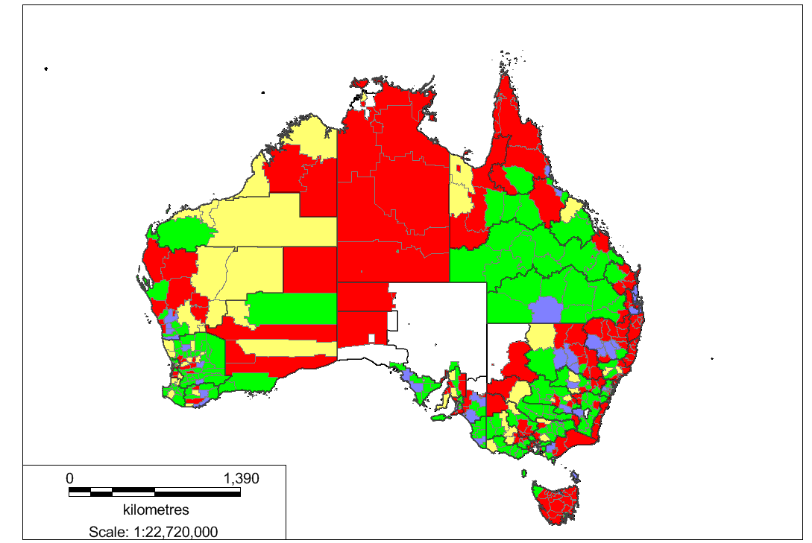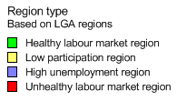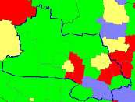

Source: RAI, 2013

This map shows that generally, regions with similar labour market outcomes are generally clustered together, with large areas of healthy and unhealthy labour markets clearly visible. It also shows that while there are spatial trends in labour market efficiency outcomes at the LGA level, these are not necessarily uniform within RDA regions.

Understanding this pattern of labour market efficiency in Australia is essential in considering the role of geographic labour mobility and associated policies in supporting increased efficiency of the national and regional labour markets over time. Mobility will have different impacts depending on where it occurs (source and destination regions) as well as the type of labour that moves.

RAI notes that opportunities are likely to exist for underperforming regions to benefit from close proximity to regions with healthy labour markets but only if labour mobility (temporal or permanent) is facilitated within the region. In contrast, loss of skilled labour and associated capital in regions with unhealthy markets or migration of unemployed, low skilled workers to these regions may exacerbate inefficiencies.

### Mobility trends

Over the top of this knowledge of the drivers of labour mobility and labour market situation at the regional level, it is important to understand mobility trends - where people have actually been moving in Australia in recent years.

The Regional Australia Institute has undertaken a significant analysis of population mobility information derived from the ABS Census 2011 in association with the Australian Population and Migration Research Centre at the University of Adelaide.

***POPULATION TRENDS IN AUSTRALIA***

*Between 2006 and 2011, 37.7% of people changed their place of residence. Of these, approximately 70% moved within their region.*

*Population turnover further demonstrates high population mobility. In Australia, the median population turnover per 1000 residents, was 441.9.*

*Demographic trends*

* *In the next two decades, the number of people aged 65+ will double.*
* *27% of the Australian population was born overseas. This is the highest proportion for any middle-sized or large country.*
* *Between the 2006 and 2011 ABS Census, the number of people away from their place of residence increased by 10.8%. This means that more than 1 million people are temporary migrants.*

*The combination of these trends, along with a number of others, are presenting Australia with a number of unique opportunities and challenges.*

This analysis shows that overall, Australia has one of the most mobile populations with more than a third of people changing their place of residence between 2006 and 2011. As a result, we have the potential, culturally, to have high labour movements and as such greater ability to spatially match supply and demand than in many other countries where people are less likely to move.

The following provides a list of key trends in general population mobility (RAI, 2013);

• Young adults are the most mobile age group.

• There continues to be a net outflow of young people from regional areas to either larger regional or capital cities.

• There is an increasing temporality in migration movements because of the advance in travel and technology.

• Areas in the wheat belt of Australia have some of the highest proportions of origin of temporal migrants.

• Western Australia and Queensland had the largest percentage of people living in a different region from the 2006 to the 2011 ABS Census.

• The Murray Darling basin regions had the least population movement between these same dates.

• The majority of coastal areas in Northern and Western Australia are experiencing growth in the over 65 year age group.

• Many coastal regions in South East Australia are experiencing low growth in this age group.

• Western Australia and Central and North Queensland had the highest population growth as well as population turnover (apart from capital cities).

* The tree and sea change migration continues to be a trend, though not as pronounced as in previous years.

Figure 3 shows the general population flows between 2006 and 2011 across Australia. The East Coast of Australia dominates movements, yet it is evident that Australia has a very mobile population.

*Figure 3: Population flows across Australia 2006-2011*

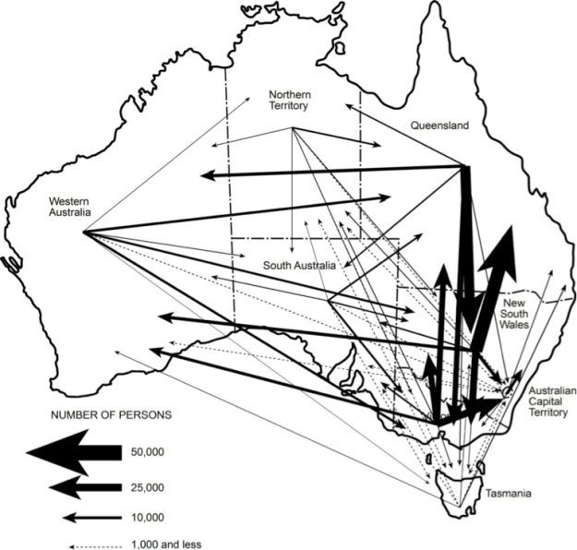

*Source: RAI, 2013*

Tree and sea changers

Tree and sea changes for retirees continues to be a trend. Though as the baby boomer population reaches their retirement years these trends may well change. Baby boomers are the most educated, diverse, wealthy group of retirees and have an unparalleled body of experience and therefore present considerable resources and potential for Australia and its regions.

Effectively engaging with and exploring the potential of this group may offer unmeasured resources, market opportunity and hence prompt more innovative solutions to labour market inefficiencies. This population would allow demands to be met not just in the paid sector but also in volunteering and mentoring younger persons.

Population turnover

Reinforcing the results of the regression analysis earlier, Figures 4 clearly demonstrates that Australia’s regions, particularly the outer regions, have experienced the highest population turnover. Such population turnover suggests that movements are opportunistic and perhaps tied to ones circumstances i.e. those that have fewer commitments and are in higher demand for their skills are more willing to resettle in these circumstances – as are those whose opportunities are limited where they normally reside.

*Figure 4: Population Turnover*

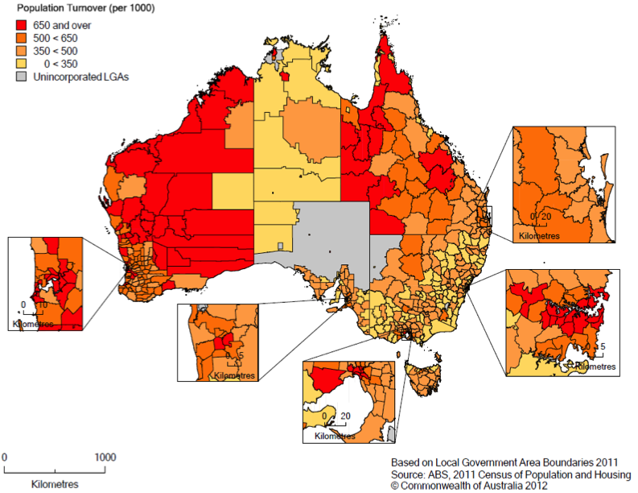

*Source: 2011 ABS Census in RAI, 2013*

Highest rates of mobility

The following groups have a higher proportion of people who moved residence between 2006 and 2011. Importantly though, this does not indicate the distance of the move and does not distinguish between mobility of the population as a choice as opposed to stability of housing options.

* Indigenous Australia;
* Unemployed persons;
* Separated or divorced persons;
* People living in group households, flats and rented dwellings are more mobile;
* People with higher levels of education; and
* People employed in agriculture have the **lowest** levels of mobility.

It is of particular note that not all groups follow the same mobility trend. Those who are mobile through capability i.e. those with higher education levels and those who are younger and in group households are more likely be able to move for personal and financial reasons. Labour mobility for these groups therefore may be beneficial as they are more likely to have the human and financial capital to move to where the demand for labour might be; benefitting the recipient regions or communities. Conversely, this also means that these people, such as doctors and professionals, are difficult to retain in areas with fewer opportunities. This then has negative flow on effects to the community and has the potential to initiate a downward spiral of reduced population, services and opportunity.

Similarly, those who are perhaps more mobile because of housing options or lack thereof, such as separated or divorced persons and unemployed persons, are less likely to benefit from labour mobility as they may not have the resources to move to where labour demand is highest or do not have the skills. So while these groups have high mobility rates there is more likely to be negative associations with them having to move.

Mobilising these lower socio-economic groups so that mobility is a positive experience and so they can in effect be a ‘labour resource’ is essential to enabling them to participate in the labour market more freely. This is a highly significant measure to reduce the disparity between the have and the have nots and can lead to improved overall national and regional efficiency.

Mobility events

It is important to note that as well as understanding the general nature of geographic labour mobility in the economy, there are a series of specific labour market events linked to rapid economic changes and disruptions which involve concentrated movements of labour. These events include very large and geographically concentrated economic expansions (most recently the ‘resources boom’), large and geographically concentrated economic contractions (structural adjustment) and natural disasters. Each of these events have significant implications for regions where they occur and the economy as a whole. They also often bring dedicated policy responses that may act to facilitate or mitigate labour movements.

The Resources boom

The expansion of the mining industry has seen a rapid increase in both permanent and temporary migration. The impacts of these on the efficiency of the labour market and productivity of the economy are myriad.

While on the one hand temporal labour movements including Fly In Fly Out (FIFO) and Drive In Drive Out (DIDO) has enabled labour supply to meet a rapid increase in local labour demand, on the other hand, the temporal nature of this supply has meant large influxes of people in remote locations with inadequate infrastructure and service provision. Figure 5 shows the concentration of high growth and high turnover population movements across Australia in these remote localities, suggesting these populations are highly fluctuating. Where mobile labour is able to outcompete locals for new employment opportunities or employers prefer mobile labour, mobility exacerbates the leakage of economic benefits from the local community. Simultaneously, these communities are placed under significant pressure to provide services for people whose primary residence is in another town or state and whose longevity is finite, whilst tackling the inflationary costs of living for existing residents due to the large increase in housing and service demand (RAI, 2013 – unpublished).

*Figure 5: High growth and high turnover trends across Australia*

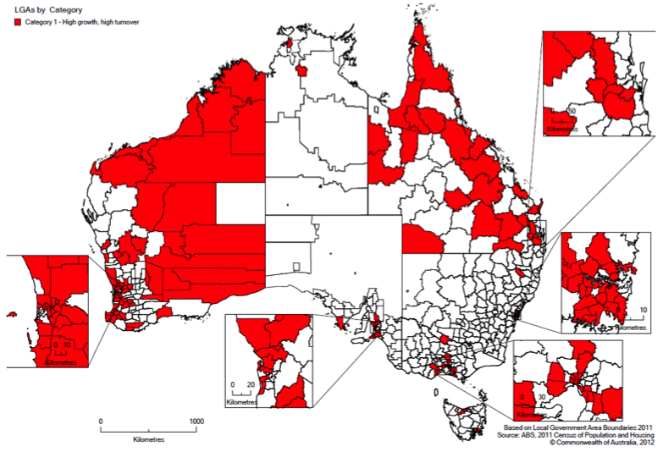

*Source: RAI, 2013 – Unpublished*

There is no question that labour mobility during the resources boom has been essential for the nation to meet soaring demand for resources and has also allowed wealth to be more widely distributed throughout Australia, particularly in those regions where the local economy did not offer similar job remuneration.

Whether this culminated in allocative efficiency however is unlikely. The ability of labour FIFO/DIDO of a locality allows a matching within the labour market but in terms of overall national efficiency and productivity the end result is much more complex. Whether labour mobility providing workers for roles with lower skill thresholds that could reasonably be met by local under-utilised labour creates further disparities by both entrenching local unemployment and reducing the availability of labour in other regions is an important consideration for policy in the aftermath of the boom.

Understanding too, that the location of physical economic activity may not indicate the location of labour demand is also essential, as in the case of the mining sector for every ten jobs created only two will be in the host community. Such a figure assists with understanding the complexity of labour market distribution.

Overall, FIFO/DIDO movements highlight the extent to which labour mobility can affect local efficiency and the policies which relate to the supply of labour can impact on national and regional productivity and the longevity of regional prosperity. There are as yet no clear solutions to this conundrum but it is an important consideration for the inquiry given Australia’s recent experience.

Structural adjustment

Significant and often rapid economic change is a permanent feature of regional economies in Australia. The combination of an open national economy and small, less diverse often natural resource based regional economies and the long term transition to a services focused knowledge economy in the developed world ensures that change will continue to be a challenge and opportunity for regional Australia.

The size, composition and characteristics of industries will continue to shift as individuals and businesses seek to respond to changing market conditions. This is referred to as structural adjustment in economics and policy.

This process brings about changes to the economy and spatial distribution of its population. Workers employed in a closing firm often need to move to other regions where there is demand for their labour if the local labour market cannot absorb the newly available labour. If mobility does not occur then this can lead to or exacerbate local and regional unemployment.

There is a long term record of policy interventions in this space including the provision of relocation incentives to encourage movement where local job opportunities are limited. The role, availability and outcomes of these policy approaches are an important consideration in any review of labour mobility.

Natural disasters

The frequency and intensity of natural disasters have caused severe social, physical and economic devastation in recent years - a trend which is expected to continue. Population displacement within these communities has a far reaching effect on the economic and community recovery process of the community. Case studies undertaken by the RAI in the severely impacted regional communities of Cardwell (QLD) and Marysville (VIC) showed the extent of population change that can occur following a disaster.

In 2006, the estimated resident population of Marysville was 517. Yet according to 2011 ABS Census, the population had dropped by over 50% to 233 residents. In addition to the reduction in population since the Black Saturday fires, the age profile has changed dramatically. In 2006, Marysville’s age profile showed 36% aged 55 years and over compared to 24% for Australia. By 2011, nearly 47% were aged 55 years and older. The median age in 2006 of 46 years had increased to 52 in 2011.

The data reflects of the loss on business and employment opportunities and the need for younger workers to move away in search of employment. Older Australians also tend to spend less which also has an impact on the local economy.

Figure 6 below displays the change in the nature of employment in Marysville from 2006 to 2011. The dominance of the “Accommodation and food services” sector, an indicator of the importance of tourism, is apparent from the table as is its significant decline by 2011.

*Figure 6: Comparison of Marysville % Population Employed by Sector*

Source: RAI, 2013 ‘From Recovery to Renewal’

Figure 6 shows that the unemployment rate in Marysville has increased dramatically from 5.6% in 2006 to 9.1% in 2011. The 2011 ABS Census showed that Marysville’s economic base and living costs had also suffered with the household median weekly income of $818 compared to the national mean of $1234. In the same census only 90 people indicated that they were employed and nearly half of these were working part-time or casually. Furthermore, the median weekly rent increased from $135 in 2006 to $350 in 2011 as a result of severe shortages in rental accommodation caused by the Black Saturday fires. In 2006 there were 65 rental accommodation units in 2011 there were only nine.

The data provides an insight into the challenges for the economic recovery of Marysville. It reflects the loss of business and employment opportunities and the need for younger workers to move away in search of employment.

Cardwell’s story is similar but less severe. The estimated resident population has declined slightly from 1252 in 2006 to 1176 in 2011. Its median age has increased from 47 years to 52 years between 2006 and 2011 compared with the national median age of 37 years. In 2006, there was a labour force participation rate of only 50%. In 2011, the labour force participation rate had dropped to 45%. Locals interviewed during the case studies confirmed that a loss of working age people due to changes in the employment market after Cyclone Yasi had been the major driver of the exacerbation of the issues in the local labour market.

Changes in the size and characteristics of communities post disaster can cripple the long term recovery of any region from natural disaster. Evidence locally and overseas suggests that the longer the displacement the less people are likely to move back to their community. People with skills sets which are in higher demand i.e. doctors, engineers etc. are also generally the first to relocate when the local economy begins to struggle.

Furthermore, post disaster reconstruction efforts bolster the local economy in the short term but often lead to decline in the long term by undermining the local economy. Labour mobility can have a large negative impact on the local economy particularly in the long term. The loss of higher skilled workers and the influx of construction workers for short periods create further downward pressure on the local economy. Areas with greater exposure to natural disasters are therefore likely to have a heightened sensitivity to the impacts of labour mobility, particularly those localities with already fragile economies.

While this event may seem ancillary to a discussion of the economic issues associated with labour mobility, the consequences for these regions in the long term are severe and potentially avoidable with good policy and implementation of recovery efforts.

Soon to be released RAI research recommends that a focus on provision of temporary housing in or near the community, supporting businesses to resume trading as soon as possible (thereby restoring jobs), directing recovery resources where possible and appropriate through local supplier and reducing competition for local businesses from charitable donations of goods and services can all serve to reduce the population displacement effect of a disaster and support more rapid re-establishment of a self-sustaining local economy in impacted communities.

### What this means for labour mobility efficiency?

Evidently, there are a wide range of factors involved in determining where labour will be demanded in the future and where labour supply may exist.

Labour supply and demand cannot in the real world operate in equilibrium as the movement of people is driven by a multitude of factors other than employment. Furthermore, simply matching supply with demand with the most easily obtained solution will not in itself automatically ensure efficiency and maximising of social benefits at the National, State or regional level.

This is because the benefits of matching individual resources can often come at the costs of other groups and localities that are not able to participate or are not in high demand by the market.

Given the ability to stratify the differing profiles of regions through characteristics such as human capital, labour demand, future markets and existing supply, a regional sensitivity model may be a useful tool to examine labour mobility efficiency. (For more information see the below section on spatial sensitivity modelling)

### The three types of regions

[In]Sight demonstrates that regions across Australia are very diverse and should be treated as such in policy and decision making as well as in labour mobility. Three distinct types of regions emerge in RAI research. These include:

* **Inner regional** – usually in close proximity to larger metropolises with strong endogenous growth potential, great lifestyle opportunities but a need to be physically connected to the city through good roads, rail and communications infrastructure to attract mobile workers and be able to provide the services these workers will demand;
* **Outer regions with resources of high demand** - these are localities who have high labour demand because of the comparative advantages presented by the natural and business environment and suitable conditions to capitalise on these advantages; and
* **Outer regions with resources of low demand** – these are localities whose comparative advantage has been in less demand due to, for example structural adjustments, where there is limited resources.

Each of these are considered to have different responses to labour mobility resulting in varied costs and benefits which require consideration in measuring efficiency. Further analysis of [In]Sight data would enable these regions to be identified and their needs and opportunities in relation to labour mobility further understood.

### What needs to be considered in assessing overall efficiency of labour mobility?

***SUGGESTED COST BENEFIT ANALYSIS THEMES FOR LABOUR MOBILITY***

* *Labour force composition*
* *Market connectivity*
* *Population composition*
* *Human Capital*
* *Business confidence*
* *Access to service*
* *Natural resources*
* *Housing costs*
* *Tech readiness*
* *Innovation*
* *Temporality of market*
* *Education levels*
* *Access to education*
* *Educational attainment*
* *Cultural behaviours to mobility*
* *Economic fundamentals*
* *Access to transport*

Optimising efficiency through labour mobility requires, in the first instance, a strong framework. To appreciate the efficiencies, RAI has developed a cost benefit framework with regard to Australia’s regions. The framework outlines some of the considerations necessary in exploring overall national efficiency in the derivation of a cost benefit analysis for labour mobility. The suggestions in this list consider the three distinct regions, the benefits and impacts of labour mobility patterns and trends on these areas.

In exploring the benefits and costs associated with labour mobility, stratification of regional types is useful in determining a set of efficiency measures at a regional scale for national level efficiency. Whilst such a model for an analysis would require extensive input, RAI offers the following themes (see text box) and considerations (Table 2) that could be adopted in calculating costs and benefits to efficiency.

Table 2: Considerations for understanding the costs and benefits of labour mobility in different types of regions

|  |  |  |  |
| --- | --- | --- | --- |
|  | Inner regional | Outer egional  (high resource demand) | Outer regional  (low resource demand) |
| Labour mobility impacts | **Growth in population due to ability to commute & improved connectivity** | **Influx of workers to meet demand and potential for further influx** | **Outflow of workers to meet demand elsewhere and low retention rates** |
| Benefits | **Improved connections to city** | **More skilled labour** | **Call to rethink comparative advantages** |
| **New local market opportunities** | **Demand for improved services (though unlikely to be met in short term)** | **Less competition for job seekers** |
| **Increased social capital** | **Increased wealth** | **Cheaper housing** |
| **Increase in wealth** | **New local market opportunities** | **Impetus for more innovative solutions to service delivery** |
| **Improved business confidence and entrepreneurialism** | **Improved business confidence and entrepreneurialism** |  |
| Costs | **Strain on local resources and services** | **Strain on local resources and services** | **Loss of skilled workers** |
| **Increased housing costs** | **Increased housing costs** | **Decreased average wealth** |
| **Increased congestion** | **Boom-bust potential** | **Loss of services** |
| **Divergence between rich and poor** | **Divergence between rich and poor** | **Loss of business confidence** |
|  | **Pressure on lower income households** | **Loss of employment opportunities** |
|  | **Temporary workers** | **Outflow of families** |

### Spatial sensitivity modeling

Examining geographic labour mobility efficiency is about meeting the demand for labour in a way that maximises benefits for the local community, the individual and the nation as a whole.

The development of a regional sensitivity model offers the dual advantage of increasing the capability to identify regions that will need to increase their workforce, as well as those regions that would offer suitable sources of labour to meet these needs. This would allow for the development and implementation of suitable strategies to achieve greater labour force efficiency.

RAI’s [In]Sight tool offers a unique look into the make-up of Australia’s regions. The provision of raw data allows its application in a number of new ways. For the purposes of labour mobility, this data could be utilised to build a regional sensitivity model to better understand the spatial patterns of labour mobility to understand who is most vulnerable and where mechanisms to improve efficiency should be focused.

[In]Sight has the dual benefit of providing information to better understand the current labour force, their skill sets and how they are currently being utilised, as well as providing information that (when coupled with market projections) would allow for an assessment of a region’s future potential. Relevant information would include the current business environment, the business sophistication of communities and their connectivity with export markets, the human capital of regions, the educational attainment of residents and their access to education as well as a host of other factors regarding industry strengths and natural resources that would allow an expansive framework for identifying and assessing future trends, implications and the relative sensitivity to labour mobility for every corner of Australia.

Conclusion and policy imperatives

Labour mobility is essential for maximising both national and regional productivity. In Australia’s regions the availability of labour and a strong labour market where supply meets demand is vital to economic development. Yet employment is not the only factor in the decision to move and the mobility of labour and people to meet economic opportunity is impeded by social, economic and structural issues.

Estimating the full costs and benefits of labour mobility requires considering the impacts of those who can’t be mobilised as much as those who can. It also requires considering the costs of regions that are likely to benefit and those that are more likely to see mobility further entrench existing regional labour market issues.

The relative mobility of different components of the labour force and existing regional disparities therefore creates a complex context for analysis and policy action. From the information available to RAI it seems imperative that:

* Policy works to reduce the proportion of the regional workforce that is mobility limited and the concentrations of this workforce in particular regions.
  + This requires the inquiry to facilitate a better understanding of the complex issues that underpin participation and the impediments to mobility for key groups, as well as regional push and pull factors that explain the current conditions.
* The likely labour dynamics in regional Australia in response to economic conditions are assessed, focusing on the geographical based prediction of skills shortages of the future. This will facilitate local, state and national policy settings that:
  + Enable regions to mobilise the potential local workforce to compete with mobile labour during periods of economic expansion. This would involve proactively equipping those lower skilled workers and workers from sectors experiencing decline, with skills which will likely be of high demand now and in the future.
  + Ensure the negative experiences of the recent mining boom are not repeated by enabling regions to minimise the social and economic impact of significant labour inflows while realising economic opportunity.
* Policy initiatives for the management of structural adjustment and natural disasters in regions account for the role of labour mobility in facilitating positive and negative outcomes and respond accordingly.
* Policy recognises that people move for reasons other than employment and employment is often not enough for someone to move.
  + Labour deficits should be addressed through a holistic approach which considers migration determinants, impediments and enablers.
  + This includes transparent, accessible and timely dissemination of information regarding employment, conditions, housing, social networks, infrastructure and services to potential labour sources for regional areas.
* There is support for the greater migration of a skilled workforce to inner regional lifestyle areas through continuing to improve their connections to nearby capital cities through enhanced physical and communications infrastructure and that these initiatives are integrated into Australia’s urban development strategies.

References

F. De Jong, G, 2000. ‘*Expectations, gender, and norms in migration decision-making’* Population Studies, Vol 54. No. 3 pp307-319

Hutson, P et. al. 2007. ‘*Human settlements: Population and settlement patterns’* Department of Local Government,

Planning, Sport and Recreation, Queensland

Mitchell, W. 2008. ‘*Labour Mobility and Low-paid Workers’* Centre of Full Employment And Equity, Report commissioned by the Australian Fair Pay Commission

Reichlova N, 2005. ‘*Can the theory of motivation explain migration decisions’* Working paper UK FSV – IES.

Regional Australia Institute, 2013. ‘*Population Dynamics in Regional Australia’* (forthcoming)

Regional Australia Institute, 2013*. ‘[In]Sight – Australia’s Regional Competitiveness Index’*

Productivity Commission Australia, 2013 ‘*On efficiency and effectiveness: some definitions’* Productivity Commission - Staff Research Note

### Contacts and further information

To discuss this submission please contact;

Jack Archer

General Manager - Policy & Research

Jack.Archer@regionalaustralia.org.au

Or

Vanessa Barnett

Manager – Policy

Vanessa.Barnett@regionalaustralia.org.au

Tel: (02) 6260 3733

Further information can be found at www.regionalaustralia.org.au