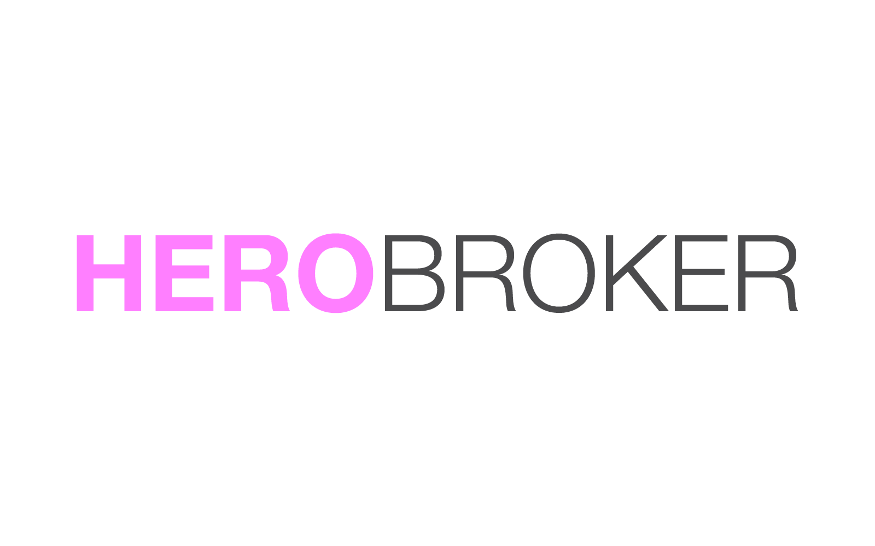
5/155 Clearance St,
Sydney, Australia
ACN: 608 729 942

Clint Howen & Hero Broker’s submission to the Australian Government’s Productivity Commission

I make this submission to highlight my own experiences working within the finance industry. The following outlines my belief there exists strong evidence of aggressive anti-competitive practices by large aggregated finance groups. These practices are preventing consumer-focused products from getting to market.

These practices are undertaken by numerous groups in collusion to unfairly strengthen their positions in the market. This behaviour goes against free market and anti-corruption principles that need be upheld to maintain a productive and profitable industry. I contend this behaviour is not only damaging to my business, but fundamentally damaging to confidence in Australian business across the board.

With the flow of mortgage business from mortgage brokers now surpassing 50%, I believe it’s vital the Commission look into the role aggregator groups play in the market and the control they have. The sector shall always be at its strongest when there is a clear and fair playing field for new and established business equally. A rigorous investigation here would ensure such values are upheld and defended.

Background on Hero Broker

Hero Broker was founded five years ago following my own personal experience with a mortgage broker. Trying to arrange finance for acquisition of an investment property, I found myself and my ability to pursue my goal throughout this process not enhanced by the broker’s work, but diminished. It made everything harder.
I knew there must be a better way, and if one didn’t exist? I’d go and create it.
Building the Hero Broker team was a matter of bringing together talented professionals, who having seen the mess that was the mortgage broker’s industry, were keen to effect a positive change.

Our goal was simple: help create better options for Australians searching and applying for home loans. Help them reduce their cost in obtaining and maintaining finance. Easier, fairer, better. Those were the values that founded Hero Broker, and they’ve been our team’s guiding stars ever since.

Since the beginning Hero Broker has aspired to be a business ran by Australians, for Australians, and we’re unapologetically passionate about this country and its people.
Hero Broker was founded with the knowledge the causes of this issue are diverse - but so too that we had the chance to make a real difference here.
Starting out, we sought out an aggregator AFG to partner with , and after months of development (alongside AFG staff,) we officially launched our product called Hero Broker on [date].
Our model provided Australian consumers greater speed and efficiency over our competitors. Because of this agility, we could operate more economically than our competitors - and we passed on the savings to our valued clients.

Our platform and the recommendations were made from an algorithm that gave unbiased results on home loan products. This ensured every time an Australian used our service they’d get a fair, accurate, and transparent result.
Our platform was designed to ensure Australians have a better understanding of their finances, and provide clarity about financial products on offer. It also offered the ability to obtain a discount on their mortgage for supplying the relevant data & documents needed to process a loan.

We founded Hero Broker knowing we could do something special in Australia, and look to give consumers a ‘fair go’. We’re a team of optimists at Hero Broker, and drive forward with confidence based on our values of fairness and hard work.
If there was one mistake we made, it was not anticipating the readiness of other competitors to go beyond ‘play the ball, not the man’ - and engage in rogue behaviour that is simply unacceptable. This all the more so in an era where new business has never been so vital to Australia’s economy.
We welcome fair competition. We will even thrive on it. A contest to deliver the best product to Australian consumers is not only one we welcome, but one we’re confident we’ll win. Cheating and collusion undermine that.

Accordingly, the timeline that follows is what we have perceived as suppliers going outside their requirements and operating in a way that leveraged their power and access to the industry to limit Hero Brokers ability to trade and operate in the market place.

Timeline

Jan 2016 - Signing An Agreement With AFG

January 2016 we signed our agreement with AFG and became credit representatives under AFG’s credit license. Hero Broker discussed the splitting of commissions with third parties and whether this came under allowed practices by AFG.

When asked multiple times, the response was always measured: that it was in good business practice to have “referrers” in order to drum up business. These referrers could be real estate agents, builders, accountants, or even hairdressers. Essentially, anyone who could refer to you a client that you could obtain a mortgage for would be allowed to receive a commission split.

AFG openly pushed these practices and had a referrer agreement and payment options set aside for such situations.

Feb 2016 - Tech Build With AFG

Following from our agreement and Hero Broker & AFG entered into a technology build that allowed the Hero Broker website to publicly display product information and allow consumers the ability to apply online.

1) 18th Of May Hero Broker launches product.

The work and goals of Hero Broker began to quickly win some attention. News of our establishment was covered up by industry-based publication The Advisor, and our business began receiving its first customers.

http://www.theadviser.com.au/breaking-news/34432-borrowers-become-brokers-with-new-platform

Comments from professionals within industry begin to flow in and the article was much talked about and circulated within the industry.

May 2016 - I am Contacted By An AFG Representative

What happened next was a series of phone conversations.In their whole, the message was clear: AFG would discontinue our agreement due to my business model and the threat we posed to existing competition. Hero Broker had adhered to our agreement with AFG, and remained in full lawful compliance with it - but our agreement was served due to industry influence.
The following is a timeline of the major communications between Hero Broker, AFG, and ASIC, and what was conveyed in each. Some comments for context to understand our position in each instance is also included.

Phone call 1)
AFG began by stating Hero Broker was non-complainant. This was despite the fact we hadn’t written a single loan as of yet. After a long conversation, the representative conceded that we were in fact compliant, and that we had done nothing wrong.

Phone call 2)
In this phone call a new avenue of criticism was pursued. This was the first time I heard the concern that our offering may devalue their service. This is something that had never previously been raised as a problem or stumbling block to an ongoing business relationship.

During this phone call the representative suggested that if mortgage brokering was opened up to everyone, and money given to the consumer, it will be very hard for them to ask the banks for more money, and that I was devaluing the mortgage brokering service and industry as a whole.

Note: It is also important to indicate this is also in contrast to our model as a whole. The aggregator role is to provide me a marketplace of home loans. They then take a payment from Hero Broker for accessing that marketplace. Most of these payments are volume-based, so it was felt AFG would be pleased with a new model, that could then bring the volume.

Phone calls 3-5)
Over the following days we had back and forth conversations. AFG eventually came to me with an offer. I could continue to work with them providing I did not discount my service. I refused, as the discount was my competitive edge, and underlying philosophy to give Australians a more affordable service.

AFG indicated they’d not support rebating of commissions to everyday Australians over their fellow professionals, and if I continued with my model they could no longer work with me.

Our team was crestfallen, thinking not just of our business, but folks we know who may be finding it hard to come up with a home loan deposit alongside all the fees involved.

Further, my response was to highlight that splitting of commissions is openly pushed by AFG and I have asked this question before with advice that it’s in good practice to split commissions with referral partners (i.e real estate agents, builders, accountants etc) and that I don't see any reason why I shouldn't be able to split the money paid by financial institutions with the consumer, if they are doing some of the work when applying for a loan. We at Hero Broker felt they should receive a reduction in their mortgage of they can help with improving the efficiency of the application process.

AFG indicated their view this is not the same as having a referral partner, and he believed he my actions would devalue AFG’s position and the whole service within the marketplace.

We refused to change our model, as we believed it was best for the consumer and us as a business to be open and transparent.

2) Shortly After AFG terminates contact on 30 day clause in contract and of no wrongdoing by our company

3) Clint Speaks to ASIC

After my discussions with AFG I contacted ASIC to discuss what had occurred. I did so also to communicate an assurance our company was acting, and continued to act in a compliant manner. ASIC went through the steps we were undertaking in our business, and affirmed Hero Broker was operating in a compliant manner.
In the interests of transparency I note too ASIC did offer so recommendations in relation to giving money back to the consumer.
The recommendations chiefly concerned a change to our model, to now offer a flat amount to the consumers. This was help prevent the consumer for potentially picking a loan that's unsuitable for them in order to receive a higher incentive.

We at Hero Broker noted these recommendations carefully, and considered them. We ultimately found agreement with ASIC’s advice, and applied the recommendations.

5) 31st of May - Hero Broker no longer working with AFG becomes public

Later in the morning the below article was released from AFG.

http://www.theadviser.com.au/breaking-news/34524-afg-terminates-agreement-with-new-mortgage-player

Both before and after the 31st of May, I had multiple instances of contact with state managers of aggregator groups. Most responded well to me, however, all of them stated that they have been told not to work with me. In multiple cases it was discovered this instruction had came from directors of these companies. None of whom I had ever met or spoken to. Accordingly, it was essentially impossible they had any direct-knowledge of our business model and exactly how we operate.

What they could have known - and had they taken steps to learn would’ve known - was we had the support of ASIC, and had recently confirmed once again we were compliant.

Thus, Hero Broker at this stage was a business permitted to operate just like any other in the sector - but seemingly blacklisted because we offered a new service that edged out all others.

Throughout all this out team continued to feel frustrated and saddened time spend in this area was time that kept us away from building our business, and a fairer and easier way for Australians to get a loan and save some costs.
This is a frustration we’ve continued to feel each day throughout this process.

Aggregators I contacted;
• Plan Australia
• Choice
• Vow Financial
• Connective
• FAST
• AFG (Australian Financial Group)
• My Local Broker

6) Tuesday, 14th Of June between 11am - 12am I had a General Manager of a smaller aggregator service.

In conversation, I was asked about why AFG didn't want to work with me. I then explained their concern about giving money back to the consumer.

He agreed and in conversation stated;

“We had a meeting with other aggregator groups and we all agreed that it would devalue our value proposition to the banks and that it's not a model everyone would want to get involved in.”

This was the first time I had heard of such meetings even taking place, and such group discussions being had. Yet, given the responses I had been receiving it was surprising but not unexpected. It made sense, as some industry-wide event had clearly occurred leading to our detriment.

Again, this goes beyond whether existing businesses would or wouldn't work with Hero Broker, and illustrates a aim to prevent a new concept from entering the market.

I do understand these are allegations and I cannot prove in totality that these events did take place. Yet, in tandem to my claims, I can affirm Aggregator Groups often get together to discuss industry-based topics of concern and collectively give their thoughts.

These happen publicly and can be viewed on the MPA Website: http://www.mpamagazine.com.au/tv/mpa-aggregator-roundtable-2016-live-stream-219986.aspx
Any suggestion by others in the industry that there would be simply no possibility or chance for such meetings to occur - as I understand some have sought to do in an effort to quiet my claims - would be rejected on this basis.

http://www.mpamagazine.com.au/tv/mpa-aggregator-roundtable-2017-239859.aspx

Articles That The Industry Has Not Responded To

In tandem to my above statement I also table for the Commission's consideration the following articles. The first was published in The Advisor.

These articles are pertinent to my claims, and evidences my contention they seemed to trigger a response from aggregator groups when we launched, but didn’t seem to trigger a response on the calls that I had been blacklisted.
To the Hero Broker team, this affirmed our view many established players in the industry were unhappy to see us rise up, and delighted to see us knocked down a little. This was was another chapter in print that we’d experienced over the phone of efforts to see us unfairly excluded and shut out.

http://www.theadviser.com.au/breaking-news/34763-aggregators-blacklist-new-broking-platform

http://collectivehub.com/2016/08/so-your-start-up-has-been-blacklisted-what-next/

Closing notes

This report has sought to show my evidence in support of what so many already know: that this industry has the deck stacked against newcomers.
This is an issue for my business certainly, but also for this business sector as a whole, and crucially the Australian people as a whole.

As a company we at Hero Broker have operated in a complaint and legal manner, and this is recognised by ASIC. However, our competitive edge was prevented from entering the market from powerful mortgage groups.

I strongly believe that aggregators are using the power within the industry to go outside their role of providing a service and actively shutting down businesses that they see as a threat. The Hero Broker experience to date has seen aggregators behaving like a monopoly, with a collective control of more than 50% of the market. Any collusion amongst these groups deserves competition and the Australian consumer.

Though the consumer may not directly pay for this collusion in each transaction, they do pay for this behaviour through the arbitrarily high operating costs of the businesses that sell them financial services.

From what I have experienced there is indeed collective discussion amongst key figures within industry on how to best protect themselves. This isn't in the name of competition and to offer better services to Australians, but instead to their detriment. Thus potentially costing Australians billions of dollars.

With the current high level of housing prices, so too are high levels of debt that aggregators and brokers make their money from. It’s to see that any aggregator has an incentive to reduce the cost of debt and I do not believe in any sense that you could call the Australian Mortgage Market innovative or transparent in its operations.

Our competitive ideal is very Australian at its core, that we ‘have a go’. That is interwoven with the ideals of mateship - and the recognition that we work hard, but play fair. These values are foundational to us, to the Hero Broker story so far, and to the one we’re set to write in future.

With so many Australians - especially in my generation - increasingly finding the idea of saving a deposit near impossible, what we do in our industry has the potential to impact the Australian Dream all over.
If this industry is properly reformed and fairly regulated, the broader Australian community is given a fair chance - and nobody would dare bet against an Australian who is given a ‘fair go’ to pursue their life and dreams.
On the other hand, if we continue to allow the bullying and isolating tactics to go on in this industry, and continue to permit the preferences of the few to dominate and malign the many new, we might see in this decade the great national dream of homeownership snuffed out.

Something future generations talk about as something ‘from a different time’ and no longer their own. And that is really dangerous. Because an investment in the Australian people’s personal dreams is an investment in our community, and country as a whole.
Nobody pretends solving this problem here will solve any and all problems for aspiring home owners. There remain challenges that are not of our making in this sector - disruption, stagnating wage growth, and globalisation - which all contribute to a turbulent economy. We can’t address all those problems - this one we can. We can make the playing field fairer.
We at Hero Broker stand ready to work with this Commission, and anyone anywhere who will work with us in sincerity and good faith to seek reform.
We go to work each day seeking to make it easier and fairer for Aussies to buy a home - and we'll keep building that brick by brick no matter what.
We now seek the helping hand of this Commission, to build the industry fairer and better in service of everyday Australians in our community.

