Indexed annuity bonds – a market failure to create the ideal pension investment?
Anthony Asher

Presented to the 26th Colloquium on Pensions and Retirement Research
UNSW, Sydney 2,3 July 2018

Abstract
The ageing population creates a growing need for investments to back income streams in retirement. Most of the investment instruments used by superannuation funds expose retirees to significant investment risks. Volatile assets need to be sold at unpredictable prices to fund consumption. It is however possible to create indexed annuity bonds (IABs) backed by the depreciation flows from physical assets such as infrastructure to provide income to pensioners. Depreciation flows in Australia are considerably larger than private and public pension payments together and have a similar average term. Appropriately structured using alternative inflation linkages and adding a link to longevity, IABs could provide returns greater than those available from “risk free” government bonds with less volatility than the current alternatives.
One reason why IABs have not been actively developed is that investment market participants have no incentive to develop “bottom drawer” investments, which would yield lower revenue streams. By their training and interests, market participants become focussed on the development of liquidity and so fail to recognise the risks that maturity transformation and market volatility presents to the economy and more particularly to pension incomes. All hedging strategies developed to address the risk are not only complex and costly, but they merely redistribute rather than reduce risk.
While the dangers of excess liquidity are not commonly discussed, it is widely recognised that many markets participants, such as the rating agencies, also face conflicts of interest. Little has been done about this until the recent Mifid II reforms in Europe. These issues suggest that superannuation trustees exert greater control of the investment process.

Introduction
It is unremarkable to note that saving for retirement could and perhaps should provide capital for long term investments. On the other hand, the design of private retirement schemes and investment institutions provide a poor match for each other.
Standard descriptions of retirement fund investment, such as Campbell and Viceira (2002), implicitly assume that the only way to invest is through liquid and volatile bond and stock markets. While some liquidity is necessary, both employer sponsors of defined benefit (DB) and the members of defined contribution (DC) funds are continually seeking ways to avoid the resulting volatility. For the former, Broadbent, Palumbo and Woodman (2006) report that the volatility has been a significant factor in the shift away from DB funds, while Clark and Monk (2006) write of the crisis created by the large deficits in some funds that has partly arisen from poor investment returns. In DC funds, where the risks have been transferred to members, Merton (2014) identifies a “crisis in financial planning”, making the point that pensioners need an inflation protected income stream for their regular expenditure.
Unwanted volatility problem can be addressed by retirement schemes acquiring and hypothecating cash flows to retirees rather than buying and selling assets to fund their pensions. These cash flows include depreciation – described in the national statistics as consumption of capital, property rents and home loan repayments. Part 2 shows that the size of these cash flows is such that they can more than fund pension payments for the foreseeable future in most developed economics, looking particularly at the case of Australia. Part 3 then describes how these cash flows can be variously packaged into indexed or linked annuity bonds that can reduce the financial risks of both investors and users of capital. In Part 4, I attempt to explain why institutional investment markets have failed to develop such instruments, and what might be done to facilitate their introduction.

Cash flows within the economy

The required cash flows
Asset decumulation in retirement is not a mirror image of asset accumulation before retirement. A significant proportion of retirement cash flows are needed for living expenses, while there is normally no pressing need to invest contributions immediately. Dollar cost averaging also works against pensioners.
The cash flow required by retired members drawing a life annuity is illustrated by Figure 2-1. It projects the number of survivors of a cohort of 65 year olds. If regular pensions are paid to survivors, the amount required reduces slowly for about 20 years, declines more steeply for a further 12 years, and then reduces more slowly again. There may however be still some requirement for payments in 40 years’ time – where there is about a 0.5% chance of survival.

Figure 2-1 Cash flow required by 100000 annuitants – Australian Life Tables 2010/12 using 125 year projection factors
Assets that need to be sold when the cash is required do not meet this need because the price of the asset fluctuates – due to changes in supply and demand for the asset and in changes to interest rates, both local and international (Bjørnland and Leitemo, 2009).

Depreciation

Internationally
Figure 2-2 shows the relative size of the consumption of fixed capital in the world’s twenty largest economies. The percentage of the gross national income (GNI) represented by the cash flows from the consumption of capital are larger for more developed economies, with the East Asian countries that have driven growth through investment being larger still.
The size can be compared with the current size of private and public pensions, where they are available from the OECD. In most cases the depreciation cash flows exceed the sum of public and private pensions. The exception is Turkey, which appears to have very little capital to consume and is typical of less developed economies, suggesting perhaps that the ability to fund pensions from capital is a phenomenon of relatively developed economies.
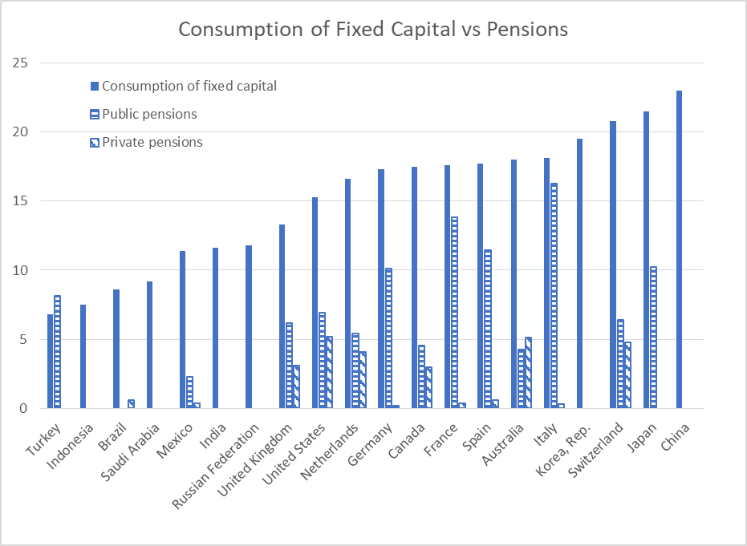
Figure 2-2 Taken from http://wdi.worldbank.org/table/4.10 and https://data.oecd.org/socialexp/pension-spending.htm

In Australia
Over the past 50 years between a quarter and a third of the Australian gross domestic product has been applied to capital formation. Figure 2-3 shows the capital formed over the past 20 years by private and government sectors and the level of depreciation over that period. While the amount of depreciation is determined by somewhat arbitrary accounting standards, it does represent the benefits derived from the investments that can be expressed as cash flows that could be used to fund pensioners. What is noticeable is that the private sector accounts for most of the capital invested, and consequentially, the depreciation.
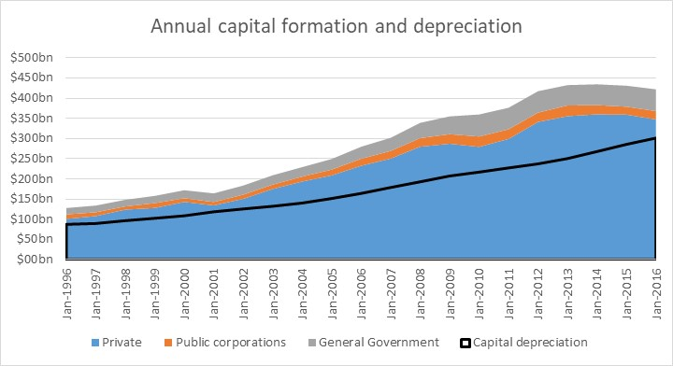
Figure 2-3 Capital formation in Australia
Analysing the depreciation by type of asset in Table 1 below, the largest category is construction, which represents commercial and retail property and infrastructure as well as private dwellings, and accounts for about 45% of depreciation and over half of the reported capital stock. These assets have an average age of 20 years. They therefore generate long-term cash flows that could provide for the payment of pensions to retirees without exposure to fluctuations in investment markets. The other asset types largely have a shorter lifespan and are less appropriate as pension investments.
Table 1 Capital and depreciation
2013 $ bn |  | Capital Stock |  | Depreciation |  | Rate of depreciation |  | Average age
Dwellings |  | 1,687 |  | 38 |  | 2% |  | 21.3
Other Construction |  | 2,023 |  | 72 |  | 4% |  | 19.8
Machinery |  | 605 |  | 69 |  | 11% |  | 8.2
Exploration |  | 64 |  | 4 |  | 6% |  | 14.7
Other |  | 438 |  | 60 |  | 14%
Total |  | 4,817 |  | 243 |  | 5%
New capital formation can also be analysed by industry. Table 2 shows that – under normal circumstances – it is relatively widely diversified through the economy. The statistics are extracted from 2007 because the last 10 years have seen an unprecedented investment in mining, which accounted for 20% of all investment in 2013.
Table 2: New capital formation by industry (2007)
Dwelling construction |  | 27%
Non-dwelling construction |  | 33%
 | Mining |  | 6%
 | Manufacturing |  | 3%
 | Electricity |  | 5%
 | Transport |  | 5%
 | Rental property |  | 3%
Machinery and Equipment |  | 28%
 | Mining |  | 3%
 | Manufacturing |  | 4%
 | Transport |  | 3%
 | Rental property |  | 3%
Computer software |  | 5%
Other |  | 8%

Profits and dividends
Equity investments have proved the most profitable assets over the last century, and there are many reasons to believe that they will continue to do so (Credit Suisse, 2016. Over a forty year career, as can be seen from Figure 2-4, until 2008 at least, an individual investing in a 100% share portfolio in the USA would always have performed at least as well as a bond portfolio, and often outperformed by as much as 5 times. Other countries are likely to show similar results, but this is only true for the accumulation phase when individuals can choose at any time to crystallise their gains by converting into low risk investments. They are not suitable cash flows in the post-retirement phase, because one can only enjoy the gains once they have been crystallised, as any losses will lead to the need to reduce expenditure.
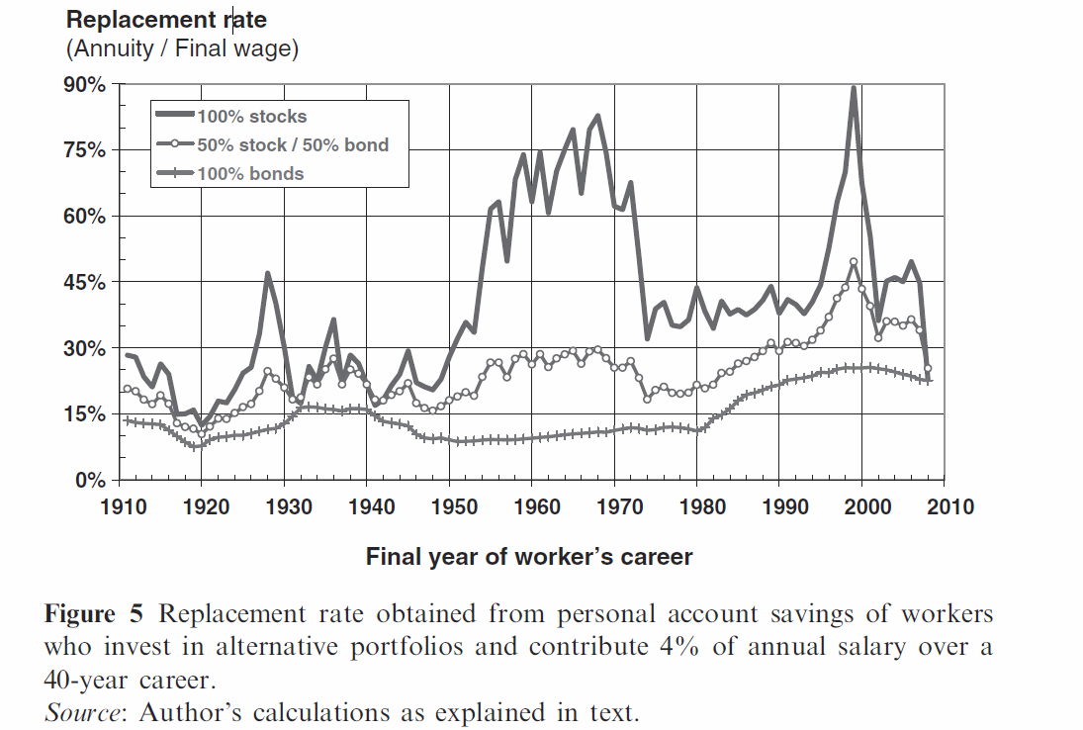
Figure 2-4: Equities outperform

Standard interest-bearing
A standard approach to reducing the volatility of the portfolio is to invest a portion of the assets in fixed interest investments of an appropriate term. There is a premium for investing over longer terms. At time of writing, however, the best six month deposit rate available of 2.7% is little different to the five year rate of 2.95%. There are however not many longer-term instruments currently available in Australia. The practical approach taken by Australian superannuation funds is to invest in short term cash assets. While they protect against the loss of capital, the rate of interest paid is volatile and entirely unsuitable to provide retirement cash flows. This has implications both for borrowers and investors. Increases in interest rates create financial hardship for borrowers, and vice versa for investors who intend to use their interest income to fund their consumption.
The volatility of these cash flows is shown in Figure 2-5, which shows the major cash flows of Australian corporations over the past 30 years. Depreciation is the smoothest of the cash flows. Interestingly, even dividend income has been considerably more stable than interest income.
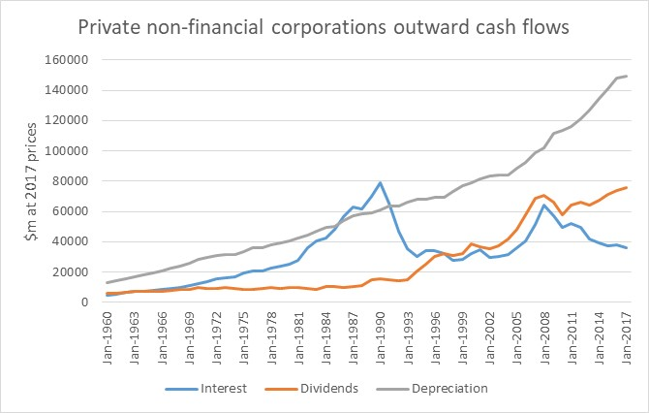
Figure 2-5: Private cash flows

Home loan repayments
Institutional investment in housing is uncommon in Australia, but widespread internationally. The problems of institutional investment in mortgage backed securities in the USA is well known, but in other countries, such as Switzerland, Bourassa, Hoesli and Scognamiglio (2010) report that institutions not only provide mortgages, but pension funds directly own almost 10% of rental housing.
While housing is largely owner occupied, it gives rise to two forms of long term cash flows. The first is rent, the second are mortgage repayments including both interest and repayment of capital. Most rental housing is privately owned not least because of the tax advantages offered by negative gearing and is therefore unlikely to be a suitable investment for Superannuation funds. Loan repayments on the other hand are relatively long term. Most mortgages are for periods from 20 to 30 years, which is an ideal time horizon, although most are repaid over much shorter periods. The actual cash flows will exceed the $64bn interest shown in Table 3, which shows the housing assets generated in 2013, the latest available year.
Table 3: Cash flows from housing (2013)
Cash flows from housing | $bn | % of GDP
Gross rent - Imputed rent for owner-occupiers | 130 | 8.5%
Gross rent - Actual rent for housing | 38 | 2.5%
Rates, land tax and insurance | 14 | 0.9%
Maintenance | 14 | 0.9%
Consumption of financial services | 20 | 1.3%
Miscellaneous (including commission) | 5 | 0.3%
Consumption of fixed capital | 53 | 3.5%
Interest payable | 64 | 4.2%

Summary of potential sources and uses
Table 4 shows the main categories of cash flow and their characteristics. Interest payments and dividends can now be accessed by investors, but – as discussed earlier – interest rates are often not attractive, and dividends are discretionary.
Table 4: Cash flow characteristics
Cash flows | Characteristics | Availability to investors
Revenue (turnover) | Relatively stable, depending on volumes and prices – difficult to increase | Needs to cover costs, but can be available
Depreciation | Arbitrarily stable | Free cash flow available but seldom hypothecated
Interest | Can be fixed, otherwise volatile | Paid to investors
Profit | Volatile as difference between two larger numbers | Some may need to be retained to grow business
Dividends | Can be more stable than profits | Paid to investors but discretionary depending on profitability and retention policy
To see the big picture, the consumption of retirees is currently approximately 7% of GDP but is likely to double by the middle of the century. The main investible cash flows within the GDP arise from depreciation (roughly 16%), dividends (7%) and home loan instalments and rent (10%). There are therefore sufficient cash flows (excluding interest) within the economy to provide for retirees, but their share is in the process of rising from 20% to 40% of these cash flows over the next 40 years.

Linked annuity bonds
These cash flows can be directly accessed to provide cash flows for pensions if they were used to pay the linked annuity bonds (LABs) described in this part. I am distinguishing LABs from IABs in that the latter are linked to CPI only.

Annuities vs bullet repayments
First, we need to question why convention bonds with a bullet repayment at maturity, and not annuities, currently dominate bond design. The cash generated by long term loans is much more likely to be matched by an annuity than interest only coupons and a lump sum repayment. Possible reasons for the bullet payments could be:
- Accounting is simpler if one must separately account for interest and capital repayments – for both borrowers and investors.
- Historical accident in that they grew out of shorter term loans.
- More cynically, bullet repayments were attractive to borrowers who wanted the benefits of the cash flow in the short run and expected to pass the burden of repayment to a later generation.
- Even more cynically, crafting instrument to adapt the cashflows of the business to those required by the borrowing instruments requires more financial services and so suits the finance industry.
One might also see the differences between annuities and bullet repayments as immaterial because it is possible for both investors and borrowers to arrange a series of bonds to smooth their cash flows. The bullet repayments however introduce another dimension to the problem of portfolio construction and make it more difficult if not impossible to hypothecate cash flows from a project to loan repayments, and to use the declining value of the underlying assets as security.

Links to inflation
The most obvious adaptation of nominal bonds is to link coupons and repayments to inflation, to suit both the incomes of the borrowers and the desired expenditure of the investors. The arguments for such linkages are made in Wilkie (1981) and Stiglitz (1994), and they are issued by several governments, including that of Australia. Table 5 shows that a number have been issued by Australian states, while Figure 3-1 shows their yields relative to capital indexed bonds (with bullet repayments).
Table 5: Indexed Annuity Bonds
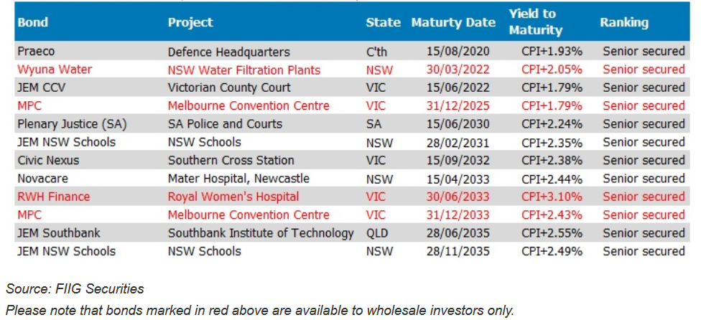
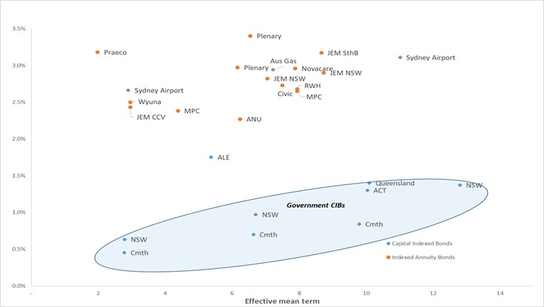
Figure 3-1 Real yields on indexed bonds
There are however alternative linkages that more directly address the risks faced by investors and borrowers, which are covered in the following two sections.

Adjusting for inflation
The subjective wellbeing of pensioners is enhanced if their incomes can keep pace not just with inflation but also with other people in their community (Preston, 2011). Ideally, therefore their incomes should be adjusted by a measure of inflation that matches prices and wages. As prices rise more slowly than wages, matching prices provides a higher initial income and so it is the CPI that is normally used. The CPI is a weighted average of different prices and will not necessarily reflect the living costs of all families, nor the revenue and cost increases of businesses and governments. It does not therefore have to be slavishly followed: in the longer term all prices will reflect changes in the value of money.
This provides an opportunity to reduce the risks faced by borrowers. Instead of linking the annuity payments in an IAB to changes in the CPI, they can be linked to changes in turnover or to the price of the borrowers’ main product or service. Linkages to turnover have ancient provenance: agricultural landlords have been sharecropping, which is charging a proportion of the crop as rent, for centuries. Reid (1975) shows that this is a relatively efficient way of renumerating capital. More recently, landlords of retail property often charge rents based on tenants’ turnover.
Linkages to turnover would transfer significant risk from borrowers to investors but would still have lower volatility than profits and dividends. Linking repayments to price increases would be even less risky to the investors. Such links could be to electricity prices, the costs of transport or rents, which are shown in Table 2: New capital formation by industry (2007) Table 2 to be main sources of depreciation cash flows. These would be entirely suitable for pensioners. Linkages to commodity prices would however seem to be too volatile.
Governments could reduce their risk by linking repayments to their main sources of revenue. For Australian states, such links could be to GST revenues as they would link to retirees need to compare to community living standards. (Linkage to the payroll tax would be better for retirees, but it is a perverse tax that should be replaced and entrenching it in financing instruments would itself be perverse.)
Home loan instalments could also be linked to borrower’s income as suggested in Asher (2011). As an example the new home buyer could agree to repay 20% of their wages for 20 years in return for a loan equal to four years of their current annual wage (20% of 20 = 4), The return on the loan would be equal to the rate of wage growth.
Similar linkages have been explained and their advantages argued by Shiller (1994) and Kamstra and Shiller (2009). The “macro market” hedges proposed in the former paper do reduce risk but are mainly new and liquid derivatives that do not match cash flows and so would be exposed to liquidity risks. The latter paper’s “Trills”, which would be government issued bonds linked to GDP, would however provide a natural cash flow to the extent that government revenue is likely to be linked to GDP, although they would not contribute to the efficient allocation of capital. Similar products have also been suggested by Merton (2014) and Merton and Muralidhar (2017) and Jennings (2006) as institutional investment. The linkages suggested in this paper are much more direct – taking risk away from borrowers as well as investors. Moreover, the investors would have access to the underlying assets as security. One would therefore expect investors to more actively apply their minds to the economic viability of the underlying projects, so contributing to better capital allocation within the economy.

Adding a longevity element
Longevity bonds, as described by Blake, Cairns and Dowd (2006), have been identified by Evans and Sherris (2011) as a missing element in the Australian financial industry if it is to make lifetime annuities more widely available. In the previous section, it was suggested that the superannuation investors could accept some of the risks faced by borrowers. In this case, it would be borrowers accepting longevity risks that are largely uncorrelated with other risks faced by the borrowers. They might therefore be prepared to accept such a risk in return for a lower cost of borrowing. Instead of a fixed term for the cash flows, the repayments would be linked to an index of longevity so that they would be repaid for longer if the population underlying the index lived longer than expected. Given that many infrastructure projects have projected lifespans well in excess of the horizons of investors, one or two years more or less in repayments thirty years into the future – are trivial risks.
These adapted LABs would be simpler contracts than the longevity bonds described by Blake, Cairns and Dowd (2006), which included interest rate swaps and special purpose vehicles – which have no immediate use for the money being raised.

Deferring initial repayments
A further adaptation that would suit the needs of both borrowers and investors would be to issue deferred LABs, where repayments begin only when the projects are cash positive. Retirement dates can be relatively well predicted in advance, so such deferred investments would be attractive to superannuation members in the few years before retirement. They may also be prepared to take more of an investment risk (and gain a higher return), given that they may well be able to defer their own retirement if investment returns are not as expected.

Developing primary and secondary markets
There is a trade-off in investment markets between pricing accuracy and the costs incurred by investors in remaining informed, by the market infrastructure in administering transactions, and by borrowers in providing the necessary financial information to create transparency.
Mispricing is more of a concern in the primary market (greenfield investments) in that capital may be wrongly allocated and the underlying investments will not earn a fair return. Projections of the cash flows will necessarily be subjective, and the large amounts of money involved mean that there are incentives for participants in the process to extract economic rents. The problems are particularly visible in the case of large infrastructure projects. It is therefore to be expected that – in spite of some enthusiastic reports about the success of Public Private Partnerships (PPP’s) – the Productivity Commission (2014) reports that experience is mixed. The issue of the governance of new infrastructure projects is discussed extensively by the Productivity Commission, while Industry Super Australia (2014) has suggested a mechanism that would operate more on the latter lines in developing greenfield projects. Flyvbjerg, Bruzelius and Rothengatter (2003) suggests large projects should be subject to four rules of accountability: transparency, clarity in performance specifications and in regulation, and the provision of appropriate risk capital by private parties.
Secondary markets in LABs will be only indirectly relevant to the problem of capital allocation, in that the capital will have been invested and the profits and losses locked in. A functioning secondary market is however necessary to manage the potential for unexpected cash outflows from funds. This may arise from changes in mortality, or commutation of pensions. It may also be desirable when the creditworthiness of some assets is downgraded, and the trustees believe they should be replaced with lower risk cash flows. New investors may continually be on the lookout for opportunities.
There is also a need to ensure that the cash flow through directly to pensioners and they are not used for new and risky investments. For account-based pensions, it would probably be best to set up closed (i.e. no new investments) pools of various durations. Once set up, all cash flows should be paid to the investors as they are received. To the extent that the cash received is not an exact match, there will be a limited need to reinvest (in another asset) or sell some of the assets.

Obstacles and their removal
Despite their obvious benefit s to investors and borrowers, IABs faced some opposition initially, and have not found a large role in commercial bond markets. It may well be that they are not suitable instruments, but there is also evidence that they face other obstacles that arise from conflicts of interest and collective action problems within the finance sector.

Opposition to government IABs
The first clue of market failure can be found in the delay in the introduction of government IABs. Wilkie (1981) and Stiglitz (1994) not only explain the benefits of IABs but are at some pains to attempt to understand the arguments made against them. The discussion on Wilkie’s paper noted that they were introduced in the UK in 1981 with some success. Stiglitz writes to explain why Treasury income protected securities (TIPS) took so long to introduce in the USA given that they appear to be "Pareto improvements ... which make everyone better off... They provide a way for households and government to reduce their risks. At the same time, they create a market that did not previously exist, and the government reaps some of the benefits of the new market in the form of lower interest charges on its debt." His comments are worth quoting in full:
“Despite these obvious attractions - and the fact that very few people would be hurt by the innovation - getting the Clinton administration to accept indexed bonds was a long and difficult process. There were three reasons for this. First, it was enormously difficult explaining the nature of the real risk faced by the government. Critics worried that if inflation increased, interest payments would increase. Try as we might, I think some never understood that the government's tax receipts also went up with inflation and thus indexed bonds actually reduced the government's real risk.
Second, some misguided inflation hawks thought that indexing would reduce the resolve of government to fight inflation. As is so often the case with such inflation hawks, they did not bother to look at the relevant empirical literature (Fischer, 1996, provides a survey), or at the counterargument that with indexed bonds, inflation has an immediate and direct budgetary impact, thus encouraging governments to act against it.
The third reason was that Treasury turned to bond traders - their natural clientele - for advice. The experience in England from the perspective of bond traders was that these bonds were a failure; that is, people bought them for their retirement and did not trade them. Without trades, where were their commissions? Of course, from the perspective of someone trying to create an instrument to enhance retirement security, this was ideal: we did not want a gambling instrument. The bond traders raised anxiety levels: Would Treasury throw a party to which no one would come?”
These three reasons can be compared with the explanation of Kamstra and Shiller (2009) of why GDP linked securities are not more common. They suggest that national treasuries are not interested in risk management but only in costs, and that their suggested securities would yield 150 bp more than ordinary government debt. Given the propensity of governments to privatise infrastructure at significantly higher returns, this seems an unlikely reason, but governments should be prepared to pay to shift risks off their balance sheet. They also suggest that treasuries would not want to reduce the size of existing bond markets as this could reduce liquidity and increase costs. Given treasuries provide as much liquidity as is demanded by routinely buying and selling government bonds to satisfy the demands of the market, this also seems an unlikely reason.
The last reason listed by Stiglitz is perhaps the most significant. If it is true that the widespread adoption of this type of instrument would significantly reduce the revenue of the financial sector, then the other reasons can perhaps be best explained as rationalizations.

Financial sector rent-seeking
Rationalizations arise to explain socially and economically destructive behaviour, such as rent seeking. Adair Turner (2009), previous head of the UK Financial Services Authority, gave expression to a widespread view that the sector has the power “…to generate unnecessary demand for its own services…and attract to themselves unnecessarily high returns and create instability which harms the rest of society.”
While a developed economy needs a developed financial sector, as documented by Rajan and Zingales (2003), they also find that private interest groups in the sector have obstructed economic development in some countries during the late twentieth century. The victory of vested interests over regulation is described by Kay (2012) as:
“...regulation that is at once extensive and intrusive, yet ineffective and largely captured by financial sector interests. Such capture is sometimes crudely corrupt, as in the US where politics is in thrall to Wall Street money. The European position is better described as intellectual capture. Regulators come to see the industry through the eyes of market participants rather than the end users they exist to serve, because market participants are the only source of the detailed information and expertise this type of regulation requires. This complexity has created a financial regulation industry – an army of compliance officers, regulators, consultants and advisers – with a vested interest in the regulation industry’s expansion.”
This echoes Adam Smith’s emphatic warning over 200 years ago:
The interest of the dealers, however, in any particular branch of trade or manufactures, is always in some respect different from, and even opposite to, that of the public. To widen the market and to narrow the competition is always in the interest of the dealers. … The proposal of any new law or regulation of commerce which comes from this order, ought always to be listened to with great precaution, and ought never to be adopted till after having been long and carefully examined, not only with the most scrupulous but the most suspicious attention.
It has also been argued that the increased funding of social security systems has been a major contributor to the growth of the finance industry, both ideologically and in its share of GNP. Engelen (2003) refers to “increasingly speculative behaviour and a frantic search for financial innovations”. Blackburn (2003) notes that “the provision of pensions seems to be about distributing wealth, not creating it” but that “decisions taken by fund managers, and deeply determined by the legal and incentive structures within which they work, shape the world in which we live” and that “the boring world of pension provision now fuels the glamorous world of high finance, property speculation, rogue traders, media and technology mergers, and stock exchange bubbles.” He links its influence to the rise of finance throughout the economy:
“the financial industry thrived mightily in the 1980s and 1990s, but largely at the expense of their host societies. The mega-salaries of the financial sector and the boardroom existed side by side with mass unemployment, social cutbacks and deindustrialisation.”
Of interest to Australia, he views compulsory membership of private funds with suspicion:
“With the lopsided recovered of the 1990s the financial services industry became more aware of the inherent limits of the pool of voluntary savers in the domestic market. Part of the answer lay in exporting the ‘Anglo-Saxon’ model, its ‘equity culture’ and flourishing private pension funds. … The World Bank alternative was centrally to comprise a novel solution to the problem of sales resistance – citizens were to be forced to buy savings schemes from commercial providers.”
The implications for regulators and trustees is set out in Blackburn’s summary of the views of Peter Drucker:
“Drucker believed that is was wrong for banking institutions to manage pension funds since it involved them in conflicts of interest. He did not believe that it was either desirable or possible for banks to construct so-called ‘Chinese Walls’ between their business loan departments and their money management departments. In his view, pension funds anyway need trustees who were independent of banks and employers and who truly represented the interests of employees whose savings they managed. Only trustees of this sort would have the legitimacy and autonomy needed to act in the long-term interests of pension fund beneficiaries, persuading them, when necessary, to raise contribution rates to ward off inflation and to ensure investment-led growth sufficient to anticipate the rising proportion of the retired and the consequent dis-savings problem.”

Persistence of conflicts
This is a direct challenge to the ownership structure of all retail and some industry funds in Australia, where trustees have a conflict between their duty to members and to their shareholders where the latter have an issue in service providers.
Another persistent conflict is faced by rating agencies which are paid by borrowers and not investors. White (2010) records that the investor pays model was only dropped in the seventies, possibly because of the difficulty of ensuring that reports were not copied. A third conflict is that faced by stockbrokers giving free advice in return for commissions on deals, which is now banned by Europe’s new MiFID II rules.
Conflicts of interest do not generate economic rents but make them more likely and difficult to judge. This is why the general law prohibits them: “human nature being what it is, there is danger … of the person holding a fiduciary position being swayed by interest rather than by duty”. It does seem to be problematic that it is common for the financial sector to contract out of the prohibition. Both superannuation and corporate law allow that conflicts of interest to persist and assume that there are ways of managing the consequences. Such an assumption could be seen as a rationalization of ongoing opportunities for rent extraction.

Identifiable mismatches
Other rationalizations for the failure to introduce new instruments are the reasons given for the persistence fundamental mismatches between the term and nature of financial sector assets and liabilities.
In terms of term, banks rationalize their function as “maturity transformation”, accepting shorter term deposits and bonds, and making loans that cannot be repaid in the short term. On the other hand, superannuation funds have longer term liabilities but cannot find assets of a suitably long matching term. It is difficult to find justification of the levels of liquidity currently available.
Liquidity and its creation is discussed by Amihud et al (1991) and Amihud and Mendelson (1991). It is often seen as a good proxy for effective markets but creates greater risks for borrowers and lower returns for investors. Some investors will be prepared to pay for liquidity, but it has minimal value for retirees. The point is that the price of liquidity is paid to those who create and participate in the investment markets. Illiquid “bottom drawer” investments exactly match cash flows and obviate the need for most trading, hedging and the financial planning necessary to meet bullet repayments. Without these functions, many in the financial sector would be made redundant. They have a vested interest in the creation of liquidity, and their views are inevitably clouded by these interests. The participants include institutional investment managers and the financial directors of borrowers in both private and public sectors.
It can be argued that liquid markets price assets more accurately and therefore contribute to a more effective allocation of capital. This is true in the case of shares, which represent the ongoing profits from a company. It is however not true in the case of the initial investment in long term projects, where the capital allocation decision is made up front, and the subsequent buying and selling of the funding instrument has minimal impact on capital allocation. For such projects, better capital allocation will occur if the project is given extensive and expert attention at the critical time before it is initiated.
Another mismatch is in the currency of assets and liabilities. As identified by the recent Financial Systems Inquiry (2015), superannuation funds invest significantly in foreign fixed interest assets while 80% of corporate bond issuance is overseas. The failure of the financial system to match local investors with local borrowers creates an expensive roundabout of investing and borrowing for no meaningful benefits except to the service providers. The rationalization that this represents diversification is at best a minimal consideration as credit risk is small and may in any event be correlated internationally as in the global financial crisis.

Addressing the obstacles
These rationalizations suggest that superannuation trustees (even where they themselves face no conflicts) face a collective action problem. Project finance (which would be the source of new LABs) is dominated by merchant and commercial banks, whose interests are to avoid bottom drawer investments and whose function is to sell the investment to investors. They are effectively paid commissions by the borrowers.
Similarly, the interests of the existing financial sector would not be served by the emergence of a relatively illiquid secondary market in infrastructure and corporate bonds. A large proportion of their income currently comes from the generation of complex financial instruments that not only cost more than is necessary but fail to manage risks because of the mismatches described in the previous section. These include a proportion of investment managers’ charges, the fees and commission charged by merchant and business banks for fund raising and financing, and the costs of unnecessary investment offshore.
Even where their investment managers are not part of the banking conglomerates, investment management charges would be lower for portfolios of LABs, and they are therefore not attractive from the investment managers’ perspective. If the trustees want independent advice, it is not excludable (because it is easily copied), thereby creating the collective action problem.
It therefore seems desirable for those funds in the superannuation industry that are sufficiently independent of the large financial service conglomerates to set up their own market to develop and trade the LABs suggested in Part 3. In doing so, they should be joined by governments interested in the development of a more efficient source of public infrastructure financing, and by corporate leaders interested in developing a corporate bond market. To do this, there will be a need to develop independent expertise to evaluate projects and value assets when they are traded. This will also require more internal investment management expertise, which has been identified as one of the keys to better investment performance in general. Similarly, rating agencies should be paid by the market administrator and not by borrowers. If such a market was set up by a consortium of superannuation funds, there would be no obstacle to SMSF investors also participating.

Conclusion
The value of various inflation linked bonds to match retirement benefits has been long recognised, but they appear to have remained underutilised. This paper describes linked annuity bonds that would reduce borrowers’ risks by linking repayments directly to their revenue, while at the same time giving a higher return to investors and potentially reducing their risks by including a longevity element. The process of issuing these bonds would contribute to the more efficient allocation of capital within the economy.
There are more than enough cash flows in the GDP to provide investments of the appropriate term for private and even public pensions. The cash flows include those that arise from the depreciation of infrastructure and other long term investments, and potentially from home loan repayments.
The failure of the market to fully exploit such instruments can be explained by the conflicted nature of much of the financial sector. It seems possible that these conflicts have not been addressed because the trustees face a collective action problem in that funds need to collaborate to access independent advice and to develop structures in which such instruments can be created.

References
Amihud, Y., Mendelson, H., Giovanninni, M. and Mayer, C., 1991. How (not) to integrate the European capital markets. European Financial Integration, pp.73-111.

Amihud, Y. and Mendelson, H., 1991. Liquidity, asset prices and financial policy. Financial Analysts Journal, 47(6), pp.56-66.

Asher, A., 2011. Salary Linked Home Finance: Reducing interest rate, inflation and idiosyncratic salary risks, Australian Actuarial Journal 17.1: 117-148.

Asher, A., 2014. Redistribution and capital market impacts of social security retirement systems: principles and scope for actuarial involvement. The Australian Journal of Actuarial Practice 2:13-20.

Bjørnland, H.C. and Leitemo, K., 2009. Identifying the interdependence between US monetary policy and the stock market. Journal of Monetary Economics, 56(2), pp.275-282.
Blackburn, R., 2003. Banking on Death, or, Investing in Life: The History and Future of Pensions. Verso.
Blake, D., Cairns, A.J. and Dowd, K., 2006. Living with mortality: Longevity bonds and other mortality-linked securities. British Actuarial Journal, 12(1), pp.153-197.
Bourassa, S., Hoesli, M. and Scognamiglio, D., 2010. International Articles: Housing Finance, Prices, and Tenure in Switzerland. Journal of Real Estate Literature, 18(2), pp.261-282.
Broadbent, J., Palumbo, M. and Woodman, E., 2006. The shift from defined benefit to defined contribution pension plans–implications for asset allocation and risk management. Reserve Bank of Australia, Board of Governors of the Federal Reserve System and Bank of Canada, pp.1-54.
Burtless, G., 2010. Lessons of the financial crisis for the design of national pension systems. CESifo Economic Studies, 56(3), pp.323-349.
Campbell, J.Y., and Viceira, L.M., 2002. Strategic asset allocation: portfolio choice for long-term investors. Clarendon Lectures in Economic Policy.
Clark, G., 2000. Pension fund capitalism. OUP Catalogue.
Clark, G.L. and Monk, A.H., 2006. The ‘crisis’ in defined benefit corporate pension liabilities Part I: Scope of the problem. Pensions: An International Journal, 12(1), pp.43-54.

Credit Suisse (2016) Global Investment Returns Yearbook. https://www.credit-suisse.com/corporate/en/articles/media-releases/credit-suisse-global-investment-returns-yearbook-2016-201602.html

Engelen E. 2003, The logic of funding European pension restructuring and the dangers of financialisation, Environment and Planning A, 35(8) 1357 – 1372.

Evans, J. and Sherris, M., 2011. The development of a life annuity market in Australia: An analysis of supplier risks and their mitigation. JASSA 2: 11.

Financial Systems Inquiry (2012) Interim Report pp 2-86 to 2-91. http://fsi.gov.au/publications/interim-report.

Flyvbjerg, B., Bruzelius, N. and Rothengatter, W., 2003. Megaprojects and risk: An anatomy of ambition. Cambridge University Press.

Industry Super Australia, 2012. The Inverted Bid Model http://www.industrysuperaustralia.com/assets/Reports/The-Inverted-Bid-Model-Final.pdf

Jennings W.W., 2006. Disaggregated TIPS: the case for disaggregating inflation-linked bonds into bonds linked to narrower CPI components Slicing and Dicing TIPS. Journal of Pension Economics & Finance, 5(3), pp.325-343.
Kamstra, Mark J. and Shiller, Robert J., 2009. The Case for Trills: Giving the People and Their Pension Funds a Stake in the Wealth of the Nation. Cowles Foundation Discussion Paper No. 1717. SSRN: https://ssrn.com/abstract=1444351
Kay J, 2012. Finance needs stewards not toll collectors http://www.johnkay.com/2012/07/22/finance-needs-stewards-not-toll-collectors.

Merton, R.C., 2014. The crisis in retirement planning. Harvard Business Review, 92(7/8),
pp.43-50.

Merton, Robert C. and Muralidhar, Arun, Time for Retirement ‘SeLFIES’? (2017). Investments and Pensions Europe, Forthcoming. Available at SSRN: https://ssrn.com/abstract=2945668

Preston, Nicholas, Keeping up with the Joneses. The impact of reference groups on the subjective financial well-being of Australian retirees. (Honours Thesis, Australian National University, 2011). http://apra.gov.au/aboutapra/workingatapra/documents/nicholas-preston-thesis.pdf.

Rajan, R. G., & Zingales, L., 2003. The great reversals: the politics of financial development in the twentieth century. Journal of Financial Economics, 69(1): 5-50.

Reid, J.D., 1975. Sharecropping in history and theory. Agricultural History, 49(2), pp.426-440.

Shiller, R.J., 1994. Macro markets: creating institutions for managing society's largest economic risks. OUP Oxford.

Stiglitz, J. 1998. 'The Private Uses of Public Interests: Incentives and Institutions' Journal of Economic Perspectives 12.2, pp. 3-22.

Tirole, J., 2010. The theory of corporate finance. Princeton University Press.

Turner, A., 2009. Mansion house speech http://www.fsa.gov.uk/library/communication/speeches/2009/0922_at.shtml

White, L.J., 2010. Markets: The credit rating agencies. Journal of Economic Perspectives, 24(2), pp.211-26.

Wilkie, A.D., 1981. Indexing long-term financial contracts. Journal of the Institute of Actuaries, 108(3), pp.299-360.

World Bank Group, 2017. The Evolution of the Canadian Pension Model Practical Lessons for Building World-class Pension Organizations. World Bank

From ABS 5204 table 8
From ABS 5204 table 56
From ABS 5204 Table 64
Returns since 1900 for 23 countries are reported in https://www.credit-suisse.com/corporate/en/articles/media-releases/credit-suisse-global-investment-returns-yearbook-2016-201602.html
Taken from Burtless (2010)
https://mozo.com.au/term-deposits
From ABS 5204 table 49
http://thewire.fiig.com.au/article/commentary/trade%20opportunities/2015/05/05/comparing-the-relative-value-of-indexed-annuity-bonds
Based on FIIG rate sheet of 21 December 2017
The first part of this section taken from Asher A (2014)
https://www.fieldfisher.com/publications/2015/03/mifid-ii-a-summary
Lord Herschel in George Bray v. John Rawlinson Ford, House of Lords; 18 December 1895; [1896] A.C. 44

