Australian Bureau of Statistics

Over the past decade, drug-induced deaths were more likely to be due to prescription drugs than illicit drugs. In 2016, there were 663 drug-induced deaths where benzodiazepines were present.

Drug Induced Deaths by drug type
When analysed by single drug type, benzodiazepines were the most common substance present in drug induced deaths in 2016, being identified in 663 (36.7%) deaths (see table below). Benzodiazepines are drugs prescribed for the treatment of anxiety and insomnia, and are prone to tolerance and addiction. Benzodiazepines are associated with both accidental and intentional overdoses and were the most common drug in both unintentional and suicidal drug deaths in 2016. They can be dangerous when taken with other substances as they affect the central nervous system and may cause respiratory depression. In over 96% of drug deaths where benzodiazepines were present in 2016, they were taken in conjunction with other drugs including alcohol. Apart from 1999, when prescription opioids were the single most identified substances in drug induced deaths, benzodiazepines have consistently been the most common single substance identified on toxicology.
Prescription painkillers such as oxycodone, morphine and codeine, which are tabulated to the "other opioid" ICD-10 category, were present in over 30% of deaths in 2016. Similar to benzodiazepines, they are associated with addiction, polypharmacy misuse, and are common in both accidental and intentional drug induced deaths. Between 2010 and 2015 there was an increase of over 100% in prescriptions of oxycodone, a slow releasing opioid (PBS, 2015). Increases in prescriptions have been hypothesised to be correlated to a variety of social and health issues, including an aging population, living with chronic pain and increasing survivability from chronic illnesses such as cancer (Blanch, Pearson & Haber, 2014).
Although deaths directly attributable to alcohol are excluded from the analysis, alcohol was the seventh most common substance present in drug induced deaths. All of these deaths were due to multiple drug overdose. Alcohol is a depressant, and when mixed with other central nervous depressants in a polypharmacy setting, can exacerbate effects and lead to respiratory depression (Ren, Ding & Greer, 2012).
Drug Induced Deaths by drug type, 1999, 2007, 2016 (a)(b)(c)
Cause of Death and ICD-10 code(a) | Common terms assigned to ICD-10 category | 1999 |  | 2007 |  | 2016 |  | Proportion  (2016) % | Median  Age (2016)
 |  | no. | rank | no. | rank | no. | rank
All Drug induced deaths |  | 1819 | n/a | 1,193 | n/a | 1,808 | n/a | n/a | 45.3
Benzodiazepines (T424) | Alprazolam, Diazepam, Oxazepam, Clonazepam, Clozapine, Temazepam, Oxazepam | 503 | 2 | 354 | 1 | 663 | 1 | 36.7% | 44.6
Other opioids (T402) | Oxycodone, Codeine, Oxycodone | 678 | 1 | 292 | 2 | 550 | 2 | 30.4% | 46.0
Psychostimulants with abuse potential (T436) | Amphetamine, Ecstasy, MDA, MDMA, Speed, Methamphetamine, Ice, Caffeine | 76 | 11 | 93 | 9 | 363 | 3 | 20.1% | 39.4
Heroin (T401) | Heroin, 6/3 Monoacetylmorphine | 441 | 3 | 127 | 6 | 361 | 4 | 20.0% | 41.2
Other and unspecified antidepressants (T432) | Sertraline, Citalopram, Venlafaxine, Fluoxetine, Mirtazepine, Fluvoxamine, Paroxetine, Duloxetine, Bupropion | 124 | 9 | 172 | 3 | 276 | 5 | 15.3% | 48.1
Other synthetic narcotics (T404) | Fentanyl, Tramadol, Pethidine | 68 | 12 | 19 | 19 | 234 | 6 | 12.9% | 41.3
Alcohol, unspecified (T519) | Alcohol | 252 | 4 | 132 | 4 | 222 | 7 | 12.3% | 47.4
Other and unspecified antipsychotics and neuroleptics (T435) | Quetiapine, Olanzapine, Antipsychotic, Risperidone | 28 | 17 | 51 | 13 | 220 | 8 | 12.2% | 45.2
Methadone (T403) | Methodone | 131 | 7 | 129 | 5 | 208 | 9 | 11.5% | 43.2
4-Aminophenol derivatives (T391) | Paracetamol | 110 | 10 | 82 | 10 | 170 | 10 | 9.4% | 50.5
(a) All causes of death data from 2006 onward are subject to a revisions process - once data for a reference year are 'final', they are no longer revised. Affected data in this table are: 1999 and 2007 (final), 2016 (preliminary). See Explanatory Notes 55-58 in this publication. See also Causes of Death Revisions, 2012 and 2013 (Technical Note) in Causes of Death, Australia, 2014 (cat. no. 3303.0).
(b) See Explanatory Notes 72-101 for further information on specific issues related to interpreting time-series and 2016 data
(c) Deaths registered on Norfolk Island from 1 July 2016 are included in this publication for the first time, see Explanatory Notes 12-15
Drug Induced Death by sex
Benzodiazepines and opiate-based painkillers are the top two drugs present in drug induced deaths for both males and females. However, the profile of substances present for males and females differs for ranks three to ten. Illicit drugs including heroin and meth/amphetamines were the third and fourth most common drugs for males. In contrast, the third most common drugs for females were antidepressants including those of the selective serotonin reuptake inhibitor (SSRI) class (e.g. fluoxetine), and the fourth most common drug was antipsychotics, (e.g. quetapine), which are prescribed for mental health conditions including schizophrenia and bipolar disorder. Although antidepressants and antipsychotics are more highly ranked for their presence in drug induced deaths in females, the number of deaths with these substances present is still higher in males.
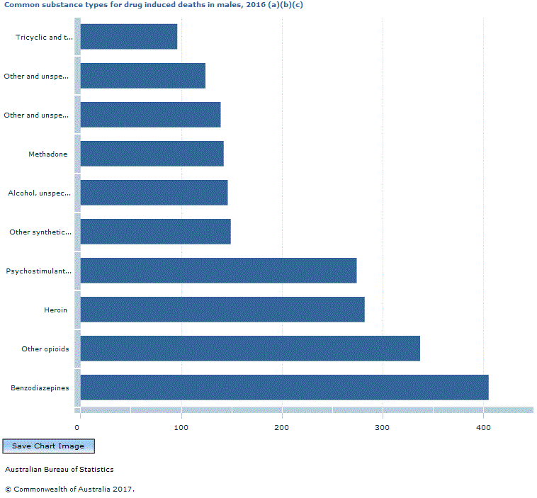
Footnote(s): (a) Causes of death data for 2016 are preliminary and subject to a revisions process. See Explanatory Notes 55-58 and A More Timely Annual Collection: Changes to ABS Processes (Technical Note) in this publication. (b) See Explanatory Notes 72-101 for further information on specific issues related to interpreting time-series and 2016 data (c) Deaths registered on Norfolk Island from 1 July 2016 are included in this publication for the first time, see Explanatory Notes 12-15
Source(s): Common substance types for drug induced deaths in males, 2016 (a)(b)(c)-Male Drug Type

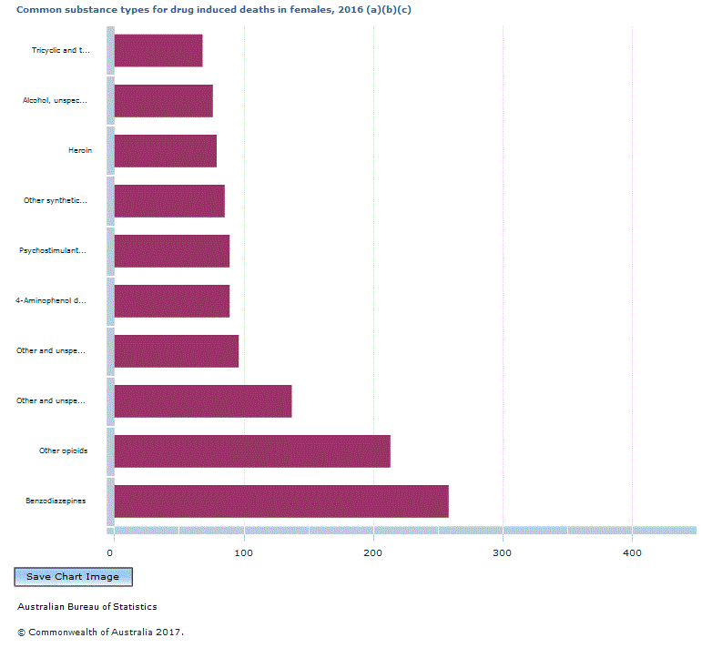
Footnote(s): (a) Causes of death data for 2016 are preliminary and subject to a revisions process. See Explanatory Notes 55-58 and A More Timely Annual Collection: Changes to ABS Processes (Technical Note) in this publication. (b) See Explanatory Notes 72-101 for further information on specific issues related to interpreting time-series and 2016 data (c) Deaths registered on Norfolk Island from 1 July 2016 are included in this publication for the first time, see Explanatory Notes 12-15
Source(s): Common substance types for drug induced deaths in females, 2016 (a)(b)(c)-Female Drug Type

This page last updated 25 September 2018

