11-Jan-20
Submission to:
Productivity Commission - Mental health
From: Theo Tsourdalakis

Introduction
I am a qualified engineer and school teacher (VIT no. 199913) in my 60s.
I have taught at various grade levels but mostly at Year 11 and 12 in public and independent schools for over 8 years. For the last 10 years I have been teaching engineers and technicians how to design, maintain and operate a leading computer control system for a large multinational organization.

I have been uncomfortable in the way that our education system, has been (I believe) damaging the psychological well-being of students for many years - but lacked the motivation to contribute in making improvements. After becoming a grandfather and sensing my responsibility to my “little buddies” and to all children, I have transitioned from indifference to action. This submission is one way I hope to bring about corrective action.

It is disturbing to see the rate of mental illness and suicide in young people is increasing along with our standard of living. Virtually no one is going hungry, there are no wars of other social unrest, yet young people are killing themselves at an ever-increasing rate. It is my understanding that this commission has been charged with the task of find the reasons why. I believe I know of a key contributing factor which is completely overlooked by most people, hence this submission. I hope you will consider it with an open mind and a willingness to thing “outside the box”.

A key contributing factor

Obviously, there are many contributing factors to mental illness and suicide. I want to suggest a key contributing factor, because this factor is forced on every child in the country by the education department.

In Victoria (other states are similar), every year 10 student will do the mandatory science component which contains unit on origins. In this unit, students will encounter something like this:
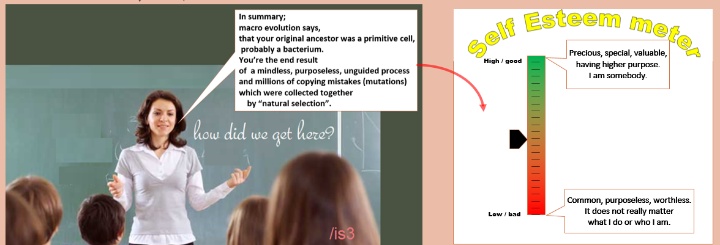

If you were a student in this class, what feelings would be aroused in you?
- Would you feel precious and loved or common and insignificant?
- Would you be inspired to strive sacrificially for some noble cause and the common good?
- Would your self-esteem go up or down?
When researchers in the late 1940s asserted that smoking had deleterious consequences to health, they were mostly dismissed because of doctors who endorsed smoking and by examples of smokers who lived into their 90s. The destructive consequences of smoking were not easy to detect or quantify. Similarly, the negative consequences of teaching macroevolution are not easily detectable and do not affect every child in the same way.
However, the increasing rate of mental illness and suicide in young people should be enough to prompt serious investigation and concerted action.
The Prime Minister recently identified teen suicide as one of his major priorities.
- Why are teens killing themselves at this elevated rate?
- Could it be that they view themselves as worthless?
- Could it be that the education system be implanting the idea that they are worthless?

Proving a cause and effect relationship for issues associated with human psychology is not easy because humans are mind-blowingly complex and diverse. Hence, testing if the current way of teaching evolution is deleterious to the emotional and psychological well-being of students is not easy. However, we need to recall that our industrial laws do not require proof that something is unsafe for it to be removed from use – all that is required is ‘reasonable suspicion’.
I submit 4 lines of evidence to support the assertion that teaching macro evolution to students is deleterious to their psychological well-being:
- Case Study
- Deductive reasoning
- Expert testimony
- Survey results
Individually, they may be discarded as ‘circumstantial’ however collectively they provide sufficient evidence to justify further research and corrective action.
Xxx 14/1/20

Case study
This case study is the personal experience of Fred (alias). Fred indicated his desire to remain anonymous but wanted to share his experience because he believes that it may be indicative of the experience of other students also.
Fred is over 40 years of age, married and working in a professional capacity. Fred was raised in a Christian household but had only a nominal understanding and commitment to Christianity or the church he attended sporadically. He did not read the Bible, but he did have a sense that a higher power (God) must exist and was ultimately responsible for the creation he saw around him. His world view was broadly Christian.
He was taught evolution in Year 8 at a northern suburbs public high school, and accepted it enthusiastically.
He said:
“Evolution seemed a bit confusing, but the fancy diagrams and scientific jargon convinced me that the problem was with my understanding as opposed to the science behind it.
The thought that they were telling me a ‘porky’ never entered my mind.”
Upon accepting evolution, Fred felt intellectually superior, enlightened and above the religious ‘myths’ that he heard from his religious father. His worldview was fundamentally changed from nominal Christian to staunch atheist. However, the smugness diminished over time - especially when he was in Year 11 and 12. His belief in evolution was challenged on two fronts; one scientific and one emotional.

Emotional challenge
The question of what subjects he would select for Year 11 and 12 led him to ask the broader questions of
“What career should I pursue?
What am I going to do with my life? Does it matter what I do with my life?”
These questions disturbed him and pushed him to the fundamental starting question of:
“Who am I?”
His nominal Christian upbringing led him to believe that he was the offspring of an intentionally created race of people. However, he had abandoned this and embraced evolution which said that he was the product of a mindless, purposeless process and millions of copying mistakes.
“This left a hollow, empty feeling in me,”
he said.
“How can a purposeless accident have a ‘higher’ purpose?
The answer is obvious - it doesn’t. What’s the point of struggling and striving to achieve anything – if evolution is true – it doesn’t matter a cracker. The sex, drugs and rock-n-roll outlook of my friends seemed really appealing. But it just felt wrong.”

These confusing, troubling thoughts and problems at home brought him to the edge of depression.

Scientific challenge
While doing Year 11 Biology, Fred became aware of the complexity of animal visual systems.
He noticed that they have a large number of components working together to produce the sensation of vision.
“It looked designed and not the product of countless copying mistakes,” Fred said.
Also, while studying the solar system in Physics, there was evidence of order and design in the laws of physics and the movement of the planets.
“Looking through the microscope and the telescope, there was strong evidence of design.
This shook my confidence and commitment to evolution,”
Fred recalled.

Fred’s commitment to evolution was being challenged on both emotional and scientific grounds. A world where evolution was true was a dark and lonely place; plus, there was strong evidence for design. Eventually he abandoned evolution and returned to the Christian worldview in a deeper, more meaningful manner.
The feelings of despair and purposelessness disappeared; a sense of striving for a “higher purpose” returned.

Fred is sharing his story because he believes that the emotional and psychological distress that he experienced as a result of being taught evolution is not unique to him. Although he did not see it at the time, with the benefit of hindsight and maturity he is completely convinced that being taught evolution was a significant contributing factor to his psychological frustrations and distress.
He asks the pointed question:
“If it happened to me – why could it not happen to others?”

Good question.

Other examples.
    - ABC radio Australia - participant
- In an ABC (Australia) radio, Life Matters with Norman Swan, 4 May 2000 ‘Black Dog Days—The Experience and Treatment of Depression’
- A person (Gerard) who had contemplated suicide said:
“I think that some people may have an inability to cope,
and maybe this might sound a bit extreme, but that might be Darwinian theory, the Darwin theory of survival of the fittest.
Maybe some of us aren’t meant to survive,
maybe some of us are meant to kill ourselves. . . .
There’s too many people in the world as it is.
Maybe it is survival of the fittest, maybe some of us are meant to just give up, and maybe that would help the species.”
- Source: https://creation.com/evolution-and-suicide and
https://answersingenesis.org/natural-selection/suicide-and-evolution/
- I was unable to locate this episode on the RN website LINK

Deductive reasoning
“Deductive reasoning
is the process of reasoning from one or more statements (premises) to reach a logically certain conclusion.”

After being taught evolution, many students will consciously or unconsciously go through the following deductive reasoning:

1 - | I am the product of a mindless, purposeless, unguided process and millions of copying mistakes.
2 - | Copying mistakes and purposeless processes produce purposeless chaotic results. They have no intrinsic purpose
3 - | Since I am the product of millions of copying mistakes;  I do not have any intrinsic purpose.
4 - | Since I do not have an intrinsic purpose, I have no intrinsic value.  Ultimately, what I do (or do not do) does not make any real difference.

Expert testimony

Principal of Britain’s Emmanuel College, Nigel McQuoid, and his predecessor, John Burn, wrote in 1997:
“To teach children that they are nothing more than developed mutations who evolved from something akin to a monkey and that death is the end of everything is hardly going to engender within them a sense of purpose, self-worth and self-respect.”

Dr. Susan Blackmore, atheist psychologist and Visiting Professor at the University of Plymouth, wrote:
“If you really think about evolution and why we human beings are here, you have to come to the conclusion that we are here for absolutely no reason at all.
That can be very scary, but it can also be comforting.”

Sam Harris, prominent atheist author and scientist, is quoted as saying:
“We are driverless cars running a program we did not write,
which we cannot control, and whose existence we are not even wired to sense.”

Discussion with registered psychologist
- I paid money to meet with a registered psychologist to explore the impact of teaching macro evolution to trusting students. She has requested that her identify be with-held, so she will be referred to by the alias of “Jane”.
- The focus of our discussion was the following diagram
- See Appendix 2 for key extracts from our discussions.
    - Key points/net conclusions
- Jane is an atheist and reasonably well informed evolutionist.
She personally does not find evolution to be negative and has managed to find a way to inject positive associations with it.
However, this is regardless of the science not because of it.
- She has chosen to believe that evolution is something “wonderful” and “amazing” although she was unable to substantiate how or why. These adjectives seem to be based a pre-conceived belief rather than rational scientific thought and does not take into consideration what is in the textbooks.
- She clearly feels that the teacher statement to the class is “very negative”.
Since the statement is very “negative” then the impact on some students will be “negative”.
- She asserts that no teacher would make that statement because it is “so negative.” This is the reaction of many people and they are largely correct that teacher would not state it so plainly and bluntly. But this is what the textbooks contain in a fragmented, sugar coated manner. The fact that teachers and textbooks go to great length to sugar coat macro-evolution clearly indicates that if/when it is stated plainly – that it is very negative and it has a negative impact on the emotions and psychology of students.
- She believes that the statement mis-characterizes macro evolution;
although she could not say how.

Statement by registered psychiatrist
“I agree that belief in evolution could lead to nihilism,
unless you were able to disassociate this belief from real life
– in other words, be in denial or be intellectually dishonest or hypocritical.
Many people manage to achieve this state of mind.”

Survey results

Year 10 student feedback in 2018
The Year 10 class of 2018 at xxxxxxxxx College were asked to comment on the questionnaire contained in Appendix 1. Feedback was requested in hard copy after receiving the opening address of the evolution unit.
Regrettably students came to the theatre without their pens, so they were asked to fill in the sheets and return them next science period. This resulted in a small number of forms being returned.
Although the population size is small it is still useful for indicative purposes.

Comment | Strongly | Agree | Neither | DISagree | Strongly
 | Agree |  |  |  | DISagree
The average year 10 student will ignore the statement; hence it will have negligible impact. | 2 | 6 | 5 | 6 | 2
It leads to feelings of irrelevance and meaninglessness. | 2 | 11 | 4 | 2 | 2
It degrades the students’ emotional well-being. | 1 | 10 | 7 | 2 | 1
It degrades the students’ self-esteem | 1 | 9 | 8 | 1 | 1
It improves the students’ self-esteem | 0 | 2 | 8 | 9 | 2
Students will feel a reduced sense of higher purpose and meaning | 3 | 7 | 8 | 3 | 0

Year 10 student feedback in 2017
In 2017, the Year 10 students were asked to indicate how they felt about the impact of teaching evolution. The results were:
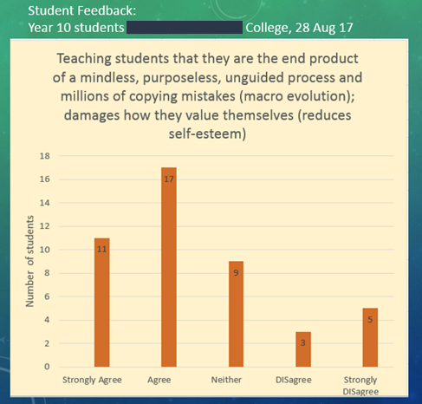

OBJECTIONS

“A TEACHER WOULD NEVER SAY THAT”
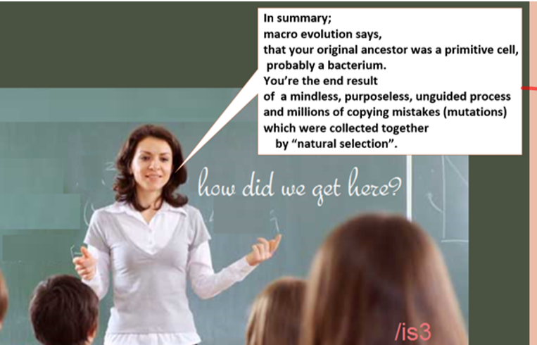
Whenever I ask parents to complete the questionnaire in Appendix 1,
their response to above image is usually the same – concern and disbelief.
“A teacher would never say that!”
They say, in stressed and perplexed tones.
Even though a teacher may not use those exact words; the textbooks DO say that, even though they do it in a concealed and confusing manner.
(See Section 2 of Teaching of Origins Scrutinized (TOS) which is attached for details.)

Even though not every student will “link the dots” and emerge with the clear summary above;
many will and most will subconsciously emerge with the overall conclusion
that we are nothing but animals with no inherent purpose or value or significance.

“EVOLUTION MAY BE BRUTAL BUT WE HAVE TO TEACH THE TRUTH”
Others may say:
“So what? Macro evolution may be brutal but if its true that is what we have to teach”

I am all for teaching “the truth’. Superficially, this sounds convincing, however when you consider macro evolution a deeper level it is based on false assumption. The assumption that macro evolution is a proven scientific “fact” or even that the evidence strongly supports it is if provable FALSE.
It is the prevailing assumption, much like the assumption that the earth was flat or that smoking is not deleterious to your health.

Recent discoveries in genetics and critical examination of the evidence yields the firm conclusion that macro evolution is fundamentally flawed and condemned rather than supported by the scientific evidence.

Dr John Sanford (Geneticist and inventor of the Gene Gun) and ex evolutionist said:
“The bottom lineis that the primary axiom
[of Darwinian/Macro evolution]
is categorically false,
you can't create information with misspellings,
not even if you use natural selection.”

Please see Section 3 of the attached document Teaching of Origins Scrutinized for details.

CONCLUSION
I fully realise that my submission will be unexpected and hard to accept.
Challenging the prevailing assumption of over 50 years is not easy; but the key tenant of the scientific method is that all ideas are open to review and scrutiny. The scientific evidence rather than tradition/habit should dominate.

The evidence is clear that mental illness and suicide rate has been increasing and the deductive reasoning above seem to have a credible link.

I plead with the commission to explore this further and possibly fund a research project to substantiate or discard my core assertions.

I would welcome the opportunity to discuss this further.

APPENDIX 1 – Feedback questionnaire
This questionnaire was used to obtain the view of students and others.

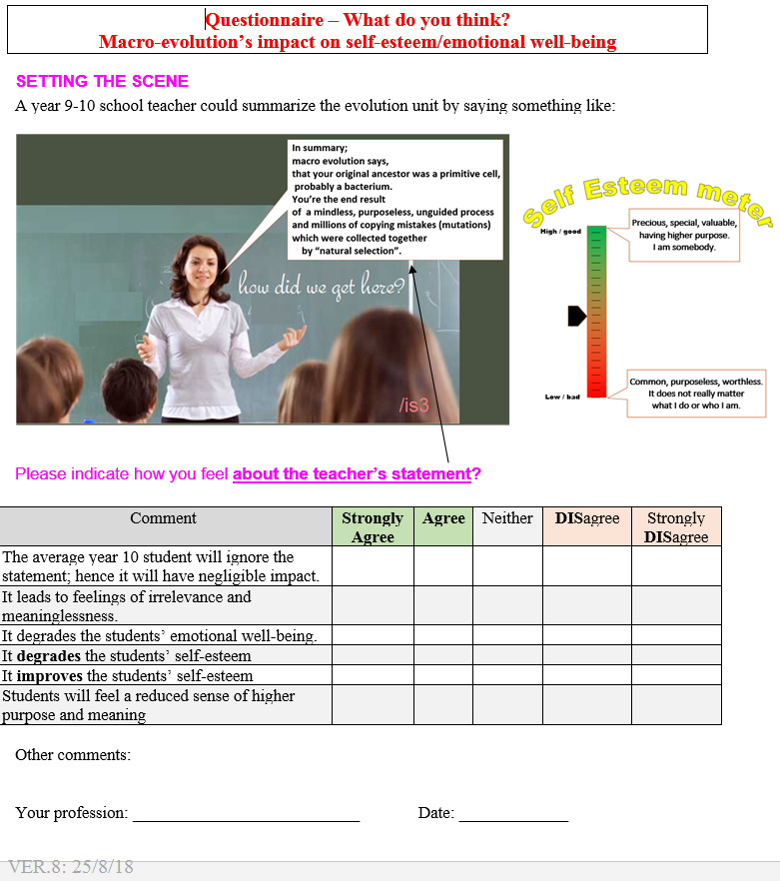

APPENDIX 2: Discussion with psychologist

Introduction
- Seven psychologists were approached to get their opinion on impact on students of being taught macroevolution. Four flatly refused the payment offer, 3 did not respond. An eight psychologist was approached and surprisingly she agreed to participate.
- She was advised over the phone about the nature of the discussion and of the request to record the interaction. She agreed to participate and to me recording the interaction. She also advised that she had an atheistic viewpoint
- The cost of the session was $170 and took place on mid-June 2019.
The friendly discussion lasted for over 1 hour 15 minutes.
- She has requested anonymity, so she will be referred by the alias “Jane”.
She is a Registered Psychologist and works with people needing assistance with a wide range of issues including:
- confidence and self-esteem problems
- post-traumatic stress,
- depression,
- anxiety,
- obsessive-compulsive behaviours,
- grief and loss issues,
- relationship difficulties,
- gender identity issues,
- and substance dependence issues,
- panic and phobias,

Key notes/extracts
- The key part of the discussion revolved around this diagram which is contained in TOS section 4 and shown here:

- Some of her comments included:
- “When I read that, my reaction to that is: Wow, I too have read things about evolution and this is such a negative slant on what I have read on evolution” 12:11 (time on audio recording)
- “To me this looks like a collection of the most negative slants you can put on a discussion of evolution. I would be very surprised if a teacher got up and said verbatim” 12:32
- “When I look at the whole of that paragraph in that box.
To me it has a very negative feel” 14:44
- “Let’s move onto the next bit which says
‘You’re the end result of a mindless, purposeless, unguided process’…
to me that sounds so negative”16:32
- “I would be surprised if any teacher would make it exactly as that whole block because to me is sounds so negative. It’s like picking out the most negative stuff… I would say it’s an amazing process where the laws of physics have contributed to molecules coming together…” 18:30
- “I don’t feel negative about this stuff.
So when I read it I think ‘Oh my gosh that seems so negative”.20:23
- “I look at that [diagram above] and I think – oh my goodness,
that sounds so negative” 23:50
- “But do I think that paragraph as a whole puts a negative slant on something something that I find as a wonderful fascinating process ….I find it wonderful and exciting. I don’t find it negative.
But that [paragraph above] feels negative when I read the whole thing”26:54
- “To me it [paragraph] has such a negative feel about it” 27:37
- Theo: “If a teacher was to stand up and say that to your children..would you be concerned. Do you think it would have a deleterious impact on at least a proportion of the children”
- “I don’t know. That’s hypothetical.
It’s quite possible. It’s quite possible” 28:42
- “This feels so negative to me. … I feel information has been edited to produce this.”37:59
- “When in all the time though Theo that I was taught evolution in high school, ..I never came across any lecturer or teacher who put it that put it in a way that sounded as negative as that sounds…
that [statement by teacher above] sounds really negative to me.” 41:53
- “I can only give you my impression. …
and say it [teacher statement] sounds negative to me”43:06
    - Key points/ net conclusions
- Jane is an atheist and reasonably well informed evolutionist.
She says that she personally does not find evolution to be negative and has managed to find a way to inject positive associations with it.
However, this is regardless of the science and is make believe.
- She has chosen to believe that evolution is something “wonderful” and “amazing” although she was unable to substantiate how or why.
- These adjectives seem to be based a pre-conceived belief rather than rational scientific thought and does not take into consideration what is in the textbooks.
- She clearly feels that the teacher statement to the class is “very negative”. She re-iterated this many times. Since the statement is very “negative”, then the impact on students will also be “negative”.
- She asserts that no teacher would make that statement because it is “so negative.” This is the reaction of many people and they are largely correct that most teachers would not state it so plainly and bluntly. But this is what the textbooks contain in a fragmented, sugar coated manner. The fact that teachers and textbooks go to great length to sugar coat macro-evolution clearly indicates that if/when it is stated plainly – that it is very negative with deleterious impact on the emotions and psychology of students.
- She believes that the statement mis-characterizes macro evolution; although she could not say how. When pressed to identify what part of the teacher statement was incorrect – she could not.

https://en.wikipedia.org/wiki/Deductive_reasoning
Branigan, T., Top school’s creationists preach value of biblical story over evolution: State-funded secondary teachers do not accept findings of Darwin, The Guardian (London), 9 March 2002, p. 3
https://www.susanblackmore.uk/journalism/the-world-according-to-dr-susan-blackmore/
https://www.chron.com/sports/outdoors/article/Kenneth-Miller-finds-good-news-in-evolution-12854049.php
The psychiatrist (MBBS FRANZCP) wishes to remain anonymous.

