Response to the Productivity Commission Inquiry into the Social and Economic Benefits of Improving Mental Health – Draft Report

Contents

REGIONAL COMMISSIONING AUTHORITIES 3

Example in practice 6

THE MURRUMBIDGEE MENTAL HEALTH, DRUG AND ALCOHOL ALLIANCE 6

COMMENTS ON RECOMMENDATION 21.3 - Approach to suicide prevention 8

INFORMATION REQUEST 23.1 9

INFORMATION REQUEST 24.1 10

INFORMATION REQUEST 25.1 10

COMMENTS ON RECOMMENDATION 5.7 11

INFORMATION REQUEST 5.2 11

Thank you for this opportunity to provide feedback in response to *Productivity Commission Inquiry into the Social and Economic Benefits of Improving Mental Health – Draft Report*. Murrumbidgee PHN is one of 31 PHNs, coordinating and commissioning primary care services to 241,641 individuals across 514 towns throughout the region. The Murrumbidgee region covers 140,000 square kilometres is in Southern NSW and includes 84 general practices, with 263 GPs and registrars and 494 allied health practices.

Murrumbidgee PHN welcomes the focus of the Productivity Commission on primary care- the cornerstone of prevention, early intervention and treatment for mental healthcare in Australia.

# REGIONAL COMMISSIONING AUTHORITIES

Murrumbidgee PHN does not agree with the rebuild model. However, we do support local regional governance arrangements between PHNs and LHNs which leverage existing structures and capabilities.

We suggest alternate arrangements to the proposed rebuild and renovate models focus on joint governance and regional planning and decision making. PHNs represent the key regional architecture for equitable planning and purchasing of mental health programs, services and developing complimentary integrated care pathways at the regional level.

We believe the infrastructure already in place can be extended and enhanced by investing in joint PHN/LHN governance at a regional level. These arrangements would build upon the maturity and capabilities that are present within the existing regional architecture. This would approach would also help to avoid a de-emphasis on the central role of primary care and general practice and reduce opportunities to invest in integrated care and cross-healthcare priorities and initiatives.

There is considerable progress already underway towards shared governance and collaborative commissioning. For example, Murrumbidgee PHN and Murrumbidgee LHD have established joint governance arrangements, shared community engagement and joint needs assessments. Murrumbidgee PHN and Murrumbidgee LHD have also commissioned in partnership where possible.

|  |
| --- |
| **Example in practice: JOINT PLANNING IN MURRUMBIDGEE**  Since 2015, Murrumbidgee PHN and Murrumbidgee LHD have undertaken regional planning and commissioning to improve mental health outcomes for individuals and wellness in communities. The joint Regional Mental Health and Suicide Prevention Plan will further embed and formalise these efforts.  Murrumbidgee PHN works in collaboration with Murrumbidgee LHD to undertake and release a joint needs assessment- working in partnership with stakeholders and communities to build agreement about regional mental health priorities. Our [MPHN Needs Assessment and Commissioning Guide](https://static1.squarespace.com/static/5b04e035f93fd49e35a6ba32/t/5dd37be576d4226b2a7dc5e4/1574141052709/MPHN+Needs+Assessment+and+Planning+Guide_Oct+2019_Final.pdf) provides a solid foundation for our needs assessment activities- ensuring that we are able to identify and understand health and social needs, service needs and expectations.  A key strength of the joint needs assessment activity is our connection with the diverse communities throughout the region. In recognition of the importance of community consultation, Murrumbidgee PHN has invested significantly in systems that allow for informal and formal consultation to occur iteratively and continuously, without being dependent on an intermittent planning cycle. This includes through our Health Needs Assessment Live (HNA Live) initiative- a consultation which occurs on a monthly cycle focussing in on a different health topic or population group each month. Murrumbidgee PHN and Murrumbidgee LHD also facilitate 33 Local Health Advisory Committee’s and host regular joint community-based forums in targeted communities to increase understanding at a town level of health needs. |

The Productivity Commission suggests that giving state/territory governments responsibility for regional commissioning ‘would be consistent with the overall approach of giving States/Territories responsibility for mental ill‑health treatment and recovery.’ However, general practices and community-based providers have a major role in care planning, treatment, integration and coordination through initiatives like the MBS, PBS and PHN-commissioned initiatives, providing coverage for most of the population. State and territory bodies fund and deliver public specialised mental healthcare services, including specialised public psychiatric hospital services, residential services and specialist community services. Therefore, responsibility for mental ill-health treatment and recovery is most certainly a shared responsibility with a focus on integrated care.

As per Figure 1 below, 2.8 million individuals will require services through primary mental healthcare. Around 400,000 people will require integrated and coordinated services across primary mental healthcare and acute/specialist care. Whereas, only 350,000 individuals will require services in state/territory mental health systems (as per Commonwealth Department of Health, Productivity Commission Submission 556).

*Figure 1: Demand and service intensity in Australia*



Therefore, most of the treatment and service demand in the population is unseen by state/territory services. Local governance arrangements will help to ensure that there is a balanced and coordinated approach to commissioning services across the stepped care continuum.

Whilst not diminishing the considerable issues associated with the ‘missing middle’ (as identified by the Productivity Commission), the ‘missing middle’ is a term used to describe individuals whose clinical and social needs are likely to require the services of both primary mental healthcare providers and state/territory providers at any point in time, requiring a high degree of cooperation, communication, coordination and integration across multiple providers. However, most people requiring or accessing primary mental healthcare services do not need multi-agency care and will be unlikely to require the services of a state/territory mental health service. Primary mental healthcare should maintain responsibility for service planning, commissioning and service delivery in such a way that it provides coverage for the entire population.

PHNs in partnership with LHNs are well placed to consider the elements of the local mental health system that would benefit most from a collaborative commissioning approach (e.g., suicide prevention, high intensity interventions) and bring in other stakeholders to support this.

We suggest it is unlikely that pooled funding at the funding level will lead to the improved experience, better integration and coordination at the individual consumer and community level. The highest potential for impact through pooled funding, is at the regional level- in the bringing together of sectors, local clinicians, and local services to plan, commission and evaluate services and outcomes collectively. Bringing together diverse but complimentary values and perspectives across primary and community care, acute and specialist care with consumer and carer experiences and goals at the centre.

PHNs and LHNs are ideally placed to operationalise regional commissioning with a core partnership between the PHN/LHN to pool funding and lead change at the local level, focussing health care around local priority population health and service needs. In the Murrumbidgee this potential is best demonstrated through our work with the Murrumbidgee Mental Health, Drug and Alcohol Alliance.

|  |
| --- |
| **Example in practice: THE MURRUMBIDGEE MENTAL HEALTH, DRUG AND ALCOHOL ALLIANCE**  Integral to the success of regional coordination and integration has been the Murrumbidgee Mental Health Drug and Alcohol (MHDA) Alliance (the Alliance) of which Murrumbidgee PHN and Murrumbidgee LHD are founding members. Over the past four years, this dedicated group of the region’s service providers have collaborated to improve mental health and drug and alcohol outcomes for the people living across the Murrumbidgee region. The Alliance focusses on consumer outcomes (as opposed to organisational outcomes) and places the consumer at the centre of its thinking. Members actively work to identify opportunities for joint initiatives and funding opportunities, promote recovery as the highest goal for consumers, and recognise that this involves the whole consumer journey not individual parts of the journey.  The Alliance currently consists of 16 agencies with considerable expansion to its membership since its inception. Members include the Murrumbidgee PHN, Murrumbidgee LHD, NSW Family and Community Services, the National Disability Insurance Agency, Aboriginal Community Controlled Health Organisations and all major mental health and drug and alcohol community managed organisations (CMOs). Consumers and carers are also engaged as members. The Alliance is supported by an independent Chairperson (currently the principal Official Visitor for NSW).  The outcomes from the Alliance have been numerous and include an integration project working towards a region wide common referral form, a person-held shared care planning tool and digital mental health service directory which can be accessed by community and health professionals. The Alliance also developed a campaign which aimed to increase awareness of access to mental health services across the Murrumbidgee region. The campaign was informed by 20 focus groups and research following the campaign demonstrated that there was an overall awareness of support services including a focus on the after-hours period.  The following three initiatives were prioritised by the Alliance, and progressed through solution-focussed co-design with consumers, carers and service providers:   1. **Common Referral Form**   Multiple provider-specific forms and provider-specific referral requirements were noted as a major concern and point of confusion for consumers, carers and referrers. Consumers and carers reported challenges gathering and submitting sufficient information, and some referrers (like GPs) were not referring to services at all- lack of user-friendliness of existing referral forms and processes were cited as a common issue.  The Murrumbidgee MHDA Alliance commenced the development of a common referral form. Throughout the development phase, a key challenge was ensuring simplicity and user-friendliness of the form whilst simultaneously meeting the information collection requirements of multiple agencies. This was achieved and the form is now in use across all 16 Alliance agencies.   1. **Single care plans (as per Recommendation 10.3)**   The Alliance is finalising a single care planning protocol and planning tool. The single care plan is developed by and can be shared across the various services the consumer accesses and can evolve to reflect the changing needs of the consumer. The single care plan is supported by an online platform designed to improve visibility and communication between the various service providers that a individual consumer may be accessing. Murrumbidgee PHN applauds the Productivity Commission’s recommendation (10.3) that the Department support the development of single care plans. In particular, the recommendation that the MBS be amended to include a specific item to compensate a clinician overseeing a single care plan for their time will be of considerable benefit.   1. **MapMyRecovery**   MapMyRecovery is a free resource, providing mental health information specific to the Murrumbidgee region. MapMyRecovery is designed for people who are experiencing mental health and/or drug and alcohol concerns as well as their friends, family, carers and service providers. A key feature of MapMyRecovery is a comprehensive directory of local programs and services with built in interactive map functionality, displaying the services closest to the individual accessing the platform.  MapMyRecovery also provides quick and easy to access information about mental illnesses, the different types of mental health workers, emergency or crisis support, local mental health and drug and alcohol services, helplines, telephone and online counselling and support, and online self-help tools. The Alliance is committed to further development of the platform, incorporating social services an individual may require. |

# COMMENTS ON RECOMMENDATION 21.3 - Approach to suicide prevention

Murrumbidgee PHN strongly agrees with the importance of undertaking evaluation of the various national and state/territory-based suicide prevention trials. There is also a critical need for information, learnings and evaluation findings to flow beyond the trial sites so that regions not involved in trials can make decisions on the best available and emerging evidence.

The Murrumbidgee region was chosen as a NSW trial site for LifeSpan- the systems approach to suicide prevention in NSW. As a result of our involvement in the trial, there has been significant progress in suicide prevention across the region.

**Aftercare services**

In 2017, Murrumbidgee PHN commissioned a region-wide aftercare service for people to access for support following a suicide attempt. In keeping with *recommendation 21.1*, the service provides practical, non-clinical support following a suicide attempt. The service aims to assist individuals and their families by linking them with appropriate support services to help manage life situations and challenges. This includes providing education and awareness and providing support to help increase resilience and coping. Clinical support (if not already available) can be easily facilitated.

|  |
| --- |
| **Example in practice: SUICIDE PREVENTION COMMUNICATION AND RESPONSE PROTOCOL**  In 2019, Murrumbidgee PHN worked with key stakeholders to articulate a suicide prevention communication and response protocol. The protocol is designed to:   * ensure a coordinated and effective response to suicide events, including suicide attempts and other critical incidents * improve community capacity to minimise the risk of contagion following a suicide event, including significant suicide attempts and other critical incidents   The protocol outlines the responsibilities of key stakeholders and articulates coordination, communication, privacy, confidentiality, and data sharing expectations. Signatories to the protocol include Murrumbidgee PHN, Murrumbidgee LHD, Wellways Australia, New South Wales Police, headspace, Relationships Australia, Riverina Medical and Dental Corporation, Centacare South West NSW, Department of Education, Family and Community Services, and New South Wales Ambulance.  When a suicide death occurs, a joint response is initiated and formalised through an Incident Response Plan. The protocol helps to:   * mobilise a coordinated and timely response * ensure that all evidence based post-vention strategies are actioned * identify and connect families, friends and communities with the support they might require * avoid isolationist and reactionary interventions by multiple agencies which risk overwhelming and confusing family, friends and the wider community. |

*Figure 2: Suicide prevention communication and response protocol overview*

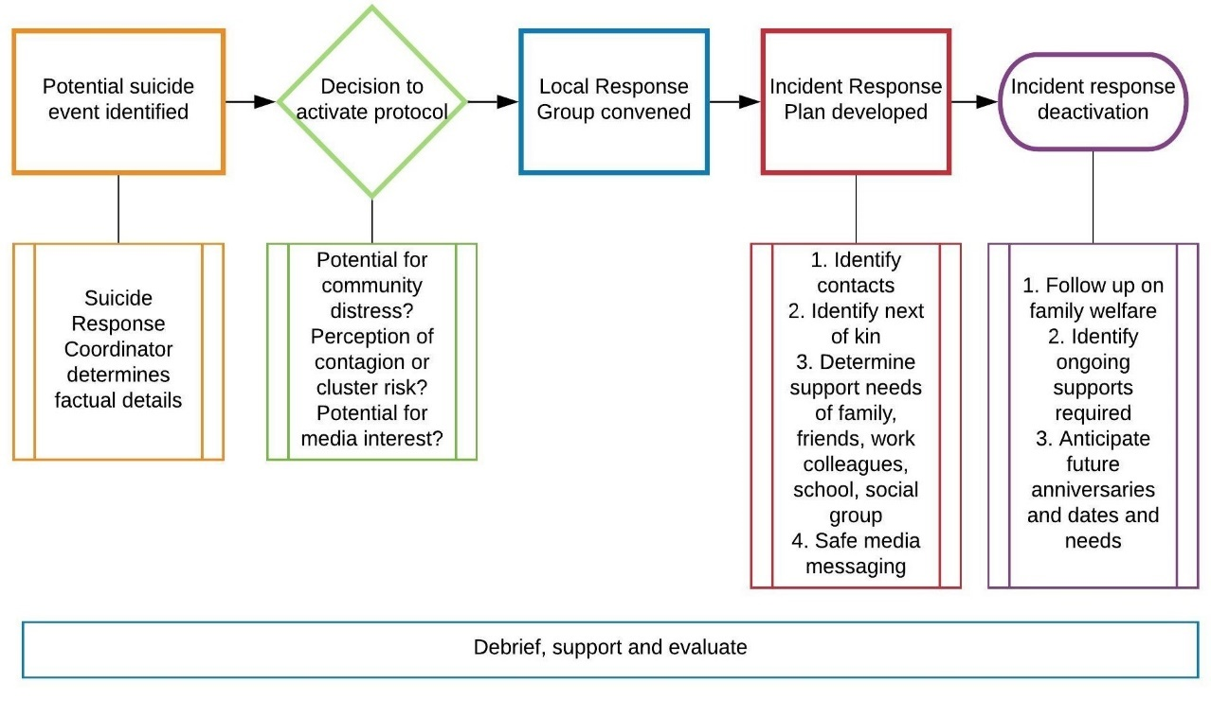

INFORMATION REQUEST 23.1 Should RCAs also hold funding for, and commission, alcohol and other drug services?

MPHN does not support the RCA approach, however given the high prevalence of people experiencing co-morbid mental health and addiction issues, the inclusion of alcohol and other drug service commissioning within regional commissioning is a sensible strategy. Isolating mental health funding under RCAs using the Productivity Commission’s proposed governance arrangements has the potential to limit procurement activities that simultaneously address multi-morbidities and/or target specific population groups (e.g., aged care initiatives incorporating psychological wellbeing).

As identified by the Productivity Commission, there is a 2-way relationship between health conditions and mental health. People with a health condition are more likely to develop a mental illness, and people with mental illness are more likely to develop a health condition. Initiatives that target both physical and mental wellness are imperative.

INFORMATION REQUEST 24.1-If the Productivity Commission were to adopt the Rebuild model, our preference would be to link RCA mental health funding with projected MBS-rebates for allied mental healthcare. Is there any reason that funding linkage should be undertaken on a different basis?

Murrumbidgee PHN would like to caution against linking funding to the volume of MBS rebates in a region. In many regions, there is an undersupply of allied mental health professionals and MBS activity (and therefore volume) arising out of the poor provider: population ratios in many rural and regional communities. MBS use is not correlated with illness prevalence or treatment demand, but rather the availability of allied mental health clinicians within a given catchment.

Therefore, linking the funding pool to MBS volume may result in an inadequate supply of funding in regions where MBS activity has not sufficiently met treatment demand due to the lack of allied mental health professionals working in the region. This will be felt most significantly in regional, rural and remote areas.

Murrumbidgee PHN welcomes the Productivity Commission’s recommendation that a Mental Health Innovation Fund (and associated evaluation expectations) be introduced (*recommendation 24.4)*. Importantly, Murrumbidgee PHN is keen to see improvement in how innovation and evaluation outcomes are shared throughout the sector.

INFORMATION REQUEST 25.1 -The Productivity Commission is seeking further information about what specific datasets are being under-utilised, the reasons why specific datasets are being under-utilised including examples of existing barriers, and what potential solutions can be practicably implemented to improve use of specific datasets.

It is important to note, that critical changes to the *Primary Mental Healthcare Minimum Data Set* are required in order to link service data across a person’s entire mental health service journey within the *Primary Mental Healthcare Minimum Data Set*. Currently, individual data is linked to an episode of care that is oriented around the service provider. Therefore, the data of the same individual accessing a subsequent service is not connected. Re-orienting data collection around the individual consumer will improve the PHN ability to understand consumer service needs and priorities for integration and coordination. Murrumbidgee PHN is optimistic about the possibility of data linkage across the *Primary Mental Healthcare Minimum Data Set* and various external data sets (*recommendation 25.1*).

The Murrumbidgee PHN processes and agreements to access external data sources for needs assessment and planning purposes have been refined over time and has included securing access to data sources not readily or publicly available. This has proven especially necessary for our work in suicide prevention- where valuable data often sits outside of and invisible to the health sector at the regional level. Notwithstanding this, it is important to reinforce that the majority of datasets are under-utilised for regional needs assessment and planning due to the significant difficulty accessing the data and accessing timely data.

COMMENTS ON RECOMMENDATION 5.7 **-** Psychology consultations via videoconference

Murrumbidgee PHN has commissioned tele-psychology services for adults, young people and children for more than 4 years. There are several advantages to tele-psychology including:

* Access to a larger clinical workforce (Australia-wide) helping to overcome the low provider: population ratios in the Murrumbidgee region
* Ability to access a wider range of multi-lingual clinicians for an increasingly multi-culturally diverse community
* Increased flexibility for non-urgent after-hours service delivery, for those people who are unable to attend services during usual hours
* A reduction in the potential for localised stigma- in small rural communities it can be harder to maintain privacy
* Reduced waiting times and reduced wait times for face to face services through increased dispersal of supply.

Murrumbidgee requests that the Productivity Commission reconsider the requirement to have a face to face component. To our knowledge, there is no evidence that a face to face component increases engagement, outcomes or experiences and may in fact, represent a barrier to access for people in regional, rural and remote communities.

INFORMATION REQUEST 5.2 **—**How should the requirements of the Mental Health Treatment Plan (MHTP) and MHTP Review be changed to ensure that GPs assess, refer and manage consumers in line with best practice (as laid out in the Australian Department of Health’s guidance)?

Motivation is at its peak at the time of initial help-seeking. An individual who encounters barriers to access at the point of help-seeking is at higher risk of dis-engaging from care or having a poor experience of care. Furthermore, a delay in accessing services due to avoidable barriers may contribute to a person experiencing prolonged distress and/or deterioration. Murrumbidgee PHN does not under-estimate the importance of a GP being involved in an individual’s mental healthcare, and an ideal situation is where an MHTP is easy to obtain prior to entry to a psychological intervention. However, if seeing a GP or gaining a MHTP represents a barrier to care, alternative referral pathways should be activated and available. This is particularly important for individuals at risk of suicide, individuals impacted by a traumatic event, and individuals living in communities with reduced access to general practitioners (e.g., based on geography, sociodemographic and cultural factors).

The current remuneration for GPs to complete and review MHTPs is grossly inadequate and does not sufficiently remunerate GPs for their time. Completing a quality MHTP is a time-intensive and complex activity, as reported in the [General Practice Health of the Nation](https://www.racgp.org.au/FSDEDEV/media/documents/Special%20events/Health-of-the-Nation-2019-Report.pdf) report:

*‘The Medicare model better supports shorter consultations for more straightforward health conditions, and essentially undervalues longer consultations that are required for complex issues. Medicare rebates for the treatment of mental illness are also lower than the rebates for physical illness. For example, the rebate for item 2713 for mental health consultations over 20 minutes is $72.85. A standard consultation of 20–40 minutes, by comparison, pays patients $73.95.9 Medicare has remained an important health policy issue for GPs.’*

Murrumbidgee PHN supports a review of Medicare rebates, so that the viability of mental healthcare within general practice is maintained.

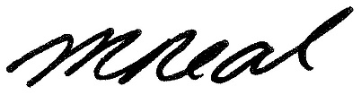

Melissa Neal

Chief Executive Officer

Email: [melissa.neal@mphn.org.au](mailto:melissa.neal@mphn.org.au)

Telephone: (02) 6923 3100