Tony Holmwood
PO Box 1009, Potts Point,
NSW 1335

Saturday, 22 August 2020

Re: Response to the Indigenous Evaluation Issues

Please find my 2 articles setting out the underlying reasons for the failure of top-down policy and evaluation approaches in the past. According to Mckinsey, 70% of change projects inevitably fail, and the reason for this is management take a top-down approach.
‘Too often, evaluations of key Indigenous reforms have been of limited usefulness for Indigenous people and policymakers. The evidence about what works, including for whom, under what circumstances, at what cost, and why, remains scant’ (Empowered Communities 2015, p. 90). Yes, I see definite parallels to how the Australian Human Resources Institute (AHRI) have failed the business community by instituting top-down HR practises and policy, and certification programs that promote conformity over individualism, rational approaches over social approaches, and fail to focus on building trust in partnerships. The Productivity Commission can learn from the failings of AHRI in there efforts to lift productivity in workplaces through taking top-down blanket approaches, rather than building trust in partnerships and competence in socially purposeful objectives.
“The 2015 National Indigenous Reform Agreement (NIRA) assessment report argued that ‘evaluation is the key to designing policies that achieve positive outcomes for Indigenous Australians’ (PC 2015, p. 168).” Note that a compliance mindset can stifle capability, innovation, and growth as it has been proven through the certification and compliance approaches as instituted by the Australian Human Resources Institute. Productivity (in the OECD since the 1970’s) has been declining throughout the rise of the HR profession, the implementation of HR practises and policies, compliance, technology enablement and outsourcing. Evaluation techniques need to be human centred and allow for adaptability and change, not top down, faceless, unemotional analytical analysis which can so easily mask social and cultural issues. Analytical or rational specialists tend to have a limited concept of cultural or social issues, so it is important aboriginal leaders and elders are involved in monitoring the outcomes. And this is also a matter of respect so programs are not imposed on the communities.
“The United Nations Declaration on the Rights of Indigenous Peoples (UNDRIP) (box 1) was endorsed by the Australian Government in 2009. The Commission considers that the UNDRIP situates the strategy within a broader international context of promoting greater self-determination for indigenous peoples.” We need to understand that self-determination can only happen once the Aboriginal population are allowed to grow confidence in their identity (self-concept) and to live as individualists, and not experience the shame of having to conform to the standards imposed on them by the government or societal norms.

We must also consider that to “promote, develop and maintain institutional structures (article 34) for their own development and decision-making (articles 18 and 20),” under the UNDRIP can only be beneficial if such structures are implemented at the community level so as to not impose blanket policy on differing community preferences, and so leaders in that community can learn the leadership behaviours required to direct their own destiny and to focus on the real issues at hand. Leadership coaching will ensure the success of this approach and is really the only way this approach will work.
“In exercising this right, they have the right to ‘autonomy or self-government’ (article 4),” will require authentic leadership approaches as set out in my article. Rational or transactional (economic) leadership approaches will inevitably fail. Economic, social, and cultural objectives must be in balance.

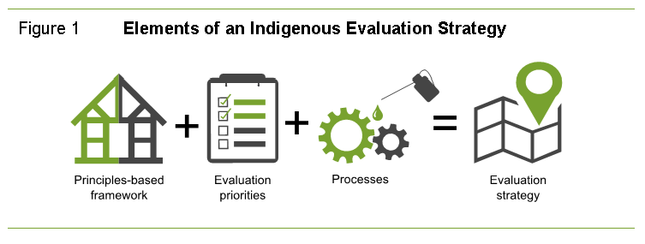
This evaluation strategy is limiting and taken purely from a rational perspective only – what about the emotional perspective? Social connection is a basic human requirement for building self-concept and self-worth – an absolute requirement for developing confident community identities. What about meaning and purpose over principles? It would be wrong to impose this framework on communities without an over-arching objective purpose as established by each community to be evaluated. (See my “Strategic Alliances” paper on the need to commission a purposeful partnership and team-based approaches that builds trust).
“The Evaluation Strategy will apply directly only to Australian Government agencies. However, the Commission recognises that other stakeholders, such as Aboriginal and Torres Strait Islander organisations, state, territory and local governments, not for profit entities, business and communities are key stakeholders, and partners, in policy implementation and evaluation.” Again, this approach will miss important community nuances and distinctions and provide a blanket evaluation response which has failed the aboriginal communities in the past. Evaluation must be directed from the bottom-up.
“Developing the Indigenous Evaluation Strategy is essentially the first stage in a process to improve evaluation practice and use across the policy cycle. Beyond this, the Letter of Direction envisages an ongoing role for the Commission in reviewing agencies’ progress in implementing the Strategy, as well as the Commission undertaking evaluations in areas in which there may be value in it doing so.” This statement just reeks of top-down establishment – change does not happen when programs are directed and overseen by bureaucrats in Canberra.

Overall, the closing of the gap objectives have not been achieved because of bureaucratic failings and this must be respected. Building partnership and trust, and associated evaluation techniques, needs to happen from the ground up with the focus on building purposeful communities and meaningful social connection, that will in turn grow community and leadership confidence and competence. Top-down evaluation techniques will fail if they are not well targeted to these objectives.

Tony Holmwood
Cultural Change Strategist and Leadership Coach
Outperf4m Consulting

