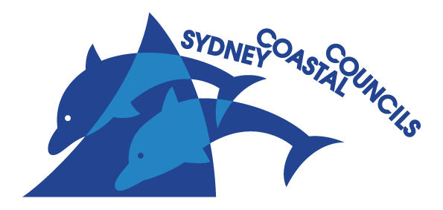
SYDNEY COASTAL COUNCILS GROUP Inc.
PO Box 999, Manly NSW 1655
Email: info@sydneycoastalcouncils.com.au
Web: www.sydneycoastalcouncils.com.au
ABN: 39 638 876 538

National Water Reform 2020
Productivity Commission
water.reform.2020@pc.gov.au
Reference: 033-20 JM

Tuesday, 25 August 2020

Re: National Water Reform Inquiry

To whom it may concern,
We appreciate the opportunity to provide a submission in response to the Issues Paper for consideration by the Productivity Commission under the National Water Reform Inquiry.
The Sydney Coastal Councils Group (SCCG) is a regional organisation of Councils that advances sustainable management of Sydney’s urban coastal and estuarine environment. We currently comprise nine member Councils who represent 1.3 million Sydneysiders. Our key goals include that:
- People and places adapt to a changing climate and future shocks and stressors
- Waterways and the foreshore are protected and healthier and
- There is a collaborative, effective and consistent approach to coastal and estuarine management.
The SCCG notes the Australian Government has asked the Commission to conduct a further inquiry into the progress of the Australian, State and Territory Governments in achieving the objectives and outcomes for water resources management under the National Water Initiative (NWI) intergovernmental agreement of 2004.
The SCCG understands that under the scope of the inquiry, the Commission will assess the progress of jurisdictions towards adopting the principles set out in the NWI, consider the outcomes of reform efforts, and the extent to which the NWI reforms help address emerging challenges, such as climate change and make recommendations on future reform priorities.
Our primary concerns relate to integrated water cycle management (IWCM) in urban areas in New South Wales, particularly cross jurisdictional responsibilities, and outcomes for stormwater management. The NWI establishes agreed outcomes, actions and implementation timelines for eight key elements, including urban water reform and aims to improve the economic efficiency and environmental sustainability of water management for both rural and urban water systems.
In consideration of the Issues Paper, the SCCG provides the following responses to questions under Information Request 11, relating to IWCM in urban areas.
What steps have been undertaken to address the priority areas for urban water reform identified in 2017?
The Inquiry in 2017 concluded that water reuse, water use efficiency, water sensitive urban design and innovation have improved since the introduction of the NWI. However, there remain ongoing issues with poor water quality of stormwater and impacts on waterway health in urban streams in Sydney catchments, particularly after rainfall events. The requirements of Local Government in NSW to construct and maintain urban stormwater infrastructure are prohibitively onerous and there is insufficient financial support to achieve adequate stormwater quality. Water sensitive urban design (WSUD) needs to be better maintained and applied broadly and consistently across catchments and jurisdictions.
Is further guidance on implementing an integrated water cycle management approach for delivering water supply, wastewater and stormwater management services required?
The SCCG has identified the need for improved guidance and training for local government on WSUD installation and maintenance. Examples include guidance on best practice techniques for bioretention in appropriate locations, considering rainfall and soil type. There is also little guidance on integrating WSUD and stormwater management with water supply and wastewater management for a cross jurisdictional approach.
How does jurisdictional urban water service planning interface with urban land-use planning at different scales? Are the roles and responsibilities clearly set out?
The Issues Paper states that IWCM is generally supported by all Governments as the approach required to move to water sensitive cities, a key action for urban water reform in the NWI. However, there are significant barriers to the effective implementation of IWCM in urban areas in New South Wales. Whilst State Government controls potable water supply and wastewater management, it has limited responsibility for stormwater management which falls largely with Local Government. Regulatory reform is needed to address cross jurisdictional deficiencies for IWCM.
We also note that an outcome of the 2017 inquiry, was to significantly enhance policy settings relating to urban water management. There is no clear leadership or mandate from State Government agencies and there is little or no integration of stormwater management between state and local jurisdictions in either policy or strategic settings, with little impetus to achieve common objectives relating to stormwater quality and impacts on waterway health.
Recommendations
- That further regulatory reforms be undertaken to ensure the effective coordination of responsibilities of State and Local Government for IWCM.
- That a set of common stormwater quality objectives be developed and adopted for both State and Local Government in NSW.
- That effective cross jurisdictional implementation and funding mechanisms be developed for achieving stormwater quality objectives and waterway health.

The SCCG also supports the issues raised and the recommendations in the submission being made to this inquiry by the Georges Riverkeeper.
If you have any queries, please contact me by email at executiveofficer@sydneycoastalcouncils.com.au or by phone.

Yours sincerely,

Sarah P Joyce
Executive Officer

