iFixit Oceania
C/O LBW & Partners
PO Box 276
Chatswood, NSW 2057

February 01, 2021

Re: Response to request for information from the Australian Productivity Commission

iFixit is an international, open-source, online repair manual for everything. Our mission is to provide people with the knowledge they need to make their things work for as long as possible.
We represent a global community of makers, tinkerers, fixers, and repair professionals. In 2020, the iFixit community taught repair to over 100 million people from almost every country in the world, including over 4 million Australians. Our strongly collaborative group has published over 70,000 repair guides on everything from home appliances to automobiles to smartphones.

This massive, free resource has helped people fix everything from cellphones and game consoles to tractors and musical instruments. iFixit stands firm in its support of the tinkerers and independent repair professionals in our community. We believe that owners should have the right to repair, modify, and tinker with the things they own, and that they should be able to access repair services of their own choosing. iFixit has made it our business to provide access to the service manuals, troubleshooting diagrams, and parts supply chains that most product manufacturers used to provide, but that many no longer do.

iFixit was founded on these beliefs:
- Consumers and product owners should have the right to decide who repairs their products. They should be able to fix it themselves if they choose.
- Creating an economy around extending the lifespan of manufactured goods will create local jobs.
- Repairing and maintaining electronics requires information, parts, and tools from the product designers. As manufacturers integrate electronics into more and more products, from tractors to refrigerators, that have been traditionally serviceable, they are shutting out independent repair organizations.
- The knowledge and tools to repair and refurbish products should be distributed as widely and freely as the products themselves are. In contrast to centralized manufacturing, reuse must be broadly distributed to achieve economies of scale.
- Extending the lifespan of manufactured goods will benefit the environment, easing the demand on natural resources and keeping electronics out of landfills.

The repair, refurbishing, and remanufacturing sectors are in their infancy, but are poorly understood. These sectors diversify the economy, adding jobs and businesses, while fostering entrepreneurship and innovation

For our members—and Australian consumers more generally—the problems of being unable to repair their own products are vast and will continue to grow. Without access to service diagnostics, products will simply stop working as cloud services change or shut down. Without access to repair parts, consumers will have to replace perfectly repairable products. And without service information, the vast diversity of products on the market will overwhelm repair shops and recyclers.

Independent repair businesses are struggling to survive, but at the same time owners of equipment with digital electronics are unable to keep their equipment operational. We need to make our products last longer. Electronics manufacturing strains the limits of our natural resources while usable products and device components are thrown into landfills instead of salvaged, fixed, and reused. We need to support local repair businesses’ ability to repair our products.

INFORMATION REQUEST 1
What would a ‘right to repair’ entail in an Australian context? How should it be defined?

A meaningful ‘right to repair’ should remove barriers to repair for both consumers and independent repair providers. This can be achieved by imposing the following 8 requirements on manufacturers:

- Require manufacturers to make service manuals public.

To keep electronic devices working for as long as possible, recyclers, professional technicians, and home repair experts need information about how to safely and successfully disassemble their electronics. Publishing comprehensive service documentation will extend electronics’ usable life better than any other single action.

These manuals should include exploded diagrams of parts, compatibility charts, wiring diagrams, step-by-step disassembly instructions with required tools, product specifications, maintenance procedures, and troubleshooting information. When good repair documents are freely and easily available, people will fix their old devices instead of buying new.

Fortunately, almost all manufacturers already have this information, and could enact real, immediate change by simply making it publicly available. Historically, manufacturers always provided this information to their customers. Recently, though, some companies have chosen to treat service documentation as proprietary information and guard it from public view. Apple in particular is known for using copyright law and legal threats to prevent retransmission of their service manuals.

Of course, not all manuals are created equal. Some manufacturers have some service documentation available, but it is not as useful as it could be. Open and useful service manuals will have these characteristics:

- User-friendly formatting​. Large images and diagrams make manuals easier to follow. Manuals should be available on the web and as downloadable PDFs for offline viewing.

- Machine-friendly file format​. In addition to being user friendly, manuals need to be available in a format that is adaptable for future uses. Machine-readable formats like XML and ​oManual​ (IEEE 1874) make full use of the information available to new distribution channels. Examples include allowing developers to use it in a cell phone app or using it at a disassembly bench in a recycling facility.

- Open-source licensing that allows redistribution and modification​. If licensed under a license like the Creative Commons (CC-BY), repair experts can improve repair documents in the future. Plus, an open license allows the documents to be distributed across jurisdictions. Dell, HP, and Lenovo already make their documentation public, which has helped create tens of thousands of repair jobs. But it would be more effective if technicians could modify and reproduce this documentation.

- Require manufacturers to make circuit diagrams public.

Repair isn’t always a matter of simply swapping out trouble components. When complex components fail, they should be fixed instead of sent off for recycling. Board-level repairs require circuit schematics, which detail component layout and electronic wiring schematics. These documents make it possible for technicians to replace individual capacitors, for example, instead of scrapping an entire circuit board. Since circuit diagrams are largely standardized for international use, these diagrams are especially useful to aftermarket refurbishers overseas, where much of the component-level repair actually takes place.

These schematics are in high demand by technicians. iFixit received a US DMCA takedown notice from Apple on December 8, 2015, demanding the removal of a circuit schematic uploaded by a community member for a MacBook Pro logic board. YouTube personalities ​Louis Rossman​ and Jessa Jones​ post popular training videos for technicians using schematics that are not available through legal means.

The circuit diagram should include the approved vendor list, or AVL, and Bill of Materials (BOM) detailing the specific part number and manufacturer for each component so that repairers can know precisely which parts are needed.

The​ ​capacitor plague (widespread failure of faulty capacitors during 1999 to 2007)​ caused millions of electronics over the last twenty years to fail prematurely. The parts needed to fix the failing devices usually cost less than $1, but knowing which parts to buy requires access to manufacturer information. Because this information is not available, relatively few of these machines have been repaired. Most were shredded.

Some particularly savvy repair technicians have reverse engineered the circuit and created informal diagrams, which vary widely in quality and availability. Authoritative circuit diagrams would make component repair more attainable for both professional technicians and do-it-yourselfers.

- Require manufacturers to make semiconductor documentation datasheets public.

Microchips are the most toxic part of electronic devices. Massive amounts of​ ​high-purity water​, electricity​, and​ ​toxic chemicals such as arsenic​ are used in semiconductor fabrication. Despite the enormous environmental costs, microchips are everywhere—from​ ​children’s toys​ to​ ​complex computers​.

Running any functional chip through a shredder is a massive waste of resources. Even when a device is beyond repair, chips can be recovered and repurposed. Made widely available on the internet, semiconductor engineering documentation would allow technicians around the world to recover microchips and reuse them in other devices.

- Require manufacturers to make service parts available to third parties.

Many companies also stymie repair by choosing not to offer official replacement parts to individuals or independent repair technicians. “We’re used to being able to buy replacement parts for our cars and appliances, but that’s often not the case with your smartphone or laptop,” iFixit Senior Technical Writer and Teardown Engineer Jeff Suovanen explains. And when manufacturers refuse to sell Original Equipment Manufacturer (OEM) parts, repair shops and users have to turn to third-party components instead, which can be problematic.

“It’s very hard to find good parts when the market is flooded with low-quality imitations that don’t perform well. In the case of batteries in particular, some of those third-party components can be dangerous—a cheap battery can destroy your device, or burn down your house.” Without access to OEM parts, service technicians are reliant on grey market parts and parts scavenging, where they pull parts from non-functional devices.

At iFixit, we source the highest quality parts we can find and test them thoroughly before selling them in ​our store​. But if you search for a replacement battery elsewhere, there’s no guarantee of what you’ll get. This whole process would be much easier and safer if people were able to buy official parts directly from the manufacturer.

- Require manufacturers to make specialized tools available to third parties.

  - Hardware tools.

Everyone has a screwdriver at home, and some tech-savvy individuals may even have a set of torx bits​ in their toolbox. But manufacturers are increasingly using even harder-to-find screws that prevent you from getting inside the chassis.

“The easiest one to pick on is Apple, because they picked a screw design so obscure we’d never even heard of it,” says Suovanen. “And we know it wasn’t for engineering reasons, because the iPhone got along fine with ordinary Phillips screws—until all of a sudden the ​iPhone 4​ ​switched to pentalobe screws​. But only on the outside—none of the interior screws were changed. Since no one had a pentalobe driver, the clear intent was to tamper-proof your iPhone.”

Apple isn’t the only manufacturer to do this, of course—Nintendo was doing it all the way back in the 80s with a ​special security bit​ on NES cartridges and, later, on ​the Super Nintendo​. These kinds of lock-out moves have only proliferated in recent years. These days, Nintendo ​uses rare tri-point screws on their hardware​, Amazon ​uses tri-wing screws on the Fire TV​, and Sony ​uses Torx security screws in the PlayStation 4​.

“Torx security screws are some of the most frustrating ones, because a lot of people have torx drivers in their toolbox,” says Suovanen. “But manufacturers take that extra little step and use a torx security​ bit—which again, adds nothing engineering-wise to the device. It’s just an attempt to keep you out.” Some manufacturers don’t go quite this far, but will still ​hide screws under rubber pads or other panels​.

If manufacturers design their products to use specialized hardware that requires the use of specialized tools that are not commonly available, then they should be required to make those tools available to consumers and independent repair technicians.

  - Software tools.

In addition to specialized hardware, some manufacturers are implementing new restrictions that impede repair using even the manufacturer’s parts without a specialized software tool.

For example, a common point of failure in the current generation of consoles is the optical drive. Replacing an optical drive is, by itself, relatively straightforward. However, over the past decade, console manufacturers have increasingly used technological protection measures, or TPMs, to “marry” motherboards to their original optical drives. Unlike replacing an optical drive, replacing an entire motherboard is expensive and complicated. Optical drives are commodity components that can be purchased from a variety of suppliers, while motherboards can only be produced by the console manufacturers. To replace the optical drive without also replacing the motherboard, a user must “divorce” the motherboard and optical drive by temporarily circumventing TPMs in both, then pair the motherboard to the replacement drive.

Touch ID on the iPhone is another example. We can get the replacement parts, but we can't 'pair' them to make them work. We have people in our forums wondering if they could jailbreak their phones to complete the repair. Apple's independent repair program provides access to this software, but before it will allow the repair, it checks with Apple's servers to make sure the technician is in good standing. The fear is that in the future, all parts will have software with cryptographic pairing, and require confirmation from the manufacturer to provision a new part. Then the company still has total control over who can pair—and therefore repair—it.

And, “if you ​replace the screen on your iPhone​—even if it’s with a brand new OEM screen off of another identical iPhone—certain features like TrueTone won’t work correctly,” says Suovanen. This compels users to go directly to the manufacturer for repairs, no matter what they cost.

When iFixit first tested Apple’s new iPhone 12 in October 2020, our engineers discovered that, when the camera on a new iPhone 12 was replaced with an original camera from the same model phone, the camera wouldIt refuse to switch to the ultrawide camera, respond only to certain camera modes, and occasionally hang and become completely unresponsive. In Apple’s internal training guides for the iPhone 12, authorized technicians are told that, starting with the 12, they will need to run Apple’s proprietary, cloud-linked System Configuration app to fully repair cameras and screens.

We recently re-tested this, and found that camera swapping between iPhone 12 models now works. But in January 2021, Apple shipped an iOS update that adds a warning (“Important Camera Message”) to consumers when the camera has been replaced, even when replaced with an original Apple camera. Given that there are few, if any, non-genuine iPhone cameras in the repair market, the iPhone warning, (and the Apple support page linked to in the warning) are actually about who replaced the camera in your iPhone. What triggers the warning is not a malfunction in the camera, but that the serial number in the camera doesn’t match that of the original phone camera—and that the person repairing didn’t have access to Apple’s System Configuration app to reset that pairing. This type of warning is likely to have a chilling effect on consumers seeking independent repair, unless Apple provides access to their System Configuration tools to independent repair providers.
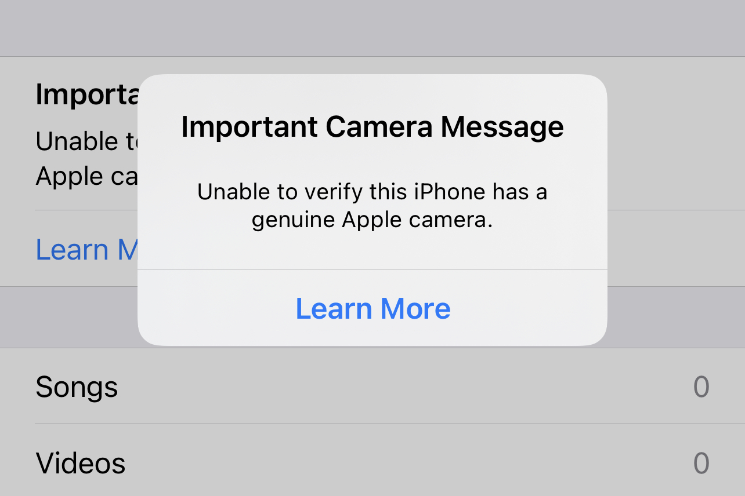

In addition, manufacturers should be required to provide access to their diagnostic tools to consumers and independent repair providers.

In 2016, Apple confirmed that a software update had been quietly killing phones repaired outside of their "authorized" service network. Initially, the software giant defended "Error 53" as a security measure—and put the blame on independent repair shops and shoddy parts. Consumers, DIY hobbyists, and repair pros called out Apple for misrepresenting the facts. Apple apologized, admitted that Error 53 was a software mistake, and issued a software patch that fixed phones "bricked" by the error.

But they continue to indicate that this software may be necessary for ​repairs going forward​: “MacRumors obtained an internal document from Apple stating that Macs with the Apple T2 chip, including the iMac Pro and 2018 MacBook Pro, must pass Apple diagnostics for certain repairs to be completed.”

Apple is not the only one limiting access to diagnostics. Farmers need access to John Deere’s diagnostic software to debug their equipment. Deere doesn’t make it available to anyone except their authorized technicians, driving farmers to extreme options. A Motherboard investigation found ​underground forums trafficking in pirated diagnostics​:

“Once I was on it, I found dozens of threads from farmers desperate to fix and modify their own tractors. According to people on the forums and the farmers who use it, much of the software is cracked in Eastern European countries such as Poland and Ukraine and then sold back to farmers in the United States. ... ”

“Farmers worry what will happen if John Deere is bought by another company, or what will happen if the company decides to stop servicing its tractors. And so they have taken matters into their own hands by taking control of the software themselves.”

- Require manufacturers to provide access to wireless telematics systems.

Access to these telematics systems is a property rights issue. Who has the right to the data from our products? Should we be able to reprogram devices to talk to our own servers, rather than the manufacturer’s?

Manufacturers are unfortunately using new technology to prevent users from accessing their data and repairing or modifying the devices they have bought, from tractors to printers to coffee makers. They are invoking vague ‘intellectual property’ concerns to justify and protect these anti-consumer behaviors.

With the advancement of vehicle ​telematics​, safety, usage, location, system health, error codes and other data from a car are now tied to cloud services controlled by the manufacturer. Manufacturers can now shut off remote services at any point and render hardware inoperable, and modifications to software to restore functionality could violate legal restrictions on circumvention of technological protection measures.

The current state of affairs is biased against product owners, turning regular people — like students, researchers, and small repair business owners — into criminals. Fortune 500 telecom manufacturer Avaya, for example, is known for ​suing service companies​, accusing them of violating copyright for simply logging in to their customer’s phone systems. ​With modern telematic systems, automotive manufacturers could use the same techniques​ to prevent independent management and service of automobiles.

These concerns are outweighed by the urgent needs of citizens to maintain their equipment. Property owners should have control over how their property is repaired or modified.

Right to Repair will enable better security. Security professionals agree that if the security of a product relies on nobody knowing how it works, it is much less likely to be effective. Opponents of the Right to Repair appeal to “​security through obscurity​” as a justification to ​keep products closed​, even though this approach has been discredited by the security community. ​Kerckhoffs's principle​ states that a cryptosystem should be secure “even if everything about the system, except the key, is public knowledge.”

Independent repair shops and software developers can only innovate around open products. The process to create new repair services and apps is only possible if the design is open and supports new ideas, products, and markets. Unfortunately, the manufacturer’s approach to telematics has been anything but transparent.

Our industry, and the members that we serve, need to be able to access telematics information. Product owners’ data should be used to serve more than the narrow commercial interests of a few large corporations.

Further, if this information was available, then governments, researchers, and software startups would be able to innovate with it. They could build proactive repair apps to help people maintain their equipment more effectively.

Imagine if consumers had the information that their vehicle emissions were spiking, and could proactively get it fixed rather than waiting for a smog check. Innovative companies could develop monitoring applications for fleets of equipment.

Open data breeds innovation. Guaranteeing access to telematics information will benefit local innovators, consumers, and the environment.

- Require manufacturers to design repairable products.

Many manufacturers frustrate repair by designing their products such that repair is difficult or impossible. Right to repair in Australia should require that manufacturers design products to be repairable, and should prohibit the following practices:

  - Glueing instead of using screws: In the age of sleek, curved devices with no obvious seams, ​many manufacturers have turned to glue​ instead of screws to hold things together. “There are legitimate reasons to use glue—like waterproofing,” says Suovanen. “But there is almost always a better way, like using screws and gaskets. Glue is very difficult to work with if you’re trying to repair something. It’s difficult to separate without breaking things, and it’s a pain to replace.” And when you use glue to hide those seams, it makes the device appear impossible to open, disincentivizing users to repair their device, instead of grabbing a Phillips head screwdriver and taking a look inside.

  - Soldering components together to make upgrades impossible: Once upon a time, you could open up your laptop, pop in some new RAM or a bigger hard drive, and get an extra couple years out of your computer. But that’s often not the case anymore. “We’ve grudgingly accepted that most mobile CPUs are soldered onto the motherboard these days, and frequently that’s the only option the manufacturer has—that’s how they come from Intel,” says Suovanen. But RAM and storage are often soldered to the motherboard unnecessarily, eliminating the possibility of otherwise easy upgrades. “There’s no reason why you can’t have a very thin, very light device with modular RAM and a removable blade SSD. We know because we’ve seen it done in devices like the ​LG Gram​ and the ​HP EliteBook line​ (which is particularly repair-friendly​).” When you see a label that says “no user serviceable parts inside,” you know the manufacturer has soldered everything together and you have no chance of squeezing a few extra years out of the device when it slows down.

  - Making it impossible to disassemble a device without destroying It. In the most egregious cases of planned obsolescence, manufacturers will make a device difficult or impossible to open—at least, without inflicting irreparable damage. “The ​Surface Laptop​ is one of the only devices that we’ve awarded a 0 out of 10 in repairability, because it was so obvious that it was designed never to be taken apart or serviced—even by professionals,” says Suovanen. “In a nutshell, Microsoft ​ultrasonically welded​ the chassis together and then glued a fabric cover down over the top. There’s no way to take that apart without destroying it. You could put it back together with a roll of duct tape, but that’s about it.” That means if your device breaks, you’re completely out of luck—the manufacturer may give you a new device under warranty, but if your warranty has ended, you’re basically stuck buying an entirely new laptop.

- Require that manufacturers provide sufficient and accurate information on repairability to consumers.

We’ve found that some manufacturers will falsely tell users that certain repairs can’t be done, even when independent shops are perfectly capable of performing them. “People go to the Genius Bar with very common problems that our repair community knows how to fix, but Apple tells them it can’t be done,” says Suovanen. For example, Apple ​won’t help you recover data on a water-damaged iPhone​, and they won’t refer you to third-party repair shops who can. In other cases, they may quote a repair price that’s high enough that most customers will just throw up their hands and buy a new device.

Others use “Warranty Void If Removed” stickers on their devices. When you crack open the back panel on your device—or perhaps even before—you’ll often find a sticker that claims your warranty will be void if you break the seal. In the United States, that practice is illegal under the Magnuson-Moss Warranty Act of 1975​. A manufacturer can’t deny a warranty repair purely because someone has used third party parts or services to repair a device. Similar protections exist under Australian law.

INFORMATION REQUEST 2
a) What types of products and repair markets should the Commission focus on?

Over the last two decades, we’ve gone from a world where software is rarely seen outside of a general-purpose computer, to a world where billions of microprocessors are embedded in virtually every type of device. As a result, software has become central to the repair of devices. Manufacturers are, unfortunately, taking this opportunity to prevent users from repairing or modifying the devices they have bought, from tractors to printers to coffee makers.

On iFixit.com, device repair pages for mobile devices, including smartphones, tablets, and laptops, are the most popular with our Australian users. This information is available in detail in Appendix A. But, we would discourage the Commission from focusing on narrow categories of products and repair markets, as these problems persist in all categories of software enabled devices.

For example, the current pandemic has highlighted the need for the right to repair medical equipment. In July 2020, the United States Public Interest Research Group (USPIRG) published a study on how manufacturer-imposed restrictions on repair of medical equipment cause potentially calamitous delays in hospitals. USPIRG spoke with more than 200 biomedical technicians (“biomeds”), whose job it is to keep hospitals’ equipment running, to understand how manufacturers restrict access to the parts, information, and tools needed to repair equipment on-site.

USPIRG found that while some manufacturers provide access to some or all of the necessary repair documentation for their devices, others require biomeds to purchase access keys or insist that the repairs be performed by their own technicians—who usually have to travel to the hospital. In the midst of the COVID-19 pandemic, travel was limited and these technicians were not allowed into the hospitals, meaning biomeds were the only ones who could fix life saving equipment.

At iFixit, we have worked with biomeds for years in our efforts to get Right to Repair legislation passed in the United States, and they have told us how they rely on forums and their own networks to find and share repair manuals. They told us how they spend innumerable hours scouring the internet, searching for crucial repair information they need to make a fix or perform preventative maintenance. And, they contributed thousands of these manuals to the online medical repair database that we launched in May—a crowdsourced project born from sheer necessity.

b) Are there common characteristics that these products share (such as embedded technology and software or a high/low degree of product durability), and which characteristics would allow policy issues to be considered more broadly?
c) If there are particular products that the Commission should focus on, what are the unique issues in those product repair markets that support such a focus?

iFixit is the electronics industry leader in rating products for ease of disassembly and repair. Unlike the rest of the tech media, we don’t judge products for their release-day usability or aesthetics—we focus on what will happen when the device (inevitably) fails. How time-consuming is it to open? Can broken components be replaced individually, or will you have to swap out more expensive larger modules? Are the components that are most likely to fail easily accessible by consumers? Our score provides a consumer with an educated guess of repair difficulty before they buy the product, and gives us insight into general trends in those markets.

A device with a perfect score may be relatively inexpensive to repair because it is easy to disassemble and has spare parts and a service manual available. Points are docked based on the difficulty of opening the device, the types of fasteners found inside, and the complexity involved in replacing major components. Points are awarded for upgradability, use of non-proprietary tools for servicing, and component modularity.

While our analysis represents a solid cross-section of the market, it is by no means exhaustive. iFixit has repair manuals for many thousands of devices, but our engineers only have time to perform repairability analysis on a much smaller subset. ​OpenSignal estimates​ there are tens of thousands of different Android handsets, while our analysis only covers 92 smartphones. These models are chosen primarily for their relevance to the future market (e.g. the Samsung Galaxy Fold), the likelihood of high sales (e.g. the iPhone XR), or design notability (e.g. the Fairphone 2).

- Trends in smartphone repairability

iFixit started scoring cell phones in earnest in 2011, but this data includes the early iPhone products because of its significance to the industry. In the feature-phone and Blackberry heyday, cell phones were known for being highly repairable. Early Nokia phones have achieved an almost mythical reputation for their indestructibility. The iPhone changed the market dramatically.

Notable historical anomalies are the original iPhone, in which serviceability suffered because of the rush to market; the HTC One that became notorious for difficult serviceability; and the Fairphone 2 that was marketed primarily as a socially responsible phone with the aim of perfect serviceability (the phone ships with a service manual and the manufacturer sells service parts).

The iPhone is designed for serviceability by Apple at their retail stores. The physical design is optimized for relatively fast replacement of the two most common failure items, the screen and the battery, at Apple’s retail locations. This somewhat repair-friendly design has helped catalyze the independent repair industry, despite a few bumps in the road (e.g. the Touch ID sensor on iPhones is not repairable by independents due to lack of diagnostic software).

The overall trend in the smartphone industry is toward integrated batteries that are glued down and difficult to remove safely, thin designs that require complete disassembly in order to replace the screen, and thin components that are very challenging to remove without damage during disassembly. The last flagship smartphone to include a user-replaceable battery was the ​LG G5​ in 2016.
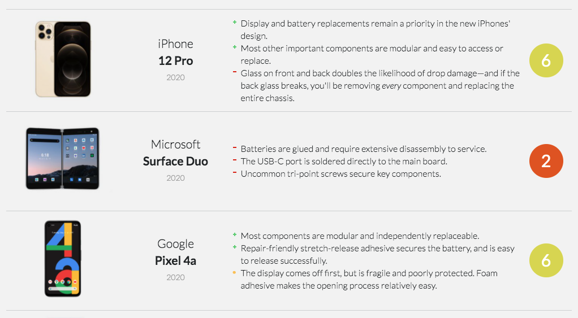
A complete teardown and repairability report for each product is available on ​iFixit.com​.

- Trends in tablet repairability

Tablets are effectively smartphones with a large battery and a large screen. The extra space could allow for improved serviceability relative to a smartphone, but only some manufacturers are taking advantage of this.

Serviceability in the tablet market is bimodal. With the exception of the original iPad, Apple and Microsoft sell tablets that are very difficult to disassemble. HP, Lenovo, Acer, Amazon, and others have sold tablets with a more serviceable design but have had trouble differentiating themselves in a market that rewards thin, glued together designs. Apple’s iPads are dramatically more challenging to repair than their iPhones.

That’s problematic for schools, which Apple has heavily targeted. Schools are a brutal place for electronics—they need to be long-lived and fixable within limited education budgets. iPads are particularly poorly configured for education. A combination of minimal waterproofing, a non-replaceable charging port, integrated battery, zero upgradability, and glue throughout makes repairs challenging enough that it can drive schools to replace devices.

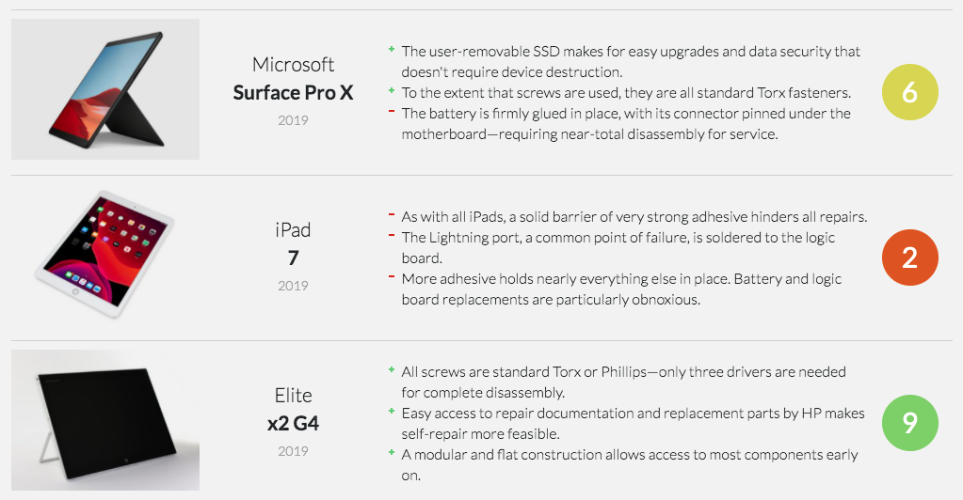

Our serviceability conclusions in the tablet market were ​replicated by Fraunhofer IZM​ in an independent study.

- Trends in laptop repairability

Due to the associated cost, iFixit assesses fewer laptops than tablets and smartphones. Because of our revenue model, most of the laptops that we assess are manufactured by Apple, and we have particularly deep insight into their serviceability trends. While the industry as a whole has many repairable laptop options still available, Apple steadily shifted toward glued-together, difficult-to-repair products since 2012. Somewhat predictably, those 2012 models are still in heavy demand, and still ​sell for upwards of $700​.
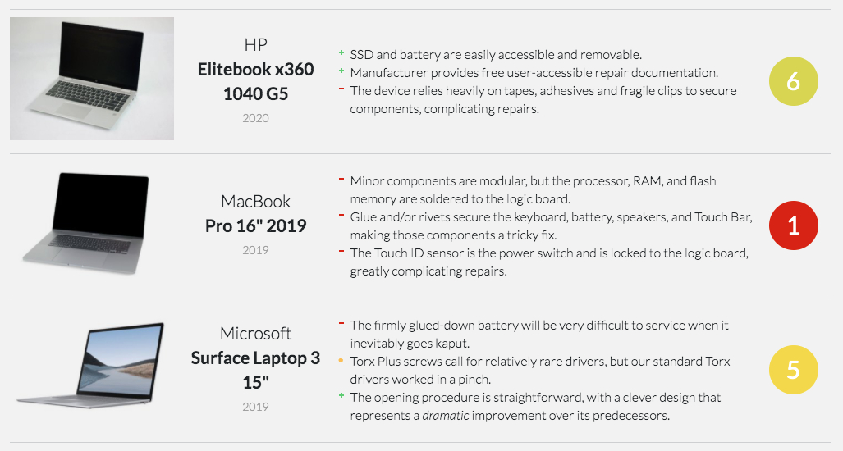
Apple’s newer laptops have suffered from a spate of ​keyboard reliability problems​. Because the design integrates multiple parts—the keyboard, trackpad, battery, and upper case are a single replaceable module—aftermarket keyboard repairs are not cost effective.

Additionally, most new laptops solder down both the RAM and storage to the board, preventing users from upgrading their devices to meet their needs. Integrating the storage into the main board is a particular challenge for service, because the device is inseparable from the data. This is a particular challenge for secure military installations and government research facilities.

INFORMATION REQUEST 3
a) Do the consumer guarantees under the ACL provide adequate access to repair remedies for defective goods? If not, what changes could be made to improve access to repair remedies? Are there barriers to repairing products purchased using new forms of payment technologies, such as ‘buy now pay later’?
b) Is the guarantee of available repair facilities and spare parts effective in providing access to repair services and parts? Or is the opt-out clause being widely used, making the guarantee ineffective?

The existing consumer guarantees under the ACL do not appear to provide adequate access to repair remedies for defective goods. Similar to the provisions in the ACL, California law requires that manufacturers make a service option available for seven years after the sale of a device. Manufacturers generally comply with this by providing repair service for a fee, rather than selling parts to independent service technicians and consumers. This means consumers have fewer options to repair their devices, and manufacturers can comply with the law while continuing to monopolize repair services. Further, once the covered period expires, consumers may lack access to independent repair services where parts and information aren’t available to them or to independent repair providers.

c) Should consumer guarantees seek to balance the broader societal costs of remedy choices (such as the environmental impacts of replacements) with consumer rights, and if so how? For example, should repairs be favoured as a remedy?

Electronics manufacturing strains the limits of our natural resources while usable products and device components are thrown into landfills instead of salvaged, fixed, and reused. Where consumers can repair their devices, they can extend device lifetimes, keeping products operational longer.

Repairing and refurbishing electronics has tremendous potential to impact carbon emissions. A recent report by McKinsey & Company and the Ellen MacArthur Foundation found that increasing reuse and refurbishment could reduce the production of emissions of mobile phones by 3 million tons of CO2. Currently, market experts estimate that only 15% of smartphones are recycled—the rest are either put in storage or thrown away. Ensuring that consumers have the right to repair their devices,, rather than just to replace them when they break, would reduce harmful environmental impacts and appropriately balance consumer rights with environmental impact.

In addition, ensuring that consumers have the right to repair their devices can help close the digital divide in our communities, providing access to expensive technologies to those in need who cannot afford to buy them new, and make sure all our communities have access to the technology needed for education, telemedicine, and all other aspects of our digital lives.

d) Are consumers sufficiently aware of the remedies that are available to them, including the option to repair faulty products, under the ACL’s consumer guarantees?
If not, would more information and education be a cost-effective measure to assist consumers understand and enforce guarantees? What would be the best way to deliver this information? What other measures would be more effective?

We have not surveyed our members in Australia on this topic, but would be open to doing this in collaboration with the Commission.

INFORMATION REQUEST 4
b) Is there any evidence of a difference in quality, safety or data security between authorised repair networks and independent repairers? Are there ways to address concerns around quality, safety or data security while promoting a vibrant independent repair market?

- Independent Repair Is an Effective, Safe Option for Consumers.

Steven and Nicole Spink own ​Olympia iPhone Repair​, and independent repair shop in Washington state. They can seemingly fix anything—board-level repairs that Apple would refuse to perform are a piece of cake for them, and far less costly than replacing your device. (You can hear Nicole describe these challenges in this Washington hearing on Right to Repair laws​—just skip to 6:40.) Unfortunately, without device schematics and other tools from Apple, they can’t always do those jobs, causing them to lose business and forcing customers to pay much more for a full part replacement from Apple.

Apple has long taken a firm stance against these types of repair shops. With scandals like ​the Error 53 debacle​, they’ve clearly planted their feet on the ground and said “you should repair your phone at an Apple store, or you should buy a new phone.” Apart from a few very select Apple Authorized Repair Providers, no one has access to the genuine, OEM parts Apple uses to make these devices, or the diagnostics and schematics that Apple keeps so close to the chest. As a result, they’re stuck turning people away, or settling for third-party components instead. If you go to a good shop, they’ll use high-quality replacement parts, but Apple ​could still brick those at any time​. Apple’s lobbyists claim that allowing independent shops access to their diagnostic data and parts will threaten their security model, which we think is rather silly—not to mention something ​other manufacturers have proven wrong time and again​.

Most independent repair shops are no different than your friendly, local auto mechanic whom you recommend to your friends and family any chance you get. And many of them are fully capable of performing the same repairs that manufacturers do—plus some repairs the manufacturers ​won’t​ do.

- Independent Shops Are Often as Good as the Manufacturers—If Not Better

Manufacturers constantly tell us that those who are properly trained, “authorized,” or “certified” by said manufacturers are the only ones who should be repairing our devices. But more often than not, independent repair shops are just as “properly trained” as anyone to fix your broken stuff.

Many independent repair technicians have gone through the same training and certification processes that manufacturers require of their own technicians. It’s also not uncommon for independent repair shops to have former technicians from big manufacturers on staff, especially from companies like Apple, HP, Microsoft, and others. iFixit even has our own ​MasterTech certification​ that independent repair technicians can earn to prove their proficiency.

What’s more, many common repairs don’t require extensive expertise. You don’t need years and years of training to replace a smartphone battery or a cracked screen. In fact, ​we constantly receive success stories​ from folks all over the world who have fixed their own device without any former training or knowledge. From retirees to teenage enthusiasts, our members are impressively capable. Obviously, you want your professional repair technician to be competent, but you don’t need a master’s degree in engineering and a handful of certifications to be good at fixing stuff.

Gabriel, who has been in the industry since 2002 and is currently the Operations Manager at ​The Computer Cellar​ in Durham, NC, can attest to this. “We’ve met teenagers that have walked into the shop and started discussing computers and technology with us and we’ve said to each other, ‘that kid could do our job,’” he says.

This is true even of those more complex repairs the manufacturers won’t tackle. “One of our ex-techs joined us at 19 with only hobbyist experience,” Gabriel says. “When he left, he was teaching himself board-level repairs. He’s now, at 22, pulling a better salary than me, plus some stellar benefits, working for a university.”

“Board-level” repairs involve fixing the circuit board itself by replacing individual components, instead of replacing the entire expensive circuit board. These advanced repairs require microsoldering skills​, specialized equipment, and a very steady hand.

Like many other businesses, local shops want to uphold a reputation for quality work. It’s in their interest to use reliable parts that meet customer expectations. While it can be difficult (or impossible) to source genuine OEM parts (most cell phone manufacturers, with the notable exception of ​Motorola​, don’t sell their parts to anyone), for some products it’s not too difficult to find aftermarket components that come from the same suppliers that manufacturers use.

“As surprising at it seems, you can buy an original Apple LCD,” says Alexandre Isaac of ​Phone Repair Toulouse​ in France. “You need the right contact in China. They usually buy it directly from the factory, as Apple can’t really perfectly control these millions of screens, so Foxconn still sells a few on the side.”

Furthermore, a lot of shops will harvest the good parts out of other broken devices in order to get that coveted OEM logo. “When appropriately refurbished with good tools, these are great and are the best solution,” says Isaac.

In fact, we know that a lot of repair shops use high-quality parts, because in some cases, we’re the ones that supply them. Through our ​iFixit Pro wholesale parts​ program, we partner with independent repair shops and offer our parts, tools, and support so that those repair shops can offer their customers a great experience. All of our parts ​are sourced from reputable, trustworthy suppliers​, and we do ​extensive in-house testing​ on everything to make sure it’s up to snuff.

- Independent Shops Can Perform Repairs That Manufacturers Won’t

Most manufacturers focus their repair training on the most frequent repairs. Apple, for example, won’t replace lightning ports in their stores—getting this service requires shipping your device to a dedicated Apple service center. It’s not uncommon for manufacturers to turn away repair jobs, either because it’s not worth their time and effort, or because they don’t have the proper tools and expertise to do the repair. Independent repair shops, however, are much more willing to do these more challenging jobs.

Isaac can attest to this, explaining that manufacturer technicians “are usually ‘good repairmen,’ but they don’t have the level that people repairing boards have, and will never have unless they train. So the Genius from Apple is even worse. He only knows how to use software that says a few things about the phone.”

Josephine and Dave Billard’s experience with their water-damaged iPhone​ is a great example. Here’s the short version: the couple wanted their photos recovered from an unresponsive iPhone, but Apple said they couldn’t help. They were able to find an independent repair shop (​iPad Rehab​ near Rochester, NY) that could perform more complex board-level repairs, getting the phone up and running just long enough to back up the photos. Apple doesn’t have the necessary tools for jobs like this, so without this independent repair shop, Josephine and Dave would’ve lost their vacation photos forever.

“My own father-in-law experienced an unresponsive screen one random day with his
5th-generation iPod Touch​,” says Craig Lloyd, staff writer at iFixit. “Apple said they couldn’t fix it, so he ended up just buying a new iPod Touch.” This kind of repair is ​definitely possible​, and a whole new screen assembly ​is just $40​. A local repair shop could perform this repair for much less than the cost of a new iPod Touch.

- Consumers should be allowed to manage their own risk tolerance

No matter what the situation is, there’s always going to be ​some​ risk involved during a repair, whether it’s a phone, car, refrigerator, or toaster. But for the most part, that risk is pretty low. Going to a reputable and trustworthy independent repair shop is perhaps no riskier than bringing the device to the manufacturer itself. Again, many shops are highly trained and use high-quality parts in their repairs. Plus, any good shop worth its salt will offer their own warranty on both the repair and the parts.

Finding a quality local repair shop is no different than finding a good, reputable auto mechanic. We have found that pros who contribute to iFixit tend to run pretty fantastic businesses, and we have a directory of them​.

c) Are there available examples of the contracts between OEMs and authorised repairers? Do these contracts limit effective competition in repair markets (such as by limiting the number and reach of authorised repairers or requiring authorised repairers to not be authorised by a competing brand)?
What is the process to become authorised? Is it open and competitive?

We’ve found that, where manufacturers make authorized repair programs available, these contracts may place unduly onerous requirements and restrictions on participating repair technicians. Apple, for example, has two different repair programs. One is their ‘Authorized Apple Service Center’ program, where shops can be reimbursed for warranty work, resell Apple products, and effectively act like a dealership. This program also restricts the repairs that technicians can do on Apple products.

Last year, Apple rolled out an ‘Independent Repair Program’ for out-of-warranty repairs. This program allows shops to buy parts from Apple and get access to tools and information. But, this program requires repair technicians to agree both to a non-disclosure agreement and a severely restrictive agreement. Under the terms of this agreement, repair shops must:

- Grant Apple access to their customer database, including personally identifiable information, for up to five years after termination of the agreement.
- Submit to audits by Apple, which can involve interviewing the repair shop’s employees, for five years following termination of the contract.
- Face potentially harsh penalties for using third party parts. If Apple determines that more than 2 percent of a repair business’s transactions involved “prohibited products,” it can, per the contract, force the business to pay Apple $1,000 for every transaction that occurred during the audit period, in addition to reimbursing Apple for the cost of its investigation.

As a result of these requirements, very few technicians would be willing to sign up for Apple’s 'Independent Repair Program.' The shops we talk to say that they may be willing to enroll if they didn’t have to sign a contract handing over their customer and supplier data.

Most other electronics manufacturers do not have a network for out of warranty repair. Motorola is a notable exception—they provide service parts and online manual for their smartphones.

d) Are there specific examples or other evidence of practices by OEMs or their
authorised repairers that create barriers to competition in repair markets?
Do other factors also create barriers to competition in repair markets, such as short-sighted consumer behaviours, switching costs, poor information availability or consumer lock-in?
e) What is the relationship between the intensity of competition in the primary product market and the risk of consumer harm from a lack of competition in repair markets? Can competitive primary markets compensate for non-competitive repair markets?
Is an absence of effective competition in the primary market a necessary condition for consumer harm from non-competitive repair markets?
To what extent would measures that enhance competition in the primary market address concerns about a lack of competition in repair markets?
f) Are the restrictive trade practices provisions of the CCA (such as the provisions on misuse of market power, exclusive dealing or anti-competitive contracts) sufficient to deal with any anti-competitive behaviours in repair markets?
g) What policy changes could be introduced if there is a need to increase competition in repair markets and improve consumer access to, and affordability of, repairs?
What are the costs and benefits of any such proposal to the community as a whole? How does it balance the rights of manufacturers and suppliers, with those of consumers and repairers?

Some responses to these questions are elsewhere in our answers. We would be happy to discuss specific policy changes in detail with the Commission.

There are a number of barriers to competition in repair markets, including abuse of specific provisions in copyright law, the prohibition on circumvention of technological protection measures, and manufacturers' refusal to make official service information, replacement parts, and specialized tools available to consumers and independent repair providers. A meaningful policy solution should address each of these barriers, as discussed in detail in our responses to information requests 1 and 5.

INFORMATION REQUEST 5
a) To what extent do current IP laws already facilitate repairs by consumers or independent third parties (e.g. the spare parts defence under the Design Act)? b) Are there any aspects of IP laws where consumers’ rights with respect to repairs are uncertain?
c) Do current IP protections (e.g. intellectual property rights, technological protection measures, end-user licencing agreements) pose a significant barrier to repair in Australia? If yes, please comment on any or all of the following:
- the specific IP protections that prevent consumers from sourcing competitive repairs and/or inhibit competition in repair markets
- the types of products or repair markets these barriers mainly affect
- the prevalence of these barriers
- the impacts of these barriers on third party repairers and consumers (e.g. financial cost, poorer quality repairs)

- Copyright

In the United States, courts have repeatedly found that Copyright law does not prevent consumers from repairing their devices. And the United States Congress further clarified that repair is non-infringing when it amending §117 of the Copyright Act to allow copying of a computer program when that copy “is made solely by virtue of the activation of a machine that lawfully contains an authorized copy of the computer program, for purposes only of maintenance or repair[.]” The United States Copyright Office has also repeatedly acknowledged that repairing a range of software-enabled devices is non-infringing.

To the best of our knowledge, Australia’s copyright laws may lack adequate protection for consumers’ right to repair. According to Professor Matthew Rimmer,
‘[a]t present, Australia has a purpose-specific defence of fair dealing under copyright law. None of the current purposes (criticism and review, research and study, reporting the news, judicial proceedings, parody and satire, disability rights) would cover repairs. Arguably, as recommended by the Productivity Commission, Australia needs a defence of fair use – which could conceivably apply repairs. Alternatively, Australia could add a further defence of fair dealing in respect of the right of repair.’

- Technological Protection Measures

17 U.S.C. §1201 (Section 1201) is arguably the most significant barrier to repair in the United States. Section 1201 prohibits circumvention of technological measures that “effectively control[] access to a [copyrighted work]” and, as manufacturers are increasingly embedding software in every imaginable device, they’re also increasingly using technological measures to prevent users from accessing the embedded software. In many cases, consumers and repair technicians alike must access this software in order to complete the repair. While Section 1201 was intended to deter people from circumventing technological measures in order to infringe copyrights, it can also be read to prohibit circumvention for a broad range of otherwise lawful activities, including repair. Indeed, companies have frequently abused this law to restrict consumer choice and inhibit market competition.

In the US, Section 1201 authorizes the Librarian of Congress to issue exemptions for particular noninfringing uses that “are, or are likely to be, adversely affected” by Section 1201. iFixit has repeatedly petitioned for, and won, exemptions through this process for software-enabled devices ranging from cell phones to tractors. However, the nature of this process and its limitations means that Section 1201 continues to impose a heavy burden on consumers and repair technicians and a number of US legislators have proposed changes to the law to enable circumvention for non-infringing uses like repair.

The U.S.-Australia Free Trade Agreement imports this scheme, and provides that exceptions may be granted for
‘non-infringing uses of a work, performance, or phonogram in a particular class of works, performances, or phonograms, when an actual or likely adverse impact on those non-infringing uses is credibly demonstrated in a legislative or administrative review or proceeding; provided that any such review or proceeding is conducted at least once every four years from the date of conclusion of such review or proceeding.’

Therefore, compliance with the terms of the U.S.-Australia Free Trade Agreement does not preclude exemptions for repair of software-enabled devices. To ensure that right to repair enables consumers and technicians alike to repair devices with embedded software, the commission should ensure that appropriate exemptions exist to legal prohibitions on circumvention of technological measures

- Patent Law and Design Law

Under U.S. patent law’s “exhaustion doctrine”, when a patent owner sells a device to a consumer, it can no longer control the consumers’ use of that device - including repair and maintenance. It also ensures that consumers can transfer that device to subsequent owners. Provided the repair does not constitute “reconstruction” of the patented device, it does not infringe the manufacturer’s patent rights.

Unlike U.S. patent law, “Australian patent law recognises a defence of experimental use.” But, whether that defense extends to repairs may be unclear. To the extent existing defenses in design law or patent law are unclear with respect to repair, clarification would provide needed certainty to consumers and repair technicians.

- Trade Secrets

In the U.S., most right to repair proposals have explicitly exempted the disclosure of trade secrets. In addition, the kind of information these proposals would require manufacturers to disclose generally does not include trade secrets - manufacturers routinely share this information with wide networks of “authorized” repair providers, who may or may not be under a legal obligation against disclosure, and in some cases such information may be ascertained through other means, including physical examination of the device.

INFORMATION REQUEST 6
a) What evidence is there of planned obsolescence in Australian product markets? Do concerns about planned obsolescence principally relate to premature failure of devices or in them being discarded still working when more attractive products enter the market?
b) How can the Commission distinguish between planned product obsolescence and the natural evolution of products due to technological change and consumer demand?
c) How does planned obsolescence affect repairers, consumers and the broader community in Australia?
d) What measures do governments currently use to prevent planned obsolescence or mitigate its effects (in Australia and overseas)? How effective are these measures?
e) What are the benefits, costs and risks of Australia adopting measures similar to those currently used overseas, such as product design standards and reparability ratings?
f) Do consumers have access to good information about durability and reparability when making purchases? If not, how could access to information be improved?

Starting at the beginning of this year, France is set to show that it is possible to have a repairability score for products. We hope this is just the beginning, and that more countries will follow Frances’s example, despite manufacturers’ attempts to undermine such initiatives.

A grade out of 10 will be added to the labels of washing machines, laptops, smartphones, TVs and lawn mowers. This score will be calculated based on criteria such as: ease of disassembly, price and availability of spare parts and access to repair information.

There’s more than one goal to the index. Firstly, it aims to bring useful information to consumers who are looking more than ever for durable and repairable products. A 2018 study found that consumers are twice as likely to choose a product labeled as “more repairable”.

Secondly, the objective is to create competition between manufacturers to design more repairable products in order to obtain the best grade. Finally, the index should help extend the lifespan of products in the interest of the environment but also of consumers’ wallets.

The French index isn’t perfect. Its first limitation is how easy it is to obtain a good grade. This is for instance the case for smartphones and laptops: by indicating simply the nature of software updates (corrective, upgradable or mixed), manufacturers can gain 1 point out of 10. This is a free point as this information does not limit software obsolescence whatsoever.

By being too generous, the index risks not differentiating enough between more and less repairable products, reducing its usefulness for consumers. This is why HOP is asking that it should be regularly reviewed to increase its ambition.

The second limit is the way the index is implemented: as scores are self-declared by manufacturers, they should be sufficiently verifiable. Anyone should know how a score was calculated by the manufacturer. While this transparency is an objective of the index, it isn’t clear enough for the public: for instance people should be able to know easily for how many years spare parts will be available for a specific product. But this might not be the case as it is not yet clear how easily the public will be able to access information on how a product scores on individual repairability criteria.

INFORMATION REQUEST 7
a)What data are available on the amount of e-waste generated in Australia?
What data is there on the composition of e-waste in terms of particular materials (such as hazardous materials) by product type?
How does hazardous e-waste compare to hazardous general waste in its prevalence and risks? Is there merit in distinguishing between hazardous e-waste and non-hazardous e-waste? And if so, how could this be done in practice?
b) What estimates are available on the costs of e-waste disposal on the environment, human health and social amenity, in Australia and internationally?
How do the impacts differ by disposal type, or by the type of product or hazardous material?
e) How can a right to repair policy further reduce the net costs of e-waste in Australia, and would such an approach be an effective and efficient means of addressing the costs of e-waste to the community?

When electronics end up in landfills, toxins like lead, mercury, and cadmium leach into the soil and water. The electronic waste problem is huge: More than 48 million tons of e-waste are produced every year. According to the UN’s Global E-Waste Monitor 2020 report, “[t]he global generation of e-waste grew by 9.2 Mt since 2014 and is projected to grow to 74.7 Mt by 2030 – almost doubling in only 16 years.” Australia alone generated 554kt of e-waste in 2019. While researchers have pointed out that, in some cases the overall weight of e-waste appears to be declining as a result of innovations that have led to smaller, more compact devices, these same innovations have made products more difficult to repair and recycle.

Guidelines on electronics reuse released in April, 2012 by respected engineering association VDI found that it was “absolutely necessary” to adopt policies to support reuse of electronics. The study found that cannibalization of new product sales would not occur because “the markets of new products and reused products can be well differentiated from one another.” VDI also identified social opportunities for reuse: “An increasing number of companies offer work to disabled people by refurbishing electronic data processing technology.” For this reason, it is important that service information be made available in a blind/screen-reader friendly, standardized electronic format accessible to people with disabilities.

An Illinois Economic Activity survey recently showed that repairing electronics creates 13 times as many jobs as recycling it. The problem that repair centers are facing now is that they cannot negotiate directly with each manufacturer for access to critical information—there are too many products and too many manufacturers. So many products end up getting shredded instead of repaired.

It’s prohibitive to expect recyclers to pay each manufacturer for information, translate the documentation, and convert it into a standardized format for use in their content management systems. Recyclers, consumers and reuse centers alike need access to standardized service documentation at no charge for the complex electronic equipment they own.
Recyclers, consumers and reuse centers alike need access to standardized service documentation at no charge for the complex electronic equipment they own.

INFORMATION REQUEST 8
a) What policy reforms or suite of policies (if any) are necessary to facilitate a ‘right to repair’ in Australia?
b) Are there any other barriers to repair and/or policy responses that the Commission should consider?
c) What are the costs and the benefits of the various policy responses that have been proposed to facilitate repair (such as those outlined in table 1)?
d) Are there other international policy measures or proposals that the Commission should consider as part of this inquiry?

These questions are addressed in detail in our responses to information requests 1, 5, and 7.

Appendix A

This table has the top products that Australian consumers accessed on iFixit last year. Due to limitations in our platform and statistical sampling when generating geo targeted results in Google Analytics, these numbers are not precisely correct—instead, they provide an approximate relative order of magnitude of interest. They are visits to specific URLs on iFixit for each device. For many popular products, we have hundreds of other URLs on iFixit that are not included in this report.

iFixit Page | Pageviews | Unique Pageviews
/Phone | 16505 | 15494
/iPhone | 16505 | 14484
/Mac | 13810 | 12800
/Mac_Laptop | 10779 | 9768
/MacBook_Pro | 11116 | 9768
/iPhone_8 | 10105 | 6400
/MacBook_Air | 6400 | 6063
/iPad | 7074 | 5726
/MacBook_Air_13" | 6737 | 5389
/iPhone_11 | 7410 | 5389
/MacBook_Pro_13"_Retina_Display | 6737 | 5053
/MacBook_Pro_15"_Retina | 6737 | 5053
/MacBook_Pro_13" | 4716 | 4716
/Tablet | 5389 | 4716
/iPhone_X | 6063 | 4716
/iPhone_7 | 7410 | 4042
/MacBook_Pro_15" | 4716 | 4042
/Android_Phone | 4042 | 3705
/Joy-Con | 4042 | 3705
/PC | 5053 | 3368
/iPhone_6s | 3368 | 3368
/Mac_Desktop | 3032 | 3032
/Game_Console | 3032 | 3032
/iMac_Intel_27" | 3368 | 3032
/iPhone_6 | 3032 | 2695
/Car_and_Truck | 3368 | 2695
/iPhone_7_Plus | 3368 | 2695
/PlayStation_4 | 5726 | 2695
/iPhone_SE | 4042 | 2695
/iMac_Intel | 2358 | 2358
/iMac | 2358 | 2358
/MacBook_Pro_13"_Unibody | 2358 | 2358
/iPad_Pro | 2358 | 2358
/MacBook_Air_11" | 2695 | 2358
/iPad_7 | 3368 | 2358
/iPad_Air_2 | 2695 | 2358
/MacBook_Pro_13"_Unibody_Mid_2012 | 2358 | 2021
/iPhone_11_Pro_Max | 2021 | 2021
/Sony_Game_Console | 2358 | 2021
/DualShock_4 | 4042 | 2021
/iPhone_XS_Max | 4042 | 2021
/MacBook_Pro_15"_Retina_Display_Mid_2012 | 4042 | 2021
/Mac_Mini_Late_2014 | 2021 | 2021
/MacBook_Pro_13"_Retina_Display_Early_2015 | 2021 | 1684
/PC_Laptop | 2695 | 1684
/iPhone_8_Plus | 2021 | 1684
/Huawei_Phone | 2021 | 1684
/Electronics | 1684 | 1684
/Sony_TV_Console | 1684 | 1684
/PlayStation_4_Pro | 2021 | 1684
/Apple_Watch_Series_4 | 2021 | 1684
/iPad_6 | 2021 | 1684
/DualShock_4_CHU-ZCT2U | 2021 | 1684
/MacBook_Pro_13"_Touch_Bar_Late_2016 | 1684 | 1684
/Samsung_Galaxy_Watch | 2021 | 1684
/MacBook_Pro_16" | 2358 | 1684
/Nintendo_Switch | 2358 | 1347
/iPhone_XR | 1684 | 1347
/Mac_Mini_Unibody | 1347 | 1347
/iPhone_XS | 2358 | 1347
/iPhone_5s | 1347 | 1347
/MacBook_Pro_15"_Unibody | 1347 | 1347
/iMac_Intel_27"_EMC_2429 | 2021 | 1347
/MacBook_Pro_15"_Retina_Display_Late_2013 | 2021 | 1347
/MacBook_Pro_15"_Retina_Display_Mid_2014 | 2021 | 1347
/Asus_Laptop | 1347 | 1347
/MacBook_Air_13"_Early_2017 | 1684 | 1347
/MacBook_Pro_15"_Touch_Bar_2017 | 3368 | 1347
/iMac_Intel_27"_EMC_2546 | 1347 | 1347
/Dyson_Vacuum | 3368 | 1347
/iPad_Air_2_Wi-Fi | 1347 | 1347
/Sony_Game_Console_Accessory | 1684 | 1347
/Apple_Keyboard | 1684 | 1347
/Dell_XPS_13 | 3032 | 1347
/Samsung_Android_Phone | 1684 | 1011
/MacBook_Pro_13"_Retina_Display_Late_2013 | 1347 | 1011
/Mac_Mini | 1011 | 1011
/MacBook_Pro_13"_Retina_Display_Mid_2014 | 1011 | 1011
/Samsung_Galaxy_S8 | 1347 | 1011
/Headphone | 1011 | 1011
/iMac_Intel_27"_Retina_5k_Display | 1011 | 1011
/MacBook_Pro_13"_Function_Keys_2017 | 1347 | 1011
/MacBook_Pro_13"_Unibody_Early_2011 | 1011 | 1011
/MacBook_Pro_15"_Touch_Bar_Late_2016 | 1011 | 1011
/Google_Phone | 1347 | 1011
/Samsung_Android_Tablet | 1684 | 1011
/iPhone_11_Pro | 2021 | 1011
/iMac_Intel_27"_EMC_2639 | 1684 | 1011
/MacBook_Pro_15"_Unibody_Mid_2012 | 1684 | 1011
/MacBook_Pro_17"_Unibody | 2021 | 1011
/iPad_Pro_11" | 1011 | 1011
/MacBook_Air_13"_Mid_2013 | 1011 | 1011
/iMac_Intel_27"_EMC_2390 | 1011 | 1011
/Samsung_Smartwatch | 1347 | 1011
/DualShock_3 | 1347 | 1011
/iPad_5 | 1347 | 1011
/MacBook_Unibody_Model_A1278 | 1347 | 1011
/MacBook_Pro_13"_Function_Keys_Late_2016 | 1011 | 1011
/Samsung_Galaxy_S10_Plus | 1011 | 1011
/Briggs_and_Stratton_675_Series_Repair | 2358 | 1011
/Samsung_Gear_S3_Frontier | 1011 | 1011
/MacBook_Pro_15"_Retina_Display_Mid_2015 | 1347 | 674
/Samsung_Galaxy_Phone_S | 1011 | 674
/iPhone_6_Plus | 674 | 674
/MacBook_Air_13"_Early_2015 | 674 | 674
/Microsoft_Game_Console | 674 | 674
/android_tablet | 674 | 674
/Appliance | 674 | 674
/Mac_mini_Late_2018 | 1684 | 674
/iPhone_6s_Plus | 1011 | 674
/Patagonia_Outerwear | 1684 | 674
/Huawei_P | 2021 | 674
/PC_Desktop | 674 | 674
/Lenovo_Laptop | 674 | 674
/Samsung_Galaxy_S7 | 1011 | 674
/iMac_Intel_27"_Retina_5K_Display_2019 | 1011 | 674
/MacBook_Pro_16"_2019 | 1011 | 674
/iPhone_5 | 1011 | 674
/PlayStation_3 | 674 | 674
/Dell_Laptop | 1011 | 674
/Samsung_Television | 1347 | 674
/MacBook_Air_13"_Retina_Display_2020 | 1011 | 674
/iPhone_SE_2020 | 674 | 674
/MacBook_Air_13"_Early_2014 | 674 | 674
/MacBook_Pro_15"_Unibody_Mid_2010 | 1347 | 674
/Apple_Watch_Series_3 | 1011 | 674
/iMac_Intel_27"_EMC_2309_and_2374 | 1011 | 674
/MacBook_Air_13”_Retina_Display_Late_2018 | 1011 | 674
/Toy | 674 | 674
/MacBook_Pro_13"_Touch_Bar_2018 | 1684 | 674
/MacBook_Pro_13"_Touch_Bar_2019 | 1011 | 674
/Samsung_Galaxy_Tab_A_10.1 | 1684 | 674
/Samsung_Galaxy_S9 | 674 | 674
/Apple_Time_Capsule | 674 | 674
/Fujifilm_Instax_Mini_Eight | 674 | 674
/MacBook_Air_11"_Mid_2011 | 674 | 674
/Xbox_One_Elite_Controller_(Model_1698) | 674 | 674
/Samsung_Galaxy_S9_Plus | 1011 | 674
/Patagonia_Down_Jacket | 1684 | 674
/MacBook_Pro_15"_Unibody_Late_2011 | 674 | 674
/Nintendo_Game_Console | 337 | 337
/HP_Laptop | 1011 | 337
/Kindle_Tablet | 337 | 337
/PlayStation_4_Slim | 337 | 337
/Camera | 337 | 337
/iPod_Classic | 337 | 337
/MacBook_Pro_13"_Unibody_Mid_2010 | 337 | 337
/Xiaomi_Phone | 674 | 337

ACCC, ‘iPhone and iPad misrepresentations cost Apple Inc $9 million in penalties’, 19 June 2018, https://www.accc.gov.au/media-release/iphone-and-ipad-misrepresentations-cost-apple-inc-9-million-in-penalties
iFixit smartphone repairability reports. https://www.ifixit.com/smartphone_repairability
iFixit tablet repairability reports. https://www.ifixit.com/tablet_repairability
Fraunhofer IZM. “Disassembly analysis of slates: Design for repair and recycling evaluation.” http://publica.fraunhofer.de/starweb/servlet.starweb?path=epub0.web&search=N-255111
iFixit laptop repairability reports. https://www.ifixit.com/laptop_repairability
See, e.g., Doan v. American Book Co., 105 F. 772 (7th Cir. 1901); Toro Co. v. R & R Prod. Co., 787 F.2d 1208, 1213 (8th Cir. 1986); ATC Distribution Grp., Inc. v. Whatever It Takes Transmissions & Parts, Inc., 402 F.3d 700, 703 (6th Cir. 2005); Southco, Inc. v. Kanebridge Corp., 258 F.3d 148 (3d Cir. 2001).
See 17 U.S.C. §117(c)
See Exemption to Prohibition on Circumvention of Copyright Protection Systems for Access Control Technologies, 83 Fed. Reg. 208, 54023 (October 26, 2018).
Matthew Rimmer, “The right to repair: Mandatory scheme for the sharing of motor vehicle service and repair information” (pp10-12)(2019). https://eprints.qut.edu.au/127446/
U.S.-Australia Free Trade Agreement, Article 17.4(7)(e)(viii) p.17-9 https://ustr.gov/sites/default/files/uploads/agreements/fta/australia/asset_upload_file148_5168.pdf
See Aro Mfg. Co., Inc. v. Convertible Top Co., 365 U.S. 336 (1961).”
Matthew Rimmer, “The right to repair: Mandatory scheme for the sharing of motor vehicle service and repair information” (pp10-12)(2019). https://eprints.qut.edu.au/127446/
http://www3.weforum.org/docs/WEF_A_New_Circular_Vision_for_Electronics.pdf
Forti V., Baldé C.P., Kuehr R., Bel G. The Global E-waste Monitor 2020: Quantities, flows and the circular economy potential. United Nations University (UNU)/United Nations Institute for Training and Research (UNITAR) – co-hosted SCYCLE Programme, International Telecommunication Union (ITU) & International Solid Waste Association (ISWA), Bonn/Geneva/Rotterdam. (p 13).
Id., at p.105
Babbit, Callie, Althaf, Shahana “Systems for managing e-waste aren't keeping up with the consumer electronics market” GreenBiz (January 14, 2021) https://www.greenbiz.com/article/systems-managing-e-waste-arent-keeping-consumer-electronics-market
VDI. Dr. Ralf Brüning, et al. “Guidelines, electronic scrap recovery. ReUse of WEEE. VDI-2343 - Recycling of electrical and electronic equipment” http://bit.ly/1ceCVjq
Illinois Department of Commerce and Economic Opportunity. “Electronics Recycling: Economic Opportunities and Environmental Impacts” http://www.illinoisbiz.biz/NR/rdonlyres/8DD41FE3-A7ED-4447-87C0-DD05815F2747/0/EwasteFactSheet.pdf

