Attachment 3, Sustainable Urban Development – Green Infrastructure and the many Benefits

Water harvesting has virtually eliminated flash flooding in German cities.

In Germany, green infrastructure is just as critical as urban infrastructure and is considered essential for residents' well-being in towns and cities and safeguarding biodiversity. Both go hand-in-hand to attain sustainable economic development and notably resource-conserving urban development.

Green Urban Street Design in Germany
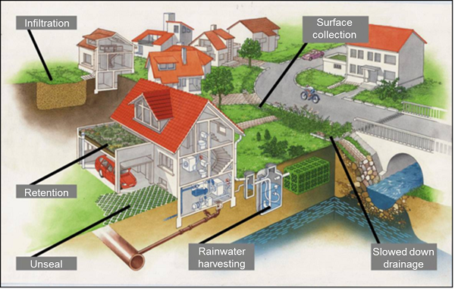

In the UK, SMART water tanks alert owners when significant rain periods are coming. Water is released slowly to empty the tanks in time to capture water from the significant rain event to mitigate flooding from stormwater.

Green Urban Infrastructure's benefits deliver a broad gamut of ecosystem services - climate mitigation and adaptation, water purification, air quality, space for recreation, and, most importantly, can lessen the risk of flooding by slowing and reducing stormwater discharges, and -

- Capturing pollution in the soil layer and breaking down many of the organic pollutants;
- Vegetative devices can remove soluble pollutants to provide habitats for wildlife and green spaces for local people. For example, ponds and wetlands
- Intercepting frequent low-intensity rainfall events so that no runoff occurs off the site;
- Slowing the flow of stormwater off the development into the water environment so that ‘peak-flows’ and flood risk are reduced;
- Providing a variety of habitats for birds, animals and insects to contribute to the wider local ecosystem and to allow all flora & fauna to thrive;
- Creating cool damp environments for insects and small animals to shelter in during heat-waves;
- Delivering urban-cooling for the comfort of people living and working in urban spaces;
- Capturing water for re-use to reduce the use of potable water and the associated costs of treatment and pumping;
- Providing pleasant, green spaces for people to step away from busy lives and to reconnect with nature;
- Delivering high-quality community spaces for children to play, and to be close to nature and wildlife;
- Allowing soil surfaces in urban areas to ‘breathe’ so that the microscopic organisms that form the foundations of all life can flourish, and
- Attenuating stormwater flows from larger high-intensity rainfall events to reduce flood risk downstream

