ASA response to the Productivity Commission Request for Submission
INQUIRY INTO VULNERABLE SUPPLY CHAINS

The Australian Steel Association (ASA) welcomes the Productivity Commission’s Inquiry into Vulnerable Supply Chains and would like to make the following key points.

- Supply Chain Logistics and the Impact of Shipping and Port operations both domestically and Globally on the Steel Supply Chain. The ASA supports the FTA (Freight Trade Alliance) submission on these issues, which is comprehensive and is included as Addendum 1 in this submission. SCL has had a profound impact on the Steel/Metals Industry as set out in the FTA document and has resulted in delayed shipments, increased costs beyond budgeted, for both commodity and most crucially steel products that are now longer produced in Australia by Local Mills. This includes (but not limited to: Stainless Steel, Aluminium, Tin plate, API Line Pipe, Special Steel Bar) which are all critical in the recovery of the Australian Economy. It should be noted that steel products are large, heavy and subject to damage. Local transport and logistics from Port to Customers are key issue for our members. Goods need to be moved from Port to Customer using Transport companies or moved via 3rd party warehouse operations. This often involves the moving heavy and long loads, often resulting in long delays due to loading of heavy and long goods. Port congestion further impacts the Steel Supply chain due to the nature of the goods (large and long) further constraining members.
- Dumping Actions against a range of Steel Products over the past 10 years has seen a reduction in the availability of alternative sources for Australian Manufacturers. Many “A” class steel mills have had dumping applied making Australia less appealing as a future market of interest. This can now be seen with shortages across a range of commodities with local mills unable to support the volumes required.
- As the Commission is aware, Dumping can completely end the commercial viability of supply chains, often with little notice. This “freezing effect” has been widely discussed by the ASA over many years. Unfortunately. in the current increasingly robust post Covid -recovery environment, mills are either unwilling or unable to support Australian demand due to International Demand, and or, dumping duties making commercial mill availability not an option for local manufacturers, distributors and trading companies.
- In order to support the current Supply chain shortages, it is key to reduce the impact of the dumping system on the supply chain.
- In this respect the ASA consider two Key aspects need to be considered
1. The Introduction of a Public interest test
2. Shorter investigations.

Recommendation: Public interest test required: The ASA has previously stated that a Public interest test or economic interest test needs to be applied.
- as currently stands a small manufacturer can deny Australia the benefits of lower cost imports – given example of power transformer investigation;
- compare to free trade agreements which allow for the lowering of tariff in the public goods after a review of the overall benefits of the FTA;
- we have heard comments that a public interest test involves a decision as to which jobs should be lost. With respect, it is better that the impact of duties on employment be debated rather than it be automatically decided that the employees of the applicant take priority over the jobs that would be saved/created by cheaper imports;
- while the report to the Minister could note the potential economic impact of the measure, the legislation should be amended to provide that this is a relevant consideration. Without this, the risk would be that the Minister by considering the potential economic impact was taking into account an irrelevant consideration;

- Time to Conduct investigations: (COVID-19) The time take for initial investigations and subsequently reviews have increased dramatically due to the closure of international travel and reverting to desktop audits of Mills. These delays negatively impact both local industry and importers; During this period, import supply chains are effectively frozen as mills and manufacturers do not know when dumping duties will actually be imposed and what the rate will be. From a compliance point of view Trading companies, Distribution companies and Manufacturers alike cannot take open risk of measures that may be applied at some “future” time. Taking into account the timeline required for Investigations, subsequent reviews, measures, further reviews and a period where a second review is being undertaken, then it can be considered nearly 5 years will have passed since the initial duties were imposed- so there will be a continuation inquiry. This basically means that the local industry can adopt strategies whereby there is ongoing uncertainty about what it will cost to import goods.
Recommendation: the ADC needs more funding to ensure investigations / reviews can be conducted in a timelier manner;
- World Demand impact on Price of Available steel inputs. Increasing demand in domestic economies of the major steel producing nations is driving a rapid and sustained increase of Steel prices. Iron Ore prices are continuing at record highs. This shall continue to impact the supply chain availability of goods in the Australian market further tightening supply of goods for construction and infrastructure projects. Recent announcement by the Chinese Government in regard to the reduction of Export rebates from 13% - 0% will have a profound effect on goods available. This is including Stainless steel and a large range Pipe Products (API Line Pipe) no longer produced in Australia. Prices globally will be impacted by this announcement .
- Impact of domestic demand shortages - Mill Over capacity issues continue to be reported by our members. However, due to the above range of overlapping issues (dumping, world demand. World Price) there are limited supply options especially in the range of FLAT ROLLED products such as Sheet and Coil, Plate using in General construction, manufacturing and housing construction. Generally speaking, long products such as Beams, Re-bar, Shapes are less impacted however non the less, mills have less capacity to support a growing Australian economy. I must be pointed out that the ASA has recorded a decline in the total imported products as per the below graph, indicating the total Steel volume available in the Australian market within the total Steel Supply chain would be constrained at this time. (Fig 1.) below.

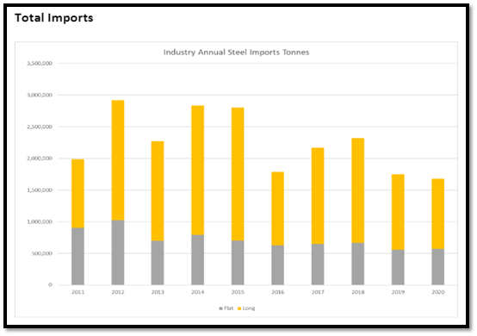
Fig 1. (Source data: ABS) .

- Contingency against Local mill breakdowns or closures is not available in a short term. With the lack of viable supply chain contingencies, the economy is most certainly vulnerable to any major breakdown or other issues facing the local mills while they are operating at 100% plus capacity. This issue cannot be understated as of writing, there are no rapid solutions, should a major failure or breakdown occur within the domestic supply chain. Please refer to previous issues which have impacted local supply chain production and international production alike:
https://www.theaustralian.com.au/news/latest-news/bluescope-fire-may-impact-supplies/news-story/64127fb0660dca4b0645c6a2af0fea87
https://www.illawarramercury.com.au/story/7111328/blaze-at-port-kembla-steelworks-leaves-150k-worth-of-damage/
https://www.nipponsteel.com/en/news/20151008.html

- Long term impact to building, construction and Infrastructure of the concentration of these above issues cannot be understated.
- Credit Insurance overlay and the impact to the industry should tightening continue or increase due to Price input increases; outstripping supply of Insurance limits, also cannot be ignored. The Steel industry is heavily supported by Credit Insurance and the increasing cost of goods will have impacts on available limits for manufactures downstream as well as distribution companies. This has the capacity to limit the economic recovery as suppliers will need to work within available limits.

Addendum ( FTA Submission )

