Centre for Educational Measurement & Assessment
Sydney School of Education & Social Work

Productivity Commission submission, June 2022

Who we are
We make this submission on behalf of the University of Sydney, Centre for Educational Measurement and Assessment (CEMA). We are an extensive community of educational experts and researchers dedicated to empowering educators and Higher Degree by Research students to work productively with educational data. We are committed to working with educational partners, government, private and not-for-profit organisations to strengthen a confident teacher voice helping to assure the technical veracity and impartiality of public commentary on educational assessment, evaluation, measurement and reporting.

Authors: Rachel Wilson, Jim Tognolini, Sofia Kesidou, Sara Ratner, Kathleen Walker, Rachael Hains-Wesson & Kathryn Bartimote.

What focus we take
We respond to “Information request 4: Measurement Framework and performance indicators”

We first summarise our thinking, then present some recommendations, based on a holistic analysis of what is required to facilitate a coherent and productive education system. In addition, we provide some brief, specific feedback on the questions for this section. Much of our thinking, recommendations, and discussion around questions, is based upon Table 1(see page 3).

What we think
Our primary argument is that the current measurement framework, and the NSRA targets, are not well aligned with the national educational goals set out in the Mparntwe (Alice Springs) statement.

We believe this is a result of the measurement framework being organically developed overtime with diverse data inputs rather than being strategically positioned and resourced to meet the needs of schools, teachers, and students. For example, the untimely development of key system components (e.g. PISA and NAPLAN before Australian Curriculum, and before MFSA) meant that alignment between these elements is poor. There has also been a lack of due consideration to the voice of teachers. The educational system architecture requires urgent attention to develop a system that is fit for purpose. This can be done by the development of system logic, with due attention to stakeholder needs and the alignment of system components parts, focusing on appropriate measures and data for our broad-based national goals that are of value. We advocate for the design of a system around the goals, following the advice of Andy Hargreaves:
“On assessment: measure what you value instead of valuing only what you can measure”- Andy Hargreaves
As is clear in the PC strategy review, evaluation of the NSRA alone would be inadequate. We, therefore, also focus on the MFSA and national reporting. We believe the NSRA took an unreasonably narrow focus in its targets, however these were developed from the MFSA which, despite recent reviews, retains a dated perspective on educational data and is unaligned with the national goals of schooling. The MFSA focuses heavily on literacy (10/32 measures) and numeracy (8/32 measures), participation and completion measures (9/32 measures), which are important for education but the framework neglects most of the more holistic Mparntwe goals. The current context in Australian schools, with societal shifts and challenges, including changing work skills and demands, mental health, COVID, and threats to global climate and democracy, mean that more holistic educational goals must be pursued.

In addition to well-designed measurement, transparent reporting is critically needed for progressing educational outcomes. There has been a lack of accessible reporting against the goals, even when data is available. Whilst there is no limitation to examine excellence and equity against the current MFSA data, the National report on Schooling does not demonstrate a thorough analysis of these. Current MFSA and NSRA mean that educational ministers, senior bureaucrats, and the broader community remain in the dark about many aspects of educational progress, particularly in relation to educational equity. Put simply, a multitude of documents profess to analyse data for educational equity groupings (see Figure 2, derived measures), but very little is actually reported, or even available for analysis on the ACARA data portal. Resolving this is an obvious strategy for monitoring equity and is needed for the appropriate application of policy and efficient allocation of resources. Reporting on progress towards educational outcomes by equity groups can serve to inform resource allocation, drive school improvement, and close the equity gaps in Australia. The OECD (2018) has reported that the disparity in student performance by socio-economic status begins early in an Australian student’s life and widens as they progress through school. Recent analysis of PISA data makes it clear that inequity among Australian 15 years of age is growing rapidly (Thomson, 2022). Through committed efforts to report on and reduce equity gaps Australia could experience a significant boost in educational and social mobility and economic productivity.

The final point in our argument relates to teachers. It is important to get the data framework right in order to work productively with teachers, and for teachers to work productively with data to improve practice and lift outcomes. The current narrow and heavy focus of the measurement framework and its misalignment with broader goals, is a cause for frustration amongst the teaching profession, whose work values align with the national goals and are anchored in broad educational enrichment and working toward educational equity. The poor alignment between our educational goals, which reflect teachers’ values, and the data currently collected is a deterrent, and practical obstacle to effective engagement with data for school improvement. So too, current level of teachers’ data and assessment literacy. Collecting appropriate data and upskilling teachers’ work with data will lift teaching and learning and is therefore urgently needed. Furthermore, a national approach to consistent data visualisation and tracking could assist teachers greatly in actively engaging with data to improve practice. Consistency in the representation of data will make multiple sources easy to access, read and action in the classroom, and is essential given the very heavy workloads of teachers.

Here to help
We hope our submission is of use to the review panel. Please note, CEMA staff are ready and willing to assist further in answering queries, presenting the material in this submission and relevant research evidence. Contact author: CEMA Contact details: Faculty of Arts & Social Sciences, School of Education & Social Work, Centre for Educational Measurement & Assessment. Room 333, Education & Social Work Building (A35) The University of Sydney NSW 2006

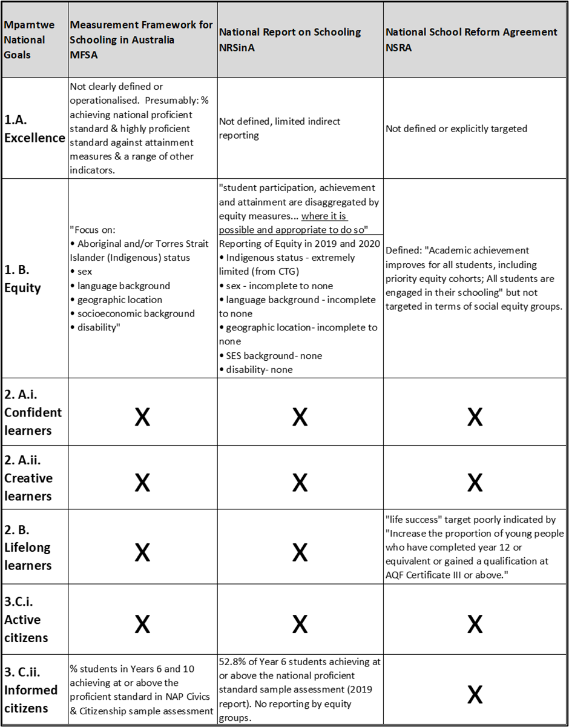
Table 1: Poor alignment to goals and omissions in the measurement framework

Recommendations

Recommendation 1
Develop and make explicit a coherent systemic logic framework for educational evaluation that specifies how progress towards meeting the educational goals in the Alice Springs (Mparntwe) Education Declaration (the Goals) will be supported, monitored, evaluated, shared and reported.

The Measurement Framework for Schooling (MFSA) and National School Reform Agreement (NSRA) should be based on the national goals and a system evaluation framework developed by a shared and collaborative stakeholder process (see also Rec 2).
The evaluation framework should:
- be guided by program theory/logic analysis to identify the measures, indicators and data needed to collect to monitor education system success (Kellogg Foundation, 2004; Alkin, 2011; Stegemann et al, 2018)
- include key components of system evaluation (student assessment, teacher/teaching appraisal, school and whole system evaluation) guided by good practice, learning and teaching principles and findings from OECD’s reviews on evaluation and assessment in education (OECD, 2013), and articulations among components to generate complementarities and promote consistency of objectives (Savage & O’Connor, 2019).
- present assessment and evaluation not as end in themselves but as important tools to achieve improved student learning outcomes;
- specify how information will be effectively and accessibly communicated to the public on how the education system is working, and how data collected, and the evaluation of results will be used to improve educational processes and outcomes in collaboration with all key stakeholders;
- be informed by stakeholders’ (students, teachers, school leaders, parents/carers) needs and perspectives.

Recommendation 2

Derive measures and indicators from the national educational goals in the Alice Springs (Mparntwe) Education Declaration. Map existing measures against goals, repurpose appropriate measures aligned to goals and develop new ones to fill gaps.
The pursuit of continual improvement in our schools will ultimately result in better outcomes for all students if the policies and practices that guide the process are aligned to the goals we share as a society.

There is wide perception that much of our education system documentation is not oriented towards the national goals in the Alice Springs Declaration; that monitoring systems are limited in the information they offer, potentially leading to policy driven in areas where there are measures available; and that progress towards many of the national goals is not measured (e.g., confidence and creativity in young Australians) or measured only partially (see Table 1 and Recommendation 3 on promoting Equity in the education system).

There is a need to evaluate the validity and limitations of current measures, identify key gaps in data availability and map out a comprehensive set of measures aligned to national educational goals. The Alice Springs Declaration outlines conceptions of excellence, equity, confidence, creativity, and lifelong learning that can guide systematic definition of constructs and corresponding measures and indicators. For example, confidence in young adults includes having a sense of self-worth, self-awareness and personal identity that enables management of wellbeing; being resilient with skills and strategies needed to tackle challenges, adapt and manage change; having a sense of optimism about the future.
A strategic approach to system improvement benefits from clear national goals and priorities so progress against these can be assessed. The national goals articulated in the Alice Springs Declaration were developed with extensive consultation and are widely supported by diverse stakeholders, and represent a broad and comprehensive, inclusive, developmental, and lifelong approach to education. Alignment of measures, indicators and data to national goals will likely support more effective policy and stakeholder engagement with data, including upskilling of teachers in working with data to lift teaching and learning.

Collect evidence on a broader set of measures. The focus should be on the measures that align with the goals and priorities; moreover, there are different approaches to collecting evidence beyond testing, such as sample-based student surveys, other surveys to seek stakeholder feedback (see Recommendation 5). Moderated school-based assessment, and research-based thematic reviews.

It is important to note that CEMA does not propose more testing. In order to evaluate progress towards goals such as confident, life-long learners it is important to select the most appropriate, valid, reliable, cost and time effective measures for inclusion in the Measurement Framework. Data that recognises student agency and assessments that include student voice must be considered. Selecting the right measures to include in the Framework is key to its effectiveness when measuring system-wide success.

Recommendation 3

Strengthen analysis, reporting and transparency on educational equity: a. Review and refine agreement on defined social equity groups; b. report on all groups, against all measurement framework data/indicators; c. Report longitudinally over at least 10 years
There is declining equity in Australian education (Thomson, 2022; Hetherington, 2018; Perry, 2018). It has been well established that equity is the hallmark of educational quality, and as far as education systems are concerned you can’t have excellence without equity (OECD, 2014; Parker, Marsh et al, 2018).

A shared understanding of equity in Australian schools is critical to this recommendation. Our definition aligns with that of the OECD (2018) and Sahlberg and Cobbold (2021), equity in education refers to the system providing both equality in learning opportunities for all learners and equality in outcomes for social equity groups. We accept there will be differences in individual student outcomes but in an equitable system those differences should not be attributable to socio-economic status, race, geography or gender. Furthermore, we note that there must also be consideration of outcomes for ‘students with disability’. This equity grouping is woefully neglected in national data, with no reporting of any data for this group in the 2019 and 2020 reports, however there is potential to improve this with integration of the NCCD database and the MFAS data.

Overall, there is inadequate reporting on equity. This is surprising as ‘excellence and equity’ are our dual foremost education goals in the Mparntwe statement. Equity has been a clear national educational goal since the 1998 Hobart Statement. Table 1 outlines the inadequate reporting on social equity groups in the National Report on Australian Schooling. Data available on the ACARA data portal (where readers interested in equity are redirected) is also inadequate and there is not a single indicator for which disaggregation by all 6-equity groupings is possible.

The Mparntwe statement explains that national goals, including “excellence and equity” will be monitored utilising the “good data” of the MFAS and inform strategic policy and reforms. The rationale statement fails to acknowledge that many of the goals, like “creative and confident learners” are not reflected in the MFAS data. However, even in the case of ‘excellence and equity” (where the goals are derived and can be examined in any educational data) this analysis and monitoring fails to materialise. This neglect occurs despite repetition of this rationale, to match goals and report against equity groups, in both the MFAS and the NRAS.

For national goals to be monitored and pursued equity needs to be reported for all social equity groupings, nationally and for state and territories jurisdictions. It is important that this data remains aggregated at a high level, and that the reporting is dealt with sensitively so as to avoid further marginalisation of disadvantaged equity groups. Development and reform of the measurement framework should be in partnership with advocates for equity groups and every effort made to ensure measures are socially and culturally appropriate to students across those groups. Measures on educational attainment should be critically reviewed for measurement bias and a student centred, strengths-based approach taken to assessment design.

For effective monitoring and strategic management of educational funding, resources and supports, data for equity groups needs to be reported longitudinally, over at least 10 years.
There may also be important intersections in equity groups which require further reporting. Current arrangements which present limited data on students who sit within one group but not any others, are unsatisfactory. Perry (2018) notes that inequalities between low and high SES are the largest because they reflect the impact of compounding disadvantage. Such compounding should also be examined at system level, perhaps in a more extended reporting cycle.

Inequity is also complicated by Australia’s high levels of school choice/competition, growing school segregation and the compositional, or peer, effects that produces. The recent rapid growth in school segregation means these effects are likely to be contributing to Australia’s educational malaise (Chesters & Daly, 2017; Bonnor, 2021). Volckmar (2019) concluded that Australian educational inequity was compounded by “a lack of federal governance, diverse and unfair school funding, and extensive use of school choice is a hindrance in promoting equality in education.” (p.629), we would add ‘inadequate monitoring and reporting’ to that list. Without full transparency on educational inequity policy is uninformed.

Continued neglect of educational equity is extremely costly. Perry (2018) points out as “17 per cent of Australian young people leave secondary school without achieving basic educational skill levels...eliminating school underperformance would reap enough fiscal benefits to pay for the country’s entire school system.”(p.64).

Recommendation 4

Appoint a single independent national body to oversee the development of the national measurement framework, ongoing associated data collection, management, reporting and communication to stakeholders, and use of data for monitoring, planning, policy development and evaluation to improve educational outcomes
The effectiveness of the Australian schooling education rests on confidence in the stewardship of the sector. Transparency in the collection, analysis and reporting of appropriate, reliable and valid data that accurately monitors national educational goals is critical.

The fragmentation and misalignment in the current system requires reform led by an expert body, providing leadership for a coherent education system. This group would provide overarching stewardship for the system and strong evidence-based advice on progress toward goals for the Education Council.

Fragmented data and agencies make an independent, coordinating body necessary. In addition to goal-data misalignment, serious structural failures have been identified (Bonnor, 2021, Reid, 2019) and policy misalignment between educational jurisdictions has been identified (Savage & O’Connor, 2019). The extensive misalignment and poor transparency outlined in this submission testifies to the need for a new overarching body.

The remit of the body would be to protect education stakeholder interests by coordinating data and reporting to ensure full transparency on educational progress, including by equity groups.
Such a body would enable the strong, long-term planning required to address Australia’s current education challenges. In particular, an independent and long-tenured body is needed to:
  - advise on reform, and ongoing evaluation and review of the MFAS
  - protect stakeholder interests, particularly those of teachers, who must be vocal and respected partners in effective policy development
  - design and work with teachers and partner organisations to provide more aligned and comprehensive national reporting against national education goals
  - coordinate and monitor system accountability through appropriate and transparent analysis and reporting
  - provide strategic advice on system trends to support long-term policy that extends beyond political terms
  - provide a strategic and proactive approach that can allow the collection of data to enable evaluation of system factors, in order to improve student and school outcomes and long-term impact
Unlike the newly formed Australian Educational Research Organisation (AERO) which is designed as “an institute to position Australia’s educators at the forefront of education research”; this independent body will focus on Australia’s education system, and its data architecture, in order to inform system improvement.

AERO has committed to the principles of: ambition, collaboration, rigour, diversity and inclusivity, and transparency and integrity. They have recognised the need to “build trust by being honest, sharing our work and supporting new ideas. We welcome scrutiny to enhance the integrity of our processes.” Similar principles could apply to the new independent body and help rebuild trust in educational system frameworks. This is an issue internationally (Richardson, 2022), but of particular concern in Australia where the current arrangements are inadequate for effective steering of school education to meet educational goals.

In addition, the body, or the Education council they report to, should commit to a series of principles for developing and dealing with data:
  - Data aligned with goals
  - Diverse data types – including stakeholder data
  - Student centred design
  - Customised design to minimise logistical and workload burdens on stakeholders
  - Joined up (e.g. integrating MFAS + ATWD + ITE + NCCD + curriculum data + school funding + longitudinal studies + stakeholder data)
  - Comprehensively reported with transparent analysis against goals
  - Reporting focus on excellence and equity (disaggregated against all specified equity groups and reported longitudinally in each annual report)
  - Access for independent analysis

Recommendation 5

Educational stakeholders should be more widely consulted and represented within policy development and documentation. Stakeholder data should be integrated into the measurement framework.
Stakeholder perspectives should be highly influential in the development and review of the measurement framework. Educational measurement and assessment should not be something that is done to teachers and students. It should, and must, be an integral part of the teaching and learning cycle. This requires strong student and teacher voice in the co-creation of the measurement framework, it is abundantly apparent that this is not the case with the current MFAS, indeed the document does not include any reference to ‘teacher/s’.

The current measurement framework data (NAPLAN, PISA, TIMMS, PIRLS, participation and attainment) is not well aligned with national goals. They are also not highly valued by teachers who report valuing work activities that are oriented to the ‘equity’ goal of education (McGrath-champ, Wilson et al.,2018). The lack of alignment between the measurement framework and teachers’ work values have been a source of growing frustration. As teachers are pivotal partners in a productive assessment system, reform is urgently needed. Furthermore, reform must exercise more respect, consultation, and partnership with the profession if we are to avoid repeating the mistakes of the past.

A productive partnership with teachers, and also students and parents/carers, in the reform of the measurement framework would serve many purposes:
  - choice or, or development of, the most appropriate indicators – in terms of construct face validity, logistical and efficiency considerations.
  - development of a shared sense of purpose that is established in classrooms and reflected up through system data and architecture
  - amelioration of teachers’’ current frustrations
  - development of data utilisation systems that would enable deeper engagement and integration with productive teaching and learning
  - potential to address current excessive teacher workload related to data and administrative work (McGrath-Champ, Wilson et al. 2018).

Stakeholder data should be valued, and where appropriate to the national goals privileged. Logic and system management approaches focus heavily on stakeholder needs assessment and utilise stakeholder data (Kellogg Foundation, 2004; Alkin, 2011; Stegemann et al, 2018), education should be no different. There have been many recent initiatives in the collection of stakeholder data however these have not been integrated in the MFAS and are not highly visible in national policy frameworks.

Modern perspectives on educational assessment and indictors promote a broad perspective on what data is and can be. The current MFSA has a heavy focus on test data across literacy (10/32 measures) and numeracy (8/32 measures), this should be balanced with data that assesses other curriculum areas covered in the Australian Curriculum (AC) as well as stakeholder data from school leaders, teachers, student and parent/carers.

Recommendation 6

Consideration must be granted to the work of teachers, the context they operate in and their level of data / assessment literacy.
The Measurement Framework ought to be positioned as a working document that is central to the endeavour of every teacher and school leader. To this end, it must consider the context it exists to serve and the work conditions of those charged to enact it. It is only by empowering educators with relevant and reliable data that is fit for purpose and easily accessible that schools, and education systems, can achieve the improvement they seek.

Ultimately, education policy changes and improvements are enacted in the classroom and the investment of teachers in the process is crucial to their effectiveness. Strong alignment between the data teachers need to drive the continual improvement of our education system towards shared goals of excellence and equity is needed in the development of the new Measurement Framework.

A national approach to consistent data visualisation and tracking could assist teachers greatly in actively engaging with data to improve practice. Consistency in the representation of data will make multiple sources easy to access, read and action in the classroom. This approach will also assist in reducing teacher data and administrative workload enabling more time for teaching and learning with students.

The inclusion of an increased focus on data and assessment literacy and active engagement with the Measurement Framework during Initial Teacher Education will also further support the inclusion of such measures as central to all teaching and learning practice in the classroom.

The manner means and motivation with which teachers enact the Measurement Framework in their schools will determine its effectiveness. Therefore, conscious understanding and acceptance of the context they operate in is essential. Any reforms need to be done in partnership with the profession, and highly cognisant of the need to develop trust in the system, authentic goal-oriented data, whilst recognising low teacher morale, heavy workload of teachers and the diverse challenges in different school contexts. Special attention should be given to the voice of Indigenous stakeholders and teachers and students from diverse backgrounds.

Response to review Questions

Information Request 4:

MEASUREMENT FRAMEWORK & PERFORMANCE INDICATORS

Does the performance reporting framework in the National School Reform Agreement (NSRA) embody the ‘right’ mix of objectives, outcomes, targets and sub-outcomes for inclusion in a future agreement?
- No, there is a lack of alignment between objectives/outcomes/targets/sub-outcomes, see Table 1.
  - The Measurement Framework has never been front and centre of the Education Policy. It has been developed organically over time. For example:
    - use of PISA data follows the opportunity its development presented, rather than development of data that is closely aligned to goals.
    - NAPLAN was developed prior to the Australian Curriculum and is also not aligned to the national goals
- Consequently, much of the data in the national framework is not fit for purpose. Available data are not well matched to goals like confident learners, creative learners, life-long learning dispositions, active and informed citizens.
- The current Measurement Framework focuses too narrowly, and the NSRA and the National Priority Initiatives focus even more narrowly. This approach is tired and data, using available data rather than data designed to monitor the direction of education reform against national goals.
- The Measurement Framework for schooling in Australia (MFSA), and also NSRA, should measure the goals and utilise key action points contained in the Alice Springs Education (Mparntwe) Declaration. We recommend the collection of new/alternative data and suggest types of indicators and repurposing of some of that have been included in Figure 2 of the report.
- The reporting in the ACARA’s annual National Report on schooling in Australia needs to be strengthened in terms of operationalisation and analysis of “excellence and equity”. While other countries responded quickly to declines in education outcomes, Australia has been slow to act, partly because of inadequate reporting, especially on growing inequity.
- There is a significant need to have a national body that collates and manages correct and quality data analysis to improve and identify best practice and innovation. This will support the development of evidenced based practice that is successful to learning outcomes, it will ensure equity in identifying where resources are most needed to lift attainment levels across the education sector and most importantly it will provide substantial evidence to ensure continuous improvement by developing an authentic source of truth to measure evidence.

Do the objectives, outcomes, targets and sub-outcomes in the NSRA align with the aspirations set out in other key documents such as the Alice Springs (Mparntwe) Education?
- No, figure 2, and table 1 above make this clear. Furthermore, focus on particular KPI’s in the NSRA narrowed focus even further. The chosen 32 KPM/KPI’s are barely aligned with the Mparntwe declaration goals and can hardly be considered a holistic assessment of education performance. This is not to mention a lack of alignment between MFSA and the Australian Curriculum.
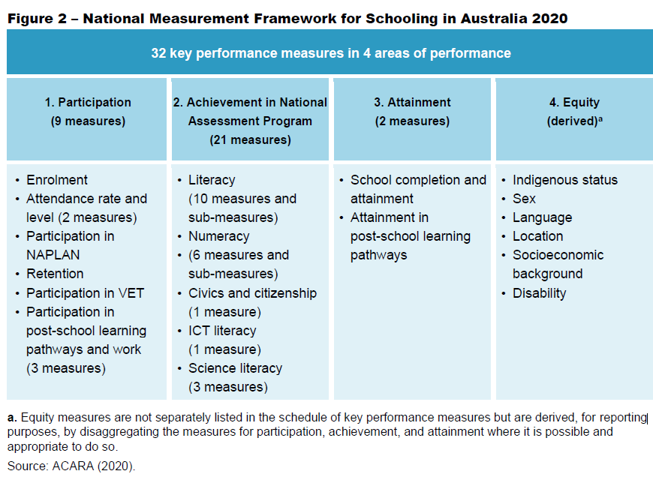
- The MFSA appears to have evolved primarily around available data, rather than data that is needed and fit for purpose. The dominance of NAPLAN and International large-scale assessments (PISA, PIRLS, TIMMS) does not appear to have been productive. Thomson (2021) provides a thorough review of the declines in equity and excellence in the PISA data. Fischman. Topper et al (2018) point out there is “little evidence that any positive or negative causal relationship exists between ILSA [international Large Scale Assessments] participation and the implementation of education reforms” and conclude that international assessments “with their multiple and ambiguous uses, increasingly function as solutions in search for the right problem”
- Logic suggests that starting with goals and then harnessing, or developing appropriate measures, would be more likely to produce appropriate indicators and desired outcomes. Research suggests this approach would also be more likely to strengthen engagement by teachers.
- Orientation to the goals needs more consultation. As primary stakeholders, teachers’ views on what data would be appropriate and useful should be central. Students are also primary stakeholders, and their views are also important. Parents' views, as secondary stakeholders, should also be considered.
- While the last two decades have seen attention on evidence and accountability for practice in schools, from our analysis it is evident that we need to develop stronger evidence and accountability for systems. While the Maprntwe statement lays out a rationale for both school/teacher accountability and system-level accountability the Measurement Framework does not currently contribute to how these will be realised. There is a need to strengthen system-level accountability through the development of:
  - Appropriate data and indicators, aligned to goals
  - Adequate reporting
  - Periodic evaluation/reviews
- Furthermore, it should be recognised that the system failure to produce an effective data framework has limited the effectiveness of efforts to strengthen practice in schools. The current system is not supporting evidence of learning or practice for policy and learning outcomes. For example, the recent Gonski Institute for Education review of NAPLAN makes it clear NAPALN tests are not designed for their proffered purpose (which was never clear), not designed as ‘assessment for learning’ and not well integrated into school teaching and learning (Wilson, Piccoli, Hargreaves et al., 2021). Thus misalignment, and poorly designed data, has effectively hamstrung teachers and schools in their efforts to lift outcomes.

Does the Measurement Framework for Schooling in Australia provide a relevant, reliable and complete picture of progress towards achieving the outcomes of the NSRA?
- The MFSA includes some relevant information. In order to pursue ‘excellence and equity’ in education inclusion of literacy, reading, numeracy, mathematics, science, ICT and Civics data is necessary. However:
  - The focus on this data is overstated, some research suggests it has led to a narrowing of the taught curriculum
  - The assessment of ‘equity’ is highly inadequate, with extremely limited reporting against the noted equity goals
  - The documented references to the assessment of ‘equity’ are via ‘social equity groups’ is inconsistent (only some documents include children with disability as an equity group, there is confusion between LBOTE and English language proficiency)
  - In the annual national report, there is currently NO reporting against the following equity groups:
  - Students with a disability
  - Socio-economically disadvantaged students
  - The assessment of ‘excellence’ against benchmarks is helpful, but the term is not well defined within policy, and has not been aligned with meaningful policy, beyond simple ‘target’ approaches

Are there performance indicators not included in the Measurement Framework that would help provide a more relevant, reliable and complete picture of student outcomes, both as identified with the NSRA and more broadly?
- Yes, performance indicators must be derived from the goals and there are many goals currently unassessed.
  - Data need not be limited to educational tests/ assessment but should also include stakeholder data. This would involve using a range of indicators for direct and indirect assessment against goals.
  - For example, confident learners.
  - Students hold high expectations - student report data
  - School culture builds confidence- student, teacher report data
  - Barriers to learning are dismantled by effective adaption to local environments and communities – reporting on assessment differentiation/adaptions/modification.
  - Types of data and prioritization
  - Effective use of sampling data in order to cover breadth in learning outcomes, curriculum areas and national goals.
  - Wide range of indicators, with inclusion of stakeholder data (including self-report data on goals like student confidence, attitudes to learning)
  - Prioritisation of outcomes, over opportunity, data in monitoring of equity. Currently 11 measures focus on participation and completion, but these data are not rich indicators of learning. Equality of outcomes in equity groups, as stipulated in Mparntwe declaration, is a higher bar and more meaningful (Sahlberg & Cobbold, 2021)
  - Literacy and numeracy may need to be integrated into goals, they should not be lost but need to fit within a broader framework under ‘lifelong learning’ (e.g. including early childhood literacy indicators (AEDC) and adult literacy (PIACC))
- It is critical that we move beyond the tests we currently employ to measure our success to unpack the means, motivation, and manner behind them. Every assessment is laden with cultural, political, and social context that must be openly acknowledged. Unpacking the power at play is essential in order to attest to the reliability and applicability of the data it generates. This means not only examining the values we openly attest to in our Australian schools but the inherent values laden in the test construction and design. As a result of standardised testing, we have the ability to measure school success and draw comparisons between schools and school systems

Are there impediments to governments adopting these indicators (for example, data availability, cost)?

- Of course, there are impediments and costs, however there is also considerable investment in the current poorly aligned data. A redesign would provide an opportunity to balance the appropriateness of the measures with the cost of the data.
- Adopting an effective range of indicators (and transparent reporting on them) is essential for system efficiency
- Full longitudinal reporting of equity groupings performance against appropriate indicators is low cost but essential to provide effective system monitoring, analysis of progress, evaluation of broad policy frameworks.
- Taking advantage of existing stakeholder data would be cost-efficient
- Integration and sharing of data are not cost efficient but essential, a single authority would be the best way to achieve this
- Addressing the growing inequity in Australian education is cost efficient and the has the potential to provide broad savings to government. As Perry (2018) points out as “17 per cent of Australian young people leave secondary school without achieving basic educational skill levels...eliminating school underperformance would reap enough fiscal benefits to pay for the country’s entire school system.” (p.64).
- Effective monitoring of goals, and equity of outcomes in them, has the potential to provide an enormous return on investment.

What are some current or planned national data projects that might be relevant to measuring progress against outcomes of the NSRA?
- Currently ACARA is the reporting authority on Data Collection, and this is not oriented to the goals but rather the reporting is focused on the KPI’s (NSRA). ACARA does note current and future data collection should be improved. If there is a National Framework there should be a national collection body that manages the collection of all relevant data. Data is available, but it is dispersed.
- ACARA has acknowledged that the Framework does not include indicators against reform direction to those relating to teaching and data quality and the need to assess the effectiveness of the reform in the development of performance measures. They propose developing new measures and assessing existing measures.
- Improvements in Students Wellbeing should be developed within the Framework with targets and measures (ICEMA should be doing work in this area, and it is has great interest internationally), some indicators are available in the national longitudinal studies and stakeholder data mentioned below.
- Potential data sources include
  - Stakeholder data – from state and territory jurisdictions and independent providers. E.g. NSW’s “tell them from me” surveys
  - AITSL’s ATWD and ITE data sets. Strengths – potential for efficient management of teacher workforce. Inadequacies – currently on 3 states have substantial participation. Don’t yet have teacher specialisation data, or teacher allocation to school factors (SES, geography), needs to be linked to other data.
  - NCCD - disability data
  - School funding data (DEST and PC)- integration and analysis is important for effective provision of school staffing and resourcing
  - National Centre for Longitudinal studies’ data, at the Commonwealth Dept of Social Service- including longitudinal studies of early childhood, Indigenous children, youth.
  - Australian Early Development Census – AEDC
  - PIAC adult literacy data
- These data and bodies are compartmentalised which supports the need for the creation of a national body that manages the process to embed how and what needs to be done with the data to improve learning outcomes
- We recommend a national body to oversee reform and remedy the data/goal alignment and transparency problems by coordinating national data collection and reporting. This will inform a holistic view of Australian education that can be used strategically, including with a proactive approach with appropriate, goal aligned data able to provide evidence on impact from education reform and theory of change.
- This coordinating body would sit alongside the Australian Educational Research Organisation (AERO). In 2020 the Education Council agreed to a $50m in funding towards the National Evidence Institute as a key recommendation of the “Gonski 2.0” review. The review recommended an evidence-based teaching system for schools ranked the most successful actions teachers can make to improve student learning. AERO was designed “an institute to position Australia’s educators at the forefront of education research”. The proposed independent body will focus on Australia’s education system, and its data architecture, in order to inform system improvement. Through this development the two accountability rationales described within the Mparntwe statement, one on the use of good data for teacher and school accountability and the other focusing on system accountability, will be realised.

References
Bonnor, C., Kidson, P., Piccoli, A., Sahlberg, P., & Wilson, R. (2021). Structural Failure: Why Australia keeps falling short of our educational goals. https://all-learning.org.au/app/uploads/2021/02/Structural-Failure_final.pdf
Chesters, J., & Daly, A. (2017). Do peer effects mediate the association between family socio‐economic status and educational achievement? Australian Journal of Social Issues, 52(1), 63-77.
Cobbold, T. (2017a) NAPLAN data shows continuing large achievement gaps between advantaged and disadvantaged students. Education Policy Comment: Save Our Schools
Fischman, G. E., Topper, A. M., Silova, I., Goebel, J., & Holloway, J. L. (2019). Examining the influence of international large-scale assessments on national education policies. Journal of education policy, 34(4), 470-499.
Hetherington, D. (2018). What price the gap? Education and inequality in Australia. https://norvaisa.lt/wp-content/uploads/2012/11/Issues-Paper_What-Price-The-Gap.pdf
McGrath-Champ, S., Wilson, R., Stacey, M., & Fitzgerald, S. (2018). Understanding work in schools: The foundation for teaching and learning. https://www.nswtf.org.au/files/18438_uwis_digital.pdf
OECD (2012), Equity and Quality in Education: Supporting Disadvantaged Students and Schools, OECD Publishing. http://dx.doi.org/10.1787/9789264130852-en
OECD (2013), Synergies for Better Learning: An International Perspective on Evaluation and Assessment, OECD Reviews of Evaluation and Assessment in Education, OECD Publishing, Paris, https://doi.org/10.1787/9789264190658-en.
OECD (2018), Equity in Education: Breaking Down Barriers to Social Mobility, PISA, OECD Publishing, Paris, https://doi.org/10.1787/9789264073234-en
Parker, P. D., Marsh, H. W., Jerrim, J. P., Guo, J., & Dicke, T. (2018). Inequity and excellence in academic performance: Evidence from 27 countries. American Educational Research Journal, 55(4), 836–858. https://doi.org/10.3102/0002831218760213
Perry, L. B. (2018). Educational inequality in Australia. Committee for economic development of Australia.
Reid, A. (2020). Changing Australian education: How policy is taking us backwards and what can be done about it. Routledge.
Richardson, M. (2022). Rebuilding Public Confidence in Educational Assessment. UCL Press. Open access at https://www.uclpress.co.uk/products/129448
Sahlberg, P., & Cobbold, T. (2021). Leadership for equity and adequacy in education. School Leadership & Management, 41(4-5), 447-469.
Savage, G. C., & O’Connor, K. (2019). What’s the problem with ‘policy alignment’? The complexities of national reform in Australia’s federal system. Journal of Education Policy, 34(6), 812-835.
Stegemann, K. C., & Jaciw, A. P. (2018). Making It Logical: Implementation of Inclusive Education Using a Logic Model Framework. Learning Disabilities: A Contemporary Journal, 16(1), 3-18.
Thomson, S. (2021). Australia: PISA Australia—Excellence and Equity?. In Improving a country’s education (pp. 25-47). Springer, Cham.
Wilson, R., Piccoli, A., Hargreaves, A., Ng, P. T., & Sahlberg, P. (2021). PUTTING STUDENTS FIRST: Moving on from NAPLAN to a new educational assessment system. Putting-Students-First_final.pdf (all-learning.org.au)
WK Kellogg Foundation. (2004). Logic model development guide: Using logic models to bring together planning, evaluation and action. WK Kellogg Foundation.

