ACHAA National Cultural Policy Submission
ATTACHMENT A
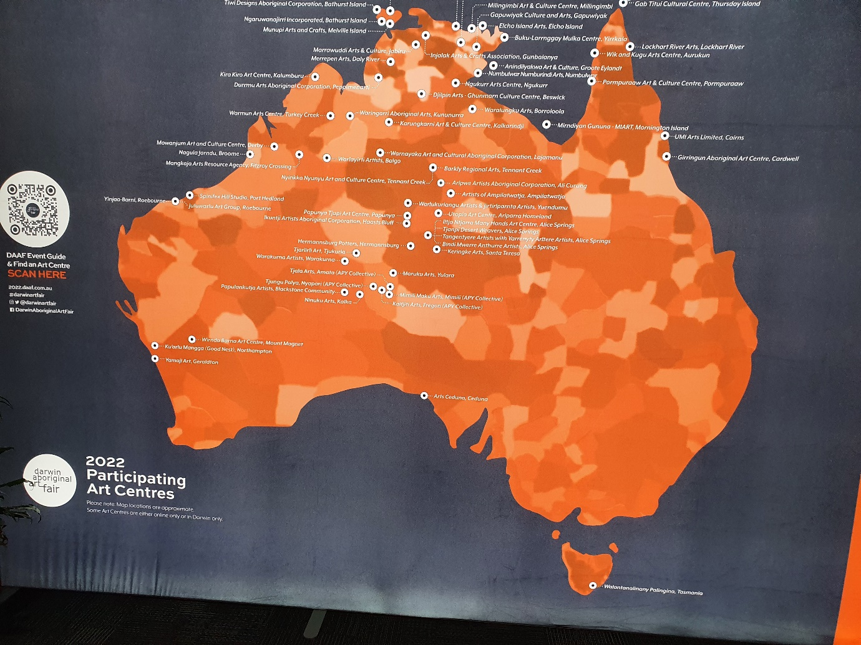

Map displayed at the Darwin Aboriginal Art Fair 2022 showing participating Art Centres
Three ACHAA member centre representatives and the ACHAA General Manager were able to attend DAAF 2022 with support from IVAIS (via DAAF) and Create NSW, to gauge interest and support for a combined ACHAA stall at DAAF 2023. Photo: Steve Miller

