Fiduciarys Friend Pty Ltd
PO Box 965
Edgecliff NSW 2027

20 April 2016

Ms Karen Chester and Ms Angela MacRae
Commissioners
Superannuation
Productivity Commission
Locked Bag 2, Collins St East
Melbourne VIC 8003

super@pc.gov.au

Dear Commissioners
EFFICIENCY AND COMPETITIVENESS OF THE SUPERANNUATION SYSTEM

I am pleased to present the attached submission on behalf of Fiduciarys Friend Pty Ltd, a company established to develop and implement Trustee Tailored Superannuation (TTS).

TTS is a tailored superannuation product designed to be applied to MySuper default funds during the accumulation phase. It is a next generation lifecycle product that uses factors beyond simply age to shape more efficient investment horizons for members of default funds.

Our interest in the Productivity Commission’s inquiry is that we believe TTS is an innovative solution which directly addresses the objectives in your Terms of Reference to improve the efficiency and competitiveness of the superannuation system. Our submission outlines how TTS works, and how it achieves greater efficiency and competitiveness of superannuation. It also addresses the specific questions outlined in your Issues Paper.

Fiduciarys Friend Pty Ltd is supported by an Advisory Board, consisting of the following members:

• Dick Warburton: Board of Taxation, Caltex, CEDA, Citigroup, David Jones, Goldfields, Mallegan, Nufarm, RBA, Southcorp, Tabcorp, Westfield
• Mark Gray: ex Qld Under Treasurer - public sector, trade and investment, economic development; Macquarie, PM medal (banking and finance)
• Rodd Pahl: Founder and MD Bluegrass Consulting (public affairs/market positioning), Burson-Marsteller, IPR Shandwick, Network Pacific
• Tony Hodgson: BRI Ferrier, Coles, HSBC, JP Morgan Advisory Board, Melbourne Port, Pact Group, Tabcorp
• Douglas Bucknell: TTS founder, AIDF, ARIA, APRA, HSBC, NAB

TTS is implementation-ready, we have a working prototype, and we are currently in the process of taking our product to market through direct engagement with individual superannuation funds and other market participants.

Please contact me should you wish to discuss this submission in further detail. We would welcome inclusion in consultation and roundtable events.

Yours sincerely

Douglas Bucknell
Managing Director
Fiduciarys Friend Pty Ltd

SUBMISSION IN RESPONSE TO PRODUCTIVITY COMMISSION ISSUES PAPER – SUPERANNUATION COMPETITIVENESS AND EFFICIENCY (MARCH 2016)

Introduction – What is Trustee Tailored Superannuation (TTS)

TTS is a tailored superannuation product designed to be applied to MySuper default funds during the accumulation phase. It is a next generation lifecycle product that uses factors beyond simply age to shape more efficient investment horizons for members of default funds.

In simple terms, TTS is what is being referred to by the industry and academia as a “Smart Default”.

An August 2015, CIFR Research and Survey confirmed that the industry's attention has moved to life-cycling, member engagement and tailoring to default members. It concluded:

“Smart defaults – As improved member outcomes are likely to result from the capacity of funds to tailor products, regulators and policy makers might aim to foster the development of smart defaults by accommodating the evolution of lifecycle products beyond simple age-based strategies.”

A number of superannuation funds have started developing lifecycle products, which provide different investment options for members based on lifecycle factors such as age. While this recognises the different investment priorities of say a 20 year old compared with a 55 year old, it does not recognise that even two 20 year olds may have different investment horizons due to say differences in income and projected retirement balances.
TTS recognises such factors explicitly, by applying different investment options to members in default schemes based on a range of lifecycle factors. As such, TTS directly aligns with the Terms of Reference of the Productivity Commission’s inquiry to “assess the efficiency and competitiveness of the superannuation system, as well as develop alternative models for allocating default fund members to products” (emphasis added).
This is exactly what the TTS product does. In simple terms, TTS Version 1.0 allocates MySuper default fund members to different investment options within the default fund based on lifecycle factors such as age, current income level and projected retirement balances. The investment options can align with the investment choice options offered by a fund, or can be structured or tailored differently in accordance with the objectives of Trustees. (In this regard, TTS is a trustee product and in no way disturbs existing relationships with administrators or funds managers.)
TTS can then re-calibrate the profile of members each year, with members being switched between options as necessary to reflect changing circumstances (e.g. significant increase in income, extended period of leave, etc.). In addition, there is a capacity within TTS to add other factors over time, such as pension eligibility, tax rates, other savings (outside super), retirement lifestyle considerations, etc. (TTS Version 2.0 and beyond). As will be evident, such a product aligns strongly with obligations of trustees to act in the best interests of members.
The TTS system comprises three simple steps:
- Set Lifestyle Retirement Bands (LRBs) for the MySuper fund
- Set glide paths (investment paths) for each LRB.
- Calculate projected retirement balance for each MySuper member.
Using fund information on age, current balance and projected retirement balance for each MySuper fund member, TTS is implemented through the following process:
- Allocate members to their LRB
- Place members on their glide path for their age
- Switch member investment option
- Recalibrate each year for changed member circumstances and new variables (such as eligibility for the age pension, tax rates, and retirement lifestyle factors).
Fiduciarys Friend has done extensive testing of this product, especially in terms of increases in returns to members and thus increases in projected retirement balances. On the analysis undertaken to date, there is scope to increase returns by around 1% pa ongoing (with a decline in average sequencing risk as retirement approaches), resulting in cumulative increase of 35-40% in the retirement balances of members from commencement of employment (although of course this will vary according to the profile and characteristics of members of a default fund).
There are obvious benefits to be derived from a Smart Default option such as TTS:
- A significant increase in retirement balances for members, offering the opportunity for a better retirement lifestyle than would otherwise have been the case
- A significant growth in the size of funds under management in individual funds, and for the sector in aggregate, thus providing a greater pool of capital to invest in growth of the Australian economy
- An opportunity for product differentiation
- Significant public policy benefits, in the form of reduced pressure on the aged pension system over time, as members become more self-sufficient due to higher retirement balances.
Fiduciarys Friend holds specific proprietary information and data which is highly relevant to the Productivity Commission inquiry. Specifically, we hold quantified metrics on allocative, dynamic and operational inefficiencies within MySuper that will allow you to develop the study’s criteria.

In essence, TTS is an efficiency measure, which makes more efficient use of long term investment horizons to generate higher investment returns at lower average risk (albeit with a higher risk profile in earlier years of the accumulation phase, when such risks are readily manageable.)

We will also provide a:
- Solution to the current inefficiencies of default funds, that improves after fee returns to members and focuses on the retirement objective of the system,
- Clear implementable alternative model for allocating default fund members to products,
- Market approach to competition driving default fund selection through these efficiency gains and in the process improving the (MySuper) Stronger Super reforms effectiveness.

This submission strongly supports and directly refers to both the FSI Superannuation elements and your terms of reference.

Question on system EFFICIENCY Objectives
Within the current policy settings, what are the objectives against which the efficiency and competitiveness of the superannuation system should be assessed? How prescriptively should the objectives be expressed?

Objectives

We broadly agree with the FSI recommendation and the Government’s intent to legislate the purpose of superannuation being:

“To provide income in retirement to substitute or supplement the Age Pension.”

It is important that the objective of superannuation is stated in a clear and unambiguous way that is not open to misinterpretation (or misrepresentation). This will then in turn provide clear guidance to trustees who have a fiduciary responsibility to act in the interests of their members. By focussing on this purpose, trustees will need to consider whether significant efficiency improvements can be achieved compared to current practices, in order to better provide acceptable incomes for members in retirement.

There has been much analysis and debate about the amount of funds required to enable retirees to be self-funded at a comfortable lifestyle, given increasing life expectancy and assuming an average standard of living in retirement. Figures range from around $650,000 for a couple (in today’s dollars), which has been suggested by ASFA, through to figures of over $1 million. TTS leaves these amount questions in the hands of trustees, however clearly there is a need to do more to boost projected retirement balances of the overwhelming majority of the population if they are to achieve balances of this order.

For Fiduciarys Friend, the primary focus is on MySuper default funds, which represent approximately 80% of members in the superannuation system. Significant effort has been devoted to improving investment choices and investment outcomes for the 20% of members who are engaged, and are making active choices about their investment preferences. However, little has been done to date to address the investment needs of the remaining 80%. It is axiomatic that improvement in investment performance of this disengaged 80% can produce significant system-wide benefits.
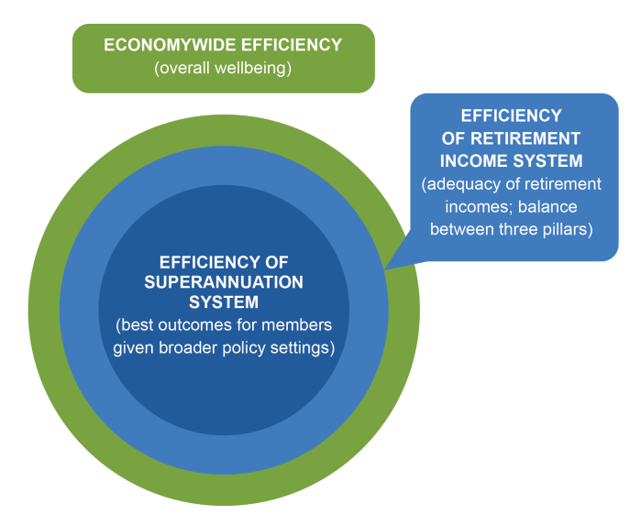
From the perspective of efficiency of the superannuation system, for MySuper
Trustees the Objective in accumulation phases is better expressed as “Act in member’s best interest – for their retirement”

Generally, the current practice with default schemes is:

- One size fits all
- Age only lifecycle
- Focus on market performance
- Current balance is the focal point

The drawbacks of current default schemes are:

- No tailoring of options to members
- Potential lifetime earnings of members not optimised
- Inefficient use of investment horizons
- Personal retirement outcomes receive insufficient attention

In particular, the historic ‘one size fits all’ default option simply bundles 20 year old members entering the workforce, with 65 year olds leaving the workforce – without regard to the Objective of superannuation.

Some funds are now providing basic lifecycle products in their default schemes, to provide different investment paths for members based on age. While this recognises the different investment horizons of a 20 year old compared with a 65 year old, it does not recognise that two 20 year olds may have different investment priorities due to differences in current income, current balances and hence projected retirement balance. Age only based life-cycling reduces average investment returns indiscriminately in order to reduce sequencing risk as members’ age and the size of their balance increases, regardless of retirement prospects.

By measuring trustees prescriptively against the Objective “Act in member’s best interest – for their retirement”, 80%+ of Australian superannuation (MySuper) members will have their investment balance more efficiently aligned to their investment time horizons, the preservation rules and their retirement lifestyle/prospects - be that fully funded, part or full age pension. This is an additional important link between the Superannuation System and the Retirement Income System.

Trustee Tailored Super (TTS) is a product specifically designed to address this fundamental objective of superannuation in its application to the approximately 80% of superannuation fund members who are disengaged and simply accept the current inefficient default (MySuper) investment option. It is a next generation lifecycle product, for the MySuper segment, during the accumulation phase. In simple terms, TTS allocates MySuper default fund members to Lifestyle Retirement Bands (LRBs) based on lifecycle factors of age, current income level and projected retirement balance (Ref. SIS Reg. 9.47). These LRBs are then used to more efficiently align the investment over time (“glide paths”) of a MySuper members balance to their retirement lifestyle prospects compared to current practices.

It aligns the investments of 80% of Australians super balances to the Purpose of Super – Retirement. The investment options can align with the existing investment choice options offered by a fund, or can be structured or tailored differently by trustees in accordance with the demographics of their fund. In this regard, TTS is a trustee product, and in no way disturbs existing structural relationships with administrators or fund managers. Trustees set the LRB and glide path parameters as part of their required investment strategy to be as efficient as possible in acting in their member’s best interest – for their retirement.

Ultimately, this Smart Default results in higher retirement balances which is the desired outcome from the perspectives of all stakeholders – members, trustees and the Federal Government (by reducing the call on the age pension system), while at the same time reducing average sequencing risks across the default fund as retirement approaches.

Competitiveness

In its Terms of Reference, the Productivity Commission has been asked to “examine alternative models for a formal competitive process for allocating default fund members in the superannuation system to products and to develop a workable model, or models, that could be implemented by Government if a new model for allocating default fund members to products is desirable”.

We do not favour a competitive tender process for allocating default fund members to products. This is likely to have the effect of establishing a small panel of preferred products or funds, which will lead to significant industry consolidation and hence concentration. Reducing the number of competitors and adopting quasi-oligopolistic approaches such as tendering, are not aligned to long term competitiveness, as is noted in Productivity Commission reports on other industries, within the FSI Report and in recent public commentary about concentration in the banking sector.

Rather, competition is more likely to be better served by encouraging a larger number of smaller participants who can compete vigorously on price (cost), quality, product differentiation, service and innovation. The more concentrated an industry becomes, ceteris paribus, the less likely it is that these competitive forces will prevail. A competitive tendering process which leads to the survival of only a limited number of funds has all the hallmarks of a government-imposed solution to what should in reality be a market-driven outcome.

We urge you to actively consider ways to foster greater competition by encouraging new players and innovative ideas. In this respect, the FSI report made recommendations on five specific themes one of which was to “Drive economic growth and productivity through settings that promote innovation.”

The terms of reference include a requirement to “develop alternative models for allocating default fund members to products.” (Emphasis added.) TTS meets this requirement by offering a more efficient solution for trustees to apply to existing MySuper default fund schemes.

It is our intention that through implementing TTS broadly within the industry, MySuper will prove to be successful and the proposed default (fund selection) auction will not be warranted.

Instead a robust dynamic industry with a broad range of funds, competing to provide the best retirement lifestyle possible for their default (MySuper) members, based on their funds demographics, will exist.

By measuring trustees prescriptively against the Objective “Act in member’s best interest – for their retirement” competition to achieve on this aspect will drive change from the trustee throughout the Superannuation Industry supply chain.

How prescriptively should objectives be expressed?

We fundamentally agree that superannuation must be measured prescriptively against its objective.

We suggest dual measurement via key performance indicators (KPI), one for the accumulation phase and one for the retirement phase. For the accumulation phase, this should be Projected Retirement Balances.

The key attributes of this KPI are:

- It will already be required to be calculated annually, per member, as a result of FSI Recommendation 37 “Publish retirement income projections on member statements from defined contribution superannuation schemes using Australian Securities and Investments Commission (ASIC) regulatory guidance.” That is because in order to calculate a ‘retirement income projection’ the starting position/number (Projected Retirement Balance) has to be calculated.
- It should be expressed in ‘today’s dollars’, and also be included on annual member statements. This approach allows members to understand the relative value now, is less complex and also avoids potentially different inflation related assumptions.
- Existing calculators on funds website can be used (consistent with ASIC guidance) on bulk facilitating consistency and accountability.

Measurements of fund performance can then be assessed by answering the following questions:

  - How much did the funds average projected retirement balance grow? By projected retirement lifestyle type (e.g. Full Age Pension), how much did the average grow?
  - In relative terms, how much did the average projected retirement balance change from last annual statement to this annual statement or over 3 or 5 annual statements?
  - For individual members, how is my fund performing, what type of retirement can I expect, what impact did that wage increase/career break/maternity leave/ voluntary contributions last year, have on my retirement prospects and what action should I now take? What is my level of sequencing risk as my retirement approaches?

Many funds already have Projected Retirement Balance or a derivative of it Projected Retirement Incomes per member included on annual statements. We have no issue with both being included or a general Lifestyle Retirement Descriptor (i.e. moderate retirement lifestyle) or a confidence interval band being included around the projected retirement balance – as some trustees may consider this assists, for example with retirement phase income versus lump sum communications.

However, as the measurement needs to be both comparable and prescriptive – Projected Retirement Balance is the best KPI for this accumulation phase purpose – rather than adding additional (variable) factors such as life expectancy to project a retirement income.

The retirement phase can have a separate KPI. To fully appreciate this spilt KPI element, the following FSI subsidiary objectives should also be considered.

Subsidiary Objectives

In addressing the FSI subsidiary objectives, included in the numbered table below, we believe there is a more logical order and some clarity available, that will assist with this study.
 | Subsidiary objective | Why the objective is important
1 | Facilitate consumption smoothing over the course of an individual’s life | Superannuation is a vehicle for individuals to fund consumption in retirement largely from working life income. The system should facilitate consumption smoothing while providing choice and flexibility to meet individual needs and preferences.
2 | Help people manage financial risks in retirement | Risk management is important as retirees generally have limited opportunities to replenish losses. The retirement income system should help individuals manage longevity risk, investment risk and inflation risk. Products with risk pooling would help people to manage longevity risk efficiently.
3 | Be fully funded from savings | A fully funded system, as opposed to an unfunded system, is important for sustainability and stability. The system is designed to be predominantly funded by savings from working life income and investment earnings, where superannuation fund members in general have claims on all assets in the fund.
4 | Be invested in the best interests of superannuation fund members | Superannuation funds are managed for the sole benefit of members, which means the investment focus should be on maximising risk-adjusted returns, net of fees and taxes, over the lifetime of a member. This results in auxiliary benefits to the economy by creating a pool of savings to fund long-term investment.
5 | Alleviate fiscal pressures on Government from the retirement income system | Government’s total contribution to the retirement income system, through both the Age Pension and superannuation tax concessions, needs to be sustainable and targeted. Higher private provisioning for retirement should reduce the burden on public finances.
6 | Be simple and efficient, and provide safeguards | The system should achieve its objectives at the minimum cost to individuals and taxpayers. Complexity is less appropriate for a compulsory system, as it tends to add to costs and to favour sophisticated and well-informed investors. Given the compulsory nature of SG contributions, the system needs prudential oversight and should provide good outcomes in both the accumulation and retirement phases for disengaged fund members.
- Source: Financial System Inquiry Final Report

Starting with item 6, we obviously agree with ‘good outcomes’ in the accumulation phase for disengaged members – given this is what TTS improves for those circa 80% of MySuper members (FUM $428+B). These members are relying on their (sophisticated and well-informed) trustee hence it is not correct to assume (some) complexity is less appropriate.

Moving to item 4, it is maximising risk-adjusted returns, net of fees and taxes, over the lifetime of a member that is important, not lower fees or annual performance. This will (as the TTS research shows) result in auxiliary benefits to the economy by creating a pool of savings to fund long-term investment (including infrastructure).

Item 3, highlights the importance of being predominantly funded by savings from working life income and investment earnings. With 80% of members disengaged and this MySuper group accounting for vast majority of the future full/part age pension burden – it is this segment that provides the biggest opportunity for improvement. The remaining 20% are actively engaged, they choose an investment option, they often have higher balances, and are as a result seen as a ‘target for tax concession reductions’.

The 80% of members who are in default funds by definition are disengaged. Implicitly, they are putting their trust in the hands of the Trustees of their fund to act in their best interests by investing their funds wisely and efficiently, in line with their fiduciary responsibilities. Would any rational investment advisor, given Preservation rules advise a 20 year old person with a 45-50 year investment horizon to invest in a ‘balanced fund’?

By simply dumping all members in a ‘one size fits all’ 70/30 balanced default, trustees are not carrying their ‘full weight or responsibility’ to society, taxpayers, the Retirement or Superannuation Systems or to their members. Trustees are not optimising for different investment horizons and this is inefficient from a system-wide perspective. Neither is it responsible to simplistically reduce average returns as balances rise, which is what occurs within an age only based default resulting in lower average retirement balances. A more effective MySuper next generation product (Smart Default) is needed to improve the overall efficiency of the superannuation system.

By targeting higher starting retirement balances throughout the accumulation phase for these MySuper members, ‘Alleviating fiscal pressures on Government from the retirement income system’ (item 5) is far more likely to be achieved in a sustainable manner. It also reinforces (item 6) the system achieving its objectives at the minimum cost to (all Choice and MySuper) individuals and taxpayers.

Items 1 and 2 are subsequent to the preceding items. We agree that providing choice and flexibility to meet individual needs/preferences and that managing risk (including sequencing risk as retirement approaches) are important, both of which are major features of TTS. However these aspects are secondary to higher projected retirement balances and the broader retirement lifestyle outcome achieved by utilising all three (superannuation, Age Pension and voluntary savings) pillars.

Questions on the Commission’s approach to assessment
Do you agree with the broad approach of combining performance benchmarks with a test of barriers to efficient or competitive outcomes in the superannuation system?
How should the unique features of the superannuation system (identified in section 2) be taken into account in developing criteria and indicators for assessing its competitiveness and efficiency? Are there other possible approaches?
To what extent do different data reporting formats make it difficult to compare SMSFs and APRA-regulated funds, and hence to assess the performance of the superannuation system as a whole?
Which of the existing composite measures of Australian superannuation fund and/or product performance would be relevant to this study and why?

Broad approach of combining performance benchmarks

We agree with this approach. Many of the difficulties and pitfalls of this approach that are outlined in the Issues Paper can be effectively overcome as outlined below.

The time for ‘averages’ is over – tailoring is now available. Performance should be measured, per individual against the retirement objective – in the best interest of members.

How should unique features be taken into account?

By measuring Projected Retirement Balance outcome, per member and including it on each annual member statement.

Disengagement – MySuper members typically become engaged when their balance grows and retirement approaches. By providing and measuring against (higher) Projected Retirement Balance on annual statements (compared to current balance) they are more likely to be nudged (ref. Nudge Theory) into engagement. It concentrates ‘what is in Super for them’.

Decisions are inherently complex, particularly during the accumulation stage – MySuper members outsource this complexity to their trustee – but they need a clear measurement that they can relate to – this is their Projected Retirement Balance – for the accumulation phase.

Disengaged members diluting competitive pressure on superannuation funds to reduce costs or improve their service offerings, especially in the accumulation stage – reducing costs or improving service offering during accumulation phase are ultimately only important to the extent they improve the ability to meet the Objective.

Default options cover decisions on the choice of fund and product, as well as the bundling of various ancillary services, such as insurance – The impact of insurance premium costs on Retirement Lifestyles, the Superannuation System purpose and Retirement Incomes Policy will be made clearer (particularly as retirement approaches and premiums rise accordingly) by using Projected Retirement Balances. Tailoring can improve default insurance efficiency.

Principal–agent relationships abound – If the principal (MySuper Trustee) is being measured against the Objective in a clear and unambiguous way, it more likely that they will (and have the direct capacity to) measure and insist their agents performance also be measured in this manner. E.g. rather than short term measures (i.e. weekly, quarterly or yearly investment option returns) – how did the agent impact member retirement balances?

Dynamic System

The superannuation system has undergone significant change over the last decade and will continue to develop and evolve – MySuper trustees need dynamic tools to be able to adjust their default offering in order to optimise value in the best interests of their members – for their retirement. They need to know and be measured against retirement goal in order to adjust these tools (including Smart Defaults) as changes occur in order to achieve this outcome.

Average balances are expected to continue growing – This is both self-evident and, with respect, a next to useless statement in terms of comparison or performance measurement. It is often repeated within the Superannuation Industry that MySuper members’ balances are too low so no action is taken. There is myopia involved.

The approach is a next to useless for two reasons, it does not differentiate between:
- a $1,000 balance for retiring 65 year old and an 18 year old with a $1,000 balance – which may also be a $1M projected retirement balance.
- two 25 year olds both with $10,000 balances, one with a Projected Retirement Balance/lifestyle of ‘self-funded’ and the other who is set to retire on the full Age Pension.

Graph 1 below from the TTS prototype, depicts this issue. The average balance ($1,000-$250,000) provides no insight into the retirement outcome objective. The light green line shows average projected retirement balances by age, in today’s dollars. It focuses on the purpose (for accumulation phase), and is comparable across the Superannuation System. The graph should be read vertically. For example, for the average member aged 35 (horizontal axis), the circumstances are as follows:

- current balance $ 143,197
- current projected retirement balance $800,560
- projected retirement balance with the application of TTS is $1,145,321.
Graph 1
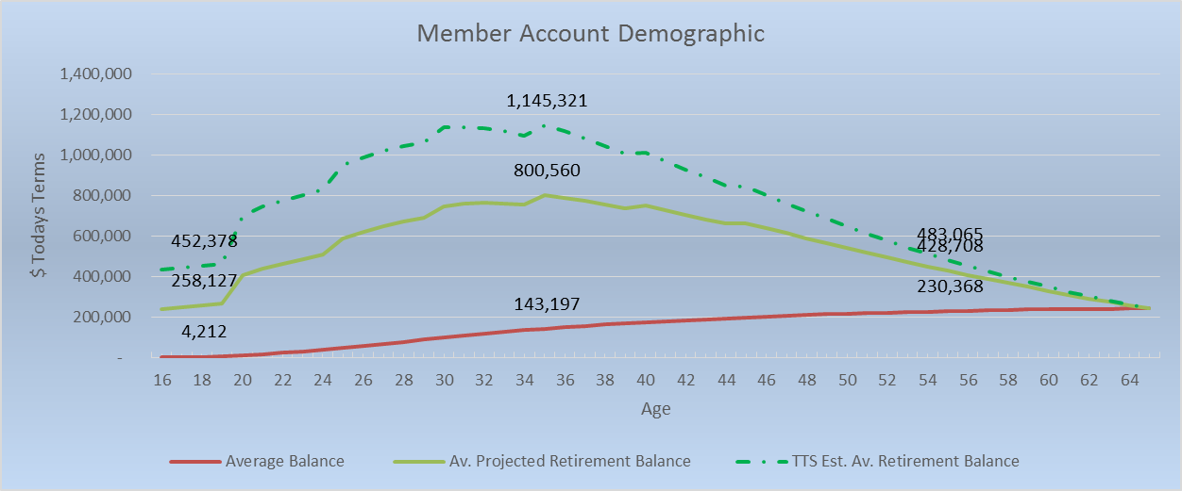

.Benchmarking
The benchmarking methodology could range from a simple comparison of particular indicators to more sophisticated modelling techniques that incorporate multiple factors, such as data envelopment analysis or stochastic frontier analysis.

Benchmarking, for the accumulation phase, needs to be straightforward and measureable using Projected Retirement Balances. Measurements of fund performance can then be assessed including:

  - How much did the funds average projected retirement balance grow? By projected retirement lifestyle type (e.g. Full Age Pension), how much did the average grow?
  - In relative terms, how much did the average projected retirement balance change from last annual statement to this annual statement or over 3 or 5 annual statements?
  - For individual members, how is my fund performing, what type of retirement can I expect, what impact did that wage increase/career break/maternity leave/ voluntary contributions last year, have on my retirement prospects and what action should I now take? What is my level of sequencing risk as my retirement approaches?

For the accumulation phase, a simple comparison of particular indicators is warranted. Retirement phase maybe different – a strong, known accumulation phase starting point will assist with that (retirement benchmark) consideration.
The benchmarking methodology could range from a simple comparison of particular indicators to more sophisticated modelling techniques that incorporate multiple factors, such as data envelopment analysis or stochastic frontier analysis.
As noted above and in the paper, the industry is dynamic and benchmarking can and should become more focussed on member outcomes against the Objective over time.
Smart defaults provide this opportunity. Graph 2 below from the TTS prototype, provides for all MySuper members regardless of age, details of their Lifestyle Retirement Band (using their current projected retirement balance) and its return and loss characteristics – using a funds current choice options and MySuper dashboard published details.

Graph 2
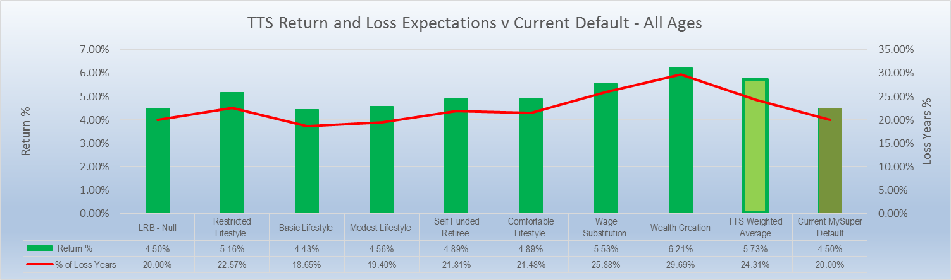

For sequencing risk, Graph 3 below from the TTS prototype, provides for all MySuper members over aged 55 (and approaching retirement), details of their Lifestyle Retirement Band risk return profile – again amalgamating each member by actual investment option.

Graph 3
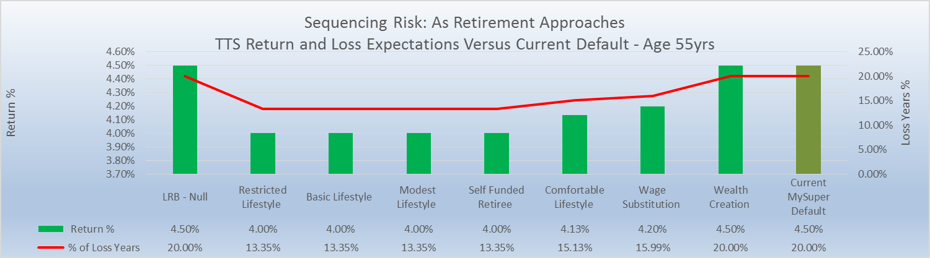

APRA Regulated Fund v’s SMSF Measurement

SMSF are already by definition engaged member/trustees – they will be looking after themselves to the best of their ability focussed on their definition of retirement purpose – meaning the efficiency and competition driver elements are removed.

It would be possible and relatively inexpensive to include projected retirement balances on annual SMSF tax returns – again using a standard (ASIC) calculator if desired for whole of Superannuation System comparison purposes.

Cross-country composite measures of pension system performance

It is not clear who might do this, and what it might achieve, given differing structures and characteristics of superannuation or pension arrangements in different countries.

Which existing composite measures of Australian superannuation fund and/or product performance would be relevant to this study and why?

My Super Dashboard reporting as outlined in the following table. These figures provide:

- A useful public comparison point between funds from a members’ perspective
- An ability to analyse efficiency through the relative difference between Return Target and Loss Years (ratio) both within a fund and across funds.
- For sequencing risk comparative analysis

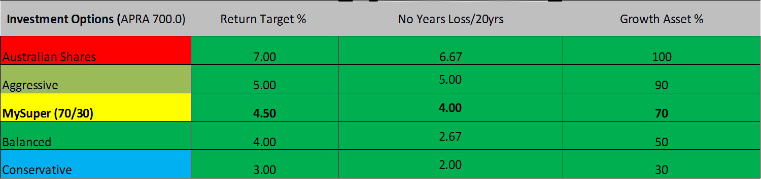

There are no issues with existing data collection, Projected Retirement Balances are already being placed on some Funds Member Statements and Funds are required to provide (which TTS uses) the above details per the MySuper dashboard regulations.

Are there other possible approaches?

Yes industry wide efficiency analysis. An example of the analysis that can be performed now on the System from an industry efficiency perspective is included below. The following graph is based on the December 2014 APRA MySuper Data, for Traditional One Size Fits All MySuper default funds.

In a snapshot, this graph indicates the diversity of return prospects versus risk of loss reported by traditional default funds. The average (by fund) Return Target is 3.2%, ranging from 2.00% to 5.50%, while the level of investment risk ranges from two to six negative years in 20.

There is limited correlation in the trade-off between ‘risk and return’ across default funds. Given a 1% difference in Return Target over a lifetime can lead to 35% change in Retirement Balance an efficient default fund structure is critical. Although some individual fund factors (i.e. demographics) may be involved, this is clearly an area where efficiency gains can be made.

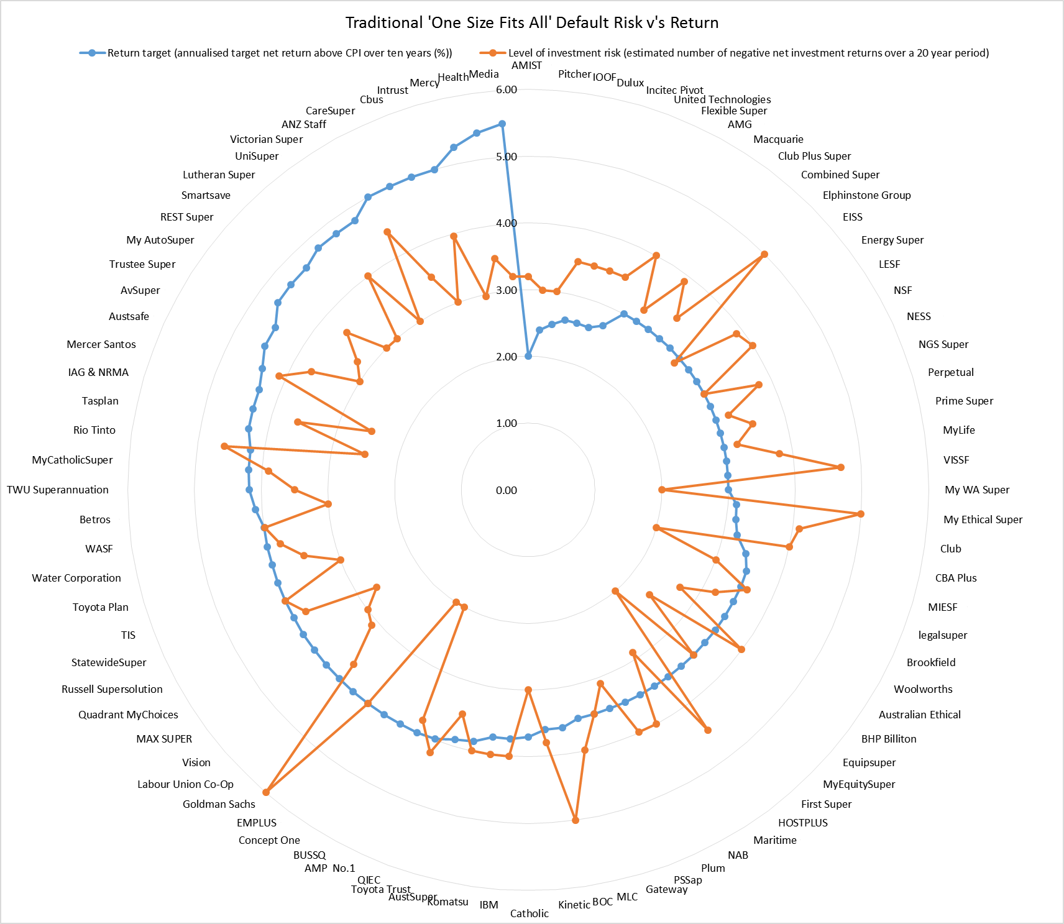
The ‘one size fits all’ traditional default structure is a major efficiency issue.
Further guidance for participant feedback
When suggesting possible assessment criteria, the Commission requests that participants identify how those criteria are influenced by current policy settings.
The Commission requests that when participants propose particular criteria and indicators, they also indicate how those should be interpreted and why, as well as any additional information that could complement the assessment.
The Commission requests that (where relevant in their responses to the questions that follow) participants indicate any current issues with the evidence and/or data, as well as the feasibility and cost of addressing them by the time of the formal review of the system (stage 3). In looking at the gaps in the evidence, the Commission is interested in:
- whether the evidence gap is due to the data not being collected or not being in the public domain
- who is best placed to collect the data that have not been previously collected, and why.

How suggested assessment criteria are influenced by current policy settings

The Projected Retirement Balance criteria, fully aligns with the Objective of Superannuation – retirement.

How should Projected Retirement Balance be interpreted and why?

For the MySuper option, projected retirement balance should be interpreted from a longer term perspective, in terms of how it contributes to the objective of providing sufficient funds in retirement, including:

- How much did the average projected retirement balance change (last annual statement to this annual statement or over 3 or 5 annual statements)?
    - Why? This is important, because it shows progress against the purpose on a whole of fund basis – for comparison between funds.

  - For those with a projected retirement balance that indicates (via Super stream collection), for example retirement on the Full Age Pension, how much did the average grow?
    - Why? Because it shows for society, tax payers, and government how each segment is performing and likely future Retirement Income System implications and indicates ways to fix future shortfalls – thereby improving system sustainability and confidence.

  - For individual members, how is my fund performing, what type of retirement can I expect, what impact did that wage increase/career break/maternity leave/ voluntary contributions last year, have on my retirement prospects and what action should I now take?
    - Why? Because it shows, on each members annual statement how they are progressing.

  - What is my level of sequencing risk as retirement approaches?
    - Why? Because combined with (MySuper) loss ratios – a range of retirement outcomes can be shown with increasing certainty as retirement approaches

Additional information that could complement the assessment

Refer to our offer on inclusion within roundtables meetings
Data

There are no issues with data. TTSv1.0 simply requires 3 columns of information being members’ current age, current balance and projected retirement balance.

Projected Retirement Balance age is set by the trustee, along with LRB and glide path as part of their existing Investment Strategy process. These will in part be fund demographic specific and adjusted to maximise efficiency (by the trustee, acting in members best interests).

Projected Retirement Balances will already be required to be calculated annually, per member, as a result of FSI Recommendation 37 “Publish retirement income projections on member statements from defined contribution superannuation schemes using Australian Securities and Investments Commission (ASIC) regulatory guidance.” That is because in order to calculate a ‘retirement income projection’ the starting position/number (Projected Retirement Balance) has to be calculated.

It should be expressed in ‘today’s dollars’, and also be included on annual member statements. This approach allows members to understand the relative value now, is less complex and also avoids potentially different inflation related assumptions.

Existing calculators on funds website can be used (consistent with ASIC guidance) on bulk to facilitate consistency and accountability.

Questions on the role of competition in superannuation
What are the key ways in which competition can improve efficiency in the superannuation system?
Is there sufficient emphasis on competition in the regulation of superannuation?
Are there any current circumstances where competition is not delivering efficient outcomes and why?
What are the key sources of economies of scale? What are the ways of realising economies of scale, in addition to fund mergers? Are there any parts of the system that may be operating with diseconomies of scale? What are the best indicators for measuring the current realisation of scale economies, and the scope for future increases?

Key ways competition can improve efficiency

New products like Smart Defaults that improve efficiency are only likely to be introduced in a competitive market where funds are pressured to overcome inertia and allowed to gain first mover advantages. This inertia is particularly strong for the MySuper disengaged segment.

The major pressure points for change are depicted below. Government and its agencies have an important role, to ensure the focus is on the Objective, particularly for this disengaged segment which accounts for such a large (80%) portion of Australians.

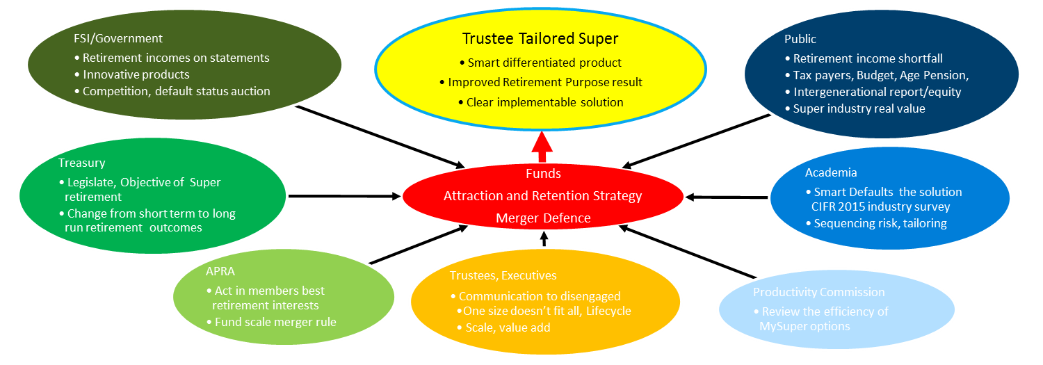

As outlined earlier in this submission, encouragement of competitive forces is more likely to produce an efficient outcome than a contrived government-imposed competitive tendering process which would only serve to narrow competition, reduce the number of market participants and impose artificial and unnecessary barriers to entry – essentially the MySuper market would be limited to a small number participants successful in the tender process. There is a danger in over-complicating the system with a complex solution – it would be preferable to just let the market work.

Is there sufficient emphasis on competition in the regulation?

No. Without active encouragement for smaller players and new ideas, industries stagnate and over economic cycles contract in part due to regulatory barriers to entry.

Regulators, unless actively encouraged/stipulated otherwise, have a propensity to reduce the number of entities being covered and oversight the remaining more intensely. This twin impact often stifles the new innovative ideas that would otherwise drive more competitive pricing and new entrants.

Current circumstances where competition is not delivering efficient outcomes and why

The issues papers following comment are particularly pertinent to Smart default introduction.

“If fund members are not well informed or engaged or have limited influence on fund governance and direction, providers may also compete on irrelevant product features that add little value to the end user. Ensuring competition acts in a manner consistent with members’ interests has an additional layer of complexity, compared to other sectors, given the unique features of the superannuation system.”

By instead focusing on the purpose of superannuation – retirement, 35+% improved retirement lifestyle outcomes for 80% of Australians can be achieved, with lower sequencing risk as retirement approaches. The reasons that Smart Defaults have not occurred to date include:

- Regulatory change – settling in of MySuper,
  - Size – MySuper is large for every fund, both in terms of funds under management and typically accounts for 80% of members
  - Career risk – the incentives for improvement individually (as trustees or executives) have not yet been sufficient.
- Its new (worldwide) – the only known fully implementable Smart Default is TTS
- It’s a trustee product – which is unusual other industry participants would either have to reach up the supply chain (administrators) or down it (custodians).

Below is an indication of how competitive forces within the market, including industry consolidation/mergers may lead a proportion of the industry to innovate, improve MySuper efficiency and hence survive. The pressure to overcome inertia is arguably greatest in the relatively smaller funds of which there are around 100 who have assets of less than $5B – it however also this group that is potentially most influenced by the preceding comments and dot points.
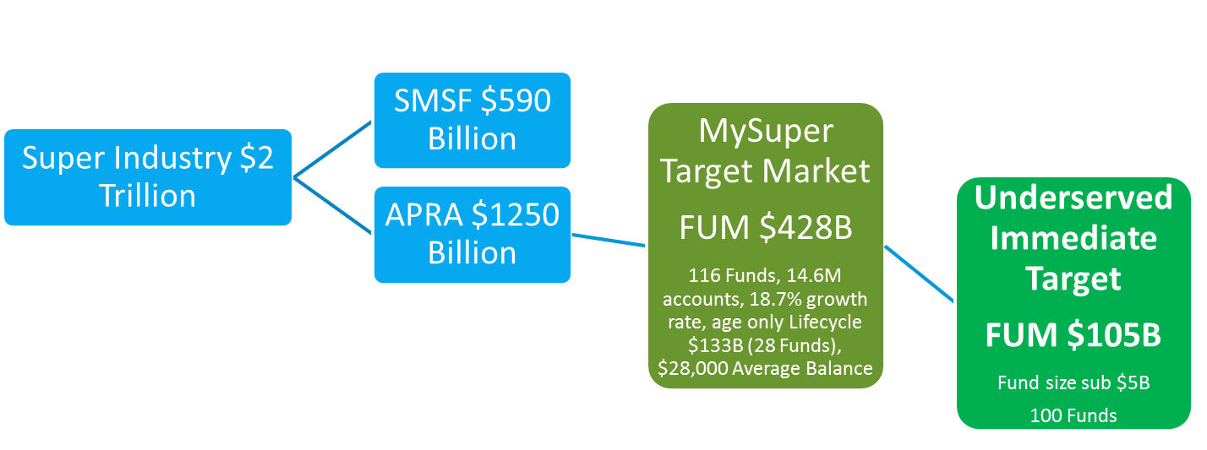
What are the key sources of economies of scale?

Ultimately, most scale benefits relate to the effective and efficient use of technology. Technology costs have and are likely to continue to rapidly decline. Improvements are being made at such a rate that nimble disruptors, particularly in Fintech are able to outcompete large slower large scale entities (at least in initial phases).
It may be that any apparent scale economies that previously existed are now being overridden by rapid technological changes (that are likely to continue to evolve). It would be unwise to impose a solution on a presumption of what might well be illusory economies of scale. Rather, the system would be better served by encouraging flexibility and innovation to enable competitive forces to respond to emerging technological advances

What are the ways of realising economies of scale, in addition to fund mergers?

Industries that allow (including through regulation) and encourage (through profit/first move advantages) new nimble disruptors, particularly in Fintech, are likely to drive the realisation of scale benefits more quickly than would otherwise occur.

Are there any parts of the system that may be operating with diseconomies of scale?

Yes - refer to investment studies (on size and cross correlations) as the relative size of funds grow compared to overall market size. A highly concentrated MySuper segment – such as would occur under the alternative proposed auction process would cancel out many of the current scale benefit and reduce the speed of adoption of new (scale) benefits.

It is our view that there are currently significant under recognised benefits to be captured through Smart Defaults using funds’ membership demographics and trustee’s knowledge of that profile.

What are the best indicators for measuring the current realisation of scale economies, and the scope for future increases?

In Accumulation phase – Projected Retirement Balances

qUESTIONS ON ASSESSING COMPETITION IN THE SUPERANNUATION SYSTEM
What are the key outcome-based indicators of competition in the superannuation system?
Market definition
For each of the levels in the vertical supply chain (figure 3), who are the relevant consumers, and which market participants within or outside of the superannuation system are the most likely source of competitive pressure?
For each of the levels in the vertical supply chain, is there evidence of competition on factors other than price, and if so what are they (for example, performance, investment options, any additional features)? What drives this choice?
On what factors and features do default funds compete in corporate tenders? What factors are relevant for the assessment and selection of platform service providers by funds?
What is the degree of substitutability between different types of superannuation funds and products? How can this be evaluated or measured?
What is the relative contribution to member fees from the various participants through the vertical value chain?
Criteria and indicators
What are the most reliable and relevant assessment criteria and indicators for measuring the competitiveness of the superannuation system?
What are the barriers to efficiency-enhancing competition in the superannuation system? In particular, what are the policy impediments to competition? How can the impacts of these barriers be measured?
How would you measure the effectiveness of regulation in promoting competition within the superannuation system?
How would you measure the extent of competitive pressure from the SMSF segment on the rest of the superannuation system?
Can levels of transparency on aspects such as conflicts of interest and details of reporting to members (for example, as income stream equivalents) be used as a measure of competition?
We agree “The ultimate outcome-based indicators of competition are efficiency-enhancing innovation that leads to improvements in service quality, downward pressure on member fees and increasing net returns for members.”
We also agree “In superannuation there is a wide acknowledgment that demand-side pressures for competition are muted due to the mandatory nature of contributions and disengaged consumers (although there are segments of the market with more engaged members).”

Questions on assessing operational efficiency of the system
Do you agree with the proposed objectives for operational efficiency? If not, what should they be?
Benchmarking
What are the most reliable and relevant assessment criteria and indicators for benchmarking operational efficiency of the superannuation system? What are the evidence requirements and current gaps in using your proposed criteria and indicators?
What are the appropriate benchmarks against which the operational efficiency of Australia’s superannuation system should be measured? Are there countries that have superannuation systems that could provide an appropriate benchmark?
What types of fees are relevant to assessing the competitiveness and efficiency of the superannuation system? How should these fees be measured? What data sources are available and to what extent are these comparable with one another?
What are the best measure(s) of (post-fee) risk adjusted rates of return? How comparable are these measures?
What aspects of operational efficiency cannot be reliably measured using a benchmarking approach? How could this assessment incorporate aspects such as service quality?
What are the advantages and disadvantages of using techniques such as data envelopment analysis over conventional approaches such as simple benchmarking of a single criterion?
Barriers to operational efficiency
What elements of regulation have the greatest effect on the operational efficiency of the system and which aspects of operations are affected? How could those impacts be measured?

Do you agree with the proposed objectives for operational efficiency?
We agree with both of the paper’s following objectives
- Operational or productive efficiency refers to producing the maximum value of output for a given level of costs.
- Maximised net risk adjusted return on member contributions during the accumulation stage, taking into account other features of the services provided to the member

What are the most reliable and relevant assessment criteria and indicators for benchmarking operational efficiency of the superannuation system?

It will come as no surprise – indeed is self-evident, that investing 80% of Australians account balances in the same investment option, is operationally inefficient and can be significantly improved.

The difficult as the paper points out is “There are also challenges in specifying the outputs of the system, particularly during the accumulation stage.” These difficulties include short timeframes and lack of investment diversity leading to increased risk of loss.

However, the suggested metric Projected Retirement Balances does not have these (short term and investment loss) issues. Instead it forms a robust long run framework.

In terms of:
- short time frames, it is each members period to retirement (investment horizon) that is measured (refer also to fee measurement below)
- Investment diversity leading to increased risk of loss, it is sequencing risk as retirement approaches that is measured

What are the evidence requirements and current gaps in using your proposed criteria and indicators?

Nil.

What types of fees are relevant to assessing the competitiveness and efficiency of the superannuation system? How should these fees be measured? What data sources are available and to what extent are these comparable with one another?

The table below provides details on industry average fees per 1% real return achieved, being in the 17-26 basis point range. Details on individual funds are available in the published APRA quarterly statistics.

MySuper | $B | % | Ref. APRA Data  June & Sept. 2015
FUM | 428.00 | 21.4% (of Industry) | SRF 533.0
Fees p.a. | 3.75 - 4.33 | 0.75% -1.01% | SRF 700.00
Average return | 15.9 -19.3 | 3.71% - 4.50%* | SRF 700.00
Av Fee/1% return | 0.833 - 1.17 | 0.17 – 0.26 | 17 – 26 basis points

Trustees should be agnostic as to how the 1% average long run real return is achieved as long as it costs between 17-26 basis points. This is totally consistent with the Maximum value of output for a given level of costs criteria. Trustees have two choices to impact this metric, reduce costs (e.g. indexing) to members or increase returns (e.g. tailoring) to members. Higher Projected Retirement Balances will result through the achievement of Maximised net risk adjusted return on member contributions during the accumulation stage, taking into account other features of the services provided to the member.

What are the best measure(s) of (post-fee) risk adjusted rates of return? How comparable are these measures?
See above – fully comparable.
Funds would be able to continue to using other short term measures of performance that link to various market performances.

What aspects of operational efficiency cannot be reliably measured using a benchmarking approach? How could this assessment incorporate aspects such as service quality?
All major operational efficiency elements in the accumulation phase are covered by these elements based on the Objective. Service quality is either reflected in Projected Retirement Balances or not relevant to the 80% of members in MySuper because they are disengaged or a minor (operational efficiency) element.
What are the advantages and disadvantages of using techniques such as data envelopment analysis over conventional approaches such as simple benchmarking of a single criterion?
Such technics would need to be tailored to the demographics of membership profile and the retirement purpose – rather than be industry wide averages in order to be appropriate.

What elements of regulation have the greatest effect on the operational efficiency of the system and which aspects of operations are affected? How could those impacts be measured?

In accumulation phase, a greater focus on Trustees “Acting in member’s best interest – for their retirement”, is measured by Projected Retirement Balances.

Questions on assessing allocative efficiency
Do you agree with the proposed objectives for allocative efficiency? If not, what should they be?
Benchmarking
What are the advantages and disadvantages of using benchmarking to assess the allocative efficiency of the superannuation system? Which aspects of the system most lend themselves to such assessment?
Which criteria and measures are most relevant to assessing the allocative efficiency of the system, and how should they be interpreted? What are the evidence requirements and current gaps in using your proposed criteria and indicators?
Barriers to allocative efficiency
How can the magnitude and cost of principal–agent problems be assessed?
Should the criteria and indicators for assessing the extent and magnitude of principal–agent and governance problems focus on outcomes or inputs and process, such as best practice governance principles, or a combination of both? What existing measures of governance could the Commission draw on, and what are their strengths and weaknesses?
What are the most important behavioural biases and cognitive constraints affecting the key superannuation saving, investment and withdrawal decisions of users? What are the best assessment criteria and indicators for examining the magnitude and effect of those biases and constraints? What are the key gaps in the evidence to enable such assessment?
What are the best assessment criteria and indicators for examining the extent to which the outcomes for users are optimal with respect to the current taxation settings?

The pictorial below summarises our views of current allocative efficiency.
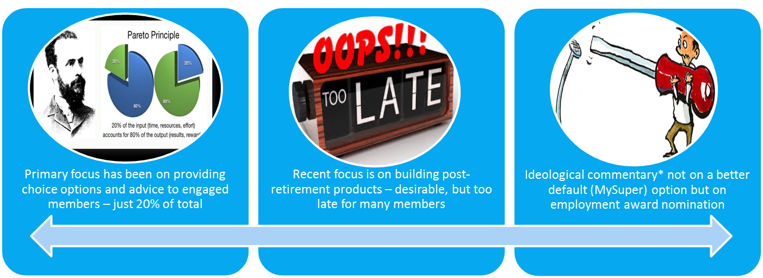
Too many resources and attention is being allocated to the 20% (choice) segment – greater efficiency can be achieved by concentrating on the 80%. Focusing on retirement products is too late for many; more resources should be allocated to those younger members. Poor tool selection is evident as resources are allocated to which fund and not what investment option.
Do you agree with the proposed objectives for allocative efficiency? If not, what should they be?
Yes, but 80% of Australians are disengaged, in MySuper and it’s their trustee that’s responsible for the Allocative efficiency. The adjustment highlighted below is warranted.
In that MySuper context Allocative efficiency refers to the allocation of resources (by trustees) to their highest value uses. Ultimately, the objective is to achieve optimal behaviour on (behalf of their) the part of members and to ensure that the outcomes of the superannuation system align with the (trustee known or knowable) preferences of (tailored sets of) members and maximise their (average) wellbeing to the greatest possible extent. In this way, allocative efficiency is also aligned with equity objectives.
Graph 4 below from the TTS prototype indicates clearly how this allocative efficiency for these MySuper member can be achieved.
Graph4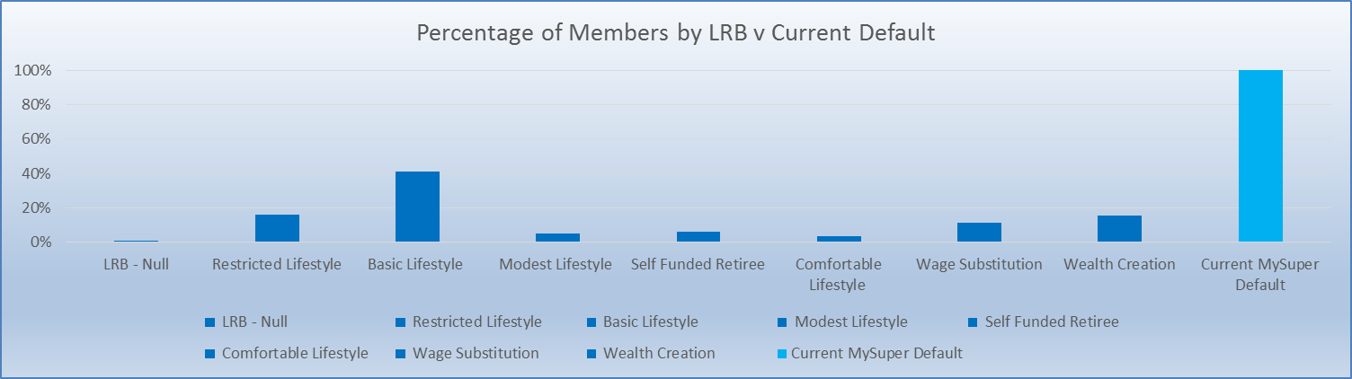
Instead of all members being in the current MySuper One Size fits all default, they are allocated each year to their Lifestyle Retirement Band. This allows the allocation of their resource (account balance) to its highest value use by the trustee investing it into an investment option aligned to known members preferences (retirement lifestyle and current age) to achieve maximised average wellbeing. We agree that “the goal of allocative efficiency can be specified as a set of objectives, including achieving optimal (subject to current policy constraints):
- size and timing of superannuation saving
- asset allocation of invested funds
- timing, rate and manner of withdrawals
- consumption of any ancillary services, including financial advice and insurance.
However, there are two distinct elements points 1 &2 belong in the accumulation phase with 3&4 in the retirement phase. We will leave others to comment on the retirement phase except noting the link that if through efficiency measures in the accumulation phase Projected Retirement Balances can be raised by 35% being by 1% real p.a. then that retirement phase becomes far easier to manage.
Therefore we agree that it “is not simply to maximise the outputs of the superannuation system, such as a retirement balance. There are various costs and trade-offs involved in making particular choices that need to be taken into account (box 5).” but it would be perilous to underestimate the importance of starting earlier to obtain a higher retirement balance.

Size and timing of superannuation saving
For MySuper members this is almost exclusively mandated contributions as a percentage of wages. Having a projection of retirement lifestyle can only assist members.
Asset allocation of invested funds
This is the key determinant for MySuper members – that can be changed by the trustee.
We strongly agree with the papers following comments which are aligned with Smart defaults:
- Assessing whether particular outcomes are allocatively efficient requires information about the preferences of users of the system (or knowledge of what outcomes would maximise their wellbeing, if preferences are sub-optimal).
- There is also significant heterogeneity of individual circumstances and preferences, and a ‘median’ user of the system will not necessarily reflect what is allocatively efficient for all or even most members.
It is not that we disagree with the following associated comments – it is simply that we know how to overcome them through the use of a Smart Default by the trustee. The paper states:

- There are many challenges.
- It is difficult to reveal members’ preferences about some of the key decisions, such as their tolerance for investment risk at different stages of the life cycle, and their demand for ancillary services, such as financial advice and insurance.
Smart Defaults, such as TTS, use data to increasingly tailor investments to MySuper members’ circumstances.

Under TTS v1.0, trustees set Lifestyle Retirement Bands (LRB) for the MySuper fund, using Projected Retirement Balances. By way of example, trustees may split the spread from zero to the highest projected retirement balance into seven LRB’s. Different funds will have a different LRB’s by number and amount.

Members whose projected Retirement Balance cannot be calculated, this year (30 June) are in LRB0 due to for example insufficient data, they remain in the 70/30 investment option.

Members in LRB1, who are likely to retire on the full Age Pension are invested in different investment options (maybe existing Choice Options) based on their age compared to those in LRB2.

Members may move between LRB, each year depending on Projected Retirement Balance which in turn maybe influenced maternity leave, promotion, voluntary contributions, etc.

Trustees also set investment glide paths for each of these LRB’s, as depicted in graph 5 below.

Importantly, trustees set the LRB’s by number and amount, and Glide Paths consistent with their Investment Strategy regulatory obligations.

Graph 5

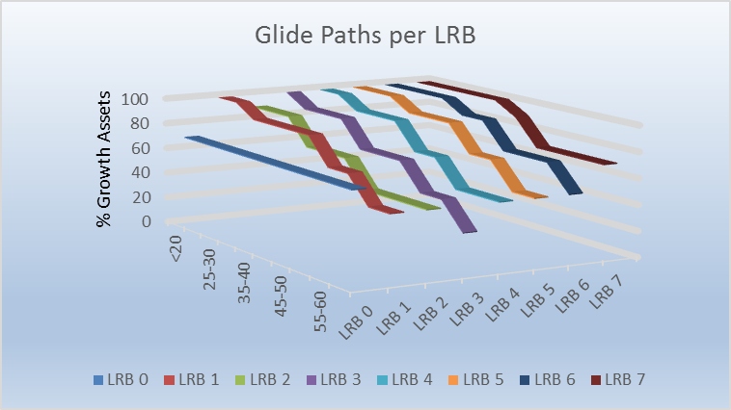

What are the advantages and disadvantages of using benchmarking to assess the allocative efficiency of the superannuation system? Which aspects of the system most lend themselves to such assessment?
Life-cycle reflective asset allocation
Refer to Graph 1, which uniquely shows how allocative efficiency can be measured over time by benchmarking Retirement Balances in a current MySuper arrangement:
- against other default options such as Age only based lifecyling
- between funds by assessing the average change in Projected Retirement Balances by Age
Refer to Graph 2, which provides details of benchmarking by projected Lifestyle Retirement Bands (i.e. individual circumstances) against other One Size fits all options.

Sequencing risk
Graph 3, provides details of benchmarking by sequencing risk by member (i.e. individual circumstances) against other (Age only) Life cycling options.

Which criteria and measures are most relevant to assessing the allocative efficiency of the system, and how should they be interpreted?
Projected Retirement Balances, by individual fund set Lifestyle Retirement Bands (LRB).
As above, interpreted by comparison, at single (30 June) point in time and also changes across multiple periods (1, 3, 5, 10 years) compared against alternative other funds and intra fund.
What are the evidence requirements and current gaps in using your proposed criteria and indicators?

Nil.
How can the magnitude and cost of principal–agent problems be assessed?
Measure the “suboptimal outcomes given the complexity of decisions, particularly during the accumulation stage” via its impact on Projected Retirement Balance.

Should the criteria and indicators for assessing the extent and magnitude of principal–agent and governance problems focus on outcomes or inputs and process, such as best practice governance principles, or a combination of both? What existing measures of governance could the Commission draw on, and what are their strengths and weaknesses?

Operationally it is more efficient to focus on outcomes as a leading indicator

What are the most important behavioural biases and cognitive constraints affecting the key superannuation saving, investment and withdrawal decisions of users? What are the best assessment criteria and indicators for examining the magnitude and effect of those biases and constraints? What are the key gaps in the evidence to enable such assessment?
This is the most important behavioural impact for MySuper members occurs via their trustee’s action or inaction. By focussing on Retirement Lifestyles through providing LRB using a members own projected retirement balances – members maybe nudged into engagement over time
What are the best assessment criteria and indicators for examining the extent to which the outcomes for users are optimal with respect to the current taxation settings?

For MySuper members, trustees may take into account societal taxation issues in setting LRB’s.

Questions on assessing dynamic efficiency
Do you agree with the proposed objectives for dynamic efficiency? If not, what should they be?
Benchmarking
What are the most reliable and relevant assessment criteria and indicators for measuring the dynamic efficiency of the superannuation system? What are the evidence requirements and current gaps in using your proposed criteria and indicators?
Barriers to dynamic efficiency
What are the key impediments to dynamic efficiency and how could they be measured?
Do you agree with the proposed objectives for dynamic efficiency? If not, what should they be?
Yes. We particularly agree that “a key force behind dynamic efficiency (particularly its operational dimension) is competition, which can drive product and service innovation, and lead to a more efficient structure and composition of the market.”
What are the most reliable and relevant assessment criteria and indicators for measuring the dynamic efficiency of the superannuation system?
Improving productive and allocative efficiency, over time, is most important. In order to achieve that short term measurements against the Retirement Objective are not useful. Projected Retirement Balances, for the accumulation phase provide the link between Operational, Allocative and Dynamic efficiency.

Measurement of the following should be weighted 80/20 to the MySuper segment in order to be efficient:
- Rate of introduction of new products and services
- Life-cycle reflective asset allocation
- Changes in system-wide asset allocations relative to broader demographic change

What are the evidence requirements and current gaps in using your proposed criteria and indicators?
Nil.
It is important that MySuper Trustee have dynamic tools that can both implement change and be improved over time. Smart Defaults such as TTS V1.0, allow trustees to vary on a regular (yearly) basis criteria (i.e. LRB and Glide paths) to take into account market changes (with a 1 year lag) such as tax, pension and regulatory changes. New versions with additional features will follow, as has occurred with tailoring in other industries (for examples refer to the history of tailoring cancer medicines).

FSI Executive Summary Page xiii
Full data set and expandable graph available via email director@trusteetailored.com

