Tasmanian Beef Production:

Genetically Modified Organism Free.

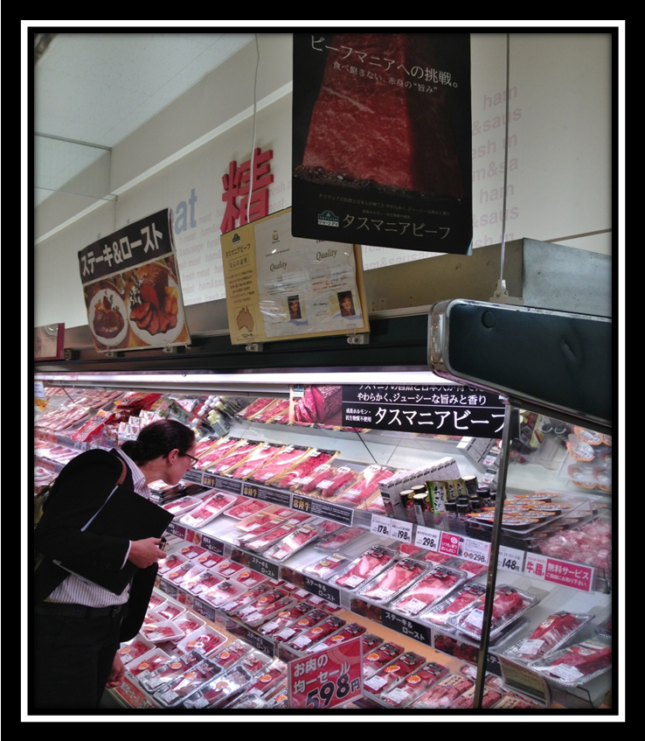

Brett Hall.

September 25th 2013.

Contents.

Summary …………………………………………………………………………………………………………………………… 3
Background history ……………………………………………………………………………………………………………. 5
World GMO Technology use ………………………………………………………………………………………………. 7
Australian GMO Technology use ………………………………………………………………………………………… 9
Reasons given for the Tasmanian beef industry to use GMO Technology …………………………. 10
Weed Chemical Resistance……………………………………………………………………………………………… 11
Pest Chemical Resistance………………………………………………………………………………………………… 13
Tasmanian Beef industry Markets and the marketing of GMO Free beef …………………………. 14

- Greenham Tasmania Pty Ltd.

- Tasmanian Feedlot.

Customer attitudes to eating GMO’s: Australia ………………………………………………………………… 20
Customer attitudes to eating GMO’s: Tasmania’s main beef Export markets …………………. 21

- Japan.

- USA.

- European Union.

- Korea.
Competitors GMO free marketing in Tasmania…………………………………………………………………..24
Conclusion………………………………………………………………………………………………………………………….26
References ………………………………………………………………………………………………………………………..27
Front cover photograph shows an AEON supermarket display in Japan of Tasmanian beef with certification of assurance from the Tasmanian Premier.
Summary.
There is a vast array of information available about Genetically Modified Organism’s (GMO’s), so much so that it is a difficult task for the “average” person to objectively assess the truth amongst all the claims and counter claims. On the one hand we have the situation where company’s fund and approve the content of published scientific studies to support GMO’s and on the other side of the spectrum we have the emotive arguments that are based on people’s feelings about the issue. Both these positions have some validity in the GMO debate, but there does seem to be a lack of truly independent scientific verification of the long term effects of GMO’s on the environment and the health of animals and people that consume them.
At present there is only one allowable GMO crop approved by the regulators that could be grown in the state; GM canola. Projections for the benefit of growing this crop in Tasmania show an estimated annual farm gate income of AUD$4 million; this would represent 0.15% of the annual AUD$2.7 billion Tasmanian food and Agriculture sector turnover (Macquarie Franklin, 2012). The amount of potential risk involved in growing this GMO crop for such a small gain does not stand the test of being an option economically, environmentally or socially. Since this estimation was completed there has been a huge increase in sales of Tasmanian GM free canola to Japan at a premium price and the projections are for this to reach 6-7 AUD$ million at the farm gate in the next 5 years (Tasmanian Agricultural Producers).
The risk involved with GMO field trials was highlighted in May 2013 when GM wheat that was not approved for release was found growing on an Oregon farm a decade after trials had been conducted on a variety of GM wheat (Reuters, 2013). Japan and South Korea immediately placed bans on importing US wheat, demonstrating the sensitivity of markets and this was just one incidence of an unauthorised GMO crop voluntarily growing on a farm, ten years after the trial.
Worldwide ordinary people are mobilising against perceived and possible dangers of GMO’s. On May 25th 2013 there was a worldwide protest against Monsanto. In 436 cities and 52 countries (CNN) over 2 million people protested. The proposed change to the “Consolidated and Further Continuing Appropriations Act” in the USA to grant Monsanto immunity from Federal court litigation in the event that one of its GMO’s causes damage to the environment or people’s health, has motivated people to unite via social media mediums to oppose all GMO food production.

The marketing of GMO free products from the state is starting to gain some momentum as producers and retailers realise that this is what the customers want. Consumers worldwide are demanding the labelling of foods containing GMO’s so that they may have an informed choice in what food they choose to eat. Ignoring the market signals from consumers is a recipe for failure. Tasmania has been very successful in the development of brands and the sentiment that brands should provide information to the consumer such as the production system, content, locality, state and country of origin has widespread support.
The Tasmanian government has taken a brave but prudent stance in legislating a ban on the commercial growing of GMO’s in the state. There is a significant risk that it would prove an impossible task to remove all the GMO material from the environment once the technology has been widely utilised. The moratorium has been in place for over a decade now and it could be argued that we have done the hard yards. To remove it now would be falling at the last hurdle, just as this point of difference for our Tasmanian product being GMO free is gaining recognition and demand amongst consumers.
We cannot make a decision to lift the GMO ban based on speculation about what may be developed in the future. It is irrational to argue that Tasmanian Agriculture will benefit from plant species that do not exist. Research & Development has delivered significant benefit to Australia’s farming industries over our history and we have a proud record of innovation. However, any new plant species needs to be acceptable to our customers who have the ultimate say. All farmers know too well that you must produce what the buyers want and there is clear resistance in Australia and our export markets to any foods that contain GMO’s. We need to acknowledge their perceptions that GMO’s are not desirable in food otherwise we will simply be producing food that nobody wants. The danger is that once we have travelled down the GMO track it will be difficult if not impossible to turn back. Surely that is too big a risk to take.

Background History.
The Commonwealth Gene Technology Act 2000 is designed to “protect the health and safety of Australians and the Australian environment by identifying risks posed by or as a result of gene technology, and by managing those risks through regulating certain dealings with genetically modified organisms” (Office of the Gene Technology Regulator). Section 21 of the Act allows State Governments to declare Genetically Modified Organism (GMO) free zones for marketing and trading purposes. Tasmania and South Australia are the only states with current GMO moratoria. These two states rely most heavily on agricultural production as a major contributor to gross state product. Both trade under ‘clean, green’ environmental credentials.
The Tasmanian state Government imposed a legislated ban on the commercial release of GMO’s for use in the state’s primary industries in 2001. The policy was reviewed in 2003 and 2007/2008 with both reviews extending the moratorium and the next review is due for completion prior to November 2014.
The Tasmanian Government’s decision to employ a GMO moratorium was largely based on maintaining the widely accepted perception amongst consumers that Tasmania’s produce is natural, safe, clean & green and that this could be used to leverage market advantage by marketing this point of difference to the world.
Another reason for the moratorium that is often overlooked is the scientific concept of “The Precautionary Principle”. This principle can be stated as: If an action or policy has a suspected risk of causing harm to the public or to the environment, in the absence of scientific consensus that the action or policy is harmful, the burden of proof that it is not harmful should fall on those taking the action. The Allen Consulting Group in its 2011 review of the Gene Technology Act 2000 made this recommendation.
“Recommendation 12: Governments in Australia maintain a science-based precautionary approach to the regulation of gene technology.”
There have been concerns expressed about possible GMO contamination of other plants in the environment including farm crops and that the process for redress of such contamination is not sufficient. The commonwealth statutory review in 2005/2006 of the Gene Technology act, 2000 rejected the need for:

- A strict liability regime for GMO contamination.
- A compensation fund to cover costs associated with losses incurred as a result of GMO contamination.
- Mandatory insurance for GMO’s.
- Third party appeal rights.
(Review of Tasmanian Gene Technology Legislation, 2007)
The Statutory Review of Tasmanian Gene Technology Legislation 2008 notes; “analysis of the Australian scheme also concludes that overall, redress in common law in the form of compensation is likely to be unavailable to most people affected by GMO contamination due to a range of practical and legal obstacles.”
Currently in Australia, the Gene Technology Regulator (the regulator) has approved the licensing of two broad acre crops containing GMO’s for commercial release. GM cotton has been grown commercially in Australia since 1996 and GM canola was released for the first time in 2008. It is interesting to note that meal from both these crops are approved by the regulator for stock feed that is suitable for ruminants and that cottonseed also may be used as a feed supplement (Office of the Gene Technology Regulator, 2008).
The importation into Australia of bulk grains containing GMO’s such as soy, maize and canola for processing and stockfeed use has occasionally been approved by the regulator. The regulator has not imposed any labelling requirements for the GMO grains that have been authorised for commercial release or import (Office of the gene Technology Regulator 2008).
In Australia, animal feed containing GM content does not require labelling as such. This differs in the European Union (EU), where all GM food and feed must be labelled above a tolerance threshold of 0.9 per cent which allows for adventitious and technically unavoidable presence. The area of ‘negative labels’ in relation to GM foods and feeds has come under the spotlight in Australia. Whilst ‘positive’ labels where GM content is present in a food are compulsory in Australia, ‘negative’ labels such as “GM-free” are not.
World GMO Technology use.
All of the commercial GM crops were initially developed to exhibit one of three basic traits; 1. Resistance to insect damage, 2. Resistance to viral infection, 3. Tolerance to a particular herbicide (WHO, 20 Questions on modified food, p.4). The most dominant characteristic chosen is herbicide resistance with 59% of all GM crops (ISAAA, 2011). In the past few years the development of multiple characteristic GM varieties is now proving a popular choice with farmers. The first biotech based drought tolerant maize is planned for commercial release in the USA by Monsanto in 2013 (ISAAA, 2012). The focus of the biotechnology research and development has been on increased production. From a consumer point of view there are no apparent direct benefits in that the products are not cheaper, do not last longer nor do they taste better; so their focus has moved to concerns about the safety of these “new” foods and what are the risks involved for the environment and for their health with long term consumption.
In 2012 there were 28 countries in the world where regulatory authorities had approved the growing of commercial GMO crops. There are 25 different types of GMO crops that are commercially available in the market place. 2012 also marked the 17th year of commercialisation of GMO crops. (Source: ISAAA Brief 44-2012.In the Gene Ethics, GM Free enews, May 2013). It is stated that 160 countries and 60 dependant Territories remain GM free and that Australian GM Canola and Cotton are grown on .09% of the Australian land mass rather than all over Australia as depicted in the ISAAA Brief 44 2012 p3.
Biotech soybean continues to be by far the largest GM crop grown with a 47% share by area of all GM crops in 2011, with maize 32%, cotton 15% and Canola 5% making up 99% of all the GM crops in 2011 (ISAAA, 2011). A significant amount of this GM soy and maize is used internationally as a feed source for livestock that are raised in the lot feeding industry. A total of 2,497 regulatory approvals involving GM crops have been approved since 1996 the largest section is for food 1,219 (49%) followed by feed use (direct or processing) 813 (33%) and 555 are for planting or release into the environment (ISAAA, 2012).
In May 2013, the USDA reported the discovery of a strain of genetically engineered wheat developed by Monsanto growing on an Oregon farm that had not been approved for sale or consumption. Monsanto had conducted 8 field trials of Roundup-Ready Spring wheat varieties between 1999 and 2001 in the state of Oregon; the GM crop was never commercially grown because of worldwide opposition to genetically engineered wheat (Reuters 2013). Japan which is the largest purchaser of US wheat has immediately suspended all imports (ABC Rural, 2013). South Korea has also suspended their tenders for US wheat and Taiwan may seek assurances that US wheat is GMO free. “USDA lists nearly 2 dozen “major incidents” of noncompliance with its rules on development of genetically modified since 1995.” (Reuters, 2013)
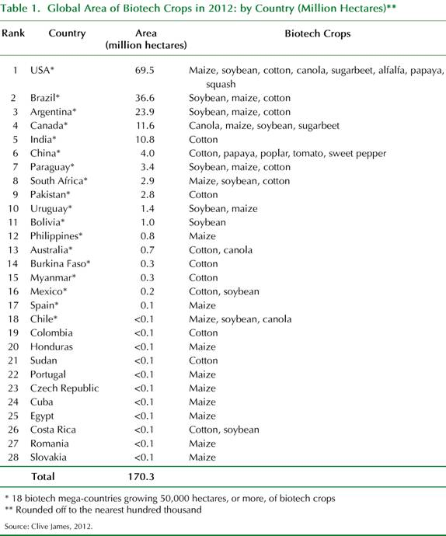

Table 1 (ISAAA, 2012) displays the global area of GM crops planted is dominated by the USA, Brazil & Argentina with a combined area of 130 Million Hectares or 77% of the total world area. Combining the areas from the next 2 largest countries, Canada and India, the area planted increases to 152.4 Million Hectares or 90% of the world’s GMO production area. Although Australia is ranked number 13 on the area planted scale, the Australian proportion is only 0.4% of the total world area.
Australian GMO Technology use.
GM cotton is the spectacular success story of GMO usage in Australia. In 2011 a record 597,000 Hectares of biotech cotton was planted in Queensland and New South Wales which represented 99.5% of all the cotton grown in Australia (ISAAA, 2011). Insect resistant GM cotton varieties have leaves that kill the major pest (Australian bollworm) when they are eaten. This has dramatically reduced the chemical use required to control pests when compared to the conventional cotton varieties (Agricultural Biotechnology Council of Australia (ABCA), 2012).
Whilst Tasmania’s climate does not allow cotton to be grown it does favour the only other regulatory approved GM option in Australia; canola. GM canola has been commercially grown in Australia since 2008 and in 2012 it represented almost 10% of the total canola crop (ABCA, 2012). All the GM canola that has been commercially grown so far in Australia is the “Roundup Ready®” Monsanto variety. Tasmania in 2009/10 produced 2,197 tonnes of canola, which was .1% of Australia’s total canola crop of 1,907,272 tonnes. Source: ABS (CAT 7121)
The Tasmanian markets for non GM canola are seed production (worth around A$900,000 annually) and oil production (worth approximately A$ 1 million annually) (Macquarie Franklin, 2012. p 17-18.). Combined, this represents 0.07% of Tasmania’s AUD $ 2.7 billion food and agriculture sector.
The only market enterprise affected by the Tasmanian moratorium, is GM Canola seed. Macquarie Franklin, in their 2012 report ‘Market Advantages of Tasmania’s GMO-free status’ estimate that the annual net loss is AUD$ 4 million. They also claim that this loss has occurred for the past decade (Key points: p.2 & p. 19) although this point may be in doubt as permission to grow GM canola commercially in Australia was only approved in 2008. Using their assumption that the GM seed planted hectares would grow to 2,000 from the current area of 200 hectares of non GMO seed production; the resulting gross margin of AUD$4 million equals 0.15% of the annual Tasmanian food and Agriculture sector turnover.
Given that currently, over 90% of the canola grown in Australia is non GM canola and the negative effect of predicted impact of increased temperatures from climate change on the canola plants’ ability to set fertile seed under these conditions, Tasmania because of its cooler climate may yet become the key supplier of the non GM seed to the rest of Australia over time.
Reasons given for the Tasmanian beef industry to use GMO Technology.
The beef industry in Tasmania is one of the main contributors to the state’s agricultural sector (161 AUD million in 2008/9. DPIPWE). It has successfully developed some of the most recognised beef brands (Cape Grim & King Island) in Australia. Tasmanian beef is recognised by consumers for its high quality, natural clean & green production system. The Tasmanian Government’s legislated prohibition of the use of Hormonal Growth Promotants and Genetically Modified Organisms in the state has been successfully utilised to compliment this consumer perception by marketing the beef as HGP & GMO free. One of the main benefits to the beef industry in regard to Tasmania’s GMO ban has been in allowing access to markets that have restrictions on GMO content food products.
The main reasons sometimes given for the Tasmanian beef industry to utilise GMO technology in the future is for increasing productivity and response to climate change. Climate change is likely to affect the main drivers of agriculture namely; temperature, solar radiation and rainfall. Estimates of the amount of change vary according to the modelling parameters but the one thing we can be sure of is that there will be more climate variability. The Climate Futures Tasmania (CFT) project has been able to downscale global climate models to provide detailed climate modelling pertaining to a specific 10 Kilometre grid. This modelling has been able to predict that, while there will be no significant change to total annual rainfall for the State, there will be greater changes to seasonal rainfall, a pattern of increased rainfall in coastal regions and reduced rainfall in some areas of the North West and the central Tasmanian region, fewer incidents of lower temperatures and increased rainfall intensity events (Grosse et al. 2010).
So what does this all mean for the Tasmanian beef industry? Based on the CFT Impacts on Agriculture Technical Report, the outlook is very positive and much better than would be expected given the negative outlook for mainland Australia. Dry land pasture production from the dominant pasture species ryegrass and other C3 grasses is predicted to increase by between 10 and 100% by the year 2085. Areas currently limited by temperature are predicted to have the greatest increase with earlier Spring growth and higher growth in Spring and early Summer. Sub clover yields are expected to increase over the century by 45 to 60% due to the benefit of higher winter temperatures. Irrigated ryegrass pastures are also projected to increase by 20-30% until around 2040 (Holz et al. 2010).
The release of a GMO grass species into the landscape would have an increased level of risk attached to it because it would be difficult for people to identify amongst other grasses and therefore monitor its spread. Once released there would be little chance of removing it from the environment. Given the positive outlook for pasture growth from climate change over the next century and the substantial increase in both the productivity of the volume of grass grown and also the amount of beef produced by utilising this forage, there would not seem to be a case for developing GMO grass species for Tasmania.
Many pasture species that are deep rooted and drought tolerant have been developed in Tasmania over the last decade and are now commercially available for adding diversity in pasture mixes that optimise production according to seasonal fluctuations. Recent research conducted by the Tasmanian Institute of Agriculture found that a limiting production factor in Tasmanian pastures was the high percentage of annuals and low productivity species currently present in pastures. (Smith et al, 2013.)
Weed Chemical Resistance.
Over 80% of the GM crops grown around the world annually are glyphosate-resistant (GR), so it is by far the most dominant genetic trait amongst GMO’s. These herbicide resistant crops are attractive economically to develop as they offer the opportunity for dual profits for the company that has ownership of the technology because they can charge a “Technology fee” in addition to the seed cost and also market the chemical upon which the trait is dependant. The GR crop technology was taken up readily by American farmers as it could replace the need for tillage as a means of weed management, and the technology was simple to implement and was flexible. In Duke and Powles’ paper presented at the AgbioForum (2009) they state “… adoption has meant continuous and intense selection pressure with glyphosate, resulting in evolution of GR weeds and shifts to weed species that are only partially controlled by glyphosate.” Overreliance on glyphosate herbicide in genetically modified glyphosate-resistant cropping systems has contributed to an outbreak of glyphosate resistant weeds. (Duke & Powles, 2009.)
The leading British science journal “Nature” has published a special issue (May 2013) on the performance of GM crops titled: “GMO’S The promise, The reality”. In this issue they remark; “Farmers had historically used multiple herbicides, which slowed the development of resistance. They also controlled weeds through ploughing and tilling.” They then added; “The GM crops allowed growers to rely almost entirely on glyphosate, … Farmers planted them year after year without rotating crop types or varying chemicals to deter resistance.” This new strategy for weed control was supported by the Monsanto Company up until 2004, who advised that with proper herbicide use, glyphosate resistance was unlikely to develop naturally in weeds. In the same year Nature released a report on a multi-year study suggesting that rotating crops and chemicals does not avert resistance. (Nature, 2013.)
This strategy has proven wrong, the red line in the diagram displayed in Figure 1 below shows the dramatic escalation in Glyphosate resistance among weeds since the glyphosate resistant GE crops were introduced in 1996. Over the same period Figure 2 displays 24 species that have been identified as resistant to Glyphosate since the commercial release of glyphosate tolerant GM crops.

Figure: 1. Rise of the herbicide resistant weeds.
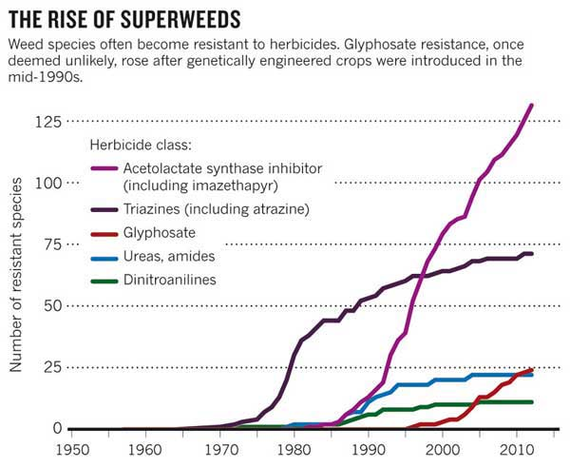
Source: Ian Heap, International survey of herbicide resistant weeds.
Glyphosate-resistant (GR) weeds have now been found in 18 countries worldwide, with significant impacts in Australia. (Nature, 2013.)
Figure: 2.
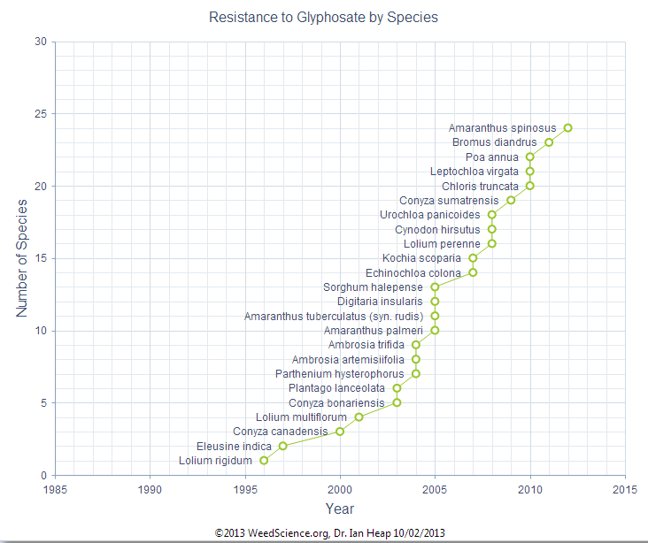
Twenty-four Glyphosate Resistant weed species have been identified since Roundup-tolerant GM crops were commercialised in 1996. (Heap, I. 2013) Note: Glyphosate resistant species may have been present prior to the introduction of GM crops but only at relatively low levels.
Pest Chemical Resistance.
Livestock producers, especially sheep farmers are familiar with treating parasites living both within and on their animals. The treatment is applied to ensure parasite numbers remain low in order to prevent weight loss in livestock and in rare cases possibly death for severe infestations. Careful management of the application and rotation of the active ingredients needs to be observed otherwise resistance to the product used will soon occur. Worm drenches across Australia have rapidly become ineffective as resistance to the ingredients occurs quickly if the worms are continuously exposed to a single type of drench. The target pests that are vulnerable to the drench are killed off and only the ones that are resistant to the drench survive, so there is a rapid selection process happening that favours the evolution of a new resistant strain of the pest.
The same situation effectively occurs with insecticide use in a crop situation. Traditionally the targeted pest was only exposed for a short period before the toxin was broken down naturally in sunlight. In the GM crops the genes from the bacterium Bacillus thuringiensis (BT) are inserted into the plant genomes so that the cells will produce insecticidal proteins. Every cell will express the BT toxin for their lifetime which constantly exposes pests to the toxin. This constant exposure speeds up the selection of the pests that are resistant.
There is no doubt that the GM BT Cotton variety reduced the amount of pesticide applied during the growing of the crop making it more profitable and causing its rapid expansion and dominance in the Australian cotton crop. However, the main pest of our cotton crop Australian boll-worm has been identified as developing resistance in the past 4 years. (Quarles. 2012)
There are questions about Genetically Engineered crops being sustainable in the longer term because farmers will rely on larger amounts of less effective pesticides. As weeds and pests become resistant the approach taken to manage for them has been to increase the amount of the pesticide applied. (Duke & Powles, 2009.) Integrated Pest Management specialist William Quarles states “Relying almost entirely on glyphosate and BT for pest management has increased pest resistance, and current GM crops may become ineffective” (Quarles, W. pp.8. 2012.)
The industry’s response to the growing problems of weed and pest resistance is to “stack” multiple traits into new GM varieties. So in the case of GR varieties they will simply add resistance to other herbicide classes. This is a short term fix and the amount of weed and pest resistance will continue to grow. This is best summed up by Mortensen et al (2012) in the paper, Navigating a Critical Juncture for Sustainable Weed Management; “First, crops with stacked herbicide resistance are likely to increase the severity of resistant weeds. Second, these crops will facilitate a significant increase in herbicide use, with potential negative consequences for environmental quality.”
Tasmanian Beef markets and the marketing of GMO free beef.
Greenham Tasmania Pty Ltd.
The company Greenham Tasmania Pty Ltd which is located in Smithton and operates one of Tasmania’s 3 main abattoirs has developed the “Cape Grim” brand of beef that supplies high value prime cuts of beef to many of the leading restaurants and hotels throughout Australia. Strong emphasis is placed on the product being GMO free as a point of difference for the marketing of the product.

Cape Grim Beef, Australia’s Finest Grass Fed Beef.
Beef produced on the green pastures of Cape Grim, Tasmania's north-western point, represents the best of its type in Australia.
That is why Cape Grim Beef has been working with close to 800 local farmers in the area since 2007. Today we produce quality hormone free and GMO free grass fed Angus and Hereford beef raised on the cleanest natural grasses and the world's purest air and rainwater.
- Hormone free
- Antibiotic free
- GMO free
- British breed beef only
- Fed on the cleanest natural grasses
- Graded to the four highest MSA tenderness grades
- Natural marbling for maximum juiciness
- 100% Grass fed beef
- Natural food for healthy minds and bodies
All our farmers grow their cattle only on natural pastures. There is some variation in management practices to meet local conditions but none of them ever use hormones, antibiotics, or feed containing unnatural, genetically modified organisms.

Greenham Tasmania Pty ltd, website product information. www.greenham.com.au
The company is also an exporter of beef internationally to countries that include Japan, South Korea and the USA. Over the past few years Greenham’s have developed a supply arrangement for Tasmanian beef to the company “US Wellness Meats” who have the personal motto on their brand label that states: “Our animals eat right, so that you can too”. The US Wellness Meats promotional video “Journey to Tasmania” is available on You Tube on the following link: http://youtu.be/eEpcBb7pSFo
Greenham Tasmania.
At 2:13 minutes in this video the voice over states: “Tasmania is home to some of the cleanest air in the world, is the ideal climate for year round grazing of cool season forages and is completely free of genetically modified foods”. This point of difference is also reinforced at 8:13 with the statement: “Greenham’s Tasmanian natural beef is 100% grass-fed beef that comes from local farmers and is free of hormones, antibiotics and GMO’s”.
The final word on Tasmania’s GMO free status regarding beef comes from Mr Peter Greenham; “Over the past few years the fact that our beef is GMO free has been one of our major selling points. The feedback we get from our overseas customers consistently says that Tasmania being GMO free is the point of difference that sets our beef apart from other competitors.”

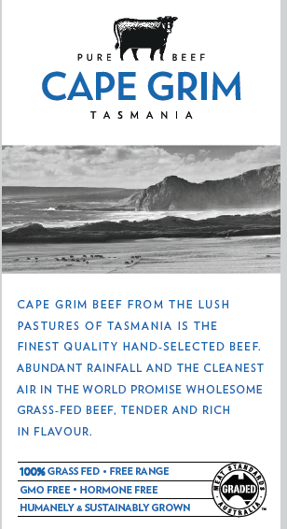 “Cape Grim” retail product label.

Tasmania Feedlot.
The Tasmania Feedlot Pty Ltd manages the largest cattle feedlot in Tasmania. The company is owned by the AEON Group based in Japan which has achieved the largest operating revenue in Japan’s Retail Industry (Yen 5,206 billion, 2011). The group has retail businesses in 12 countries throughout Asia. AEON Group’s Supermarket chain is called AEON Co which is also Japan’s largest. The annual value of the Angus cattle sold from Tasmania through the feedlot and exported to Japan is approximately AUD $45 million. (Pers comms Mr Andrew Thompson. Tasmania Feedlot Manager. Sept 2013.
The Group owns 1,537 supermarkets, and 222 shopping centres. For example “Mozo Wonder City” in Nagoya, which offers in their Food Section “Tasmanian beef from cattle raised on AEON’s directly managed farms on feed which is organically grown and not genetically modified called “Top Green Value Tasmanian Beef” (Mozo Wonder City, 2009).

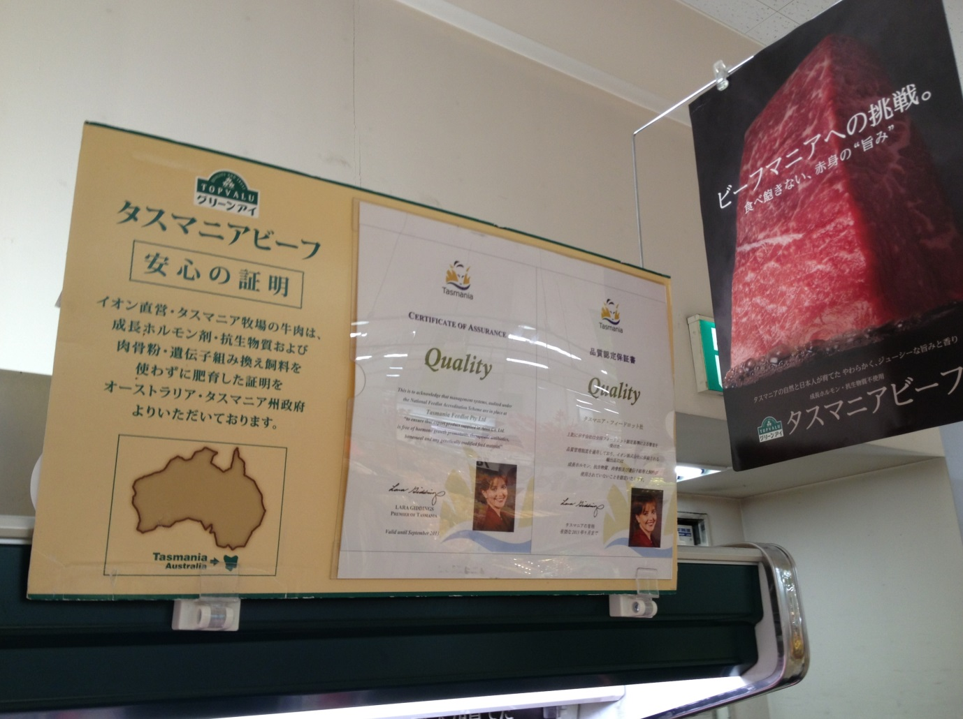

Aeon Supermarket display in Japan (2013) featuring the Tasmanian Premier’s “Certification of Assurance” for quality in both English and Japanese languages.
The Tasmania Feedlot supplies pure Angus beef to AEON Company that must be Hormone Growth Promotant (HGP) free, no antibiotics, high marbling and has not been fed any material containing Genetically Modified Organisms. The AEON Company provides an assurance program for the beef imported from the Tasmanian Feedlot via a Certificate of Assurance audited through the National Feedlot Accreditation Scheme. This certificate provides assurance that the beef is “free from hormone growth promotants, therapeutic antibiotics, bone meal and any genetically modified feed materials.” (Clemons, 2003. P.3) In addition, at each meat service counter in AEON’s Japanese stores where the Tasmanian beef is sold, there is a certificate displayed with the Tasmanian Premier’s photograph and signature endorsing that the cattle are fed in an audited system which specifically excludes the use of Hormonal Growth promotants and any genetically modified food material.

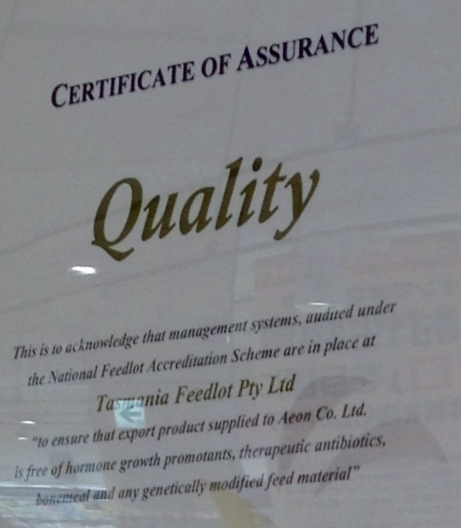
For over a decade the Tasmanian Feedlot has been exporting GMO free beef to the Japanese market. Customers are informed on the product labelling that the animals are produced without any feed that may contain Genetically Modified material.

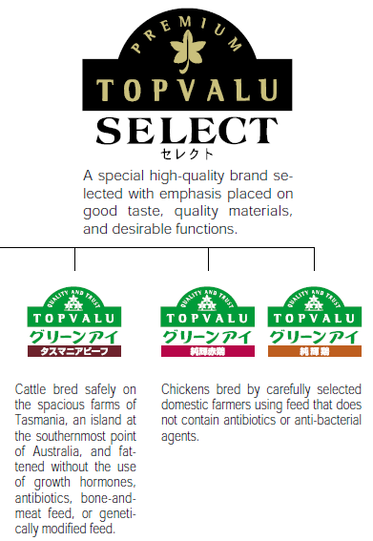

AEON Annual Report 2002. http://www.aeon.info/export/sites/renewal/common/images/en/environment/report/e_2002pdf/e_all.pdf

AEON’s website information about their speciality “Topvalu” brand of Tasmanian Beef.

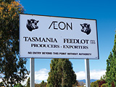

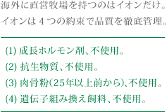

Translation: …“AEON thoroughly manage the quality promise of four”
(1) growth hormone agent, non-use.
(2) antibiotic non-use.
(3) meat and bone meal (from more than 25 years ago), non-use.
(4) genetically modified feed, non-use.
AEON Topvalue website. http://www.topvalu.net/brand/greeneye/tasmanianbeef.html

Consumer attitudes to eating GMOs: Australia.
The willingness of Australian’s to consume a number of food options containing GM has fallen since 2007. Decreases in consumer willingness to eat genetically modified fruit and vegetables (down from 5.0 to 4.6 out of 10), meat from genetically modified animals (down from 4.3 to 3.9 out of 10) and meat from cloned animals down from 3.8 to 3.5 out of 10 (DIISR 2010 p 9).
Table 2.
Consumer willingness to eat GM foods relative to willingness to eat other types of foods 2009-10
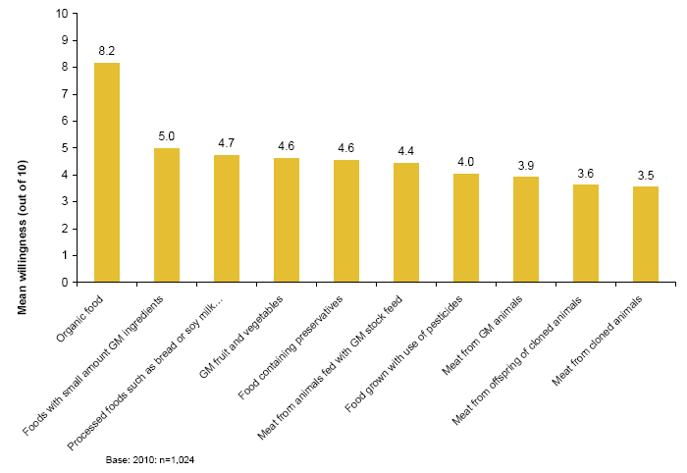
Source: Commonwealth Department of Innovation, Industry, Science & Research (DIISR) 2010.
When the Australian consumer focus moves to meat, the amount of willingness to eat Genetically Modified meat is noticeably lower. Table 4 shows that the results for meat as a GM food are all down in the lower end of the desirability scale, for example; Meat from animals fed with genetically modified stock feed 4.4, meat from genetically modified animals (mean rating 3.9), cloned animals (3.5) and from the offspring of cloned animals (3.6). Genetically modified animals and animal products face a more challenging path to market from a consumer perception perspective compared to plant-based products. There is no precedent for a GM animal product in the marketplace to use as a gauge for likely consumer reaction.
The survey results also state “Since 2007, there has been a significant decrease in the proportion of consumers who perceive genetic modification and biotechnology in food as useful” (DIISR 2010 p 4). It also concludes that “GM food continues to be one of the least well supported biotechnologies,” (DIISR 2010 p 1). Some attitudinal statements were also tested and found that the majority of participants (66%) agreed that we should use more natural ways of farming.

Consumer attitudes to eating GMO’s: Tasmania’s main Beef Export markets.
Japan.
Japan is Australia’s largest export market for beef, and also the largest Tasmanian beef export market. It was worth over A$ 75 million for Tasmania in 2009/10 (ABS. unpublished trade data). Japanese consumers lack confidence in their government’s ability to ensure food safety following the BSE crisis and various other food related problems, so supermarkets have used traceability as a marketing tool to engender consumer confidence in food products (Clemons, 2003). “In a culture where loss of reputation is often of greater concern than is litigation, supermarkets are staking their reputations on being able to provide safe food. To supply to these supermarkets, producers must stake their reputations as well.” (Clemons, 2003. P. 2) Organic and non-GM foods are a growing market in Japan. Austrade Japan’s Catherine Taylor states: “Consumers are saying no to GM and that’s an opportunity for us.” (Austrade, 2009. A Yen for Profits, P4)
The USDA Foreign Agricultural Service summarised the Japanese market in 2011 as: “It is common wisdom that Japanese consumers are uneasy about GM crops, and for over a decade, this understanding of consumer views has been reflected in government regulations, including labelling rules”.
United States of America.
The USA consumer market is often thought of as being more accepting of food containing GMO’s in comparison to other countries. On November 6th 2012 in the state of California, 46.3% of voters supported the proposed state petition on “Mandatory Labelling of Genetically Engineered Food initiative” (ISAAA, 2012 p.5). This would seem to add support to the argument that there is growing consumer resistance to unlabelled GMO products and concern with the safety of GMO foods in the US.
The change to the “Consolidated and Further Continuing Appropriations Act” in the USA to grant Monsanto immunity from Federal court litigation in the event that one its GMO’s causes damage to the environment or people’s health, has motivated people across America to unite via social media to oppose all GMO food production. On May 25th 2013 there was a worldwide protest against Monsanto. In 436 cities and 52 countries (CNN) collectively over 2 million people protested. The “March against Monsanto” was started in the US by creating a Facebook page on the 28th of February 2013. Supermarket retailer “Whole Foods Markets Inc” says there is growing demand for non GMO products with sales of a “Non- GMO” verification label spiking 15-30% (Associated Press, guardian.co.uk).
The size of the losses to producers from market access loss in cases of GMO contamination can be enormous as emphasised in this statement: “In 2006, a large part of the U.S long-grain rice crop was contaminated by an experimental strain from Bayer Crop Science, prompting import bans in Europe and Japan and sharply lowering market prices. The Company agreed in court in 2011 to pay $750 million to growers in compensation.” (Reuters 2013) The question that remains unanswered in the advent of removing the GMO moratorium in Tasmanian is who would cover the cost of compensation to the affected farmers in cases of contamination?

European Union
According to a Eurobarometer survey on Life Sciences and Biotechnology undertaken across 32 European countries in 2010, consumers are becoming less concerned about these technologies, with the exception of GM foods. Key findings include:
  - In general, support for GM food (just over 30 per cent) is declining across many of the EU Member States.
  - Between 1996-2010 there was a downward trend in the percentage of supporters for GM foods. Denmark and the UK are the most supportive countries whilst Austria is the least supportive.
  - Only 18% support the cloning of animals for food purposes.
Source: Agriculture Biotechnology Council of Australia.
In the 2010 Eurobarometer Food-Related Risks Survey (27,000 people) when people were asked “Please tell me to what extent you are worried or not about the following issues.” 66% were either “fairly worried” or “very worried” about genetically modified organisms found in food or drinks (EFSA, 2010 p.15.). It also goes on to say that “Worry on this issue has increased significantly in 10 member states since 2005, (EFSA, 2010, p 30) and the overall EU figure increasing by 4%.

South Korea.
Labelling of products that are GM is mandatory in Korea, with the public attitude generally negative towards GM products and very few GM products are sold (Macquarie Franklin, 2012. p. 61). Some large food companies have declared themselves GM-free.
According to a 2008 survey of politicians, over 50 per cent felt uneasy about eating GM food; more than 75 per cent wanted labelling laws extended to include highly refined products such as oils. (Agriculture Biotechnology Council of Australia.)

In 2011, a survey of 1000 consumers found:
  - Over 48 per cent said GM food was against nature.
  - 70.4 per cent said they would not buy GM salmon.
  - Over 30 per cent would buy Golden Rice.

  - 80 per cent supported use of biotech in medical and bio-energy sectors
Korea is active in the production of GM animals and products which is largely for the development of biomedicines and bio-organs.
(Agriculture Biotechnology Council of Australia.)
http://gain.fas.usda.gov/Recent%20GAIN%20Publications/Agricultural%20Biotechnology%20Annual_Seoul_Korea%20-%20Republic%20of_7-30-2012.pdf

Asian Government policies have been formulated in response to public concern about food safety and quality especially in regard to imports. Tasmania has been widely promoted as the potential food bowl of Asia in the next few years. There has been significant public and private investment in infrastructure to accommodate such a scenario. If we are to see this eventuate the consumer perceptions prevalent in these countries must be understood and taken into consideration when deciding what agricultural practices are to be utilised in food production so that the product is acceptable in these markets.

Competitors GMO free marketing in Tasmania.
There is no doubt that Tasmanian producers and retailers need to increase their promotion about their product being GMO free and this is a point of difference from other alternatives. Both the State Government and the stakeholders need to work together to ensure the benefit of Tasmania being GMO free is communicated effectively to the consumer. To obtain the full benefit of the moratorium we must advertise this status to consumers as it compliments Tasmania’s “clean green” image and influences the purchase decision because it provides the “why”. Already the benefits of being GMO free are being utilised by competitors in our local market. Featured below are 2 examples of products sold locally that come from New Zealand and are sold as GMO free.

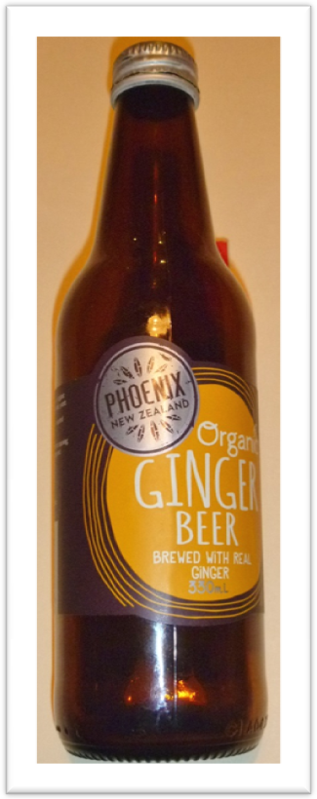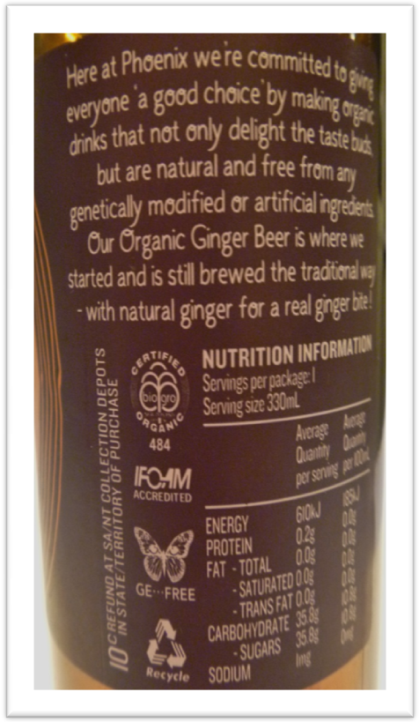
“Phoenix” Ginger Beer sold at retail outlets labelled as Genetically Engineered (GE) free and free from any Genetically Modified ingredients.
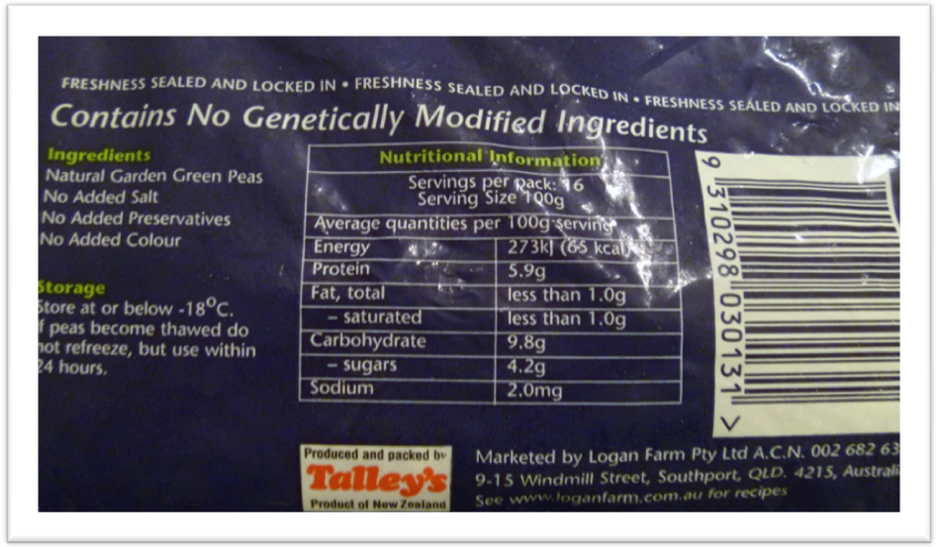This packet of peas available at supermarkets sells under the brand “Logan Farm” which is based in Queensland and was imported from New Zealand. The highlighted area shows the largest print on the rear side of the package which reads; “Contains No Genetically Modified Ingredients”.
Tasmania has one of the last vegetable processing plants in Australia located in Devonport. Amongst their products are peas sourced from Tasmania and sold under the “Birds Eye” brand and yet they are not labelled as GMO free. This is just one example of the opportunities available to communicate to consumers the GMO free advantage that we have. With manufacturers finding it difficult to compete against cheap imports, we need all the positive attributes of Tasmania’s produce included on the labelling. Moving the focus from what it is and how it’s made to why you should buy this product should increase sales. The two examples given here show the difference in the marketing approach, with the labelling explaining the reasons why the consumer should choose to buy this product. (Sinek, S. 2012) http://www.youtube.com/watch?v=l5Tw0PGcyN0
A recent (2012) survey of 145 organic consumers in southern Tasmania revealed that organic consumers were as likely to buy local produce as organic, but they thought that product labelling was insufficient to advise consumers on the original (e.g. locally produced) or content (e.g. presence of GMOs) of food sold in Tasmanian stores (Kim and Bridle unpublished data).

Conclusion.
Tasmania has built an international reputation as Australia's finest producer of high quality safe food. The fertile soils, geographical situation, temperate climate and reliable rainfall combine to make the island the ideal place to grow food of the highest quality and supply it to the rest of the world.
Concerns about food safety in an increasingly polluted world have focused attention on Tasmania's famously clean air, ample supplies of clean water and freedom from many of the outside world's pests and diseases. Because the livestock are GM-free and artificial hormones and antibiotics are not used to promote growth, it is as safe as it is delicious. The State’s meat brands are firmly established in niche markets around the world where quality is more important than price
http://brandtasmania.com/show.php?ACT=Public&menu_code=600&load_sub=1
Tasmania trades on its clean green image, and the more proactive marketers are taking advantage of this by utilising all the points of difference to gain market access and advertise to consumers the unique qualities of the State’s produce. Collectively we need to keep building on this and encourage those that take it for granted to empower themselves by using Tasmania’s attributes to market their product. We need to protect these unique points of difference such as being GMO free. Acting strategically by maintaining the GMO moratorium is a sound decision for the longer term that will provide benefits to the economy, environment and the people.

References.
AEON Annual Report 2002. http://www.aeon.info/export/sites/renewal/common/images/en/environment/report/e_2002pdf/e_all.pdf
AEON Topvalue website. http://www.topvalu.net/brand/greeneye/tasmanianbeef.html
Australian Broadcasting Commission (ABC), 2013. Lucy Barbour, ABC Rural, 31st May.
The Agricultural Biotechnology Council of Australia, 2012. GM Cotton in Australia: a resource guide.
The Agricultural Biotechnology Council of Australia, 2012. Genetically Modified Canola: a resource guide. www.abca.com.au/wp-content/uploads/2012/09/ABCA.Resource.Guide_1_v2.pdf
The Allen Consulting Group, 2011. Review of the Gene Technology Act 2000, Final Report. Report to the Department of Health and Ageing.
Austrade, 2009. A Yen For Profits – Inside Japan’s New Economy. Getting food on plates, p. 4-5. www.austrade.gov.au/ArticleDocuments/2147/A yen for Profits Part1.pdf.aspx
Clemons, R, 2003. Meat Traceability in Japan. Iowa Ag Review, vol. 9, no. 4. www.card.iastate.edu.
Commonwealth Department of Innovation, Industry, Science & Research. Public Attitudes towards Biotechnology in Australia- Results of a survey of public attitudes 2009-10.
Duke, S.O. and S.B. Powles. 2009. Glyphosate resistant crops and weeds: now and in the future. AgBioForum 12(3/4):346-357
European Food Safety Authority, 2010. Special Eurobarometer 354; Food-Related Risks.
Gene Ethics, GM- Free enews, May 2013.
Grose MR, Barnes-Keoghan I, Corney SP, White CJ, Holz GK, Bennett JB, Gaynor SM and Bindoff NL, 2010. Climate Futures for Tasmania: general climate impacts technical report, Antarctic Climate and Ecosystems Cooperative Research Centre, Hobart, Tasmania.
Heap, I. 2013. The International Survey of Herbicide Resistant Weeds.www.weedscience.org
Holz GK, Grose MR, Bennett JC, Corney SP, White CJ, Phelan D, Potter K, Kriticos D, Rawnsley R, Parsons D, Lisson S, Gaynor SM & Bindoff NL 2010, Climate Futures for Tasmania: impacts on agriculture technical report, Antarctic Climate and Ecosystems Cooperative Research Centre, Hobart, Tasmania.
International Service for the Acquisition of Agri-biotech Applications (ISAAA). ISAAA Brief 44-2012: Executive Summary, Global Status of Commercialised Biotech/GM Crops 2012.
International service for the Acquisition of Agri-biotech Applications (2011) ISAAA Brief 43-2011: Executive Summary, Global status of Commercial Biotech/GM crops 2011.dia: http://isaaa.org/resources/publications/briefs/43/executivesummary/default.asp.
Macquarie Franklin, 2012. Market Advantage of Tasmania’s GMO-Free Status; Current and Potential Future Benefits and Costs, Devonport, Tasmania.
Mortenson, D.A. Egan, J.F. Maxwell, B.D. Ryan, M.R. and Smith, R.G. 2012. Navigating a Critical Juncture for Sustainable Weed Management. BioScience Vol. 62, No. 1, pp. 75-84. University of California Press.
http://www.jstor.org/stable/10.1525/bio.2012.62.1.12
Mozo Wonder City, 2009. Mozo Wonder City to Open on Tuesday April 21.
Nature 2013. Case studies: A hard look at GM crops. Vol. 497, pp. 24-26.
Doi: 10.1038/497024a
Office of the Gene Technology Regulator. - http://www.otgr.gov.au
Office of the gene Technology Regulator, 2008. Fact sheet – GM crops and stockfeed.
Quarles, W. 2012. Brave New World- Systemic Pesticides and Genetically Engineered Crops. The IPM Practitioner. Volume XXXlll, Number3/4. Bio-Integral Resource Centre (BIRC) California.
Review of Tasmanian Gene Technology Legislation, 2007. Consultation Paper.
Reuters, 2013. Charles Abbot, Washington, May 29th. In.reuters.com/assets/print?aid=INL2NOEA1Li20130529
Sinek, S. 2012. TED. The Golden Circle. http://www.youtube.com/watch?v=l5Tw0PGcyN0
Smith, R., Corkrey, R., Webb, M., Martin, G., Field, B. and Ball, P. Opportunity beckons for livestock production through pasture improvement at a landscape scale. In 'Proceedings of the 53rd Annual Conference of the Grassland Society of Southern Australia, 25-27 July 2012, Launceston, Tasmania (2012).
Statutory Review of Tasmania’s Gene Technology Act 2001, 2008. Department of Primary Industries and Water.
World Health Organisation (WHO), 20 Questions on genetically modified foods. dia- www.who.int/foodsafety/publications/biotech/20questions/en/?utm

