DR. YVONNE McMASTER OAM
M.B.,B.S. (SYD), F.R.A.C.G.P.

Palliative Care Consultant (retired)
Advocate for palliative care
Founder of Push for Palliative

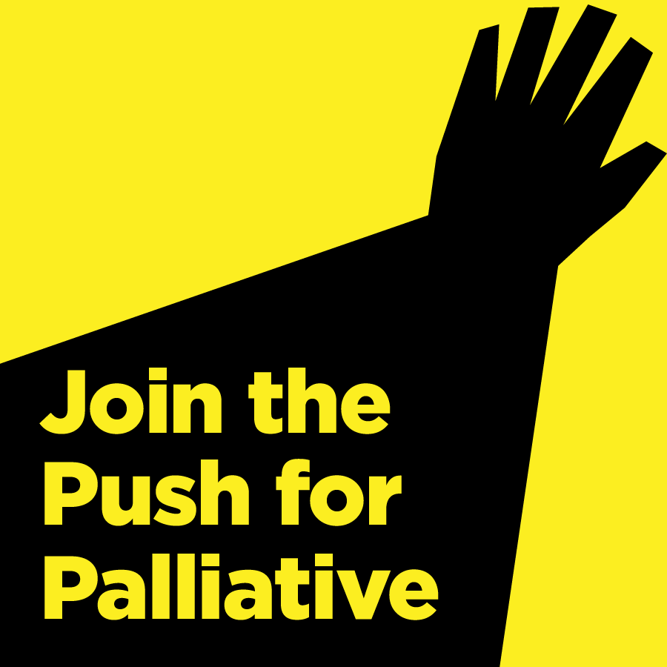

Response to the Draft Reforms to Human Services: July 2017

About Push for Palliative
Established in 2012 in response to the deepening crisis in provision of palliative care in NSW, Push for Palliative subsequently also became involved in the ACT, Queensland, South Australia and Tasmania, when there were funding cuts and workforce issues needing our palliative care advocacy.
Push for Palliative advocates for everyone to have timely access to palliative care expertise and support when and where they need it. Our hand written petition¹ to the NSW Government to that effect has raised 85,707 signatures, triggered four debates in the NSW Parliament and contributed to the recent $100M palliative care enhancement in NSW².
Across Australia, palliative care has been disregarded by governments and palliative care services have been underfunded for decades.
What we now call palliative care started in the UK in the 1960s in response to the terrible, often unrelieved pain and suffering of cancer patients. I began working full time with dying people in Sydney in 1975.
Palliative care became a medical specialty in 1998. Palliative specialists now have both the knowledge and the means to relieve most pain and other symptoms and to relieve much of the suffering that attends the end of life for both patients and their loved-ones.
Push for Palliative warmly welcomes the Productivity Commission’s Draft Report regarding End of Life Care, Chapter 3 and wishes to add the following:

General remarks about palliative and end of life care
• Palliative care is more than just the last year of life
• Palliative care and end of life care are more than just personal care and compassion.
• Palliative care and end of life care requires training and experience. It is rarely done really well by part-time palliative care providers such as GPs, community nurses, whose major body of work is in other areas. This is because there are so many different scenarios presenting in a palliative phase that only regular, frequent exposure to these scenarios and specialist training can make the clinician experienced and effective.
• Palliative care and end of life care takes time. Time to carefully assess and follow up, time to monitor and adjust and, most importantly, time to listen and absorb. Just as a counselling session typically should take 50 minutes, so should a palliative visit not take less than 50 minutes. Administrators and managers rarely understand this. We have heard of palliative providers in the private (NGO) sector being told that their visits must be restricted to 8 minutes! We have heard of one NGO, claiming to provide a comprehensive service, only providing one “nurse” visit once a week to a dying patient.
• Palliative care doesn’t have a strong constituency – the dead can’t speak, the dying are to sick or too busy getting on with what time is left to speak, once they are gone, the family are often too distressed to speak and don’t want their loved one’s bad experience spread across the newspapers and the employed professionals are forbidden to speak.
• Pathways and other gimics which are ways to by-pass access to specialist palliative care have led to disaster in many places. This is where the Liverpool Care Pathway fell over. The idea that there is a set way to “process” people is NOT person centred. The only solution is what I have spoken about above – regular visits and support from the people who have training and experience in the myriad problems which beset dying and distressed people, namely specialist palliative care.
• Turning over palliative and end of life care to services without a high level of specialist palliative expertise would be turning the clock back 50 years and will be resisted strongly by Push for Palliative.

Community Palliative Care
• The current model of community palliative care in NSW where specialist doctors, nurses and allied health are employed by LHDs or NGOs contracted to the LHDs works fairly well when the services have adequate funding and capacity and when the NGOs can resist some LHDs’ recurrent attempts to prop up their bottom line by taking funding from the NGO.
• Problems arise because the palliative care services have to report to managers in the LHDs with little or no understanding of palliative care.
• There appears to be an opinion among health bureaucrats that GPs and registered nurses with some palliative care experience are sufficient to provide palliative care in the community. This may be so for uncomplicated cases. However for complex medical and psycho-social problems, specialised nurses and physicians are indispensable to ensure quality care and allow patients to die in the place of their choosing.
• I am concerned about the possible introduction of more generalist-based community palliative care services using GPs, non-specialist nurses and assistants in nursing for personal care. This risks turning the clock back 50 years. If personal care assistants are needed they should be coordinated and integrated into the whole palliative care service. It will be vitally important not to give contracts to services which do not comprise adequate numbers of specialist physicians, nurses and allied health to meet the community’s needs.

End of life in aged care facilities
I agree with the remarks in the Draft and would like to add:
• Not all RACFs have registered nurses 24/7. This should be mandated, regardless of cost. It is a humanitarian issue to be able to receive appropriate PRN medication and skilled attention 24/7.
• One excellent approach to providing expert care in RACFs is delivered by Palliative Care Aged Care Consultancy Service in NSW³. RACFs are visited by a palliative specialist nurse at least once a week. The specialist palliative care nurse spends up to eight hours in each facility, seeing patients, meeting relatives, having discussions, making clinical recommendations, up-skilling staff in capacity and confidence, liaising with GPs and ensuring that the necessary medications are on hand. Advice is available 24/7. This service reduced transfers to hospital by two thirds in its first year of operation. It has changed the culture in all the facilities it covers.
• I am shocked to read that the 2011 Productivity Commission Report recommended many improvements in aged care and that these recommendations were ignored. SHAME!

Acute Hospitals
• Every acute hospital requires access to specialist palliative care. The ideal is in-house palliative physicians, supported by specialist nurses. Smaller hospitals can make do with specialist nurses with regular (minimum weekly, but preferably thrice weekly) visits by a palliative physician whose job is to assess patients and recommend management but also VITALLY to teach and train both senior and junior staff and to model consultations and difficult conversations. This is the ideal way to get the next generation of doctors able to deal with difficult conversations.
• Every acute hospital should have provision for a palliative care area, with space for relatives to congregate and with staff attuned to the pace of palliative care – sitting and listening unlike the intense action-oriented delivery of assessment and treatment in the main hospital.

Palliative care units and hospices
Every LHD requires some beautiful places where patients who are not suited to community care – those without at least two family carers, those for whom home is unsuitable and younger people not able to access aged care, can be cared for with compassion and expertise. These units are areas of palliative excellence and are a centre from which community palliative care services can operate 24/7 and palliative education and research can be undertaken .

References:
- Petition with 85,707 hand written signatures: https://morefundsforpalliativecare.wordpress.com/petition/
- NSW Government Announcement June 2017: https://www.nsw.gov.au/your-government/the-premier/media-releases-from-the-premier/nsw-budget-record-100m-palliative-care-funding
- Palliative Aged Care Consultancy: See page 46: https://www.caresearch.com.au/Caresearch/Portals/0/Decision-Assist-Linkages/DA_Linkage_Project_Case_Studies_040417.pdf

