Murray Darling Association (MDA)
ceo@mda.asn.au
October 2018
Submission to the Productivity Commission Murray-Darling Basin Plan: Five-year assessment - Draft Report

Executive summary
The Murray Darling Association acknowledges the comprehensive and detailed assessment by the Productivity Commission in its five-year assessment of the Murray-Darling Basin Plan.
The Murray Darling Association supports the findings and recommendations contained in the report. The findings are salient, broad ranging and are consistent with those views and opinions expressed by our regions and member councils.
The recommendations are practical, achievable and if implemented will go a significant way to ensuring the Basin Plan is delivered effectively and efficiently.
The MDA notes the significant focus in the findings on the importance of Basin governments working together, and the need for adequate community consultation.
In its initial submission to the Productivity Commission in April, the MDA expressed the view that
one of the most significant and fundamental risks to the effective implementation of the Basin Plan is the omission of local government from any formal role in the institutional and governance arrangements of the Plan.
With this view, and the need for an agreed framework and guidelines for socio-economic impact assessment in the context of the Basin Plan reinforced by resolution of the general assembly at the national conference and AGM in August this year, the MDA has proposed amendments to recommendation 14.3 and Recommendation 5.3.
The case for the proposed amendments is provided detail in the submission.
Support is also noted in relation to the following key areas in which the findings and recommendations of the Commission align strongly with the adopted positions of the MDA.
- Joint responsibility of Basin governments for implementing the Plan
- Capability and resourcing
- Integrated delivery of the package of supply measures
- Adequate community consultation to underpin the water resource plans
- Delivery capacity and constraint issues associated with changes in water use and trade
- Ensure supply projects offer value for money
- Strategy for recovering the additional 450GL
- Processes for coordinating event-based watering decisions
- Assistance to communities suffering adverse impacts from water recovery

The Murray Darling Association would like to thank the Commissioners for their inclusion of an MDA representative on the stakeholder working group, and for the presentation of their Draft Report at the Murray Darling Association 74th national conference and AGM on August 30, 2018.

- Introduction

The Murray Darling Association is a membership-based peak representative organisation representing local government and the communities we serve across the Murray-Darling Basin since 1944.
Built on strong foundations of good governance and high standards of accountability and integrity, the performance of the MDA compares favourably with our LGA peers across the sector, and with other levels of government.
We work with and for member councils engaging also with National and state based local government associations, Regional Organisations of Councils, Joint Organisations and other local government affiliations.
Operation of the MDA is parliamentary in nature, having the executive power vested in a board composed of members of the regions, individually and collectively responsible to the membership, and each of whom are democratically elected.
We are the only association of local government that covers all 4 Basin states and has a focus solely on Basin related issues. We offer a unique capacity to bring a “whole of Basin” perspective to planning matters and community engagement, while also contributing a wealth of local knowledge and solutions to Basin wide issues.
Our purpose is to provide effective representation of local government and communities at state and federal level in the development of policy and the management of Murray-Darling Basin resources.
Local government is one of three levels of government in Australia. We are the level of government most directly connected to the communities we serve.
Councils across the Basin have a valuable contribution to make in community consultation, in the continuing implementation of the Basin Plan, in the development of the carp control plan, in planning for sustainable development and renewable energy installations, and in the management of our Basin resources more broadly.
Local government as a sector has the capacity, expertise, and local knowledge required to understand, balance, plan for, and serve the various and often competing needs and interests that exist within and across our local communities.
It is in the interest of every level of government and every community in the Murray-Darling Basin for local government to participate in informing the decisions and policies of state and federal governments on issues that impact our rural and regional economies, towns and communities.

- Joint responsibility of Basin governments for implementing the Plan

The MDA agrees that implementation of the Plan is a joint responsibility of Basin governments – of which local government is an essential part.
In its initial submission to the Productivity Commission in April, the MDA expressed the view that
one of the most significant and fundamental risks to the effective implementation of the Basin Plan is the omission of local government from any formal role in the institutional and governance arrangements of the Plan.
Current reference to Basin governments makes a fundamental omission of one of the three levels of government we have in Australia.
Local government has, for too long occupied an uncertain space seen somewhere between a Basin government and a community stakeholder in the implementation of the Basin Plan.
Local government is arguably that level of government most intimately connected with the communities we serve. It has the organisational capacity and structural governance perfectly fit to engage the Basin community in the implementation process.
State and federal government, agencies and the authority have sought to engage councils as though they were a community group or external stakeholder, expecting that to do so constitutes adequate stakeholder engagement.
While stakeholder engagement has, from the outset of the Basin Plan, been undertaken with enough regularity and intensity as to create fatigue; at significant expense; and with unquestionable if varying degrees of good will and genuine intention, it is fair to say that there remains among the Basin community a deficit of trust and confidence in the implementation process.
The draft report notes that for the most part, participants to the enquiry expressed dissatisfaction with the community engagement process.
In Chapter 14 of the Draft Report the Commission has drawn on the work of the OECD and the ANAO in relation to better practice institutional and governance arrangements to identify several key principles to assess the effectiveness of the current arrangements.
While the Commission has applied these principles in considering a range of challenges as identified in the institutional and governance arrangements of the Murray Darling Basin Authority, the MDA will argue that the same principles apply equally to the omission of local government from the current institutional settings and relationships.

Box 1. Principles for effective institutional arrangements and good governance
Clear roles and responsibilities
Role clarity supports clear expectations and accountabilities among collaborating institutions, by ensuring that each understands its own role as well as the roles and responsibilities of its partner institutions
Effective processes for collaboration
Coordination among government institutions helps streamline decision making and avoids overlaps and duplication.
Capability
All institutions should have appropriate resources and capabilities to comply with legislative obligations, discharge their functions, and achieve policy objectives.
Effective engagement of stakeholders
Constructively engaging stakeholders in government decision making supports the identification of new opportunities or potential problems (and possible solutions). Done well, it is a key mechanism to manage risks, both through better program design and smoother implementation. Engagement also facilitates openness and transparency, which promotes accountability.
Meaningful stakeholder engagement enables governments to prioritise their activities to take into account stakeholder and community views; offers valuable feedback on how their activities are viewed by the community; and builds public confidence in decision making. It is characterised by:
- fair consideration of the diverse interests and expectations of all affected stakeholders
- consultation methods that are fit-for-purpose and that offer stakeholders genuine opportunities to influence decisions
- a culture of engagement, where stakeholders’ views are valued.

Meaningful engagement with stakeholders involves identifying key stakeholders that may be materially affected and those that may be interested in the outcomes of a decision or program of work. Stakeholders should be involved in the design of the processes for engagement.

Sources: ANAO (2014, 2018b); OECD (2014); PC (2016, 2017a) in Productivity Commission 2018, Murray-Darling Basin Plan: Five-year assessment, Draft report, Canberra p291

The MDA has long argued that the inclusion of local government at the institutional level in the arrangements that overarch the implementation of the Basin Plan is key to delivering effective and meaningful community engagement, informing better policy decisions, providing structured local knowledge, delivering meaningful community engagement and will be an important factor in managing the significant risks to the successful implementation of the Plan identified in the inquiry.
The inclusion of local government is also essential to ensuring effective institutional arrangements and good governance.
It is important that local government is considered here in it’s collective, or institutional capacity.
Local government, as with our state and federal counterparts, is comprised of community representatives as elected from time to time, and the organisations or bureaucracies that provide the stability, professionalism, skill and technical capacity to comply with legislative obligations, discharge their functions and achieve policy objectives.
As noted above, the role of local government in informing decisions that impact their local community in the implementation of the Basin Plan is lacking clarity, undermining the expectations of both community and collaborating institutions.
Local government is both a conduit to, and an essential nexus point for effective community consultation.
Local government is responsible for meeting the needs of communities impacted by the Basin Plan. However, councils have no clear role or responsibility in informing the decisions made or the actions taken in the implementation process, neither individually nor collectively.
The draft report acknowledges that stakeholders do not feel engaged despite key institutions having made significant efforts to engage with regional communities.
For local knowledge to inform decision making, there must be a clear role for local government in the institutional and governance arrangements, and there needs to be clear assignment of responsibilities, adequately resourced, for local government to consult with communities and provide informed advice as part of the Basin Plan implementation decision making processes..
Local government has both the capacity and the local knowledge required to understand, balance, plan for, and serve the various and often competing needs and interests that exist within and across our local communities.
Established relationships and communication channels with community provide a reliable and effective vehicle for local information sharing, engagement, and collaboration.
Local government, when included in the institutional arrangements, and provided with clear roles and responsibilities is a conduit to effective stakeholder engagement.

At the 74th annual general meeting of the Murray Darling Association held in Leeton on 30th August 2018 delegates representing councils and local government across all four Basin states voted unanimously to call for a formal role for local government in Murray-Darling Basin Plan decision making via an advisory seat at the Murray-Darling Basin Ministerial Council.

Proposed amendment #1

The Murray Darling Association respectfully submits that
- the draft report recommend that local government be identified and included in the definition on Basin Governments, and
- Draft Recommendation 14.3 and associated recommendations be amended to include local government in the institutional and governance arrangements as per the diagram below.

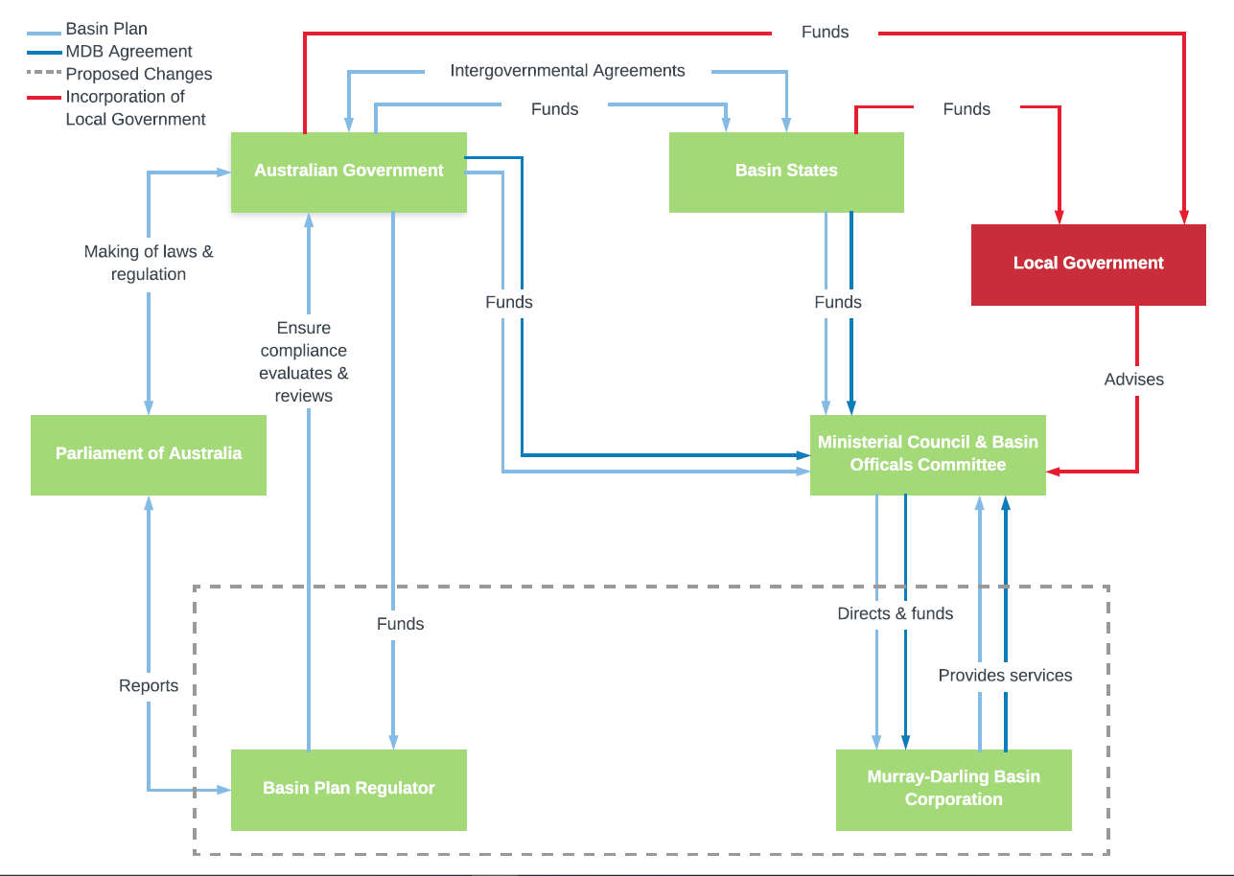

3. Strategy for recovering the additional 450 GL to include ‘no regrets’ principles.
The draft report finds that Basin governments have not yet agreed on an efficiency measures work plan to recover 450 GL by 2024 including how major socio-economic impacts will be addressed.
The report recommends that ‘no regrets’ water recovery requires that the program design and implementation should explicitly consider potential socio-economic impacts and include mitigation strategies, and that this should include close engagement with affected communities and industries.
The MDA supports this recommendation in its entirety, and proposes it is expanded to further recommend the development of an socio-economic impacts assessment (SIA) framework and guidelines.
The Murray Darling Association advocates the development of socio-economic impacts assessment (SIA) framework to be applied in the context of the Basin Plan. As noted in our original submission, the MDA has partnered with the CSIRO and the University of Canberra in our proposal and advocacy for this work to be done. Water Resource Allocation – Socio-economic Impacts Assessment and Response Framework: Project Proposal MARCH 2018.
For effective design of a no regrets water recovery strategy, agreed principles of socio-economic impact assessment in the context of the Basin Plan are essential.
In a report prepared by Aither for the New South Wales Department of Primary Industries – Water in March 2017 A review of socio-economic neutrality in the context of Murray-Darling
Basin Plan implementation, the author notes
The provision [for socio-economic neutrality as provided in the Basin Plan] is also inconsistent with Commonwealth guidelines on socioeconomic impact assessment (see, for example, Bureau of Rural Services [sic], 2005), and does not meet the overarching intent of the Basin Plan to consider the socio-economic impacts of ‘upwater’ programs. (p.1)
The absence of agreed SIA principles and guidelines in the context of the MDBAP is widely acknowledged and poses a significant risk to the effective implementation of the Plan, and to the objectives of trust and unity.
There are some Australian guidelines, but these are usually not formal. NSW has developed some guidance recently in relation to mining, as has the Bureau of Rural Sciences 2005 in relation to fisheries http://www.fisheries-esd.com.au/a/pdf/Social_Assessment_Handbook.pdf. Neither these nor the MPA guidelines are formal requirements but have acted as best practice guidance in other government applications.
There are international guidelines which are widely used, for example http://www.socialimpactassessment.com/documents/IAIA%202015%20Social%20Impact%20Assessment%20guidance%20document.pdf, and https://www.tandfonline.com/doi/pdf/10.3152/147154603781766491, which are referred to in almost every guidance document on SIA produced for any topic worldwide, including here in Australia.
State level guidance in SIA includes mostly work developed for mining. While it is not directly transferable the Basin Plan application, it is relevant.
For Queensland see https://www.statedevelopment.qld.gov.au/resources/cg/social-impact-assessment-guideline.pdf and for NSW see https://www.planning.nsw.gov.au/policy-and-legislation/under-review-and-new-policy-and-legislation/social-impact-assessment
At the 74th annual general meeting of the Murray Darling Association held in Leeton on 30th August 2018, delegates representing councils and communities across all four Basin states voted unanimously to call on Basin Governments to establish an agreed definition for socio-economic neutrality in the context for the Water Act 2007 - Basin Plan 2012, and a fair, equitable and agreed framework for assessing it.

Proposed amendment #2

The Murray Darling Association respectfully submits that Recommendation 5.2 be expanded to include the development of an SIA framework and guidelines, applicable in the context of the Murray-Darling Basin Plan.

4. Combined recommendations
The Murray Darling Association offers strong support for all recommendations contained in the draft report, particularly those noted below.
- Target any further assistance to communities where substantial adverse impacts from water recovery have been identified (3.3)
- Integrated plan for delivering package of supply measures incl extension of timeframe. (4.1 – 4.2)
- Extension of timelines for WRP accreditation to give enough time for adequate community consultation (6.1)
- Publish a work plan that describes how delivery capacity and constraint issues associated with changes in water use and trade will be investigated and managed (10.2)
- The Department of Agriculture and Water Resources (DAWR) to establish a review process to determine if supply projects offer value for money prior to funding (4.4)
- CEWH to ensure processes are in place for coordinating event-based watering decisions (11.5).
- Agree and embark on the institutional reform to establish the Murray-Darling Basin Corporation — an agent of Basin Governments, and the Basin Plan Regulator — an independent Commonwealth statutory authority (14.2)

These recommendations are singled out not with the intention of diminishing the importance of any other finding or recommendation of the draft report, but rather due to their strong alignment with the adopted position and advocacy priorities of the Murray Darling Association as resolved by the councils and communities we represent and published on the MDA website.
As the Productivity Commission draft report notes, any temptation to ignore any one of the recommended changes places the delivery of the Plan at risk.
In 2018, a formal role for local government, as a collective, in the Basin Plan decision making process and confirmed in its institutional and governance arrangements, and agreed SIA framework and guidelines can only add to the recommendations of the Productivity Commission.
It is the view of the MDA that acknowledgement of the finding, and implementation of the recommendations (as amended) are fundamental to ensuring the trust, unity, equity and growth required of Basin governments to implement this challenging but ultimately essential and regenerative Basin Plan.

October 2018

Productivity Commission 2018, Murray-Darling Basin Plan: Five-year assessment, Draft report, Canberra p291
ibid p 298

