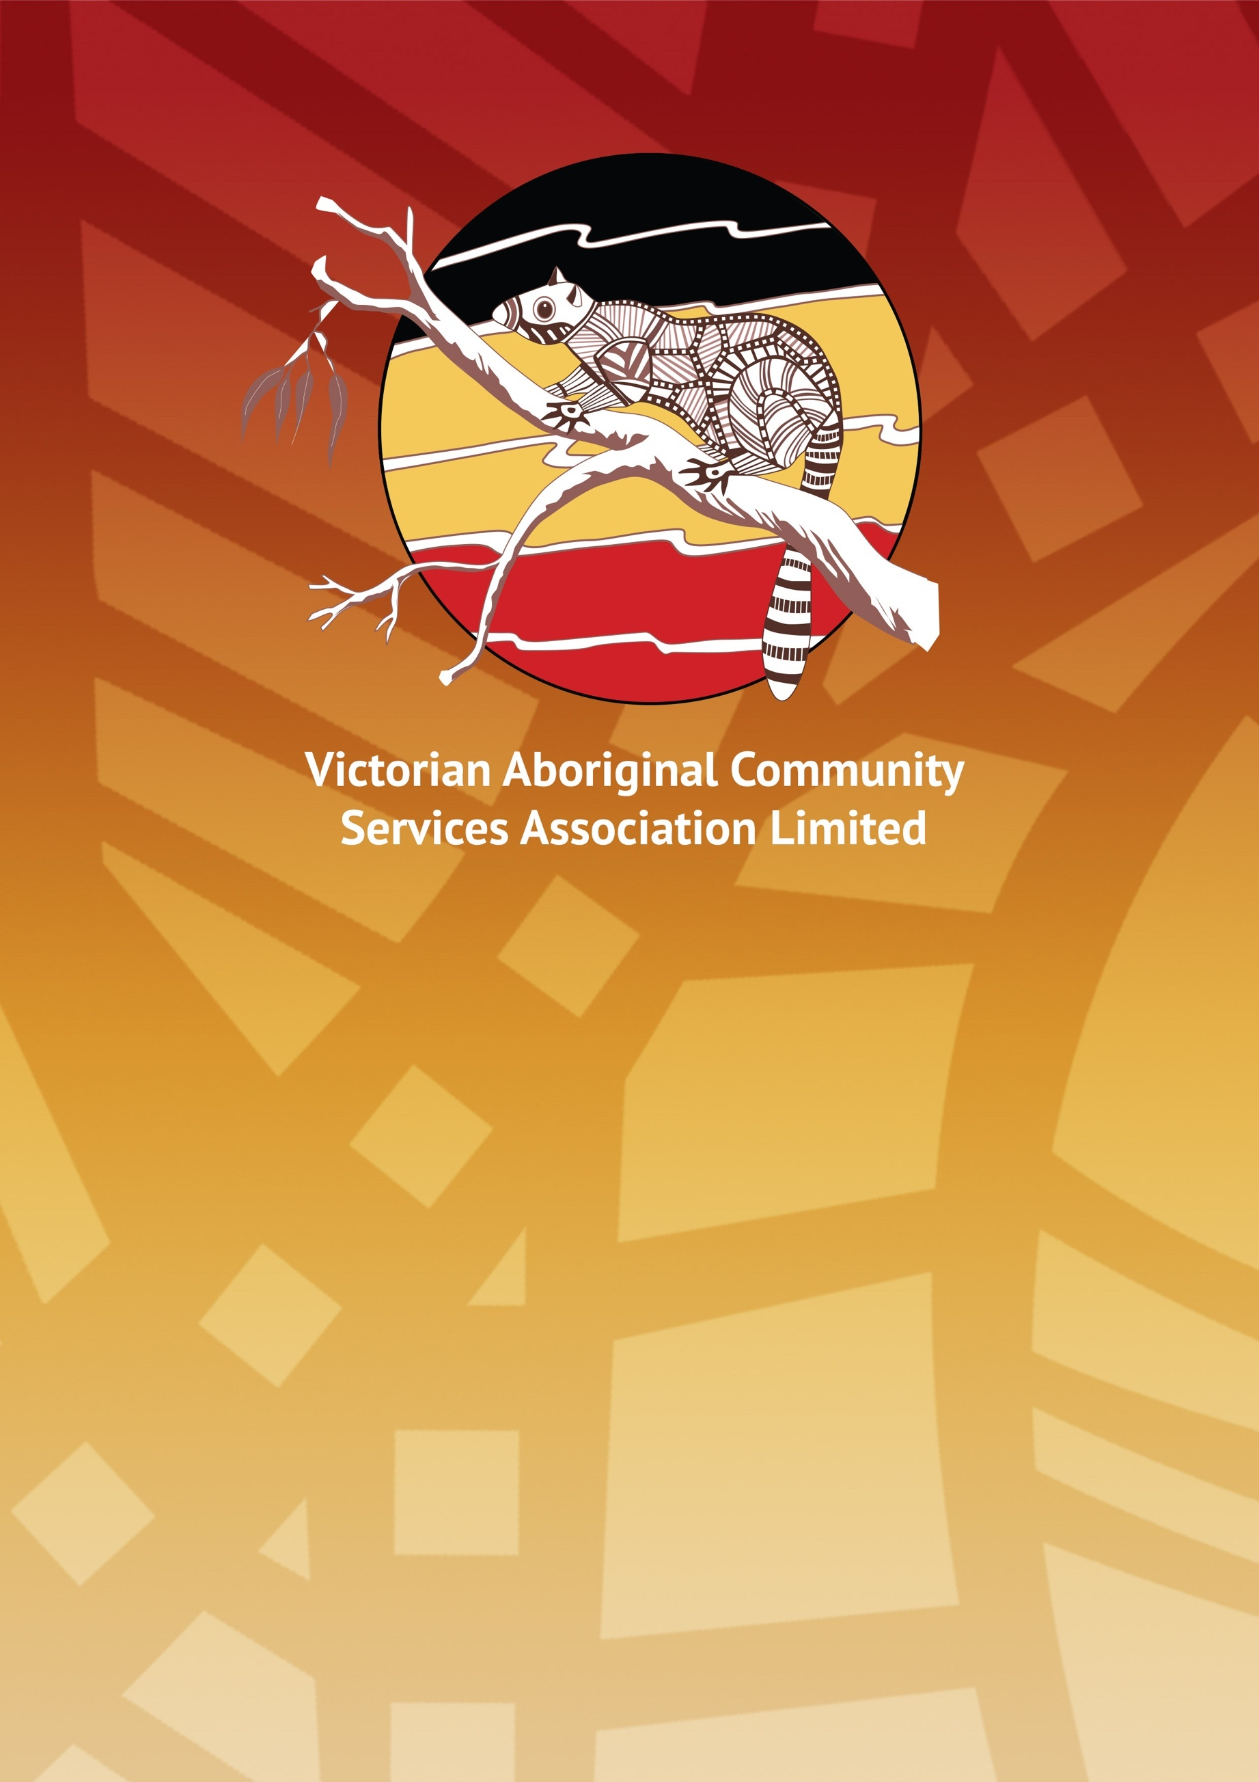

Submission to the royal commission on mental health Victoria 2019

Contents

Executive Summary and recommendations page 3

Introduction page 4

Response to issues paper pages 5, 6

Executive summary

The Victorian Aboriginal Community Service Association limited (VACSAL) supports an integrated approach from all service systems in reducing and preventing mental illness in society as a whole and welcome the Victorian State government’s commitment and investment to redirecting the mental health system in Victoria to better support Aboriginal peoples.

“A person can change if they get the support to do so. Cultural well-being starts with yourself, includes your family and then the Koorie community” Dr Mary Atkinson 2002

The prevalence of mental health within Victorian Aboriginal communities can be directly related to the loss of land, culture, identity, self-respect, self-worth and the breakdown of traditional roles within communities. Systemic racism has been a significant factor in ensuring Aboriginal communities remain fragmented and disjointed and has supported the social isolation, trauma and depression of many Aboriginal communities’ members.

VACSAL strongly support community led responses that look toward the healing of all family members acknowledging that the wellbeing of our children and families are paramount in maintaining a vibrant culture and community.

VACSAL support systematic change within the clinical structure that can improve the integration with Aboriginal community led wellbeing supports. The strength of our sense of identity self-esteem and worth influences the ability to maintain wellbeing which is attributed to connection to community.

This submission concentrates on 4 recommendations that support Aboriginal peoples beyond and on the peripheral of the mental health system, it offers recommendations at the early years of education and opportunities for community supports services and housing support to work together and contribute to improving mental wellbeing outcomes for Aboriginal people.

Recommendations

- Recommendation cultural training to all clinical and community support services that treat and support Aboriginal people with the emphasis on responding to and understanding intergenerational trauma to be funded by government

- Recommendation that racism be acknowledged as a contributing factor in the early years of a child’s life that can lead to mental illness, that government work through the MARRUNG Aboriginal Education Plan to guarantee that Aboriginal culture, language and practice is in the core curriculum to all students at a primary school level.

- Recommendation that government fund Aboriginal community organisations that provide homeless/youth/family support services to provide mental illness/wellbeing community responses to people in housing, isolation and social crisis.

- Recommendation that funding be made available to Aboriginal organisations for the establishment of partnerships with mainstream mental health providers to develop Aboriginal wellbeing healing hubs.

Introduction

The Victorian Aboriginal Community Services Association Ltd (VACSAL) is a community based organisation established in 1984 that supports a range of services and provides advice to Government on a range of policy issues impacting on Aboriginal people. VACSAL has a strong interest in mental illness and homelessness and the associated issues. We have long advocated for the need to develop innovative and community driven solutions.

It is important that the definition of mental illness recognizes and reflects the perspectives of Victoria Aboriginal communities and takes into account the social, emotional, spiritual, and cultural wellbeing of a person. It is crucial to invest resources in developing a raft of intensive interventions that will heal, support, and create further opportunity, especially for the children of most vulnerable families.

Health is holistic, self-determination is a right, kinship is central, aboriginal cultures are diverse, human rights are respected, cultural understanding is essential, aboriginal strengths are acknowledged, historical trauma and loss and the experience of racism and stigma have and continue to negatively affect Aboriginal social and emotional wellbeing.

Balit Murrup: The Aboriginal social and emotional wellbeing model is a therapeutic model that includes mental health and mental illness as elements of social and emotional wellbeing. The model is a strengths-based approach to working with mental health and wellbeing. The aim is to emphasise the importance of building strengths, resilience and connectedness in Aboriginal people and communities as pathways to positive mental health and wellbeing

Research shows that mental illness can lead to suicide, for those living with a complex mental illness, they are 13-45 times more likely to take their own life than those living without a mental illness. In order to support people with mental illness, and reduce or prevent suicide we must implement prevention strategies focused on increasing mental health literacy, reducing stigma and increasing access to care.

We support the investment in the new Orygen Youth Mental Health Care and Research Centre at Parkville and system level improvements that integrated mental health and suicide prevention planning to be available to Aboriginal people that utilise the public system. VACSAL welcomes the investment in education, training and resourcing for those in health and social support roles, to work not only with the patient but also the family in their care plan.

Victoria 10 year mental health plan aims to deliver a better service for better outcomes that respects and responds to diversity and takes into account a person’s life experiences, expectations, culture and beliefs, age, sex, gender, gender identity, sexual orientation and ethnicity, and the relationship between these factors, all influence their understanding and experience of mental health.

Many Aboriginal people experience discrimination, marginalisation and disadvantage that in turn increases their risk of maintaining a strong spiritual connection and wellbeing to manage from day to day.

Any design the Victorian Government plans to provide and promote equitable access, must ensure that Aboriginal cultural integrity is ingrained in the delivery of treatment and community supports that Aboriginal people receive.

Healing is one of the most common ways of understanding Aboriginal peoples’ experiences of recovery from trauma and other mental health and social and emotional wellbeing difficulties, including transgenerational trauma, unresolved grief and loss (Phillips & O’Brien 2009; Atkinson 2002; Caruana 2010).

- Recommendation cultural training to all clinical and community support services that treat and support Aboriginal people with the emphasis on responding to and understanding intergenerational trauma to be funded by government to Aboriginal organisations to provide,

In a Victorian study by The Lowitja Institute, 97 per cent of Aboriginal and Torres Strait Islander people surveyed experienced racism multiple times. The study showed this increased their risk of psychological distress. Subtle forms of racial discrimination such as ‘being left out or avoided’ were shown to be just as harmful to mental health as more overt forms.

The multicultural policy launched by the Victorian Government on February 19 2017. Victorian. And proud of it states that "Everyone has a responsibility to promote inclusion and participation and to reject exclusion, racism and all forms of violence. A society free of discrimination is better able to tackle problems like economic and social disengagement and improve health and wellbeing for all."

Undoubtedly if we want to realize generational improvement in health and wellbeing we need to begin in the early years of life. A student’s access to knowledge and understanding about Aboriginal histories and cultures currently depends on individual schools, principals and teachers’ enthusiasm and energy.

Learning about Aboriginal histories and cultures allows all students to develop respect for diversity and understanding of cultural differences. It provides all students with a rich and well-rounded knowledge. Furthermore, it promotes the closing of the gap between Indigenous and non-Indigenous Australians, educational achievement and employment opportunities and breaks down the ignorance between white Australia and Aboriginal Australia.

The inclusion of Aboriginal content in classroom teaching has been shown to improve educational outcomes of Aboriginal students, educated people have been found to be less likely to suffer from depression, anxiety and other disorders and conditions affecting mental/psychological.

- Recommendation that racism be acknowledged as a contributing factor in the early years of a child’s life that can lead to mental illness, that government work through the MARRUNG Aboriginal Education Plan to guarantee that Aboriginal culture, language and practice is in the core curriculum to all students at a primary school level.

Aboriginal households were less likely to own their own house outright or with a mortgage (38% in 2016 ABS) than other households (66%). Key trends are a decline in home ownership, an increase in the number of private renters, rising housing and rental costs, and ongoing decline of social housing stock in relation to population growth.

The links between housing, mental health and homelessness are shaped by the structural factors and dynamics driving the Australian housing system. When people think about housing and support, they picture support that relates specifically to housing services. However, it is clear that the supports that are critical to assisting people stay housed are those that assist them holistically manage anything that can jeopardise their ability to stay housed.

Maintaining a tenancy is about our people’s social support options, is about self-determination, and is about connection to community and their housing environment. Aboriginal organisations know their community and know how to connect Aboriginal peoples to their community. Our support staff, like many other Aboriginal organisations do visit people daily or as required, do assist people in their community of choice and are oriented supporting recovery and wellbeing of our Aboriginal people.

Aboriginal people are over represented in the homeless population. Aboriginal people make up 3 per cent of the Australian population, yet constituted 20 per cent (23,437) of all persons who were homeless on Census night in 2016 (ABS 2018).

- Recommendation that government fund Aboriginal community controlled organisations who provide homeless/youth/family support services to provide mental illness/wellbeing community responses to people in housing, isolation and social crisis.

The Balit Murrup framework highlights a number of commitments and strategies to improve Aboriginal social and emotional wellbeing. It states that collaboration occur across funding streams to target funding to innovative Aboriginal community designed social and emotional wellbeing, treatment and recovery approaches that embed traditional and contemporary healing practices.

Programs that are based on Aboriginal cultural practices that support the recovery or maintains our people’s wellbeing is necessary to be recognised as a significant element of someone’s mental health recovery.

Enabling communities to identify and address their own needs starts from the knowledge that communities have existing strengths and assets that make them part of the solution. The creation of Aboriginal wellbeing hubs, could provide a shared responsibility of practice amongst Aboriginal community support, such as homeless, recreational, group work services to mainstream providing clinical and community support all within the same building. This partnered approach could utilise existing resources to create opportunities for individuals and groups to enrich their lives through connections they might not otherwise make.

Many Aboriginal organisations have property or ownership of land resource across Victoria, such as the Victorian Aboriginal Community Service (VACSAL) 30 acre camp facilities in Torquay. These resources exist across Victoria should be considered when designing models of care for Aboriginal people living with mental health in the community who will benefit from connection to community, recovery retreats or group activities, within Aboriginal community settings that are culturally safe.

- Recommendation that funding be made available to Aboriginal organisations for the establishment of partnerships with mainstream mental health providers to develop Aboriginal wellbeing healing hubs.

