Submission in Response to National Water Reform Issues Paper

21/8/2020
Michael Smit, Kingspan
Adam Jones, BMT
Simon Fane, Institute for Sustainable Futures
Chris Philpot, Smart Approved Watermark
Reid Butler, REIDenvironmental

We welcome the opportunity to comment on the Productivity Commission National Water Reform Issues Paper (May 2020).

Information Request 2
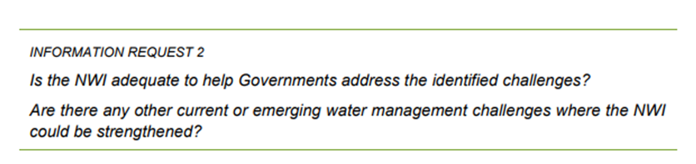
There is an emerging issue of water conservation efforts being under-represented and under-resourced throughout Australia's water industry, risking a lower levels of productivity due to inefficient water use and a growing cost base. It is recommended the NWI consider what are the best options for improving oversight of appropriate ongoing investment in water conservation initiatives across the country.

As an example, the Auditor General's Report (Water Conservation in Greater Sydney) has highlighted that governance, planning, reporting and support for water conservation is "weak" and that DPIE "should establish clear mechanisms to ensure water conservation is treated explicitly in the management of Greater Sydney's water resources"
https://www.audit.nsw.gov.au/our-work/reports/water-conservation-in-greater-sydney .

These issues are not in any way unique to the situation in NSW and the issues should be considered nationally.

Information Request 4
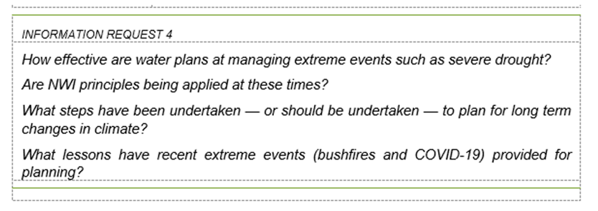
- Recent drought conditions triggered panic for many water supply utilities that realised they did not have sufficient lead-time to react to dropping water supply levels without rainfall relief. This highlights that the 'resilience' considered in existing water plans needs a firmer foundation to drive more effective proactive preparation for rainfall variability. This could be underpinned by:
  - Gaining a better understanding the economic value of water security
  - Improving our assumptions about the potential severity of 'severe' drought, and expanding our planning scope in line with this
  - Ensuring that a true assessment of all supply and demand management options for improving resilience are continuously and appropriately assessed well ahead of a reactive emergency scenario so measures and timeframes are known and can be effectively staged.
  - Having a suite of demand-side options developed before droughts strikes that can be assessed against supply augmentation - especially as these often have much shorter implementation lead-times once a suite of options is identified. This requires both an ongoing investment in understanding urban water demand in detail including particularly non-residential demand and an on-going investment in ‘foundation’ demand management programs and staffing that allows the ‘ramped up’ of programs during drought
- Investment in minimising water wastage and continuous improvement in maximising the utility of available water sources is a prudent response to long-term changes in climate, especially for communities with projected growth. This appears to be a gap across the Australian water industry, with investment in water conservation low throughout Australia.

Information Request 5
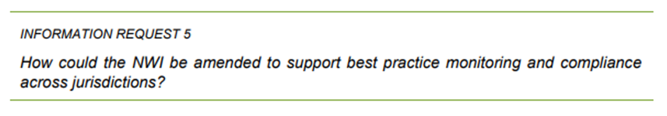
- Water conservation, water efficiency and demand management by households and industry appear to be absent from the 166 performance indicators.
http://www.bom.gov.au/water/npr/docs/Appendix_D_Urban_performance_indicators.pdf
- The NPR needs to be amended to include both dollars spent on water efficiency programs in domestic and commercial settings and megalitres saved by each water utility.
- The NPR needs to be amended to include measures to use pricing to encourage the efficient use of water in domestic and commercial settings and megalitres saved by each water utility

Information Request 12
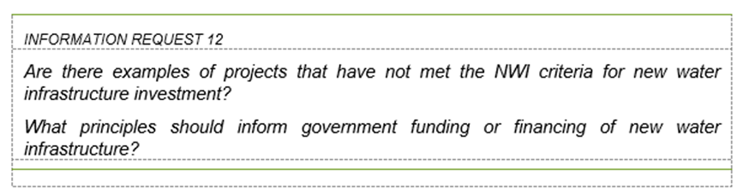
- In the interest of the public good, Government financing of new water infrastructure should require a careful options assessment to ensure that all reasonable alternative options have been considered equivalently, and all costs have been taken into account in the assessment.
  - This is necessary to avoid significant infrastructure spending being expediated by political drivers or existing financial incentives from stakeholders to favour revenue and asset-base building.
  - It is likely that improved options assessment will require a review of methods for comparing options - for example an assessment that captures advantages and disadvantages of decentralised water supply options and demand management options alongside traditional centralised water supply options.
  - This will require setting a higher standard for the inclusion of costs in the assessment of water supply infrastructure
- The Commissioners might like to consider whether the infrastructure investment decision making process for the Dangowan dam, with the stated purpose of providing urban water security for Tamworth in NSW would meet the National urban water planning principles, particularly in relation to principle 4 and 5.”
https://www.waternsw.com.au/projects/new-dams-for-nsw/dungowan-dam
https://www.agriculture.gov.au/water/urban/policy-reform-urban-water/planning-principles

