Our Ref:#6435585

25 August 2020

National Water Reform 2020
Productivity Commission
Locked Bag 2, Collins St East
Melbourne VIC 8003
Via: online portal

Dear Commission

National Water Reform – Productivity Commission Issues Paper – May 2020

Thank you for the opportunity to provide comment on the National Water Reform Issues Paper – May 2020. Thank you also for agreeing to take this submission 4 days late.

The Far North Queensland Regional Organisation of Councils (FNQROC) was established in the 1980’s and represents 13 member councils in far north Queensland. The FNQROC region is the largest and fastest growing region in Northern Australia. It extends over 320,000 square kilometres with a population of approximately 278,000 and a gross regional product (GRP) of $16.33 billion (pre COVID-19).

The thirteen councils have collectively focussed on five key areas; Transport networks, Respecting our environment, Water and Electricity equity, Social infrastructure equity and equitable communication.

FNQROC has long been advocating for water security for urban and agricultural uses. We are fully aware that water underpins economic development in our region.

We understood the need and the driving principles behind the 1994 COAG Water Reform Framework and continual refinement undertaken since.
In terms of the scope of the enquiry, this submission particularly focusses on:
- the provision of specific practical advice on ways in which the NWI could be improved to support better social, economic and environmental outcomes.
- The interaction of water policy with other policy areas such as climate, energy, agriculture, forestry, land use planning and urban development
- The provision of reliable water services to regional, rural and remote communities
- The principles to be satisfied for any government investment in major water infrastructure projects, and
- International experiences and examples.

General Comment 1 – Long term benefits of Dams
As we understand it, despite funding allocations requiring a long-term study in to the benefits of Dams funded, no such study is yet to be completed in Australia. As a result, previous reviews of the NWI have identified there is no evidence that Dams contribute to economic development of a region.

We would like the Commission to be aware of a study FNQROC is currently undertaking through Aurecon and FTI Consulting to review dams that have been in operation for extended periods of time, with a view to identifying the longer- term benefits that such critical pieces of infrastructure can bring to regions and their communities. These benefits would be in addition to those considered in the original business cases that formed part of the dam approval process.

The approach to this study has been to undertake a series of evidence-based case studies on dams operating for 30 years and over and compare them to a base case where a dam has been considered but not developed. To provide for realistic and meaningful comparisons, the sites selected for this study have the following characteristics:
- The dam had to be a public sector developed piece of infrastructure (implying a substantive minimum capacity and availability of the water)
- Water was available for commercial use under the prevailing National Water Initiative Pricing Principles (NWIPP) or its predecessors
- The primary function of the dam has been to provide water security for agricultural production
- Potable water supply is an adjunct use but not the primary use of the water
- Power generation and recreational use are adjunct uses but secondary uses

The dams and associated regions assessed as Case Studies in this report include:
- Rockhampton Region (Base Case where a dam was considered but not constructed. It is noted that the Rookwood Weir on the Fitzroy River has recently been approved for construction).
- Tinaroo Falls Dam – Atherton Tablelands and the Mareeba-Dimbulah Water Supply Scheme (MDWSS)
- Fairbairn Dam – Emerald
- Wellington Dam Western Australia
- San Luis Dam, California
This collection should demonstrate that:
- Traditional Cost Benefit Analysis (CBA) for large scale investments in water infrastructure typically takes a relatively inflexible view of the potential benefits because of the inherent information uncertainties in assessing benefits that will evolve over the life of the dam.
- When water security/soil productivity is markedly impacted by investments in water infrastructure, there are potentially transformative impacts on the types of local agriculture available in that region. These changes are dynamic, and not able to be predicted by policymakers at the time of the investment. For example, the global demand boom for avocadoes was not foreseen by policymakers in the 1950s, but the well irrigated soils of the Tablelands region combined with the region’s water security enabled local farmers to pivot to this higher yielding crop when the domestic tobacco industry declined
- Transformational changes to local agriculture can have significant upstream and downstream impacts, potentially impacting the breadth and depth of the manufacturing industry and providing critical mass for transport and services industries. In the case of the transport industry, consultation has strongly indicated that high value crops lead to high margin transport that is an important source of local employment.
- Other applications of CBAs have well established methodologies that capture a fair swath of the external benefits that may accrue from large scale investments, for example roads. Cost Benefit Analysis of dam investment is more limited in its scope.

This study has commenced and we anticipate a draft report end of September and final in October.

General Comment 2 - Challenges
The Issue Paper continually points to the challenges posed by severe drought, bushfires and the challenges of COVID-19 and how the Governments can best prepare for and manage extreme events and manage the risks from long-term changes in climate.

This focus is important however the focus only appears to be on ‘fixing’ those areas where this has occurred, it appears there is little national strategic focus on those areas which could ‘fill the gap’ if supported.

It is important to have a national water focus but the focus shouldn’t be a ‘blanket’ across Australia. The NWI should provide ways to support the emerging changing climate. As an example, there should be strategies for those areas which have had prolonged rainfall deficiencies and strategies for those areas which have ample rainfall but little storage; these areas when supported can help fill the national agriculture gaps which are emerging.

Issue Paper Questions:

Information request 9
How can small regional provider’s best balance affordability with longer-term service quality? Are there barriers to effective local planning?
Is there scope for greater collaboration between small providers? When might government support be warranted, and how should it be provided?

Understanding Far North Queensland:
In 2013, FNQROC investigated the potential collaborative mechanisms for FNQ Urban Water Services. The six local government areas reviewed in this assessment are significantly different in geographical profile and population: ranging from urban profile, to rural townships and remote communities.

Across the 6 councils within the study area there are a total of 43 water supply schemes and 20 wastewater schemes. Water supply schemes range from small water distribution schemes servicing less than 50 connections, through to supply, treatment and distribution schemes servicing up to 70,000 connections.

The geographical disparity of these water supply schemes also mean that each network has differing water source availability and consumption profiles. Similarly, the wastewater schemes range from small schemes servicing several hundred connections to larger urban schemes servicing over 20,000 connections.

The geographical constraints in servicing such varying and dispersed communities in the region limits the opportunity for economies of scale usually gained by connecting the individual schemes to form larger network grids. To put the area into perspective, you are looking at over 250,000 square kilometres.

The small size of the schemes (all except one scheme services less than 7,000 connections) provides a challenge in terms of achieving financial sustainability with the small dispersed schemes generally having higher operating costs (per property) than larger urban schemes.

The councils need to balance full cost recovery targets at scheme and whole of business level, to ensure equity of pricing (taking into account any cross-subsidisation), whilst still ensuring affordability for customers.
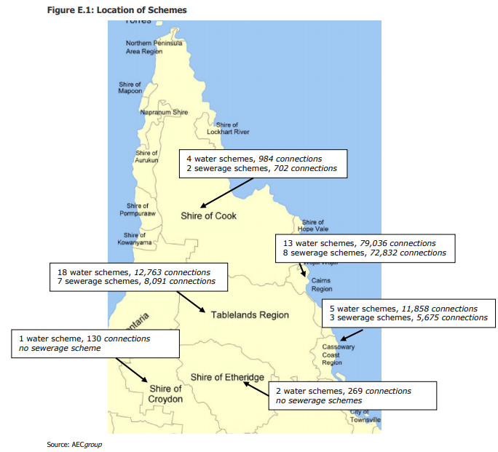

In years of past, councils used to be supported through long term funding plans with the State Government contributing 40% of the costs for upgrades and new infrastructure. This long term funding allow councils to forward plan with some confidence.

This significant loss of funding has left a long term growing up affecting forward planning. As at 14 October 2009 four councils (Cairns, Tablelands, Mareeba and Cassowary coast) had 4 year forward projects planned at a total cost $326.5mil. Councils had developed these plans with the knowledge there was 40% subsidy, when this was lost they were left to fund $131m within 4 years.

This 40% subsidy scheme was replaced with a $45mil competitive funding arrangement across the State and across all infrastructure types.

Although anecdotal, it is believed these funding cuts were as a result of the excess costs associated with the development of the SEQ water Grid.

While the council areas are disperse, these councils have worked collectively to reduce operational costs and share experiences and increase technical knowledge. These councils have worked collaboratively on the following regional arrangements:
- Purchase and delivery of Sodium Hypochloride (over 8 years running)
- Purchase and delivery of Liquid Alum (over 8 years running)
- Drinking Water Quality Management Plan Audits
- Biosolids (3 years running)
- Sewer relining (first year)
These regional arrangements are based on those areas where there is limited suppliers and or service delivery shortfalls/risk.

Information request 12
What principles should inform government funding or financing of new water infrastructure?

FNQROC has been continually frustrated by this issue – please note general comments 1. Our frustrations have been borne from:
- Previous NWI reviews have focused on negative examples related to regional development; specifically identifying there is no evidence of economic development as a result of new infrastructure.
- Lack of transparency in the benefit-cost analysis and methodology. The methodology utilised appears to be politically driven based on the State’s desire to fund infrastructure in any particular location.
- User pays based on economic life not useful life – some methodologies have used 30 years, some 50 years there is no consistency, yet the useful life of a dam exceeds 100years.

Thank you again for the opportunity to comment on the Issues Paper. Should you wish to discuss any aspect of our submission please to not hesitate to contact me on 0403 808 680.

Yours sincerely

Darlene Irvine
Executive Officer
Far North Queensland Regional Organisation of Councils

https://www.fnqroc.qld.gov.au/files/media/original/003/eee/fb9/c61/4256001%20-%201%20-%20LIVE.PDF

