Submission by the Maritime Union of Australia

Productivity Commission Inquiry into Vulnerable Supply Chains

Response to Interim Report of 26 March 2021

30 April 2021

Submitted electronically.

Paddy Crumlin, National Secretary,
Maritime Union of Australia
A Division of the Construction, Forestry, Maritime, Mining and Energy Union
365 Sussex St, Level 2,
Sydney, NSW, 2000

Website: www.mua.org.au

Contents
Contents 3
Introduction 3
Summary – the MUA response to the Productivity Commission’s Interim Report 3
Case study: Australia’s oil and petroleum supply chains and the shipping involved in importation 7
Contrary to Government and petroleum industry claims, Australia’s oil and refined petroleum imports are not well diversified 7
Ownership and market power of ships servicing the oil and refined petroleum products market 12
The import fertiliser supply chain, critical to food production, along with refined petroleum products, exhibits similar vulnerabilities 14
The control of ships and shipping for the transportation of crude oil and refined petroleum products (and other critical imports) 16
Shipping specific factors which can impact on the vulnerability of supply chains 17
The security of trade routes 17
Time to arrange ships and receive delivery 21
Cargo contract terms 24
National sovereignty and commercial advantage from owning ships 26
The seafarer labour market 28
Reducing oil/refined petroleum product and shipping supply chain risk 29
Recommendations 32

Introduction

This submission has been prepared by Maritime Union of Australia (MUA). The MUA is a Division of the 120,000-member Construction, Forestry, Maritime, Mining and Energy Union and an affiliate of the 20-million-member International Transport Workers’ Federation (ITF).

The MUA represents approximately 14,000 workers in the shipping, offshore oil and gas, stevedoring, port services and commercial diving sectors of the Australian maritime industry.

The MUA represent workers across various areas of maritime operations that contribute to Australia’s export industries and in supply chains supporting both exports and imports as well as in domestic supply chains.

Summary – the MUA response to the Productivity Commission’s Interim Report

We welcome the Interim Report and the opportunity to provide comment.

We appreciate that the Productivity Commission (PC) has sought to develop a methodology for assessing supply chain vulnerability, albeit in a short time frame. However, we are pleased that the PC has adopted a ‘data-with-experts’ approach because we submit that there is a major flaw in the data driven aspect of the PC methodology that requires more detailed consultation with industry to address the flaw.

That flaw relates to the absence of an analysis of the role of ships that are the critical pieces of infrastructure in all supply chains involving the transportation of imports and exports to and from Australia. The report only mentions ships once and shipping a couple of times. We note in Figure 3.1 on P33, providing examples of components of supply chains, that "Road, rail and air transport, communications, wholesale, retail" are mentioned, but there is no mention of shipping or ships.

We also note that on P34 the PC sets out its analytical approach that is designed to identify goods: 1. whose supply chains might be vulnerable to the risk of disruption; 2. are essential to the wellbeing of Australians; and 3. are critical to the production of an essential good or service, but it does not refer to services. Shipping is a service industry, and so may have been missed by the PCs methodology.

We responded to this same flaw in the MUAs response to the Department of Home Affairs Consultation Paper: Protecting Critical Infrastructure and Systems of National Significance of August 2020, and in our submission to the Parliamentary Joint Committee on Intelligence and Security in its Review of the Security Legislation Amendment (Critical Infrastructure) Bill 2020 and Statutory Review of the Security of Critical Infrastructure Act 2018. In that submission we noted that supply chain security cannot be assured unless all shipping, including foreign ships, are captured by the provisions of the legislation given that ships provide almost the entire freight transport task to and from Australia, and a significant part of freight transport around Australia.

This flaw is also evident in the National Freight and Supply Chain Strategy approved by the Transport and Infrastructure Ministerial Council in August 2019, and in the associated Action Plan, which do not contain a single proposal regarding the shipping component of supply chains, domestically or internationally.

We submit that no matter how diverse the sourcing and availability of a product, no matter how substitutable a product, no matter how long or short the supply chain is, if the timely availability of a suitable ship or ships (that are competitively priced) to transport the product to or from Australia is disrupted or withdrawn, then the supply of that product is also immediately disrupted.

We say that ships are the overwhelming or critical vulnerability point that underpins all other supply chain vulnerabilities. Regrettably, in our view, the Interim Report has severely underestimated this vulnerability. Indeed it has largely ignored the role of ships. It is the elephant in the room and must be given far greater attention in the Final Report.

We have undertaken a case study of the shipping aspects of the supply of oil and refined petroleum products to Australia, particularly crude oil and feedstock for refining; automotive gasoline; and diesel oil, to illustrate why ships must be regarded as the overwhelming or critical vulnerability point in Australia’s supply chains. We have chosen fuel for our case study as fuel is one of the six main imports to Australia by value identified by the PC (P4) and in Figure 4.2 on P46.

An additional reason we have chosen fuel products is that they are so critical to the functioning of the economy and the wellbeing of Australian citizens as illustrated by the data in Table 1 showing Australian petroleum consumption by industry. Table 1 reveals that all Australia’s major industries that provide food, energy, housing and transportation as well as major export income, are highly dependent on petroleum products, and that petroleum energy consumption is increasing over time, with the possible exception to that trend being manufacturing; and electricity, gas, water and waste services.

Table 1: Petroleum usage—Australian petroleum consumption, by industry—Australia – 1980-81 to 2018-19

Financial year | Agriculture, forestry and fishing | Mining | Manufacturing | Electricity, gas, water and waste services | Construction, commercial and services | Transport, postal and warehousing | Residential | Total petroleum consumption | Total energy consumption
Petajoules
1980-81 | 43.70 | 20.00 | 294.60 | 52.90 | 57.40 | 302.67 | 5.20 | 61308.01 | 3146.30
1981-82 | 47.90 | 20.20 | 266.10 | 56.70 | 57.40 | 302.67 | 5.50 | 60129.67 | 3237.60
1982-83 | 43.30 | 19.50 | 221.20 | 50.00 | 51.70 | 302.67 | 5.50 | 58945.86 | 3122.70
1983-84 | 49.60 | 19.60 | 244.20 | 48.80 | 49.20 | 244.08 | 5.80 | 57827.63 | 3221.20
1984-85 | 48.30 | 20.60 | 228.70 | 44.00 | 47.00 | 244.04 | 6.30 | 56676.77 | 3370.70
1985-86 | 47.30 | 22.20 | 217.50 | 38.30 | 51.00 | 243.57 | 6.80 | 55518.43 | 3402.50
1986-87 | 49.30 | 24.90 | 215.30 | 29.60 | 51.40 | 0.00 | 7.20 | 54364.77 | 3514.40
1987-88 | 48.10 | 25.80 | 231.00 | 24.30 | 56.40 | 0.00 | 7.50 | 53206.64 | 3623.00
1988-89 | 51.00 | 30.40 | 237.30 | 31.50 | 59.10 | 0.00 | 7.70 | 51998.30 | 3832.70
1989-90 | 48.70 | 35.20 | 232.20 | 42.00 | 59.30 | 0.00 | 8.00 | 50737.53 | 3945.90
1990-91 | 49.20 | 36.60 | 235.80 | 42.50 | 56.30 | 0.00 | 8.30 | 49452.95 | 3949.90
1991-92 | 50.10 | 38.10 | 229.60 | 30.50 | 55.70 | 0.00 | 8.50 | 48185.52 | 3982.70
1992-93 | 51.60 | 40.10 | 243.90 | 30.80 | 54.40 | 0.00 | 9.00 | 46913.29 | 4081.80
1993-94 | 53.40 | 42.30 | 248.50 | 30.70 | 53.40 | 0.00 | 9.10 | 45608.01 | 4181.90
1994-95 | 55.20 | 44.90 | 255.70 | 34.50 | 52.40 | 0.00 | 9.60 | 44267.89 | 4365.40
1995-96 | 55.40 | 52.30 | 257.70 | 34.90 | 51.10 | 0.00 | 9.90 | 42856.06 | 4505.50
1996-97 | 57.60 | 58.90 | 223.50 | 27.80 | 50.10 | 0.00 | 10.00 | 41405.86 | 4611.10
1997-98 | 59.00 | 60.50 | 235.40 | 25.00 | 49.00 | 0.00 | 10.10 | 39944.60 | 4777.60
1998-99 | 61.10 | 61.90 | 239.30 | 23.20 | 47.60 | 0.00 | 10.20 | 38477.71 | 4884.70
1999-00 | 63.20 | 63.40 | 243.70 | 21.40 | 47.10 | 332.58 | 10.40 | 36995.34 | 4971.00
2000-01 | 77.70 | 71.10 | 222.80 | 18.20 | 45.00 | 332.58 | 10.80 | 35468.30 | 5011.80
2001-02 | 78.80 | 77.00 | 220.40 | 18.50 | 46.20 | 332.58 | 11.00 | 33946.39 | 5097.00
2002-03 | 87.73 | 93.39 | 235.68 | 27.37 | 44.30 | 332.58 | 11.36 | 32407.50 | 5138.67
2003-04 | 87.90 | 98.24 | 265.26 | 34.23 | 45.83 | 332.58 | 11.17 | 30845.29 | 5284.73
2004-05 | 92.69 | 112.74 | 284.07 | 36.06 | 45.64 | 332.58 | 11.31 | 29208.89 | 5399.20
2005-06 | 87.76 | 107.70 | 283.66 | 38.81 | 47.40 | 332.58 | 13.90 | 27526.46 | 5546.74
2006-07 | 84.78 | 103.06 | 285.71 | 36.39 | 48.03 | 332.58 | 13.20 | 25813.71 | 5723.99
2007-08 | 85.75 | 109.54 | 290.40 | 50.23 | 48.87 | 0.00 | 15.00 | 24074.86 | 5738.33
2008-09 | 85.46 | 118.57 | 269.03 | 38.55 | 48.71 | 0.00 | 15.10 | 22278.31 | 5843.79
2009-10 | 87.58 | 122.89 | 265.47 | 34.64 | 48.37 | 0.00 | 14.70 | 20481.69 | 5823.32
2010-11 | 88.01 | 141.42 | 307.64 | 33.67 | 50.09 | 0.00 | 15.60 | 18651.99 | 5902.20
2011-12 | 89.26 | 176.40 | 345.06 | 36.76 | 50.55 | 16.12 | 15.30 | 16746.19 | 5887.79
2012-13 | 90.44 | 210.63 | 344.12 | 38.29 | 51.61 | 16.12 | 15.70 | 14771.71 | 5915.30
2013-14 | 89.40 | 214.93 | 331.07 | 47.51 | 52.74 | 617.29 | 15.41 | 12743.62 | 5891.44
2014-15 | 94.74 | 203.93 | 272.56 | 58.17 | 53.35 | 619.51 | 14.88 | 10691.48 | 5897.33
2015-16 | 100.45 | 204.01 | 241.52 | 53.33 | 53.32 | 967.09 | 17.56 | 8619.57 | 6040.78
2016-17 | 108.06 | 217.22 | 230.95 | 52.26 | 54.36 | 967.10 | 15.44 | 6539.76 | 6114.57
2017-18 | 108.77 | 237.12 | 218.81 | 50.08 | 55.30 | 1663.14 | 15.54 | 4390.90 | 6159.13
2018-19 | 93.95 | 252.25 | 217.58 | 49.09 | 50.36 | 1698.04 | 16.02 | 2203.73 | 6195.97
Note: Manufacturing figures do not include solvents, lubricants or bitumen which are included in the total energy consumption.
Note: Construction, commercial and services figures do not include LPG which is included in the total energy consumption.
Note: Transport postal and warehousing figures do not include lubricants and greases which are included in the total energy consumption.
Note: Total petroleum consumption figures do not include crude oil and other refinery feedstock which are included in the total energy consumption.
Note: petroleum products includes: Crude oil and other refinery feedstock, LPG, auto-gasoline leaded, auto-gasoline unleaded, aviation gasoline, aviation turbine fuel, lighting kerosene, power kerosene, heating oil, automotive diesel oil (ADO), industrial diesel fuel (IDF), Fuel oil, petroleum products nec, Solvents, Lubricants and greases.
Source: Department of Industry, Science, Energy and Resources, Australian Energy Statistics (2020c).
Source: Department of Infrastructure, Transport, Regional Development and Communications, Australian Infrastructure Statistics—Yearbook 2020, Table E 2.13,
https://www.bitre.gov.au/publications/2020/australian-infrastructure-statistics-yearbook-2020

The criticality of refined petroleum products to Australian citizens, including as the labour force for production and service delivery, and for industry and the economy as a whole is further illustrated by Figure 1 showing the major sectors’ proportional uses of refined petroleum products in Australia.

Figure 1: Use of refined petroleum products as a share of total Australian use – 2016-17
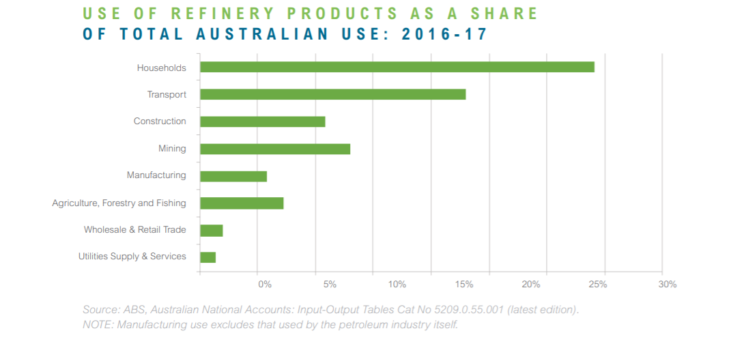
Source: Australian Institute of Petroleum, Downstream Petroleum, https://www.aip.com.au/sites/default/files/download-files/2020-04/Downstream%20Petroleum.pdf

We submit that oil and petroleum are vulnerable to supply chain disruption in three respects:
- The sourcing of crude oil that is the raw material for refined petroleum products;
- The sourcing of the refined petroleum products, that Australia will now need in greater quantities due to Australian refinery closures; and
- The shipping of these products to Australia.

These vulnerable products are a major input to production in just about all essential industries. Furthermore, they cannot be substituted except over long time scales, nor can production processes be adapted through use of an alternative to liquid fuels, at least not in the short to medium term.

We also challenge the decision of the PC not to include food on the basis that “Australia is a major and diversified producer of food” and that “while food products may have vulnerable supply chains, food as a category is much less so.” That might be so to a point, but food production is critically dependant on fuel, fertiliser and chemicals, largely imported and transported by ships.

We conclude that it would be prudent for the PC to undertake a specific stakeholder engagement on the supply, suitability and pricing of ships, and to undertake more detailed research on the ship component of supply chains prior to releasing an Interim Report on exports and prior to issuing a Final Report.

We therefore commend the PC on its intention include in the Final Report additional data analysis to identify export markets that might be vulnerable to short-term threats such as reduced demand due to natural disasters, geopolitical reasons, or transport disruptions (P14), and urge that it include a closer analysis of the vulnerability of the shipping aspect of supply chains and policies that could mitigate that vulnerability, in its Final Report.

Case study: Australia’s oil and petroleum supply chains and the shipping involved in importation

Contrary to Government and petroleum industry claims, Australia’s oil and refined petroleum imports are not well diversified

In 2019-20, Malaysia was Australia’s largest supplier of crude oil and other refinery feedstocks among Australia’s 26 crude suppliers, followed by the USA, the United Arab Emirates, Libya, Brunei Darussalam and Algeria. This is shown in Table 2. These 6 major suppliers provided 76.22 per cent of Australia’s imported crude oil and refinery feedstocks to its four Australian refineries.

Table 2: Origin of Australia’s Crude oil & other refinery feedstocks - 2019-20

Supplier nation | Volume (ML)
Malaysia | 4,609.70
United States of America | 3,738.80
United Arab Emirates | 2,005.60
Libya | 1,261.40
Brunei Darussalam | 1,210.00
Algeria | 1,042.50
New Zealand | 795.30
Nigeria | 753.00
Vietnam | 522.60
Indonesia | 476.90
Congo | 301.80
Papua New Guinea | 280.00
Azerbaijan | 259.20
Gabon | 243.30
Estonia | 223.70
Singapore | 177.70
Yemen | 136.20
Russia | 93.80
Pakistan | 61.40
Thailand | 1.40
Switzerland | 0.70
Korea, Republic of (South) | 0.30
United Kingdom | 0.20
Total | 18,195.50
Source: MUA compilation from Department of Industry, Science, Energy and Resources, Australian Petroleum Statistics 2021, PP51/52 https://www.energy.gov.au/sites/default/files/Australian%20Petroleum%20Statistics%20-%20Issue%20293%20December%202020.pdf

During that same year, 2019-20, Singapore was Australia’s largest supplier of automotive gasoline, as shown in Table 3. In the case of automotive gasoline, two nations, Singapore and South Korea, provided 76.33 per cent of Australia’s imports.

Table 3: Origin of Australia’s Automotive Gasoline - 2019-20

Supplier nation | Volume (ML)
Singapore | 1,995.80
Korea, Republic of (South) | 1,729.80
United States of America | 529.00
Netherlands | 263.30
China | 185.70
Malaysia | 155.60
Brunei Darussalam | 21.60
Indonesia | 0.20
Total | 4,881.00
Source: MUA compilation from Department of Industry, Science, Energy and Resources, Australian Petroleum Statistics 2021, PP51/52 https://www.energy.gov.au/sites/default/files/Australian%20Petroleum%20Statistics%20-%20Issue%20293%20December%202020.pdf

The majority of the crude oil supplying the Singapore refineries (60 per cent) is imported from the middle east, as shown in Figure 2.

Figure 2: Singapore crude oil imports by source - 2012

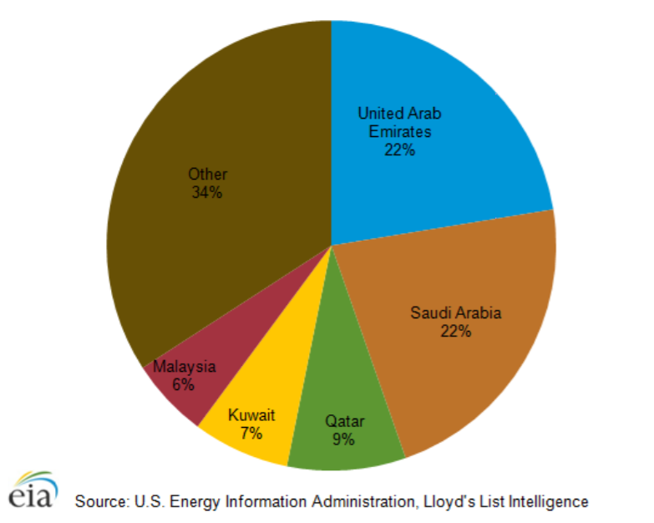

The other major supplier of automotive gasoline among Australia’s eight supplying nations is South Korea, which also imports the majority of its crude oil (64 per cent in 2019) from the middle east, with Russia being its second major supplier, notwithstanding South Korea is taking steps to diversify its crude oil imports, as shown in Figure 3.

Figure 3: Korean crude oil imports by origin – 2017 to 2019

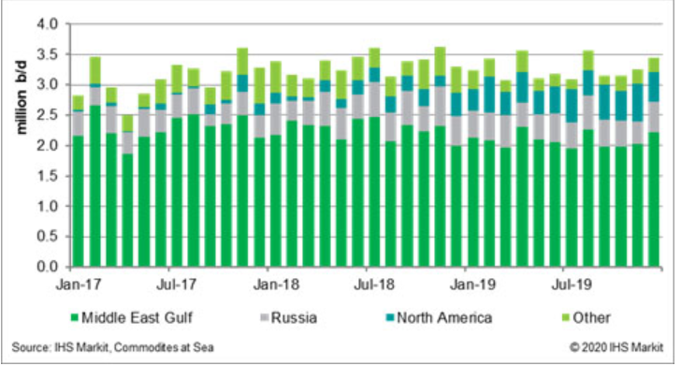
Source: HIS Markit, Crude Oil Trade: South Korea importing more US barrels, mitigating potential disruption through the Strait of Hormuz, 16 January 2020

Together, Singapore and South Korea provided 76.33 per cent of Australia’s imported automotive gasoline, the large bulk of which was produced from middle east oil.

Singapore was also Australia’s largest supplier of diesel oil in 2019-20, followed by China, South Korea, Malaysia, Brunei Darussalam and Indonesia. These top six nations supplied 96.2 per cent of Australia’s imported diesel oil, with the top three suppliers providing 69.98 per cent. It should be noted that China’s five major crude petroleum suppliers are Saudi Arabia, Russia, Iraq, Angola and Brazil which provide over half (59.3%) of overall Chinese crude oil imports in 2019.

Table 4: Origin of Australia’s diesel oil - 2019-20

Supplier nation | Volume (ML)
Singapore | 5,162.30
China | 3,202.60
Korea, Republic of (South) | 2,339.70
Malaysia | 1,742.30
Brunei Darussalam | 1,136.90
Indonesia | 1,132.30
United Arab Emirates | 456.90
United States of America | 83.20
Thailand | 27.00
New Zealand | 11.50
Netherlands | 1.00
Total | 15,295.70
Source: MUA compilation from Department of Industry, Science, Energy and Resources, Australian Petroleum Statistics 2021, PP51/52 https://www.energy.gov.au/sites/default/files/Australian%20Petroleum%20Statistics%20-%20Issue%20293%20December%202020.pdf

A useful overview of Australia’s supply chain vulnerability can be found in a Conversation article of May 2018 entitled Australia imports almost all of its oil, and there are pitfalls all over the globe. It asserted that “Australia’s fuel security is far more precarious than we might realise.” A useful overview of the Australian Government’s response to the fuel security crises can be found in a Parliamentary Library overview entitled Australian oil refineries and fuel security of December 2020.

We note that the PC Interim Report found that Australia imported 5,950 different product aggregates in 2016-17 from 223 countries, although, the majority by value were from the five largest suppliers — China, the United States, Japan, Thailand and Germany. In assessing the vulnerability of supply chain sourcing it is important to disaggregate the nations of origin because while the top 5 by value including nations such as the USA and Germany may superficially appear to be secure supply sources, a closer examination of critical products such as fuels and fertilisers shows that the main sources of supply are from nations with varying approaches to the international rules based system, nations which are distant and are subject to considerable supply volatility and insecurity.

We submit that Australia’s high dependency on Singapore, South Korea and China for the majority of its refined petroleum product supplies, which will increase once the BP Kwinana and the ExxonMobil Altona refineries cease operations, given the concomitant high dependence by the refineries in those nations on middle east and Russian crude oil, shows that Australia’s fuel supplies are not as secure as Australians have been led to believe by industry lobbyists and government.

We say these supplies are in fact highly concentrated and that alternative sources of supply do not exist in practice and therefore could not be readily utilised should the need arise.

These issues are highlighted in a 2019 ABC report entitled Australia's fuel supplies vulnerable if Middle East conflict cuts supply, where Retired Air Vice Marshal John Blackburn, who has undertaken extensive studies on Australia’s fuel security, was quoted as saying that "We are just basically at the mercy of the market. And you've got to remember, most of the oil companies we deal with are foreign owned." The article included data from the Department of Environment and Energy showing the high concentration of middle east oil for Asian refineries – see Table 5.

Table 5: Proportion of middle east crude oil used by Asian refineries

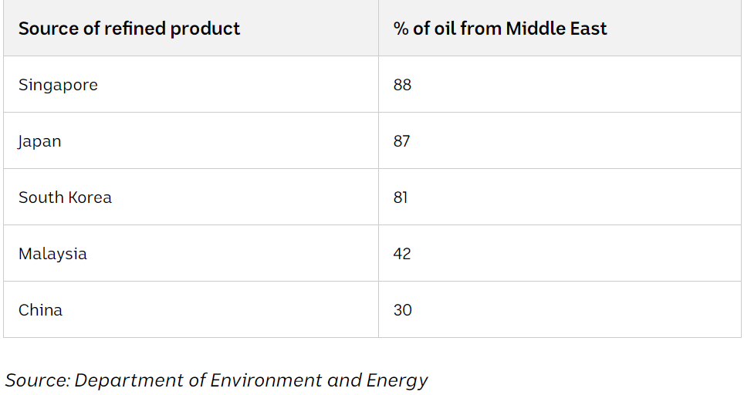
Source: ABC, Australia's fuel supplies vulnerable if Middle East conflict cuts supply, 19 September 2019

We therefore agree with Finding 4.6 in the PCs Interim Report that “vulnerable imports that are inputs into the goods-producing industries of petrol refining and medicine manufacturing are more likely to be critical”, and that further analysis be undertaking in the Final Report on the vulnerability of Australia’s fuel supply, including the shipping elements which we address in the next section.

Ownership and market power of ships servicing the oil and refined petroleum products market

The data in Table 6 shows that the top global 10 crude oil and petroleum tanker owners, which effectively control the shipping of the world’s oil and refined petroleum products, are dominated by just a few nations, including China, Japan, Iran, Saudi Arabia, Canada, Greece, Russia and Belgium.

Included among those nations are several with whom Australia is in conflict regarding trade and other diplomatic issues. Ownership of those fleets provides those nations with the power to disrupt the global crude oil transportation market and hence the global refined petroleum product market.

Table 6: Top 10 crude oil and petroleum product tankers ship owners by tonnage and ships owned

Company | Nation | Dead weight tonnage | No of ships
COSCO Shipping Energy  Transportation (CSET) | China | 18.7 mill dwt  Plus 4.6 mill dwt newbuildings | 122 vessels, including 116 owned,  including subsidiaries, plus six chartered in -  five VLCCs and one Panamax.  In addition, CSET has a substantial  orderbook, including 10 VLCCs, three  Suezmaxes, five Aframaxes and six  Panamaxes, as of 31st December 2017.  At the end of 2017, CSET controlled  44 VLCCs, three Suezmaxes, 12 Aframaxes,  26 Panamaxes and 37 MR/Handysize size  products and crude carriers but is also a large charterer of tonnage.
Mitsui- OSK (MOL) | Japan | 15.9 mill dwt | 63 ships of which 41 are crude oil tankers
National Iranian Tanker Company (NITC), a subsidiary of the National Iranian Oil Company | Iran | 13.9 mill | 78 oil tankers are flagged to Iran, which includes at least 37 VLCCs, nine  Suezmaxes, five Aframaxes and three  Handysize tankers
China Merchants Energy Shipping (CMES)  China VLCC (CVLCC), jointly established  in September 2014, is the VLCC subsidiary  of CMES | China | 13.4 mill dwt, plus 3.8 mill dwt newbuildings | 41 VLCCs with  an additional 12 newbuildings on order at end 2017
Bahri, the National Shipping Corporation of  Saudi Arabia | Saudi Arabia | 12.9 mill dwt, plus 1.5 mill dwt  newbuildings | 41 VLCCs and 36 product/chemical carriers, with another five VLCCs under construction in 2017, mostly due for delivery in 2018
Teekay Group | Canada | 12.8 mill dwt, plus 680,000 dwt  newbuildings | One VLCC, 34 Suezmaxes, 19 Aframaxes, nine LR2s, one MR, 33 shuttle tankers (including five newbuildings) plus two chartered in shuttle tankers
Maran  Tankers  Management  (MTM) | Greece | 12.2 mill dwt,  plus 2.9 mill dwt  newbuildings | Manages 28 VLCCs plus 19 Suezmaxes and Aframaxes, and 12 new builds on order for delivery in 2021 to 2023
Sovcomfot (SCF) | Russia | 12.2 mill dwt, plus 700,000 dwt newbuildings | 22 x 47,000 dwt product  tankers, four Handysize, five 50,000 dwt  MRs doubling as chemical tankers, nine  LR1s, nine LR2s, 42 Aframaxes (with  another six LNG dual-fuelled newbuildings  still to be delivered), 15 Suezmaxes and two  VLCCs.
Euronav  Note: Since its 2018 merger with Gener8 Maritime it may now be the leading independent large crude tanker operator in the world | Belgium | 11.9 mill dwt, plus 626,000 dwt newbuildings | 47 VLCCs, 28 Suezmax’s,
Source: Seaconnect, TankerOperator’s: Top 30 Owners and Operators, 2017, https://www.sea-connect.com/uploads/pdf/f1e2680d9cf34f844bd9318f494d3fbd.pdf. Where data is not drawn from this report, it is specifically footnoted.

Data compiled by the Bureau of Infrastructure, Transport and Regional Economics shows that in 2016-17 (the latest available data) tankers from overseas made 1,110 port calls at Australian ports, involving some 508 tankers, being on average 3 tankers every 2 days. Time has not permitted an analysis of which of those 500 plus tankers are controlled by a company from which nation, but that data is required to fully understand the vulnerability of ships providing Australia’s fuel security, and should be obtained by the PC.

The import fertiliser supply chain, critical to food production, along with refined petroleum products, exhibits similar vulnerabilities

Fertiliser is an essential input to food production. Table 7 shows that Australia imports the majority of its nitrogenous and potassium fertiliser, and a significant volume of its phosphate fertiliser.

Table 7: Australian fertiliser consumption sourced from imports in 2007

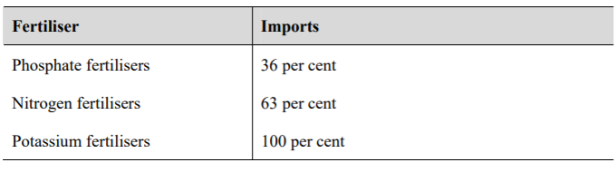
Note: Data calculated on basis of sales statistics of major fertiliser products compiled by the Fertiliser Industry Federation of Australia.
Source: ACCC, Examination of fertiliser prices 31 July 2008, https://www.accc.gov.au/system/files/ACCC%20examination%20of%20fertiliser%20prices.pdf

According to an ACCC report examining fertiliser prices of 2008:
- Phosphate fertilisers include single superphosphate (SSP) di-ammonium phosphate (DAP), mono-ammonium phosphate (MAP) and triple superphosphate. There are few deposits of phosphate rock around the world and Australian demand is largely met from mines at Phosphate Hill (Queensland), Christmas Island and Morocco. Phosphate rock from Phosphate Hill is suitable only for the manufacture of MAP and DAP, and not SSP. Consequently, all phosphate rock used for SSP in Australia is imported.
- Common forms of nitrogen-based fertilisers include urea, anhydrous ammonia, ammonium sulphate and ammonium nitrate. Urea is the most common nitrogen fertiliser used in Australia. It is the most concentrated form of solid nitrogen fertiliser and is manufactured by combining ammonia and carbon dioxide under pressure. Ammonia is the key input for all major nitrogen fertilisers. Only about a third of Australia’s nitrogen fertilizer requirements are manufactured domestically.
- Currently, there are no commercial deposits of potassium in Australia and all potassium fertilisers supplied in Australia are sourced through imports including from Canada, the United States and Europe.

Table 8 shows the sources of the raw material for Australia’s imported fertilisers from Canada, the United States and Europe. While sources appear relatively diversified, many of the source countries are involved in long supply chains and given Australia is a relatively small market from a global perspective, we have little control over supply availability.

Table 8: Supply sources of Australian fertiliser inputs

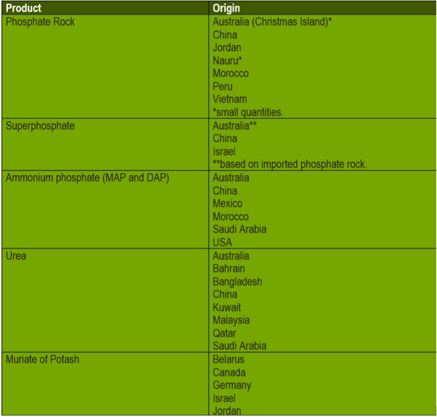
Source: Fertilizer Australia, Supply Sources, https://fertilizer.org.au/Fertilizer-Industry/Supply-Sources

The control of ships and shipping for the transportation of crude oil and refined petroleum products (and other critical imports)

As the PC correctly identifies, supply chains are subject to many types of shocks, including:
- Geopolitical shocks, such as a trade war that might affect regional or global trade;
- Environmental shocks, such as the 2019–2020 bushfires in Australia that affected transport and communication;
- Economic shocks, such as the 1973 oil crisis that changed how firms and households use energy’;
- Societal shocks, such as labour disputes or pandemics that affect labour supply and demand; and
- Infrastructure-related shocks, such as cyberattacks or disruptions at a port or along a road.

The PC also noted (at P21) that global transport, a key part of supply chains, relies on a large, relatively low-skilled workforce of drivers, but also on more skilled workers such as air and marine pilots and logisticians and on a few workers with highly specialised skills, such as helicopter pilots who ferry marine pilots to bulk carriers.

However, the PC Interim Report omitted to mention seafarers, the key workforce in global supply chains, nor the functioning of the seafarer labour market, which is central to the functioning of ships in global supply chains. We address the seafarer labour market below.

We concur with the PCs view (P27) that the architecture of the supply chain will also determine vulnerability to risk and we strongly support the PC view that although all supply chains are vulnerable to infrastructure-related risks, because they rely on transport systems, some supply chains characteristics can increase risks, such as:
- Limited flexibility — a supply chain that depends on a node or a link that is not easily substitutable;
- Geographic clustering — if all the firms in one tier are geographically clustered, this increases the exposure to localised environmental risk, localised geopolitical risks and localised infrastructure-related risks; and
- Length — a long supply chain involving inputs changing hands between many firms.

We believe there are other characteristics that should be included in the PCs consideration of supply chain vulnerability, specifically related to the shipping component of supply chains, such as:
- Commercial ship contractual arrangements; and
- National strategic considerations that result in the exercise of market power, which is an important feature of shipping supply arrangements.

These characteristics are addressed below.

Shipping specific factors which can impact on the vulnerability of supply chains

The security of trade routes

We note that the Interim Report (P28) refers to bottlenecks in transport links that increase the vulnerability of a supply chain as there may be limited substitute routes in the event of a disruption. Bottlenecks include reliance on a port or a specific maritime, land or air route, and that imports into Australia are dependent on a small number of domestic ports, each with limited capacity, and thus are at risk of significant delay in the event of a natural disaster or infrastructure failure.

However, we believe that insufficient attention has been given to potential disruption to ships and shipping in the trade routes that service Australia.

The Interim Report (at P46) correctly identified that imported goods are more susceptible to geopolitical events (such as trade disputes), and disruptions to transport corridors that they may pass through (such as the Strait of Hormuz).

In the case of crude oil for Australian refineries, and oil for production of refined petroleum product which Australian purchases from Asia, where the origin of the crude oil for Australia’s major purchases are the middle east nations of United Arab Emirates, Libya, Algeria, Iraq, along with Russia, the oil is invariably shipped through the Strait of Hormuz (30 per cent of the world’s seaborne-traded crude oil passes through the Strait of Hormuz each day). The International Crisis Group has stated that “an intentional or inadvertent incident at sea could quickly escalate into a direct military confrontation, and risk shipping through the critical energy chokepoint (referring to the Strait of Hormuz).”

The Suez Canal is another choke point that is susceptible to disruption from strategic disputes, terrorist attack or blockages from a shipping accident as occurred in March 2021, blocking the Canal for around 6 days and holding up nearly 400 ships.

In our own region the Strait of Malacca is the main corridor between the Indian Ocean and the South China Sea. According to a report on sea lane security prepared by the Economic Research Institute for ASEAN and East Asia (ERIA) “growing oil demand in East Asia will increase the number of the tankers passing through the strait from 7,723 in 2014 to 11,615 in 2030 and 12,211 in 2040. Increasing numbers of tankers passing through the strait will increase the risk of safety and security.”

Lombok Strait in Indonesia is another important sea lane, located between the islands of Bali and Lombok. Lombok strait is an alternative and safer route for large tankers. Ships travelling in the Lombok Strait usually pass through the Makassar Strait located between Kalimantan and Sulawesi. An estimated 3,900 ships transit through Lombok Strait annually. In terms of value, more than 140 MT of goods worth $40 billion pass through the Lombok Strait. An illustration of this is provided in Figure 4, relating to the LNG trade.

Figure 4: LNG Transport through Lombok Strait

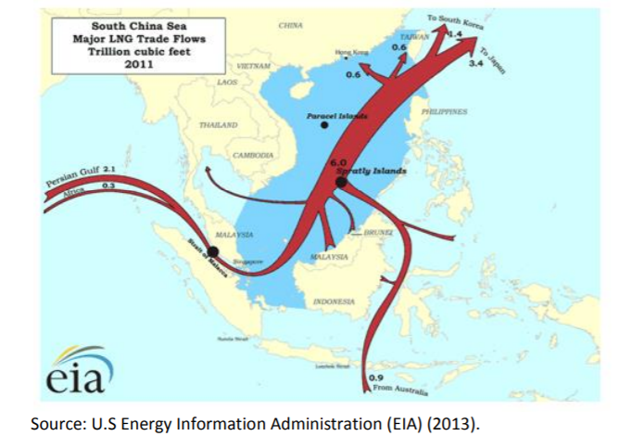

The ERIA report concludes that in the event the Malacca Strait is closed due to an accident or terrorist attack or has congested traffic, the Lombok and Sunda Straits could be viable alternatives. However, the diversion route from the Malacca Strait to the Lombok Strait will increase the distance by 2,500 nautical miles, equal to 168 voyage hours and is estimated to increase the transportation costs by 20 percent.

The following Figures 5 and 6 reveal the importance of these potential choke points or disruption points in the supply of Australia’s crude oil imports for its refineries as well as supply of refined petroleum products from Australia’s predominantly Asian suppliers. Figures 5 and 6 also show the duration of ship voyages from key supply nodes, which is important in two respects. Firstly, in terms of the ship steaming duration involved in supplying these products from foreign markets and secondly the additional steaming time and hence additional cost if alternative routes were to be required in the event of a disruption to an existing trade route.

Figure 5: Australia’s major import crude oil shipping routes

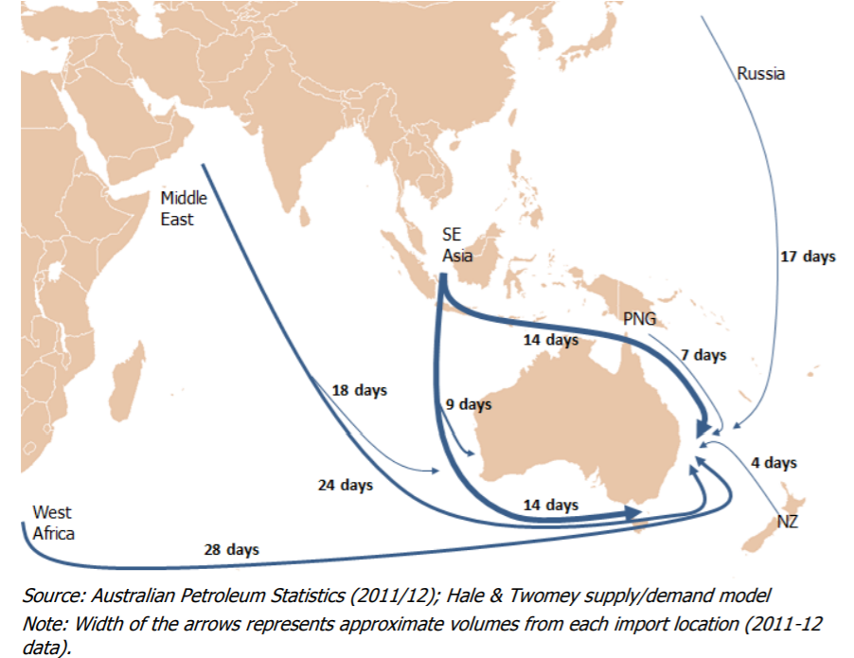
Source: Hale and Twomey, Australia's Maritime Petroleum Supply Chain, Prepared for the Department of Resources, Energy and Tourism, Canberra, June 2013 https://www.aip.com.au/sites/default/files/download-files/2017-09/Report_into_Australias_Maritime_Petroleum_Supply_Chain.pdf

Figure 6: Australia’s major import product shipping routes

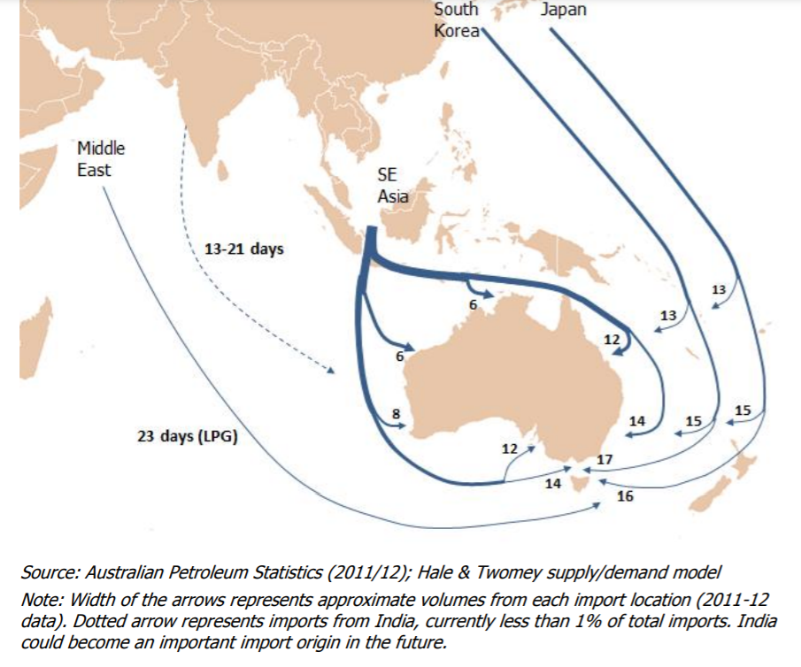
Source: Hale and Twomey, Australia's Maritime Petroleum Supply Chain, Prepared for the Department of Resources, Energy and Tourism, Canberra, June 2013 https://www.aip.com.au/sites/default/files/download-files/2017-09/Report_into_Australias_Maritime_Petroleum_Supply_Chain.pdf

The PC notes (at P46) that “If most of the supply is from one location, vulnerability is greater: a natural disaster or other shock in that location can disrupt supply. The degree of vulnerability would generally increase when the number of actual and potential suppliers decrease, and when suppliers have market power. In the language of chapter 2, vulnerability is greater if there is geographic clustering, or limited flexibility.”

A good analysis of the risks to ships in global supply chains appears in an article written by Alan Dupont in the Australian, headed Australia needs its own fuel reserves, in October 2019. In that article, Dupont makes the following points:
- “The transport sector is the biggest user of fuel (this includes ships), making up 75 per cent of total liquid fuel demand. Less known is the critical role of liquid fuels in sustaining the other foundational systems of our society. Mining and agriculture are more than 90 per cent reliant on diesel, and demand for diesel is growing much faster than the economy at 6 per cent a year.
- Diesel shortfalls would translate quickly into food and resource shortages, illustrating the likely flow-on effects of an extended disruption to liquid fuel supplies. Diesel also provides emergency back-up for many of our essential services including water, sanitation and electricity.
- Petrochemicals refined from crude oil and condensates are important, too. They are used in manufacturing for everything from plastics to makeup and super glue. In fact, we use three times more energy from liquid fuel than electricity. Our annual spending on liquid fuel is $57bn compared with $38bn on electricity and $37bn on gas. Stressed consumers anxious about their rising electricity bills would have much more to worry about if disruptions to oil supplies were to last more than a few weeks.”

On supply chain security, Dupont says that:
- We can “expect to see further disruptions to oil supplies in the years ahead because Iran regards Saudi Arabia’s oil industry as the country’s achilles heel in the contest between the two states for regional supremacy. The airborne strikes on Saudi Arabia’s Abqaiq facility and the nearby Khurais oil field, which evaded Riyadh’s supposedly state-of-the-art air defence system, demonstrate how easy it is to damage vital oil installations and their associated infrastructure with relatively cheap drones and cruise missiles.
- Oil supplies also could be disrupted by conflicts closer to home as tensions between China and the US ramp up in the western ­Pacific and the long-running North Korean nuclear problem continues to simmer. Renewed ballistic missile testing by North Korea or an incident in the South China Sea involving US and Chinese ships or aircraft could quickly roil oil markets, sending prices higher. A more serious confrontation between the US and Chinese navies that led to a blockade of the Malacca Strait and disrupted imports of refined liquid fuel from Singapore and other Asian refineries cannot be ruled out.”

These issues are addressed below.

Time to arrange ships and receive delivery

The 2013 report on Australia's Maritime Petroleum Supply Chain (Hale and Twomey) noted that usually, commitments are made for purchase of cargoes well in advance of the process for committing to purchase shipping, which the report suggests in a disruption where additional product is required, it is usually access to additional cargoes rather than access to additional shipping which is the constraint.

The process and timelines referred to are shown in Table 9.

Table 9: Timing for securing import shipping
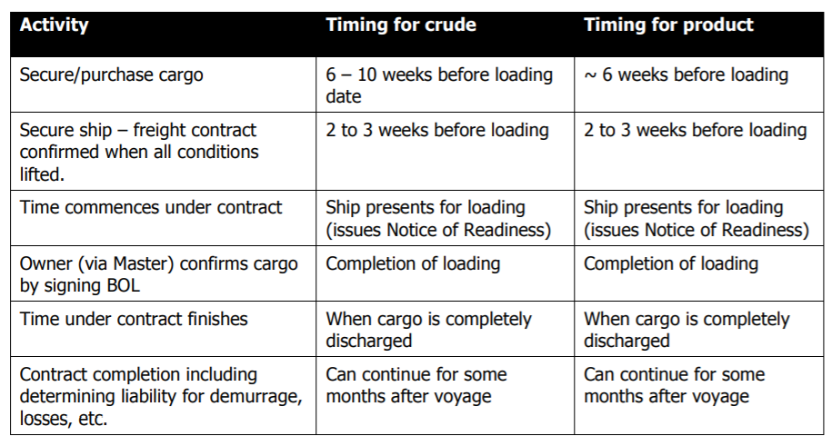
Source: Hale and Twomey, Australia's Maritime Petroleum Supply Chain, June 2013, https://www.energy.gov.au/sites/default/files/aust-maritime-petroleum-supply-chain-report-2013.pdf

Notwithstanding that observation, securing or chartering a suitable ship in a timely way in an emergency for oil and petroleum products can be highly problematic where factors such as oil cartel production variations, refinery demand/supply, fuel quality requirements, levels of oil in storage on ships and in onshore facilities, trade sanctions, foreign policy tensions, export controls (such as those that allegedly held up supplies of COVID-19 vaccines from Europe), terrorist and cybersecurity events can all impact on suitable ship availability and pricing, and the ability to source a ship in a timely manner in an emergency.

This was illustrated during late 2019 when, as part of the Trump administration’s continuing pressure on parties involved in oil trading with Iran, the US Treasury Department announced that it was adding two affiliates of COSCO Shipping - COSCO Shipping Tanker (Dalian) Co and COSCO Shipping Tanker (Dalian) Seaman & Ship Management Co - to the Office of Foreign Assets Control’s (OFAC) designated nationals and blocked persons list.

This resulted in an immediate spike in freight rates for very large crude carriers (VLCCs) which rose within a month or so by around 100 percent to approximately $300,000 per day, as shown in Figure 7.

Figure 7: VLCC TCE rates since US sanctions on COSCO - 2019
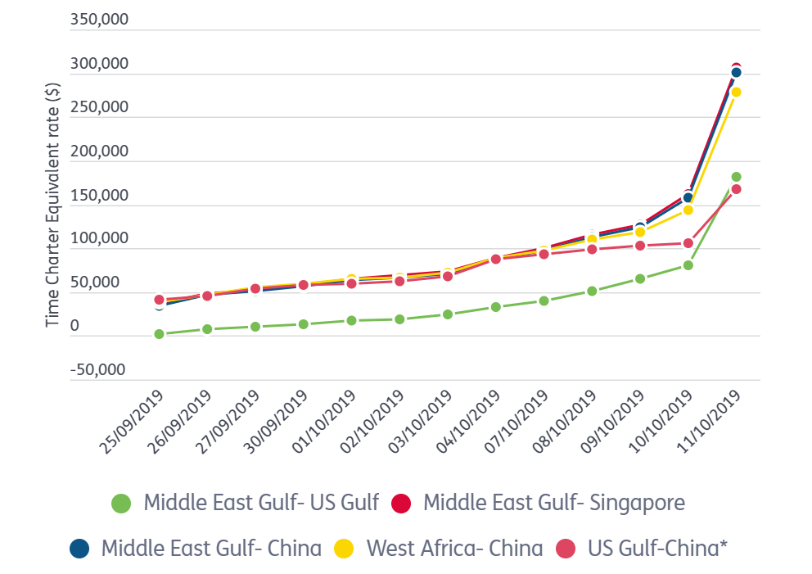
Source: Seatime Maritime News, Cosco Shipping units hit by US sanctions, tanker rates spike, 30 September 2019, https://lloydslist.maritimeintelligence.informa.com/LL1129517/VLCC-spot-charter-breaks-300000-level-on-market-disruption

Such factors may reinforce the view of the PC on P92 where the Interim Report says that "By storing crude oil in the United States, Australia meets some of its international treaty obligations, but its role in supporting Australia's physical or strategic oil reserve is less clear. In addition to possible geopolitical risks, time delays in shipping and refining the oil once in Australia are also a risk.´´

Other factors impacting on ship availability and pricing relate to matters such as voyage delays due to oil-market disruptions which can reduce vessel supply. For example, ships can become caught on “stranded voyages” - spot voyages booked at lower-than-current rates that were scheduled to discharge on a specified date but were not able to do so because of logistical constraints, including refinery closures or lack of onshore storage. The voyage charterer pays for a specified period under a spot contract, and if the ship is returned late, the charterer pays a separately negotiated daily “demurrage” charge that is lower than the implied daily voyage rate. In such cases the ship is returned late, disrupting forward trading opportunities and the ship owner suffers economic loss.

In one example, a Diamond S-owned Suezmax ship (Diamond S is a US listed company) was booked for a five-day job to “lighter” (ship-to-ship transfer to unload) a VLCC off the US West Coast. The refinery shut down before the ship could discharge. The ship finally offloaded that cargo after being stranded for one and a half months.

Another chartering issue involves time-charter coverage. In a typical shipping cycle, as spot rates rise toward above-average levels, charterers seek long-term time-charter coverage to cap future transport costs. Shipowners also become more amenable to putting some vessels away on time charters, even if it means losing out on spot upside, as insurance against a sudden rate slump.

Cargo contract terms

Hale and Twomey have clearly articulated the relationship between petroleum contracting and shipping
contracting. They identify the importance of understanding the distinction between a contract for purchase of a cargo (in the analysis, they focussed on petroleum) and the contract with a shipping provider to transport the cargo, noting that in some cases the owner of the oil may be the same as the charterer but that is not always the case.

Table 10 sets out the typical contracting arrangements for petroleum and how these interact with the arrangements for freighting the cargo.

Table 10: Freight and ship contracting (using the example of oil/petroleum)

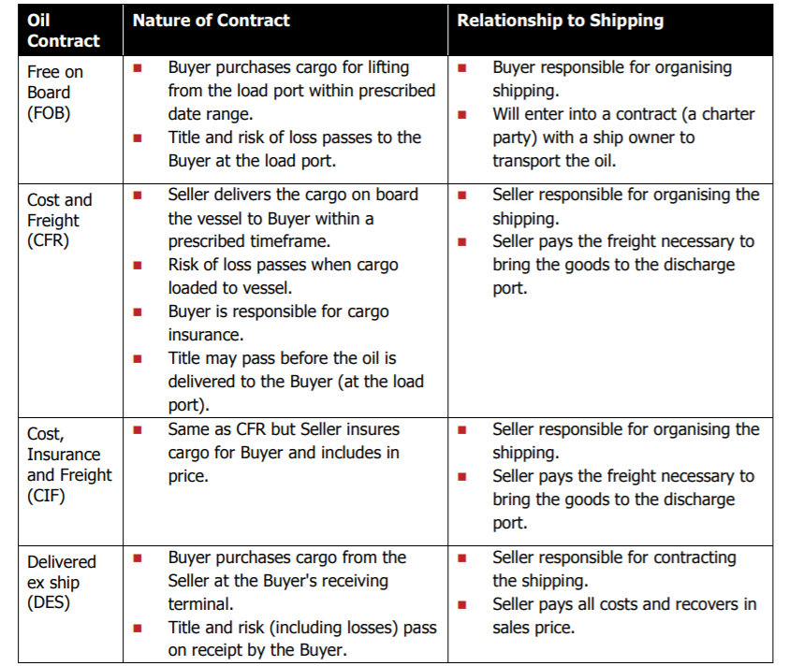
Source: Hale and Twomey, Australia's Maritime Petroleum Supply Chain, Prepared for the Department of Resources, Energy and Tourism, Canberra, June 2013 https://www.aip.com.au/sites/default/files/download-files/2017-09/Report_into_Australias_Maritime_Petroleum_Supply_Chain.pdf

A related issue is the willingness of the world’s marine insurers to insure ships during a conflict. Senator Jim Molan raised this issue in an ABC media article in May 2018 where he noted “an on-sea incident during the 2006 Lebanon War. As a result, ……. no ship went in or out of Israel for 30 days as no one would pay the insurance requirements.” Another contemporary example is the Ever Given container ship that blocked the Suez Canal in March 2021 with some 10,000 containers on board, which has been impounded by Egyptian authorities since it was refloated due to a financial dispute, allegedly involving at least US$900 million, with its owner. Egypt has said the Ever Given would not be allowed to leave the country until a compensation amount is settled with the vessel’s owner. This could take months.

The freight and ship contracting arrangements are important to Australian supply chain vulnerability because, as a nation that: (i) imports large volumes of crude oil and refined petroleum products; and (ii) owns and sells large volumes of bulk commodities including some crude oil/condensates, but has so few shipowners (and no Australian oil tankers or refined petroleum product tankers on its Register of ships) its ability to maintain control over the shipping component of its supply chains is severely limited.

We have not been able to establish the predominant form of shipping terms that importers of refined petroleum products favour, though we believe it is likely that shipments are purchased on Free on Board (FOB) terms, meaning the Australian purchaser arranges the shipping. However, given the concentration of ship ownership by nations with whom Australia does not have stable relationships (see the section below) that is cold comfort to supply chain security.

In relation to Australian exports, cargo interests (sellers) typically arrange freight (i.e. charter ships) on an FOB contract basis, meaning the commodity buyer has arranged the shipping and becomes responsible for the freight at the point of the loading port.

In other words, those cargo interests, typically large multinational corporations owned predominantly by foreign shareholders, as big global commodity exporters, have effectively handed over control of the shipping aspects of their supply chain, at the loading port, to foreign shipowners/operators. Australian cargo owners servicing export markets, with only one exception in the last 40 years, have invariably chosen to sell their cargo on an FOB basis. The one exception is the joint venture participants in the North West Shelf (NWS) LNG Project, the joint beneficial owner of four Australian flagged LNG tankers servicing the NWS LNG project, which owns four ships registered on the Australian General Shipping Register under the Shipping Registration Act 1981. For nearly the whole life of that LNG project, commencing in 1989, the NWS LNG was sold on Delivered Ex-Ship (DES) contract terms, where the seller controls the shipping. This was supported by a Continuity of Operations Agreement (COA) with the maritime unions that remains in place today and has resulted in thousands of exports shipments of LNG without a single delay due to an industrial dispute.

Those four Australian LNG ships represent just 0.06 per cent of the individual ships that transport Australian commodity exports.

Given that Australian LNG is now increasingly being sold through commodity traders or on the spot market, rather than on long term LNG contracts with LNG energy companies in the importing nations like Japan, the sellers do not have the same commercial relationship with buyers, who are now insisting on FOB shipping contracts. This is a major factor that has led Woodside Energy/NWSSSC to commence a phasing out of the 4 Australian LNG tankers servicing the NWS LNG project, with the result that by around 2024 there will be no Australian ships in the nation’s LNG trade, and therefore not a single Australian registered ship in Australia’s commodity export supply chains.

National sovereignty and commercial advantage from owning ships

Australia has been consistently outsmarted by its trading partners in terms of supply chain sovereignty, particularly in relation to ship ownership. As can be seen in Table 11, all Australia’s key trading partners including Japan, China, Singapore, USA, Germany and UK are also among the largest owners of ships.

Table 11: Top 10 ship owning nations

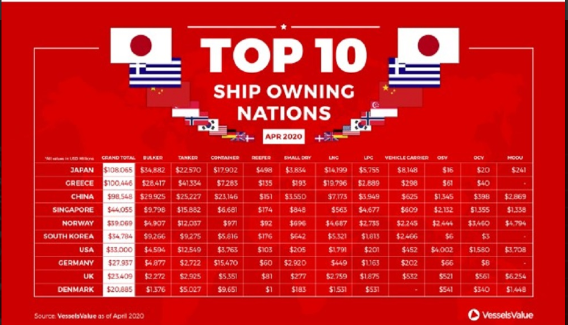
Source: International Ship Engineering Service Association (I.S.E.S.) Ltd, Top 10 ship owning nations by value, April 2020, https://www.isesassociation.com/top-10-ship-owning-nations/

A number of these ship owning nations are also major shipbuilding nations, such as Korea, Japan, China and Singapore. This is shown in Table 12.

Table 12: The top 10 global shipbuilding nations, by revenue

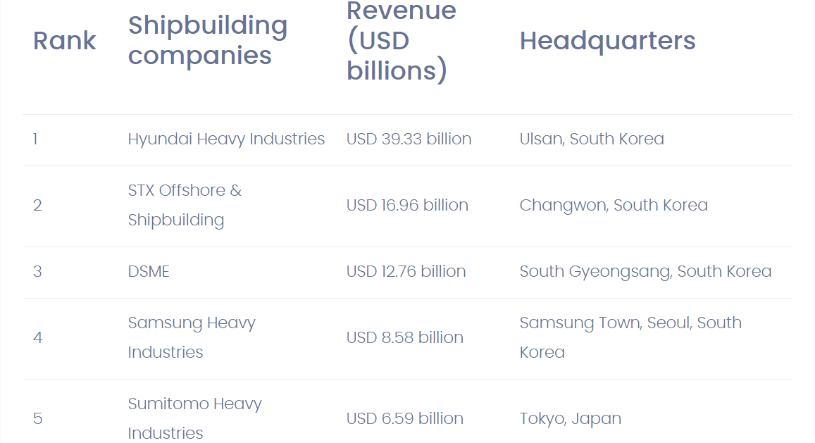
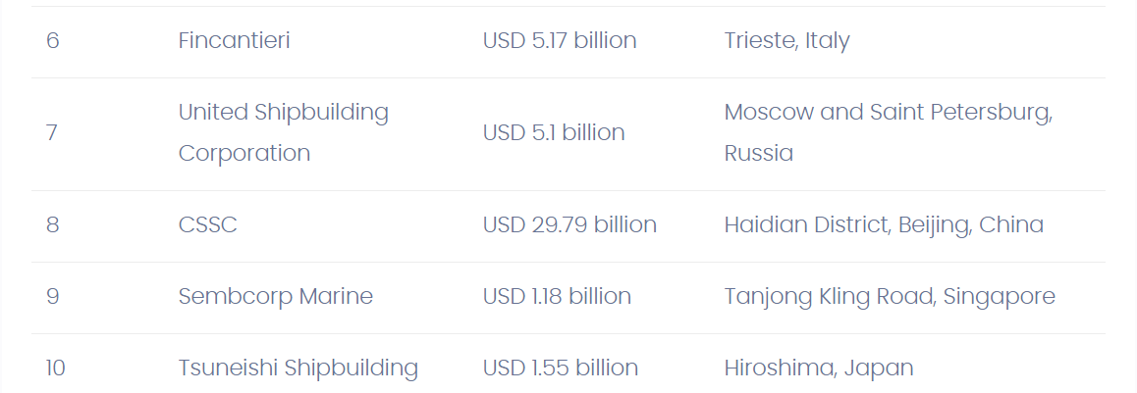

Source: BizVibe, Top 10 Largest Shipbuilding Companies in the World 2020 by revenue, https://blog.bizvibe.com/blog/top-shipbuilding-companies-world

These nations seek to control their international goods supply chains through all facets of the ship supply chain, from shipbuilding to ship ownership, to ship management, to shipping contracts, and often part ownership of the production of the cargo e.g. oil, refined petroleum, LNG, coal and iron ore.

Vertical integration has been a conscious decision of the commodity traders in those nations, supported by clear government policy, regulatory settings and industry policy support. The result is that their product supply chains are highly secured, in marked contrast to Australia. Notwithstanding Australia is a major importer of goods, and major exporter of primary production in global trading terms, it does not build a single commercial trading ship, owns and operates only 4 international trading vessels (soon to be phased out), owns virtually no ship management companies with any scale in global terms and sells almost all its bulk commodity exports in an FOB basis. There will soon be no labour Continuity of Operations Agreements in any of Australia’s export supply chains.

These are all critical factors that we urge the PC to take into consideration in its Final Report, because they are critical to an assessment of the vulnerability of Australia’s supply chains.

The seafarer labour market

We note that at P44, the Interim Report reported that "The COVID-19 pandemic, for example, has restricted the movement of people across domestic and international borders. Supply chain disruptions may occur where these people have specialist skills that Australia or its particular states may lack. Supply chain vulnerability to imported services and the movement of skilled labour should also be assessed using the best available information." We agree.

A rupture to the global seafarer labour market would have a catastrophic impact on the availability of global shipping. Such a rupture is on the brink of reality at the time of making this submission where some 400,000 plus seafarers remain trapped at sea and unable to depart their ship and be repatriated to their home nation in accordance with their seafarer employment agreement (contract) due to border restrictions and other policies imposed as a result of the COVID-19 pandemic. Nor are they able to access shore leave. These rights are meant to be guaranteed under the International Maritime Organisation’s (IMOs) Maritime Labour Convention (MLC) to which Australia is a signatory, and which is meant to be given effect by Marine Order 11 (Living and working conditions on vessels) made under the Navigation Act 2012.

This seafarer labour market rupture would have already occurred if governments fully enforced compliance with the International Maritime Organisation’s (IMOs) Recommended Framework of Protocols for ensuring safe ship crew changes and travel during the Coronavirus (COVID-19) pandemic. Regrettably, Governments have not been prepared to act in harmony to resolve the seafarer crew change crisis, and in the process have forced shipowners to effectively condone forced labour (seafarers being held at sea against their will, well beyond the term of engagement in their seafarer employment agreement) in contravention of International Labour Organisation (ILO) Convention obligations, and in contravention of the standards in modern slavery legislation, including the Modern Slavey Act 2018 (C’th).

If a critical mass of shipowners/operators become a signatory to The Neptune Declaration on Seafarer Wellbeing and Crew Change and fully comply with its shipowner obligations, this could trigger the rupture, with a rapid breakdown in ship availability, with consequential disruption to world trade and to supplies of critical products. That is a real supply chain vulnerability.

We submit that the PC is misguided in accepting the notion that Australia has done a wonderful job in keeping maritime supply chains functioning (for example see the reference to the pharmaceuticals industry at P76) if it requires violations of seafarer human rights and breaches of the nation’s treaty obligations to achieve the continued functioning of supply chains. We note that some of Australia’s own seafarers have endured up to 5 periods of quarantine just to go to and from work across the country due to the failure of national coordination and policy consistency around the crewing of ships being used in domestic industries.

Australian seafarers are yet to be designated as key or essential workers in contravention of a United Nations General Assembly (UNGA) resolution of 1 December 2020 calling on governments to designate seafarers as key workers and to ensure the implementation of the IMOs crew change protocols. Similarly on 1 October 2020, the ILO Special Tripartite Committee (STC) of the Maritime Labour Convention, 2006, issued a statement that requested Member States to bring together the appropriate departments and agencies urgently to, among others, “ensure that, as key workers, seafarers have access to a programme of vaccination, once developed, as a matter of priority to enable them to discharge their crucial role”. This call has been reiterated by the International Chamber of Shipping (ICS) and the International Transport Workers Federation (ITF). This too would be a sensible, practical measure that would reduce shipping supply chain vulnerability.

More recently on 23 April 2021 the Fourth Meeting of the Special Tripartite Committee of the Maritime Labour Convention, 2006 (MLC, 2006), passed two important resolutions that must now be implemented by governments, or a major global humanitarian catastrophe is likely, that will be disruptive of global supply chains.

Reducing oil/refined petroleum product and shipping supply chain risk

We note the key mitigation strategies which the PC suggests could be adopted to prepare for supply chain risks, which include, inter alia, stockpiling, supplier diversification, contingent contracting, and developing domestic capability.

The PC suggests that government could consider options ranging from providing information about risks that they are best informed about, to taking more direct ownership of risk management (such as maintaining government stockpiles, mandating or subsidising private stockpiles, or maintaining domestic production capacity).

We note the submission of Maritime Industry Australia Ltd (MIAL, the Australian shipowner/operator industry association) to the Department of Home Affairs regarding the Exposure Draft Critical Infrastructure Bill 2020 that concluded: “In short, unless there is an understanding and acceptance within Government of the national vulnerability that exists (referring to shipping), because the vast majority of our sea transport capability is performed by foreign entities, and takes action ………, then it is not considered possible to reliably state that critical supply chains will be secured.”

We concur with that conclusion.

We submit that a legitimate and practical mitigation strategy that could readily be supported by government is establishment of a national strategic fleet, that is, to develop domestic shipping capability. A national strategic shipping fleet would comprise ships which are of strategic importance to the nation, contribute to national sovereignty and to maintaining supply chain security, assist in achieving national self-sufficiency in critical supplies required by businesses and citizens and provide a social and or community service benefit to the nation.

Establishment of a strategic fleet is now regarded by many security experts as an essential part of the package for delivering energy security for Australia. A strategic fleet would ensure a proportion of the seaborne transportation needs for the movement of critical energy supplies are transported in Australian ships. Such ships would be available to transport (i) oil for Australia’s remaining refineries; (ii) refined petroleum products from refineries and refined petroleum products import storage facilities to population centres around the Australian coast; (iii) gas from gas producing areas for distribution to mobile floating storage and regassification units (FSRUs) located in regional ports and to supply imported gas (from Australian and international gas producing regions) to enter the domestic gas distribution network; and for offshore wind farm construction, supply and maintenance ships involved in expansion of Australian renewable energy production.

We urge the PC’s Final Report to recommend that government commit to supporting a strategic fleet which would involve the operation of dedicated Australian oil tankers, refined petroleum product tankers, gas ships and offshore wind farm construction, supply and maintenance ships, under Australian ship registration.

A strategic fleet of commercial Australian ships transporting oil, refined petroleum products and gas will contribute to Australia’ energy security in several ways, including:
- Contributing to Australia’s fuel security by ensuring Australian sovereignty over the shipping transportation aspects of international importation, and domestic distribution, of refined petroleum products;
- Contributing to an increase in gas supply for households and manufacturing industry through provision of control over mobile floating storage and regassification units (FSRUs) located in regional ports and to supply imported gas (from Australian and international gas producing regions) to enter the domestic gas distribution network;
- Providing a reliable supply of gas fuel for the next generation of ships powered by gas fired propulsion systems that will enter service arising from implementation of the IMO sulphur emissions regulations, which saw the global sulphur limit drop from 3.5% to 0.5% at end 2020; and
- Providing security of supply of high demand offshore wind farm ships that will be building the offshore wind farms to help Australia meet its renewable energy target, and Paris Climate Conference Agreement commitments on reducing carbon emissions. Wind farm energy production is already being planned as part of the regeneration of Australian manufacturing, itself an important contribution to reducing supply chain vulnerability by increasing self-sufficiency in major inputs to a productive economy such as steel.

There are several positive spin-offs to be gained from establishment of a strategic fleet, including:
- Provision of additional ships on which seafarer training can take place, including mandatory sea time in gaining occupational licenses and VET qualifications (to overcome the declining access to ship’s berths for trainee ratings and cadet engineers/officers);
- Improved reliability of supply of gas as a transitional fuel to keep Australia’s manufacturing plants open with positive consequences for well-paid secure jobs – in industries such as steel, cement and other building products, aluminium, fertiliser and other chemicals/explosives etc; and
- A vastly increased capacity for the Defence forces and emergency management agencies to requisition ships to supplement Navy ships in times of national emergency.

We refer the PC to the shipping reform agenda that was recently laid out in the Report of the Senate Rural and Regional Affairs and Transport References Committee Inquiry into the Policy, regulatory, taxation, administrative and funding priorities for Australian shipping tabled in the Parliament on 15 December 2020. That report emphasises the need for policy and regulatory certainty to create the conditions for investment in Australian ships, as well as creation of a level playing field between transport modes to deliver fair competition and effective modal choice for shippers (freight interests), all practical and efficient measures that would mitigate the risk to Australia’s supply chains through the vulnerability of ship infrastructure.

Additionally, Australia should be seeking to reduce its dependency on non-national seafarers in the domestic sea freight market. There are a large number of seafarers entering Australian on foreign registered ships annually (approximately 138,000), some entering Australia on multiple occasions, a figure which is not that far below Australia’s net overseas annual migration [around 180,000 in recent years].

Of those non-national seafarers that remain in Australia working regularly in the domestic freight market in areas such as the transportation of bauxite, alumina, iron ore and other ferrous metals, building products (cement, potash etc), ammonium nitrate, LPG and containers, largely free of domestic labour relations, work health and safety, workers’ compensation, personal taxation laws are replacing the employment of Australian seafarers, a number of occupations of which are in short supply, not just to crew Australian ships, but to provide the supply of seafaring skills required for a range of on-shore maritime roles. By failing to guarantee the supply of highly skilled seafarers to the IMO STCW standards, Australia’s shipping supply chains are made more vulnerable and dependant on non-national workers.

Furthermore, those non-national seafarers remaining in Australia to work in the domestic sea freight market are accessing critical infrastructure (ports) using only a Subclass 988 Maritime Crew visa (MCV). Many of those foreign seafarers holding a MCV remain in Australia in coastal trade for long periods (up to 11 months, and in the current COVID-19 pandemic for up to 14 months or longer), without the requirement to transfer to a genuine work visa for employment in a domestic industry, like the Temporary Skill Shortage visa (subclass 482).

Securing a MCV for a foreign seafarer requires only the flimsiest of checking which does not match the requirements of Australian nationals who require access a port (defined as critical infrastructure in the Security of Critical Infrastructure Act 2018 (SOCI Act)) for employment and other purposes. All that is required to obtain a MCV is an identification document, name of ship, a maritime occupational licence and meeting a character check. The MCV is granted within two to four days.

In contrast, Australian nationals wishing to access a port are required to hold a Maritime Security Identification Card (MSIC) consistent with the provisions of the Maritime Transport and Offshore Facilities Security Act 2003. The AusCheck scheme established in relation MSICs includes an identity check, a criminal history check, an immigration status check, and a security assessment conducted by the Australian Security Intelligence Organisation (ASIO) under Part IV of the Australian Security Intelligence Organisation Act 1979. This process can sometimes take weeks or longer, often jeopardising continuity of employment of Australian nationals.

No such checks are required for non-national seafarers to secure a Subclass 988 Maritime Crew visa, yet those non-national seafarers are entering the same ports and often working side by side with Australian port workers who require an MSIC.

We submit that this should be rectified as one of the key risk mitigation strategies in minimising threats to national critical infrastructure and to mitigate the vulnerability of Australia’s supply chains.

Recommendations

- That the Productivity Commission acknowledge that ships are the overwhelming or critical vulnerability point that underpins all other supply chain vulnerabilities and that the role of ships be given far greater attention in the Final Report.

- That the Productivity Commission undertake a specific stakeholder engagement on the supply, suitability and pricing of ships, and to undertake more detailed research on the vulnerability of the shipping component of supply chain policies that could mitigate that vulnerability, prior to releasing an Interim Report on exports and prior to issuing a Final Report.

- That the Productivity Commission review its decision to not include food, given that food production is critically dependant on fuel, fertiliser and chemicals, largely imported and transported by ships.

- That the Productivity Commission recommend in its Final Report that the Government commit to supporting a strategic fleet as a key mitigation strategy to improve Australia’s supply supply chain security.

Since FY2019-20, BP announced in October 2020 that it intends closing its Kwinana Perth refinery, and in February 2021 ExxonMobil announced it intends closing its Altona refinery in Melbourne, a loss of 50 per cent of its current refining capacity, leaving Australia with only two refineries with a combined capacity of 13,770 ml/annum, down from 27,820 in 2019 [IPA]. Ampol, which owns the Lytton refinery in Brisbane is reviewing whether to keep its refinery open or convert it into a fuel import terminal, with a decision expected in the June quarter 2021. If the Lytton refinery closes, Australia will then be left with just one refinery, Viva Energy's refinery in Geelong, Victoria. Its future remains dependent on the Federal Government’s Refinery Production Payment currently in place for six months from January-July 2021, requiring Viva to maintain operations at least during the tenure of the program. Viva has stated that should refining margins stay on an upward trajectory, the company expects to be able to maintain refining operations once the interim Refinery Production Payment concludes at the end of June 2021.
HIS Markit, Crude Oil Trade: South Korea importing more US barrels, mitigating potential disruption through the Strait of Hormuz, 16 January 2020, https://ihsmarkit.com/research-analysis/crude-oil-trade-south-korea-importing-more-us-barrels.html
Workman Daniel, Top 15 Crude Oil Suppliers to China, http://www.worldstopexports.com/top-15-crude-oil-suppliers-to-china/
The Conversation, Australia imports almost all of its oil, and there are pitfalls all over the globe, 24 May 2018, https://theconversation.com/australia-imports-almost-all-of-its-oil-and-there-are-pitfalls-all-over-the-globe-97070#:~:text=Currently%2C%2051%2D53%25%20of,of%20production%20and%20transport%20costs
Laidlaw, Dr Hunter, Parliamentary Library, Australian oil refineries and fuel security, 17 December 2020, https://www.aph.gov.au/About_Parliament/Parliamentary_Departments/Parliamentary_Library/FlagPost/2020/December/Oil_refineries_and_fuel_security
ABC, Australia's fuel supplies vulnerable if Middle East conflict cuts supply, 19 September 2019, https://www.abc.net.au/news/2019-09-19/australia-remains-vulnerable-to-running-out-of-fuel/11527492
On an alternative size measure, by 12-month trailing (TTM) revenue (of shipowner companies that are publicly traded in the US and Canada, either directly or through American Depository Receipts (ADRs - a form of equity security created to simplify foreign investing for American investors), the top 5 oil tanker owning companies are: (i) Teekay Tankers Canada; (ii) Euronav, Belgium; (iii) Scorpio Tankers Inc, Monaco (owns or finance leases 128 product tankers (42 LR2 tankers, 12 LR1 tankers, 56 MR tankers including 4 newbuilds and 14 Handymax tankers) and time or bareboat charters-in 10 product tankers (three MR tankers and seven Handymax tankers); (iv) Frontline Inc, Bermuda/Sweden (60 ships) ; and (v) DHT Holdings Inc, Bermuda (28 VLCCs), - Investopedia, 5 Biggest Oil Tanker Companies, September 2020, https://www.investopedia.com/articles/investing/123115/top-6-companies-crude-tanker-business.asp
The market and rankings remains fluid. On 31 March 2021 International Seaways and Diamond S Shipping announced a merger. The merger will create the second largest US-listed tanker company by vessel count and the third largest by deadweight tonnage. The combined company will have 100 vessels, shipping revenues of over $1 billion, over 2,200 employees, and an enterprise value of approximately $2 billion.
MOL Annual Report 2020, P24, https://www.mol.co.jp/en/ir/data/annual/pdf/ar-e2020.pdf
http://www.levantnetworks.com/2020/05/07/national-iranian-tanker-company-shuffling-front-companies-for-tanker-fleet/
https://pdf4pro.com/view/top-30-tanker-companies-tankeroperator-s-59f4c7.html#google_vignette
Maran Tankers Management Inc, Our Fleet, https://marantankers.gr/our-fleet/
Bureau of Infrastructure, Transport and Regional Economics (BITRE), 2019, Australian sea freight 2016–17, Canberra, ACT (derived from Tables 4.5 and 4.9) https://www.bitre.gov.au/sites/default/files/documents/asf_2016_17.pdf
International Crisis Group, Strait of Hormuz, 7 April 2021, https://www.crisisgroup.org/trigger-list/iran-us-trigger-list/flashpoints/hormuz
Economic Research Institute for ASEAN and East Asia (ERIA), Sea lane security in the selected EAS countries, November 2016, derived from Kimura, S., T. Morikawa and S. Singh (eds.), Sea Lane Security of Oil and Liquefied Natural Gas in the EAS Region. ERIA Research Project Report 2015-14, Jakarta: ERIA, pp.41-55, https://www.eria.org/RPR_FY2015_No.14_Chapter_4.pdf
Ibid P43
Dupont. Alan, Australian, Australia needs its own fuel reserves, 5 October 2019, https://www.theaustralian.com.au/inquirer/australia-needs-its-own-fuelreserves/newsstory/8a5b2bb595a0de268ed270868e6dcdef .Alan Dupont is a Nonresident Fellow at the Lowy Institute for International Policy, and a professor of International Security at the University of New South Wales.
Freightwaves, Tanker veteran warns on rates: The storm is coming, 8 May 2020 https://www.freightwaves.com/news/tanker-veteran-warns-on-rates-the-storm-is-coming
ABC, Is Australia's fuel supply about to be cut off?, 7 May 2018, https://www.sbs.com.au/news/is-australia-s-fuel-supply-about-to-be-cut-off
Australia’s foreign owned and operated ship dependency is best illustrated by the fact that only (only 4 [or 0.06 per cent] of the nearly 6,000 different ships annually involved in Australia’s imports and exports, offshore oil and gas operations and large cruise ship trades are Australian registered ships crewed by Australian nationals.
NWSSSC is the North West Shelf Shipping Service Company Pty Ltd (NWSSSC), the shipping adviser to International Gas Transportation Company Limited (IGTC), a Bermuda registered shipping company responsible for providing shipping LNG capacity to the North West Shelf Project participants. Both IGTC and NWSSSC are equally owned by the North West Shelf Project participants: BHP Billiton Petroleum (North West Shelf) Pty Ltd, BP Developments Australia Pty Ltd, Chevron Australia Pty Ltd, Japan Australia LNG (MIMI) Pty Ltd, Shell Australia Pty Ltd and Woodside Energy Ltd. Whilst IGTC is responsible for making key commercial decisions in relation to the North West Shelf Project's fleet of owned and time-chartered LNG vessels, NWSSSC provides advise and expertise to support IGTC is assuring the safe, environmentally responsible and reliable transportation of LNG from Australia's North West Shelf to long-term customers in the Asia Pacific region.
ILO Special Tripartite Committee (STC) of the Maritime Labour Convention, 2006, Information note on maritime labour issues and coronavirus (COVID-19) Revised version 3.0, 3 February 2021, Clause 31, https://www.ilo.org/wcmsp5/groups/public/---ed_norm/---normes/documents/genericdocument/wcms_741024.pdf
ILO, Fourth Meeting of the Special Tripartite Committee of the Maritime Labour Convention, 2006 (MLC, 2006), 19–23 April 2021, Resolution concerning the implementation and practical application of the MLC, 2006 during the COVID-19 pandemic, and Resolution concerning COVID-19 vaccination for seafarers, https://www.ilo.org/global/standards/maritime-labour-convention/events/WCMS_679152/lang--en/index.htm
Maritime Industry Australia Ltd (MAIL), Submission to the Department of Home Affairs regarding the Exposure Draft Critical Infrastructure Bill 2020, https://www.homeaffairs.gov.au/reports-and-pubs/files/critical-infrastructure-consultation-submissions/EDS095-CISoNS-MaritimeIndustryAustraliaLimited.PDF

