Submission for the Review of the National School Reform Agreement
I am making this submission as I am:
- A teacher in the public education system
- A parent of children in the public education system
- A student carrying out research towards a Masters of Education in Entrepreneurial Education at the University of Adelaide.
Thus, I believe I have a lot of insights and also this is something I am highly concerned about.
Reason for my submission
There is a lack of discussion around Entrepreneurial Education in the report. In fact, the words enterprise or entrepreneurial education do not occur at all despite the fact one of the main goals is to prepare students for pathways outside of school.

Research on the need to include more Entrepreneurial Education in Australia. This research focuses on the South Australian context, but the majority of it is applicable for the whole country. (It is taken from a paper submitted as part of a course for a Master’s of Education, at the University of Adelaide)
This research focuses on the third key outcome from the NSRA
- Students gain the skills they need to transition to further study and/or work and life success.
(COAG, 2018, pp 7-8)

And to a lesser extent closing the gap as it is disadvantaged students who miss out on Entrepreneurial Education as their schools can’t afford to run the programs.

In short, the National School Reform Agreement should be considering Entrepreneurial Education in more depth.

Introduction
- The need for 21st century learning
Although there are many complex challenges involved in implementing and evaluating Entrepreneurship Education in South Australia, the imperative for change and the potential opportunities make it worthwhile overcoming those challenges. The idea that there needs to be a paradigm shift in education to one that fosters entrepreneurial mindsets and competencies has gained traction in the 21st century as people such as Yong Zhao and Ken Robinson explain that our current paradigm of education is outdated and unsuitable for the demands of our contemporary world and our uncertain future (Anderson, Hinz &Matus, 2017, Hannon & Peterson, 2017; Robinson, 2006, 2010,2017; Strauss, 2006 in Zhao 2018a; Zhao, 2006, 2012, 2018a, 2019).
Nationally through the General Capabilities, (ACARA, 2020) and at a South Australian level in the Entrepreneurial Learning Strategy (ELS DfE, 2019) there is a recognition that EE can help to equip students with the skills they need to face the issues of the 21st century and become constructive members of the economy. However, while there seems to be a consensus that it is a good idea for schools to run EE programs there is less support at a national and local level for a complete shift in paradigm (DfE Strategic Plan, 2019, ISA, 2017). Perhaps this is in part because there are many challenges in evaluating and measuring the success of EE programs and as a result there is only scant empirical evidence available about the benefits EE can offer.
- What is Entrepreneurship Education?
Entrepreneurship Education or Enterprise Education(EE) has many definitions ranging from specifically focusing on learning about business (TESDA, 2010) to the broader concept of developing the non-cognitive skills needed for an entrepreneurial mindset (Anderson, Hinz, Matus, 2017; Lackeus, 2015; Rogers &Hewson 2016; UNESCO, 2006; Zhao, 2012, 2019b).
The definition of “entrepreneurship” presented in the European Union’s EntreComp: The Entrepreneurship Competence Framework was created after a “comprehensive review of literature” and provides a useful definition to work with when examining the challenges and opportunities in implementing entrepreneurship education:
“EntreComp defines entrepreneurship as a transversal competence, which applies to all spheres of life: from nurturing personal development, to actively participating in society, to (re)entering the job market as an employee or as a self-employed person, and also to starting up ventures (cultural, social or commercial).

It builds upon a broad definition of entrepreneurship that hinges on the creation of cultural, social or economic value. It thus embraces different types of entrepreneurship, including intrapreneurship, social entrepreneurship, green entrepreneurship and digital entrepreneurship. It applies to individuals and groups (teams or organizations) and it refers to value creation in the private, public and third sectors and in any hybrid combination of the three.
Lastly, it is domain neutral: one can act upon ideas and opportunities to generate value for others in any domain and possible value chain.”
(Bacigalupo, Kampylis, Punie, Van den Brande, (2016). p.6)
It has been acknowledged that, what is meant by Entrepreneurship(al)/Enterprise Education (EE) “differs wildly” (Lackeus, 2015) and thus the author of this review defines it as education that enables students to develop the mindset and competencies required for entrepreneurship (as defined above) in all areas of life.
Limitations:
This review examines the minimal empirical evidence available that reveals the success of EE programs globally, the opportunities they have provided, and discusses the implications for the South Australian context. Despite extensive searching of the datbase Eric, the Barr Smith Library, various reference lists and Google Scholar using terms such as: Entrepreneurial Education, Entrepreneurship, and Innovation the researcher found zero peer-reviewed studies about these activities specific to South Australia. Some non-peer-reviewed articles and a master’s thesis were found on some of the programs running in Australia, but the peer-reviewed studies that were found were based on international examples. Much of the research used is found in grey literature and self-reporting by organisations involved in the provision of EE, which is a limitation of this study. The fast-paced rate with which schools are implementing EE, lack of funding and the difficulties encountered in carrying out randomized experiments in schools (Schanzenbach, 2012) explain to some extent the lack of research in this area and it is the cause of one of the main challenges faced in implementing EE in South Australia.
However, the other available evidence to support the hypothesis that EE provides many opportunities for South Australians are the numerous EE programs provided by external providers in Australia. The financial viability of these businesses and the fact that many principals are paying for their EE programs suggests that many educators can see the benefits of EE. Auditing and researching the efficacy of these programs is an area for further research.
Due to word constraints, this review will just examine EE programs that are running in mainstream education rather than exploring sites that have implemented a complete paradigm shift such as those explored in Rosie Clayton’s 2017 Building Innovation Ecosystems in Education to Reinvent School A study of innovation & system change in the USA.
Findings:
Despite the lack of context-specific rigorous research, the author found that there are compelling reasons to implement EE in South Australia (and Nationally) due to the opportunities for students to develop the entrepreneurial skills needed in the 21st century, enabling students to consider becoming entrepreneurs to improve the dyer employment situation for young people in Australia, the enhancement of engagement and the provision of socially just access to quality pedagogy. On the other hand, there are numerous challenges in implementing EE including: cost, ethical considerations, political obstacles, and difficulty in measuring the efficacy of the programs. The lack of research, measurement and evaluation tools, and teacher training are the biggest hurdles facing the widespread adoption of EE in South Australian schools and are certainly areas that need further research and funding.

Opportunities
- The imperative for Entrepreneurial Education (EE) Due to a Changing and Challenging World
It is recognised that the world is rapidly changing and that there are numerous challenges that our students will need to contend with (Zhao, 2012). Globally many international organisations have identified a myriad of challenges that our young people face (See Table 1) and they call for a change in education so that young people can deal with these issues (OECD, 2018, 2020, WEF, 2019, UNSDG, 2015). Around the world, policymakers are looking to EE to help to deal with global challenges and underemployment (EC, 2015; GEM, 2020; OECD, 2018, 2020, FYA, 2019; WEF, 2019; UNSDG, 2015). In 2015, the World Economic Forum outlined the 21st century skills, which include competencies and capabilities that are part of an entrepreneurial mindset, See Figure 1 (WEF, 2015). Notably, the Global Entrepreneurship Monitor 2019/2020 Global Report lists “entrepreneurship education at school” as the first area that needs improvement around the world to support entrepreneurship (Bosma, N et al, 2020, p.69). Alarmingly, Australia receives a score of 3.75 out of 10 for “Entrepreneurial education at school stage” with a 0 representing “very inadequate status” and 10 representing a “very adequate status” (Bosma et al, 2020, p. 84). As Australia still manages to place 15th out of the 54 countries measured, it is clear the status of EE around the world needs improvement (Bosma et al, 2020, p. 84). While other international bodies such as The European Commission report on the necessity of EE in maintaining a strong European Economy (EC, 2015), concerningly the Australian Government does not identify EE as a key area for developing innovation in Australia (ISA&HP, 2017). Perhaps, this is why there are 25 countries ahead of Australia on the GEM National Entrepreneurship Context Index (NECI) for 54 economies. (See Tables 2 &3). Internationally, it is recognised that there is an imperative for EE to deal with our changing world (Bosma et al, 2020) and South Australia must embrace EE if it is to remain globally competitive.

- Combating the High Rates of Unemployment in Young People and improving the economy
Nationally, there are alarmingly high rates of unemployment and underemployment of Australia’s young people (AHRC, 2014; FYA, 2015; FYA, 2016; FYA, 2017a; Lamb, Huo,2017). Notably, “roughly one-quarter of… 24-year-olds are not actively engaged in work or education” (Lamb et al., 2015 in Lamb, Huo 2017). It is suggested that developing entrepreneurial skills will better equip students to creatively deal with these issues and will enable them to create their own employment opportunities rather than becoming passive employees (FYA, 2016, 2017a, 2018, 2019; WEF 2015). There is some evidence in the literature to support these claims, including a longitudinal study (Athayde, 2012), with studies showing that students improve their entrepreneurial intentions and capacity by participating in EE (Athayde, 2009, Belwal, Belushi, Belwal 2015; Chatzichristou et al, 2015; Vangaard, 2018; Rogers, Hewson, 2016; Wennberg, 2011). In the grey literature of the European Commission’s (EC) meta-analysis of “91 national and transnational research projects” in the Entrepreneurship Education: A road to success report (2015), the research suggests that EE “boosts career ambitions” and supports a high rate of start-ups and “successful ventures” (p. 10). The EC’s 2015 report also gathers evidence from studies in the UK, USA and Sweden to suggest that EE has a direct impact on the economy through both jobs creation and higher turnover in companies run by people who participated in EE (p. 11). However, an issue with this report is that on page 11 it suggests there is economic impact and on page 86 it suggests that there are no studies that show evidence of economic growth (See Figure 2). As the authors do not reference the studies, they are referring to throughout the report, it is hard to validate and critique the findings. Furthermore, two (non-peer-reviewed) studies in Australia found that after Australian students had completed the Australian Business Week EE program and the $20 Boss EE program they were less likely to want to start their own business (Beriman, 2019; Hawke, 2003). The conflicting results in this area call for further research to see what needs to happen in EE to promote entrepreneurial intentions in the participants.

Figure 1 - World Economic Forum 21st Century Skills (WEF, 2015, p. 3)
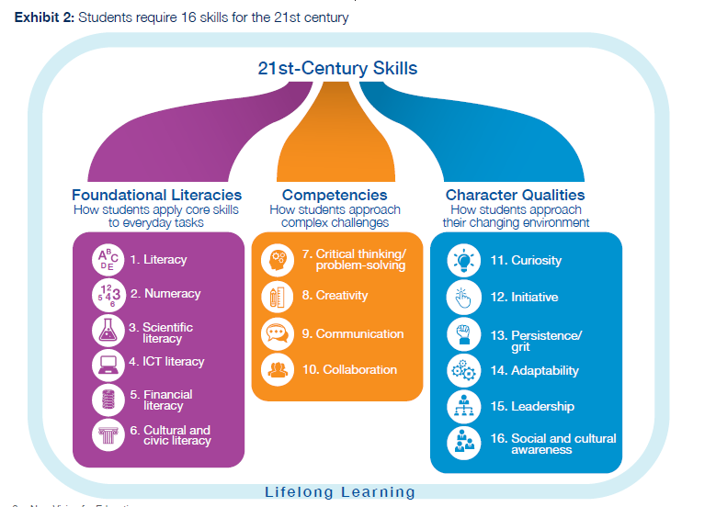

Table 1
Global challenges (OECD, 2018, 2020, WEF, 2019, UNSDG, 2015)
Environmental:
- Global warming
- The depletion of natural resources
- Covid-19
Economic:
- Both the opportunities and risks brought about by unprecedented rapid innovation in science and technology
- The development of artificial intelligence
- Data being collected, shared, used and abused at a global level posing problems with cybersecurity

Social:
- Increases in social and cultural diversity
- Poverty and inequalities of living standards widening in many parts of the world
- Conflict and populist politics eroding trust in traditional governments
- Increased threats of war and terrorism
- Rebellion against globalisation
(Searson, 2019 with the addition of ‘Covid-19’ 2020)

Table 2
GEM’s Entrepreneurship context: national Entrepreneurship Framework Conditions
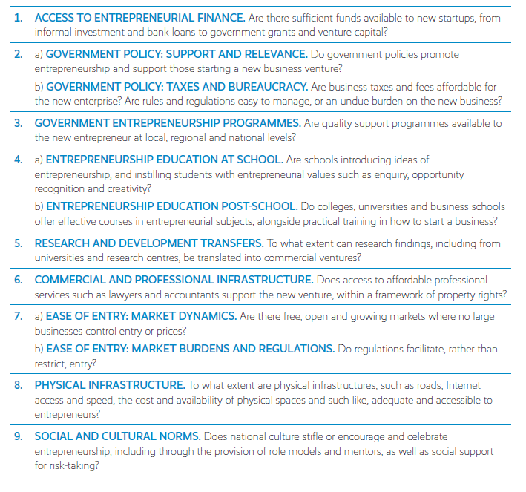
Bosma, N, et al (2020) Global Entrepreneurship Monitor 2018/1019, Page 69.

Table 3
National Entrepreneurship Context Index (NECI) for 54 economies. Source: GEM Audit Population Survey, 2019.
“The GEM National Entrepreneurship Context Index (NECI), a composite index representing in one figure the weighted average state of the set of national Entrepreneurship Framework Conditions.” (Bosma, N, 2020, p71)
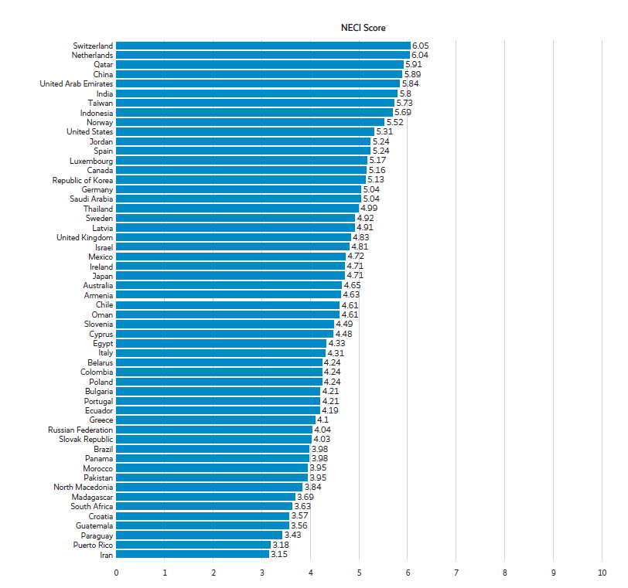
Bosma, N, et al (2020) Global Entrepreneurship Monitor 2018/1019, Page 71

Figure 2.  Clusters of evidence for the impact of entrepreneurship education | 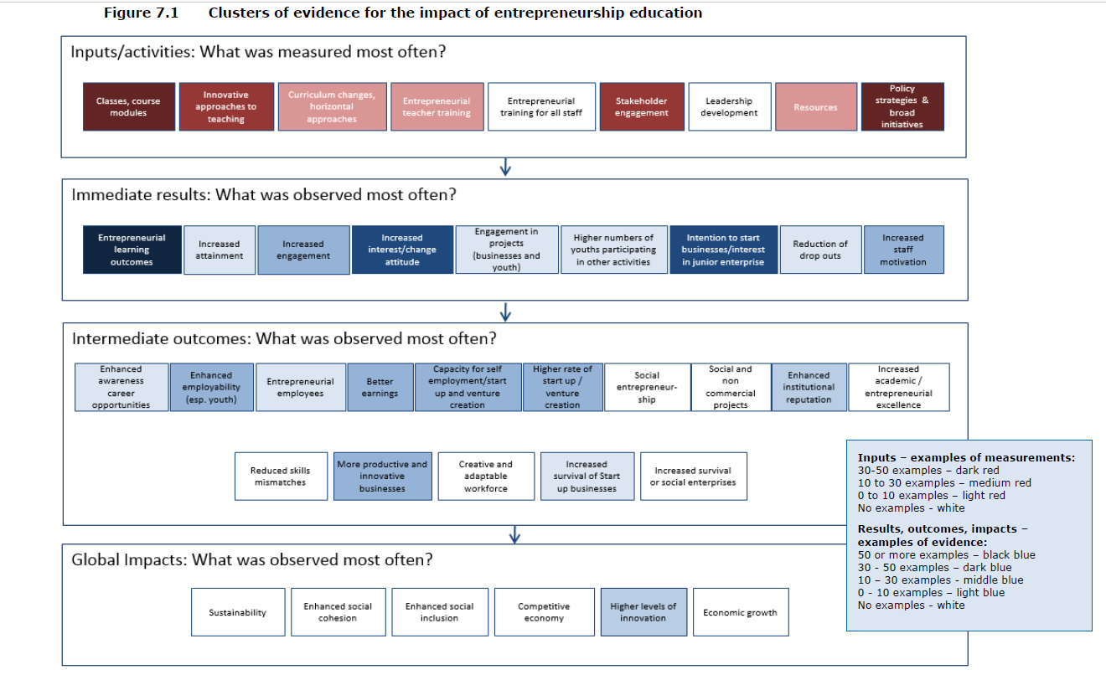 | European Commission, (2015) Entrepreneurship Education: A road to success, p. 86
Opportunities continued:
- Enabling students to develop an Entrepreneurial Mindset - Global Studies
Globally there are several programmes that aim to deliver EE to school children. One of the biggest is Junior Achievement whose website explains that they work in, “over 100 countries” and reach, “more than 12 million students each year” teaching them to, “think entrepreneurially” (jaworld.org, 2020). In 2015, a report was prepared for the European Commission, which conducted a meta-analysis of several studies that examined the impact of JA-YE programs. It presented the work of the organisation in a very favourable light and suggests the research offers, “significant proof” of the positive impact of EE programs (p.43). While there are some issues with this research, such as the fact that most of it is self-reporting on their own company, the meta-analysis does include some rigorous pieces of research including longitudinal studies from Sweden (Elert, Anderson, Wennberg, 2015) and the UK (Athayde, 2012) and some studies that involve control groups (Athayde, 2012) adding creditability to the overall findings. Furthermore, several other studies also report on the efficacy of EE helping students to develop soft skills, which are part of having an entrepreneurial mindset (EC, 2015). An Irish study suggests that students can develop greater self-confidence, improved communication skills, and improved presentation skills (Birdthistle et al., 2016). Similarly, case studies in Finland of music teachers (Hietanen, Ruismäki, 2016) and science teachers (Deveci, Seikkula-Leino, 2015) reported that students were able to exhibit and use entrepreneurial skills within their subjects. However, although these are promising results, they are based solely on teacher observations so further empirical research is required to support these findings.

Johansen Vangaard’s 2018 Innovation Cluster of Entrepreneurship Education report is one of the most rigorous pieces of research on EE including both quantitative surveys with 12 000 respondents including students, teachers, parents and industry members and qualitative interviews with 150 participants. The research was also carried out in multiple countries. The research looks at students who participated in the JA mini-company program over one year. The results compare a control group that did not participate in the mini-company program, students who participated for over 100 hours, and those who participated for less than 99 hours over a two-year period. Vangaard’s empirical findings provide important information for policymakers in relation to how to implement EE in South Australian schools. It was discovered that, students needed to complete more than 100 hours of EE to make an impact on the individual. Encouragingly, there were no negative impacts on the students who participated for over 100 hours. In fact, the opposite was true with this group improving their grade point average in other subjects and teachers reporting that students were more engaged and had a greater understanding of the relevancy of their other subjects. Students, teachers, and parents all reported that students developed skills in teamwork, presentation, being entrepreneurial, creativity, solving conflicts, and knowledge in running a business. Importantly, this study reveals that there are ways of gathering empirical evidence on EE and provides opportunities for other countries and researches to use similar methods to support their less empirical findings.

Opportunities continued:

- Studies within Australia and future opportunities for research
Within Australia there are many, many examples of EE programmes, but very little research about their efficacy.
Rogers and Hewson’s work on creating an innovation culture in Australia provides useful insights suggesting that it is important to start the development of non-cognitive skills in primary school and that it is necessary to teach both cognitive skills and knowledge and support the development of non-cognitive skills. It is suggested that this is best done through experiential learning (Rogers, Hewson,2016; Zhao 2012, 2019a).
Geof Hawke has written two evaluations of the Australian Business Week (ABW) program which has been running in Australia for 25 years. Unfortunately, his latest report is from 2003 and therefore one would imagine that given the immense digital change that has happened since then would not be entirely relevant to the current generation of young people. Nonetheless, an important finding from his work is that while students increased their knowledge of business practices by over 15% through participation in the intensive weeklong program, the proportion of those who would like to run a business went down (Hawke, 2003, p. 8). When considered alongside Vangaard’s 2017 findings that students needed to participate in over 100 hours to see positive impacts it suggests that policymakers should consider longer programs rather than shorter challenges if their aim is to increase the number of people starting businesses. The superiority of longer programmes has also been identified by the director of Lemonade Stand Steven Galveski (2020) and Nicole Dyson the director of FutureAnything (Personal communication, 5 May, 2020). Likewise, Beriman’s comparison of the term long $20 Boss program and the three-day Glo event found greater impacts for the students who participated in the longer EE program (2019).
Another interesting finding in Hawke’s work are the significant difference in responses between students in regional and city areas highlighting that EE programs need to be developed with context in mind and should not be administered in a one size fits all approach. These findings are supported by the more contemporary research seen in Anderson, Hinz and Matus’ report on The Paradigm Shifters program (2017), which operated in multiple different urban, regional and rural communities in NSW and VIC. It was noted that their research was not “generalisable” as the school contexts were all so different (p. 11 & 14).
Unlike much of the EE now happening in Australia, the successful EE seen in the Paradigm Shifters Program was not implemented by outside companies. Rather schools worked within the following key principles to develop their own site-based initiatives:
- Develop more personalised education experiences, so each person can pursue passions and talents to excel in unique ways.
- Engage in creative and entrepreneurial product-oriented learning experiences that can, in authentic ways, benefit local communities.
- Cultivate and prototype new approaches, processes or products.
(Anderson, Hinz, Matus, 2017, p. 10)

Some important features that need to be considered in implementing EE in South Australia are that schools participated through an ‘opt-in’ process. Furthermore, each state had a leader who was employed
Opportunities continued:

to support the delivery of the initiatives indicating the need to properly finance specialist teachers and leaders to oversee the implementation of programs. Promisingly, student-reported outcomes included enhanced entrepreneurial mindsets, increased confidence and resilience, a more positive view of school and improved agency (ibid. p. 12) However, like many of the other studies these results were established through self-reporting highlighting the need to develop a more empirical way to measure the efficacy of EE.

The most recent piece of research on EE in Australian schools compared two EE programs ($20 Boss and the Glo@Logan three-day program) using pre and post surveying of Years 9 and 10 students (Beriman, 2019). Beriman’s 2019 research is important for the implementation of EE in South Australia as it confirms the findings of studies in Europe and America in an Australian context using the $20 program, which South Australians’ can access. The research confirms that, students developed their teamwork, budgeting and presentation skills and improved their knowledge and value of entrepreneurship. However, similarly to Hawke’s 2003 work on ABW it revealed that participating in the EE program did not increase the students’ desires to become entrepreneurs. However, they could see how the entrepreneurial skills developed would be transferrable to university studies or future employment. Given that many start-ups fail, the fact that these programs may not be increasing students’ desires to be entrepreneurs could, in fact, be playing an important role in giving students a safe place to test their ideas and abilities and furthermore motivate them to try harder in other areas when they see the reality of running a business; this is an area for further research. Beriman’s thesis also combines the findings of her research with wider reading providing a useful outline of the key elements needed for implementing an effective EE program in school: “problem-based learning, teamwork, lean start-up methodology, authentic environment, cross-curricular, prototyping the minimal viable product, financial literacy, formalised presentation and working with industry mentors” (Beriman, 2019, pp 121-123). The inclusion of pre-tests in this study is an improvement on some previous studies as is the inclusion of two different programs and students from multiple schools. However, the research could have been improved by including follow up surveys to gauge the longitudinal impact of the work and by the inclusion of a control group and working with a larger sample. As the research was done for a master’s thesis, it would have been difficult to carry out longitudinal measurements. Further research is needed to confirm these results and to further explore why participation in EE programs appears not to encourage Australian students to start their own businesses.

- A sample of EE programs running in South Australia
As Australia has been relatively slow in embedding EE into the curriculum many entrepreneurs have seen the gap in the market and have developed a myriad of programs that can be run in schools. Some are provided by not for profits who are concerned by the startling statistics about the employability of young people (FYA, 2015, 2016, 2017, 2018; Lamb, Hua, 2017) others are for profit. (See Table 4 for a sample of programs)
The popularity of these programs is testament to teachers and principals’ belief in the necessity of EE as most schools have very tight budgets. These programs provide an opportunity for young people to access essential EE and most fulfil many of the requirements outlined in Beriman’s work. Some are completely

Opportunities continued:

directed towards start-ups and making money such as Lemonade Stand (Personal communication, S. Glaveski, 7 May 2020) while others, such as the Future Anything programs and $20 Boss, also focus on social entrepreneurship or in the case of Future Anything developing an entrepreneurial mindset to implement in other areas of life. (Personal communication, N. Dyson, Future Anything 5 May 2020; FYA, 2020). The programs listed in the table are available to everyone. There are also competitions available for young people who already have an idea and require mentoring such as Future Anything’s Youthx and FYA’s Young Social Pioneer program. (FA, 2020; FYA, 2020)
There are serious issues with equity as students’ access to all of the programs is dependent on the financial resources of the school and the know-how and impetus of individual principals and teachers. Notably, the majority of programs cost between one and six thousand dollars making them prohibitive for many schools and students. Furthermore, as there is no system of accreditation or quality control schools could pay thousands of dollars for a program and potentially provide a terrible learning experience resulting in the opposite of what was hoped in relation to improving the students’ entrepreneurial mindsets. In his work on positive education, Mathew White noted that one of the main eight obstacles to creating a policy shift in relation to well-being in education was:
“Maverick providers: providers who deliver questionable training around the topic that claim to have impact with limited evidence.” (White, 2016)
EE in South Australia (and Nationally) is at risk of the same fate as governments may assume that they do not need to provide policy as it is already being delivered or if its delivery creates poor results governments may decide not to implement it at a systemic level. There is an urgent need for a proper registration and quality control system to be developed for these initiatives in which an audit could provide accurate and useful information to schools when they are choosing where to allocate their resources. Ultimately, the South Australian Department for Education needs to work with these providers to ensure that all South Australian students get equitable access to quality EE.

Table 4. Example EE programs in Australia run by external providers in 2020
$20 Boss - FYA
https://www.fya.org.au/programs/20boss/
Lemonade Stand
https://www.lemonadestand.rocks/
Young Change Agents
https://youngchangeagents.com/
Kidreneur
https://www.theentropolis.com/kidpreneur-challenge/
Futurepreneurs
https://www.theentropolis.com/futurepreneurs-academy/
FutureAnything
Sparke
https://www.futureanything.com/#our_programs

FutureAnyting
Ignite
https://www.futureanything.com/#our_programs
FutureAnything
Activate
https://www.futureanything.com/#our_programs
Australian Business Week
https://www.abw.org.au/
Shark Tank
https://www.adelaide.edu.au/echallenge/shark-tank-eschool

Opportunities continued:

What are South Australian Educational Leaders Doing?

In addition to the thousands of dollars being spent on EE programs, there is other evidence that educators in independent, Catholic and public schools in South Australia are embracing EE. In 2019, The Association of Independent Schools of South Australia (AISSA) and the South Australian Secondary Principals’ Association (SASPA) worked on a joint project with Yong Zhao in which ten independent and ten public schools explored the possibilities and challenges of implementing “Professor Zhao’s principles of student autonomy, product-oriented learning and the global campus which, he believes, are foundational to a world class education”(TPSLS, 2019). While this belief and encouragement from leaders of education in South Australia in relation to EE is a step in the right direction, the problem remains that these are isolated examples of practice. Furthermore, despite the wealth of knowledge that would have been gained through this process, there are no peer-reviewed articles or empirical research connected with the initiative making it harder to convince Federal Government policymakers, who only believe in “evidenced-based” (DfE Startegic Plan, 2019) education to implement these changes in a widespread and socially just fashion through the curriculum. The book, An Education Crisis Is a Terrible Thing to Waste: How Radical Changes Can Spark Student Excitement and Success (Zhao, Emler, Snethen, Yin, 2019) brings together a number of case studies of schools and networks implementing change including the South Australian School, Annesley Junior College and the Paradigm Shifters Network, however, their work has not been peer-reviewed and it does not report on every school in the program. Similarly, within Catholic Education, there was also an “Entrepreneurial and Innovation Network” in 2019, who worked in partnership with Yong Zhao to develop a range of EE initiatives at many primary and secondary schools in the Catholic system, but there is no publicly published material on the outcomes (CEA, 2020). Further work needs to be done to organise a systematic way to share the learnings gained from South Australian sites who are implementing innovative examples of EE.

Finally, one of the most important opportunities for implementing and evaluating EE in South Australia is that there is evidence that the mindset of some policymakers is shifting to embrace EE. The South Australian Department for Education released the Entrepreneurial Learning Strategy in 2018, which aims for students to “develop an entrepreneurial mindset” (ELS, 2018, p.2). Initially, five pilot high schools are developing EE practices and programs, which it is hoped they will then share across the school networks. Encouragingly they are following the effective practice seen in the 2017 Paradigm Shifters report as all schools are participating through an opt-in model (Anderson, Hinz, Matus, 2017). Similarly, honouring the “personalizable” approach advocated by Zhao (2019a), they are developing different programs that suit their contexts. Although not mentioned in the report, discussions with William Denny, the Senior Policy and Project Officer in Further Education and Pathways at the Department for Education South Australia confirm that the pilot schools are engaging with primary schools in their regions and that a competency framework is under development to support the widespread development of assessable EE programs in South Australian schools. (W. Denny, personal communication, May 4, 2020). Moreover, given the widespread research showing its necessity (Androutsos & Brinia, 2019; Birdthistle et al, 2016; Borasi & Finnigan, 2010; Deveci &Seikkula-Leino, 2015; Roffel, 2010; Ruskovaara, Pihkala, 2013; Ruskovaara, Pihkala, 2015) it is promising that the strategy includes a goal for the “number of teachers undertaking entrepreneurial professional development” to increase (ELS, 2018, p. 10). Of concern, is that while the pilot schools are funded to have an Assistant Principal and Teacher overseeing EE there is no mention of the funding extending to all schools. Similarly, there is no mention of how the teacher training will be funded. Furthermore, schools that want to develop these initiatives need to do so within the context of the State and Federal Governments’ overarching policies for education which are focused on “evidence based” practice to improve our standing in world tests of numeracy, literacy and science (Eacott, 2017; Hattie, 2009; ISA&HP, 2017; DfE Strategic Plan, 2019).

Challenges
- Lack of Government Policy and Direction
Unfortunately, while some schools are developing fantastic practices in EE they and the rest of the public schools in South Australia still need to comply with the Department’s overall strategic aspirations which are to provide a: “World class” and “Evidenced-based education” (DfE Strategic Plan, 2019). While at first glance these don’t seem like poor goals, they put a very narrow focus on education. One result of globalization is a standardization of skills and as a result many countries wish to compare themselves with other countries (Zhao, 2012). They do this by looking at their rankings on international literacy, science, and numeracy tests such as PISA and TIMSS and as these are the only things that are measured and compared on an international level, they end up receiving the majority of resourcing. “World Class” translates to the best at preparing students to take literacy and numeracy tests. The current obsession with basing educational policy and funding decisions on “evidence based” (which means relating to test scores) and inspired by the work of John Hattie “evidence-informed” (2009) (which means based on research) is a significant challenge for implementing and evaluating EE in South Australia as currently there is minimal research on this type of education. Hopefully, the Department for Education’s development of competencies for EE will enable some of the initiatives to be measured and evaluated and then perhaps they might start to attract some of the funding that is currently swept up in literacy and numeracy programs.
South Australia’s focus on “evidenced-based” education is supported by the Federal Government’s position. While many European countries have specific EE reports and policies, (EC, 2017, p 22-24) Australia does not. The Australian Curriculum has a subject called Work Studies, but it is still focused on career planning rather than the development of an entrepreneurial mindset (AC, 2020). Similarly, the Federal Government’s 2019 Future Ready: A student-focused National Career Strategy does not mention EE, entrepreneurial skills or 21st century skills and instead is rooted in the 20th-century concept of students having a “career” a word that is mentioned 78 times in the 25-page document (AG, 2019). Likewise, the “much anticipated” (Dayton, Green, 2018) Australia 2030: Prosperity Through Innovation report identifies education as one of five “imperatives” of innovation, but then lists very narrow and non-entrepreneurial targets. Despite acknowledging that people in the future will need “entrepreneurial skills”, the report claims that the best way to do this is to ensure that students have “foundation” (p.2) skills in STEM subjects, the arts, social sciences, and humanities. It does not specify teaching specific entrepreneurial skills or EE anywhere (ISA&HP, 2017 ). While it briefly acknowledges that, “Only 1 in 10 teachers has recently participated in professional development to help students to develop generic, transferable skills for future work” (Freeman, O’Malley, Eveleigh, 2014 in ISA&HP, 2017) the rest of the focus for several paragraphs is the importance of professional development for teachers in subject-specific skills in STEM subjects such as maths and science and many mentions of the need to be “world class” in rankings in international tests (ISA&HP, 2017 pp 26- 38). The narrow focus on STEM is stark with 63 references throughout the 125-page document in contrast to only 5 references to 21st- century skills (ISA&HP, 2017). Research is emerging that suggests that not only is a narrow focus on STEM not pedagogically sound, but also economically unwise (Zhao, 2018.) Zhao reports that due to the drastic increase in personal income, by 2026, 9 out of 10 jobs in the USA in 2026 will be in the service industry and therefore, “In today’s vastly networked hyper-specialised economy, no one type of talent is sufficient. Economic productivity requires a multitude of talents” (Zhao, 2018, p. 64). While literacy, numeracy and STEM skills are all important 21st century skills they are not the only skills students need in the future.
The conflict between aspirations to include 21st century skills into education and a reliance on international tests to measure the success of education systems is a major challenge for the effective implementation of EE in South Australia. Even at an international level, organisations such as the OECD, who have published many reports championing the cause of EE (Lackéus/OECD, 2015; OECD,2016, 2020) also continue to print reports that claim that education is in crisis based solely on results in the PISA tests on literacy, numeracy and science going down(OECD,2019).
A challenge for implementing EE in Australia is that the test-based culture currently prevalent in the State and Federal education departments conflicts with the intent of the Australian Curriculum’s (AC) general capabilities, which are essentially 21st century skills, (See Figure 3). The 2014 review of the AC found that they were not integrated well because of the extensive content that teachers were required to teach (AGDE, 2014, p.3). When teachers have too much to teach, they will prioritise what is being measured (Zhao, 2012). The twelve specific examples of entrepreneurial practice that are provided on the AC website as examples of Illustrations of Practice (AC, 2020) are inspiring and demonstrate EE in action, but they all involved significant additional planning and programming by the teachers and are not sustainable models for widespread adoption of EE and the inculcation of EE in the Australian Curriculum. Nor are they representative of the education being delivered to the majority of students in Australia. Furthermore, the AC has not kept up with the demands of our changing world. While it does specify that students should learn about digital technologies it only allocates 2% of the week to this subject for Years 9 and 10 and 4% for Year 8 (Lynch, 2013). Considering that the Foundation for Young Australians suggests that over 50% Australia’s workforce will need to either configure and use digital systems or build digital technology (FYA, 2016) it is hard to understand why such a small amount of time is allocated to its delivery. Better supporting teachers to integrate the general capabilities into their delivery of the curriculum is an important challenge in implementing EE in South Australia.
Figure 3 – The general capabilities in the Australian national curriculum
(ACARA, 2019)
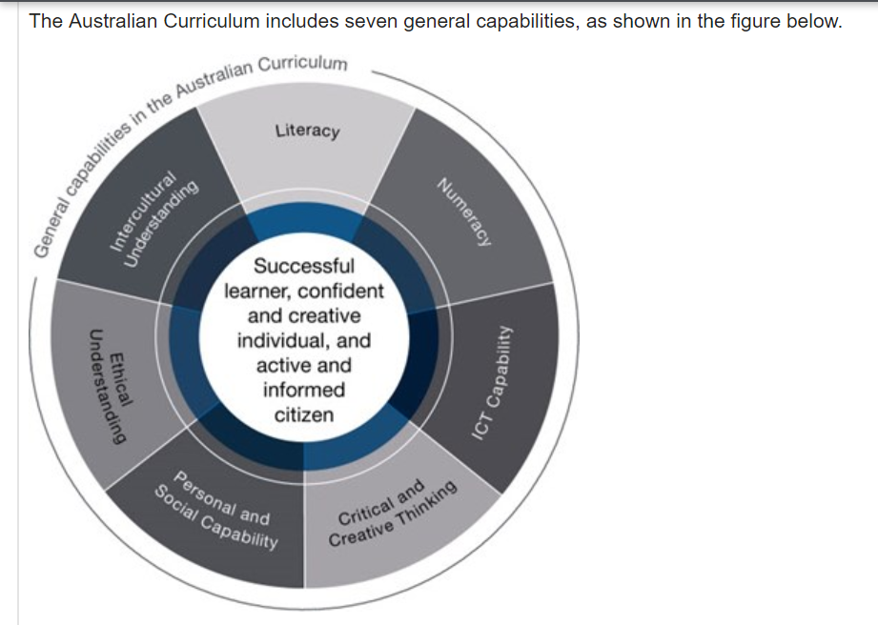
Challenges continued
- Lack of teacher knowledge
Globally the research reveals that a key challenge when implementing EE is a lack of teacher training and knowledge, with this being the key issue identified in peer-reviewed papers (Androutsos & Brinia, 2019; Birdthistle et al, 2016; Borasi & Finnigan, 2010; Deveci &Seikkula-Leino, 2015; Roffel, 2010; Ruskovaara, Pihkala, 2013; Ruskovaara, Pihkala, 2015). Notably, Isa Deveci and Jaana Seikkula-Leino’s 2018 literature review of EE in teacher education identifies that there are 29 quantitative, 23 qualitative and 30 ‘other’ studies on this topic suggesting that there is ample evidence to justify improvements in both pre-service teacher training in EE and in-service training for practicing teachers in South Australia.
The form that this training takes needs to both teach the specialist entrepreneurial subjects (Birthistle et al, 2016; Roffel 2010, EC, 2015) and different pedagogical approaches that facilitate more student-driven models such as product-oriented teaching (Zhao, 2016, 2018) to facilitate the development of an entrepreneurial mindset in students. There is evidence that exposing teachers to entrepreneurial approaches to education will prepare them to become more effective “agents of change” (Anderson, Hinz & Matus, 2017; Borasi & Finnigan, 2010, p, 1; Androutsos & Brinia, 2019; Zhao, 2012, 2016, 2018b).
There is almost a unanimous call for greater training in general for the delivery of EE in schools and research also shows that specific areas of EE also need greater teacher training even within groups of people who are trained in teaching about entrepreneurship. Lynne Wyness, Paul Jones, and Rita Klapper’s 2015 research calls for “entrepreneurship educators to …embed the core facets of social, environmental and … ethical sustainability” into their tertiary courses. While they surveyed university practitioners and not teachers, their research shows that many tertiary educators only focus on the economic side of entrepreneurship. Whether the same is true for school practitioners is an area for research and potential training for educators, particularly as “Sustainability” is one of the “Cross Curriculum Priorities” of the Australian National Curriculum (AC, 2020).

- What are the side effects?
In his 2017 book, What works may hurt: Side effects in education, Yong Zhao presents a well-argued case that educational research should consider the side effects of educational interventions and policies in much the same way as medical research is required to. When considering implementing EE in South Australia it is important to look at possible side effects to ensure ethical educational opportunities for the students and to prevent naysayers gathering evidence to argue against it being systematically embedded. Amyssoun Sukarieh and Stuart Tannock’s 2009 study of Junior Achievement Worldwide highlights the need to carefully guard against the commercialisation of the education system through EE. This is a sentiment also highlighted by Lackéus when he sites multiple authors (Erkkilä, 2000, p. 124; Komulainen et al., 2011; Berglund, 2013; Dahlstedt and Hertzberg, 2012 in Lackéus, 2017, p. 634), who are concerned about neoliberal ideologies infiltrating education through EE. While much of the research suggests that partnerships with industry are an essential and productive element of EE (Beriman, 2019, pp 121-123; EC, 2015), the South Australian Department for Education must proceed with caution and carefully create a policy to ensure that industry participants are not unduly prejudicing students towards their commercial interests. Furthermore, it is imperative that research is considered through a socially just lens as many of the minority groups in South Australia are those that need EE the most(AHRC, 2014). Almost every study found that there are differences in the impact of EE based on sex, background, and ethnicity this information should be used to ensure that different programs are developed to cater to the range of needs and not as one researcher suggested as a possibility to target, “those with… high…social and human capital” (Athayde, 2012, p.20) to ensure the greatest economic return on the investment. Approaching EE with a, “student as giver” approach has been posited by Lackéus as a constructive solution to both enable students to develop entrepreneurial mindsets and support students who are “not served” by “today’s neoliberal marketized society” (2017, p. 645).

Conclusion
There are many real and difficult challenges to implementing and evaluating entrepreneurship education in South Australia. Foremost, the lack of funding and resourcing caused by unsupportive government policies and priorities. Secondly, the lack of any research at a local level and the minimal amount of empirical peer-reviewed literature at a global level, which also makes it hard to change the government policies. It has been recognised both in the literature and by the government that there needs to be significant increases in pre and in-service training for teachers to enable them to confidently and successfully deliver EE and until government policy shifts it is hard to envisage how this training will be funded. Finally, there are ethical considerations that must be thought through both in the implementation of EE and in further research.
However, the many opportunities provided by EE outweigh the complicated challenges faced. Most importantly, there is an extreme imperative for a paradigm shift in education to a more entrepreneurial model. The world is facing innumerable challenges and students must be equipped to deal with them. The evidence proves that our current system does not adequately prepare all young people for the world of work so something must change. On a more positive note, the minimal evidence that exists all reveals positive outcomes from EE including, but not limited to: improved entrepreneurial mindsets and greater contributions to the economy.
This literature review has identified numerous areas for further research, and it is vital this is carried out soon as many of the main barriers impacting the speedy implementation of EE could be countered with sound peer-reviewed evidence.
Areas for further research include:
- Ways to empirically measure the success of EE
- The impacts of EE initiatives in South Australia
- Longitudinal studies on the impact of EE in Australia
  - Exploring why Australian students do not have a greater wish to become entrepreneurs after participating in EE programs
- The impact of EE on students from low socio-economic backgrounds
- How to implement EE in a socially just manner
- Ways to improve governance in providing quality control of external providers of EE

References

- Anderson, M., Hinz, B. and Matus, H. (2017). The Paradigm Shifters: Entrepreneurial Learning in Schools. Research report, Mitchell Institute Report No. 04/2017. Mitchell Institute, Melbourne. Available from www.mitchellinstitute.org.au

- Athayde, R., (2009). Measuring enterprise potential in young people. Entrepreneurship Theory & Practice 33, 481–500.

- Athayde, R (2012). Impact: 50 years of young enterprise. (Technical Report) Young Enterprise. 44 p.

- Australian Human Rights Commission (2014) Face the Facts view online at: www.humanrights.gov.au

- Australian National Curriculum (2020) General Capabilities. Retrieved from: https://www.australiancurriculum.edu.au/f-10-curriculum/general-capabilities/

- Australian Curriculum, (2020), General Capabilities Illustrations of Practice Retreived from: https://www.australiancurriculum.edu.au/f-10-curriculum/general-capabilities/

- Australian Curriculum,(2020) Sustainability Cross Curriculum Priority on the Australian Curriculum Website: Retrieved from: https://www.australiancurriculum.edu.au/f-10-curriculum/cross-curriculum-priorities/sustainability/

- Australian Curriculum, (2020) Work Studies, Retrieved from: https://www.australiancurriculum.edu.au/f-10-curriculum/work-studies/

- Australian Government Department of Education (2014), Review of the Australian curriculum: final report, Department of Education, Canberra, https://docs.education.gov.au/documents/review-australian-curriculum-final-report

- Australian Government, (2019) National Career and Education Strategy Retrieved from: https://www.education.gov.au/national-career-education-strategy

- Bacigalupo, M., Kampylis, P., Punie, Y., Van den Brande, G. (2016). EntreComp: The Entrepreneur-ship Competence Framework. Luxembourg: Publication Office of the European Union; EUR 27939 EN; doi:10.2791/593884

- Belwal, R., Al Balushi, H., & Belwal, S. (2015). Students' perception of entrepreneurship and enterprise education in Oman. Education & Training, 57(8-9), 924-947. doi:http://dx.doi.org.proxy.library.adelaide.edu.au/10.1108/ET-12-2014-0149

- Beriman, G. (2019). An Exploration of Two Entrepreneurship Education Programs Delivered to Secondary School Students and Their Impact on Student Self-Efficacy (Masters Thesis, Griffith University).

- Birdthistle, N., Costin, Y., & Hynes, B. (2016). Engendering entrepreneurial competencies in the youth of today: A teacher's perspective. Education & Training, 58(7-8), 766-782. doi:http://dx.doi.org.proxy.library.adelaide.edu.au/10.1108/ET-02-2016-0031

- Bosma, N, Stephen Hill, Aileen Ionescu-Somers, Donna Kelley, Jonathan Levie, Anna Tarnawa (2020) Global Entrepreneurship Monitor 2018/1019, Global Entrepreneurship Research Association, London Business School. Retrieved from: file:///C:/Users/seark/Downloads/gem-2019-2020-global-report-rev-220420-1587544406%20(1).pdf

- Catholic Education Australia (CEA) (2020) Website: Registration: entrepreneurial and innovation network. Retrieved from: https://registrationcentre.cesa.catholic.edu.au/event-3228265

- Chatzichristou, S., Curth, A., Feifa, I., Gosset, M., Kadunc, M., Mosca, M., Vale, P., Williamson, N.,Allinson, R. and Håkansson, A. (2015), Entrepreneurship Education: A Road to Success – 13 Case Studies, European Commission, Brussels.

- Clayton, R. (2017). Building Innovation Ecosystems in Education to Reinvent School A study of innovation & system change in the USA.

- Department for Education [South Australia] (2019) Strategic Plan. Retrieved from: https://www.education.sa.gov.au/sites/default/files/strategic-plan-2019-department-for-education.pdf

- Deveci, I., & Seikkula-Lein, J. (2016). Finnish science teacher educators' opinions about the implementation process related to entrepreneurship education. Electronic Journal of Science Education, 20(4), 1-20. Retrieved from http://proxy.library.adelaide.edu.au/login?url=https://search-proquest-com.proxy.library.adelaide.edu.au/docview/2101885612?accountid=8203

- Deveci, I., & Seikkula-Leino, J. (2018). A review of entrepreneurship education in teacher education. Malaysian Journal of Learning and Instruction, 15(1), 105-148. Retrieved from http://proxy.library.adelaide.edu.au/login?url=https://search-proquest-com.proxy.library.adelaide.edu.au/docview/2101892665?accountid=8203

- Eacott, S. (2017) School leadership and the cult of the guru: the neo-Taylorism of Hattie, School Leadership & Management, 37:4, 413-426, DOI: 10.1080/13632434.2017.1327428

- Elert, N, Andersson, FW & Wennberg, K 2015, ‘The impact of entrepreneurship education in high school on long-term entrepreneurial performance’, Journal of Economic Behavior and Organization, vol. 111, no. C, pp. 209–223.

- European Commission, (2015) Entrepreneurship Education: A road to success, Retrieved from: https://ec.europa.eu/growth/content/entrepreneurship-education-road-success-0_en

- Hietanen, L., & Ruismäki, H. (2016). Awakening students' entrepreneurial selves: Case music in basic education. Education & Training, 58(7-8), 832-848. doi:http://dx.doi.org.proxy.library.adelaide.edu.au/10.1108/ET-02-2016-0047

- Hannon, V. and Peterson A (2017), Thrive: Schools Reinvented for the real challenges we face, Innovation Unit Press, London, http://www.innovationunit.org/wp-content/uploads/2017/04/Thrive_Preface.pdf

- Foundation for Young Australians. (2015). Report Card 2015 How are young people faring in the transition from school to work? Retrieved from: https://www.fya.org.au/wp-content/uploads/2015/11/How-young-people-are-faring-report-card-2015-FINAL.pdf

- Foundation for Young Australians. (2016). The new basics: Big data reveals the skills young people need for the new work order. Retrieved from https://www.fya.org.au/report/thenew-basics/

- Foundation for Young Australians. (2017). The new work order: Ensuring young Australians have skills and experience for the jobs of the future, not the past. Retrieved from: http://www.fya.org.au/wp-content/uploads/2015/08/fya-future-of-work-report-final-lr.pdf

- Foundation for Young Australians. (2019) FYA Annual Report 2018: Rethink the world, unleash the future, Retrieved from: https://www.fya.org.au/wp-content/uploads/2019/05/fya-annual-report-2018.pdf

- Freeman, C, O’Malley, K & Eveleigh, F (Australian Council for Educational Research) 2014, Australian teachers and the learning environment: an analysis of teacher response to TALIS 2013, Australian Government Department of Education, Canberra,

- Glaveski, S (2020) 5 Things Schools Get Wrong About Teaching Entrepreneurship. Retrieved from: https://www.lemonadestand.online/blog/5-things-schools-get-wrong-about-teaching-entrepreneurship

- Hattie, J. A. C. 2009. Visible Learning: A Synthesis of over 800 Meta-analyses Relating to Achievement. London: Routledge.

- Hawke, G. (2001). The ABW Enterprise Education Program: A three-year review.

- Innovation and Science Australia & Howard Partners (2017), Australia 2030: prosperity through innovation: a plan for Australia to thrive in the global innovation race, Department of Industry, Innovation and Science, Canberra, viewed 06 May 2020, <https://industry.gov.au/Innovation-and-Science-Australia/Australia-2030/Pages/default.aspx>.

- Lackéus, M. (2015). Entprepreneurship in Education:What, Why, When, How. OECD, Retrieved from: https://www.oecd.org/general/searchresults/?q=Lackeus

- Lackéus, M. (2017). Does entrepreneurial education trigger more or less neoliberalism in education? Education & Training, 59(6), 635-650. doi:http://dx.doi.org.proxy.library.adelaide.edu.au/10.1108/ET-09-2016-0151

- Lamb, S. and Huo, S. Counting the costs of lost opportunity in Australian education. Mitchell Institute report No. 02/2017. Mitchell Institute, Melbourne. Available from: www.mitchellinstitute.org.au
- Lynch, M. (2013). Guidelines for the Implementation of the Australian Curriculum in DECD Schools: Reception – Year 10. (June 2013). Retrieved from https://myintranet.learnlink.sa.edu.au/library/document-library/controlled-guidelines/guidelines-for-the-implementation-of-the-australian-curriculum-in-decd-schools-reception-to-year-ten.pdf

- OECD. (2016)"The Innovation Imperative in Education." Innovating Education and Educating for Innovation: The Power of Digital Technologies and Skills. Paris: OECD,. 11-34. Educational Research and Innovation. Web.

- OECD. (2018). The Future of Education and Skills: Education 2030. OECD Education Working Papers, 23. https://doi.org/10.1111/j.1440-1827.2012.02814.x

- OECD, 2020 Tackling coronavirus (Covid-19) retrieved on 3/5/20 from: https://www.oecd.org/coronavirus/en/

- Robinson, K (2006) Do Schools Kill Creativity? TED Talk. Retrieved from: https://www.ted.com/talks/ken_robinson_says_schools_kill_creativity#t-14412

- Robinson, K (2010) Bring on the Learning Revolution! TED Talk. Retrieved from: https://www.ted.com/talks/sir_ken_robinson_bring_on_the_revolution

- Robinson, K (2013) How to escape education’s Death Valley. TED Talk retrieved from: https://www.ted.com/talks/ken_robinson_how_to_escape_education_s_death_valley#t-21037

- Robinson, K (2017) Out of Our Minds - the Power of Being Creative, Third Edition. John Wiley and Sons Ltd. Great Britain.

- Rogers, A & Hewson, E (2016), ‘Development of an early on-set innovation culture in Australia’, Small Enterprise Research, vol. 23, no. 2, pp. 182–189.

- Roffe, I (2010), ‘Sustainability of curriculum development for enterprise education’, Education + Training, vol. 52, no. 2, pp. 140–164.

- Strauss, S. (2006, June 26) Education for entrepreneurs. USA Today. Retrieved April 8, 2012, from http://wwwusatoday.com/money/smallbusiness/columnist/strauss/2006-06-26-education_x.htm in Zhao, Y (2012) World Class Learners: Educating Creative and Entrepreneurial Students. Corwin. USA.

- Schanzenbach, DW 2012, ‘Limitations of Experiments in Education Research’, Education Finance and Policy., vol. 7, no. 2.

- Searson, C (2019) ‘Table 1. Global Challenges’ from the unpublished work: Case Study: Innovation and Creativity in Education submitted for the subject Creativity and Innovation at the University of Adelaide Trimester 2, 2019.

- Sukarieh, M., & Tannock, S. (2009). Putting school commercialism in context: A global history of junior achievement worldwide. Journal of Education Policy, 24(6), 769-786. Retrieved from http://proxy.library.adelaide.edu.au/login?url=https://search-proquest-com.proxy.library.adelaide.edu.au/docview/61818713?accountid=8203

- Technical education and Skills Development Authority (TESDA) 2010, Glossary of Terms 4th Edition Philippines

- The Paradigm Shifters Symposium Website, (2019) Overview and Program. Retrieved from: https://www.ais.sa.edu.au/events/paradigm-shifters-symposium/

- Turner, P & Robinson, C 2000, ‘High performance enterprise communities: a new wave of enterprise education in South Australia’, Vocal, vol. 3, no. 2000-2001, pp. 42–45.

- Ruskovaara, E & Pihkala, T 2013, ‘Teachers implementing entrepreneurship education: classroom practices’, Education + Training, vol. 55, no. 2, pp. 204–216

- Ruskovaara, E & Pihkala, T (2015) Entrepreneurship Education in Schools: Empirical Evidence on the Teacher's Role, The Journal of Educational Research, 108:3, 236-249, DOI: 10.1080/00220671.2013.878301

- UNESCO/ILO 2006 Global United Nations.(2019) Website: ‘Sustainability Development Goals’(2015). Retrieved from: https://www.un.org/sustainabledevelopment/education/

- WEF. (2015). 21st Century Learning - New Vision for Education Unlocking the Potential of Technology. New Vision for Education: Unlocking the Potential of Technology, 1–32. Retrieved from www.weforum.org 13/7/19

- Wennberg, K (2011), Practice Makes Perfect? A Longitudinal investigation of Junior Achievement Sweden alumni and their entrepreneurial careers, 1990- 2007. Retrieved from: https://www.dropbox.com/s/71m2id6gp0gvw88/22-Practice%20Makes%20Perfect-A%20Longitudinal%20Investigation%20of%20Junior%20Achievement%20%28JA%29%20Sweden%20Alumni%20and%20Their%20Entrepreneurial%20Careers.pdf?dl=0

- White M. A. (2016). Why won't it Stick? Positive Psychology and Positive Education. Psychology of well-being, 6, 2. https://doi.org/10.1186/s13612-016-0039-1

- Zhao, Y. (2006). Are we fixing the wrong things? Educational Leadership, 63(8), 28-31. Retrieved from http://proxy.library.adelaide.edu.au/login?url=https://search-proquest-com.proxy.library.adelaide.edu.au/docview/62105325?accountid=8203

- Zhao, Y (2012) World Class Learners: Educating Creative and Entrepreneurial Students. Corwin. USA.

- Zhao, Yong, et al. (2016) The Take-Action Guide to World Class Learners Book 2 : How to "Make" Product-Oriented Learning Happen, SAGE Publications, ProQuest Ebook Central, https://ebookcentral.proquest.com/lib/adelaide/detail.action?docID=4733057.

- Zhao, Y. (2017). What works may hurt: Side effects in education. Book Kindle edition.

- Zhao, Y. (2018). The Changing Context of Teaching and Implications for Teacher Education. Peabody Journal of Education, 93(3), 295–308. https://doi.org/10.1080/0161956X.2018.1449896

- Zhao, Y (2018b). Reach for Greatness: Personalizable Education for All Children, Thousand Oaks, California: Corwin (Kindle edition)

- Zhao, Y. (2019). The Rise of the Useless: the Case for Talent Diversity. Journal of Science Education and Technology, 28(1), 62–68. https://doi.org/10.1007/s10956-018-9743-3

- Zhao, Y (2019b), An Education Crisis Is a Terrible Thing to Waste: How Radical Changes Can Spark Student Excitement and Success.

