Dr Stephen King
Presiding Commissioner
Ms Julie Abramson
Commissioner
Inquiry Australian Maritime Logistics Systems
Productivity Commission

Dear Commissioners
We thank the Productivity Commission for the opportunity to comment on the draft report Lifting productivity at Australia's container ports: between water, wharf and warehouse. We appreciate that this submission is being made after completion of the draft report but hope we can add further perspective to the inquiry.
Business SA, the Chamber of Commerce and Industry, represents over 3,900 members and has advocated for South Australian businesses for over 180 years. We are a not-for-profit, membership-based organisation which represents the interests of business community in pursuit of economic prosperity in South Australia.
We have continually heard from our members on the increased costs of freight over the last two years. Indeed, the draft report touches upon those costs experienced by exporters and importers. However, many of our members have also found the costs associated with using Flinders Port considerable.
Information request 3.4
The Commission is seeking feedback on its proposed methodology for benchmarking Australia’s ports. Would it be feasible and useful? Would alternative approaches have greater merit? If benchmarking is considered useful, who should undertake it? And how often should it be undertaken?
Business SA supports the need for further enhancement of port performance measures. A comprehensive set of measures that can be easily benchmarked would have great value in identifying where ports are lagging. Performance measurement should be comprehensive from quay to gate. Performance should not only be limited to ports and stevedores but also to the users of the ports. For example, shipping lines meeting scheduled times and transport operators meeting slot times. We know from Flinders Ports that factors outside of their control have a significant impact on their operations. On the one hand, ships calling in late have shorter times in port. On the other hand, transport operators missing their slots leads to longer late times at the gate. Performance measures should be made to the ACCC and included in their yearly Container stevedoring monitoring report.
Draft recommendation 6.2
Terminal access charges and other fixed fees for delivering or collecting a container from a terminal should be regulated so that they can only be charged to shipping lines and not to transport operators.
Business SA supports the regulation of landside charges. However, but argues these should not be charged fully to shipping lines, as we believe this would disadvantage the state. Port Adelaide is already at a disadvantage in attracting shipping lines to the port, and experiences instances of ships bypassing it due to bunkerage costs or being behind schedule due to delays in other ports.
We support container terminals being regulated by state economic regulators. Currently, the Essential Services Commission of South Australia (ESCOSA) regulates the seaside fees but has no mandate to regulate landside fees, these being the Terminal Access Charges (TAC) and other compliance charges.
Since 2019 these fees have risen considerably. The graph below demonstrates how these increases have impacted one of our members since 2018. The total fees paid to Flinders Adelaide Container Terminal (FACT) only includes the compulsory charges: TAC, slot charge and weighing charges (Imports only) and does not include compliance and other charges.
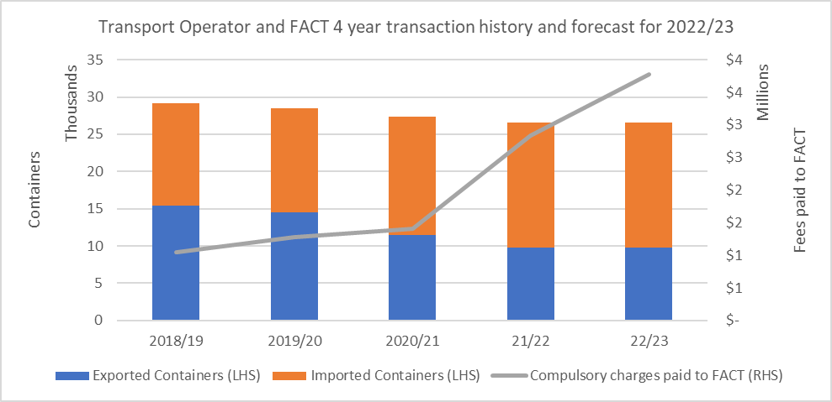
*2022/23 number of containers is based off the number of containers used in 2021/22.
Business SA also questions the introduction of a road train charge at FACT. Considering 59 per cent of vehicles entering FACT are high efficiency vehicles, the charge is counterproductive and penalises operators from using more productive vehicles. The use of high-efficiency vehicles seems to be the standard rather than a once-off.
A history of FACT terminal landside charges can be found in Appendix A.

Infrastructure Investment

The draft report highlights the growth in container ships being built and the potential for larger ships calling into Australia. While this will require further investment on the seaside, there will be a need to invest on the landside as well. This will ultimately lead to times of acute demand on both the seaside and landside. Transport operators will be incentivised to use high-efficiency vehicles at peak times to maximise slot times.

Business SA members have continually reported periods of intense demand with significant wait times for vehicles to enter the port. We would state that landside investment is just as important as seaside and container terminals should consider both.
For any inquires related to this submission, please contact Jordan Smith, Policy Adviser.

Yours sincerely

Andrew Kay
CEO
Business SA

Appendix A: FACT terminal landside charges

Terminal Landside related charges | Rate as of 1 July 2015 | Rate as of 1 July 2018 | Rate as of 1 July 2019 | Rate as of 1 July 2020 | Rates as of 1 July 2021 | Rate as of 1 April 2022
Terminal Access Charge (export) |  | $ 28.50 | $ 28.96 | $ 29.60 | $ 75.00 | $ 79.50
Terminal Access Charge (import) |  |  |  |  |  | $ 112.50
VBS slot per container | $ 7.50 | $ 7.50 | $ 11.00 | $ 15.50 | $ 22.50 | $ 30.50
Container weighing per container |  |  | $ 10.16 | $ 10.38 | $ 15.00 | $ 18.00
No show container | $ 50.00 | $ 50.00 | $ 55.20 | $ 85.00 | $ 100.00 | $ 140.00
late cancellation per conatainer | $ 20.00 | $ 20.00 | $ 22.07 | $ 42.00 | $ 60.00 | $ 84.00
Early/late per container | $ 10.00 | $ 10.00 | $ 22.07 | $ 42.00 | $ 60.00 | $ 84.00
Container turning per container |  |  | $ 55.20 | $ 85.00 | $ 100.00 | $ 140.00
Stack/bulk run per conatiner |  |  | $ 11.00 | $ 15.50 | $ 22.50 | $ 30.50
Direct return of empty slot |  |  | $ 11.00 | $ 15.50 | $ 22.50 | $ 48.00
Maunal (R&D) processing per container |  |  | $ 55.20 | $ 85.00 | $ 100.00 | $ 100.00
RFID tag |  |  | $ 120.00 | $ 140.00 | $ 140.00 | $ 140.00
Road train Lane surcharge per conatainer |  |  |  | $ 5.75 | $ 6.50 | $ 7.00

Standard Charges
Compliance Charges
Other Charges
Processing Charges

