Australian Bureau of Statistics submission to the Productivity Commission’s Inquiry into Business Set-up, Transfer and Closure
Introduction
The Australian Bureau of Statistics (ABS) is Australia's national statistical agency, and aims
to assist and encourage informed decision making, research and discussion within
Government and the community by leading a high quality, objective and responsive national
statistical service. The ABS as Australia’s national statistical agency has two key roles: as a producer of official statistics and, as a leader within the National Statistical Service (NSS), coordinating statistical activities across official bodies.

The main focus of this submission is to identify potential sources of data and other evidence that may exist to assist the Productivity Commission in answering the questions raised in the Issues Paper: Business Set-Up Transfer and Closure. The ABS is committed, within available resources, to regularly collecting a range of information on business demography and performance to meet the information needs of governments, researchers, and the community. The ABS regularly seeks advice on statistical priorities and work program from the Australian Statistical Advisory Council, data users, and through regular engagement with the Australian Government and State and Territory Governments to ensure its work program remains relevant.

The final part of the ABS submission to this inquiry relates to the coordination role in relation to unlocking the statistical potential of administrative datasets to improve the richness of information available to policy and decision makers.

A. Current Evidence Base

This section of the response discusses the current statistical information that is readily accessible as an evidence base, including an example that maximises the utilisation of non-published Business Characteristics Survey (BCS) results.

1. Business Characteristics Survey

The Business Characteristics Survey is an annual ABS survey and is conducted via a mail-out/mail-back questionnaire. It is designed to collect characteristics data. Each year the survey contains a consistent set of core questions to allow comparison over time. The survey also includes more detailed information for business use of information technology and innovation in business in alternate years. Data from businesses on the following topics (identified in the table below) are available including some detailed information collected that may be of relevance to the questions raised in the issues paper.

Topic | Description
Business structure and operations | Age of business, foreign ownership export status, franchising arrangements, collaborative arrangements, business performance indicators, IP status
Finance | Financial assistance from Australian government, Debt or Equity finance and reasons for seeking debt or equity finance
Markets and Competition | Geographic markets - local, state, Australia, Overseas; number and size of competitor's , main customer type and main supplier type
Innovation | Innovation status by type of innovation, drivers of innovation, main source of ideas, collaboration for innovation and innovation expenditure
Barriers to Business performance | Range of potential barriers for general business performance and barriers to innovation
Skills | Types of skills used in undertaking core business activities and Shortage or deficiency in skills used or needed to undertake core business activities
Use of IT | Detailed information related to incidence of IT including web presence, social media, e-commerce and business activities undertaken via Internet

Examples of possible outputs from the BCS

From the BCS, the proportion of businesses with various combinations of characteristics can be determined for the population. Of particular relevance is that any of the items can be cross-classified by other items. For example, by turning age of business into a classification, any of the data items output by age and then by size and/or industry can be derived. The following is an example of the type of information that could be produced to assist the Productivity Commission with this Inquiry.

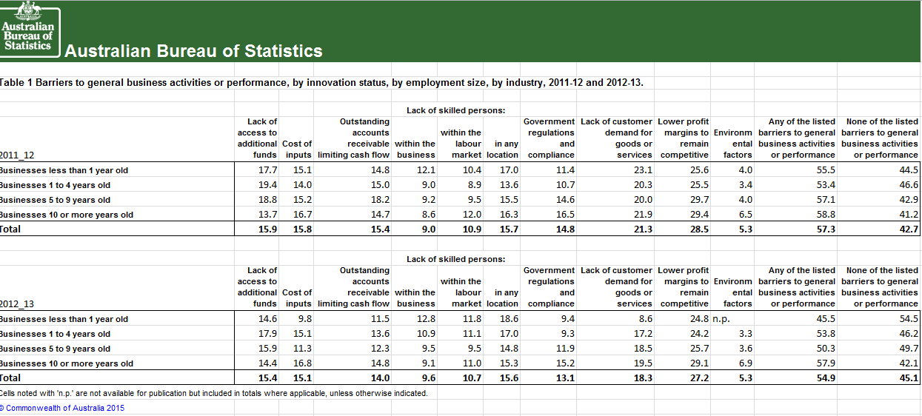
The BCS information can be linked to ABS held Australian Taxation Office (ATO) economic performance data and ABS Business Register data to investigate business set-up, transfer and closure including barriers. This can be done via the Business Longitudinal Database (BLD) or the Expanded Analytical Business Longitudinal Database (EABLD) discussed below.

2. Business Longitudinal Database

The Business Longitudinal Database (BLD), Confidentialised Unit record File (CURF) enables users to manipulate business microdata and perform both point-in-time and longitudinal unit record analysis on the topics discussed above. The BLD provides a rich dataset for analysing firm dynamics over time and it is the only Australian longitudinal business dataset amenable to merging with other ABS financial or employee based data. The BLD is populated from administrative data provided to the ABS for statistical purposes by other government agencies and data directly collected via the ABS Business Characteristics Survey. Administrative data includes Total sales, Export sales, Other GST free sales, Capital purchases, Non-capital purchases, Total salaries wages and other payments from ATO Business Activity Statements (BAS) and the value of import and exporting goods from ABS held customs data.

3. Expanded Analytical Business Longitudinal Database (EABLD)

The ABS has recently created an EABLD that links ABS held Tax Business Activity Statements (BAS) and Business Income Tax (BIT), Business Register (BR), BCS and Economic Activity Survey (EAS) data. This is part of development work being undertaken by the ABS that will act as proof of concept for the Firm level Strategy (see below). Each source can be investigated individually or in combination. For instance if you look at tax data only, you will be investigating the majority of the population.

The ABS is looking at ways to improve access arrangements to this dataset to enable analytical work to be undertaken on ABS held datasets, while ensuring individual businesses are not identified. This dataset offers greater and timelier access by non-ABS researchers for undertaking policy based research and program evaluation analysis. Improved access to the dataset include;

- ABS undertaking research on behalf of client via a consultancy. (this work is performed on a user pays basis)
- Client designs and sends code to the ABS to be run against the EA BLD. The output is confidentialised and returned to the client and can be an iterative process. (this work is performed on a user pays basis)
- Secondment to the ABS from another government agency. (subject to approval by the Australian Statistician).

4. Relevant ABS-held Australian Taxation Office adminstrative data for business

Business Activity Statements (BAS) are submitted by businesses in respect of their GST obligations. Activity statements are submitted to the ATO on either a monthly, quarterly or annual basis, depending on the size and, to some degree, preference of the business. BAS data included in the BLD are as provided by the ATO. The Income Tax Assessment Act 1936 provides for the ATO to pass information to the Australian Statistician for the purposes of the Census and Statistics Act 1905. Data items of potential interest include:
- Total sales
- Export Sales
- Capital purchases
- Non-Capital purchases
- Total wages salaries and other payments
- Proxy Valued added=Total Sales -Non-capital purchases
- Proxy Productivity=(Value added/Total wages salaries and other payments)

There are also around 20 more detailed Business Income Taxation data items such as Total business Income, Total expenses, Total profit/loss, Total salary and wage expenses, Sales of goods and services.

5. Personal Income Tax (PIT) and Pay As You Go (PAYG)

These data are available to the ABS and there will be potential to add this to the EA BLD in the future. This will assist in with employment size and allow business set-ups transfers and closures to be identified.

6. ABS Business Register information

The ABS uses information from the Australian Business Register to populate its internal register of businesses, the Australian Bureau of Statistics Business Register (ABSBR), which is used as a source for business survey frames and business counts.

Data items of potential interest from the ABSBR data items include:
- Type of business entity
- State of operation
- Industry division
- Geo-coding (should be available in the future.)
- Employment or derived employment size
- Foreign controlled
- Large business status.

7. Counts of Australian Business Entry and Exits (CABEE)

This ABS product presents business counts, including rates of business entries to and exits from the Australian economy, and rates of business survival. These data are sourced from the Australian Bureau of Statistics Business Register. Detailed counts are presented by industry, main state and territory, type of legal organisation, institutional sector, employment size ranges and annual turnover size ranges. The Issues paper released by the Productivity Commission used readily available CABEE data from the ABS website using Tables 1 and 10 for the 2012-13 financial year, including
- Entries;
- Exits;
- Operating at end of financial year business counts;
- TOLO; and
- Entry and Exit percentage rates

Industry breakdown data are also available as well as survival.

The ABS have identified opportunities to further refine the definition of Entries and Exits (pending the question of resources) to render them closer to the OECD recommendations for Business Demography statistics.

B. Potential for the Future - Firm Level Strategy (FLS)

Currently, the level of data available for analysis and evaluation for policy makers is limited (i.e. not well integrated or fit for the purposes of firm level analysis). To address this, the Firm Level Strategy is being developed. This strategy is aimed at increasing the capacity to undertake firm-level analysis of micro-economic drivers of performance, competitiveness, productivity, and improve evidence base for policy development and evaluation, leading to more targeted expenditure of government funds. Financial support is critical to the success of the strategy and is subject to consultation with stakeholders and delivery of current proof of concept projects.

The firm level plan has four elements - establishing the infrastructure, expanding firm level data, enhancing access and growing analytical capability - and to achieve these, the following four initiatives are proposed:
- Creation of a backbone longitudinal dataset for all businesses using administrative data from the ABS Business Register and the Australian Taxation Office in the first instance including development of capability to integrate and link other survey/administrative data held by government agencies. The Expanded Analytical BLD is a significant proof of concept project under this initiative;
- Enhancement of the ABS' Business Longitudinal Database including creation of a dedicated longitudinal panel for R&D performers;
- Enhancement of analytical capability in the ABS and improvement of infrastructure used to access confidentialised micro data; and
- Development of a Linked Longitudinal Employer-Employee Database.

Some of the benefits of the Firm Level Strategy may include:

- Fit for purpose, longitudinal core financial performance data for all businesses
- Provision of more tailored firm-level statistical outputs
- Greater firm level responsiveness to policy based information needs
- Firm level productivity and performance studies for any user defined population
- Capacity to import and link ABN based administrative datasets
- Linked, longitudinal employer/employee dataset
- Increased analytical capability within the ABS and capacity to partner with research community
- New infrastructure for accessing confidentialised unit record files.

As part of this review operationalising the Firm Level Strategy is one possible solution that should be considered to improve the evidence base.

Contact information
For further information on the availability of statistics that might support the work of the Inquiry, or if you have questions about the information above, please contact:
Bruce Hockman
First Assistant Statistician
Business, Industry and Environment Statistics Division
Australian Bureau of Statistics
Locked Bag 10
Belconnen ACT 2616

